**Management Information Systems**

Assignment Number 2 (Spring 2022)

=====================================================================================

Marks 10 Due Date: By 26th May2022

Instructions:

* Marks deduction will be done for assignments submitted after due date.
* Plagiarism shall be penalized.
* Save the answer files in the format First Name_RollNumber_MIS_A2.xxx

1. **Business Intelligence has become need of the time. How would elaborate the concept of Business intelligence? (1)**

**Answer:**

By displaying current and historical data within the context of their business, business intelligence can assist firms in making better decisions. Analysts can use business intelligence to provide performance and competitive benchmarks to help the organization run more smoothly and efficiently.

Analysts can also notice market trends more easily, which can help enhance sales or revenue. When used correctly, data may assist with everything from compliance to employment initiatives. Here are a few examples of how business intelligence may assist firms in making better, data-driven decisions:

* Identify ways to increase profit
* Analyze customer behavior
* Compare data with competitors
* Track performance
* Optimize operations
* Predict success
* Spot market trends
* Discover issues or problems

1. **Compare importance of Fault tolerance and Backups?**  (1)

Answers:

In a disaster recovery approach, fault tolerance might be beneficial. Fault-tolerant systems with cloud backup components, for example, can quickly restore mission-critical systems even if on-premise IT infrastructure is destroyed by a natural or human-caused disaster.

In Back up we can say Parallel systems that are identical or similar keep operations flowing.

1. **What is VPN? How VPN is important for accessing business applications**  (1)

Answers:

A virtual private network (VPN) creates a secure connection between you and the internet. All of your data traffic is routed over an encrypted virtual tunnel via the VPN.

A VPN is commonly used by businesses to provide remote employees with access to corporate programmers and data, as well as to build a single shared network between numerous office locations. The ultimate purpose in both cases is to keep online traffic, particularly traffic holding proprietary data, off the open Internet.

1. **Explain the concept and benefits of virtualization. Also describe the types of hypervisors**. (2)

Answer:

A hypervisor, often known as a virtual machine monitor or VMM, is a piece of software that allows you to create and run virtual machines (VMs). A hypervisor allows a single host computer to handle numerous virtual machines (VMs) by sharing resources like memory and computation.

**Types:**

Type 1 (or "bare metal") and Type 2 (or "hosted") are the two most common hypervisor types.

A type 1 hypervisor functions as a light operating system that runs directly on the host's hardware, but

A type 2 hypervisor functions as a software overlay on top of an operating system, similar to other computer programs.

1. **Task:** Create a Dashboard using Power BI Tool with provided data in Excel Sheet. (4)

**Required:** 2 files (Power BI File and Snap Shots collected in one File, MSWord or PDF) (Snap and written Answers of the following Insights)

**Dashboard**

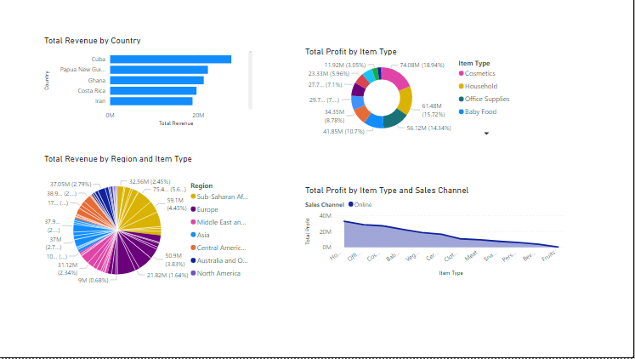

1. Top 5 Countries with **revenue** figures

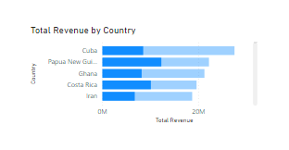

1. Which Region generates highest revenue and which Product category in that region is on top?

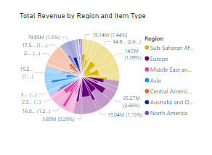

1. Which category of Product generates most profit **overall**?

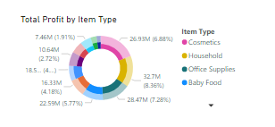

1. Which Product category generates most profit in **online sales**?

