# CHAPTER 1

# INTRODUCTION AND MOTIVATION

The history of the word quality is littered with meanings, features, and case studies. Quality, in all of its manifestations, has recently been a crucial consideration considered by all firms, including small enterprises. In this sense, standards, procedures, tools, and techniques can assist firms in integrating quality into their daily operations by ensuring standardization and ease of application. However, observing the correlations between the installation and maintenance of quality throughout a product's lifecycle and the project management process of that product reveals an interesting element.

Another essential consideration is how the agile approach and quality work together to assure the delivery of high-quality products and/or services.

Given the complexity of today's products, the expanding number of software products available for practically every purpose, and the enormous number of competitors, manufacturers have been compelled to provide higher-quality products while keeping prices low. Now that agile development methodology has gained a lot of traction in the IT sector, Risks abound in the project management cycle. Old project management entails: It may be difficult to immediately identify these risks before they have an impact on the project. Agile management is ready to carry such challenges to bear throughout product development life cycle because it focuses on incremental releases.so it is very importance to understand about Agile project management and how to implement quality tools and techniques in agile development methodology. Agile methodologies encourage engineers to participate in testing rather than having a separate quality assurance team. Agile approaches have gained popularity as a result of their capacity to work effectively and efficiently in dynamic contexts. This is owing to modern processes and ideas that allow development teams to finish software on time.

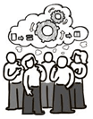

Figure:1 Agile project management

For the uninitiated, agile methodologies may appear to be lacking in quality assurance. For example, the Scrum Guide only mentions the development team, not the QA team. Agile projects don't have a testing phase, and they're intentionally sparse on paperwork like requirements and QA plans. While these views are fair, they overlook the more powerful options available on well-executed agile initiatives.

QAs are part of the development team and are involved right from the start. They attend planning meetings, have access to the client, and devise strategies for validating functionality as it is being developed by developers. Quality is baked in from the beginning, rather than being attempted to be tested later. Similarly, because features are produced in order of importance, the most crucial aspects receive the most testing and exposure because they are present from the start.

Indeed, the mechanisms and methods for guaranteeing that testing takes place—and that tests pass—are light years ahead of typical late-phase validation. TDD (test-driven development), automated builds, continuous integration, continuous delivery, and DevOps techniques enable on-demand release or rollback with excellent reporting and analytics.

While the majority of traditional QA and release management difficulties are now manageable, project managers and sponsors still face some intriguing philosophical questions and misconceptions. Let's take a look at a couple of the more prevalent ones:

* Beginning development before gathering all of the criteria
* Permitting deviations from the specification
* Is it truly sensible or safe to have less documentation?
* Creating a minimal viable product (MVP) vs. adding all the extras

## 

## 1.2 Beginning development before gathering all of the criteria

It seems paradoxical not to obtain as much information about the needs as possible before commencing work. Surely, this foresight will pay off in the future? It could, if it was accurate and consistent.

Not all of the needs for knowledge work are known at the outset of the project. When we look at how components fit together, some criteria emerge (or as technologies, platforms and competitor products evolve during the lifecycle of development)

When gathering requirements, human personality qualities are frequently at play. People frequently request what they require in addition to what they desire, with some additional stretch goals tossed in for good measure. This is to make up for not obtaining everything they want when other stakeholder desires are taken into account. Then there are the unavoidable reductions in size due to budgetary limits, schedules, and other factors. As a result, people will request what they require plus 20% more in order to increase the likelihood of completing all of their high-priority tasks.

Creating a minimum viable product (MVP) early helps to avoid scope inflation. Demonstrating what has been developed to the business and product owner is important. Then, when discussions about priority and what to create next, the gold-plating of requirements that might occur with big-design-upfront techniques is usually limited. Although the technique isn't perfect, improved exposure and transparency appear to keep unwanted characteristics at bay.

## 1.3 Permitting deviations from the specification

There's no getting around the fact that changes are expensive. Things must be rewritten, processes must be rerun—and this is time spent on development that we will never get back. Meanwhile, our money is still being depleted, and our competitors are working on new features and products of their own.

While revisions are costly, they are not as costly as developing a bad product or service. Any project's viability can be harmed by developing the incorrect product, failing to remedy an omission, or missing an opportunity to improve. Completing to specification is easier in terms of decision-making, but it is worse in terms of optimising business value.

We must analyse and enable changes in order to remain adaptable and competitive; the costs must be weighed against the advantages. This is true for traditional projects, but agile methodologies integrate this more neatly into the workflow. Changes and existing requirements are handled easily by the backlog, prioritisation, and sprint planning processes. It is more efficient to have an engaged product owner than to convene a change-control board. Because change is unavoidable, let's make the most of it.

## 1.4 Is it truly sensible or safe to have less documentation?

We may rephrase the question to ask if the best approach to assure quality or suitability is through documentation. Is a 2,000-page specification better than a 20-page one by a factor of 100? Is automated testing or documentation a better way to ensure quality?

There is no simple answer. Of course, proper documentation is important, but so is putting a working prototype to the test. Specifications, like regression test tools, have utility. Perhaps a better question is, "How should the next dollar be spent?" Should we start with requirements validation and then go on to user input sessions, or should we start with documentation and then move on to design?

There is no rule in Agile that says you can't develop documentation. "Hey, maybe there's more value in doing these things than in documenting everything," it simply says.Executives, sponsors, and project managers should rejoice. We're still in command, and we get to decide how much paperwork we need based on our industry's needs and the specifics of our initiatives.

## 1.5 Creating a minimal viable product (MVP) vs. adding all the extras

Some people think agile teams create a minimum viable product then stop, which is not the case. Only knowing half the story is another human trait. We are inherently lazy, and it takes interest or focused effort to learn the whole story. Most things in our lives we deem not worth the effort. The original waterfall white paper recommends exercising the waterfall lifecycle twice, but that’s not what most people remember. They read to the waterfall diagram, assumed they understood it and stopped paying attention.

It's the same with our goods and services. We begin with a minimal viable product and add functionality until the business determines that the development expenditures are no longer justified by the return on investment. We may never be "done" with digital products like business websites, ecommerce platforms, and digital services. This is when the distinction between product development (which has no set endpoint) and project development (which is a temporary undertaking) begins to emerge.

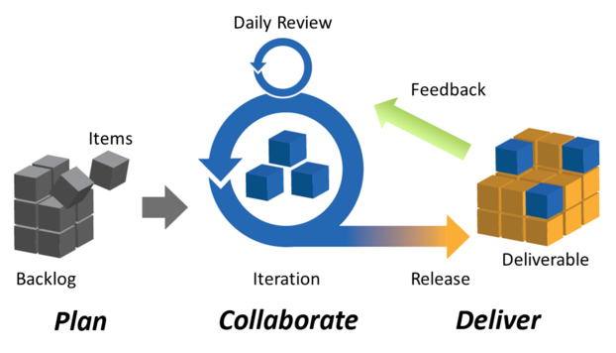

Figure:2 Agile project management Iteration

# CHAPTER 2

# LITERATURE REVIEW

Quality has evolved and developed around the needs of manufacturing firms and production plants from its inception in the late 13th century, when craftsmen began gathering into guilds called guilds, and has since been part of the modern company’s aims. Given that there are various interpretations of quality and quality control systems, so implementation of quality control activities in scrum produces the quality product [1].with reference to key feature of quality, project management, and agile development, quality also monitored by the integration of new quality management and creativity tools into agile development [2], The best monitoring metric is GQM it investigates prominent cloud-based project management tools, which produces clear Quantitative data that may be used for later decision-making and project management. [4], as well as the Success factors of agile methodologies, and compared them to the success factors of Total Quality Management (TQM). By doing so, I was able to highlight the success factors that were present in Both TQM and Agile methodologies, as well as provide recommendations for future improvements. When it comes to agile project management, scrum and its artifacts play a significant role in achieving the desired results, and daily meetings to manage quality activities (e.g., as part of Scrum) and user stories serve as the foundation for comprehending quality needs. Daily meetings also said to be standup meeting which usually arrange be the scrum masters. So here the scrum master is responsible to maintain and control the quality of meeting. [6]. In this study M. Rizwan Jameel Qureshi [7] addresses the issues with XP and Scrum by combining them in order to strengthen XP’s and Scrum’s strengths while minimizing their weaknesses. And also evaluate the quality of XModel. Quantitative and qualitative data are used to present the findings. The findings show that the proposed XScrum is significantly better than existing XP and Scrum in terms of quality. In Year 2020 Prerana Shakya, and Subarna Shakya, [8] this research work in which it was examine the numerous essential success aspects of agile methodology and to provide insight into how these factors impact overall business success and assist managers to achieve corporate goals. Michael Bauer [9], research and focused on quality assurance as part of MVP development, which enables and increases MVP’s benefits by offering a semi-automated feedback elicitation, analysis, and processing framework. The Opti4Apps approach adapts to mobile development habits by providing automatic feedback and data processing infrastructure. Opti4Apps develops and uses a framework based on automatic elicitation and analysis of feedback, as well as an effective and efficient quality assurance approach, to apply and extend the benefits of MVP development.

Dovleac Raluca, and Suciu Cristina [10] examined these difficulties in this research to better understand the relationship between Quality Assurance and Agile development processes, as well as to make recommendations for future integration of Quality Assurance components into agile development practices.

# CHAPTER 3

# RESEARCH QUESTIONS

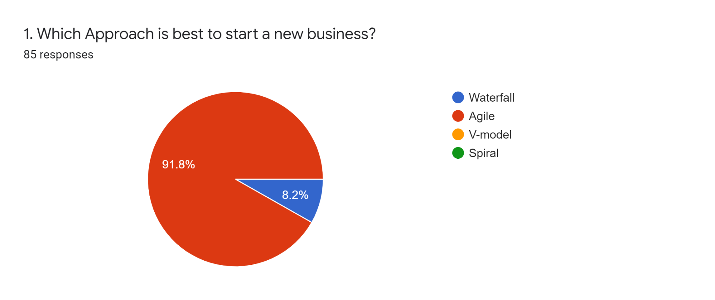

Figure:3

It is necessary to understand the nature of business, and which approach is suitable for the business to adopt, so we decided to go for a survey, in which we ask people what is the better approach more than 90 percent people choose agile, and the reason behind choosing agile is that, it is better to attain goal in sprints so that if we want any change the easily handle it. Customer collaboration is also the demand of all. On the other hand the traditional approach (waterfall) is now not so comfortable for the people.

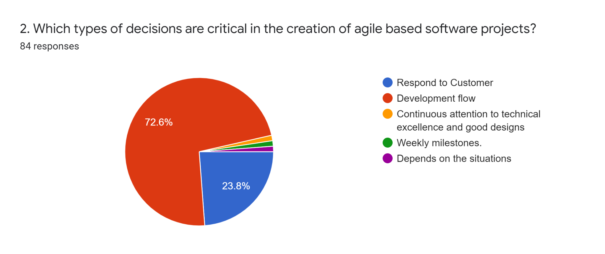

Figure:4

Agile principles clearly states about the customer collaboration, whenever there is a change needed according to the customer, then there is no other way to follow the development flow until and unless the product owner approve it that it can be done after the ongoing flow, so according to survey most of the time continuing development flow is not an easy task when changes arrived.

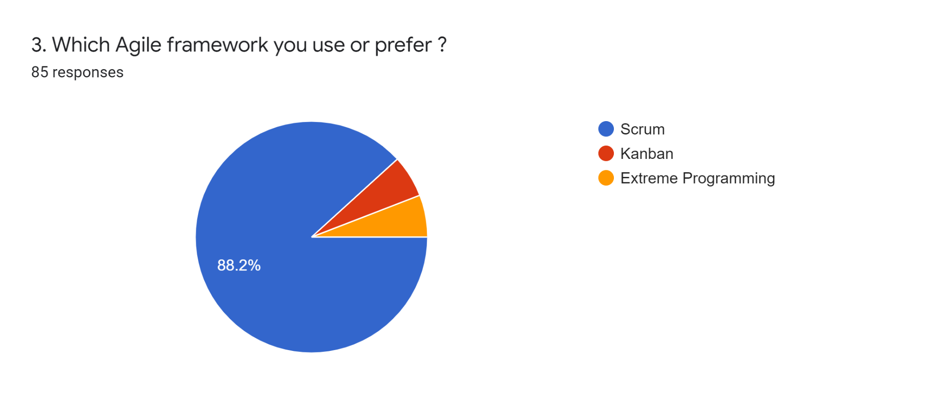

Figure:5

Agile is playing a vital role in software industry, following agile concepts there are different sets of guidelines that help to deliver the product in small increments know as MVP (Minimal Viable Product), according to survey scrum is the most commonly used agile framework because of its pillars Transparency, Adaptation and Inspection.

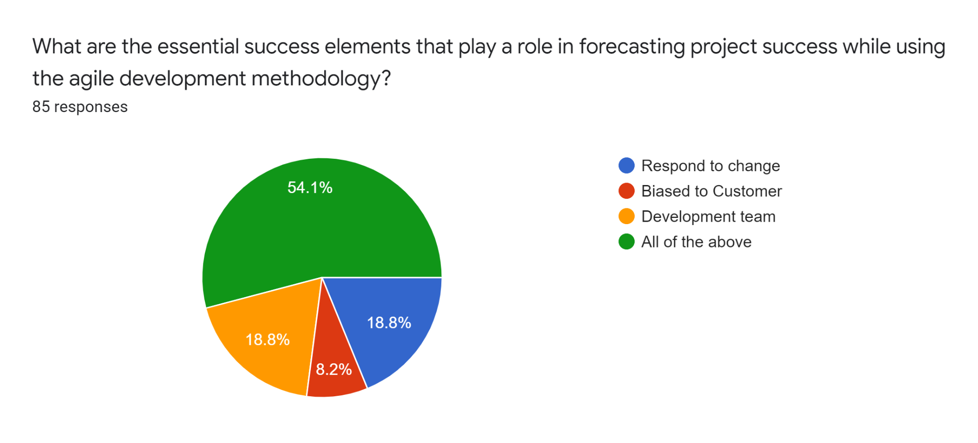

Figure:6

Agile development methodology always welcome changes even they are late in project, agile emphasize on customer satisfaction, development team also play a vital role in the development providing MVP sprint by sprint. On the behalf of this our survey also recommends all these things are important to keep the track smooth and move towards success.

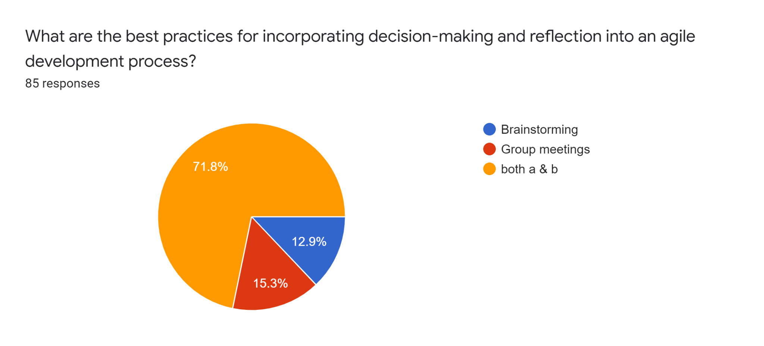

Figure:7

Agile practices are very much helpful for everyone in the team because transparency make it clear to team members, brainstorming and group meetings maintains the track of the development of the project. In scrum framework it is known as daily scrum.

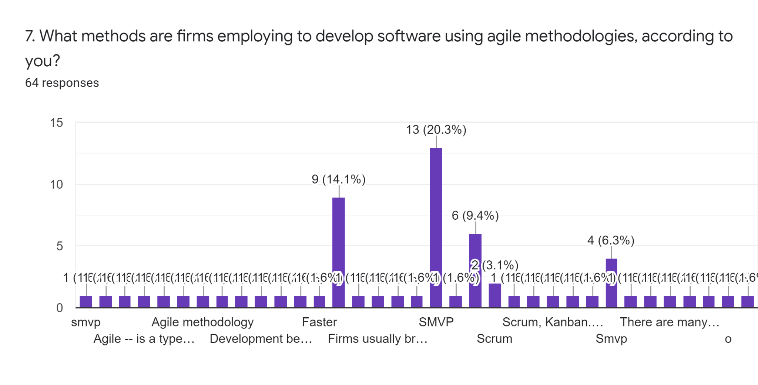

Figure:8

Agile is now one of the most popular methodology, almost every firm implementing agile in their own way, especially in Pakistan. Usually MVP is used for continuous deliveries so that customer feedback will provide better tracking of the project.

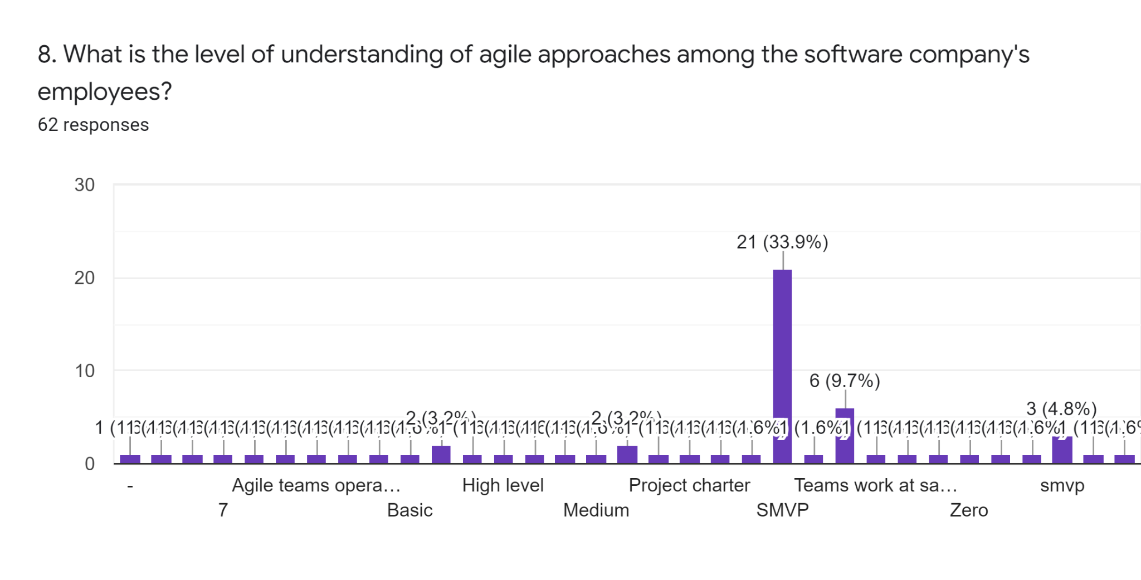

Figure:9

Agile is attracting everyone, software companies are now adopting agile very fast but the concept of agile is not so much clear in Pakistan, according to our survey we got different type of answers about the agile approaches but now different software companies are hiring teams according to scrum like scrum master and cross-functional development team.

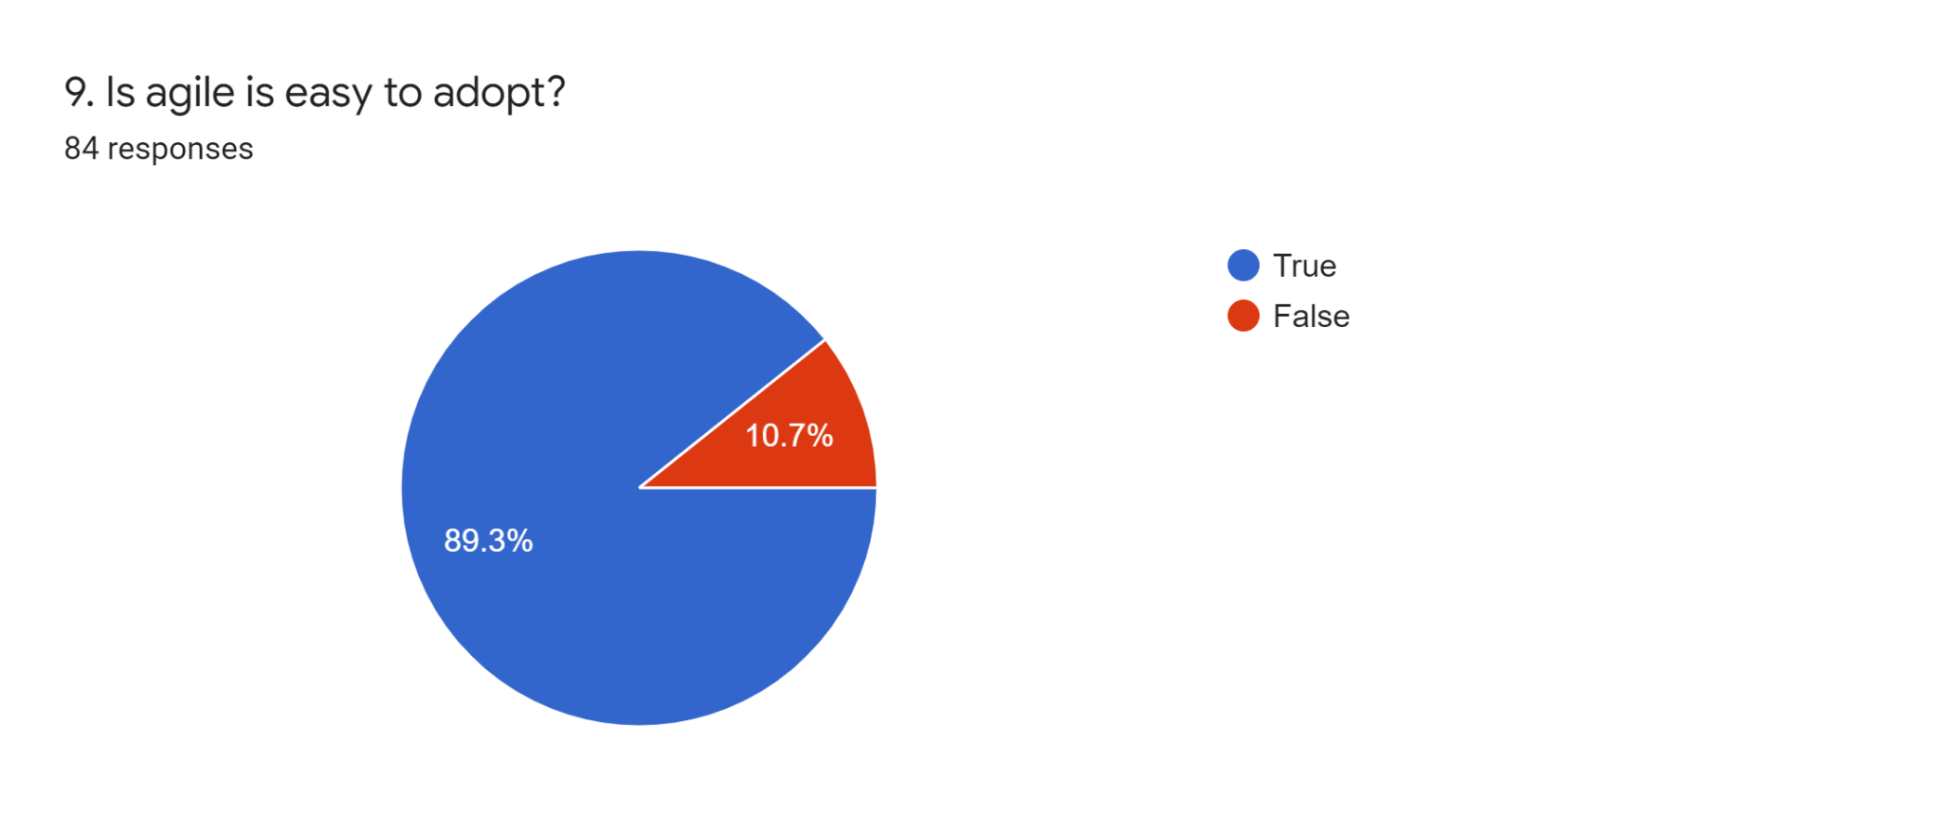

Figure:10

Yes, agile is easy to adopt but continuous collaboration with customer and welcoming changes are the major things to work on, to adopt agile we need to figure out what is agile manifesto that summarize the story of every project by clearing roles of the team.

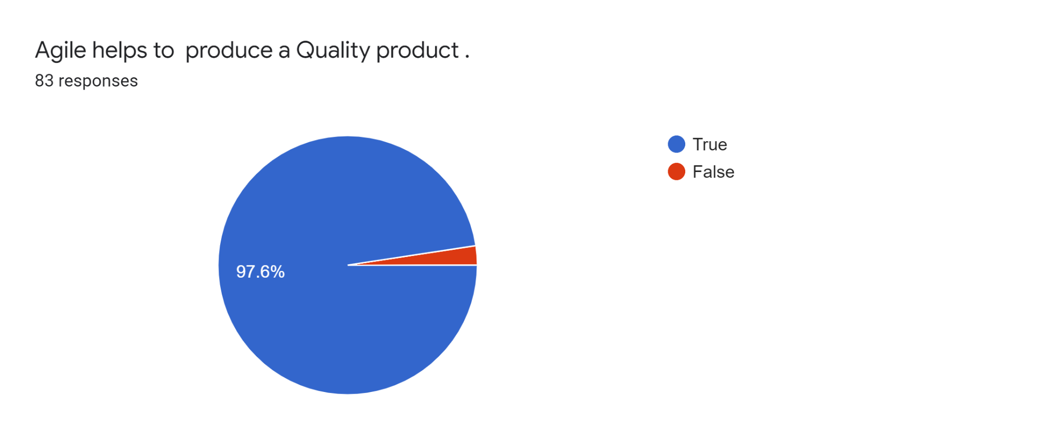

Figure:11

Yes, agile helps to produce to quality product, because the product is divided into different sprints, so that goals are efficiently focused, and by adding increments according to customer, the feedback cycle will also helpful for the developers to maintain the track of the project.

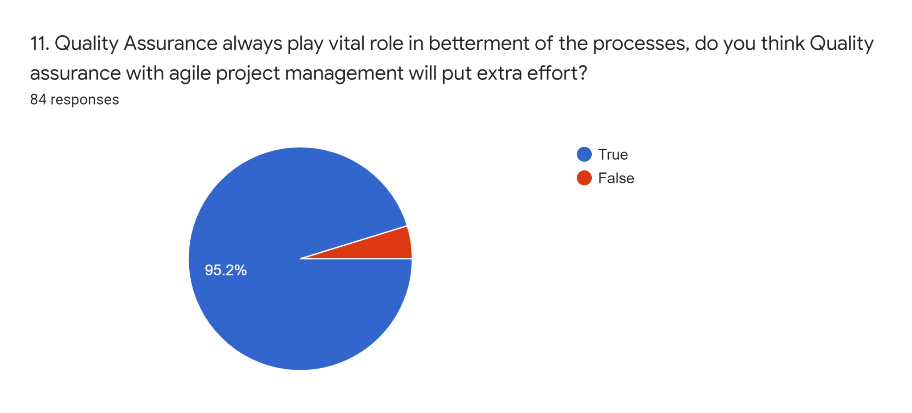

Figure:12

Yes, quality assurance will take some extra effort to produce a quality product, agile is a concept the processes we are applying may be sometimes make it more complex so quality assurance plays a vital role in the betterment in the processes with agile project management.

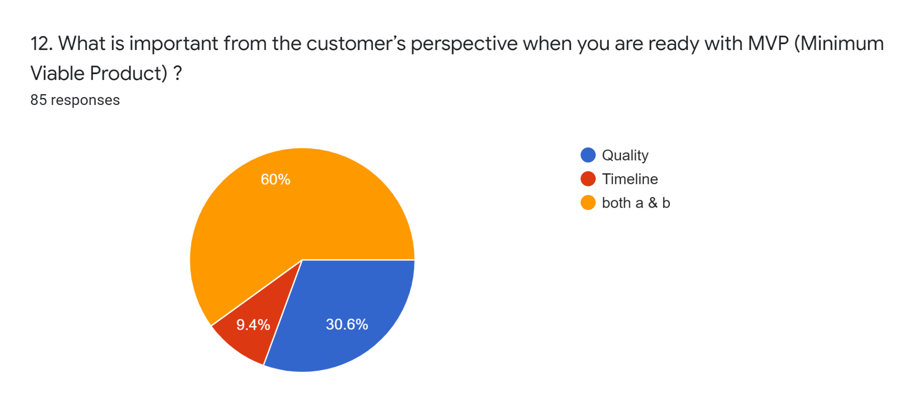

Figure:13

Customer always expect a quality product, if the timeline is uncertainly is not according to the customer deliveries then quality will be the only key thing that customer will compromise on it. Well we got mix answer for this question most of the developer thinks both timeline and quality matters.

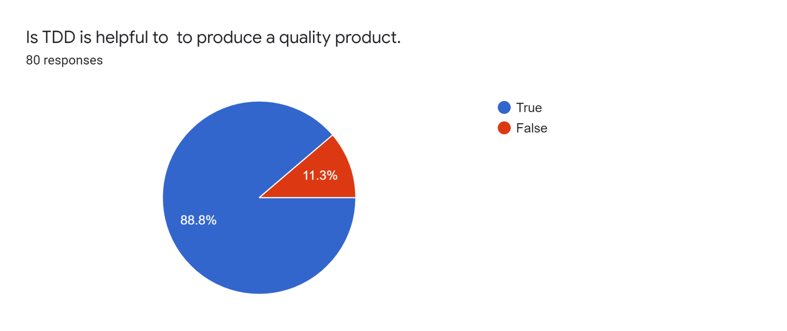

Figure:14

Yes, test driven development provide a better way to refactor the code, it provides higher code quality, it provides easier maintenance and code flexibility. As per our concerns we also get this response that TDD is helpful to produce a better quality, especially in the long run.

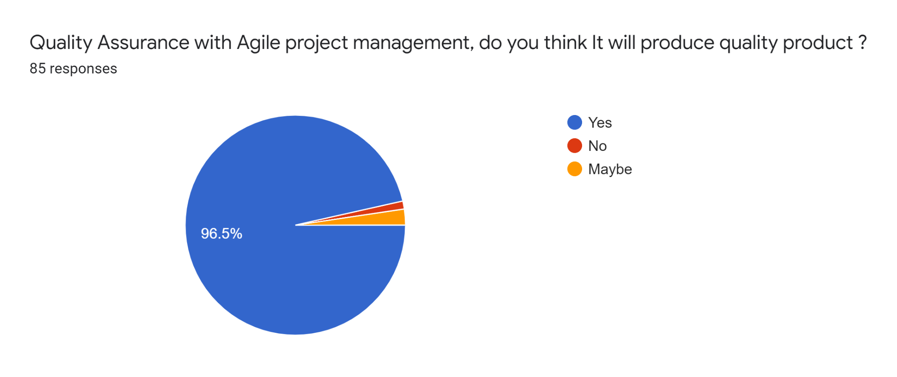

Figure:15

Quality product is the need of the customer and for the development team as well, to better the process with any management will give the good outcome. According to our survey agile project management will get a real boost by applying quality assurance to make processes better.

# Summary

|  |  |  |  |  |
| --- | --- | --- | --- | --- |
| **RQ No** | **Research Question** | **Positive** | **Negative** | **Neutral** |
| **RQ:1** | Which Approach is best to start a new business? | Agile  92 % | Waterfall  8% | - |
| **RQ:2** | Which types of decisions are critical in the creation of agile based software projects? |  |  |  |
| **RQ:3** | Which Agile framework you use or prefer? |  |  |  |
| **RQ:4** | What are the essential success elements that play a role in forecasting project success while using the agile development methodology? |  |  |  |
| **RQ:5** | What are the best practices for incorporating decision-making and reflection into an agile development process? |  |  |  |
| **RQ:6** | What methods are firms employing to develop software using agile methodologies, according to you? |  |  |  |
| **RQ:7** | What is the level of understanding of agile approaches among the software company's employees? |  |  |  |
| **RQ:8** | Is agile is easy to adopt? |  |  |  |
| **RQ:9** | Agile helps to produce a Quality product . |  |  |  |
| **RQ:10** | Quality Assurance always play vital role in betterment of the processes, do you think Quality assurance with agile will put extra effort? |  |  |  |
| **RQ :11** | What is important as for the customer’s perspective when you are ready to launch the increment? |  |  |  |
| **RQ:12** | Is TDD is helpful to produce a qualityproduct**.** |  |  |  |
| **RQ:13** | Quality Assurance with Agile project management, do you think It will make will produce quality product ? |  |  |  |

# CHAPTER 4

# METHODOLOGY

## 4.1 PROBLEM STATEMENT

Old project management techniques are not enough to cope up with new emerging challenges, Old project management entails: It may be difficult to immediately identify these risks before they have an impact on the project. Agile management is ready to carry such challenges to bear throughout product development life cycle because it focuses on incremental releases.so it is very importance to understand about Agile project management and how to implement quality tools and techniques in agile development methodology. The traditional project management adopts a typical forecasting management method. First, the feasibility of the project is analyzed, and then the project plan is formulated. The specific implementation of the project is a continuous process. This project management model has great shortcomings. When a project plan changes, it is inevitable to adjust the subsequent activities. In an agile approach to project quality, there is an emphasis on continuous improvement of the delivered product - the team is constantly striving to make the product better.

## 4.2 GAP IDENTIFICATION

Risks abound in the project management cycle now that agile development methodology has gained a lot of support in the IT business. It may be impossible to immediately identify these risks before they have an impact on the project, as is the case with traditional project management. In this article, I’ve analyzed that agile development methodology is one of the most demanding and convenient approaches for business professionals to start their firm from the ground up and take it to the next level, so it’s critical to keep quality throughout the development life cycle. The old traditional techniques are not enough to maintain the quality of product high. So we need to incorporate agile project management to build and maintain the quality product in minimal duration of time.

## 4.3 PROPOSED SOLUTION

In this research I have analyze that agile development has introduced in a slew of practical approaches for creating high quality software at a rapid pace. Test-Driven Development (TDD) is one such strategy that is now widely regarded as an effective method for achieving positive outcomes. It is necessary to involve developer as a tester it ensures that your source code is extensively checked at the level of confirmation. Once the code is written in a good manner so it will automatically produce a quality product. TDD’s testfirst strategy also aids in the elimination of major bottlenecks that inhibit software quality and delivery. The system evolves to guarantee that everything functions as it should based on continual input, issue patches, and the inclusion of new features. TDD improves communication between members of the development and quality assurance teams, as well as with the client. Furthermore, because the tests are already written, teams don’t have to waste time rewriting lengthy test scripts.

## 4.4 METHODOLOGY DIAGRAM

The mostly used agile frame work is Scrum. It is an effective agile framework, it is adaptable, fast and flexible and it works in a way to deliver value to the customer throughout the development. Scrum has its own guideline through which we can easily achieve our goal.it includes scrum roles(Product Owner, Scrum Master and Developer),scrum pillars (Transparency, Inspection, Adaptation), scrum events(Sprint Planning, Daily Scrum, Sprint Review and Sprint Retrospective) scrum helps in all ways to produce a better life cycle. TDD is a software development discipline where developer writes automated test cases for enhancement or new features before they write any code. It helps whenever we need modifications, like agile is always open for respond to change, so it is easy understand the business process of such module. TDD allows us to maintain a constant cost of change and break the negative feedback loop.

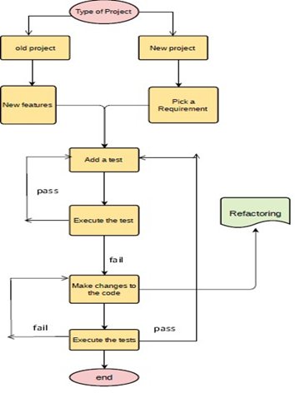

Figure:3 Steps of Test-Driven Development.

## 4.5 CODE IMPLEMENTATION

In this section we have implemented the steps of TDD

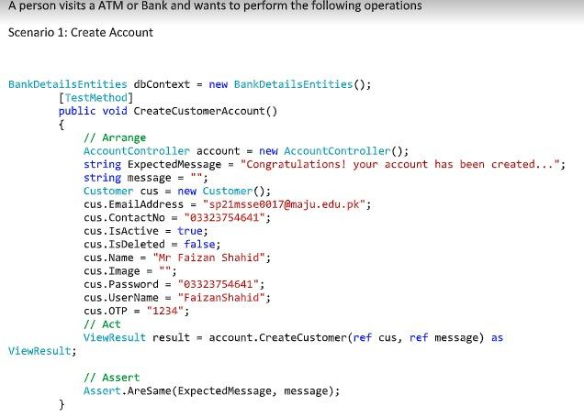

This sample code defines that end-user needs to create an account in customer portal if we discuss in details about code and how it works so first of all we create the object of database entities which is included in our solution when we add ADO.Net to access database from visual studio then we create the function of CreateCustomerAccount to create a customer in this void function we create another object of Account controller and then we create the third and last object of customer class and set all columns or attribute in it . Then we create a customer after this we check the exception message with message by using assert function which is pre-defined.

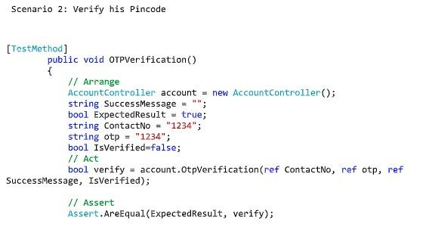

This sample code defines that end-user needs to verify his OTP pin code, so that customer can login to the portal, user is trying to verify his OTP code.

# CHAPTER 5

# RESULT AND DISCUSSION

The Agile Project Management methodology has been increasingly popular in the twenty-first century, notably for application development and other IT efforts.

**It Can Be Difficult to Do Quality Assurance in Agile Project Management**

The importance of quality assurance (QA) in software development has always been recognised. There can be no software development team without a tester or two (or someone who will be conducting the testing but doesn't like labels).In an Agile context, QA is significantly different from what it is in a traditional one. With that in mind, let's take a look at quality assurance in Agile project management and how difficult it may be.The importance of quality assurance (QA) in software development has always been recognised. There can be no software development team without a tester or two (or someone who will be conducting the testing but doesn't like labels).In an Agile context, QA is significantly different from what it is in a traditional one. With that in mind, let's take a look at quality assurance in Agile project management and how difficult it may be.

**RQ1:What are the differences in QA between the two methods?**

Traditionally, the job of quality assurance in software development has had little to do with project involvement. Testing teams are separate from development teams, and their tasks are completed at the end of the project.

In other words, once the development team has completed all of the coding, the testers receive the code as well as the requirements documentation so that they may create and execute test cases to confirm that the code is operating as expected. If any major defects are discovered during testing, the code is returned to the development team, and the process begins again.

In an Agile environment, on the other hand, QA teams are given a completely new set of tasks and functions. Agile QA teams, for example, are self-organizing and cross-functional, which means they collaborate closely with development teams QA teams work closely with the rest of the team on all aspect of the project development cycle, from interviewing clients and reviewing their insights to assuring that the strongest quality product will be delivered to the client at the end.

**RQ:2 Where is the difficult part in QA assurance ?**

The phase where QA members deviate from their usual jobs and adopt Agile practices is the tricky part. As previously said, in the waterfall system, QA had a definite purpose, however in the Agile environment, their duties and responsibilities grow dramatically, frequently tenfold.

It can be difficult for QA members who have spent a long period working in a traditional environment to adjust to their new surroundings. In most circumstances, this phase of adjustment entails the acquisition of new abilities as well as a shift in one's mentality.

To say the least, this procedure is difficult. The adaptation would entail learning new communication skills, participating in previously unseen processes and practises, and developing collaborative thinking, among other things. When switching to Agile methodology, traditionally separated QA teams have a lot on their plates. In other words, in an Agile setting, QA personnel are expected to know the ins and outs of the entire project, which can be intimidating at times.

# CHAPTER 6

# CONCLUSION

In this research survey we have done literature review and also surveys via research questions so we conclude our findings and research by analyzing the questionnaire which are being conducted from 10 different companies where we meet with the project managers and also ask them to share their view about Quality assurance in agile project management . although we have received almost 60% satisfaction level from them that they believe and prefer agile project management in their companies but almost 40% companies still unaware from agile project management so we also took their point of views and note them on the other hand we also ask them to tell the best to tell us the best approach to fulfill the quality aspects they said the best approach could be TDD because TDD aids in the development of more modularized, extensible, and adaptable code. The Agile team uses the Test Driven Development approach to plan, produce, and test tiny components that will be combined at a later stage. Because the concerned member is more focused on a smaller unit, he or she delivers and performs better under this technique. TDD's advantages go beyond the validation of accuracy through step-by-step scaling. TDD-adopting enterprises can simply make modifications to existing apps without disrupting everyday operations. Most firms need to update their software to deal with the challenges given by ongoing technological innovation and competition, and Agile TDD allows them the flexibility to deal with new requirements or unforeseen circumstances.