**ORO24.ae Frontend Testing**

1. Please change this form



Into below: and once the customer fills up and register customer should receive an email that we have received your details will call you back. And even oro24 admin should receive email on [contact@oro24.ae](mailto:contact@oro24.ae) or whatever email they will request us. Please create back end to manage these requests also.

1. Please change the below picture to high resolution. Current picture is blur.

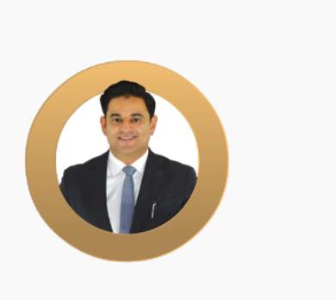

1. Please change below structure picture to high resolution. Current picture is blur.

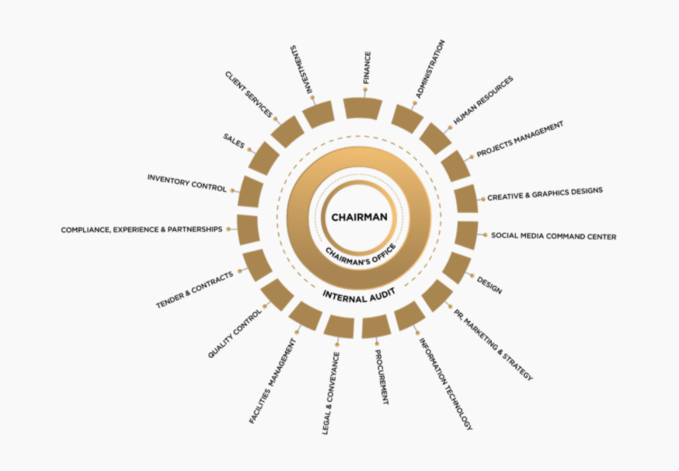

1. By clicking on Residentials, Commercials & Hospitality there are no project records showing, but we can see the latest projects under the same page. Where these projects assigned? If they are not assigned to any of the main category then its should not be allowed. Please refer the below image.

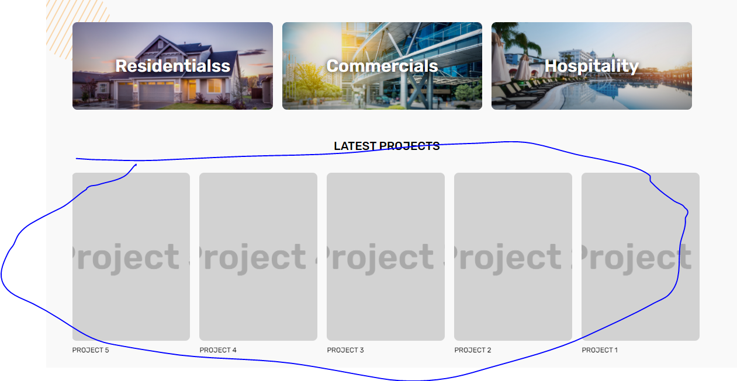

1. Inside the projects, Unit enquiry form

* Full name should not accept the numbers.
* Phone Number should be international format like 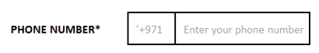
* All validation messages should show properly.
* Upon submitting the form error message is 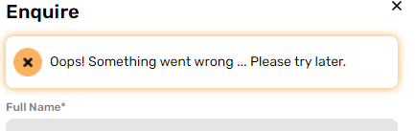

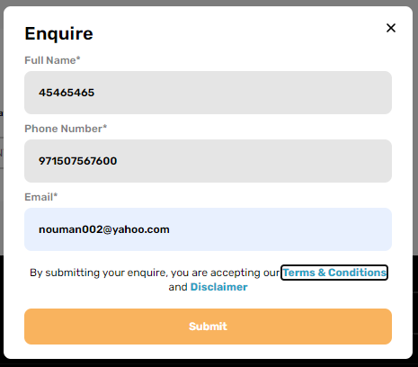

1. In unit detail’s location map is not working.

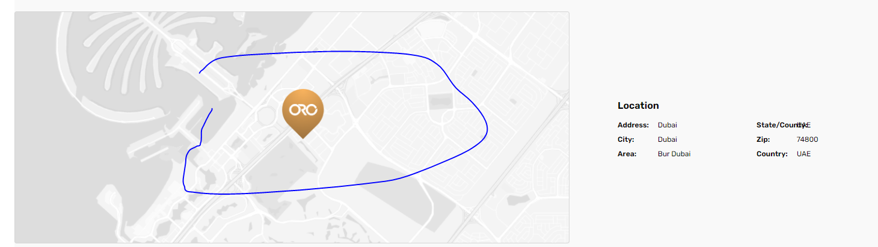

1. In project, you have to click on the image in unit tile to enter, customer should be able to click whole tile to enter inside the unit details.
2. Even on property PDF and virtual tour you have to click on icon to download or view. The click should work on the whole tile.

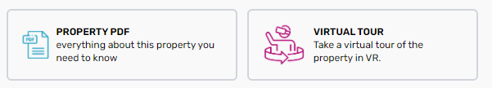

1. In unit “Book Now” should take the customer to signup page and then on the customer details page and once the customer updates the details it should take him to the payment page.
2. Please give the proper validation to the below form.

* Give First Name and Last Name, full name is not required.
* Phone number should be in international format like
* Country should show all the countries by default, take it from HR job apply form you guys created.
* City should be open same as HR job apply form.
* Area is not required.
* Give address like below.

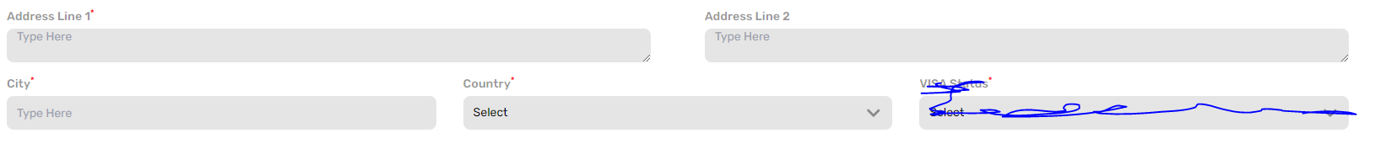

* PO. BOX is not mandatory it should be optional pls mention optional.
* Zip code is not required.
* Emirates ID is not mandatory. Please fix the form like this 784-1981-2080527-4 mask like (xxx-xxxx-xxxxxxx-x).
* Emirates id expiry date put calendar should not be allowed in back dates. this field also not mandatory.
* Passport Number is mandatory and passport expiry should not be allowed in back dates.

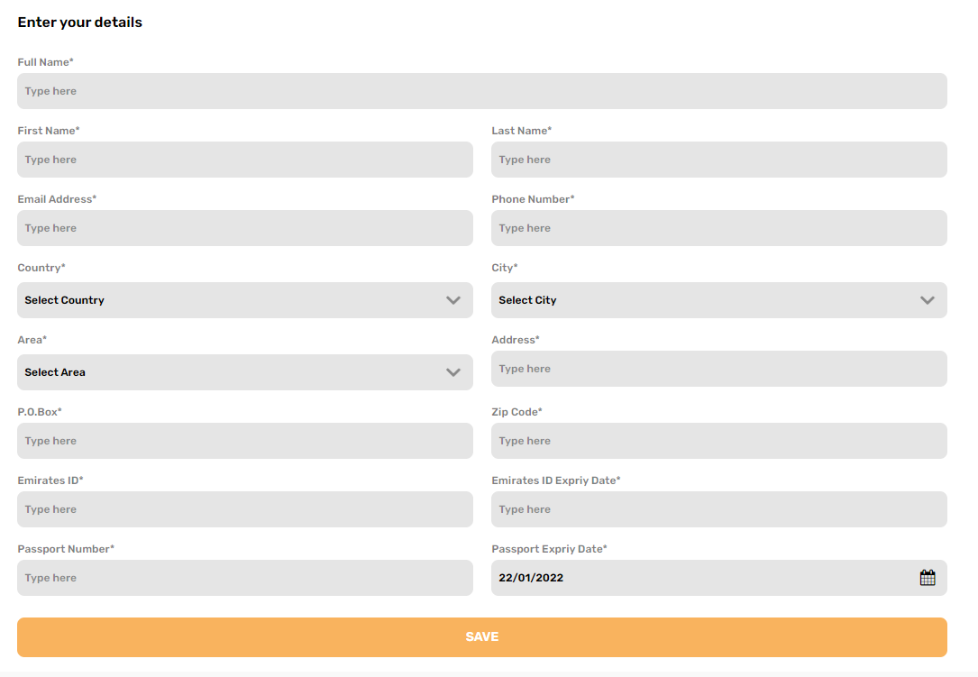

1. Join our newsletter is not working showing error 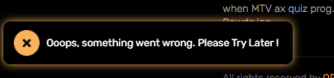
2. Please note in case of no projects, VR tours, news & events the page should show no records found exactly like blogs.

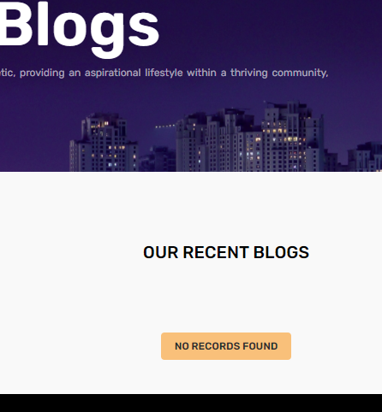

1. Why the records are not coming in left to right direction in news & events and even others projects, blogs etc. Pls fix this.

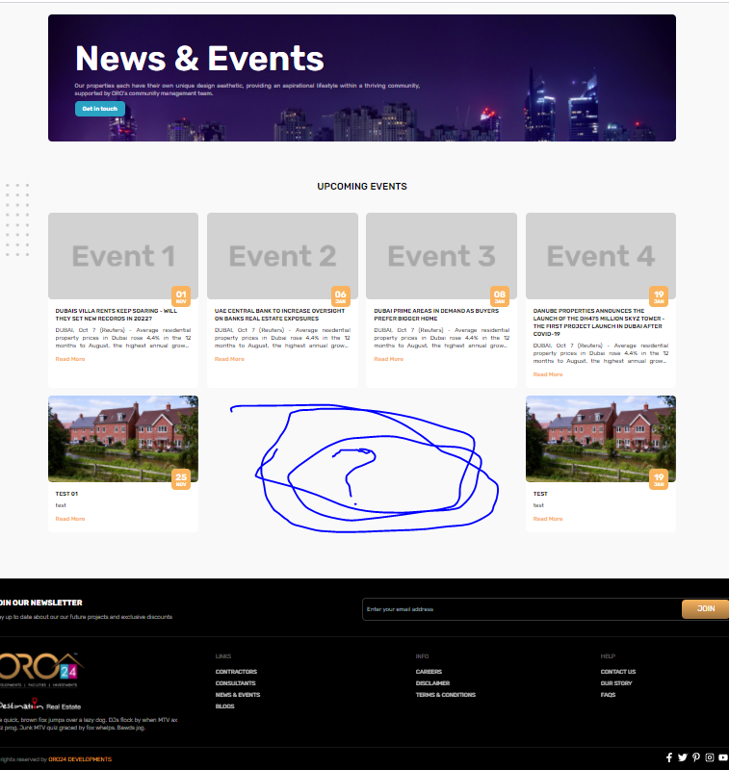

1. Please disable the contractors, consultants and FAQs for time being.

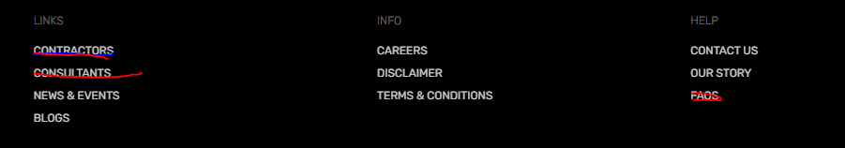

1. Please add the FAQs section in project since each project will have its own FAQs and it should be dynamic.
2. In signup page phone number should be international format and password should have also confirmed password field. This mechanism should work exactly like Tanjimsquad.store for local OTP, email verifications and for international only email verification. The image will be changed to the Oro reception image which they will be providing soon.

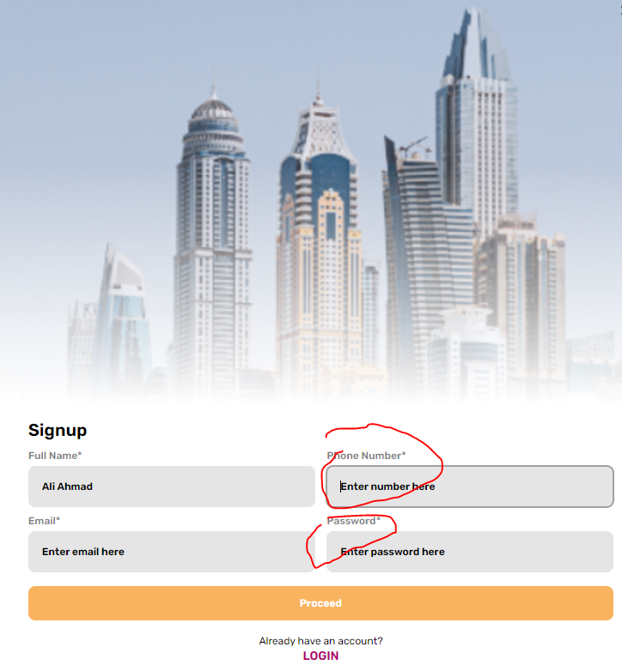

1. Schedule an Appointment selection should not be back dates and restrict appointment time from 09 am to 05 pm.
2. Please increase the size of virtual tour, physical site tour and meeting and booking size. The guy image will be change, waiting ORO to provide the image.

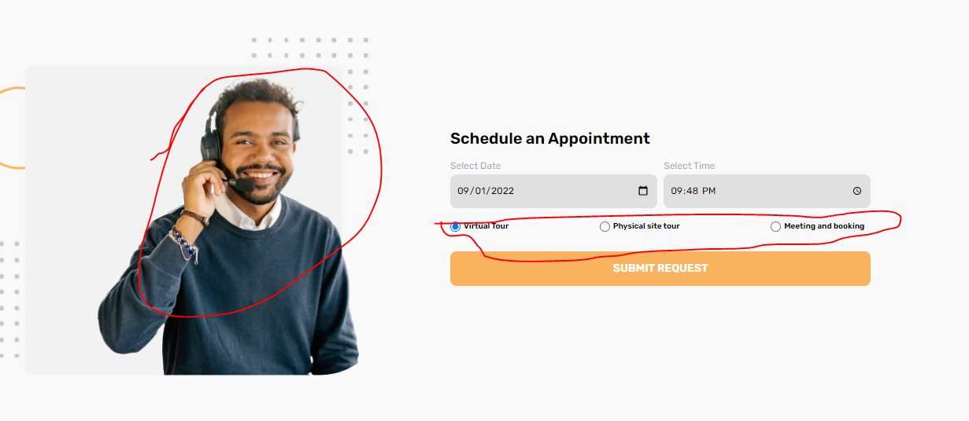

1. How can customer will see the appointment statues which he required? Do we have any mechanism for that or can we give this in customer portal?
2. We need to configure the payment gateway with my booking once get the payment gateway credentials.
3. We need to add the call-to-action buttons like below for direct call, email and WhatsApp.



**ORO24.ae Backend Testing**

1. (Faizan Shahid)Dashboard – show the below graph.
   * Customer request graph
   * Appointment’s graph
   * Enquiries graph
   * Unit booking graph
   * Dashboard tiles link to respective pages. (Done)
2. (Faizan Shahid)Users > Add Users update below
   * Change the Name to “Full Name”
   * Make password policy easy (same like TANJIM which auto show in green if password policy matches) and give “confirm password” field.
   * Give mobile format like UAE +971 fixed and nine digits. (Done)
3. (Faizan Shahid)While creating user its not accepting any password even I used “1234@Find*&()”, pls fix. (Done)

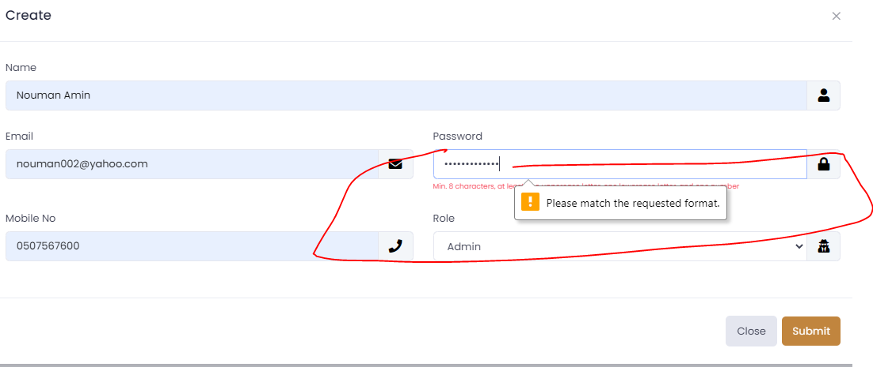

1. (Faizan Shahid)Not able to create Roles and privileges. Even not able to assign to users. (Working fine)

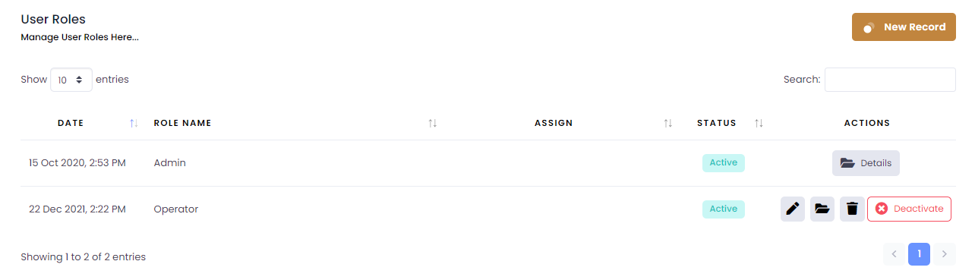

1. (Faraz Hasnain)Not able to do bulk country upload getting this error 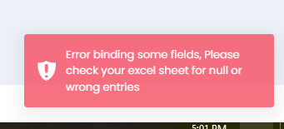.this is the excel uploading. (Working fine)
2. (Faraz Hasnain)Not able to do bulk city upload getting this error 

this is the excel uploading. (Working fine)

1. (Faizan Shahid)Business setting is not yet link, like when I am trying to add the Facebook link the front-end icons are already there but without link on footer area. It should be dynamic. Also please fix the phone number format like UAE +971 fixed and nine digits. (Implemented On admin Portal)

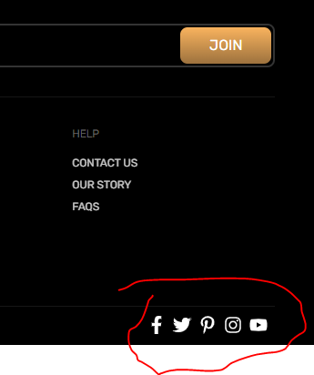

1. (Faraz Hasnain)Change Tax Settings to “TAX Settings” in Advance Setup.(Done)
2. (Faraz Hasnain)Change the Gallery Images in Our Story > Introduction to “Introduction Gallery”.(Done)
3. (Faraz Hasnain)Please mentioned the headings for below. Like for main image mentioned “Introduction Main Image” and for Video mentioned “Introduction Video”.

( Done)

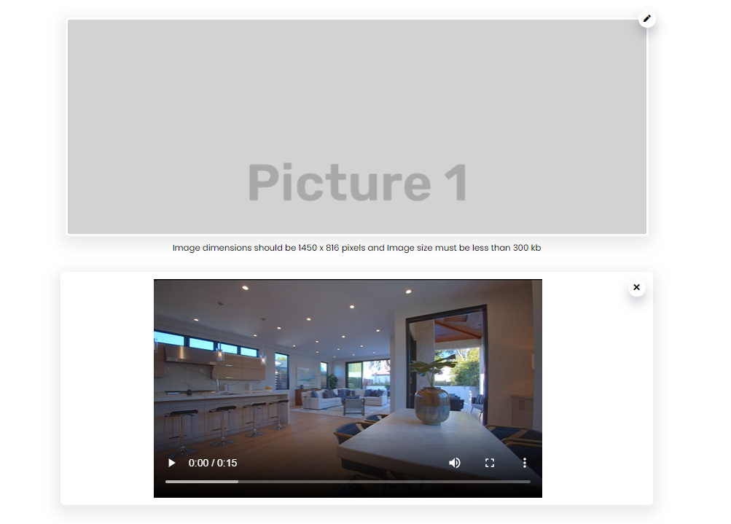

Loop: false

1. For workforce
   * Workforce showing five and backend its only four.
   * 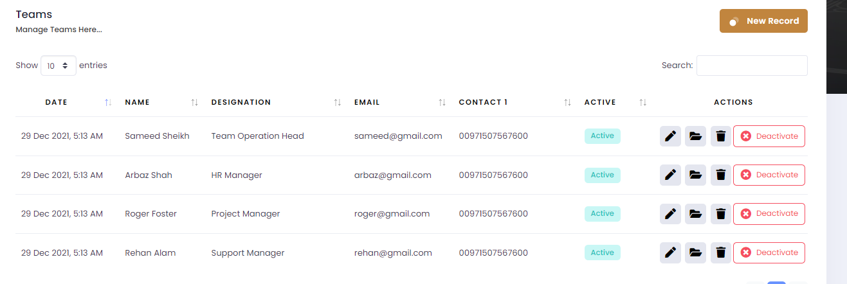
   * 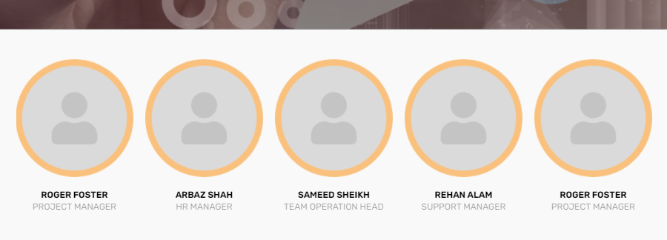
   * Deactivation is not working.
   * (Faizan Shahid)Please add email validation and the phone number format like UAE +971 fixed and nine digits.( done)
2. For Awards
   * Deactivation is not working.
   * 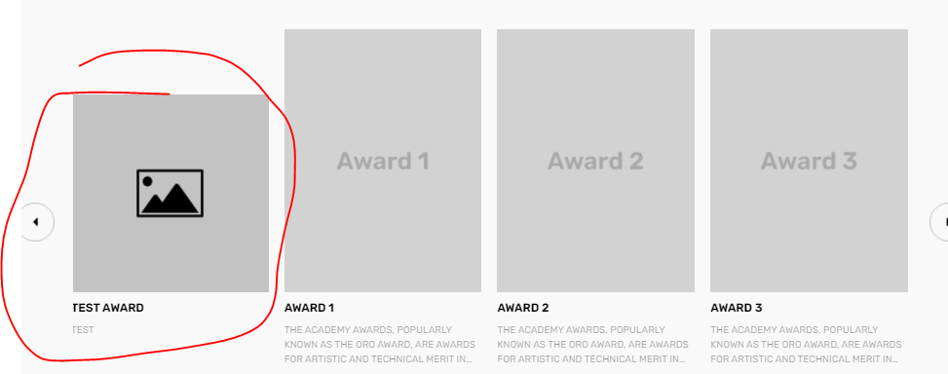
   * 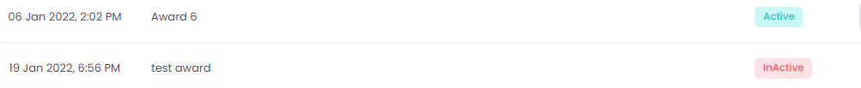
   * Please make award open as popup if someone clicks on award.
3. (Faraz Hasnain) Change the Gallery Images in Our Story > Ozone to “Ozone Gallery”.(Done)
4. (Faraz Hasnain) Please mentioned the headings for below. Like for main image mentioned “OZONE Main Image” and for Video mentioned “Ozone Video”.(Done)
5. Why we are not showing Ozone video on Ozone frontend page? Pls fix.

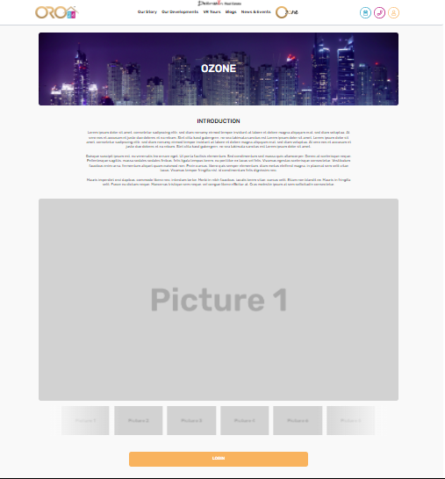

1. Need to check banner setting currently it’s not working. Pls fix and do let me know to test the whole flow.
2. (Faraz Hasnain) In Development> Projects > Projects change it to “List of Projects”.(Done)
3. Project deactivation and activation is not working.
4. Front website only showing project 1 under latest projects.
5. I can see this 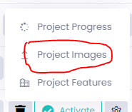 project images where it will be showing???
6. (Faraz Hasnain) When adding a feature and amenities record to project its showing below error.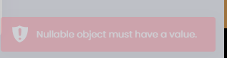(Working Fine)
7. I can see this 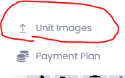 unit images where it will be showing???
8. Deactivation is not working for Document types.



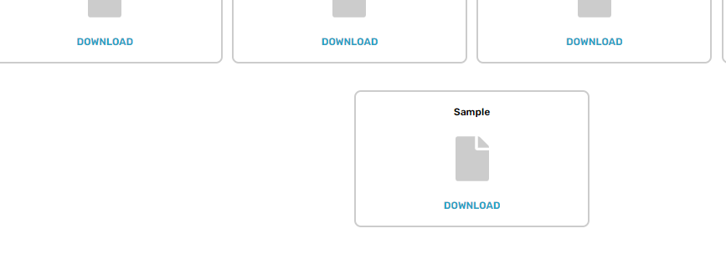

1. (Faizan Shahid)Customer Document Requests> The last request should come first on the data table.(Done)
2. (Faraz Hasnain) There should be only three statues request pending, request completed and request rejected (rejected should be with remarks which customer can view what is the reason it got rejected).(Done)
3. (Faraz Hasnain) Request completed and rejected should not show under customer document requested, you may make a sub menu like completed, rejected and pending.(Done)
4. No delete option for customer document requests.(Faizan bhai )
5. (Faizan Shahid)On document completed there should be an email to generate to customer that document request is updated.(done)
6. (Faizan Shahid)Appointments > The last request should come first on the data table.(not done)
7. (Faraz Hasnain) Completed and pending appointments should not show under appointment only, you may make a sub menu like pending and completed appointment to show the data table.(Done)
8. (Faizan Shahid)No delete option for appointments.(Done)
9. (Faizan Shahid)On appointment approved there should be an email to generate to customer that with the date and time of appointment.(Done)
10. Contact us or enquires form is not working showing this error 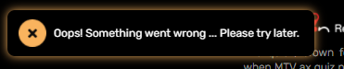
11. An email should send to the [contact@oro24.ae](mailto:contact@oro24.ae) as well and back is fine.
12. (Faraz Hasnain)From backend we should able to update the enquiry status like pending or completed with remarks.(Done)
13. (Faizan Shahid)Enquires > The last request should come first on the data table.(Done)
14. (Faraz Hasnain) Completed and pending enquires should not show under enquires only, you may make a sub menu like pending and completed enquires to show the data table.(Done)
15. (Faizan Shahid)We should able to export the list of subscribers in to excel format.(Done)
16. Not able to create and edit the blogs. (Working Fine)
17. Blogs deactivation and action is not working. (Working Fine)
18. Not able to create and edit the news and events. (Working Fine)
19. News and event deactivation and action is not working properly. (Working Fine)
20. We have four active news but showing five. Even the design is not ok if we have two news and events there is a gap in centre. Please refer below. The third one is deleted but still showing.

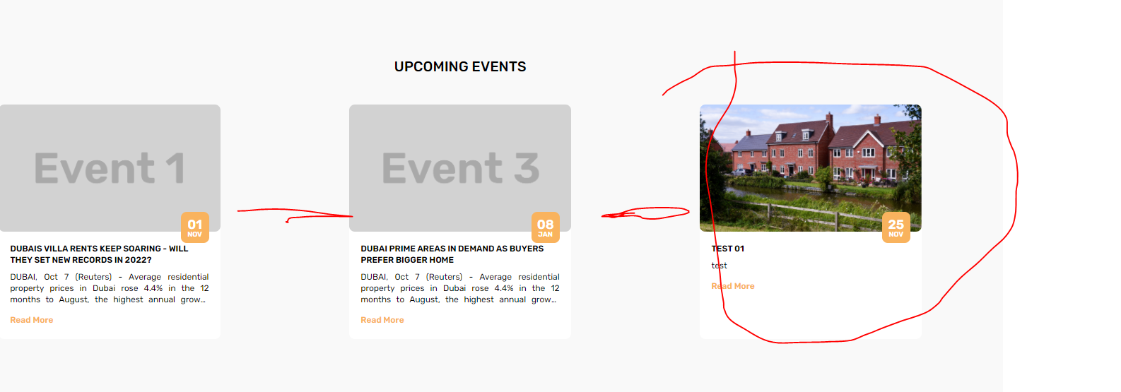

1. (Faizan Shahid)Announcements or custom notification make like TANJIM but keep the search box.(Done)

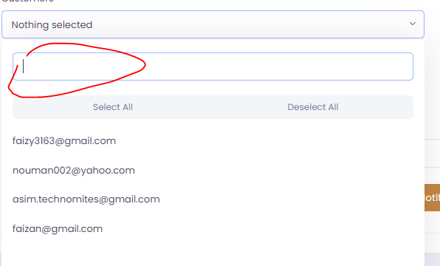

1. (Faizan Shahid)Password change in profile section please make the password policy exactly like TANJIM and its turn green if the password policy and both password matches.(Done)

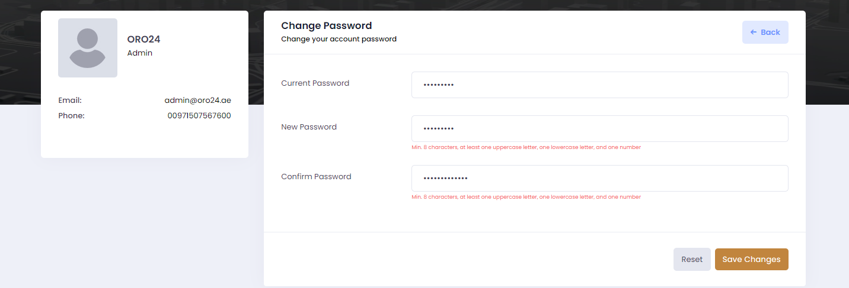

1. (Faizan Shahid)I am not able to check the forgot password since not able to create the user.(WorkingFine)

Note: We will work on the calculator and review the website once again once the all issues are fixed.

THANK YOU!