No one should able to delete the default gateway.(Done)

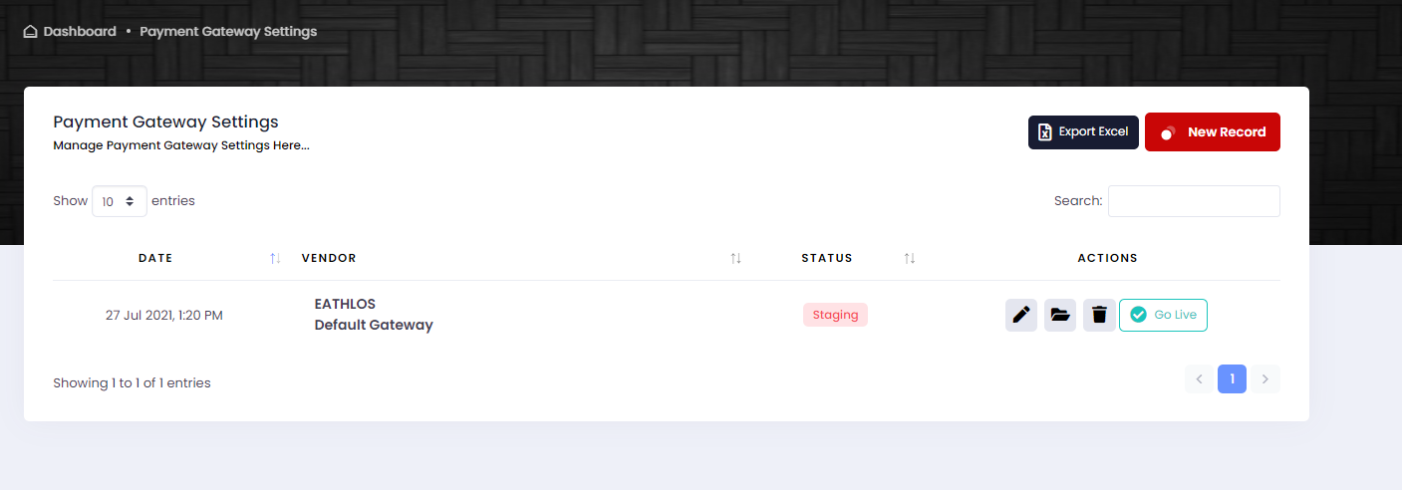

Billing Period please make dropdown.(Working fine)

Add Supplier code in transaction history list, (Done)

Add supplier code in the Payment gateway. (Done)

Change Date in Details Venue bookings to Created on and Show slots booking date.(Done)

Pls add the transaction details in the booking of each module.(Done)

Shopping module calculation should be like tanjim.’

Tournament creation upon editing individual its asking for number of players.(Done)

**VENDOR REGISTRATION PROCESS:**

Please give the green colour button “Partner with Us” top right next to the “Get the App”.

Change the “Become A Vendor” text to “Partner with Us”.

Change the “Name” text to “Legal Name as per Trade License”.

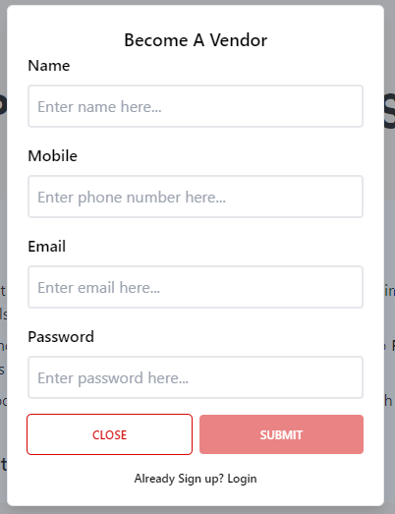

Please update the link for “Already sign up? Login” to <https://portal.eathlos.com/vendor/Account/Login>.

Please note anyone can registered with any email and mobile number. We need to place the mobile OTP and email verification process here.

Please explain what vendor should do on this screen? We can add below text to make vendor know the steps.

Step 1: Please select the package that suites to your business activity.

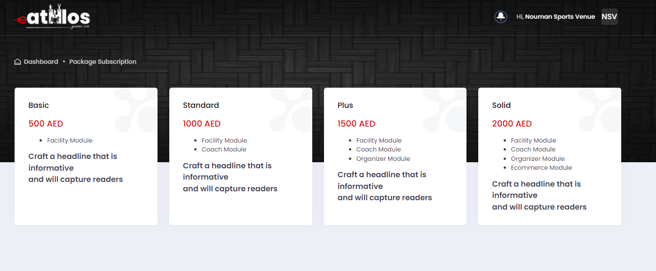

After payment vendor needs to logout to see the below page. Refer **“Video_1”(Done)**

