Congressional Stock Analysis — Summary Report
Generated: March 09, 2026
Dataset: 15,117 modelled purchases | Train: 12,092 | Test: 3,025
Model: XGBoost classifier | Target: realized_car_hybrid > 0

This report summarises the end-to-end Congressional Stock Analysis pipeline. It examines whether U.S. Congress members' equity purchases systematically outperform the market, identifies which features predict outperformance, and evaluates an XGBoost classifier trained to flag the most promising trades. The analysis covers five sections: (1) a descriptive overview of all trades, (2) exploratory analysis of features relative to the return target, (3) model performance metrics and a dollar-value simulation, (4) analysis of predicted-positive tickers, and (5) error analysis to understand model failure modes.

1. Trade Overview
This section summarises the full dataset of congressional stock transactions, focusing on purchase activity across parties and chambers. The core performance metric is realized_car_hybrid — the cumulative abnormal return (CAR) calculated either from the actual buy-to-sell period when the position was closed within 12 months, or from the 12-month fixed window otherwise. A positive value means the politician's stock outperformed the market benchmark over that horizon.

Metric | Value
Total records (all transaction types) | 39,334
Purchases | 19,096
Date range (traded) | 2012-09-13 – 2026-01-30
% Positive realized_car_hybrid | 48.5%
Mean realized_car_hybrid | -0.0259
Median realized_car_hybrid | -0.0052
Std dev realized_car_hybrid | 0.2945
Key finding: the mean realized CAR across all modelled purchases is -0.0259 (-2.6%), with only 48.5% of trades beating the market. The median is -0.0052, also below zero. This confirms that the average congressional stock purchase does not reliably outperform the benchmark — making the model's task of identifying the positive tail non-trivial.

CAR Distributions Across Holding Horizons
The charts below show the distribution of cumulative abnormal returns (CAR) for each measurement window. The grey vertical line marks zero (market parity); the bold coloured line marks the mean for that distribution. Note that the mean sits below zero across all horizons — indicating that in aggregate, congressional purchases do not outperform. The right tail (large positive returns) is heavier than the left, suggesting occasional outsized winners drag the average upward, but the median remains negative.

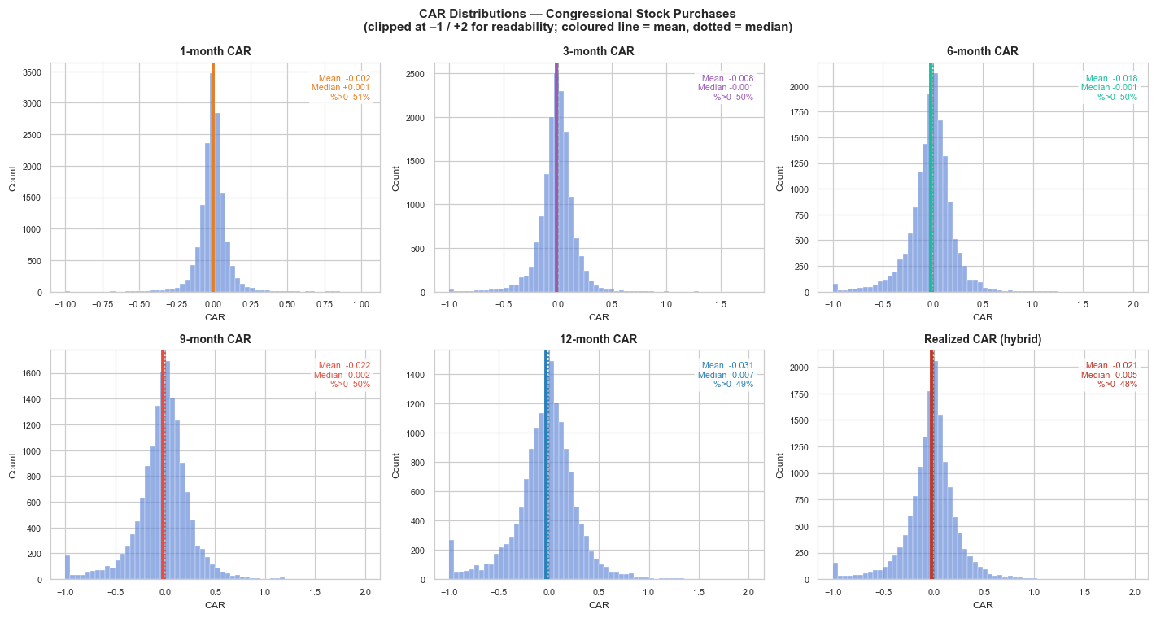

% Positive CAR by Party and Chamber
The table below breaks down trade performance by party affiliation and chamber. Differences between groups reveal whether structural factors (majority party, access to classified information in Senate committees, etc.) correlate with better market timing, independent of stock selection skill.

By Party:
Party | N | % Positive | Mean CAR | Median CAR
D | 7688 | 48.2% | -0.0265 | -0.0069
I | 28 | 60.7% | +0.0455 | +0.0450
R | 7401 | 48.7% | -0.0254 | -0.0038

By Chamber:
Chamber | N | % Positive | Mean CAR | Median CAR
Representatives | 11616 | 47.8% | -0.0306 | -0.0076
Senate | 3501 | 50.9% | -0.0101 | +0.0030

Trade Volume & % Positive CAR Over Time
The chart below tracks quarterly purchase volume (bars, left axis) and the fraction of those purchases that ended up with a positive realized CAR (line, right axis). Spikes in the positive-rate line around major market events (e.g. post-COVID recovery 2020–2021) suggest that congressional timing may be partly driven by macro conditions rather than stock-specific insight. Periods of low positive rate often coincide with broad market drawdowns.

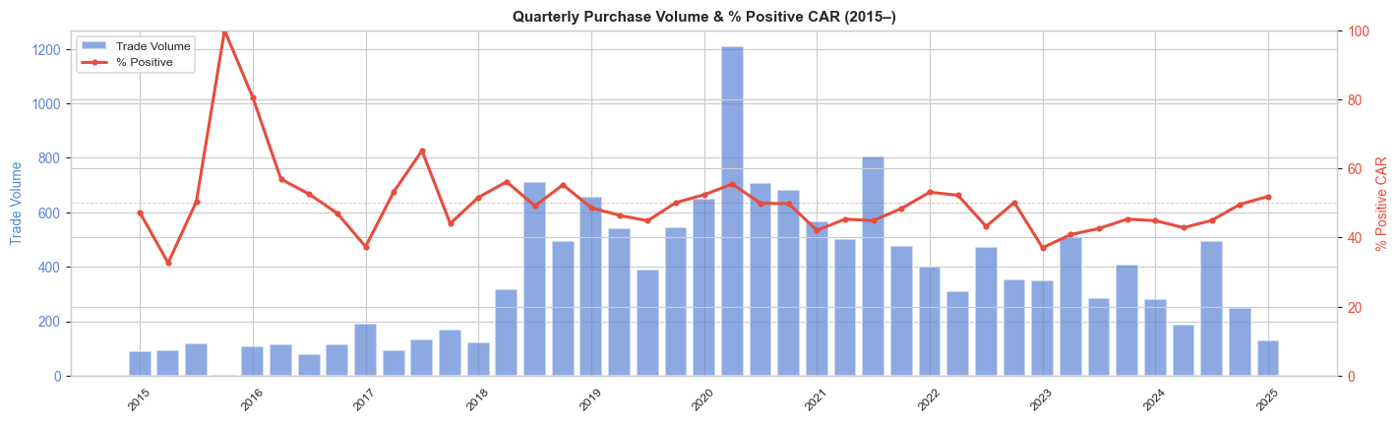

2. Exploratory Data Analysis — Features vs Target
This section investigates which measurable factors correlate with positive realized CAR. The goal is to build intuition about what drives outperformance before examining the model's learned behaviour in Section 3. We look at four categories: (A) politician skill signals, (B) committee membership and lobbying activity, (C) stock-level characteristics, and (D) numerical feature correlations with the target.

2a. Politician Skill Signals
The two most direct measures of politician trading skill are: (1) politician_hit_rate_past — the fraction of that politician's prior purchases that achieved a positive CAR, and (2) politician_mean_car_past — the average CAR on their prior purchases. Both are computed with a look-ahead gap: a past trade's outcome is only counted once the filing date + 12 months has elapsed, preventing data leakage. The charts below split trades into quintiles of each signal and show how mean CAR and the % positive rate change across quintiles.

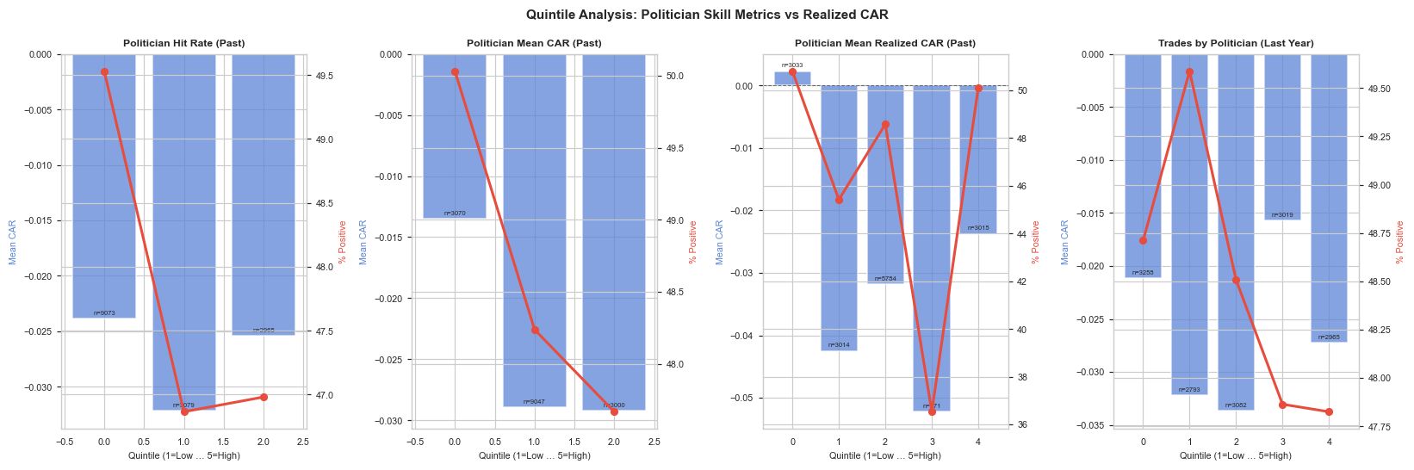
Interpretation: if the quintile charts show a monotonically increasing pattern (both mean CAR and % positive rising from Q1 to Q5), that confirms the skill signal has predictive value. A flat or noisy pattern suggests the signal may be weak or overshadowed by market conditions during training.

2b. Committee Membership and Lobbying Activity
Congress members on committees overseeing specific industries may have informational advantages when trading in those sectors. The chart below shows the positive CAR rate for trades made by politicians on each of the nine committee category groups, split by whether the flag is 1 (on committee) or 0 (not on committee). The is_committee_chair and is_committee_majority flags capture additional seniority and political-majority effects. lobbied_any_90d indicates whether the traded company filed a lobbying disclosure in the 90 days prior to the trade — a sign of active Washington engagement that tends to correlate with higher institutional visibility.

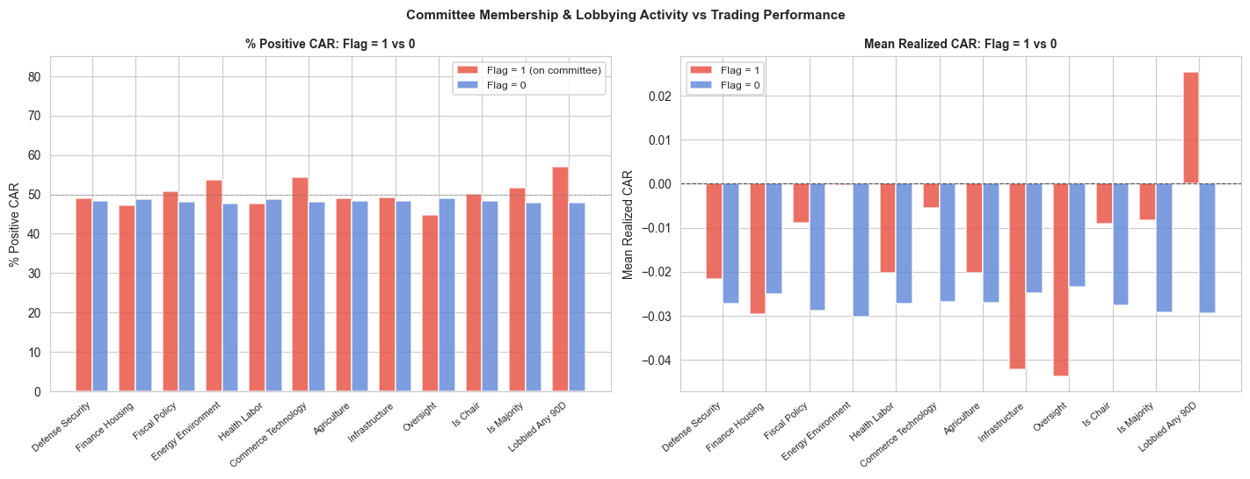
Flag | %Pos (Flag=1) | %Pos (Flag=0) | Mean CAR (1) | Mean CAR (0) | N (Flag=1) | Lift (%Pos)
Defense Security | 48.9% | 48.4% | -0.0216 | -0.0271 | 3490 | +0.6pp
Finance Housing | 47.1% | 48.8% | -0.0297 | -0.0251 | 2636 | -1.7pp
Fiscal Policy | 50.8% | 48.1% | -0.0089 | -0.0288 | 2219 | +2.7pp
Energy Environment | 53.8% | 47.6% | -0.0003 | -0.0302 | 2201 | +6.2pp
Health Labor | 47.6% | 48.7% | -0.0203 | -0.0271 | 2804 | -1.1pp
Commerce Technology | 54.3% | 48.2% | -0.0055 | -0.0269 | 702 | +6.1pp
Agriculture | 49.1% | 48.4% | -0.0203 | -0.0269 | 2434 | +0.7pp
Infrastructure | 49.2% | 48.4% | -0.0421 | -0.0247 | 971 | +0.8pp
Oversight | 44.7% | 49.0% | -0.0437 | -0.0235 | 1759 | -4.2pp
Is Chair | 50.1% | 48.3% | -0.0090 | -0.0276 | 1406 | +1.7pp
Is Majority | 51.6% | 47.9% | -0.0083 | -0.0292 | 2434 | +3.8pp
Lobbied Any 90D | 57.1% | 47.9% | +0.0254 | -0.0294 | 971 | +9.2pp
Positive lift values indicate that being on a given committee category is associated with higher positive-CAR rates. A large lift on lobbied_any_90d suggests that actively lobbied companies may be better-known large-caps rather than a direct insider-information signal.

2c. Stock-Level Characteristics
Beyond politician-specific signals, the stock's own momentum and volatility at the time of purchase may predict future performance. High momentum stocks could indicate trend-following behaviour; high volatility introduces noise. Beta captures systematic market exposure — low-beta defensive stocks may behave differently under different market regimes.

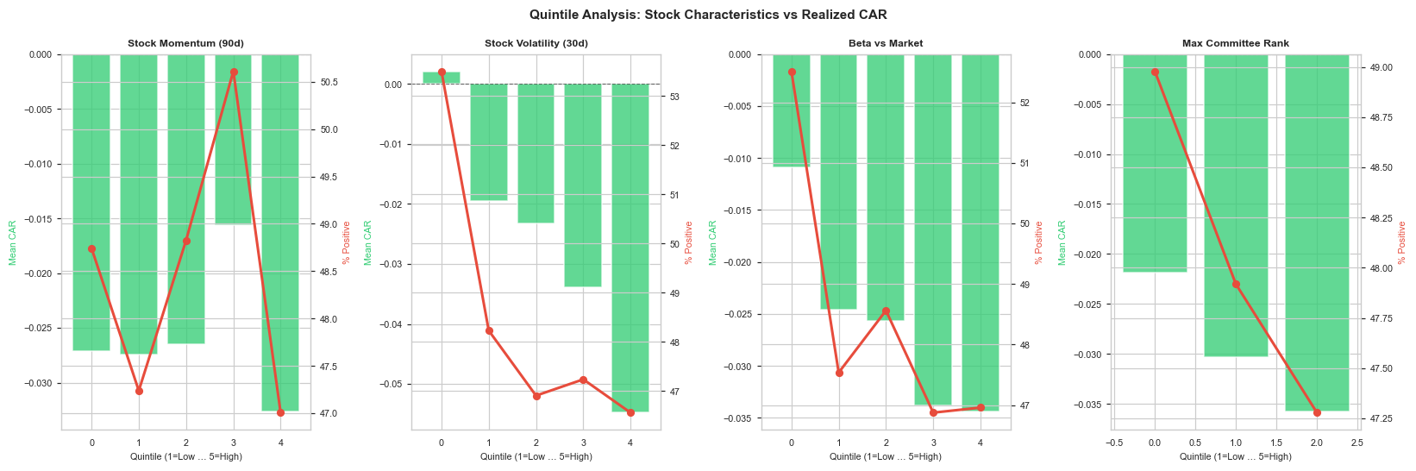
Note: for momentum, a positive slope from Q1 to Q5 would indicate that politicians are buying into rising stocks that continue to outperform (momentum effect). A U-shaped or inverted pattern would suggest mean reversion dynamics. Volatility quintiles help assess whether the model should favour lower-risk, steadier outperformers.

2d. Feature Correlations with Realized CAR
The table below shows the Pearson and Spearman correlations between each numerical feature and the realized_car_hybrid target, computed on the full modelled dataset (before train/test split). Pearson captures linear relationships; Spearman captures monotonic ones. Features with high absolute Spearman correlation are the most consistently predictive across the distribution.

Feature | Pearson r | Spearman ρ
all_pol_sells_same_ticker_30d | +0.0368 | +0.0468
beta | -0.0262 | -0.0448
stock_volatility_30d | -0.0579 | -0.0421
politician_mean_car_past | -0.0276 | -0.0317
max_committee_rank | -0.0165 | -0.0289
ticker_prior_buys | +0.0155 | +0.0230
n_committees | +0.0265 | +0.0213
log_trade_size | -0.0227 | -0.0191
stock_momentum_90d | -0.0496 | -0.0144
stock_momentum_30d | -0.0463 | -0.0111
politician_mean_realized_car_past | -0.0358 | -0.0092
politician_trades_last_year | +0.0022 | -0.0057
politician_hit_rate_past | +0.0151 | -0.0049
car_traded_to_filed | +0.0479 | +0.0006
Features at the top of this table provide the strongest monotonic signal for predicting above-market returns. Even modest correlations (~0.05–0.15) can be economically significant when combined in an ensemble model, especially if they are orthogonal (i.e. each captures a different aspect of the trade).

3. Model Performance & Feature Importances
The model is an XGBoost classifier trained on an 80/20 time-based split (never random, always chronological) to prevent look-ahead bias. The target is a binary indicator: does the realized_car_hybrid exceed 0? Model inputs are 31 features spanning politician skill, stock characteristics, committee membership, and lobbying signals. This section covers (A) which features the model learned to rely on most, followed by (B) threshold-level precision/recall trade-offs, (C) the confusion matrix, and (D) a dollar-value simulation on the test set.

3a. XGBoost Feature Importances
Feature importance (measured by average gain across all splits using each feature) shows which signals the model weighted most heavily. Features at the top explain a disproportionate share of the model's predictive power. It is notable whether politician-specific skill signals (hit rate, mean CAR) dominate over market signals (momentum, volatility) — this has implications for the source of any alpha in the model.

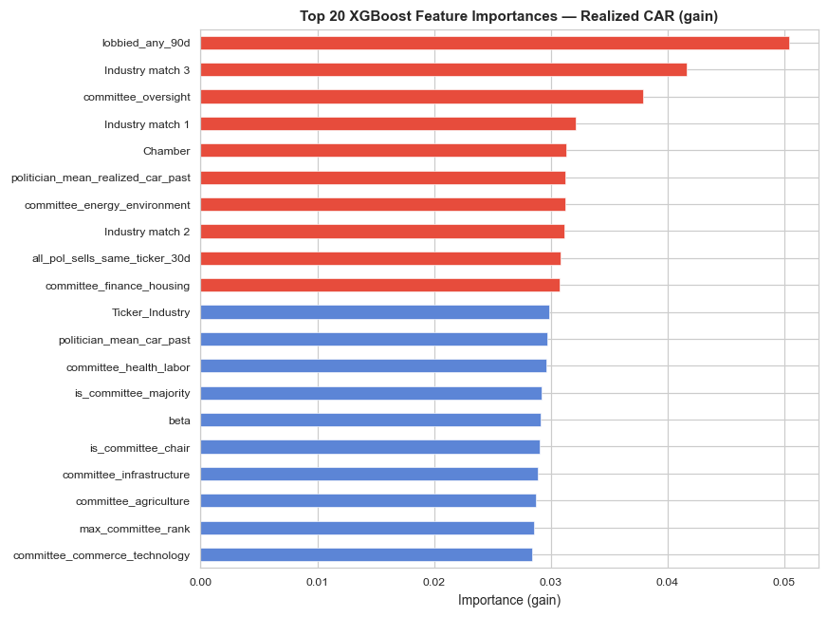
Feature | Importance (gain)
lobbied_any_90d | 0.050378
Industry match 3 | 0.041657
committee_oversight | 0.037881
Industry match 1 | 0.032111
Chamber | 0.031334
politician_mean_realized_car_past | 0.031226
committee_energy_environment | 0.031221
Industry match 2 | 0.031200
all_pol_sells_same_ticker_30d | 0.030806
committee_finance_housing | 0.030760
Red bars mark features above the median importance threshold. A model heavily dominated by one or two features may be overfitting to that signal; a more distributed importance profile suggests the model is combining complementary signals.

3b. Threshold Performance Table
Adjusting the classification threshold changes the precision/recall trade-off. A higher threshold means the model only signals a trade when it is highly confident, reducing the number of predictions but increasing precision. The 'Mean CAR (Pred +)' column shows the average return of the trades flagged as positive at each threshold — this is the most economically relevant metric.

Train/test split date: 2022-12-07 | Test set size: 3,025 trades

Threshold | Precision | Recall | F1 | N Predictions | Mean CAR (Pred +)
0.50 | 0.470 | 0.514 | 0.491 | 1,472 | -0.0205
0.55 | 0.458 | 0.440 | 0.449 | 1,296 | -0.0229
0.60 | 0.464 | 0.373 | 0.413 | 1,083 | -0.0197
0.65 | 0.465 | 0.309 | 0.371 | 894 | -0.0197
0.70 | 0.466 | 0.257 | 0.331 | 743 | -0.0207
Precision is the fraction of predicted positives that actually beat the market. At threshold 0.60 the model offers a balance between coverage (recall) and accuracy (precision). The mean CAR of predicted positives is the key figure: any value meaningfully above the test-set baseline indicates genuine lift.

3c. Confusion Matrix (threshold = 0.6)
At the default threshold of 0.6, the confusion matrix below shows the counts of true positives, false positives, true negatives, and false negatives on the test set. A high false-positive count is costly in practical terms (investing in trades that underperform); false negatives represent missed opportunities.

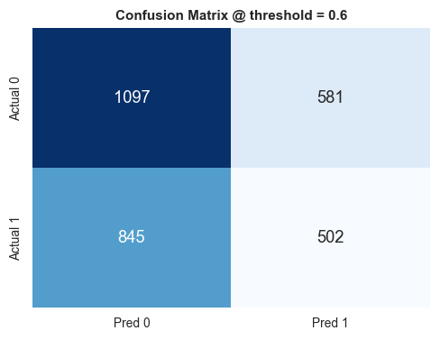

3d. $100-per-Trade Cumulative Return Simulation
To put model performance in practical context, the simulation below assumes an investor places $100 into each trade flagged as positive by the model (threshold = 0.6), or $100 into every purchase for the naive baseline. The y-axis shows cumulative total receipts (principal + return) as trades are entered in chronological order through the test set. The SPY benchmark invests $100 on each of the same trade dates and measures the 12-month forward return on the S&P 500 ETF, providing a like-for-like comparison against a passive index strategy.

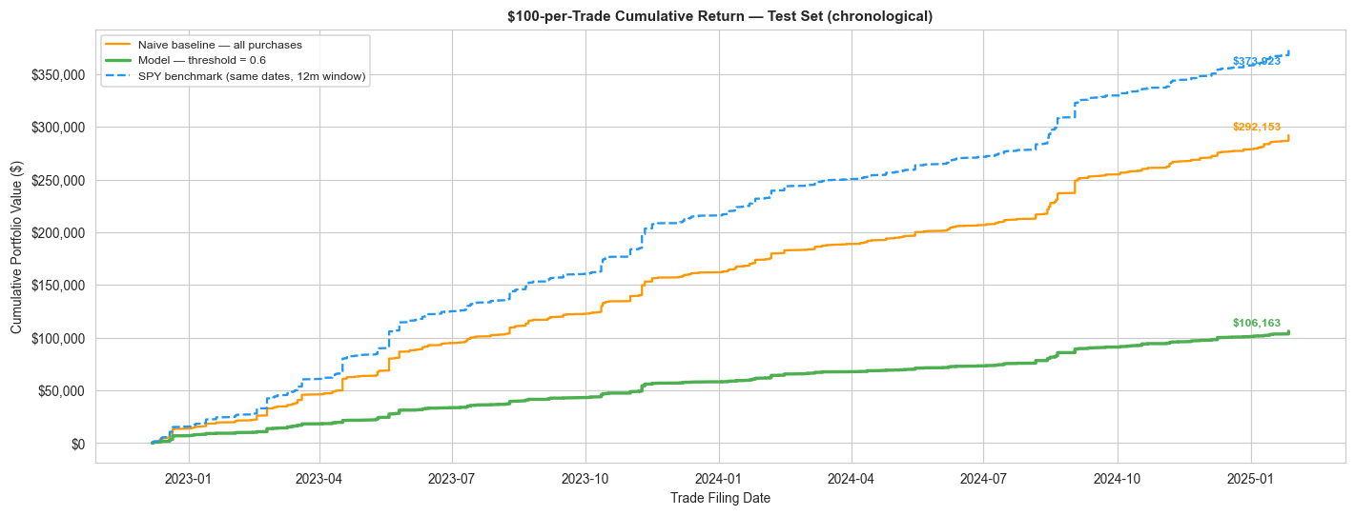
The model selected 1,083 trades (35.8% of the test set), investing $108,300 for a final cumulative value of $106,163 (return: -2.0%). The naive baseline invested $302,500 across all 3,025 test purchases and accumulated $292,153 (return: -3.4%). Interpret with caution: this simulation assumes no transaction costs, full execution at filing date, and no position-size constraints.

4. Predicted Positive Ticker Analysis
This section examines which stocks the model most frequently identifies as likely outperformers, and whether those predictions are actually correct. Concentration in a small number of tickers could indicate the model has learned issuer-specific patterns (e.g. a politician who consistently trades one stock well) rather than generalisable signals. Sector-level analysis reveals whether the model overweights certain industries.

Top 20 Tickers Most Frequently Predicted Positive
Each bar represents the count of test-set trades where the model predicted positive for that ticker. The orange line (right axis) shows the actual mean realized CAR for those predicted trades. Tickers with many predictions but a negative mean CAR are systematically false-positived by the model.

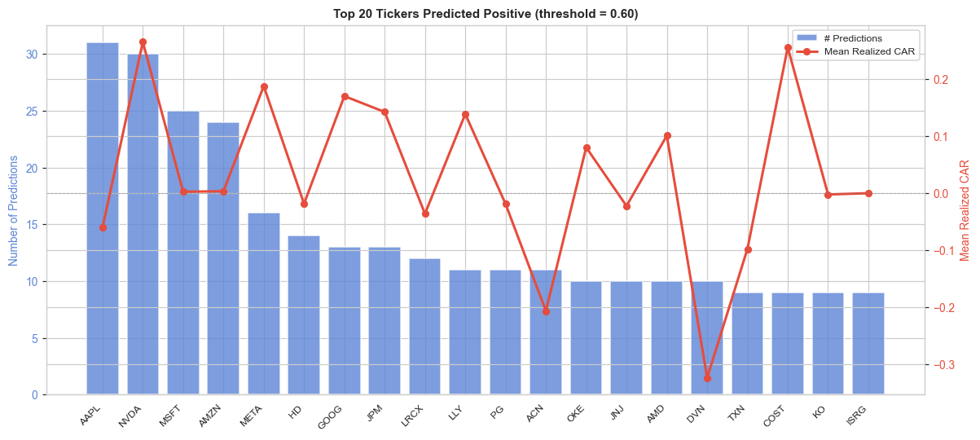

Sector Distribution: Predicted Positives vs All Test Trades
If the model's predicted positives mirror the sector distribution of all test trades, it is sector-agnostic. Deviations show sector tilt — whether by design (committee-linked sectors genuinely outperform) or by overfitting to historical sector cycles within the training window.

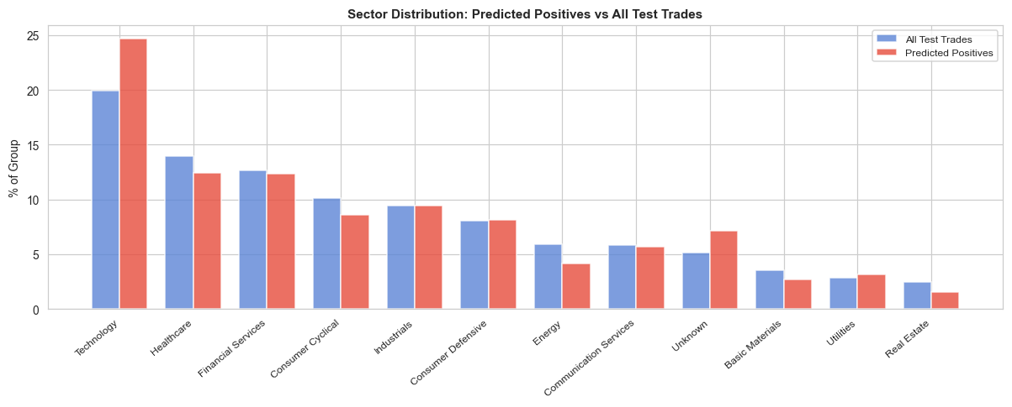

Predicted Probability vs Actual CAR (TP / FP)
Each point is a trade predicted positive by the model. Green points (TP) are trades that actually beat the market; red points (FP) did not. A well-calibrated model should show green points more densely at high probabilities and more red points at lower probabilities just above the 0.6 cut-off. The horizontal dashed line marks CAR = 0.

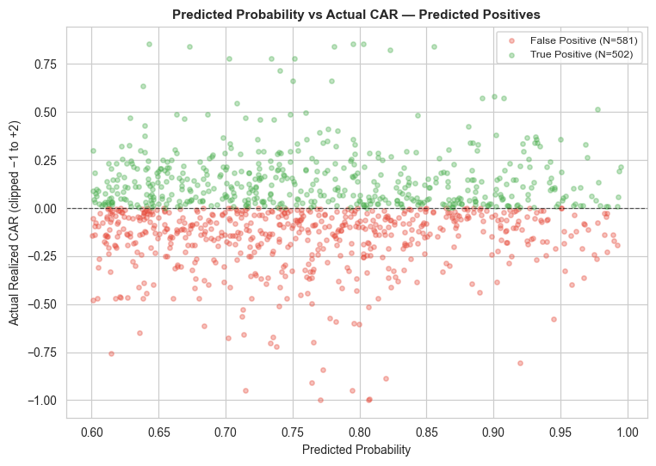

5. Error Analysis
Understanding when and why the model makes mistakes is critical for improving it. This section compares the average feature values for true positives (TP), false positives (FP), true negatives (TN), and false negatives (FN). Features where TP mean >> FP mean are those where the model partially uses the right signal but may need a stronger threshold. Features where FN mean >> TN mean are the ones the model is failing to exploit for the missed positive trades.

False Positive vs True Positive — Feature Means
N True Positives: 502 | N False Positives: 581 (threshold = 0.6). A positive 'TP − FP' difference means true positives score higher on that feature. Negative differences reveal features where false positives are unexpectedly high — potential sources of model confusion.

Feature | TP Mean | FP Mean | TP − FP
log_trade_size | 7.4584 | 7.5096 | -0.0512
car_traded_to_filed | 0.0026 | -0.0058 | 0.0084
politician_trades_last_year | 59.8785 | 61.0465 | -1.168
politician_hit_rate_past | 0.3308 | 0.2936 | 0.0372
politician_mean_car_past | -0.0331 | -0.0297 | -0.0034
politician_mean_realized_car_past | -0.0937 | -0.0913 | -0.0024
stock_momentum_90d | 0.0216 | 0.031 | -0.0094
stock_volatility_30d | 0.0183 | 0.018 | 0.0003
beta | 0.9774 | 1.0683 | -0.0909
max_committee_rank | 80.0219 | 129.864 | -49.8421
all_pol_sells_same_ticker_30d | 0.6434 | 0.5852 | 0.0582
n_committees | 2.3665 | 2.0361 | 0.3304
ticker_prior_buys | 3.5737 | 3.0499 | 0.5238

False Negative vs True Negative — Feature Means
N False Negatives: 845 | N True Negatives: 1,097. False negatives are trades the model missed — trades that actually beat the market but were not flagged. A positive 'FN − TN' difference on a feature means that missed trades scored higher on that signal, suggesting the model may not be weighting it sufficiently for borderline cases.

Feature | FN Mean | TN Mean | FN − TN
log_trade_size | 7.4077 | 7.4857 | -0.078
car_traded_to_filed | 0.004 | -0.0183 | 0.0223
politician_trades_last_year | 72.4959 | 77.773 | -5.2771
politician_hit_rate_past | 0.3029 | 0.3164 | -0.0135
politician_mean_car_past | -0.0296 | -0.021 | -0.0086
politician_mean_realized_car_past | -0.0864 | -0.0805 | -0.0059
stock_momentum_90d | 0.0251 | 0.022 | 0.0031
stock_volatility_30d | 0.0208 | 0.0201 | 0.0007
beta | 0.9344 | 0.9951 | -0.0607
max_committee_rank | 107.3515 | 98.7429 | 8.6086
all_pol_sells_same_ticker_30d | 0.4568 | 0.4002 | 0.0566
n_committees | 2.3444 | 2.2598 | 0.0846
ticker_prior_buys | 3.3101 | 3.1222 | 0.1879

Calibration Plot
A well-calibrated model's predicted probabilities should match the observed positive rate. The diagonal dashed line represents perfect calibration. If the curve bows above the diagonal the model is under-confident (predicting lower probabilities than the true rate); below the diagonal indicates over-confidence. Significant miscalibration at high probabilities is most impactful because it affects the trades that would actually be selected.

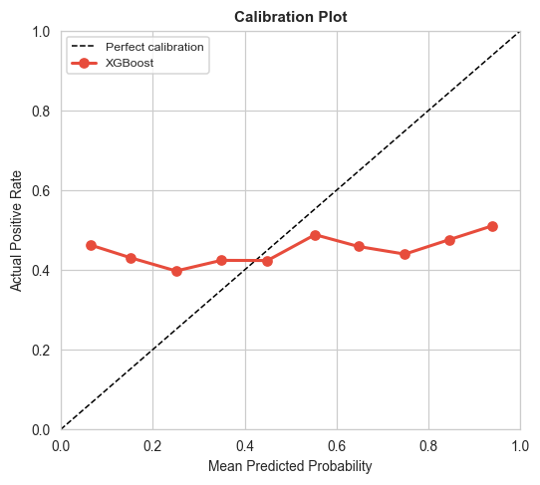

CAR Distribution by Prediction Type (TP / TN / FP / FN)
The overlaid density histograms below show the realized CAR distribution separately for each of the four prediction outcomes. Ideally, TP trades should have a distribution shifted strongly to the right; FP trades should cluster near zero or negative territory, showing the model is picking up borderline cases. A wide FN distribution that overlaps with TP suggests the model's false negatives are not obviously different from true positives — making them genuinely hard to predict.

