**WEEK 1**---**ALGORITHMS AND DATA STRUCTURES**

**Exercise 2: E-commerce Platform Search Function :**

* Big(O) notation tells us about the upperbound of an algorithm’s in terms of the input size n . It also tells us how the runtime of an algorithm scales with grow in input size

Eg: O(1), O(n), O(log n)……..etc.

Here we are going to apply search operations in this exercise, so there can be best case , average case or worst case scenario :

Linear Binary

Best Case --------------Found early-----------O(1)-----------------------O(1)(if found in mid)

Avearge Case ---------Found in mid---------O(n/2)🡪O(n)-----------O(log n )

Worst Case ------------Not found-------------O(n)-----------------------O(log n)

* **Code:**

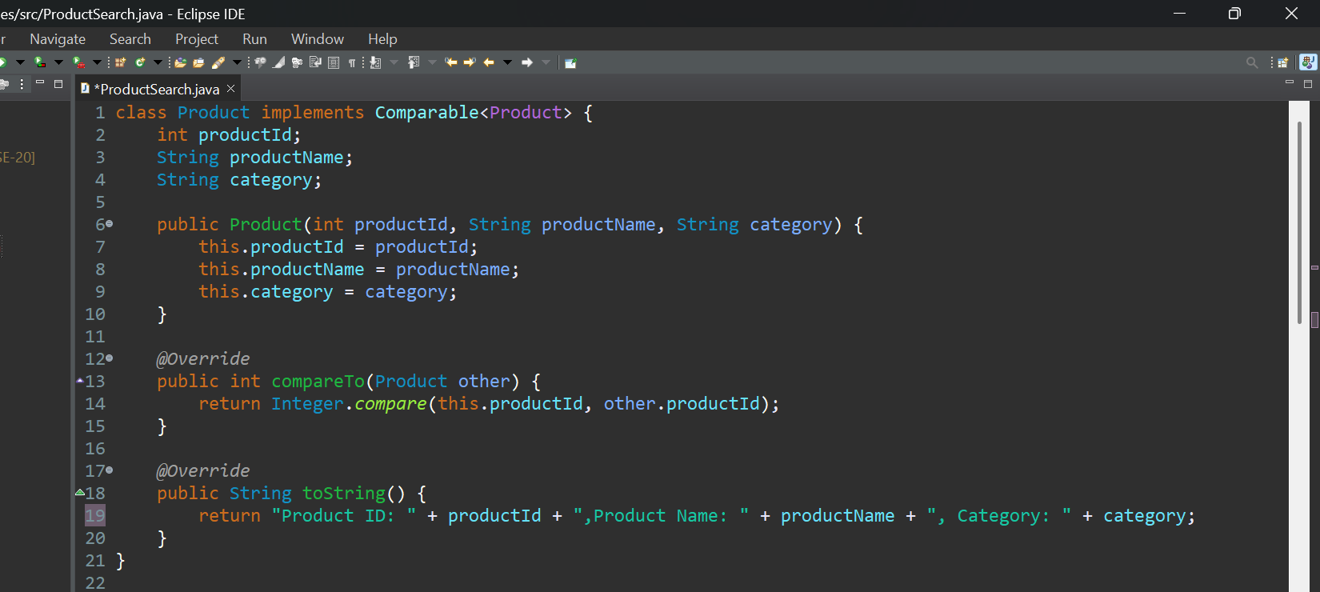

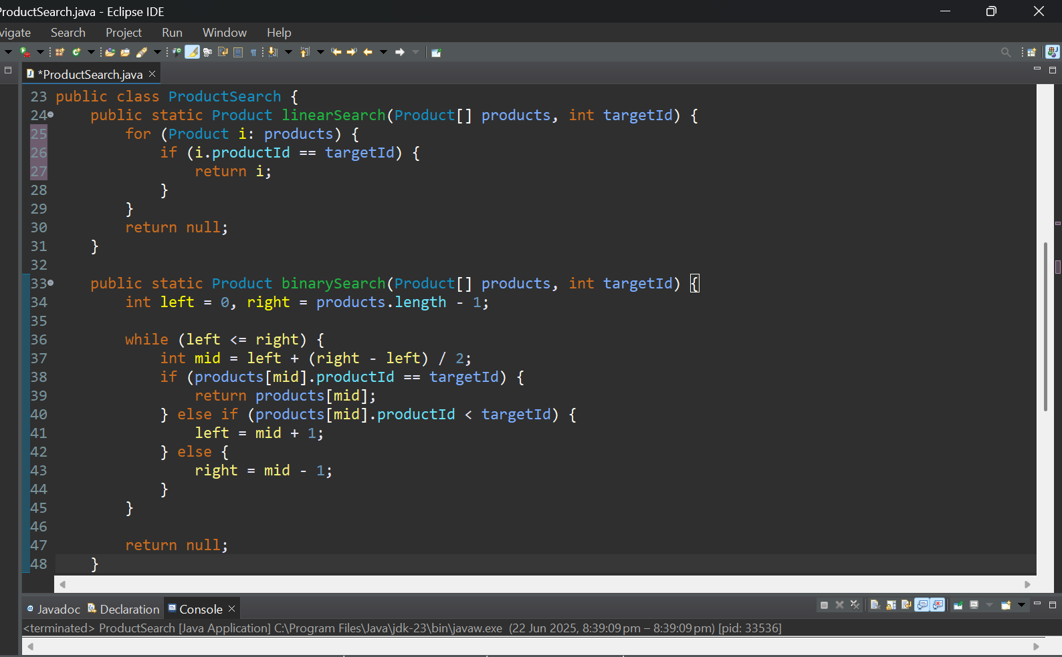

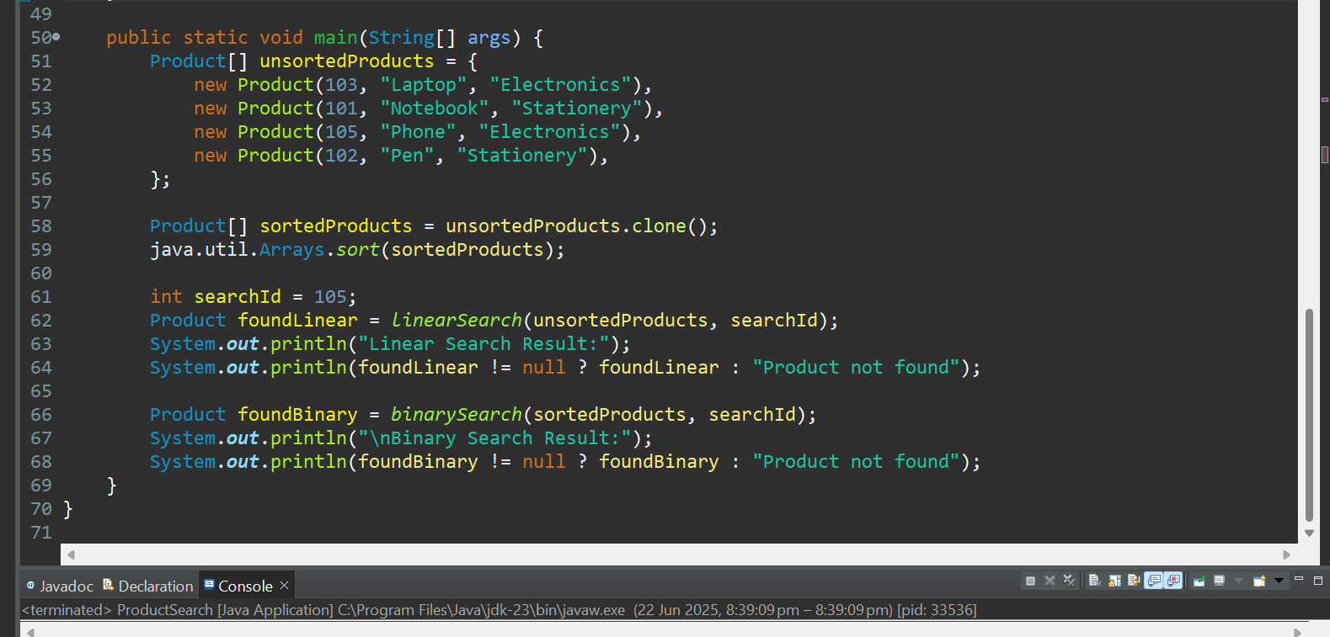

* **Output:**

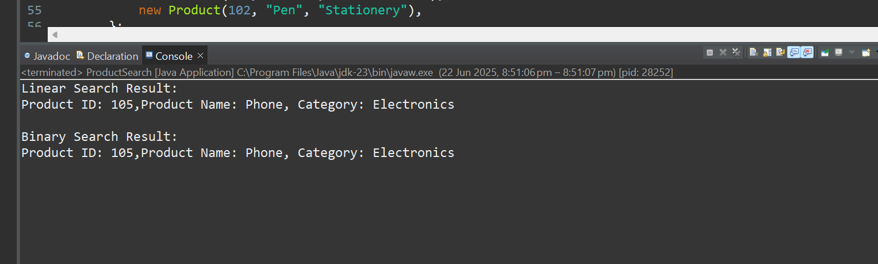

* In this scenario , it is best to use binary search if we have large sorted arrays with time complexity O(log n), but if we have small unsorted array then we can use the linear search with time complexity O(n).For simple queries in E commerce we can linearly searvh through the array, but for faster complex searching binary searching will be suitable.

**Exercise 7: Financial Forecasting :**

* Recursion is a technique where a function calls itself to solve a problem . It mainly has two case :

(i)Base case : It stops the recursion.

(ii)Recursive case: here the function calls itself with a simpler input.

We use recursion to solve the type of problems which are sequential and divide and conquer.

Eg: Factorial, Exponentiation…..etc.

In this case , here we have to calculate about future values.

So, we assume ,

Initial investment =P;

Rate=r%;

Forecasting Period=n years;

* **Code:**

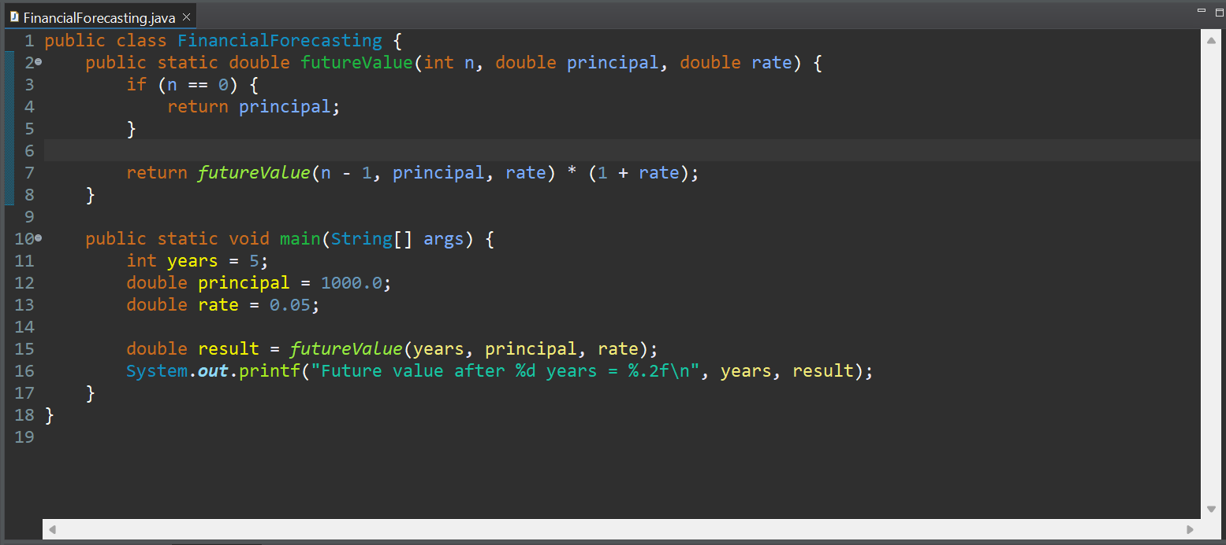

* **Output :**

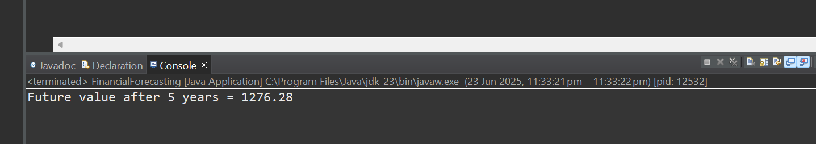

Here, the complexity is O(n), because the function calls itself n times before reaching the base vase.

* We can improve the approach by using iteration over the time period because recursive approach become insignificant when the period is large .
* **Code using Iterative approach:**

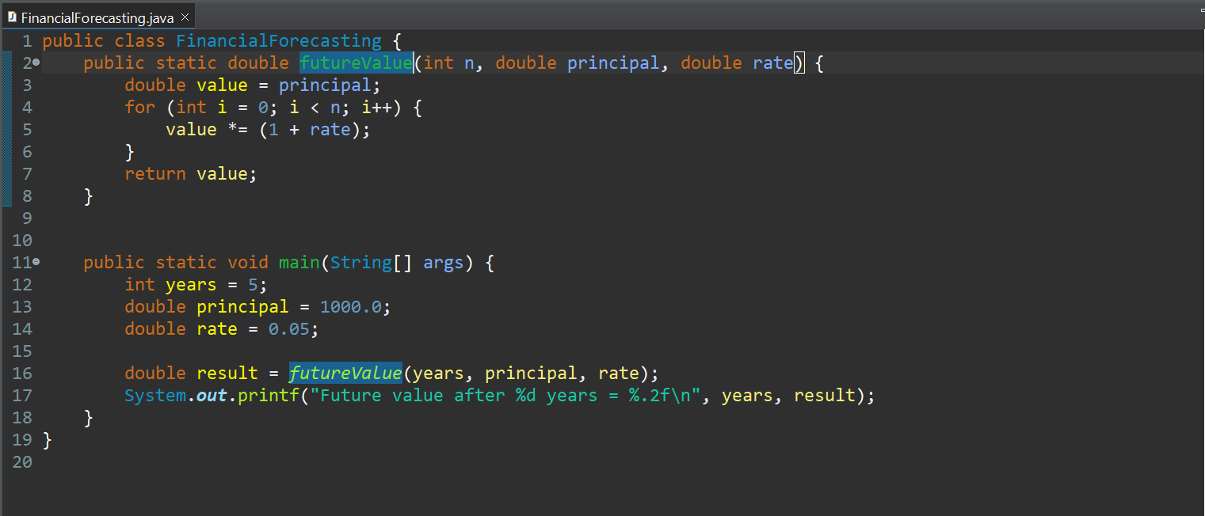

* **Output:**

