**WEEK 2 : DESIGN PATTERNS AND PRINCIPLES**

**Exercise 1: Implementing the Singleton Pattern**

* **Code : Logger.java**

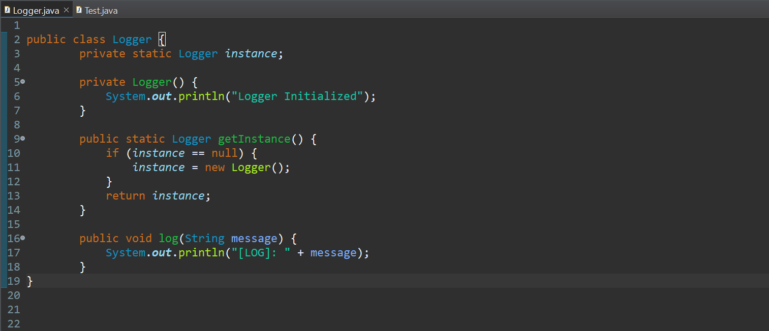

* **Code: Test.java**

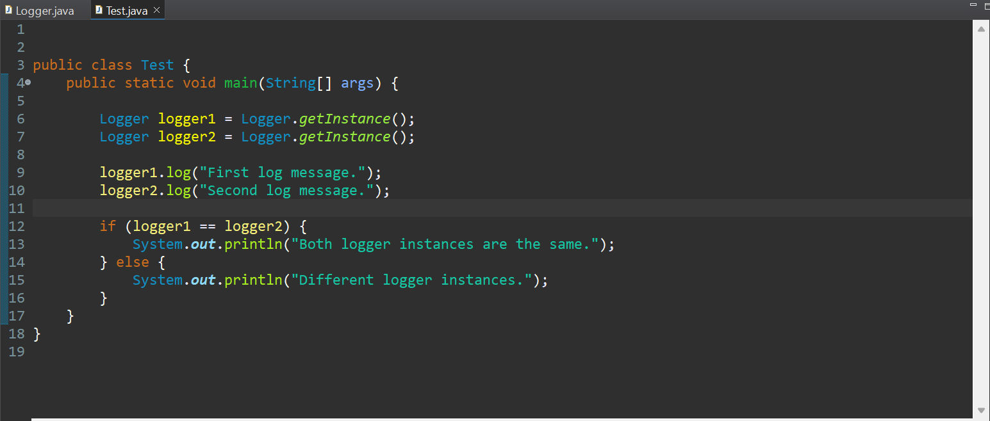

* **Output:**

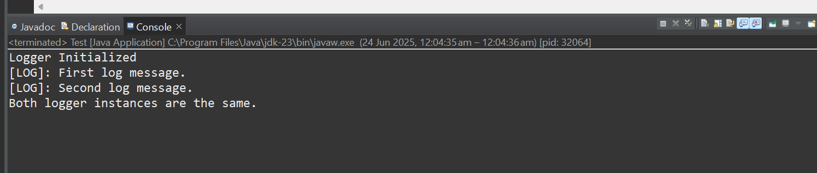

**Exercise 2: Implementing the Factory Method Pattern:**

* **Code: Document.java**

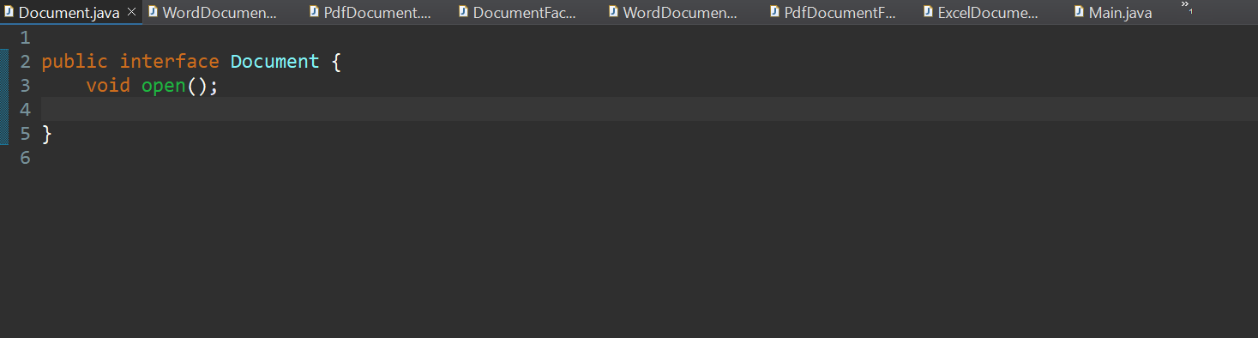

* **Code: WordDocument.java**

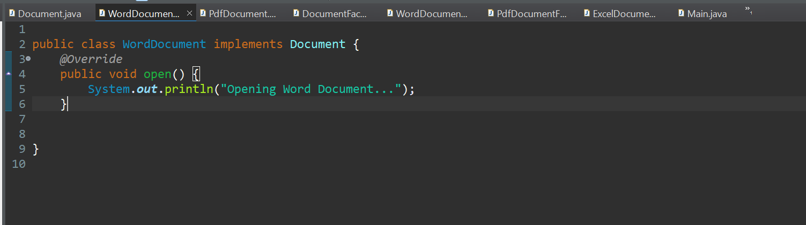

* **Code: PdfDocument.java**

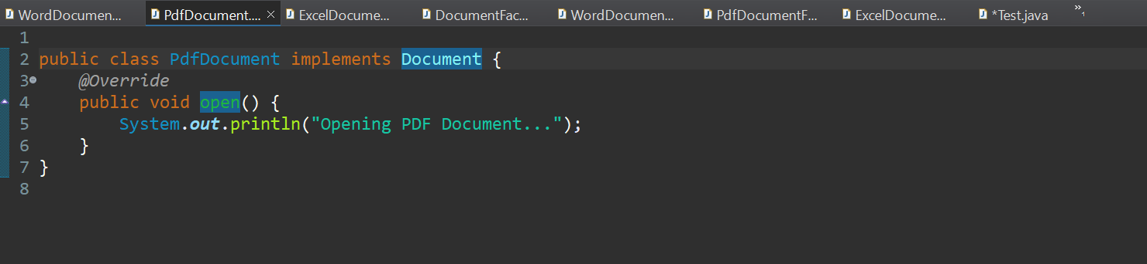

* **Code: ExcelDocument.java**

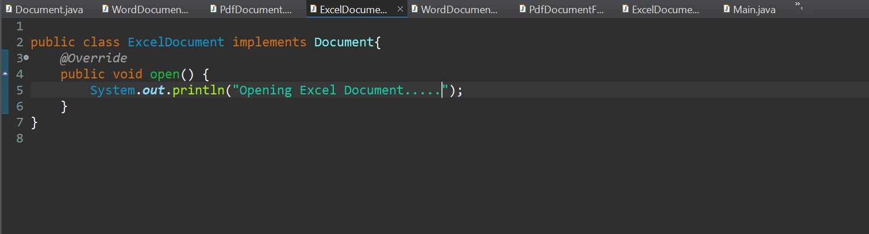

* **Code: DocumentFactory.java**

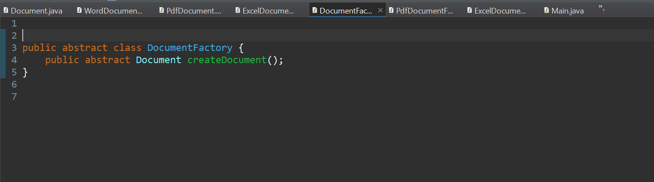

* **Code: WordDocumentFactory.java**

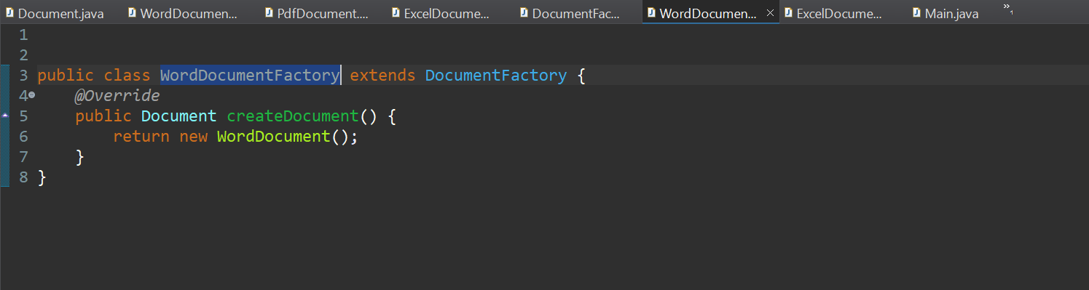

* **Code: PdfDocumentFactory.java**

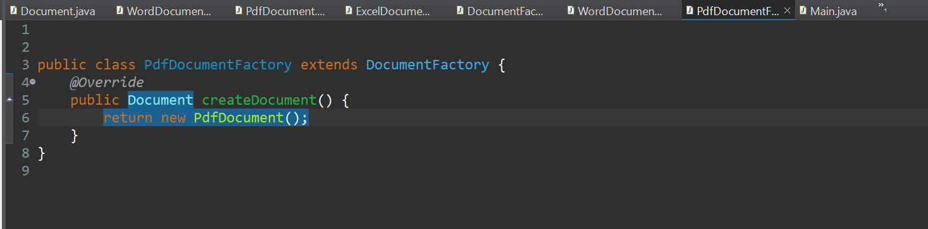

* **Code: ExcelDocumentFactory.java**

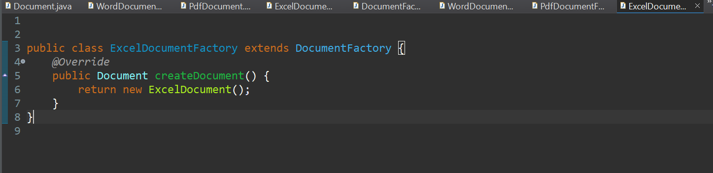

* **Code: Test.java**

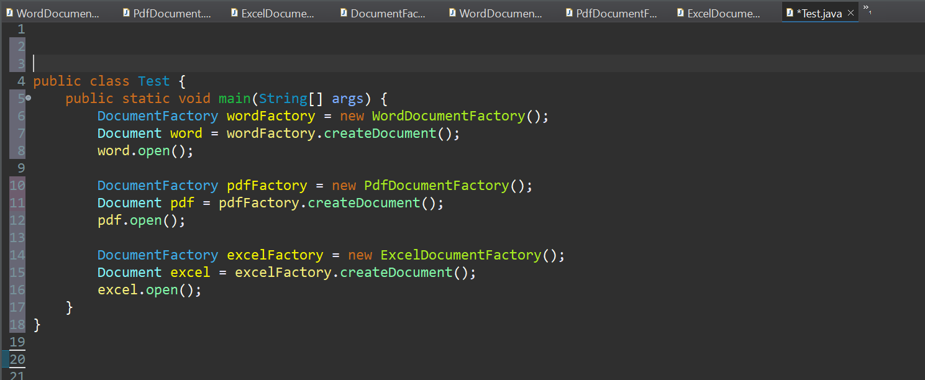

* **OUTPUT:**

