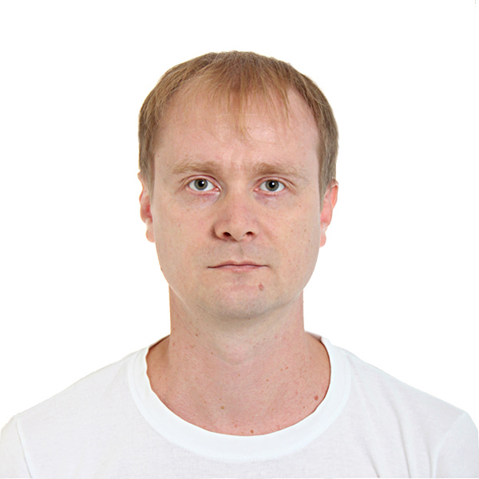
ARTEM SHAHANOV
City Kropivnitskiy, Ukraine
(Ready to relocate)
Phone, Viber: +380679426661
E-Mail: a.shaganov@gmail.com

Personal Details
Date of birth: October 10, 1980, marital status: married

Professional experience
2014 – present Engineer second category, Software developer, “PC RPC "Radiy" (Kropivnitskiy);
2009 – 2014 Deputy Head of IT Department, State Employment Center of Ukraine (Kropivnitskiy);
2007 – 2009 Network and System Administrator, Company "Service Center" (Kyiv);
2000 – 2007 Specialist of IT Department, State Pension Fund of Ukraine (Kropivnitskiy);

Education
1997 – 2003 Kirovograd's State Technical University, systems engineering, control systems and automation

Knowledge of foreign languages
English: between A2-B1

Skills and qualifications
- Program languages: C#, Delphi, Java и C++ (only embedded);
- IDE: Microsoft Visual Studio, Android Studio;
- Program platforms: NET Framework, Compact Framework;
- Use systems: WPF, Winform, for create client app, and ASP.NET MVC (Razor) for create websites or веб-web-portals;
- Use design patterns: MVVM, Singleton, Builder, Bridge, Observer and other;
- Use WCF for data exchange between app, ORM nHibernate for work with databases and Unit Tests for testing code;
- Knowledge SQL for create query and work experience with DB MySQL, MSSQL;
- Use subversion system SVN and bug tracker MantisBT;
- Embedded: ability to work with microcontrollers of the family MSP430;
- System administration: ОС Windows, Windows Server (2000 - 2008), Linux and RouterOS;
- Configuring AD, DNS, DHCP, VPN, OpenVPN, Filters, NAT and etc;
- Configuring local and virtual (vlan) network on OS, switches and routers such as: Mikrotik, HP, TP-Link;
- Knowledge and free use Microsoft Office, VM Oracle, VMWare, antiviruses and other;
- Participation in commissioning works;

Projects in which he took part
- Fire alarm system FAS1 (СПС1) - http://www.radiy.com/ru/produktsiya-dlya-aes/produktsiya/promyshlennye-ius-i-sistemy-kontrolya/sistema-pozharnoj-signalizatsii.html
- Lighting - https://youtu.be/CogTpLyNlyM

Additional skills
- Driving license category “B”;
- Very good knowledge of install and configure satellite devices;
- Communication and teamwork skills;

