Demo Brand: Carter

Product url: <http://www.carters.com/carters-baby-baby-boy-sets/V_121D096.html?dwvar_V__121D096_size=12M&dwvar_V__121D096_color=Color>

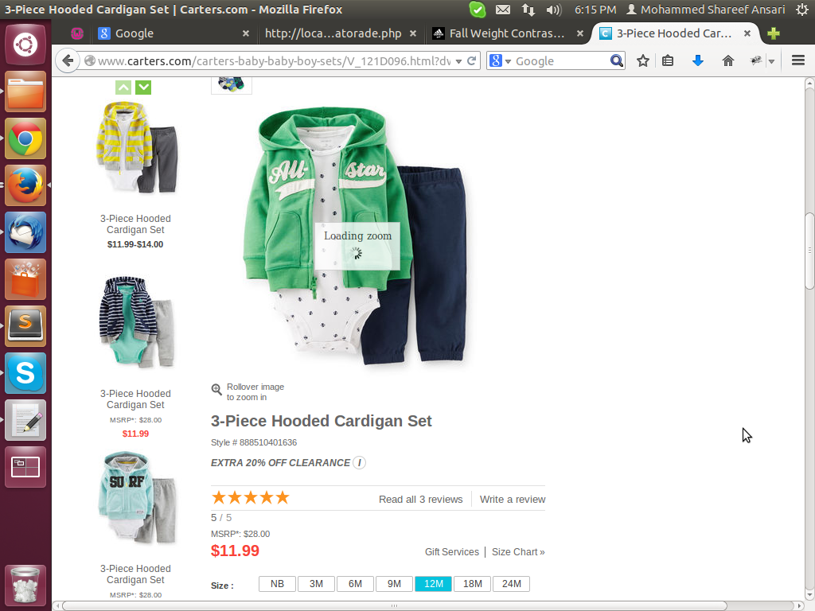

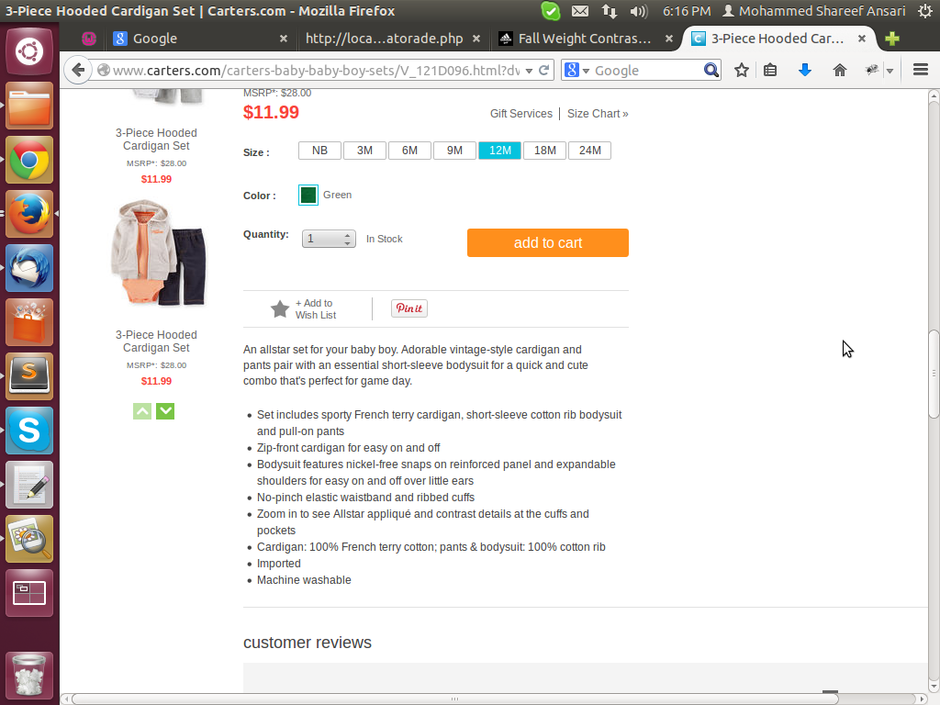

**Crawling can be done in two ways: using 80 App's js script or using php's custom script**

First we will try to get the product details using the js script. If it's not possible due to some reason then we will write custom script in PHP.

**Steps to follow for crawlling:**

1- First, we check view source of the product page to see whether product details like name, price, colors and size, etc. are present or not.

2- If product details are present in the view source, then we write script to get product details.

3- These are the details of product which must be taken from view source:

a- name of product

b- price,

c- product id

d- product image (only one is enough)

e- product details or description

4- These are optional details of a product, we need to get if available:

a- colors

b size

c- quantity (take only if this is given in a list)

d- flavors

e- features of a product.

5- Take also Extra information except listed above if available.

a- ingredients

b- sku

c- fragrances

**Method to get data of a product using JS:**

**1-** We have a sample script for this. We shall use that to write script for a brand/product.

**2-** First we check whether the url is of a product details page or not.

e.g. if ($html.find("div.product-detail-cols").length > 0)

{

.........

........

}

3 – To get title of the page we write the following code:

object.title = $html.filter('title').text().trim();

4- brand code of the product

product_data.brand = "CARTERSINCCHILDRENSAPPAREL";

5- To get product name, we write the following code:

product_data.name = $html.find('div.product-col-2 h1.product-name').text().trim();

(complete script for the Carter's product is attached here...)

To test the JS script

* Go to the URL: <http://80apptester.80legs.com/>
* Write the URL of the sample product page
* Paste the script code in the code area
* Click on “Crawl URL” button to test the code

To create Json array of the brand

* Go to the URL: <https://portal.80legs.com/apps>
* Click on “My 80apps” tab then click on “Create an 80app” link
* Type name for the brand and paste the script code in the code area
* Click on “My URL List” tab and then click on “Create a URL List” link
* Type name for the brand same as written in previous step
* Write the base URL of the site
* Click on the “Create a Crawl” tab
* Type Crawl Name same as written for the create URL list
* Select brand name from the Existing URL's list, select crawl size as M
* Again select brand name from list we already typed in previous steps
* Click on “Create Crawl” button to start the crawling process.

**Method to get data of a product using PHP:**

* Parse the page of the given url using the getPage method
* Navigate the links follows under the main menu in the page and store those in an array
* Navigate further those links to get sub-links if available or product detail page link if its a catalog/category page and store those links in an array
* Visit the final links of the product details page to get details of the product one by one
* Store the information of a product in an array
* Finally, after collecting all product's details in array, we will create json array and store it in a text file