

SUMMER 2019

ASSIGNMENT 3

DISTRIBUTED EVENT MANAGEMENT SYSTEM (DEMS)

USING

**DESIGN DOCUMENTATION**

Submitted by:

Tushar Verma 40089254

Siddhant Arora 40085538

Table of contents

Introduction 3

Architecture 3

Technologies Used 4

Data Structures 5

Logging 6

Challenges Faced during 6

Test Scenarios 7

Bibliography 9

# Introduction

The aim for this assignment was to design and build a distributed event management system, for a leading corporate event management company: a system which distributed through different servers in which event manager who manages the information about the events and customer who is also book and cancel an event across the company’s different branches.

# Architecture

The architecture used is clean and easily divided into clients and servers, all the client files are placed in a single package client and three different server packages are made each having implementation, interface and server classes.

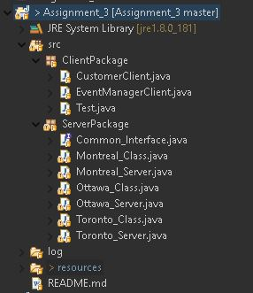

Packages

1. Client- There is of two types either CustomerClient or an EventManaegrClient.

CustomerClient- The operations that can be performed by a customer are the following:

• Booking of a event.

• Display their booking schedule.

• Cancel a booked event.

Swapping of event

EventManagerClient- A manager has responsibilities of a Customer as well as some additional responsibilities like adding an event or removing one. The operations that can be performed by an event manager are the following: -:

• Add a new event for their city.

• Remove an event.

• Check the event available for the given event type.

Swapping of event.

1. Server - Server package contains the same classes defined below-:

• server class- Each class creates a remote object registry that accepts calls on a specific port. A thread is also started which handle the socket connection on a particular port using UDP as protocol. It accepts all the UDP messages from different servers and routes them to the implementation class for the correct response.

• Common Interface class- Contains all the methods performed by the client. It is used by the client to make calls to the servers

• Implementation class- Implements the interface methods. All the business logic is written here.

# Technologies Used

1. UDP

The UDP protocol provides a mode of network communication whereby applications send packets of data, called datagrams, to one another. A datagram is an independent, self-contained message sent over the network whose arrival, arrival time, and content are not guaranteed. The DatagramPacket and DatagramSocket classes in the java.net package implement system-independent datagram communication using UDP. [1]

UDP has been used in the project to perform Inter Server communication i.e.

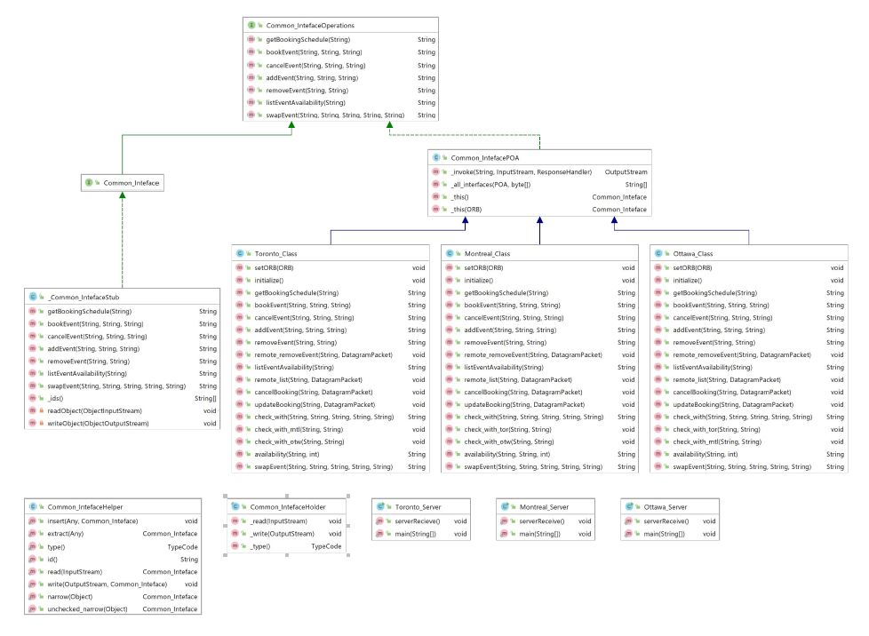• In the case of booking for a course by a client of different cities.

• By the manager to get the course availability from different cities.

1. Multithreading

Multithreaded execution is an essential feature of the Java platform. Every application has at least one thread — or several if you count "system" threads that do things like memory management and signal handling. But from the application programmer's point of view, you start with just one thread, called the *main thread*. [2]

1. Web Services

Web services are client and server applications that communicate over the World Wide Web’s (WWW) HyperText Transfer Protocol (HTTP). As described by the World Wide Web Consortium (W3C), web services provide a standard means of interoperating between software applications running on a variety of platforms and frameworks. Web services are characterized by their great interoperability and extensibility, as well as their machine-processable descriptions, thanks to the use of XML. Web services can be combined in a loosely coupled way to achieve complex operations. Programs providing simple services can interact with each other to deliver sophisticated added-value services. [3]

[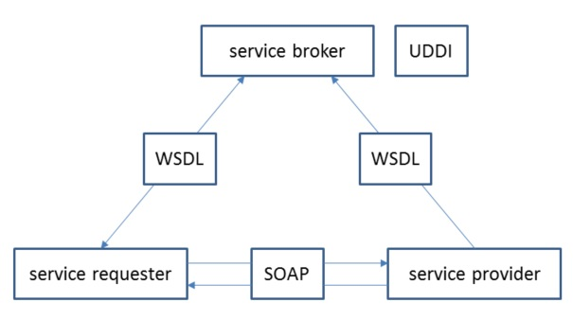](https://images.idgesg.net/assets/2017/07/jw-javaqa-post31-figure4.jpg)

# Data Structures

* HashMap “city”_hashmap: is used to maintain the list of events of each type, here semester (Seminar/Conference/TradeShow) are used as keys and the value is again a HashMap containing key as the Event ID (e.g. MTLE100519) and its value is an ArrayList of string type. This ArrayList as the key holds the information like the capacity of the event and number of available seats remaining in that course.
* HashMap client_” city”_info is used to hold information about the client. Key is the event type and the value is an ArrayList of a string containing the number of events in a particular event type and their total number.

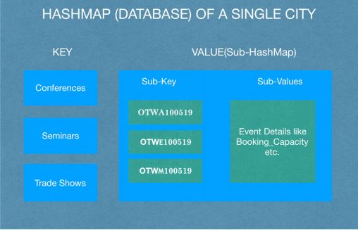

# Logging

Each server also maintains a log file containing the history of all the operations that have been performed on that server.

These are some details that a single log file record contains:

• Date and time the request was sent.

• Request type (book an event, cancel an event, etc.).

• Request parameters (clientID, eventID, etc.).

• Request successfully completed/failed.

• Server response for the particular request.

# Challenges Faced during

The major challenges faced were their-server communication between different cities and the back reply from them to check the occupancy and availabilities for which ExecutorService, Callable was used to create a temporary server and to managing reply to the client in a single request.

For performing the reply for a enrollment and listing courses availability ExecutorService is used , an executor thread is launched (along with callable and future) . It provides the UDP response while different other UDP calls are made.

# Test Scenarios

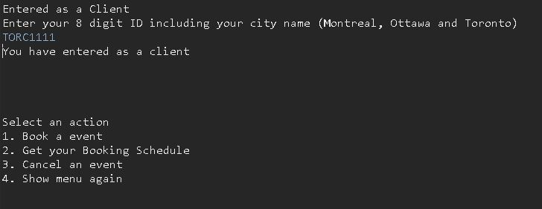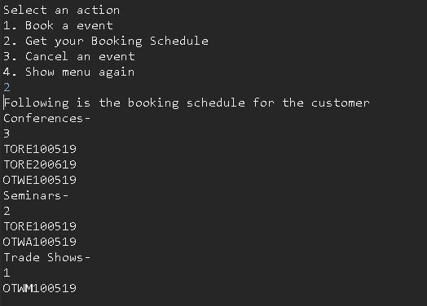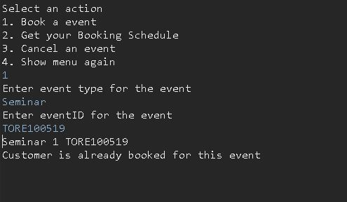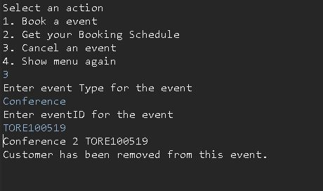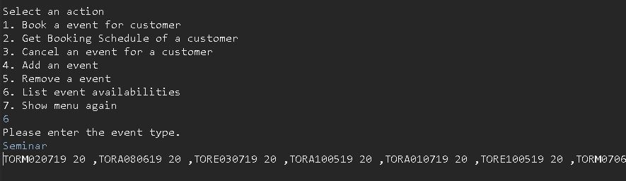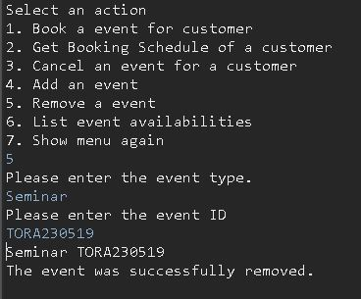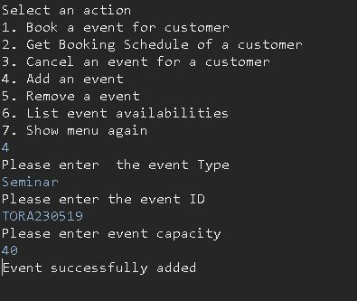

# Bibliography

|  |  |
| --- | --- |
| [1] | “Lesson: All About Datagrams (The Java™ Tutorials > Custom Networking),” Oracle, [Online]. Available: https://docs.oracle.com/javase/tutorial/networking/datagrams/index.html. |
| [2] | “Processes and Threads (The Java™ Tutorials > Essential Classes > Concurrency),” Oracle, [Online]. Available: https://docs.oracle.com/javase/tutorial/essential/concurrency/procthread.html. |
| [3] | “Getting Started with Java IDL,” [Online]. Available: https://docs.oracle.com/javase/8/docs/technotes/guides/idl/GShome.html. |