III. RESULTS AND DISCUSSION
In this section, a detailed evaluation of the Physics-Informed Neural Network (PINN) framework is provided in terms of predicting the performance of analog integrated circuits. A quantitative comparison of the proposed model is performed with other traditional machine learning techniques. To ensure relevance to analog IC design, flow-protected results are validated through Cadence® simulations.

- Model Efficiency and Training Stability Analysis
Table III shows the optimised hyperparameters obtained from the Optuna framework, which uses Bayesian optimisation with a Tree-structured Parzen Estimator (TPE) to systematically explore the design space and select a configuration associated with the minimum validation loss. The chosen learning rate is within the stable operating environment of the Adam optimizer and supports reliable convergence while optimizing both supervised and physics-informed losses. Experimental results indicate that four hidden layers of a 128-unit backbone facilitate an optimal balance between modelling complexity and generalization. Shallower topologies lacked adequate ability to describe the nonlinear mapping from transistor sizing parameters to the nine-output metrics, while deeper or wider networks exhibited evidence of overfitting. A dropout rate of 0.047 was considered after each hidden layer, enabling light regularization without disrupting the shared feature representations important to the multi-task learning objective. The regression MSE and classification cross-entropy losses operate on different numerical scales hence, the classification loss was amplified by a factor of 4.30 to preserve comparable gradient influence across both tasks. For the PINN-specific design, the physics loss is set to 0.58 to balance the influence of physics-informed regularization, and supervised objectives have equal contribution at optimization convergence. To improve training stability, the physics loss weight α was linearly increased from zero during the initial training phase. This ensures that the model converges towards physically consistent outputs. This in turn ensures that the gradients are more stable. A fixed training schedule with 50 epochs and a batch size of 64 was used, as this was found to be sufficient for convergence in each of the five folds of the cross-validation.
Table III: Hyperparameter settings
Parameters | Values
Learning rate | 0.0008657
Batch size | 64
Epochs | 50
Optimiser | Adam
Loss functions | MSE Loss, Cross Entropy Loss
Number of folds (Cross Validation) | 5

Table IV presents a comparative analysis of the benchmarked circuit with recent neural network-based models across dataset size, training efficiency, and network complexity. We can infer from the table that the proposed architecture framework demonstrates faster convergence, and due to the embedded physics constraints, the training behaviour is stable.

Table IV: Comparison of PINN model with State-of-the-Art Neural Network Approaches
Specification | [23] | [33] | This Work
Fabrication Technology | CMOS  < 1µm | SCL  0.18µm | UMC  180 nm
Design Parameters | 6 | 5 | 4
Dataset Size | 9000 | 1,20,383 | 16000
ML approaches | Deep Learning | DNN + Trinet | Physics Informed Neural Networks
NN Complexity2 | 15366 | 665 | 52,750
Training time | 18 mins | 8 hrs | 124.26 Secs

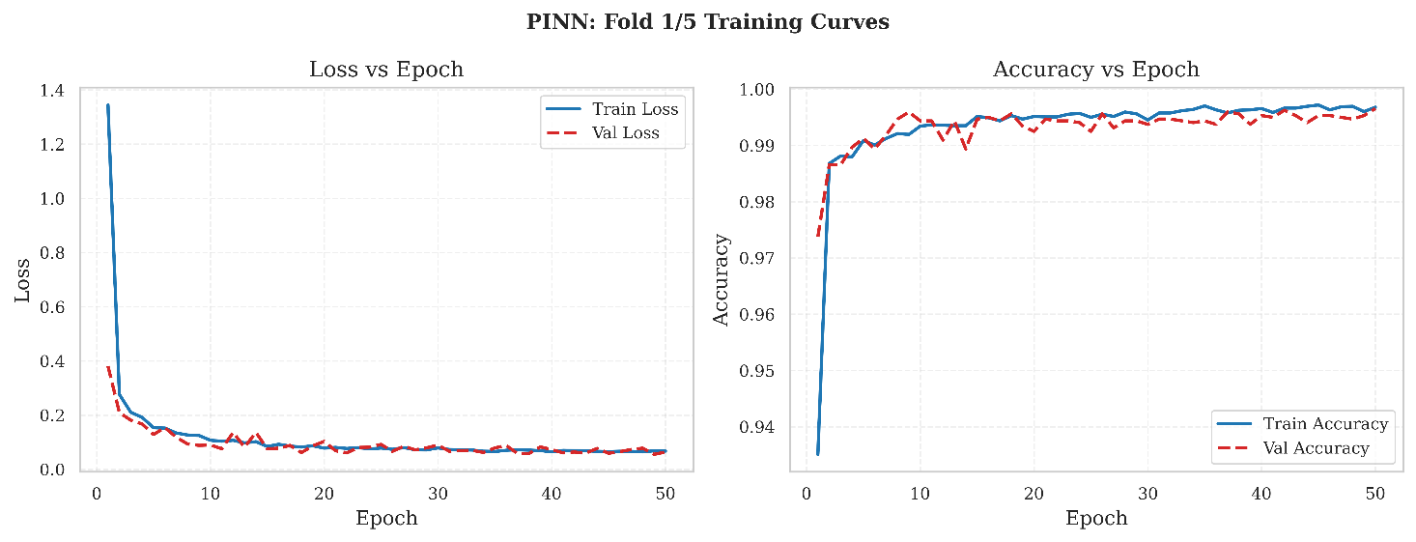
Figure 4: Training convergence behaviour of the Physics-Informed Neural Network (PINN): (left) training and validation loss vs epochs, and (right) training and validation accuracy vs epochs for Fold-1.
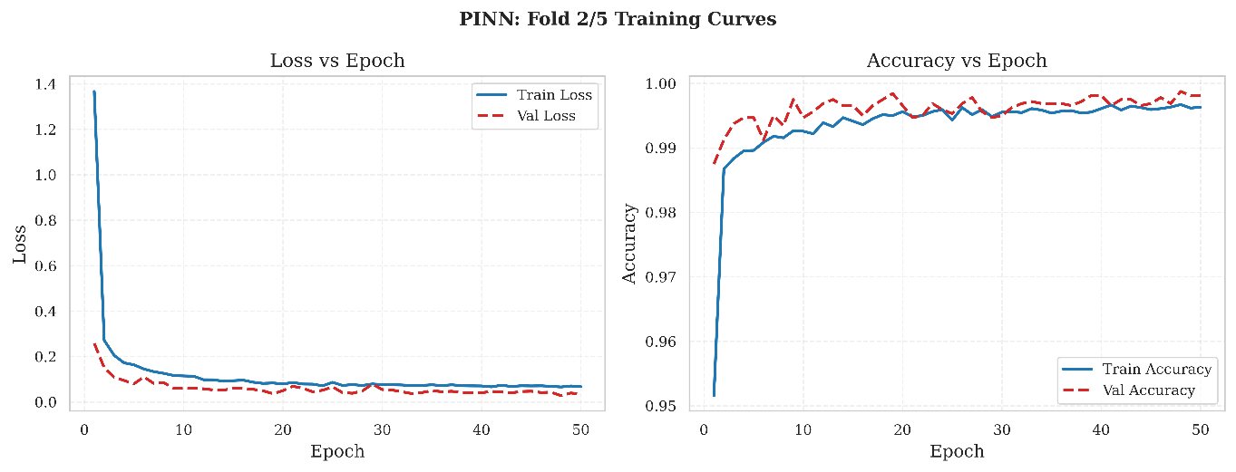 Figure 5: Training convergence behaviour of the Physics-Informed Neural Network (PINN): (left) training and validation loss vs epochs, and (right) training and validation accuracy vs epochs for Fold-2.
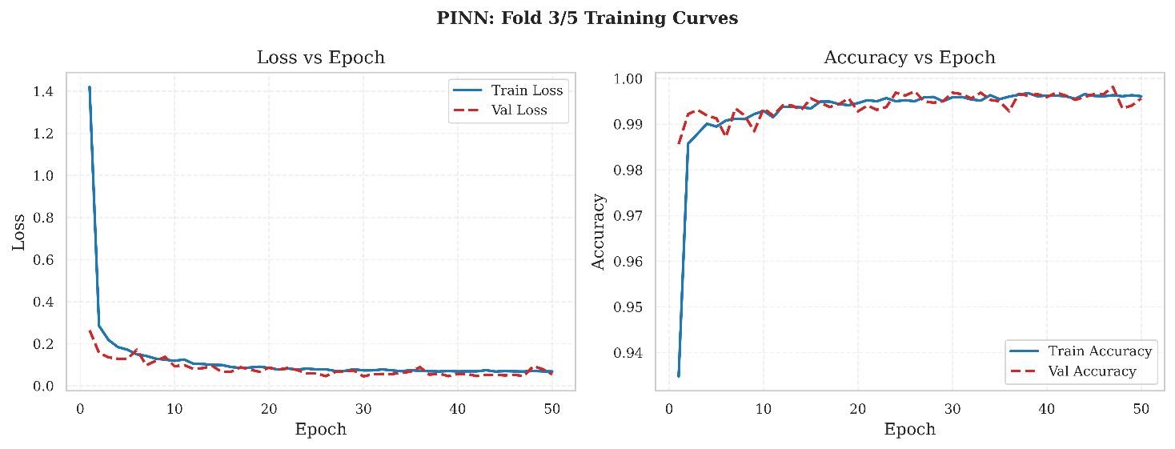
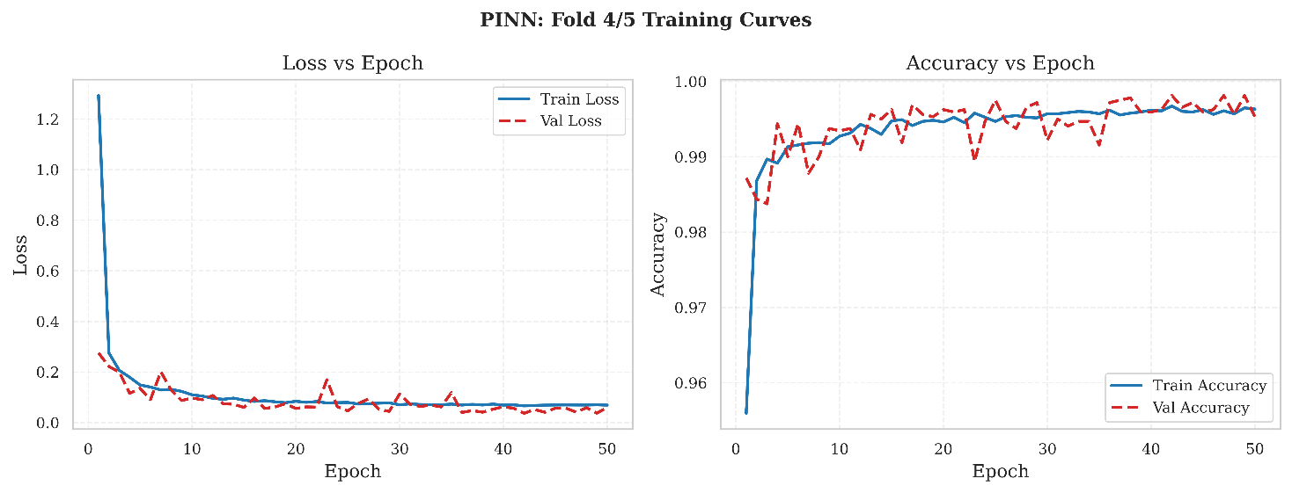
Figure 6: Training convergence behaviour of the Physics-Informed Neural Network (PINN): (left) training and validation loss vs epochs, and (right) training and validation accuracy vs epochs for Fold-3.

Figure 7: Training convergence behaviour of the Physics-Informed Neural Network (PINN): (left) training and validation loss vs epochs, and (right) training and validation accuracy vs epochs for Fold-4.
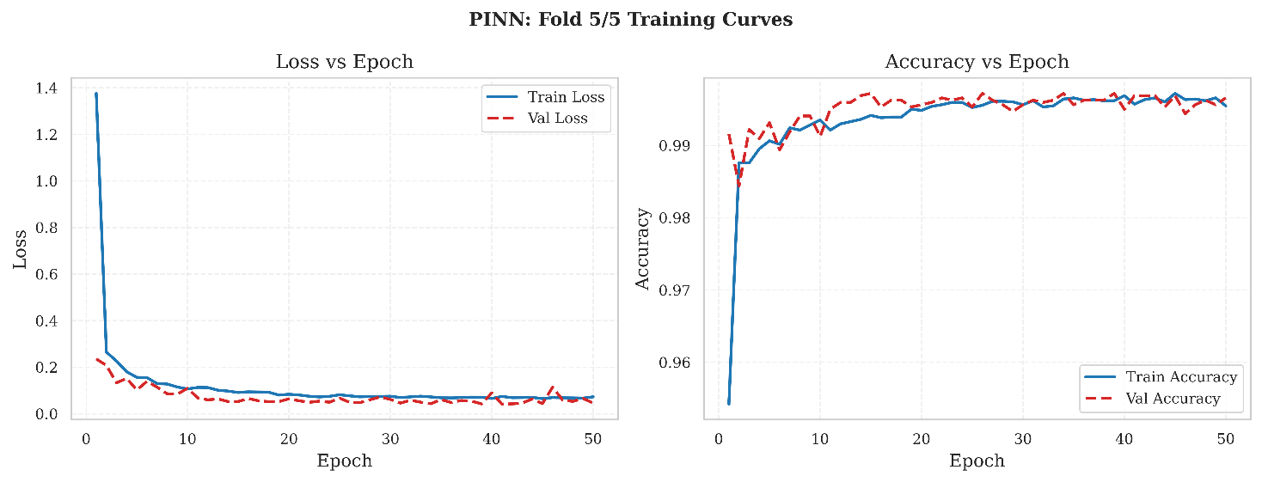
Figure 8: Training convergence behaviour of the Physics-Informed Neural Network (PINN): (left) training and validation loss vs epochs, and (right) training and validation accuracy vs epochs for Fold-5.

The training and validation curves shown in figures 4,5,6,7,8 represent the k-fold cross-validation process, thus clearly indicating that our model reduces training/validation losses across all k-fold validation consistently by supporting learning in a stable manner and facilitating good generalization capabilities. The figures contain two subplots each, with the first subplot representing the loss curves (where training/validation losses drop smoothly together), and the second subplot representing the classification accuracy curves (where accuracy increases smoothly on the right subplot, usually to very high values by epoch 30-40). There does not seem to be overfitting, and validation stays remarkably close to training across all k-fold validation. This kind of close tracking of training/validation curves is not necessarily guaranteed with deep models, although this behavior largely results from the physics loss acting as a soft regularizer to prevent unphysical behavior. In the presence of noisy and sparsely populated analog data, the level of stability shown by our model indicates good reliability of prediction beyond the training data.

- Classification performance evaluation
Table V describes the classification performance of the models that have been evaluated, with PINN having consistent performance. The improved performance can be explained by the capacity of PINN to incorporate domain-aware physical relationships in the learning process. The importance of physics-guided learning in improving the performance of the prediction can be explained by the advantage of the model over all the evaluation criteria when the baseline models have good classification performance.

Table V: Classification performance analysis across models

Model | Accuracy | Precision | Recall | F1
PINN | 0.9964 ± 0.0011 | 0.9965 ± 0.0011 | 0.9964 ± 0.0011 | 0.9964 ± 0.0011
Random Forest | 0.9975 ± 0.0010 | 0.9975 ± 0.0010 | 0.9975 ± 0.0010 | 0.9975 ± 0.0010
SVM | 0.9948 ± 0.0016 | 0.9948 ± 0.0016 | 0.9948 ± 0.0016 | 0.9948 ± 0.0016
Standard MLP | 0.9963 ± 0.0012 | 0.9963 ± 0.0012 | 0.9963 ± 0.0012 | 0.9963 ± 0.0012

- Prediction Accuracy Comparison
Tables VI, VII, and VIII show the prediction accuracy of all the tested models, as indicated by the mean absolute error, the root mean square error, and the coefficient of determination, respectively, on the selected performance metrics. The selected metrics indicate the average prediction performance, sensitivity of the errors, as well as consistency with the circuit-level simulation results. The proposed PINN model shows consistency in accuracy by constraining the physical relationships at the circuit level, although the Random Forest shows good performance in some of the metrics. Moreover, the inclusion of the physics-aware formulation improves the ability of the model to generalize the prediction at unknown operating conditions, which is important in the design of analogue circuits.
Table VI and Figure 9 show the results of the Mean Absolute Error (MAE) on four key metrics, namely Gain, Bandwidth, GBW, and Power. Table VI: Prediction Accuracy (MAE) Comparison for Two-Stage OTA. MAE is used as it represents the error in physical units, as it is the average error. Although the Random Forest algorithm achieved low error rates on occasion, the results were not as consistent as those achieved by the PINN.
Table VI: Prediction Accuracy (MAE) Comparison for Two-Stage OTA

Model | Gain(dB) MAE | Bandwidth(Hz) MAE | GBW(MHz) MAE | Power(uW) MAE
PINN | 0.4833 ± 0.0978 | 2242.6489 ± 257.7727 | 0.9321 ± 0.1190 | 33.6891 ± 3.6237
Random Forest | 0.0301 ± 0.0012 | 91.2463 ± 15.8883 | 0.1032 ± 0.0025 | 1.0425 ± 0.0335
SVM | 0.3670 ± 0.0043 | 3123.2485 ± 78.9055 | 0.8016 ± 0.0086 | 17.0466 ± 0.1191
Standard MLP | 0.2710 ± 0.0471 | 1808.9738 ± 484.7171 | 0.8109 ± 0.1114 | 12.9773 ± 2.8249

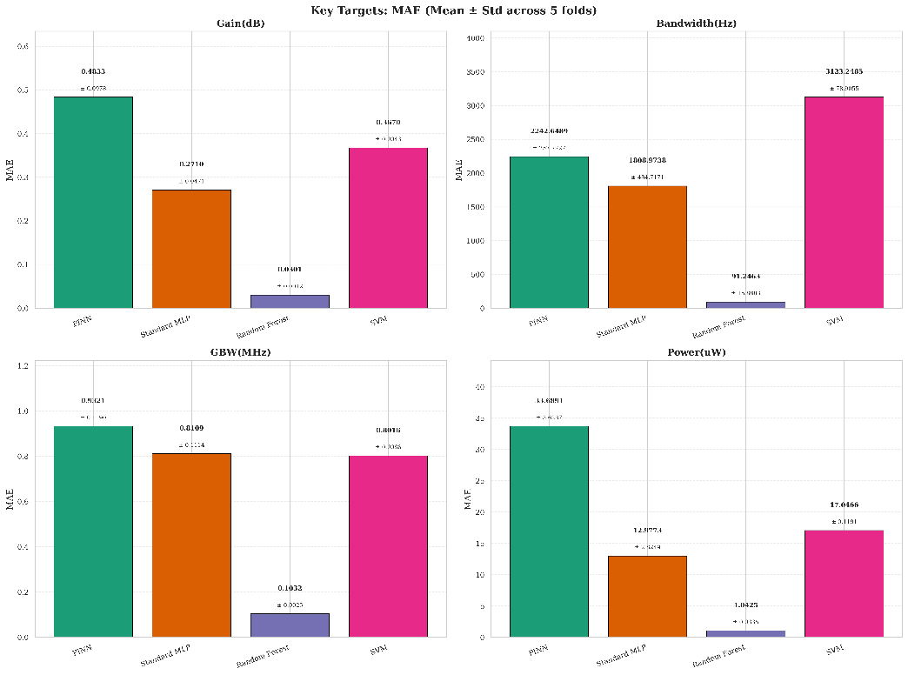
Figure 9: Mean Absolute Error (MAE) comparison of PINN, Standard MLP, Random Forest, and SVM models for predicting Gain, Bandwidth, GBW, and Power.

Table VII and Figure 10 measure the prediction ability of the models by utilizing the Root Mean Square Error (RMSE) metric. The RMSE metric heavily penalizes large prediction errors, and as such, the results presented in the table indicate the worst-case prediction stability of the models. The bar charts presented in Figure 8 illustrate the data presented in the table, emphasizing the ability of the PINN framework to regulate the maximum prediction deviations. Compared with the SVM and Standard MLP, which show large prediction variances, the PINN framework effectively limits the prediction errors that do not adhere to the basic laws of physics in the circuit.
Table VII. Prediction Accuracy (RMSE) Comparison for Two-Stage OTA

Model | Gain(dB) RMSE | Bandwidth(Hz) RMSE | GBW(MHz) RMSE | Power(uW) RMSE
PINN | 0.7849 ± 0.1731 | 3919.5392 ± 817.4870 | 1.2418 ± 0.1423 | 47.7888 ± 6.4723
Random Forest | 0.0629 ± 0.0017 | 1033.5082 ± 550.5945 | 0.2446 ± 0.0089 | 2.2206 ± 0.0266
SVM | 0.4133 ± 0.0045 | 6674.4737 ± 416.2461 | 0.9330 ± 0.0095 | 19.8493 ± 0.0913
Standard MLP | 0.3671 ± 0.0671 | 3156.7830 ± 547.5278 | 1.0686 ± 0.1328 | 16.9898 ± 2.8540
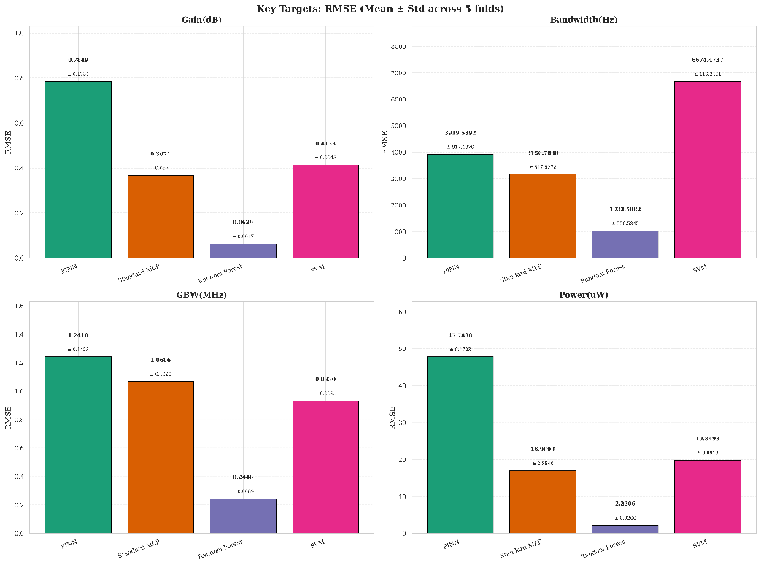
Figure 10: Root Mean Square Error (RMSE) comparison of PINN, Standard MLP, Random Forest, and SVM models for predicting Gain, Bandwidth, GBW, and Power.
Table VIII and Figure 11 display the Coefficient of Determination (R²) score of the assessed models with regards to the target performance metrics. The R² score measures the goodness-of-fit of the predicted values with regards to the variance of the true simulated data. As depicted in Figure 9, all models exhibit high linear goodness-of-fit values, with all values above 0.97. The PINN consistently demonstrates the same high R² performance as the data-driven baselines, which confirms that the physical relationship constraints did not compromise the network's capacity to learn the intricate and nonlinear dependencies between the sizing parameters and performance outputs of the OTA
Table VIII. Prediction Accuracy (R²) Comparison for Two-Stage OTA

Model | Gain(dB) R2 | Bandwidth(Hz) R2 | GBW(MHz) R2 | Power(uW) R2
PINN | 0.9852 ± 0.0058 | 0.9903 ± 0.0035 | 0.9932 ± 0.0019 | 0.9789 ± 0.0052
Random Forest | 0.9999 ± 0.0000 | 0.9992 ± 0.0007 | 0.9997 ± 0.0000 | 1.0000 ± 0.0000
SVM | 0.9960 ± 0.0003 | 0.9724 ± 0.0017 | 0.9962 ± 0.0001 | 0.9964 ± 0.0001
Standard MLP | 0.9967 ± 0.0014 | 0.9936 ± 0.0025 | 0.9949 ± 0.0013 | 0.9973 ± 0.0009
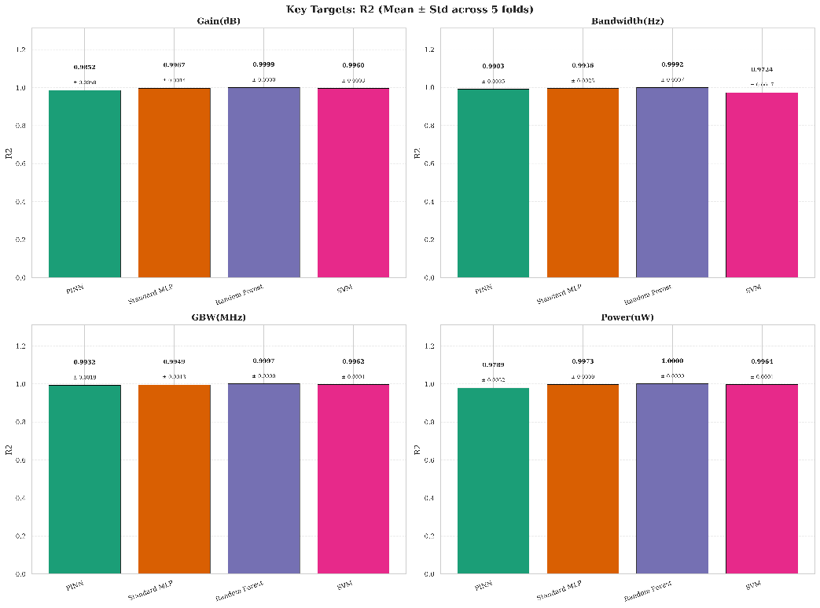
Figure 11: R² score comparison of PINN, Standard MLP, Random Forest, and SVM models across Gain, Bandwidth, GBW, and Power predictions.
Figures 9, 10, and 11 illustrate the MAE, RMSE, and R² comparisons, respectively, between PINN, Standard MLP, Random Forest, and SVM algorithms in the prediction of Gain, Bandwidth, GBW, and Power. It is evident that the Random Forest algorithm has the minimum MAE and RMSE values in all cases, with the best performance in the prediction of Bandwidth (MAE=72.52 Hz, RMSE=493.42 Hz) and Power (MAE=1.06 µW, RMSE=2.22 µW). SVM demonstrates the largest error in the prediction of Bandwidth (MAE=3224.21 Hz, RMSE=6492.56 Hz). Even though PINN demonstrates larger MAE and RMSE values than the other algorithms, the R² values are high at 0.99 for Gain, Bandwidth, and GBW, with a slight reduction to 0.97 in the prediction of Power, similar to the performance of the Standard MLP and Random Forest algorithms, which achieve near-perfect R² values of 1.00 across all targets. This indicates that the absolute error in predictions is slightly higher for PINN due to the additional regularization terms in the loss function, but it still delivers higher predictive accuracy and robust generalization capability for across key circuit performance indicators.
- Predicted versus Simulated Performance
Fig. 12 depicts scatter plots of actual vs. predicted values for Gain, Bandwidth, GBW, and Power. High predictive accuracy is observed with Standard MLP, Random Forest, and SVM, achieving an R² score of 1.00. Visual assessment shows that PINN’s predictions are closely grouped on a diagonal line, indicating minimal scatter. Hence, we can conclude that there is excellent prediction fidelity with minimal scatter. However, in conventional benchmark models, namely SVM, there are excellent trends, notable deviations and structural inconsistencies evident at certain specific data points. Additionally, the PINN has lower R² scores of 0.99 on most targets and 0.97 on Power, which is due to an additional term in the PINN’s loss function that sacrifices some prediction accuracy in favour of physical consistency.

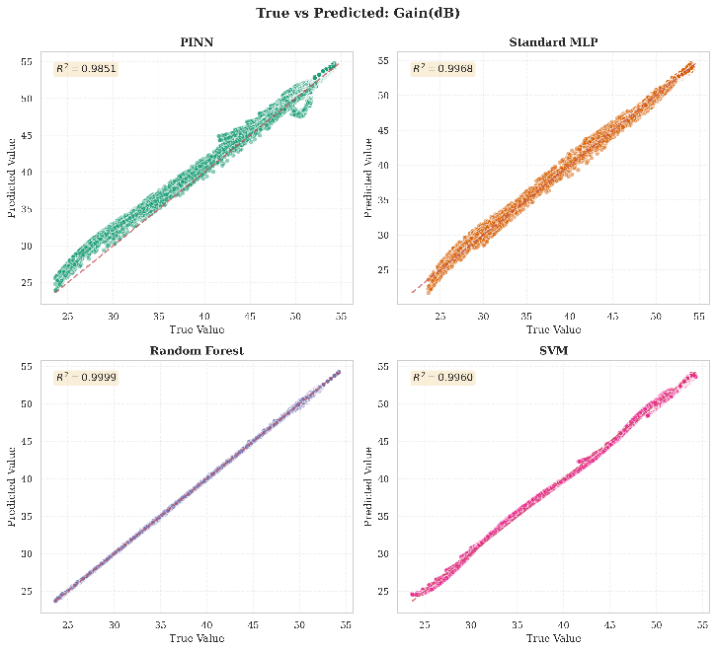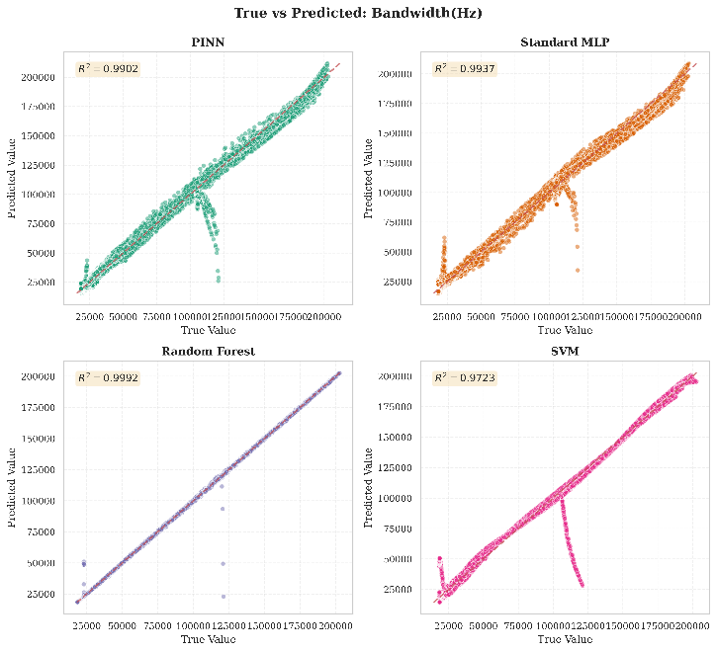
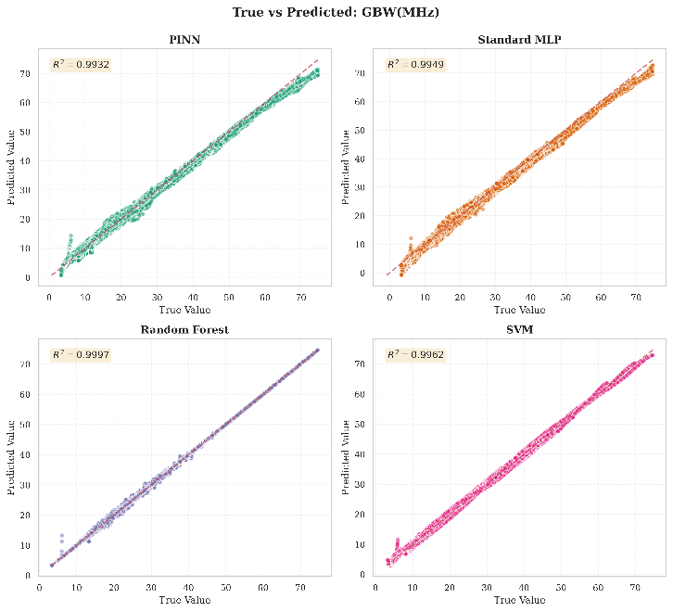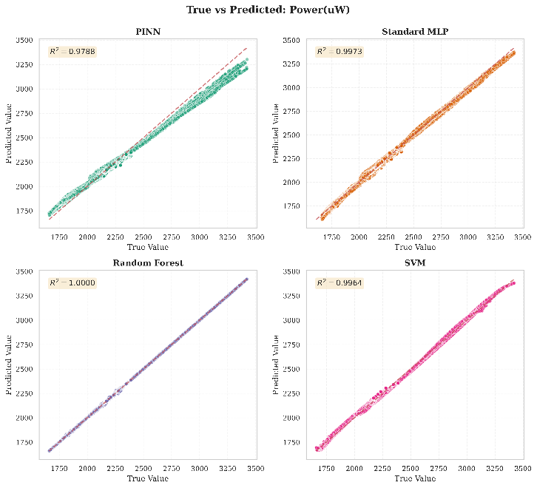

Figure 12: True vs. predicted value plots for PINN, Standard MLP, Random Forest, and SVM models across Gain, GBW, Bandwidth, and Power parameters.
- Physics Consistency Analysis
The physical coherence of the model predictions is measured using a physics consistency error. In this case, the analysis calculates the GBW using the model's predictions of Gain, Bandwidth, and Phase Margin and compares them with the model's direct prediction of GBW. In addition, the performance of the model is measured using different metrics. These metrics include R², which is used to measure the linear consistency between the model's predictions and the direct prediction of the model. Moreover, the model's performance is measured using the Mean Absolute Percentage Error (MAPE), which is used to measure the percentage error and the amount of violation in the model's predictions with regard to the underlying physics relationship. Figure 13 extends the accuracy of the model's performance beyond statistical accuracy and attempts to measure the actual physical consistency of the model's predictions. In this case, the model is presented with an R² consistency score that measures the mathematical consistency of the network's independent predictions of Gain, Bandwidth, and Phase Margin in the calculation of the Gain-Bandwidth Product (GBW). PINN far outperforms the data-driven baselines with its impressive consistency score of 0.952. By comparison, the more traditional MLP and Random Forest achieve much lower consistency scores of 0.669 and 0.702, respectively, indicating that although the black box models can individually minimize numerical error, the aggregate output can still break basic laws of circuits.
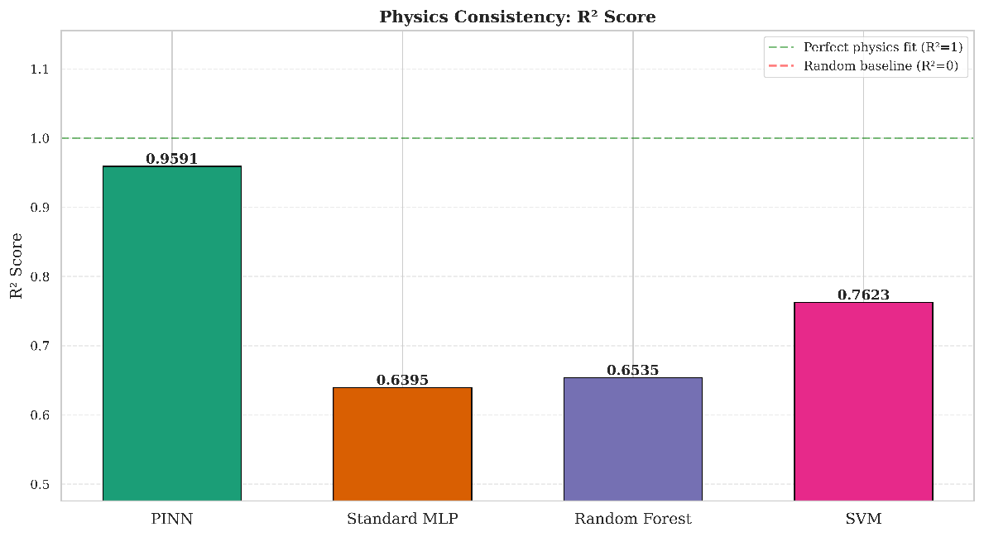
Figure 13: Physics consistency score (R²) comparison of PINN, Standard MLP, Random Forest, and SVM models.
Figure 14 can be seen as an additional analysis to the physical consistency analysis by depicting the Mean Absolute Percentage Error (MAPE) between the theoretically computed GBW (obtained from the predicted Gain, Bandwidth, and Phase Margin by the model) and the directly predicted GBW by the model. It can be seen that the PINN obtains the minimum percentage error (0.1030), which demonstrates that the learned representations by the PINN are highly consistent with the intrinsic structural relationships of the OTA. It can also be seen from the relatively higher percentage errors of the performance metrics predicted by the Standard MLP, Random Forest, and SVM models that one of the major pitfalls of using conventional ML techniques in analog design is that the models are highly susceptible to producing mathematically disjointed performance metrics.
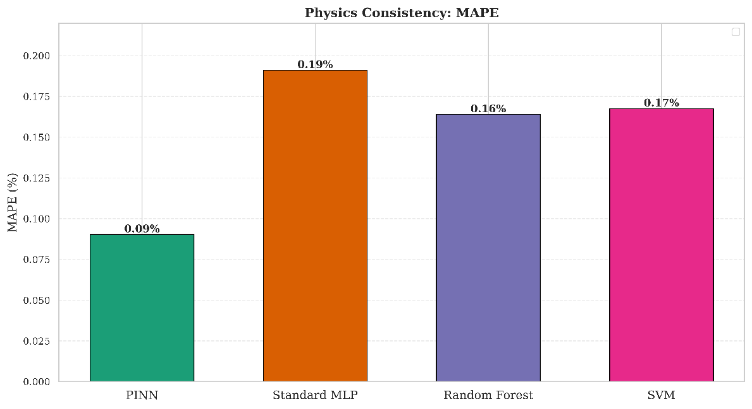
Figure 14: Physics consistency evaluation using GBW MAPE (calculated vs predicted) for PINN, Standard MLP, Random Forest, and SVM models.
Table VIII illustrates that the ±10% threshold is an engineering tolerance band range. A sample is considered physically compliant if the model's predicted GBW deviates by no more than 10% from the value derived by substituting the model's own Gain, Bandwidth, and Phase Margin predictions into the GBW physics formula. A higher compliance percentage indicates that the model's multi-output predictions are mutually self-consistent with circuit theory, which is a necessary condition for trustworthy use in analog design automation. PINN’s superior compliance (63.84%) as compared to the Standard MLP (33.47%) provides validation of the effectiveness of physics-informed regularization in enforcing inter-output coherence, surpassing the limitations of what data-driven training can achieve.
Table VIII. Physics Violation Index
Model | Mean Violation | Std. Dev | Max. Violation | % Samples within ±10%
PINN | 0.0903 | 0.1151 | 0.6813 | 75.11
Random Forest | 0.1639 | 0.1559 | 0.925 | 40.16
SVM | 0.1676 | 0.1694 | 0.8936 | 41.42
Standard MLP | 0.1911 | 0.1652 | 1.0037 | 32.99

IV. CONCLUSION
Our research work demonstrates that integrating physics knowledge within the learning model facilitates reliable and accurate predictions while effectively guiding and supporting efficient analog OTA performance. The physics consistency score of 0.952 is markedly higher than the conventional models (0.669 for standard MLP, 0.702 for RF,0.767 for SVM), indicating the PINN framework's strength and effectiveness in generating predictions. The findings demonstrate that the learning framework facilitates a reliable methodology for analog circuit design, providing a distinct edge over baseline data-driven approaches evaluated in this work. Implementing the PINN framework, predictions exhibit high accuracy (R² = 0.99 for Gain, Bandwidth, and GBW, and 0.97 for Power) and maintain strong alignment with physics constraints across all predicted outputs. Compared to conventional baseline models, PINN ensures self-consistent predictions that inherently remain consistent by incorporating physics-informed constraints enabling stable training, robust generalization and smoother convergence across all cross-validation folds. In future research work, we aim to extend the evaluation of the framework by integrating Monte Carlo simulations and wider PVT conditions to examine its resilience and generalization in comparison with traditional data-driven approaches. Further, we plan to explore the scalability of the framework across different technology nodes for complete performance evaluation.

References

[1] K. G. Liakos and F. Plessas, “Analog design and machine learning: A review,” Electronics, vol. 14, no. 17, p. 3541, 2025, doi: 10.3390/electronics14173541.
[2] A. Lberni, M. A. Marktani, A. Ahaitouf, and A. Ahaitouf, “Analog circuit sizing based on evolutionary algorithms and deep learning,” Expert Systems with Applications, vol. 237, p. 121480, 2024, doi: 10.1016/j.eswa.2023.121480.
[3] E. Afacan, N. Lourenço, R. Martins, and G. Dündar, “Machine learning techniques in analog/RF integrated circuit design, synthesis, layout, and test,” Integration, the VLSI Journal, vol. 77, pp. 113–130, 2021, doi: 10.1016/j.vlsi.2020.11.006.
[4] W. Cao, J. Gao, T. Ma, R. Ma, M. Benosman, and X. Zhang, “RoSE-Opt: Robust and efficient analog circuit parameter optimization with knowledge-infused reinforcement learning,” IEEE Trans. on CAD of ICs and Systems, vol. 44, no. 2, pp. 627–640, Feb. 2025, doi: 10.1109/TCAD.2024.3435692.
[5] R. Mina, C. Jabbour, and G. E. Sakr, “A review of machine learning techniques in analog integrated circuit design automation,” Electronics, vol. 11, no. 3, p. 435, 2022, doi: 10.3390/electronics11030435.
[6] A. Mehradfar, X. Zhao, Y. Niu, S. Babakniya, M. Alesheikh, H. Aghasi, and S. A. Avestimehr, “Supervised learning for analog and RF circuit design: Benchmarks and comparative insights,” arXiv preprint, arXiv:2501.11839, 2025.
[7] S. Du, H. Liu, Q. Hong, and C. Wang, “A surrogate-based parallel optimization of analog circuits using multi-acquisition functions,” AEU – International Journal of Electronics and Communications, vol. 146, p. 154105, Mar. 2022, doi: 10.1016/j.aeue.2022.154105.
[8] C. Vişan, O. Pascu, M. Stănescu, E. D. Şandru, C. Diaconu, A. Buzo, G. Pelz, and H. Cucu, “Automated circuit sizing with multi-objective optimization based on differential evolution and Bayesian inference,” Knowledge-Based Systems, vol. 258, p. 109987, Dec. 2022, doi: 10.1016/j.knosys.2022.109987.
[9] Y. Yin, R. Wang, J. Zhang, and Y. Wang, “Asynchronous parallel expected improvement matrix-based constrained multi-objective optimization for analog circuit sizing,” IEEE Transactions on Circuits and Systems II: Express Briefs, vol. 69, no. 9, pp. 3869–3873, 2022, doi: 10.1109/TCSII.2022.3172408.
[10] D. Chen, Y. Yang, X. Wang, D. Li, G. Xin, and Y. Yang, “A high-efficiency modelling method for analog integrated circuits,” Chip, vol. 4, art. no. 100135, 2025, doi: 10.1016/j.chip.2025.100135.
[11] A. Moreto, M. T. Penna, and E. Costa, “Analog circuit sizing using evolutionary computation and machine learning techniques,” Microelectronics Journal, vol. 88, pp. 85–96, 2019, doi: 10.1016/j.mejo.2019.02.008.
[12] A. Lberni, M. A. Marktani, A. Ahaitouf, and A. Ahaitouf, “Metaheuristics for analog circuit design optimization: A survey,” Swarm and Evolutionary Computation, vol. 99, p. 102170, 2025. doi: 10.1016/j.swevo.2024.102170.
[13] G. Chiari, M. Piccoli, and D. Zoni, “OSIRIS: Bridging analog circuit design and machine learning with scalable dataset generation,” arXiv preprint arXiv:2601.19439, 2026. doi: 10.48550/arXiv.2601.19439.
[14] M. Raissi, P. Perdikaris, and G. E. Karniadakis, “Physics-informed neural networks: A deep learning framework for solving forward and inverse problems involving nonlinear partial differential equations,” J. Comput. Phys., vol. 378, pp. 686–707, 2019, doi: 10.1016/j.jcp.2018.10.045.
[15] S. Son, J. Jeong, D. Jeong, K. H. Sun, and K. Y. Oh, “Physics-informed neural network: principles and applications,” in Recent Advances in Neuromorphic Computing, K. J. Bai and Y. Yi, Eds., IntechOpen, Rijeka, Croatia, 2024, ch. 4, doi: 10.5772/intechopen. 1006130.
[16] G. E. Karniadakis, I. G. Kevrekidis, L. Lu, P. Perdikaris, S. Wang, and L. Yang, “Physics-informed machine learning,” Nature Reviews Physics, vol. 3, no. 6, pp. 422–440, 2021, doi: 10.1038/s42254-021-00314-5.
[17] S. Cuomo, V. S. Di Cola, F. Giampaolo, G. Rozza, M. Raissi, and F. Piccialli, “Scientific machine learning through physics-informed neural networks: Where we are and what’s next,” J. Sci. Comput., vol. 92, no. 3, p. 88, 2022, doi: 10.1007/s10915-022-01939-z.
[18] Cadence Design Systems, Virtuoso® OCEAN Reference Manual, San Jose, CA, USA, 2023.
[19] A. P. Chavan, S. Shrish, M. Sanket, A. G. Abhishek, S. Kishan, R. Aradhya, and P. Pawar, “Integrating Neural Network Models for Advanced Automation in Analog Amplifier Circuit Design,” in 2024 IEEE Int. Conf. on Electronics, Computing and Communication Technologies (CONECCT), Bangalore, India, 12–14 Jul. 2024, pp. 1–6, doi: 10.1109/CONECCT62155.2024.10677072.
[20] R. Rashid, K. Krishna, C. P. George, and N. Nambath, “Machine learning driven global optimisation framework for analog circuit design,” Microelectronics J., vol. 151, p. 106362, 2024, doi: 10.1016/j.mejo.2024.106362.
[21] S. Srinivasan, N. R. Aithal, S. Janani, S. S. Rao, and R. Mathew, “High Performance Two-Stage Operational Transconductance Amplifier (OTA) for Biomedical Applications: Design, Simulation & Performance Analysis,” in Proc. 2025 IEEE 2nd Int. Conf. for Women in Computing (InCoWoCo), Nov. 2025, pp. 1–8, doi: 10.1109/InCoWoCo68239.2025.11407259.
[22] M. Fukuda, T. Ishii, and N. Takai, “OP-AMP sizing by inference of element values using machine learning,” in Proc. 2017 Int. Symp. Intelligent Signal Processing and Communication Systems (ISPACS), Xiamen, China, Nov. 2017, pp. 622–627, doi: 10.1109/ISPACS.2017.8266553.
[23] Z. Wang, X. Luo, and Z. Gong, “Application of deep learning in analog circuit sizing,” in Proc. 2018 2nd Int. Conf. Computer Science and Artificial Intelligence (CSAI), Shenzhen, China, Dec. 2018, pp. 571–575, doi: 10.1145/3297156.3297160.
[24] S. R. Dubey, S. K. Singh, and B. B. Chaudhuri, “Activation functions in deep learning: A comprehensive survey and benchmark,” Neurocomputing, vol. 503, pp. 92–108, 2022, doi: 10.1016/j.neucom.2022.06.111.
[25] J. Mahattanakul, “Design procedure for two-stage CMOS operational amplifiers employing current buffer,” IEEE Trans. Circuits Syst. II: Express Briefs, vol. 52, no. 11, pp. 766–770, Nov. 2005, doi: 10.1109/TCSII.2005.853258.
[26] P. R. Gray, P. J. Hurst, S. H. Lewis, and R. G. Meyer, Analysis and Design of Analog Integrated Circuits, 6th ed., Hoboken, NJ, USA: John Wiley & Sons, 2024, doi: 10.1002/9781119895727.
[27] K. Bult and G. J. Geelen, “A fast-settling CMOS op amp for SC circuits with 90-dB DC gain,” IEEE J. Solid-State Circuits, vol. 25, no. 6, pp. 1379–1384, Dec. 1990, doi: 10.1109/4.62131.
[28] R. J. Baker, CMOS: Circuit Design, Layout, and Simulation, 4th ed., Hoboken, NJ, USA: John Wiley & Sons, 2019, doi: 10.1002/9781119491953.
[29] H. Zhao, H. Zheng, S. Ma, and K. Wang, “16.2-μW Super Class-AB OTA with current reuse technique achieving 130.3 μA/μA FoM,” Microelectronics J., vol. 150, p. 106265, 2024, doi: 10.1016/j.mejo.2024.106265.
[30] Y. Liu, L. Cai, Y. Chen, and B. Wang, “Physics informed neural networks based on adaptive weighted loss functions for Hamilton Jacobi equations,” Math. Biosci. Eng., vol. 19, no. 12, pp. 12866–12896, 2022, doi: 10.3934/mbe.2022601.
[31] J. Hua, Y. Li, C. Liu, P. Wan, and X. Liu, “Physics informed neural networks with weighted losses by uncertainty evaluation for accurate and stable prediction of manufacturing systems,” IEEE Trans. Neural Netw. Learn. Syst., vol. 35, no. 8, pp. 11064–11076, Aug. 2024, doi: 10.1109/TNNLS.2023.3247163.
[32] A. Mehradfar, X. Zhao, Y. Niu, S. Babakniya, M. Alesheikh, H. Aghasi, and S. Avestimehr, “AICircuit: A Multi Level Dataset and Benchmark for AI Driven Analog Integrated Circuit Design,” arXiv preprint arXiv:2407.18272, 2024, doi:10.48550/arXiv.2407.18272.
[33] A. P. Chavan, S. S. Vaidya, S. M. Mantrashetti, A. G. Dastikopp, K. S. Murthy, H. V. Ravish Aradhya, and P. Pawar, “A novel TriNet architecture for enhanced analog IC design automation,” IEEE Trans. VLSI Syst., vol. 32, no. 11, pp. 2046–2059, Nov. 2024, doi: 10.1109/TVLSI.2024.3452032.

