BattleShip

by  
Florian Gartner,

Martin Hutter,

Thurid Reichel,

Georg Schmitzer,

Andreas Staudacher

Contents

Project Team 3

Work packages 3

CSS design - FXML design (Splash, Menu, Edit, Play, End) 3

CSS design - FXML design (Connect, Highscores, Replay, Credits) 3

Edit mode 3

Splash screen + Welcome screen 3

Multiplayer online functionality (=socket programming) 3

Highscore list 4

Test writing – Spec writing 4

Battlenames – Creation 4

In.game-graphics and sounds 4

Presentation – Preperation 4

Documentation 4

Bugfixing 4

Project cost calculation 5

Paper Mockup 5

Splash 6

Menu 7

Edit 7

Play 7

End 7

Connect 7

Highscores 7

Replay 7

Credits 7

# Project Team

Teamname:

DasTeamDasMirPersoenlichAmBestenGefaellt (DTDMPABG)

Florian Gartner

Martin Hutter

Thurid Reichel

Georg Schmitzer

Andreas Staudacher - Teamleader

## Work packages

### CSS design - FXML design (Splash, Menu, Edit, Play, End)

making a pretty looking game, using css and fxml

Estimated time: 6 Ph

Responsible: Florian Gartner, Thurid Reichel

### CSS design - FXML design (Connect, Highscores, Replay, Credits)

making a pretty looking game, using css and fxml

Estimated time: 6 Ph

Responsible: Florian Gartner, Georg Schmitzer

### Edit mode

At the start of the game you are able to position your ships.

Estimated time: 3 Ph

Responsible: Martin Hutter, Andreas Staudacher

### Splash screen + Welcome screen

Show an animation at the start of the application.

On interaction show the main menu.

Estimated time: 2 Ph

Responsible: Florian Gartner

### Multiplayer online functionality (=socket programming)

Establishing an TCP/IP connection to communicate with another instance of the program.

Estimated time: 7 Ph

Responsible: Andreas Staudacher

### Highscore list

Show a list of the top 10 fastest games (number of moves) and be able to replay them. (battlename + moves)

Estimated time: 4 Ph

Responsible: Martin Hutter, Thurid Reichel

### Test writing – Spec writing

Writing automated tests to confirm the correct functionality of the program.

Estimated time: 3 Ph

Responsible: Florian Gartner, Andreas Staudacher

### Battlenames – Creation

Creating a set of words of which battle-names get generated randomly.

Estimated time: 2 Ph

Responsible: Thurid Reichel, Georg Schmitzer

### In.game-graphics and sounds

Updating the current graphics and playing sounds depending on what is currently happening in the game.

Estimated time: 5 Ph

Responsible: Florian Gartner, Andreas Staudacher

### Presentation – Preperation

Preparing a nice presentation for our client, Mr. Ladstätter.

Estimated time: 2 Ph

Responsible: Florian Gartner, Martin Hutter, Thurid Reichel, Andreas Staudacher

### Documentation

Creating a comprehensible, complete documentation of the project.

Estimated time: 5 Ph

Responsible: Florian Gartner, Martin Hutter, Thurid Reichel, Andreas Staudacher, Georg Schmitzer

### Bugfixing

Estimated time: 14 h

Responsible: Florian Gartner, Martin Hutter, Thurid Reichel, Andreas Staudacher, Georg Schmitzer

# Project cost calculation

Total amount of Ph = 50

Costs per hour: 80 €

Total costs: 4000 €

# Paper Mockup

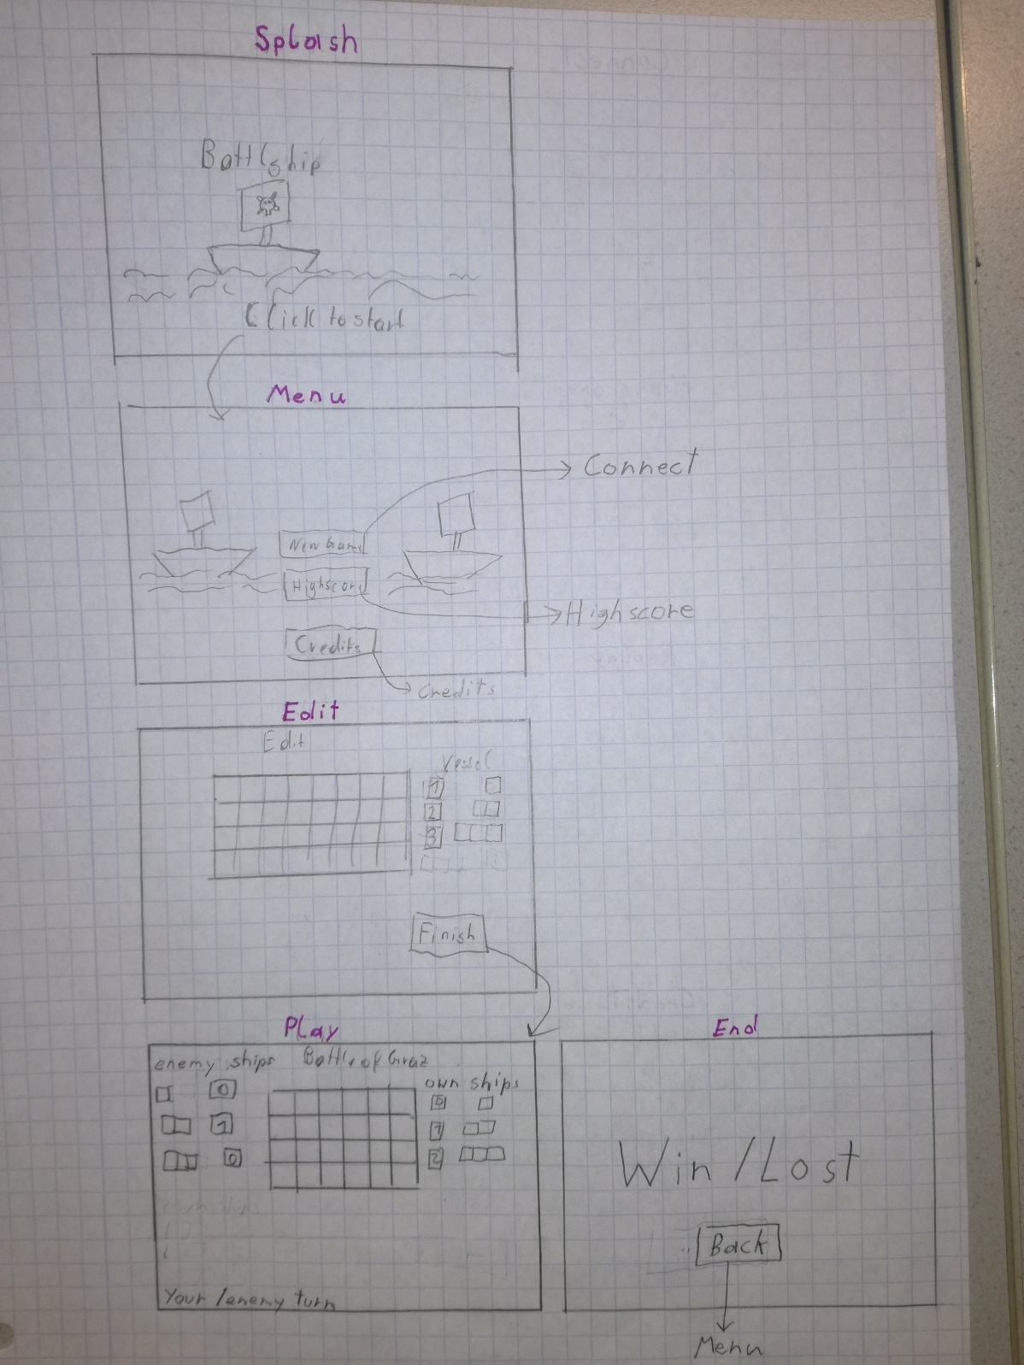

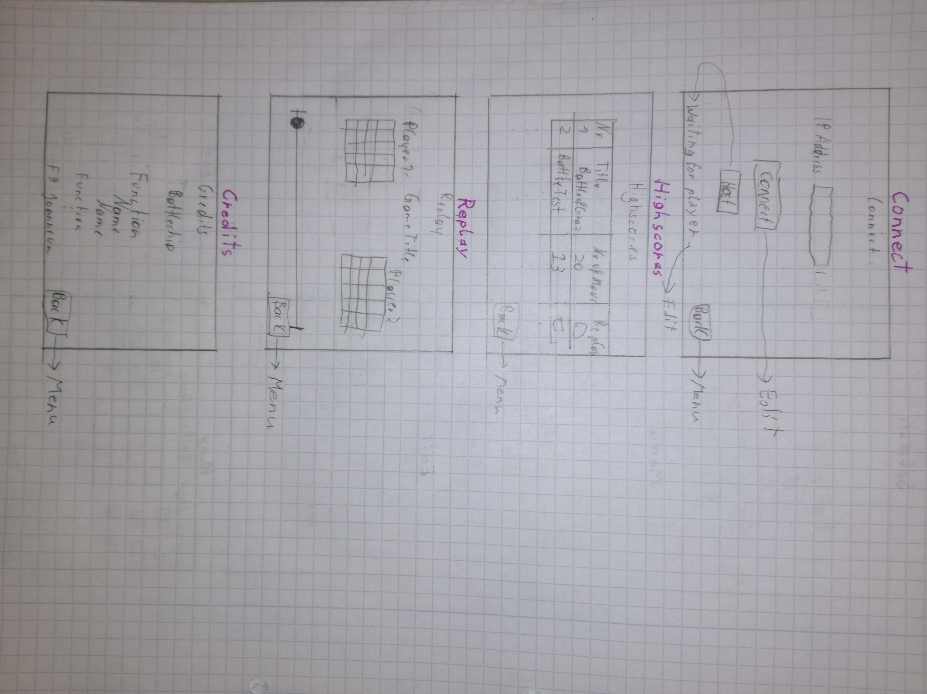

## Splash

Animated background. When you click anywhere or press any button you get to the Menu.

## Menu

Same animated background as Splash. With the New Game button you get to Connect.

The Highscores button brings you to the Highscores.

With the Credits button you get to the Credits.

## Edit

You can choose the type of ship on the right by clicking. Selected ship type gets highlighted by a colour border or glow. Left of the ship types you see how many moor ships you can place

You place a ship by clicking on the battlefield.

After all ships have been placed the Finish button gets active and by clicking it you get to Connect.

## Play

The title of the game (example: Battle of Graz) is displayed at the top. Enemy and own remaining ships are displayed left and right of the enemy’s battlefield. The battlefield changes colour, depending on who’s turn it is and this information is also displayed in the bottom left.

When all the ships of one player are destroyed you get to End.

## End

Displays win or lost depending on if you win or lost. The Back button brings you back to Menu.

If you won the text is green, else it is red.

## Connect

When you click Host, a text in the bottom left appears saying “Waiting for player”, until another player connects. Then you get to Play.

When you enter an IP Address and click on connect you get to Play.

Back button brings you to Menu.

## Highscores

Displays list of top 10 games. Replay button on each game brings you to Replay.

Back button brings you to Menu.

## Replay

Sliding the slider displays the moves on the battlefields. The player that won is green. The other is red. Back button leads to Menu.

## Credits

List of who did what. FH Joanneum Logo at the bottom.