TEzADOGis component. Microsoft SQL server spatial database versión.
© 2002 EzSoft Engineering

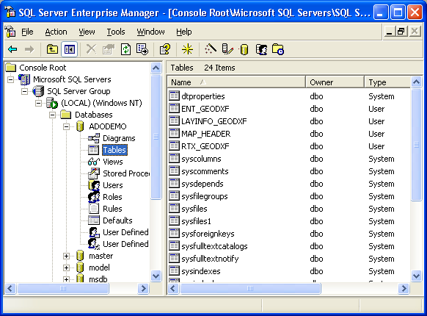

Figure 1.1 a view of the files created with the map in SQL Enterprise Manager.

Introduction

In order to create maps in client/server version, EzSoft Engineering created a version that will work with databases/tables created with Microsoft SQL Server. For optimal results, we recommend you to use Microfost SQL Server 2000, although previous version will work as well. Also, the components will work with Delphi 5, 6 Enterprise version only. This last means, that we used for the implementation, the ADO tab on the components palette in Delphi, classes TADOConnection and TADODataset.

Component Architecture.

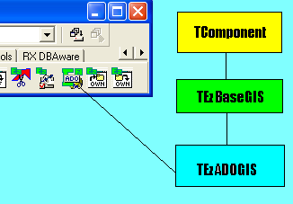

As you can see from the picture above, TEzADOGIS descends from TEzBaseGIS and as a consequence, inherits all its properties, methods and events. This last means that you can use this component as if you were using TEzGIS component.

Basically, the few additions to this component are listed following:

Property ADOConnection: TADOConnection Read FADOConnection;

This is a TADOConnection component created on the TEzADOGIS constructor in order to configure for connections with the SQL Server database.

Also, you must take into account that this class creates its own instance of TezBaseLayers, named TEzADOLayers, and TezBaseLayer, also named TEzADOLayer. This descendants will access to SQL server tables instead of accesing to desktop databases. Anyway, the TEzADOLayers will accept memory layers or desktop layers. This last means that in a SQL server map, you can mix different layers without any problem. Take a look at the demo example when a new layer is created for an explain of how to proceed when you want different layers on the same map.

DATABASE ORGANIZATION

When you create a map, some tables are created on a Microsoft SQL Server database. Suppose you create the map named ADODEMO, then in SQL Server you will have a new database name “ADODEMO”. Inside this database, the following elements are created:

TABLES

MAP_HEADER.- This table contains all the map general information, like: Extension for the map, current layer, last view of the map, units system, coordinate system, area clipped, guidelines, User Defined Functions, etc. This table contains only one record.

The command used to create this table is:

CREATE TABLE [MAP_HEADER] (
[VERSION] [int] NULL ,
[EXTENSION_x1] [float] NULL ,
[EXTENSION_y1] [float] NULL ,
[EXTENSION_x2] [float] NULL ,
[EXTENSION_Y2] [float] NULL ,
[CURRENTLAYER] [varchar] (60) NULL ,
[AERIALVIEWLAYER] [varchar] (60) NULL ,
[LASTVIEW_x1] [float] NULL ,
[LASTVIEW_y1] [float] NULL ,
[LASTVIEW_x2] [float] NULL ,
[LASTVIEW_y2] [float] NULL ,
[COORDSUNITS] [int] NULL ,
[COORDSYSTEM] [int] NULL ,
[ISAREACLIPPED] [bit] NULL ,
[AREACLIPPED_x1] [float] NULL ,
[AREACLIPPED_y1] [float] NULL ,
[AREACLIPPED_x2] [float] NULL ,
[AREACLIPPED_y2] [float] NULL ,
[CLIPAREAKIND] [int] NULL ,
[POLYCLIPAREA] [image] NULL ,
[PROJ_PARAMS] [image] NULL ,
[GUIDELINES] [image] NULL ,
[UDFS] [image] NULL ,
[SYMBOLS] [image] NULL ,
[LAYERS] [image] NULL
)

LAYERS

For every layer, several tables are created on the same database. Example, for layer DEMO, the following tables will be created:

LAYINFO_DEMO.- This table will contain the general information for the layer, like: if the layer is visible, selectable, the user defined functions, the extension of the layer, units, coordinate system, etc. Also, this table will contain general information for indexing spatially to this layer. This table contains only one record.

CREATE TABLE [LAYINFO_DEMO] (
[VERSION] [int] NULL DEFAULT (100),
[LASTUID] [int] NULL DEFAULT (0),
[UDFS] [image] NULL ,
[VISIBLE] [bit] NULL DEFAULT (1),
[SELECTABLE] [bit] NULL DEFAULT (1),
[CANCELEVENTS] [bit] NULL DEFAULT (0),
[TEXT_HAS_SHADOW] [bit] NULL DEFAULT (0),
[EXTENSION_x1] [float] NULL DEFAULT (0),
[EXTENSION_y1] [float] NULL DEFAULT (0),
[EXTENSION_x2] [float] NULL DEFAULT (0),
[EXTENSION_y2] [float] NULL DEFAULT (0),
[COORDSUNITS] [int] NULL DEFAULT (0),
[COORDSYSTEM] [int] NULL DEFAULT (0),
[OVERLAPPED_TEXT_ACTION] [smallint] DEFAULT (0),
[OVERLAPPED_TEXT_COLOR] [int] NULL DEFAULT (0),
[TEXT_FIXED_SIZE] [smallint] NULL DEFAULT (0),
[ROOTNODE] [int] NULL DEFAULT (0),
[DEPTH] [int] NULL DEFAULT (0),
[TREETYPE] [int] NULL DEFAULT (0),
[MULTIPLIER] [int] NULL DEFAULT (1),
[BUCKETSIZE] [int] NULL DEFAULT (50),
[LOWERBOUND] [int] NULL DEFAULT (20)
)

ENT_DEMO.- This table will contain the entity information for the layer. This table will contain as many records as entities exists on that layer. The information contained on this table is : The unique identifier for the entity (UID), a bit field indicating if the entity is deleted (entities are here marked also as deleted, and when you issue a TEzADOLayer.Pack, the entities are permanentely deleted from the table), the min and max extents for the entity, the shape type for the entity, and a blob field (GEOMETRY) containing the coordinate and attributes information.

NOTE: blob fields in SQL Server are named “image” fields.

CREATE TABLE [ENT_DEMO] (
[UID] [int] IDENTITY (1, 1) NOT NULL ,
[DELETED] [bit] NULL DEFAULT (0),
[XMIN] [float] NULL ,
[YMIN] [float] NULL ,
[XMAX] [float] NULL ,
[YMAX] [float] NULL ,
[SHAPETYPE] [smallint] NULL ,
[GEOMETRY] [image] NULL ,
PRIMARY KEY CLUSTERED
(
[UID]
) ON [PRIMARY]
)

Example screen:

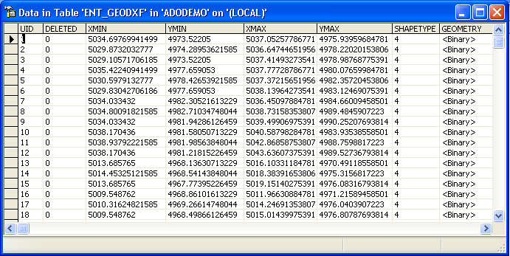

RTX_DEMO.- This table will contain the spatial index for the layer. This file is somewhat complex to explain and is mostly used internally. Basically, this file will contains the nodes for the r-tree indexing and every page contains the following fields: PAGEID is the identifier for the page, PARENT indicate which is the parent for this node, FULLENTRIES, indicates how many entries on this node are occupied, LEAF is a Boolean field indicating if the page is a leaf or not, ENTRIES is a blob field saving information about the entries on this page.

CREATE TABLE [RTX_DEMO] (
[PAGEID] [int] IDENTITY (1, 1) NOT NULL ,
[PARENT] [int] NULL DEFAULT (0),
[FULLENTRIES] [int] NULL DEFAULT (0),
[LEAF] [bit] NULL DEFAULT (0),
[ENTRIES] [char] (3000) NULL ,
PRIMARY KEY CLUSTERED
(
[PAGEID]
)

Also, on the same database some other elements are created:

- On the User Defined Functions section of the database, several functions are created, like the following: imax, imin, rtree_contains, rtree_equals, rtree_overlaps, and for every layer, a search_XXX function is created, where XXX = name of the layer. This last is a very complex functions created for searching for entities that overlaps to a rectangular area on a map, and in a very efficient way.
- On the Stored Procedures section of the database, several stored procedures are created, like the following: addentity_XXX this is used for adding entities efficiently to the database tables, where XXX = name of the layer; rtree_addnode_XXX is used by adentity_XXX procedure for updating the r-tree tables.

The search_xxx function is listed on following listing:

CREATE FUNCTION dbo.search_DEMO(@searchtype int, @dx1 float, @dy1 float, @dx2 float, @dy2 float)
returns @retRecords table (uid int)
as
begin
declare @rootid int
declare @multiplier int
declare @x1 int, @y1 int, @x2 int, @y2 int
declare @rx1 int, @ry1 int, @rx2 int, @ry2 int
declare @pid int, @icount int, @leaf bit, @answer int, @rchild int
declare @entries char(3000)
declare @fullentries int
declare @maxuid int
declare @stacktable varchar(3000)
declare @stackcount int
select @rootid = rootnode, @multiplier = multiplier from layinfo_DEMO
set @x1 = round(@dx1 * @multiplier, 0, 1)
set @y1 = round(@dy1 * @multiplier, 0, 1)
set @x2 = round(@dx2 * @multiplier, 0, 1)
set @y2 = round(@dy2 * @multiplier, 0, 1)
set @pid = @rootid
set @stacktable = ''
set @stackcount = 0
recursive_entry:
SELECT @leaf = leaf, @fullentries = fullentries, @entries = entries FROM rtx_DEMO WHERE pageid = @PID
set @icount = 0
page_loop:
set @rx1 = cast(substring(@entries, @icount * 60 + 1, 12) as int)
set @ry1 = cast(substring(@entries, @icount * 60 + 13, 12) as int)
set @rx2 = cast(substring(@entries, @icount * 60 + 25, 12) as int)
set @ry2 = cast(substring(@entries, @icount * 60 + 37, 12) as int)
set @rchild = cast(substring(@entries, @icount * 60 + 49, 12) as int)
if @leaf = 1
begin
if @searchtype = 1
set @answer = dbo.rtree_overlaps(@x1, @y1, @x2, @y2, @rx1, @ry1, @rx2, @ry2)
else if @searchtype = 0
set @answer = dbo.rtree_contains(@x1, @y1, @x2, @y2, @rx1, @ry1, @rx2, @ry2)
else if @searchtype = 2
set @answer = dbo.rtree_equals(@x1, @y1, @x2, @y2, @rx1, @ry1, @rx2, @ry2)
else
set @answer = 0
if @answer = 1
insert into @retRecords (uid) values (@rchild)
set @icount = @icount + 1
if @icount < @fullentries
goto page_loop
end
else
begin
set @answer = dbo.rtree_overlaps(@x1, @y1, @x2, @y2, @rx1, @ry1, @rx2, @ry2)
if @answer = 1
begin
set @stackcount = @stackcount + 1
set @stacktable = @stacktable + cast(@pid as char(15)) + cast(@icount as char(3))
set @pid = @rchild
goto recursive_entry
end
else
begin
return_entry:
set @icount = @icount + 1
if @icount < @fullentries
goto page_loop
end
end
if @stackcount > 0
begin
set @pid = cast(substring(@stacktable, (@stackcount - 1) * 18 + 1, 15) as int)
set @icount = cast(substring(@stacktable, (@stackcount - 1) * 18 + 16, 3) as int)
set @stackcount = @stackcount - 1
set @stacktable = left(@stacktable, @stackcount * 18)
select @leaf = leaf, @fullentries = fullentries, @entries = entries from rtx_DEMO where pageid = @pid
goto return_entry
end
return
end

Using TEzADOGIS.

The use of this component is very simple. We will explain with an example:

For the examples that follows, we will assume that you are using the main demo that is distributed together with the components. That demo uses a TEzGIS component, but instead of that component, we will replace with a TEzADOGIS component, so please follow the steps below:

- Delete the TEzGIS components from the main form of the main demo application.
- Now, drop a TEzADOGIS component on the form and connect the TezDrawBox component with this TEzADOGIS.
- Go to the object inspector and change the name of the new added component to ADOGis1. This last is for the purposes of the mentioning of this components on the following explain.

Creating a New Map.

For creating a new map database on Microsoft SQL Server, you will create it with a TADOQuery component that comes with Delphi. For that purpose, you need to follow the below steps:

- First, place a TADOQuery component on any form or data module and name it ADOQuery1, then on the speed button, or menu option for creating a new map, type the following code:

var
DatabaseName: string;

Begin
// here ask for the name of the new database to create and path location
if not SaveDialog1.Execute then Exit;
ADOGis1.Close;
DatabaseName:= ‘DEMO’;
SetConnectionDefaults;
// link TADOQuery on this form, to a valid connection.
ADOQuery1.Connection:= ADOGis1.ADOConnection;

{ create the database }
with ADOQuery1 do
begin
Close;
SQL.Clear;
SQL.Add(Format(' CREATE DATABASE %s ',[DatabaseName]));
SQL.Add(' ON ');
SQL.Add('(');
SQL.Add(Format(' NAME = %s, ', [DatabaseName]));
SQL.Add(Format(' FILENAME = ''%s'' ', [SaveDialog1.FileName]));
// other possible parameters
//SQL.Add(', SIZE = 10')
//SQL.Add(', MAXSIZE = 50')
//SQL.Add(', FILEGROWTH = 5')
SQL.Add(')');
ExecSQL;
Close;
end;
ADOGis1.ADOConnection.DefaultDatabase := DatabaseName;
{ Now, create all files on this database }
ADOGis1.CreateNew( DatabaseName );
ADOGis1.FileName:= DatabaseName;
ADOGis1.Open;

End;

SetConnectionDefaults method is defined this way:

procedure TForm1.SetConnectionDefaults;
begin
ADOGis1.ADOConnection.ConnectionString:=
{ you must provide/configure here your connection string }
'Provider=SQLOLEDB.1;Integrated Security=SSPI;Persist Security Info=False;'+
'Data Source=MYCOMPUTERNAME;Use Procedure for Prepare=1;Auto Translate=True;'+
'Packet Size=4096;Workstation ID= MYCOMPUTERNAME;Use Encryption for Data=False;'+
'Tag with column collation when possible=False';
ADOGis1.ADOConnection.CursorLocation:= clUseClient;
ADOGis1.ADOConnection.DefaultDatabase:= 'master';
ADOGis1.ADOConnection.KeepConnection:= true;
ADOGis1.ADOConnection.LoginPrompt:= False;
end;

You must change the connection string in order to fit your needs.

And a new SQL Server Spatial database will be created.

Opening an existing map.

The following code will demonstrate how to open an existing spatial SQL server database:

var
DatabaseName: string;
begin
DatabaseName:= InputBox('Database to open', 'Database :', '');
if Length(DatabaseName)=0 then Exit;
ADOGis1.Close;
SetConnectionDefaults;

ADOGis1.ADOConnection.DefaultDatabase:= DatabaseName;
ADOGis1.FileName:= DatabaseName;
ADOGis1.Open;
End;

On the previous example, you must know the name of the existing database in order to open it, or… is there a way in SQL Server if a database exists ?

All other functionality is similar to the TEzGIS component, so we suggest that you take a look to that component if you are interested in getting more information about its use.

End of document.

