TEzIBGis component. Interbase server spatial database versión.
© 2002 EzSoft Engineering

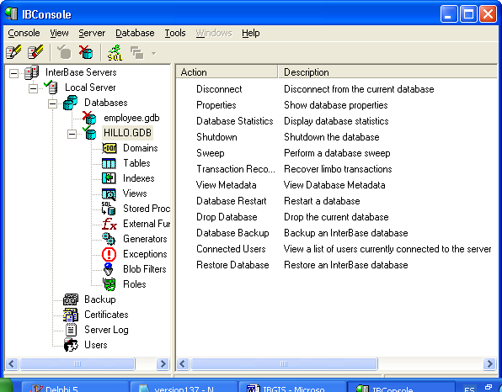

Figure 1.1 a view of the files created with the map in IBConsole.

Introduction

In order to create maps in client/server version, EzSoft Engineering created a version that will work with databases/tables created with Interbase Server. For optimal results, we recommend you to use Interbase 6.x, although previous version will work as well. Also, the components will work with Delphi 5, 6 version only. This last means that the “Interbase” tab in Delphi will be used for the purpose of working with Interbase databases and tables.

Component Architecture.

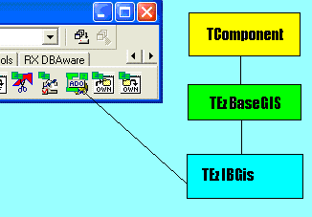

As you can see from the picture above, TEzIBGIS descends from TEzBaseGIS and as a consequence, inherits all its properties, methods and events. This last means that you can use this component as if you were using TEzGIS component.

Also, you must take into account that this class creates its own instance of TezBaseLayers, named TEzIBLayers, and TEzBaseLayer, also named TEzIBLayer. This descendants will access to Interbase server tables instead of accesing to desktop databases. Anyway, the TEzIBLayers will accept memory layers or desktop layers. This last means that in an Interbase server map, you can mix different layers without any problem. Take a look at the demo example when a new layer is created for an explain of how to proceed when you want different layers on the same map.

Basically, the few additions to this component are listed following:

TEzCreateIBSQLEvent = Procedure ( Sender: TObject; var IBSQL: TIBSQL ) Of Object;

Property OnCreateIBSQL : TEzCreateIBSQLEvent read FOnCreateIBSQL write FOnCreateIBSQL;

This event will be fired when TEzIBGis needs a TIBSQL component for internal working. Example, when a layer is opened, TEzIBGIS will need one TIBSQL component in order to connect to the corresponding table(s) for that layer, then this event will be fired.

In this event, it is supposed that in your main form or data module you already have placed a TIBDatabase and TIBTransaction components, ready for communicating to an existing database.

In that event, you must code something like the following:

procedure TForm1.Gis1CreateIBSQL(Sender: TObject; var IBSQL: TIBSQL);
begin
IBSQL:= TIBSQL.Create(Nil);
IBSQL.Database:= IBDatabase1;
IBSQL.Transaction:= IBTransaction1;
end;

As you can see, a dynamically created TIBSQL component is used.

DATABASE ORGANIZATION

When you create a map, some tables are created on a, Interbase database. Suppose you create the map named IBDEMO, then in Interbase you will have a new database name “IBDEMO”. Inside this database, the following elements are created:

TABLES

MAP_HEADER.- This table contains all the map general information, like: Extension for the map, current layer, last view of the map, units system, coordinate system, area clipped, guidelines, User Defined Functions, etc. This table contains only one record.

The command used to create this table is:

/* Table: MAP_HEADER, Owner: SYSDBA */

CREATE TABLE "MAP_HEADER"
(
"VERSION" INTEGER DEFAULT 141,
"EXTENSION_X1" DOUBLE PRECISION DEFAULT 1.0E100,
"EXTENSION_Y1" DOUBLE PRECISION DEFAULT 1.0E100,
"EXTENSION_X2" DOUBLE PRECISION DEFAULT -1.0E100,
"EXTENSION_Y2" DOUBLE PRECISION DEFAULT -1.0E100,
"CURRENTLAYER" VARCHAR(60) DEFAULT '',
"AERIALVIEWLAYER" VARCHAR(60) DEFAULT '',
"LASTVIEW_X1" DOUBLE PRECISION DEFAULT 0,
"LASTVIEW_Y1" DOUBLE PRECISION DEFAULT 0,
"LASTVIEW_X2" DOUBLE PRECISION DEFAULT 100,
"LASTVIEW_Y2" DOUBLE PRECISION DEFAULT 100,
"COORDSUNITS" INTEGER DEFAULT 0,
"COORDSYSTEM" INTEGER DEFAULT 0,
"ISAREACLIPPED" "DMNBOOLEAN" DEFAULT 'N',
"AREACLIPPED_X1" DOUBLE PRECISION DEFAULT 0,
"AREACLIPPED_Y1" DOUBLE PRECISION DEFAULT 0,
"AREACLIPPED_X2" DOUBLE PRECISION DEFAULT 0,
"AREACLIPPED_Y2" DOUBLE PRECISION DEFAULT 0,
"CLIPAREAKIND" INTEGER DEFAULT 0,
"POLYCLIPAREA" BLOB SUB_TYPE 0 SEGMENT SIZE 1024,
"PROJ_PARAMS" BLOB SUB_TYPE 0 SEGMENT SIZE 120,
"GUIDELINES" BLOB SUB_TYPE 0 SEGMENT SIZE 1024,
"UDFS" BLOB SUB_TYPE 0 SEGMENT SIZE 1024,
"SYMBOLS" BLOB SUB_TYPE 0 SEGMENT SIZE 1024,
"LAYERS" BLOB SUB_TYPE TEXT SEGMENT SIZE 120
);

LAYERS

For every layer, several tables are created on the same database. Example, for layer DEMO, the following tables will be created:

LAYINFO_DEMO.- This table will contain the general information for the layer, like: if the layer is visible, selectable, the user defined functions, the extension of the layer, units, coordinate system, etc. Also, this table will contain general information for indexing spatially to this layer. This table contains only one record.

/* Domain definitions */
CREATE DOMAIN "DMNBOOLEAN" AS CHAR(1)
CHECK ( VALUE IN ('Y', 'N') ) NOT NULL;

/* Table: LAYINFO_HILLO, Owner: SYSDBA */

CREATE TABLE "LAYINFO_DEMO"
(
"VERSION" INTEGER DEFAULT 141,
"LASTUID" INTEGER DEFAULT 0,
"UDFS" BLOB SUB_TYPE 0 SEGMENT SIZE 1024,
"VISIBLE" "DMNBOOLEAN" DEFAULT 'Y',
"SELECTABLE" "DMNBOOLEAN" DEFAULT 'Y',
"CANCELEVENTS" "DMNBOOLEAN" DEFAULT 'N',
"TEXT_HAS_SHADOW" "DMNBOOLEAN" DEFAULT 'N',
"EXTENSION_X1" DOUBLE PRECISION DEFAULT 1.0E100,
"EXTENSION_Y1" DOUBLE PRECISION DEFAULT 1.0E100,
"EXTENSION_X2" DOUBLE PRECISION DEFAULT -1.0E100,
"EXTENSION_Y2" DOUBLE PRECISION DEFAULT -1.0E100,
"COORDSUNITS" INTEGER DEFAULT 0,
"COORDSYSTEM" INTEGER DEFAULT 0,
"OVERLAPPED_TEXT_ACTION" SMALLINT DEFAULT 0,
"OVERLAPPED_TEXT_COLOR" INTEGER DEFAULT 0,
"TEXT_FIXED_SIZE" SMALLINT DEFAULT 0,
"ROOTNODE" INTEGER DEFAULT 0,
"DEPTH" INTEGER DEFAULT 0,
"TREETYPE" INTEGER DEFAULT 0,
"MULTIPLIER" INTEGER DEFAULT 1,
"BUCKETSIZE" INTEGER DEFAULT 50,
"LOWERBOUND" INTEGER DEFAULT 20
);

ENT_DEMO.- This table will contain the entity information for the layer. This table will contain as many records as entities exists on that layer. The information contained on this table is : The unique identifier for the entity (UID), a boolean field indicating if the entity is deleted (entities are here marked also as deleted, and when you issue a TEzIBLayer.Pack, the entities are permanentely deleted from the table), the min and max extents for the entity, the shape type for the entity, and a blob field (GEOMETRY) containing the coordinate and attributes information.

NOTE: blob fields in SQL Server are named “image” fields.

/* Table: ENT_HILLO, Owner: SYSDBA */

CREATE TABLE "ENT_HILLO"
(
"UID" INTEGER NOT NULL,
"DELETED" "DMNBOOLEAN" DEFAULT 'N',
"XMIN" DOUBLE PRECISION DEFAULT 0,
"YMIN" DOUBLE PRECISION DEFAULT 0,
"XMAX" DOUBLE PRECISION DEFAULT 0,
"YMAX" DOUBLE PRECISION DEFAULT 0,
"SHAPETYPE" SMALLINT DEFAULT 0,
"GEOMETRY" BLOB SUB_TYPE 0 SEGMENT SIZE 80,
PRIMARY KEY ("UID")
);

Example screen:

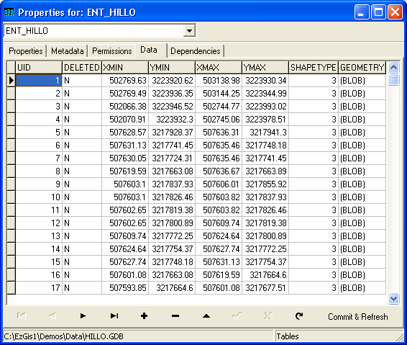

RTX_DEMO.- This table will contain the spatial index for the layer. This file is somewhat complex to explain and is mostly used internally. Basically, this file will contains the nodes for the r-tree indexing and every page contains the following fields: PAGEID is the identifier for the page, PARENT indicate which is the parent for this node, FULLENTRIES, indicates how many entries on this node are occupied, LEAF is a Boolean field indicating if the page is a leaf or not, ENTRIES is a blob field saving information about the entries on this page.

/* Table: RTX_HILLO, Owner: SYSDBA */

CREATE TABLE "RTX_HILLO"
(
"PAGEID" INTEGER NOT NULL,
"PARENT" INTEGER DEFAULT 0,
"FULLENTRIES" INTEGER DEFAULT 0,
"LEAF" "DMNBOOLEAN" DEFAULT 'Y',
"ENTRIES" CHAR(3000),
PRIMARY KEY ("PAGEID")
);

Also, on the same database some other elements are created:

- On the External Functions section of the database, several functions are created, like the following: ezsearch_init, ezsearch_finish, ezsearch_first, ezsearch_next. IMPORTANT: This external functions resides on library ib_ezudfs.dll. This dll must be placed where Interbase can found it. In last version of Interbase, this library must be placed on the UDF subdirectory. If the previous is not done, then you cannot work with TEzIBGIS. This is a library that we provide and that was installed on the same directory where the components were installed.
- On the Stored Procedures section of the database, several stored procedures are created, like the following: addentity_XXX this is used for adding entities efficiently to the database tables, where XXX = name of the layer; addnode_XXX is used by adentity_XXX procedure for updating the r-tree tables.
- Finally and very IMPORTANT. A Search_xxx procedure is used for searching on the database. This stored procedure used the previously explained ezsearch_??? External functions.

The search_xxx function is listed on following listing:

CREATE PROCEDURE "SEARCH_HILLO"
(
"X1" INTEGER,
"Y1" INTEGER,
"X2" INTEGER,
"Y2" INTEGER
)
RETURNS
(
"UID" INTEGER
)
AS
BEGIN EXIT; END ^

ALTER PROCEDURE "SEARCH_HILLO"
(
"X1" INTEGER,
"Y1" INTEGER,
"X2" INTEGER,
"Y2" INTEGER
)
RETURNS
(
"UID" INTEGER
)
AS
declare variable v_leaf char(1) ;
declare variable v_entries char(3000) ;
declare variable v_fullentries int ;
declare variable v_pid int ;
declare variable runid int;
declare variable zone int ;
declare variable temp varchar(1) ;
begin
select rootnode from layinfo_HILLO into :v_pid ;

runid = ezsearch_init ( x1, y1, x2, y2 );

zone = 0; /* zone to reentry */
while (v_pid <> 0) do
begin

SELECT leaf, fullentries, entries FROM rtx_HILLO WHERE pageid = :v_pid
into :v_leaf, :v_fullentries, :v_entries ;

temp = v_leaf;
v_pid = ezsearch_find( runid, zone, v_pid, temp, v_entries, v_fullentries );

if (v_pid <> 0) then
begin
if (v_pid < 0) then
begin
v_pid = -v_pid;
zone = 1;
end else
begin
zone = 0;
end
end
end

/* retrieve the results */
uid = ezsearch_first ( runid );
while (uid <> 0) do
begin
suspend;
uid = ezsearch_next( runid );
end

runid = ezsearch_finish ( runid );

end

The external DLL library ib_ezudfs.dll is used in this stored procedure.

Using TEzIBGIS.

The use of this component is very simple. We will explain with an example:

For the examples that follows, we will assume that you are using the main demo that is distributed together with the components. That demo uses a TEzGIS component, but instead of that component, we will replace with a TEzIBGIS component, so please follow the steps below:

- Delete the TEzGIS components from the main form of the main demo application.
- Now, drop a TEzIBGIS component on the form and connect the TEzDrawBox component with this TEzIBGIS.
- Go to the object inspector and change the name of the new added component to IBGis1. This last is for the purposes of the mentioning of this components on the following explain.

Creating a New Map.

For creating a new map database on Interbase Server, you will create it with a TIBDatabase and a TIBTransaction component that comes with Delphi. For that purpose, you need to follow the below steps:

- First, place a TIBDatabase component on any form or data module and name it IBDatabase1,
- Now place a TIBTransaction component and set DefaultDatabase property to IBDatabase.
- Set IBDatabase1.DefaultTransaction property to IBTransaction1.
- Now drop a TspeedButton on the toolbar on the speed button, or menu option for creating a new map, type the following code:

procedure TForm1.New1Click(Sender: TObject);
begin
if not SaveDialog4.Execute then Exit;
Gis1.Close;

{ example of how to create the database. }
with IBDatabase1 do
begin
Connected:= false;
DatabaseName:= SaveDialog4.FileName;
Params.Clear;
Params.Add( ' USER "SYSDBA" ' );
Params.Add( ' PASSWORD "masterkey" ' );
//Params.Add( ' PAGE SIZE 4096' );
SQLDialect := 3;
CreateDatabase;
end;

{ connect to this database }
IBDatabase1.Connected:= true;

{ Now, create all files on this database }
Gis1.CreateNew( SaveDialog4.FileName );
Gis1.FileName:= SaveDialog4.FileName;
Gis1.Open;

Caption:= 'TEzIBGis Demo - ' + SaveDialog4.FileName;
end;

Opening an existing map.

The following code will demonstrate how to open an existing spatial Interbase server database:

procedure TForm1.Open1Click(Sender: TObject);
var
DatabaseName: string;
begin
Gis1.Close;
if not OpenDialog4.Execute then exit;
DatabaseName:= OpenDialog4.FileName;

IBDatabase1.Connected:= False;
IBDatabase1.DatabaseName:= DatabaseName;
IBDatabase1.Connected:= true;
IBTransaction1.Active:= true;

Gis1.FileName:= DatabaseName;
Gis1.Open;
end;

All other functionality is similar to the TEzGIS component, so we suggest that you take a look to that component if you are interested in getting more information about its use.

End of document.

