TEzIWMap component.
© 2002 EzSoft Engineering

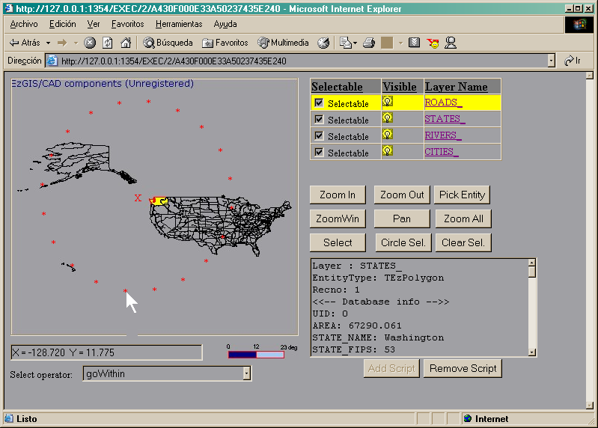

TEzIWMap component.

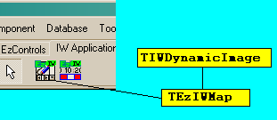

As you can see from the image above, TEzIWMap descends directly from TIWDynamicImage, and as a consequence, inherited all its properties, methods and events.

The methods added to TEzIWMap are listed following:

- Procedure AddScript(Form : TIWAppForm);
This procedure is used in order to add to the property “Form.JavaScript”, an script made by us, EzSoft Engineering. The use of this method is described more detailed on the sectioin “How to use the Script”. If you add twice the script to the form, it will raises an exception, due to that internally, instances of TIWLabel components are generated, and those can be removed with the method that is described following, and after the script has been removed, then you can call to this new method, in order to load again the mentioned script.

- Procedure RemoveScriptFrom(Form : TIWAppForm);
This procedure is used in order to remove the Script described in the previous section.

Properties added to this component includes the following:

- DrawBox: This property is used in order to link th TEzIWMap component, with a TezDrawBox. The TEzIWMap component will show automatically, an image of what is contained on the TezDrawBox control ScreenBitmap buffer property.

TEzIWMap will preserve its place on the form or browser, that was assigned at design time, and its dimensions will grow or shrink to accommodate in order to meet those of TEzDrawBox.
TEzIWMap use the same dimensions of TezDrawBox. This last is in order to display the full contents of the TezDrawBox onf the TEzIWMap component. Neverthless, the scrollbars are not included in the mentioned dimensions, and this can causes that the image seems some strange and can be seen as like some section of the bitmap is missing. This problem is solved if you set ScrollBars to “ssNone” in TezDrawBox.

Note: When you place a TezDrawBox on an IntraWeb form (Intraweb uses its own forms), the following warning message will be displayed and you can completely ignore.

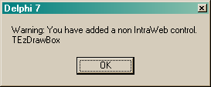
IWScaleBar: This property is used in order to link the TEzIWMap component with a TEzIWScaleBar component, and is used in order that when you add the Script to the form, an script is also added in order to that the browser can manipulate the scale bar (that is to say: move with the mouse, etc.). If this property is not assigned, then TEzIWScaleBar will stay static on the browser in the position assigned at design time.

- CoordFunction: When the script is added to the intraweb form, this will includes one function used to calculate the world coordinates at the current mouse position when the mouse is moved over an TEzIWMap component. All these operations are done at the script level, that is to say, at the end-user machine (example, in IE browser). In order to use this functionality, you must write a javascript function with the following format:

function MyMouseMove(x, y){
…
}

Later, you must assign the name of this function (in this case “MyMouseMove”) to the property CoordFunction of TEzIWMap component. Once the previous was done, and when you move the mouse on the browser and over the TEzIWMap, automatically this function is triggered.
An application example could be:

function MouseMove2D( x, y){
var tmp = "" + x;
tmp = tmp.substring(0, tmp.indexOf('.', 1) + 4);

var tmp2 = "" + y;
tmp2 = tmp2.substring(0, tmp2.indexOf('.', 1) + 4);

SubmitForm.IWEDIT1.value = "X = " + tmp + " Y = " + tmp2;
}

The previous code must be added to the form where you placed a TEzIWMap component, and to the JavaScript property (Intraweb forms contains this property), in order to that when you call to the TEzIWMap.AddScript method, that code must be already implemented and also the property CoordFunction must be assigned, and in the example given, the value must be “MouseMove2D”.

In order to that the previous example could work, you need to place on the form a TIWEdit and name it IWEdit1. When IntraWeb generates the Web page, it uses only upper case letters in order to name the objects, so the name of the IWEdit on the script must be IWEDIT1 (JavaScript is case sensitivity). SubmitForm is the form where the objects on the page are found. This las is added automatically by IntraWeb engine.

Later on, and due to that variables (x,y) contains values with floating decimal point, we convert it to string and later trimmed in order to show only 3 decimal places.
An example about how to use the features described is the following:

procedure TformMain.IWAppFormCreate(Sender: TObject);
begin
{ Here is important to take into account that JavaScript is case sensitivity, that is to say, that the name given to the script function, must be exactly the same you use in this script }
JavaScript.Add(‘function MouseMove2D( x, y){‘);
JavaScript.Add(‘ var tmp = "" + x; ’);
JavaScript.Add(‘tmp = tmp.substring(0, tmp.indexOf('’.’', 1) + 4); ’);
JavaScript.Add(‘var tmp2 = "" + y; ’);
JavaScript.Add(‘tmp2 = tmp2.substring(0, tmp2.indexOf(‘'.’', 1) + 4); ’);
JavaScript.Add(‘ SubmitForm.IWEDIT1.value = "X = " + tmp + " Y = " + tmp2; ’);
JavaScript.Add(‘}’);
IWMap1.CoordFunction := ‘MouseMove2D’;
IWMap1.AddScript(Self);
end;

- NumberOfLabelsInCS: This property is used in order to calculate the number of asterisks labels (“*”) used when a circular selection is done. The greater, better resolution of the circle area.

- GraphicOperator: This property will be used in order to define the type of selection when one of the selection tools are used. Posible values for this is listed following (you can take a deeper explanation at the help files of our components:

goWithin
goEntirelyWithin
goContains
goContainsEntire
goIntersects
goEntirelyWithinNoEdgeTouched
goContainsEntireNoEdgeTouched
goExtentOverlaps
goShareCommonPoint
goShareCommonLine
goLineCross
goCommonPointOrLineCross
goEdgeTouch
goEdgeTouchOrIntersect
goPointInPolygon
goCentroidInPolygon
goIdentical

TEzIWScaleBar component.

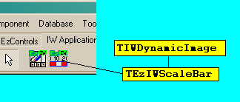

As you can see from the above image, TEzIWScaleBar descends directly from TIWDynamicImage, and as a consequence, it inherites all its properties, methods and events.
To use the TEzIWScaleBar is very easy, due to that only one new property is used “IWMap”, and this property is used in order to link to the TEzIWMap component. This last is needed in order to display the current scale of the displayed map and both are synchronized, when the zoom scale changes.
In order to the TEzIWScaleBar works correctly, the following rules must be applied:

- Must be linked to the TEzIWMap component.
- The TEzIWMap must be linked to one TEzDrawBox.
- The TEzDrawBox Must be linked to a TEzScaleBar (please don’t confuse this with the more specialized TEzIWScaleBar).

Note: TEzIWMap has one property named IWScaleBar, which does not have a direct relationship with the previously mentioned, due to that this property is used in order to determine if at the moment of to add a script to the intraweb form, the functions that permit that the TEzIWScaleBar could be dragged with the mouse when it is browsed on the internet navigator, must be included.

How to use the Script.

The Script included in the components will take care of handling the events of the mouse on the internet navigator.
When you add the script to the form, the Onclick and the OnMouseDown events of TEzIWMap are disabled, due to that the script is taking care of working with that events and to send the form back to the server only when it is needed, and this last will help to not to communicate frequently with the server.
When the script determines that it needs to resend the form to the server, TEzIWMap internally will take care of how to interpret the instructions that the script is needing, and to request to the server, in order to redisplay the page again on the client.
All the method names that the script adds, start with the TEzIWMap (the component name), that is to say, the name as is known in the object inspector (example IWMap1).

Note: Always takes into account that JavaScript differentiates between upper and lower caser.

If you have placed on the form a EzIWMap1 component, then the functions and the variables used on the script will begin with as in the following:

var EzIWMap1VariableName = InitialValue;

function EzIWMap1FunctionName(Parameters){
}

The main function, or the function that the script is controlled is the function “SetAction(Action)” (The example included will clarify this more precisely). The purpose is to define the action on the map. The possible actions are listed following:

- “caNone” : Ignored completely any mouse click.
- “caZoomIn”: Zoom in to the map in about 15% scale when it is clicked
- “caZoomOut”: The opposite of the previous.
- “caZoomExtension”: Show the map at its full extents
- “caZoomWin”: Will allow you to interactively to define the zoom region by clicking a rectangular area on the map
- “caPan”: Will allow you to interactively pan the map current display area to any direction.
- “caSelect”: Can be used in order to select entities on a rectangular marked. This will use the “Selectable” properties for every layer, and also will use the GraphicOperator property of TEzIWMap.
- “caCircleSelect”: Will allow you to define a circle area or region. The entities inside that region will be selected. The selection takes into account the same criteria described in the previous option.

Note: again, care must be taken with the use of upper/lower case on the name of objects on the script because if you use “caselect” will not be the same as the correct word, that is “caSelect”. “caselect” will be ignored by the script.

Now on, if you have a TEzIWMap component named “Map”, what you must accomplish in order to assign the “caSelect” action is the following:

First, you must use a component that supports JavaScript, like a button:

btnSelect.ScriptEvents.Values[‘OnClick’] := ‘MapSetAction(“caSelect”)’;
btnCircleSelect.ScriptEvents.Values[‘OnClick’] := ‘MapSetAction(“caCircleSelect”)’;
btnZoomIn.ScriptEvents.Values[‘OnClick’] := ‘MapSetAction(“caZoomIn”)’;
btnZoomOut.ScriptEvents.Values[‘OnClick’] := ‘MapSetAction(“caZoomOut”)’;
btnZoomWin.ScriptEvents.Values[‘OnClick’] := ‘MapSetAction(“caZoomWin”)’;
btnZoomAll.ScriptEvents.Values[‘OnClick’] := ‘MapSetAction(“caZoomExtension”)’;
btnPane.ScriptEvents.Values[‘OnClick’] := Map.Name + ‘SetAction(“caPane”)’;

For a better understanding of the above, you must take a look at the IntraWeb demo.

