IT Risk Monitoring and Resilience Platform
Standalone architecture and technical design for a Luxembourg-regulated financial firm
Cross-domain event correlation, AI-assisted incident analysis, human-controlled workflow, and draft regulatory reporting support

Document purpose: describe the target operating model, design principles, technology stack, control boundaries, data structures, AI orchestration pattern, and implementation scope for a resilience platform that combines deterministic controls with bounded AI assistance.

1. Executive overview
The platform is intended to operate as a cross-domain IT risk monitoring and resilience control tower. It ingests telemetry, security events, access anomalies, vendor-health indicators, operational failures, and structured risk context; correlates them into candidate incidents; enriches them with bounded AI-generated analysis; and routes them into a human-controlled incident and reporting lane.
The goal is not to build a chatbot for operations. The goal is to build a governed system that can detect earlier, package evidence better, accelerate triage and investigation, support remediation tracking, and prepare draft reporting material without weakening control, accountability, or traceability.
The key design rule is simple: AI may assist with summarization, root-cause hypothesis generation, impact wording, and draft reporting text, but it must not replace deterministic thresholds, authoritative workflow transitions, or accountable human decisions. Formal classification, approvals, and submission authority remain in the control plane.
The architecture is event-driven even if first-release volumes are expected to be low. Low volume changes sizing decisions, not the control model. Replayability, evidence preservation, and durable workflow state are still required from day one because they are part of the supervisory and operational value of the platform, not merely a scale optimization.

2. Objectives and success criteria
- Create one operational view of candidate incidents across infrastructure, cyber, identity, vendor dependency, and service-operation domains.
- Detect candidate incidents from combinations of weak signals rather than relying only on single-tool alerts.
- Preserve deterministic control over thresholds, workflow transitions, timers, approvals, and reporting gates.
- Allow AI to produce bounded analytical outputs that improve speed and quality without becoming the system of record.
- Remain neutral with respect to downstream systems of action so ServiceNow, Jira Service Desk, or a comparable enterprise workflow tool can be integrated without changing the core design.
- Support internal incident handling from day one and also support draft regulator-ready reporting packages, even if some reporting fields or submission mechanics are added later.
The success criterion is not only earlier detection. The platform should consistently generate four governed outputs:
- decision-ready incident packs
- analysis-ready root-cause hypotheses
- execution-ready remediation tracking
- regulator-ready reporting support

3. Business operating model
The platform should continuously answer five questions: what is happening, which weak signals belong together, do they form a candidate incident, does the event plausibly enter the regulatory reporting lane, and what must happen next.
The intended operating sequence is: ingest signals, validate and normalize them, correlate them into candidate incidents, enrich the candidate with context and AI assistance, route the case to human review, decide classification and escalation, track remediation, and preserve the full evidence trail.
The platform therefore sits between fragmented monitoring sources and the accountable operational and risk functions. It does not replace those functions. It packages information for them in a faster and more structured way.

4. Design principles

4.1 AI assists, rules decide, humans validate
The design separates detection and correlation, AI enrichment, and authoritative classification/reporting.
Models may summarize evidence, propose likely causes, draft review memos, and draft report narratives.
Models must not autonomously classify a reportable incident, submit notifications, suppress incidents without review, alter thresholds, or advance workflow state without an explicit deterministic service action and human approval.

4.2 Evidence first
Every meaningful transformation should leave a trace: raw source-event reference, canonical normalized event, correlation output, candidate incident creation record, retrieval references, prompt template version, model route, AI output, human decision, report versions, and remediation closure evidence.

4.3 Deterministic control lane
Authoritative incident state, approvals, deadlines, timers, remediation status, and report package state remain in a private deterministic control lane.
Hybrid or managed inference may be used, but only as a bounded intelligence extension. It does not become the control plane.

4.4 Event-native architecture
The core should be designed around canonical events and replayable flows rather than point-to-point scripts. Even at low volume this improves explainability, testability, and resilience.

4.5 ITSM neutrality
The platform should expose its own incident and action model and synchronize with enterprise workflow tools through adapters. ServiceNow and Jira should be implementation choices at the edge, not architecture-defining dependencies.

4.6 Progressive complexity
Graph technology, advanced risk scoring, and automated remediation should remain optional. The first release should solve signal fusion, evidence packaging, workflow control, and human review before adding elegant but non-essential layers.

5. Functional architecture
The cleanest practical structure is a five-plane architecture with one clear rule: intelligence can enrich, but only the control plane can change authoritative incident state.
Plane | Primary role | Typical components
Integration | Collect and validate source signals | adapters, schema validation, vendor polling, webhook receivers, API connectors, n8n for selected connector-heavy flows
Detection and correlation | Transform multi-source signals into candidate incidents | Kafka, normalization workers, enrichment workers, Flink rules, confidence scoring, de-duplication
Intelligence | Assemble bounded AI context and generate advisory outputs | retrieval service, prompt builder, policy guardrails, vLLM and/or managed model gateway
Control | Own authoritative state, approvals, timers, and report package state | Incident State Service, PostgreSQL, Temporal workflows, reporting service, remediation service
Evidence and presentation | Preserve traceability and expose review surfaces | immutable object storage, Elasticsearch, audit journal, commander UI, review views, exports

Image 1. Functional Architecture.
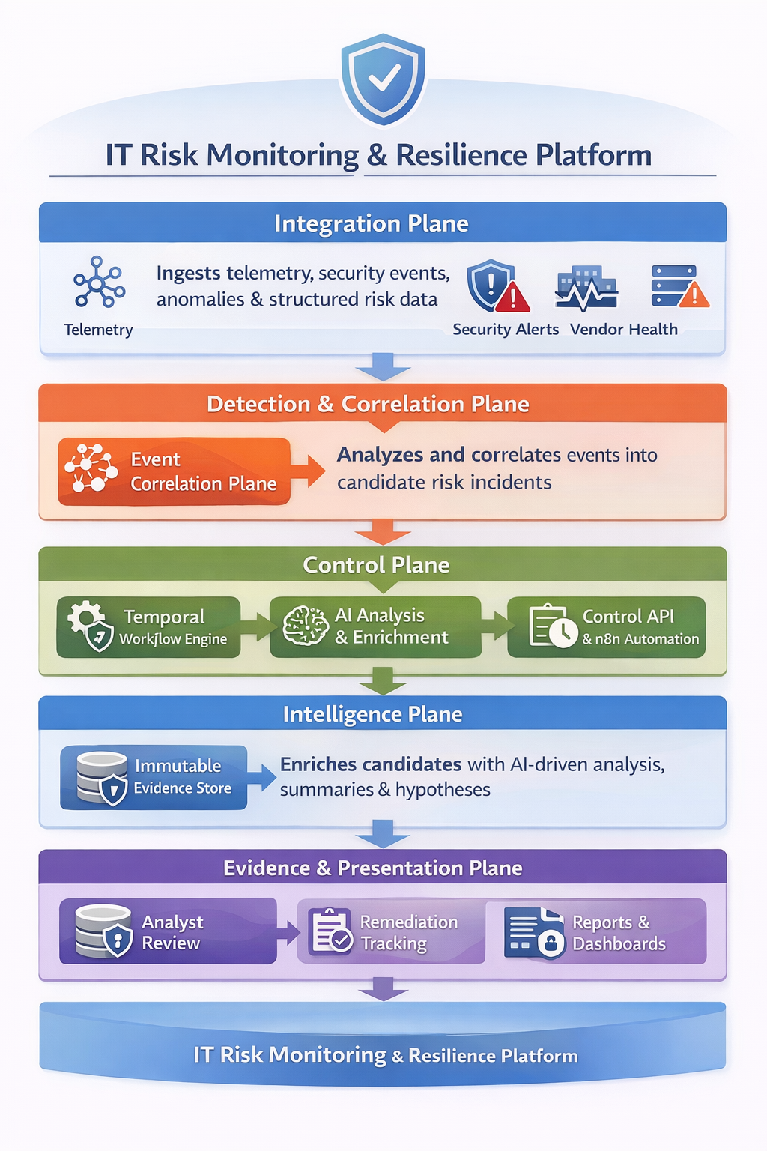

6. Recommended technology stack

Capability | Recommended implementation | Role in the design
Telemetry and observability | Grafana + OpenTelemetry | metrics, logs, traces, observability feed
Security events | QRadar or equivalent SIEM | structured cyber and security signals
Identity and privileged access | IAM/PAM/directory logs | access anomalies and privileged activity
Vendor and third-party health | status APIs, synthetic checks, optional n8n flows | dependency degradation signals
Structured risk context | ServiceNow IRM or equivalent | risk context, criticality, obligations
Event backbone | Apache Kafka | durable event streaming and replay
Stream correlation | Apache Flink | stateful rule execution, windows, joins, de-duplication
Authoritative state | PostgreSQL | incident, remediation, report, and audit references
Workflow and timers | Temporal | durable lifecycle control, deadlines, escalations, approvals
Search and retrieval | Elasticsearch | evidence lookup, incident search, metadata search, optional vector retrieval
Private model serving | vLLM | in-cluster inference for sensitive workloads
Managed model route | private-connected managed LLM gateway | approved hybrid inference workloads
Secrets and identity | Vault + Kubernetes secrets pattern | credential control and service authentication
Service networking | Istio or equivalent service mesh | mTLS, service identity, traffic policy
Deployment control | Argo CD | GitOps release control
Connector automation | n8n | selected non-authoritative integration and analyst automation flows
Evidence artifacts | MinIO or S3-compatible private object storage | immutable bundles, prompt-response archives, report artifacts

7. End-to-end processing flow
The canonical processing sequence should be explicit and deterministic.
Step 1: source adapters receive or poll signals from telemetry, security, identity, vendor-health, and operational systems.
Step 2: every source record is schema-validated, normalized into a canonical event structure, and published onto the event backbone.
Step 3: correlation logic groups weak signals across time, domain, asset, service, owner, or vendor context and emits candidate incidents rather than final incidents.
Step 4: the control plane creates an authoritative candidate incident record and starts the review workflow.
Step 5: the intelligence plane retrieves approved context, assembles a bounded prompt package, invokes the appropriate inference route, validates the response schema, and stores the resulting enrichment pack.
Step 6: reviewers receive a decision-ready incident pack, validate the case, decide severity and escalation path, and open remediation or reporting actions where required.
Step 7: report drafts, approvals, escalations, final closure notes, and lessons learned are stored as governed artifacts linked to the authoritative incident record.

8. Canonical data model
Two objects matter most in the first release: the canonical event and the authoritative incident.

8.1 Canonical event
Every source signal should be normalized into a common structure. The minimum useful fields are: event_id, source_system, source_type, event_type, timestamp, severity, affected_asset, linked_service, vendor_reference, evidence_pointer, enrichment_tags, and ingesting_adapter.
The point of canonicalization is not elegance. It is to remove adapter-specific logic from downstream correlation, retrieval, and evidence handling.

Illustrative canonical event structure
{
"event_id": "uuid",
"source_system": "qradar",
"source_type": "security_event",
"event_type": "failed_privileged_access",
"timestamp": "2026-04-15T09:18:00Z",
"severity": "medium",
"affected_asset": "srv-ops-17",
"linked_service": "portfolio-api",
"vendor_reference": null,
"evidence_pointer": "evidence://raw/qradar/2026/04/15/abc123",
"enrichment_tags": ["privileged", "critical_service"],
"ingesting_adapter": "siem-adapter-v1"
}

8.2 Authoritative incident object
The incident object is the first meaningful control object and should live in PostgreSQL, with selected metadata mirrored to Elasticsearch for search and retrieval.
The incident should remain compact enough to be governable. Large narrative artifacts, prompt-response bundles, report files, and evidence collections should be stored as linked governed objects rather than embedded indiscriminately into one oversized JSON record.
{
"incident_id": "uuid",
"status": "candidate",
"created_at": "timestamp",
"updated_at": "timestamp",
"source_event_refs": ["event_ref_1", "event_ref_2"],
"correlation": {
"rule_hits": ["VENDOR_DEGRADATION", "PRIVILEGED_ACCESS_ANOMALY"],
"confidence_score": 0.73
},
"business_context": {
"service_name": "portfolio-api",
"critical_service": true,
"owner": "application_support_team",
"vendor_name": "market-data-gateway",
"risk_context_refs": ["irm_ref_1"]
},
"classification_support": {
"threshold_flags": {
"critical_service_impact": true,
"unauthorized_access_indicator": true
},
"draft_severity": "high"
},
"workflow": {
"assigned_to": "incident_commander",
"review_due_at": "timestamp",
"initial_report_due_at": "timestamp"
},
"artifacts": {
"incident_pack_ref": "pack_ref",
"enrichment_ref": "enrich_ref",
"reporting_pack_ref": "report_ref",
"remediation_ref": "rem_ref"
},
"decision": {
"decision_maker": null,
"final_classification": null,
"decision_notes": null
}
}

9. Correlation and candidate-incident logic
The correlation layer should emit candidate incidents, not authoritative incidents. That distinction matters because the correlation layer expresses pattern confidence, while the control plane expresses official status.
The first release does not need a huge rule universe. A disciplined day-one pack is enough: privileged-access anomaly on a critical service; vendor degradation affecting an internal service; Kubernetes or platform instability affecting a critical workload; cyber signal plus operational degradation; risk amplification from structured risk context; and repeated weak-signal burst.
The correlation engine should combine thresholds, time-window joins, de-duplication, suppression of repetitive noise, service or vendor context, and confidence scoring. The output should explain why the candidate was created: rule hits, key triggering events, and confidence basis.

10. Intelligence orchestration
The intelligence layer should follow a deterministic sequence rather than free-form prompting.
First, read the candidate incident and identify the workload type. Second, retrieve similar incidents, runbooks, architecture descriptions, escalation templates, and reporting templates from approved stores. Third, retrieve service, owner, and dependency context from structured reference data. Fourth, assemble a bounded prompt package from fixed sections. Fifth, route the request to the approved inference backend. Sixth, validate the output against a schema before it is linked to the incident. Seventh, persist request metadata, retrieval references, route selection, and response artifacts.
This pattern gives the AI layer useful context while keeping the workload bounded, inspectable, and reproducible.

10.1 Approved and blocked AI workloads
Approved workload | Reason it is acceptable
Summarize the evidence pack | advisory, bounded, reproducible
Generate root-cause hypotheses | advisory, not authoritative
Draft an initial report narrative | still requires human approval
Produce impact wording for analyst review | assists but does not decide
Find similar prior incidents | retrieval-grounded analytical support

Blocked workload | Reason it is blocked
Decide whether this is a reportable incident | authoritative classification
Submit the regulator report now | reporting authority cannot be delegated
Ignore this event pattern without review | hidden suppression risk
Scan all raw logs and improvise a conclusion | unbounded scope and weak explainability
Advance workflow to closure automatically | control-plane authority required

11. Prompt construction and persistence
Prompting should be treated as a governed analytical interface, not as an informal message. Every prompt should be assembled from fixed sections so the model solves a bounded task rather than improvising.
The fixed sections should be: system instruction, task instruction, incident context, retrieved evidence, constraints, and output schema.
The outbound prompt should be masked or redacted where required, hashed for integrity tracking, and stored together with route selection, template version, retrieval references, response validation result, latency metadata, and initiating service identity.

11.1 Example prompt package
{
"system": "You are an incident-intelligence assistant operating inside a regulated financial firm's resilience platform. You may summarize evidence, suggest likely causes, and draft review material. You must not make final regulatory classifications, must not invent facts, and must state uncertainty clearly. Output valid JSON only.",
"task": "Summarize the candidate incident, identify up to 3 plausible root-cause hypotheses grounded in the supplied evidence, describe likely business impact, and draft a review memo for the incident commander.",
"incident_context": {
"incident_id": "inc-2026-000145",
"service": "portfolio-api",
"criticality": "high",
"rule_hits": ["VENDOR_DEGRADATION", "PRIVILEGED_ACCESS_ANOMALY"],
"current_status": "under_review"
},
"retrieved_evidence": {
"prior_incidents": ["inc-2025-00491", "inc-2025-00614"],
"runbook_excerpt": "Validate whether retries from a degraded dependency are amplifying service instability before escalating.",
"topology_facts": [
"portfolio-api depends on market-data gateway",
"portfolio-api is classified as critical",
"PAM logs show repeated failed privileged attempts on related support account"
]
},
"constraints": {
"do_not_classify_finally": true,
"do_not_submit_report": true,
"do_not_invent_missing_evidence": true,
"max_root_cause_hypotheses": 3
},
"output_schema": {
"summary": "string",
"root_cause_hypotheses": [{"hypothesis": "string", "supporting_evidence": ["string"], "confidence": "low|medium|high"}],
"likely_business_impact": "string",
"review_memo": "string",
"uncertainties": ["string"]
}
}

11.2 What should be persisted for every inference request
- inference request ID and incident ID
- workload type and route used
- model ID and prompt template version
- retrieval reference IDs
- redaction or masking manifest
- hash of the outbound prompt
- full masked prompt as sent
- response body and schema-validation result
- token and latency metadata
- initiating service identity and timestamp

12. Knowledge and retrieval model
The model will only produce credible hypotheses and review material if it receives a sufficiently rich and current context bundle. It should not be expected to 'know the enterprise' from model weights.
The context bundle should draw from four families of knowledge: technical architecture and runtime context; business and service criticality context; operational and prior-incident context; and control and reporting templates.
The practical implication is that knowledge freshness matters more than model memory. Enterprise knowledge should remain in governed retrieval systems, structured stores, and operational reference data, not embedded irreversibly into model weights.

Recommended indexed or referenced content
- prior incidents, postmortems, and lessons learned
- runbooks and escalation playbooks
- reporting templates and review memo templates
- architecture descriptions and system inventories
- service ownership, criticality, and escalation mapping
- vendor relationships and dependency references
- prompt and response audit metadata
- risk context references from the enterprise risk platform

13. Governing the four outputs

13.1 Decision-ready incident pack
A dedicated Incident Pack service in the control plane should assemble a structured dossier from the authoritative incident record, linked source events, AI enrichment outputs, dependency and ownership context, and workflow metadata.
The pack should include incident identity and state, correlated-event timeline, affected services and vendors, threshold flags, business context, hypotheses with uncertainties, review memo, deadlines, and assigned reviewers.

13.2 Analysis-ready root-cause hypotheses
The intelligence layer should return a bounded set of plausible causes, each linked to supporting evidence and a confidence level. Hypotheses remain advisory and should explicitly identify uncertainties and missing evidence.

13.3 Execution-ready remediation tracking
A remediation service should convert the incident into governed corrective actions with owner, due date, dependency note, status, closure evidence, and lessons learned. The record may synchronize to ServiceNow or Jira, but the platform should preserve its own neutral action model.

13.4 Regulator-ready reporting support
A reporting service should merge approved incident facts, approved classification state, AI-generated draft text, and evidence references into structured draft artifacts for internal review.
The platform should support draft initial, intermediate, and final report packages from day one, even if some submission mechanics or regulator-specific fields are completed later.

14. Workflow, approvals, and reporting lane
The incident lifecycle should be explicit and enforced by durable workflow state. A practical lifecycle is: candidate, triage_pending, under_review, classified_internal, classified_reportable, reported_initial, reported_intermediate, reported_final, remediation_open, and closed.
Approval points should be explicit for classification, initial reporting package, intermediate and final reporting package, and closure.
Once an incident is marked reportable, timers should start for the required next steps. Even if not all reporting automation is implemented on day one, the timer and approval logic should exist from the beginning because that logic is a core control feature.
The human decision lane should bring together incident commanders, operations, security, risk, and compliance. Their role is to validate evidence, approve or reject draft material, decide escalation, and own closure decisions.

15. Security, traceability, and control hardening
- strict namespace or service-boundary segregation inside Kubernetes
- service-to-service authentication and encrypted internal traffic
- centralized secret management and rotation
- immutable or append-controlled evidence bundles
- prompt and response audit trails with masking support
- idempotent event ingestion and explicit replay handling
- schema validation at ingress and output-schema validation at AI egress
- manual-only override and break-glass modes for critical workflow paths
- clear separation between authoring draft content and approving authoritative content
- retention and deletion rules aligned with legal, security, and supervisory expectations

16. Deployment topology
A single Kubernetes cluster with strict logical segregation is sufficient for the first release. Low expected volumes do not justify premature multi-cluster complexity unless there is a separate security or tenancy reason.
A practical namespace split is: integration, stream-processing, intelligence, workflow, evidence, and human-lane. The design rule remains the same in every namespace: intelligence can enrich, but only workflow and approved human actions can change authoritative state.
The managed inference route, if used, should be treated as a bounded extension of the intelligence plane. Incident state, evidence, deadlines, report package state, and approvals remain inside the private environment.

17. Recommended phase-one implementation scope
Include in phase one: telemetry and observability ingestion, security-event ingestion, identity and privileged-access signals, vendor-health adapters, structured risk-context import, canonical event normalization, a small rule pack, candidate incident creation, bounded AI enrichment, incident packs, remediation tracking, draft reporting support, and synchronization adapters for enterprise workflow tools.
Defer from phase one: full graph platform, advanced graph analytics, automated remediation, large-scale dynamic risk scoring, and broad autonomous action-taking.
The first release should be judged by whether it produces a credible candidate incident, a usable evidence package, a bounded AI enrichment pack, a governed remediation record, and a reviewable reporting draft. If it does not produce those outputs, it is still only a monitoring enhancement rather than a resilience platform.

18. Integration concerns to resolve later
- how authoritative incident and action records synchronize with ServiceNow or Jira without losing neutrality or creating state divergence
- which reporting fields and submission mechanics are mandatory in phase one versus later increments
- how data minimization and masking rules apply to raw source events, retrieval corpora, prompts, and archived evidence bundles
- which dependency data is genuinely needed before introducing graph technology
- the latency targets, operator SLOs, and queue back-pressure thresholds once scope is stabilized
- the model-routing policy between private inference and managed inference
- how prompt templates, schemas, and analytical policies are versioned and approved

19. Closing summary
This platform is intended to act as a resilience control tower rather than a collection of disconnected monitoring tools. It fuses signals across domains, produces candidate incidents from weak evidence, supports analysts and reviewers with bounded AI assistance, and preserves a full audit and evidence trail.
The recommended stack is deliberately balanced. Kafka and Flink handle event movement and multi-signal correlation. PostgreSQL and Temporal hold authoritative incident, remediation, and reporting state. Elasticsearch and object storage preserve evidence and retrieval material. vLLM and an optional managed inference route provide bounded analytical assistance. n8n is included where it adds practical value for connectors, notifications, and workflow synchronization, but not as the authoritative control engine.
The most important design rule is simple: AI may assist the process, but deterministic services and accountable humans remain responsible for classification, approvals, reporting, and closure.
The next implementation decisions should focus on integration contracts, phase-one reporting scope, data minimization, and the exact latency and operating targets. Those concerns should refine the build, but they do not change the core architecture.

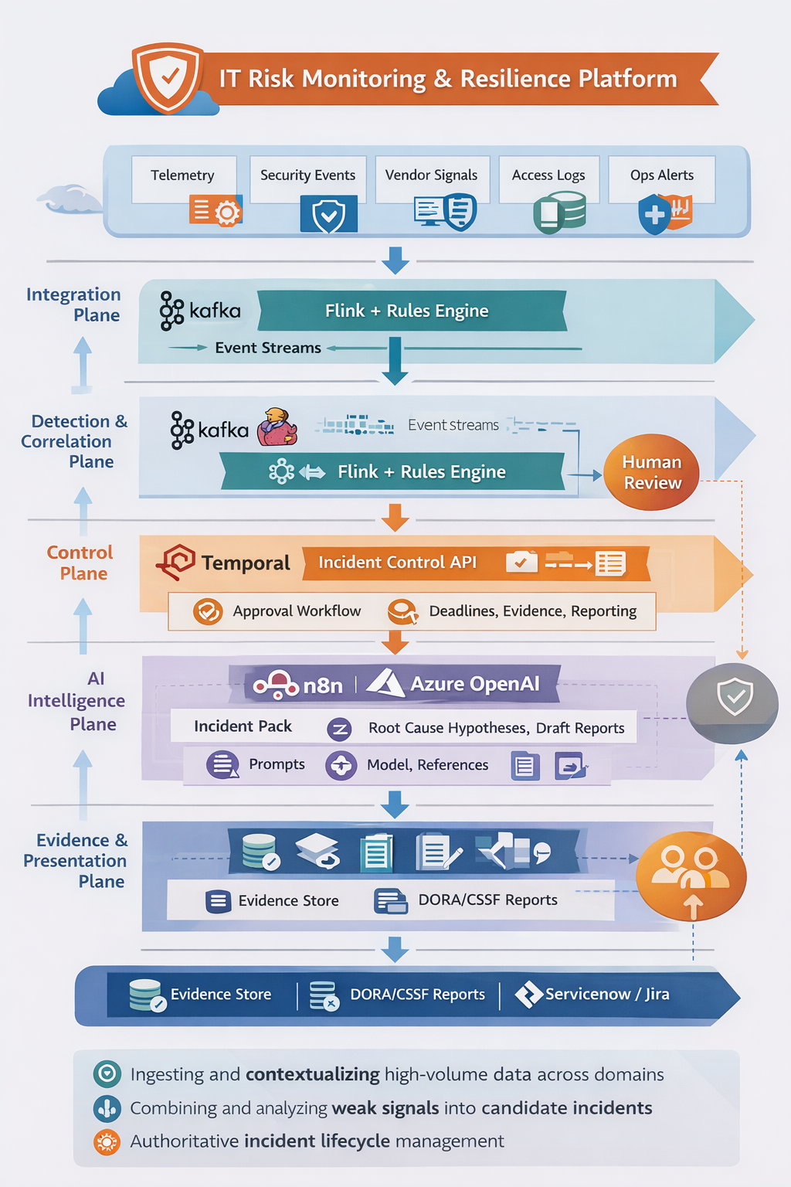
Image 2: Technical Architecture.

