JENKINS  
  
  
create a new item and select freestyle project  
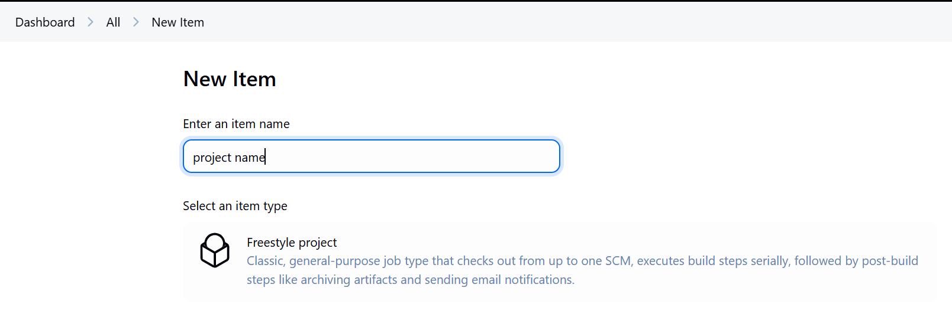  
  
To integrate GIT  
under scm add git repository and provide credentials  
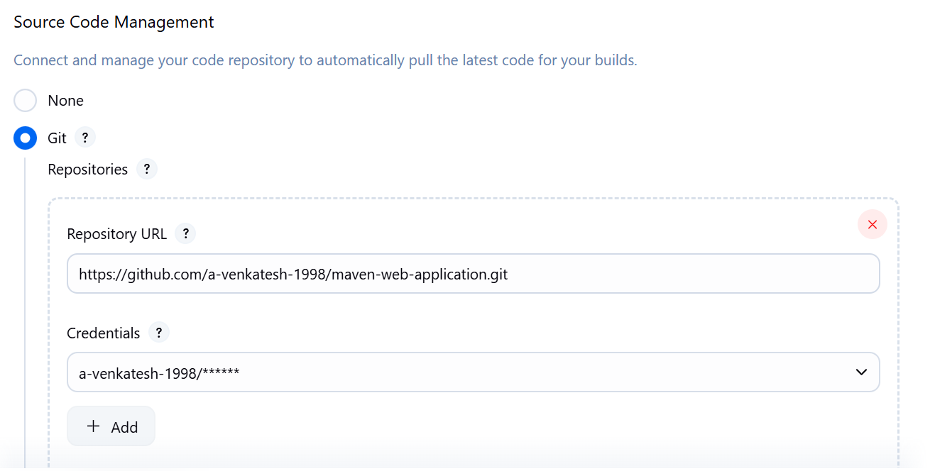  
  
  
To integrate MAVEN  
In order to use maven use below steps Managejenkins🡪Tools and install specific maven version  
  
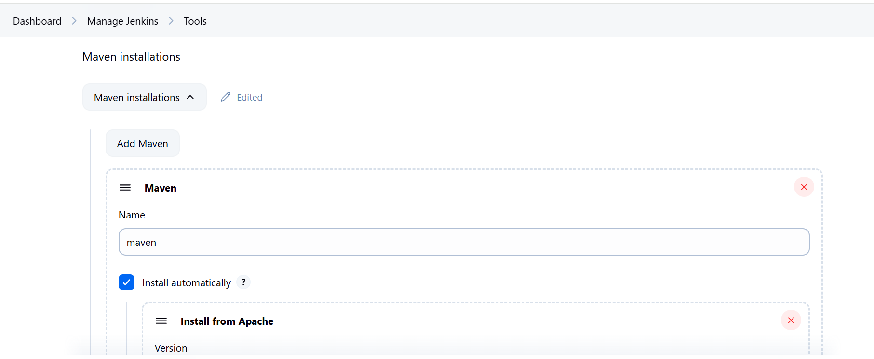  
  
add clean package and build it will sucess  
   
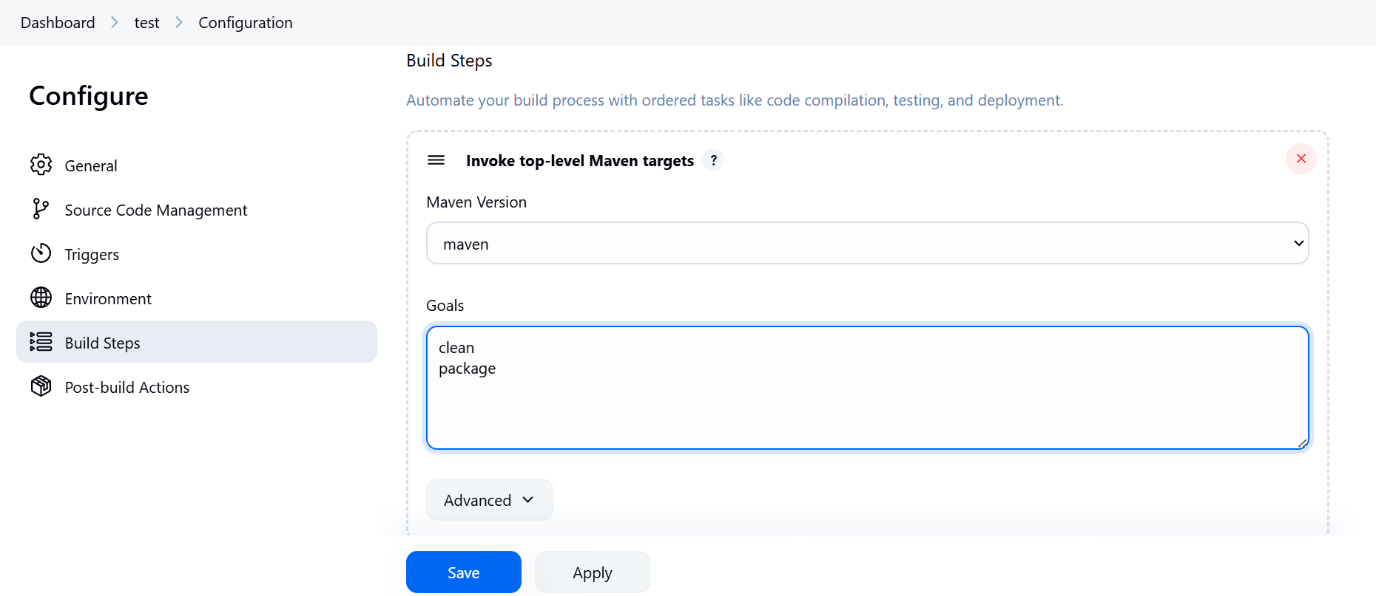  
  
To integrate sonarqube  
  
change pom.xml in github  
  
<properties>

<jdk.version>1.8</jdk.version>

<spring.version>5.1.2.RELEASE</spring.version>

<junit.version>4.11</junit.version>

<log4j.version>1.2.17</log4j.version>

<sonar.host.url>http://172.31.33.143:9000/</sonar.host.url>

<sonar.login>admin</sonar.login>

<sonar.password>passw0rd</sonar.password>

<project.build.sourceEncoding>UTF-8</project.build.sourceEncoding>

<project.reporting.outputEncoding>UTF-8</project.reporting.outputEncoding>

</properties>  
  
  
  
  
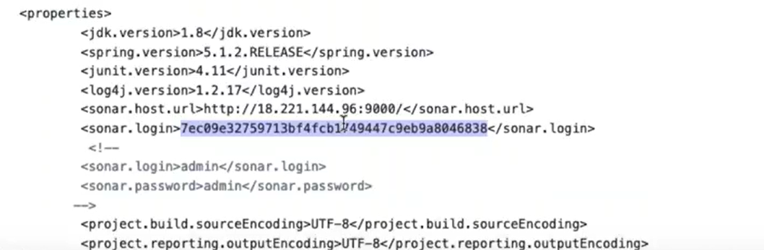  
  
  
  
myaccount🡪security🡪  
  
  
  
Add sonar:sonar in maven targets  
  
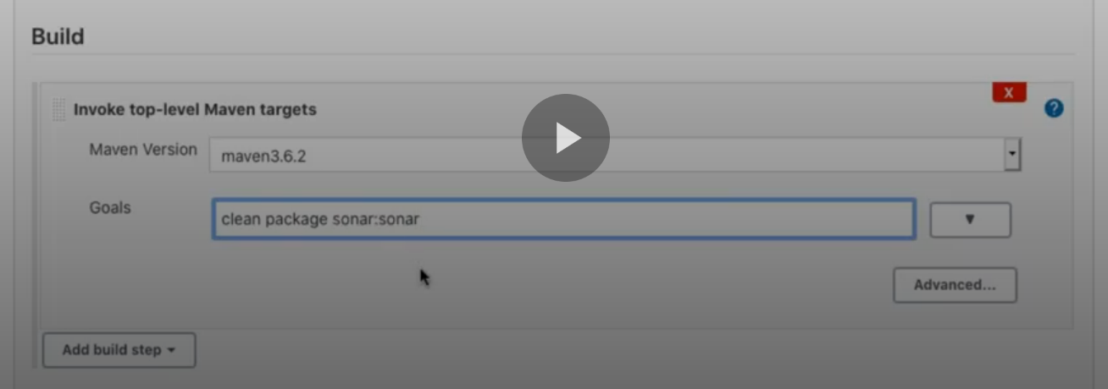  
  
  
once after the build you will see the o/p  
  
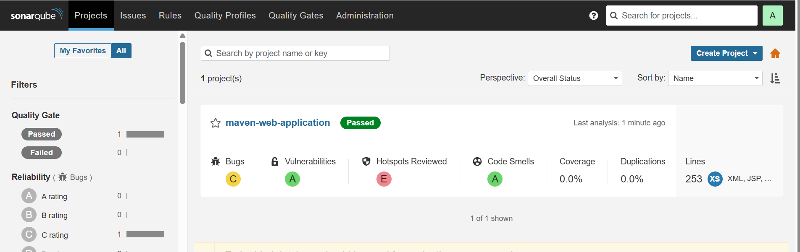  
  
  
To integrate NEXUS  
  
login to nexus and create two repositories  
  
  
  
  
  
  
  
In github pom.xml change the repo names  
  
 <distributionManagement>

<repository>

<id>nexus</id>

<name>Mithun Technologies Releases Nexus Repository</name>

<url>http://172.31.42.154:9980/mithuntechnologies/repository/canarabank-release/</url>

</repository>

<snapshotRepository>

<id>nexus</id>

<name>Mithun Technologies Snapshot Nexus Repository </name>

<url>http://172.31.42.154:9980/mithuntechnologies/repository/canarabank-snapshot/</url>

</snapshotRepository>

</distributionManagement>  
  
  
  
  
under golas add deploy  
  
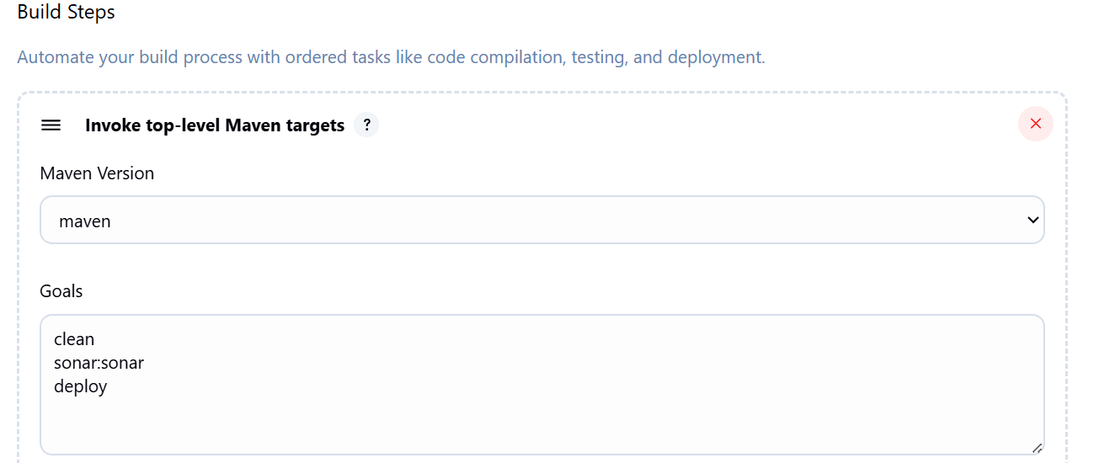  
  
  
  
need to add nexus credentials in setting.xml since i am using maven of Jenkins use below steps if it is installed in vm then go to the path and change  
  
Make sure the **Config File Provider Plugin** is installed:

1. Go to **Manage Jenkins** → **Plugins** → **Installed** tab
2. Search for **"Config File Provider"**
3. If not found, go to **Available** tab, search and install it.

**Step 1: Create the settings.xml in Jenkins (Global Config)**

1. Go to **Manage Jenkins** → **Managed Files**  
   URL: http://<your-jenkins-host>/configfiles/
2. Click **"Add a new Config"** → Choose **"Maven settings.xml"**
3. Fill in:
   * **ID**: custom-maven-settings (or anything you prefer)
   * **Name**: Custom Maven Settings
   * **Comment**: (optional)
   * **Content**: Paste your full settings.xml contents here, e.g.:

Id nexus should match with id in the pom.xml  
  
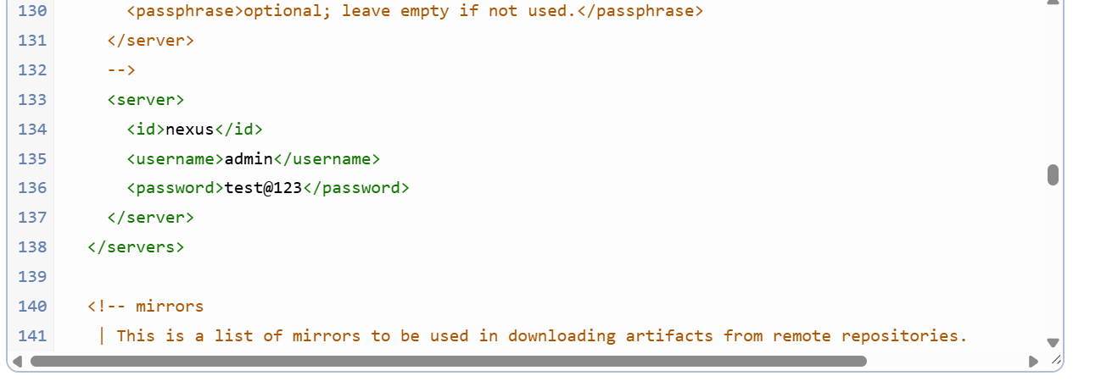

Now in the job configure use the setting file you have created  
this Environment step is not mandatory tested it is working without this step as-well  
  
  
  
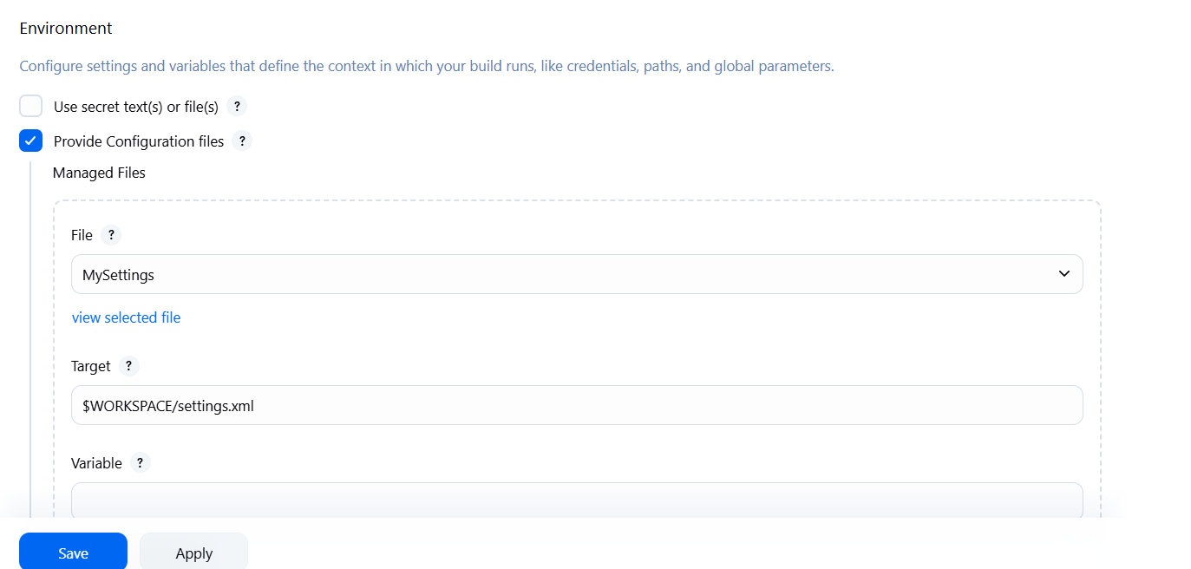  
  
  
now in maven advanced steps in settings file give the setting .xml which we have created  
  
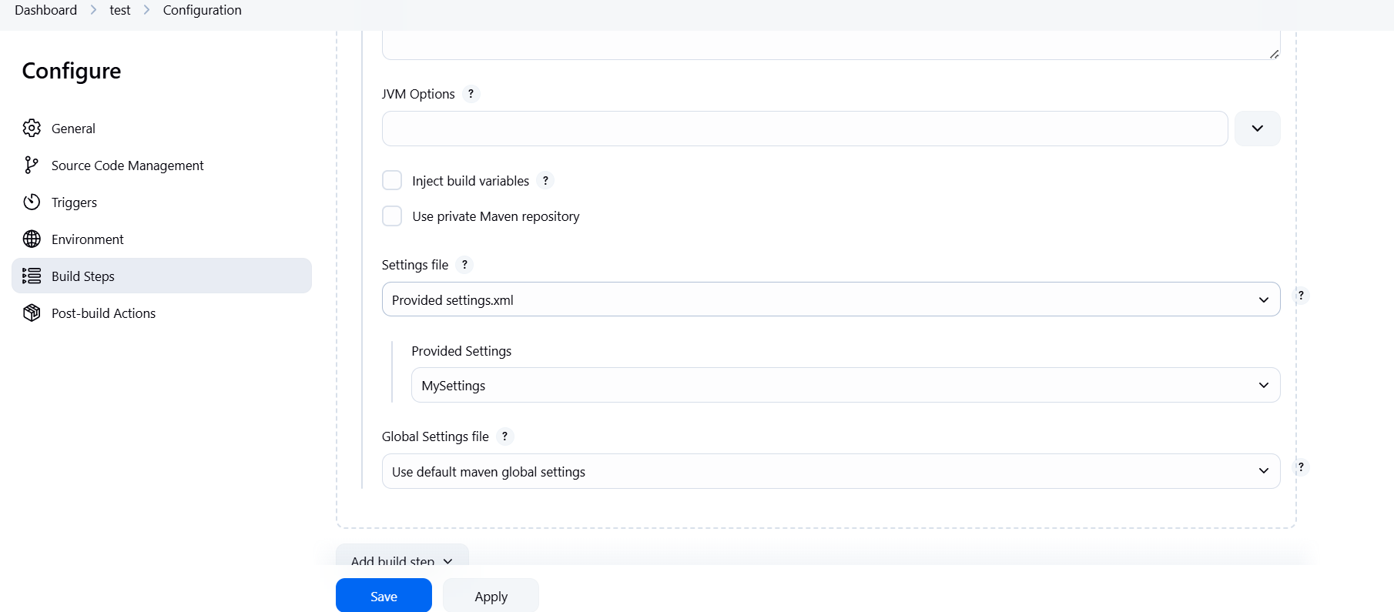  
  
  
To deploy in Tomcat

install the plugin deploytocontainer  
  
  
/opt/bitnami/tomcat/conf/tomcat-users.xml