Data visualization course

**Laboratory work 6**

# Gephi for Graphs Vizualization

To download Gephi, go to <https://gephi.org>, and then download and install the program by following the instructions for your operating system.

After that, download one of the datasets from the link: <https://github.com/gephi/gephi/wiki/Datasets>.

The dataset number depends on the number of the student in the list. Check it out below. The example in this document will be on the "Les Miserables" dataset.

Unzip the downloaded archive and open your dataset in Gephi using File → Open.

A window will appear on the screen containing a report on the results of the import (Figure 1). In this window, it is important to specify the graph type (in our case – unoriented). Then click "OK".

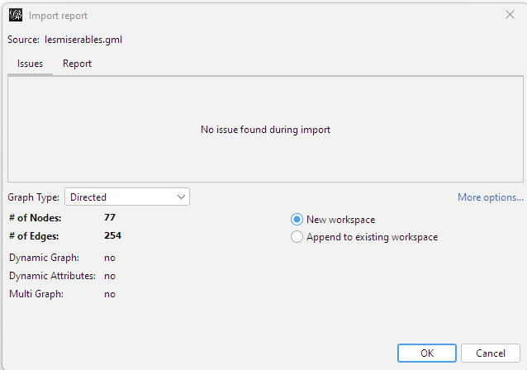

Figure 1 – Import Results Report

After that, the first representation of the graph will appear on the screen. Vertices and edges are arranged randomly on the screen. You can zoom in on the image with the mouse wheel and move it by holding down the right key.

By clicking on the "T" button at the bottom of the view window, you can add the names of the vertices of the graph so that you know which vertex belongs to which entity (character in our case). After scaling, fitting, and adding names, the graph looks like Figure 4.

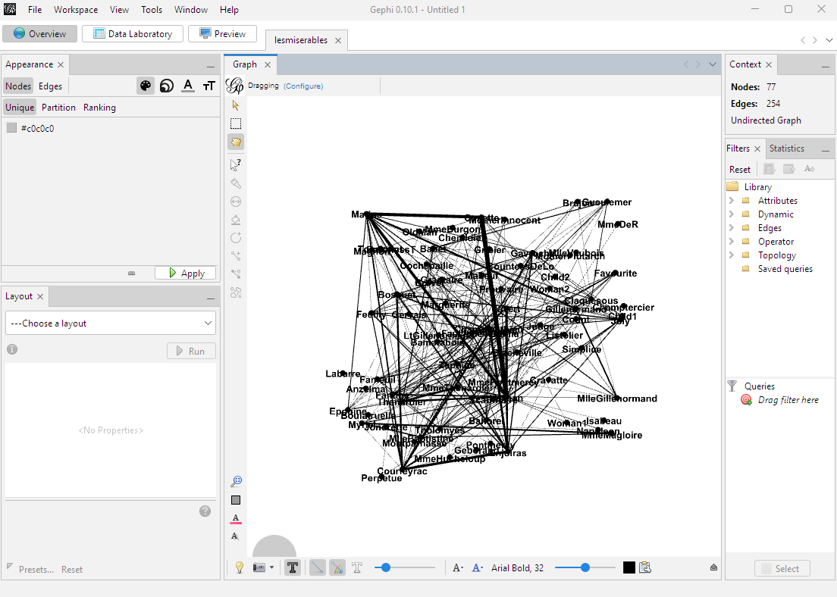

Figure 2 – Graph representation in Gephi

To improve the appearance of the graph, you need to use one of the layout methods (the layout panel in the lower left corner).

Table 1 – Basic layout algorithms

|  |  |
| --- | --- |
| **Algorithm** | **Description** |
| Force Atlas 2 | a force-directed algorithm close to other algorithms used for spatial networks |
| Fruchterman Reingold | Force-directed algorithm |
| OpenOrd | Force-directed algorithm for large graphs |

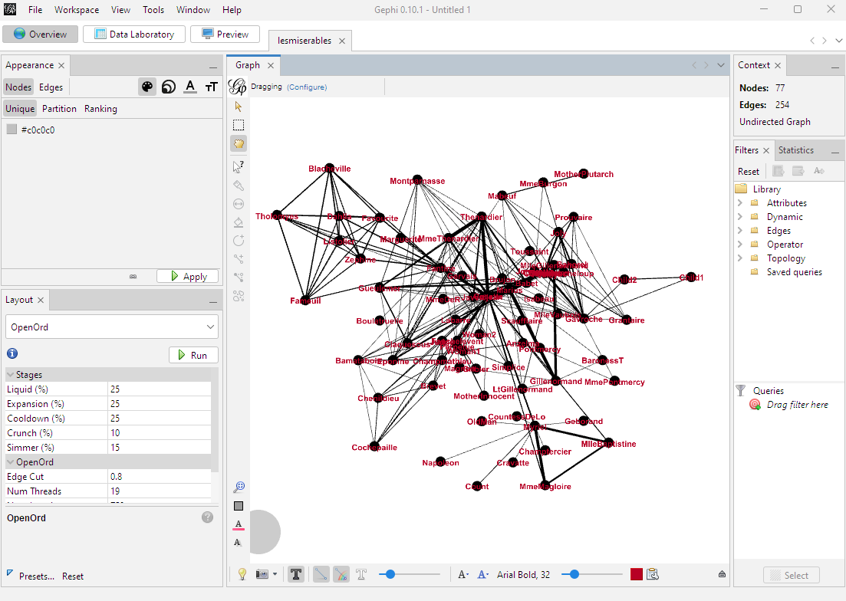

Figure 3 – Results of plotting the graph using the OpenOrd method (node labels are colored red)

To understand the state of the graph's average path length, click the Network Diameter button on the right in the statistics tab. Clicking will bring up a pop-up window like the one shown in Fig. 4, where the average path length of the graph is 2.6411.

Close the pop-up window and activate nodes ranking: Move to Appearance tab on the left, select Nodes distribution, and select node’s size option by clicing on an icon next to “Nodes” and “Edges” buttons (3 circles). Then move to the Ranking section, and select “Degree” from the drop-out menu. Your options should look like on the Figure 5. Then click “Apply”.

In the same section, when you click on the palette instead of size icon, you can set the coloring of the nodes. In this example, coloring is chosen depending on the degree (Degree) of the node (Fig. 5).

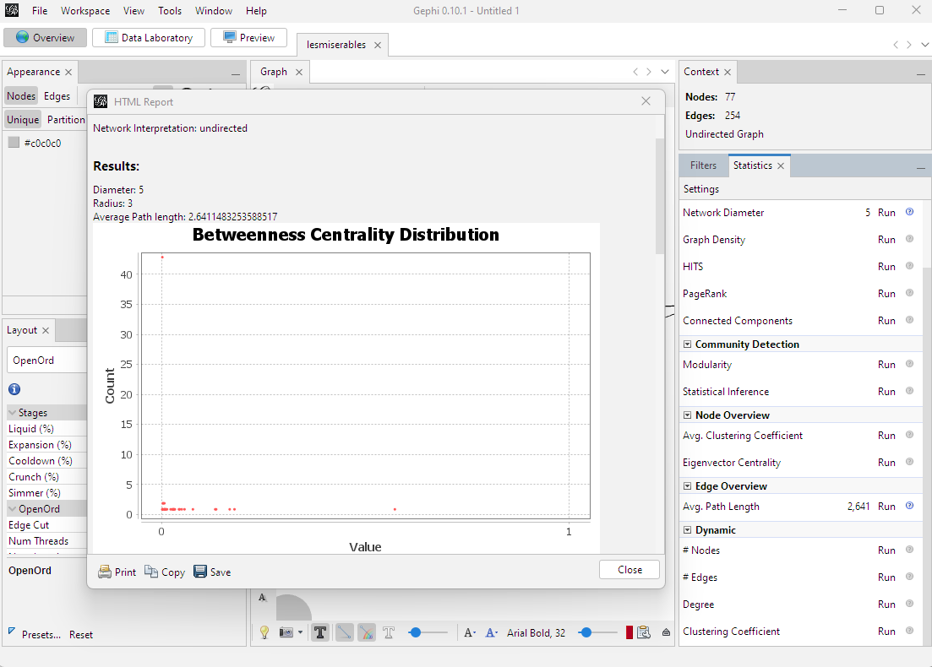

Figure 4 – Grapth path length statistics

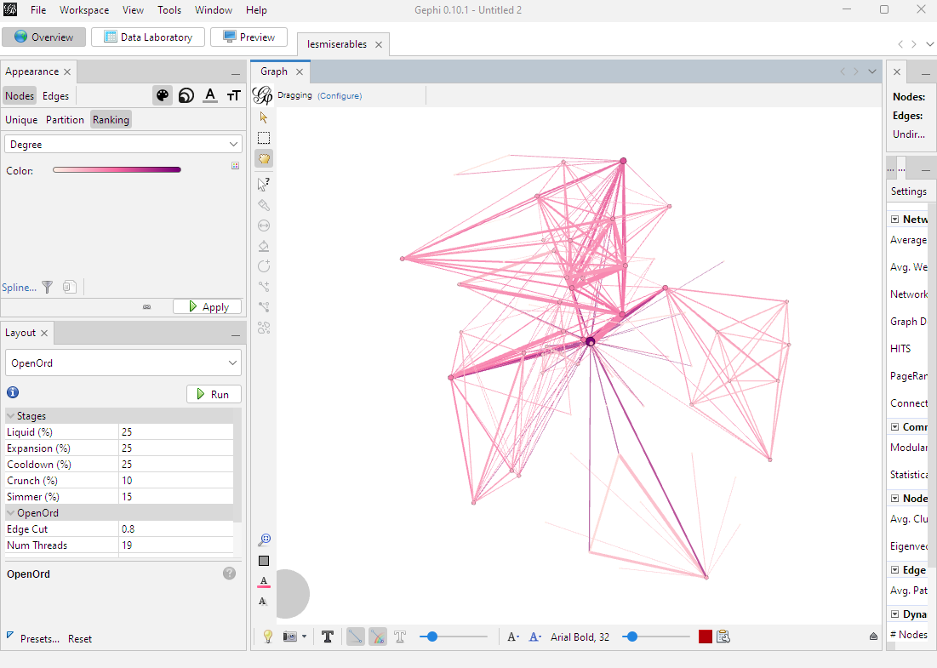

Figure 5 – The result of setting the size and color of the nodes

To prepare the graph for printing, go to the preview panel at the top of the screen. Under the Preview Setting tab, select the Black Background preset from the drop-down menu of presets and click the Refresh button in the lower left corner of the window. To save the rendering result, click on "export svg/pdf/png" in the lower left corner.

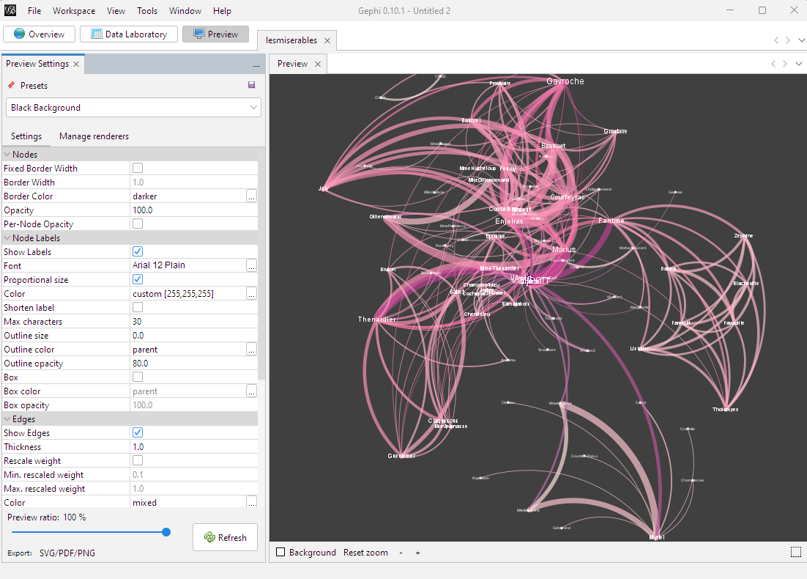

Figure 6 – The graph visualization result

# Task

According to the option, visualize the dataset (student number – dataset number) at the link in two ways:

1. Using gephi

2. Using networkx

To open dataset in networkx, you can use:

G = nx.read_gml("test.gml")

Datasets:

1. Web and Internet: Internet
2. Social networks: Zachary's karate club
3. Social networks: Coauthorships in network science
4. Infrastructure networks: Power grid
5. Word adjacencies