Table of Contents

This is a piecemeal rendition of the University of Arizona thesis class (uathesis) reworked to be compatible with Rmarkdown. The majority of the heavy lifting was already done by colleagues in the Department of Planetary Sciences at the U of A (see the uathesis.cls file for more information). In essence all I have done is include the proper adjustments so that it plays nicely with knitr. As of now (Sat Sep 10 14:21:53 2016), knitr and R are fully functional. That said, some other issues still remain.

# Issues

* Knitr captions
  + include captions from knitr call
  + include figure in LOF from knitr call

# Basic structure

The basic structure of the thesis package has been cleaned up significantly. There are now two folders inside the main directory: **includes** and **sections**. The includes folder contains most of the under the hood files that you will generally edit one time to set up the project metadata (i.e. the title, committee members, etc.), but also includes .bib files and figures. The sections folder is where the chapters of the dissertation live. Each chapter is its own .Rmd file. You will write you chapters in these files and compile the master document. This folder is home to the other less important (but required) sections (i.e. acknowledgments, dedications, abstracts and appendices).[1] The underlying engine is . To generate the dissertation pdf, compile the master.Rmd file in your favorite text editor.

# Sections

You can use either markdown or  to create sections in the document (see general markdown syntax for more information). In both cases, cross-referencing figure, tables, sections, chapters, etc. can only be done if a label{} is created. For example, this is section . I generated that number by first labeling the section

# Sections\label{sections}

and then by typing

\ref{sections}

It is helpful to use this with figures and tables. Like, for Figure and Table below.

## Subsections

You can use hashtags or the \subsection{} command to create a subsection.

### Subsubsections

These have been fixed. You can use \subsubsection{} or 3 hashtags.

If you really need to go this deep, I suggest using the \paragraph{} command.

# Math Example

Equations can be rendered beautifully by using the equation environment.

But, old school math works too!

$$\begin{matrix}y & =β_{0}+β_{1}+x_{1}+ϵ\end{matrix}$$

But putting it inside the equation environment will number it (as in the first example), and has the added advantage of centering automatically as well.

# How to cite your references

One relevant difference from the previous iteration of this package is that it now uses Rmarkdown/pandoc to render citations. This is a work is progress, but for now you can reference by using the standard [@citekey] method. For example, citations are cool [1]. For inline citations, remove the brackets (i.e. @articletwo). As in [2] said many things.

# Graphics

This took a little cajoling, but the figures are now working. They are automatically included in the list of figures and you can use the brackets in the caption to establish a different LOF caption (separate from the one you see below.).

One thing to remember is that when including images the home directory is always that of the master.Rmd document. Therefore, it is necessary to establish the path to the img file from there. Here is the code used to produce the above figure:

\begin{figure}[h]  
 \centering  
 \includegraphics[width=.75\textwidth]{./includes/figures/ex.png}  
 \caption[Example figure]{Here is a screeny of the sections folder.}  
 \label{fig:firstfig}  
\end{figure}

# Tables

Tables work the same way as before

They can be rendered in markdown now as well (and can include r code), but I don't recommend this combination (for now)

|  |  |  |
| --- | --- | --- |
| Col 1 | Col 2 | col 3 |
| 4 | plus | 8 |
| equals | 12 | nice! |

On the next page is a sample table, placed on the page by itself. Sometimes tables can be wider than they are tall, and you may need to rotate the table by ${90}^{∘}$ to make it fit better on a page by itself. To do that you can use the lscape package. To use it, wrap the table commands in a begin and end landscape command and that table will be properly rotated.

Note that the command can have a short and a long version inside a table environment, just like inside a figure environment (see ).

# TIPA

You can include IPA characters via the TIPA package. Here is an example:

- Looks good.

# Basic math

Here are some simple math examples

24 - 23

## [1] 1

2345 * 23

## [1] 53935

# Inline expressions

You can use inline r expressions like 2 plus 2 = 0

# Run models

library(xtable); library(dplyr)  
mtcars %>%  
 glm(vs ~ mpg, data = ., family = "binomial") %>%  
 xtable(., type = "latex") %>%  
 print(comment = FALSE)

# Plots

And you can generate plots directly from this file as well.

library(ggplot2)  
ggplot(mtcars, aes(x = mpg, y = vs)) +   
geom_point() +   
geom_smooth(method = "glm", method.args=list(family="binomial"))

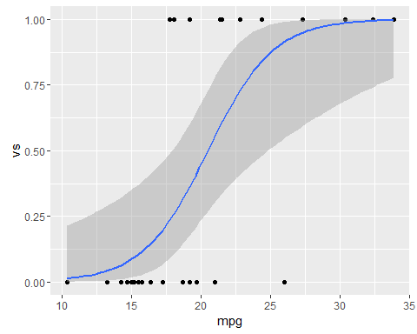

# Import scripts

We can use the following command to import an r script:

library(knitr)  
read_chunk('../includes/scripts/test.R')

# Call chunks

library(dplyr); library(lingStuff)

# Generate data  
set.seed(1)  
vot = rnorm(20, 15, 5)  
vot = sort(vot)  
phon = c(0,1,0,0,0,0,0,1,0,1,0,1,0,1,1,1,1,1,1,1)  
df = as.data.frame(cbind(vot, phon))

# Fit model  
glm <- glm(phon ~ vot, data = df, family = "binomial")

# Get crossover point  
  
crossOver(glm)

## [1] 15.53595

. Good. Let's plot it -->

# Plot regression with crossover point  
  
plot(df$vot, df$phon, xlab = "vot", ylab = "phon",  
 pch = 16, col = rgb(0, 0, 204, 102, maxColorValue = 255))  
curve(predict(glm, data.frame(vot = x), type = "resp"), add = TRUE)  
points(vot, fitted(glm), pch = 20)  
abline(v = crossOver(glm), lty = 2, lwd = 0.75)  
abline(h = 0.5, v = 0)

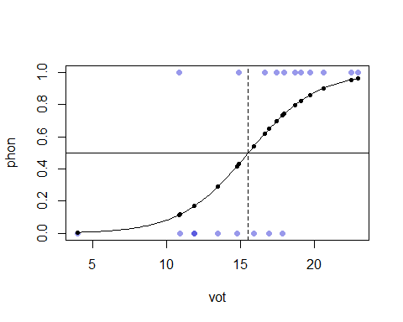

This is the caption

Stuff.....

Lorem ipsum dolor sit amet, consectetur adipisicing elit, sed do eiusmod tempor incididunt ut labore et dolore magna aliqua. Ut enim ad minim veniam, quis nostrud exercitation ullamco laboris nisi ut aliquip ex ea commodo consequat. Duis aute irure dolor in reprehenderit in voluptate velit esse cillum dolore eu fugiat nulla pariatur. Excepteur sint occaecat cupidatat non proident, sunt in culpa qui officia deserunt mollit anim id est laborum.

[1] Author F, Author S, Author T. Random article about some stuff. Random Journal 2002;666:1–20.

[2] Author F, Author S, Author T. Some more random stuff. Random Journal 2015;675:1–20.

1. All of these files are imported into the final pdf in the master.Rmd file via knitr or specific commands written for the uathesis class.