Alan Wang
16.90
Project #2
Simulation of the Inviscid Supersonic Flow over a Cylinder
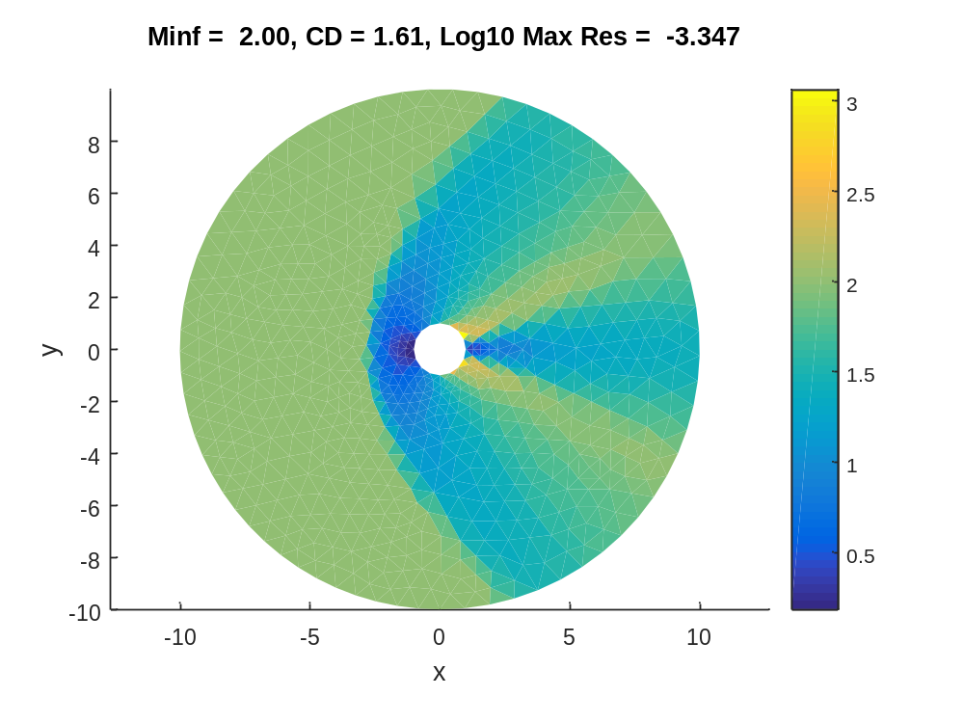
Finite Volume Method for the 2-D Euler Equations

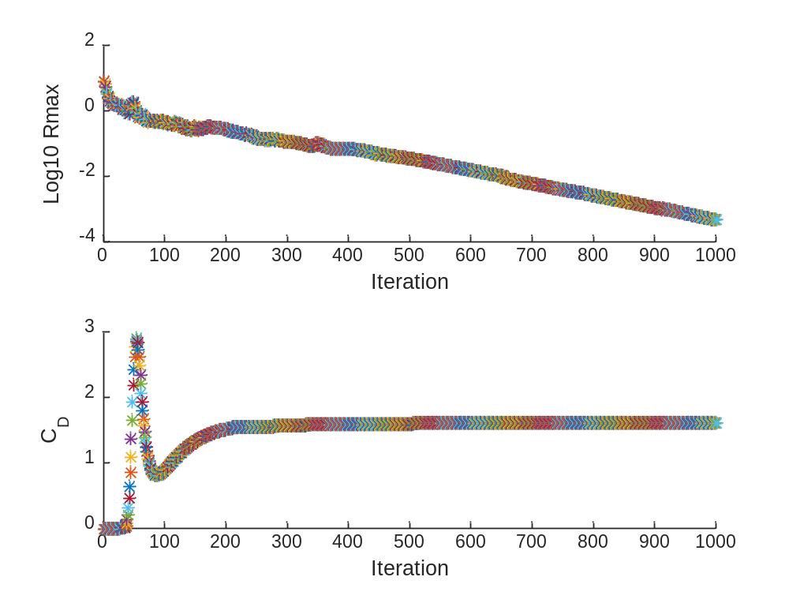

The first plot above is a Mach number distribution around a cylinder with a free stream Mach number of 2 found using a finite volume method. No adaptation was used for the mesh. The second plot is the maximum residual and coefficient of drag vs. iteration. For this simulation, 1000 iterations were used. From the plot, we can see that the coefficient of drag is converging to 1.61 while the base 10 logarithm of the maximum residual is decreasing linearly with iteration.
A Grid Adaptive Method
I chose to use the adaptation algorithm described in the problem statement. I ran the unadapted mesh FVM for 1000 iterations. Then using the solution for Mach number distribution from the last iteration, I calculated error indicator values for each cell. The error indicator value for a cell was computed as the sum of the absolute value of mach number difference between the current cell and adjacent cells multiplied by the length of the edge between adjacent cells:
$${Error Indicator}_{0}= \sum_{i=1}^{e}{\left|M_{i}-M_{0}\right|*h_{i}}$$
Farfield boundaries contributions were not included into the error indicator. However, solid wall boundaries of the cylinder were accounted for by using the Mach value normal to the solid boundary multiplied by the length of the edge of the solid boundary. The reasoning behind this method is because the Mach number normal to the solid boundary should be 0.
After the error indicator values for all cells were computed. The error indicator vector was sorted in descending order. I chose to adapt 25% of cells. Using the indices of the top 25% of cells, I populated the RefineList vector to run cyl_adaptmesh.
After running cyl_adaptmesh, I increased ntol by 100 and ran FVM again with the new mesh. I repeated this process numerous times increasing ntol by 100 each time. The following are plots of the adapted meshes, their respective Mach distributions, and the histories of Residual and Drag Coefficient. The Drag Coefficient does appear to converge as the mesh is adapted. My best estimate for the drag coefficient for this problem is 1.50 which is probably a little high. If you repeat this process enough times, the number should converge to the exact drag coefficient. Based on computational time limitations, I only repeated the process a few number of times.

