MATLAB Reproduction Report
Efficient Ordered Statistics Decoding of BCH Codes Without Gaussian Elimination
Generated by the Base MATLAB R2022b implementation. It reproduces GF arithmetic, BCH/BM, OSD, LLOSD, SLLOSD, HSD, baselines, ML search, Monte Carlo experiments, figures and tables.
Artifacts and methodology
Numerical entry points resolve outputs from their own source location and write figures/data/tables under this work's assets directory. Monte-Carlo random streams are MATLAB Twister streams, so individual trials need not coincide byte-for-byte with NumPy PCG64, while the algorithms and fixed-vector regression results are equivalent.
Reference paper
Open the reference-paper PDF
Generated figures
Fig. 2: average BCH candidates
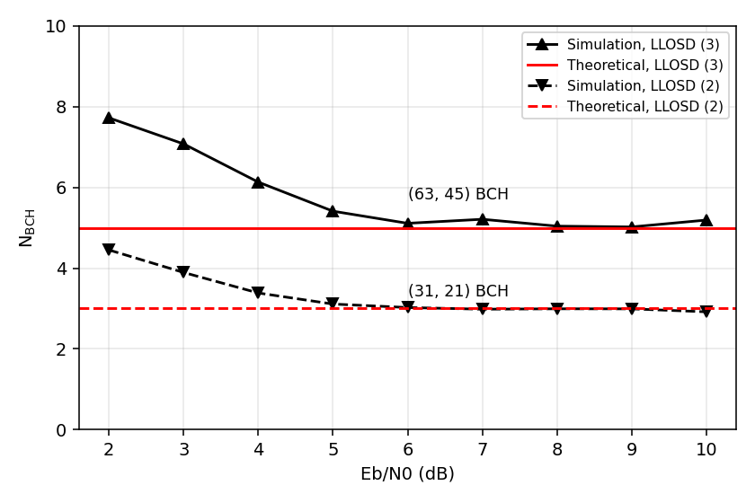
Fig. 3: (31,21) FER
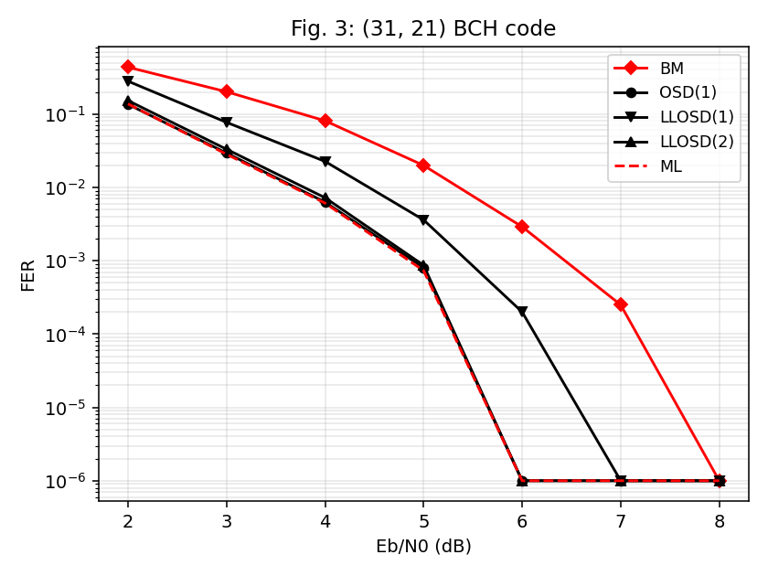
Fig. 4: (63,45) FER
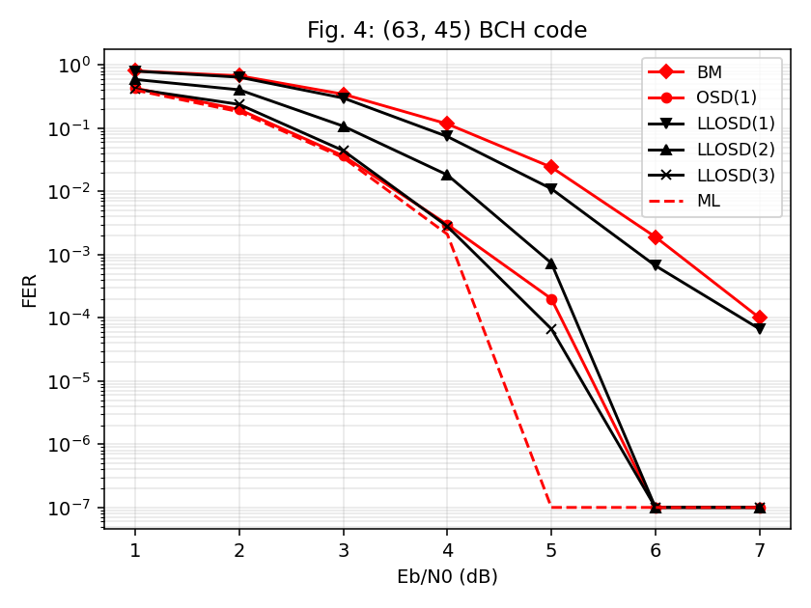
Fig. 5: decoder comparison
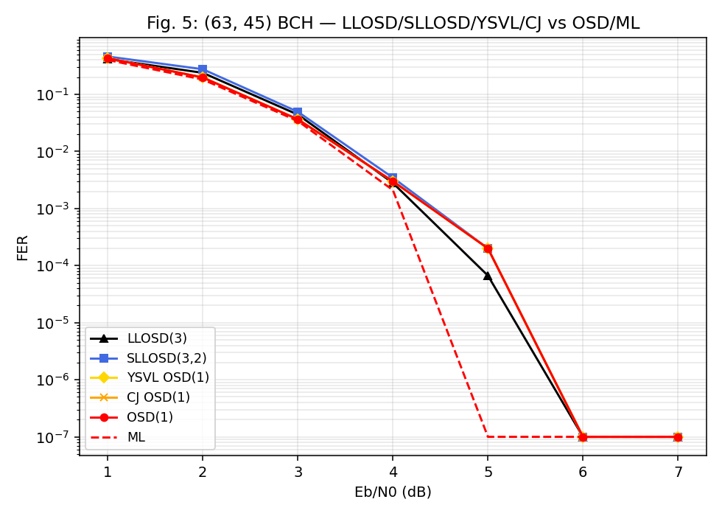
Fig. 7: (127,99) FER
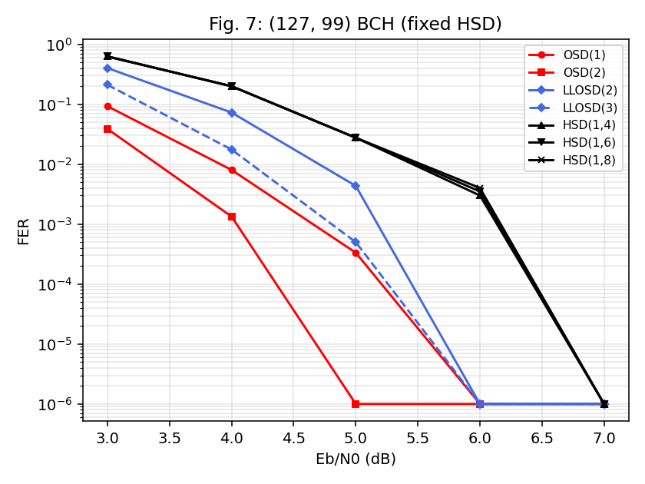
Fig. 8: rate sweep
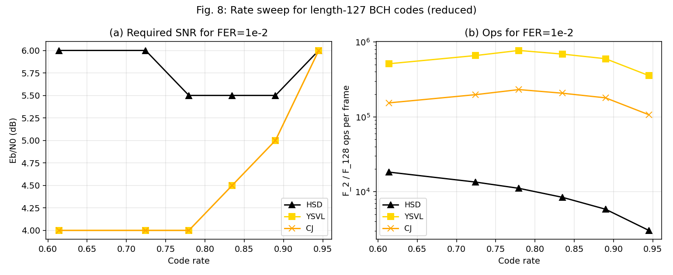
Fig. 9: (255,223) FER
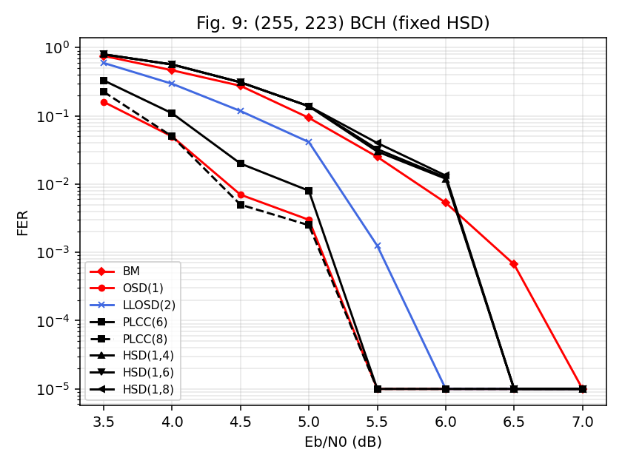
Fig. 10: average TEPs
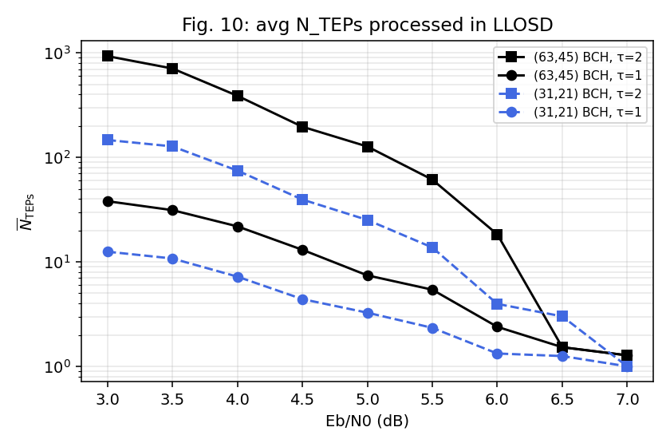
Fig. 11: average TVs
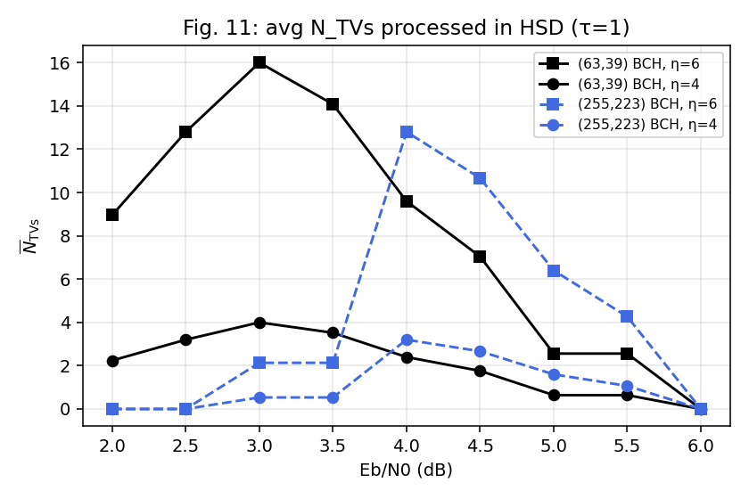
Latency comparison
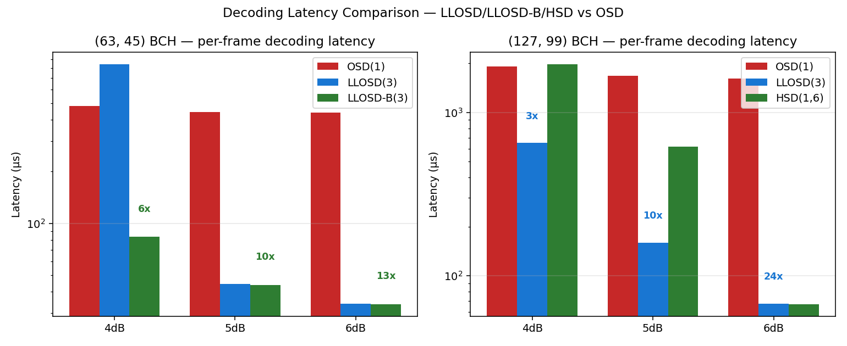
Latency versus SNR
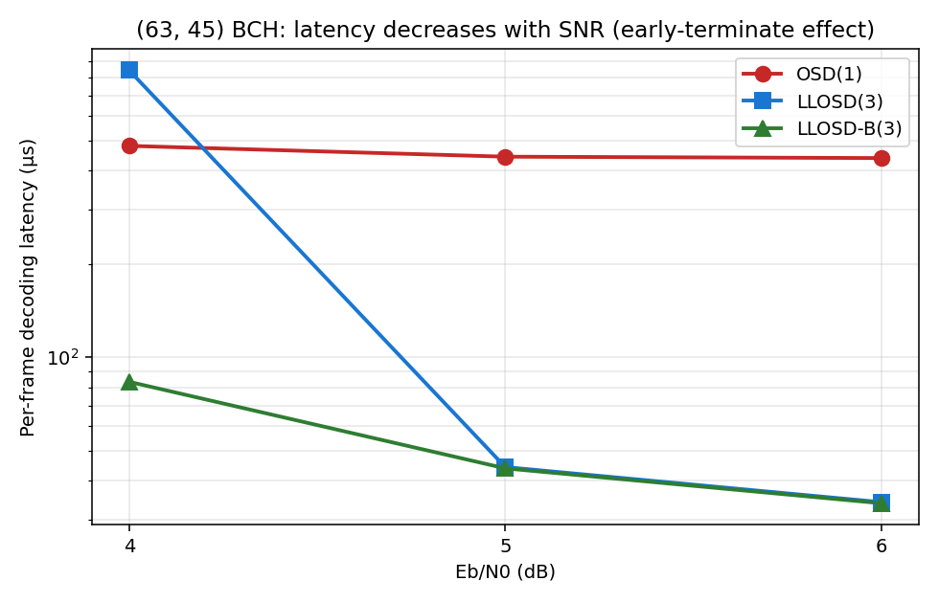
How to reproduce
Run `run_work01_tests.m` for fixed-vector verification. Run `run_all_numeric_experiments` for all numerical artifacts; it is intentionally computationally heavy with paper-matching defaults.

Reference paper PDF:

