Note: This document does not act as a template for the visuals of the webpage. The function of this document is only to contain the text and graphics to be pasted onto these webpages.

UCD centre of mechanics

Mechanics fun walk

Uphill Roller

When you place the roller at the bottom of the slope, it looks like the roller is rolling up the slope.

However, it is actually rolling *downwards*!

When an object moves due to gravity, it is because gravity is trying to move it downwards. Gravity wants to move the object from a higher position to a lower position.

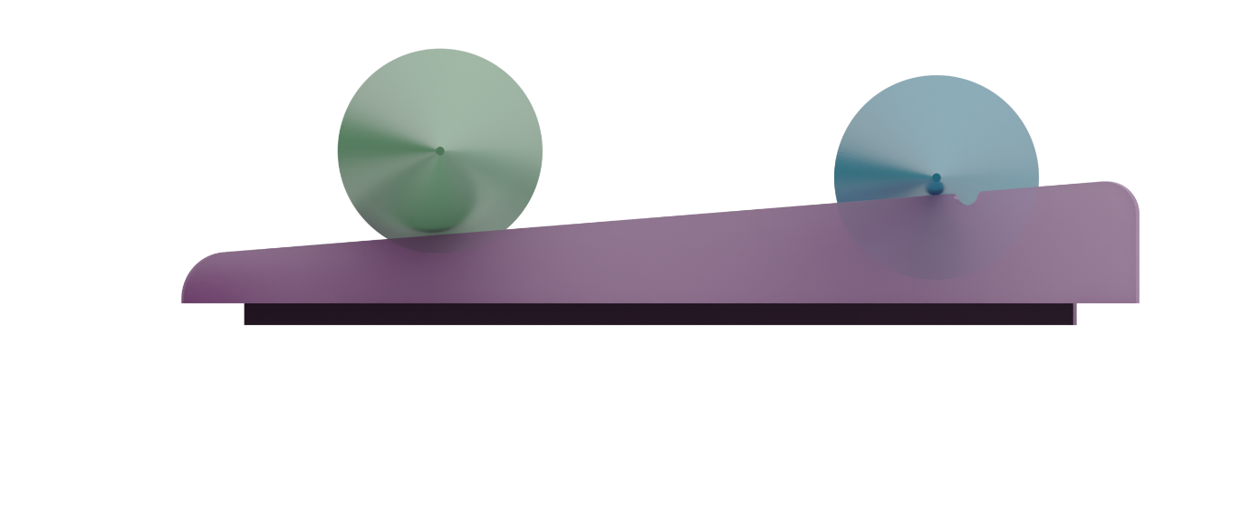

1

2

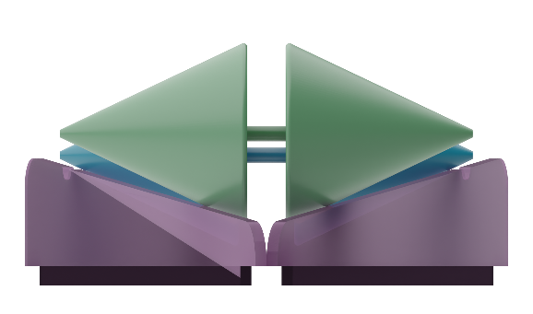

If we look at the roller from the side, we can see that the cone does actually end up lower than it started.

This is because of the shape of the track and the cone. The roller and rails are shaped such that when the cone-shaped roller rolls to the wider part of the track, its height is lower than at the narrower part of the track.

If we make the rails steeper and steeper, eventually the roller will start rolling in the other direction.

Double Pendulum

The 2 pendulums are basically identical.

When they are left to swing, they start in the same way. However, after some time, they swing with completely different paths.

Why is that if they are *almost exactly the same*?

The key is that they are “**almost**” exactly the same.

The double pendulum is a chaotic machine, meaning that how it behaves is extremely sensitive to how it started.

Even if you make them start as similarly as possible, there will always be a huge difference in outcome, because even the smallest difference has a big effect in chaotic systems.

This extreme sensitivity to the *initial conditions* is often referred to as the **Butterfly Effect**.

Galton board

The Galton board demonstrates the “Central Limit Theorem”.

The Central Limit Theorem suggests that when there is a sufficiently large number of random events, a normal distribution will be formed in the results.

**Normal Distribution, or “Bell Curve”**

For example, if you weigh an apple, you can’t predict what its exact weight will be, only what it is likely to be. If you weigh 100 apples, and graph the weight against how many apples have this weight, you’ll get a bell shaped curve, called a “normal distribution”. In this case, the random event is the weight of the apple.

**Normal Distribution formed by Galton Board**

In the Galton board, each peg represents a random event: a 50% chance to go right and 50% to go left. If you drop each ball through the pegs one by one, there is no way of predicting where it will end up. But if you drop 100 balls through the pegs, a bell shape curved always forms at the bottom. This is because of the Central Limit theorem.

So even though the path of each individual ball is random, as a whole we can accurately predict how many balls will go in each direction.

Brachistochrone Problem

The Brachistochrone problem is the problem of finding the path of least time – the fastest path from point A (at the top) to point B (at the bottom)

The shortest distance between 2 points is a straight line, so you might think that a straight line from A to B is the fastest path. However, this would only be the fastest path if the speed travelled along the path was not affected by the path itself.

For example, if you needed to walk from point C to D and there was thick mud and road to cross, it would be faster to walk on more road and less mud even if it meant taking a longer path.

The Blue path is the longest, but spends the least time in the mud. The orange path is the shortest distance overall, but spends a lot of time in the mud. The pink path is a shorter distance overall than the blue path, but spends more time in the mud. Which of these would be fastest?

The Brachistochrone problem is similar to the mud and road problem. A steeper path builds up faster speed more quickly, but requires the coin to roll a longer distance. It’s a trade-off of acceleration and distance.

What curve would produce the fastest possible path overall?

This problem was solved 300 years ago by the greatest mathematicians, including Isaac Newton.

By coincidence, the fastest curve was found to be a “cycloid”. This is the path traced by a point on the edge of a rolling circle.



Metronome Synchronisation

Why do the metronomes synchronise?

Swing your arm just like the metronome arm swings. Do you feel this action applying a swaying force to your body?

This force is also applied to the body of the metronome and the base that they sit in, whenever the metronome arm ticks.

Since the base is not rigid and can move, the force can be transferred through the base to the other metronomes.

Whenever a metronome arm ticks, the force it creates causes the other metronome’s arm to speed up or slow down.

The metronomes keep getting sped up and slowed down by each other until they all tick at the same time!

Nails in a Box

Tensegrity

The top is being held up by tension and compression.

Tension is the force exerted when something is being pulled apart. Compression is the force exerted when something is being pushed together.

The string is only able to resist tension. If you take a noodle and push it together, it doesn’t stop you, but if you try to pull it apart, it becomes taut.

The arch of the top board is hanging by a string below the arch of the bottom board. The string is in tension and supports the weight of the top board.

But this isn’t stable. The other strings hold the top in place so that the bottom can support the downwards weight.

All of these forces can be represented with a **diagram**.

In the centre, a single string supports the downwards weight of the top board.

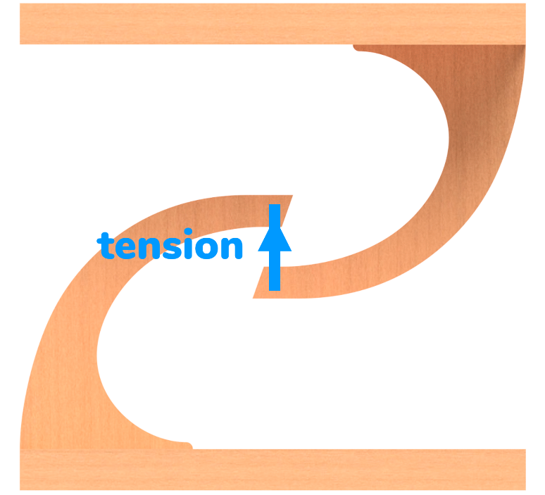

Because of the arch, the ‘centre of mass’ of the top board is towards the right. This means that it is unbalanced, and will tip over towards the clockwise.

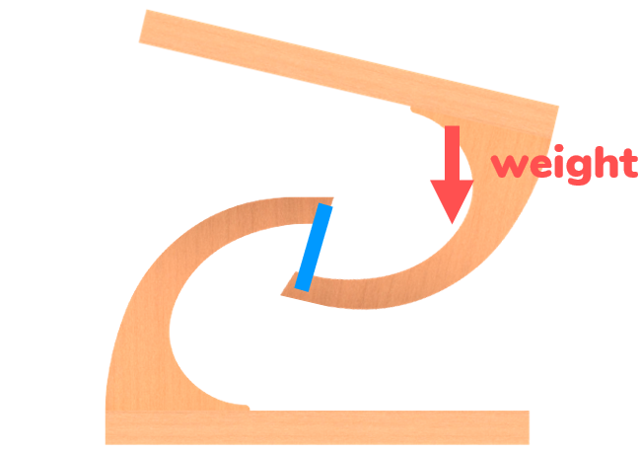

To prevent this, strings are in place on the left to prevent the clockwise rotation. These have lower tension than the middle string, because their only job is to prevent the tipping.

These 3 strings (2 on the right, one in the middle) are enough to hold up the top board. To make the structure even more stable, 2 more strings can be put on the left, to prevent it from tipping in the directions into and out of the screen.

Precession

2 weird things happened with this demonstration:

1. The spinner did not fall down

2. The spinner turned around in a circle

These are both the result of the spinning of the spinner in combination with gravity.

The spinner does not fall down, and this appears as though it is defying gravity. But of course, that is impossible. The effect of gravity is not always to cause them to fall down.

Gravity is just a force that applies in a downwards direction.

Let us pretend that our spinner looks like this, for simplicity.

Gravity acts at the centre of the spinner. There is also a corresponding upwards force in the string due to tension that holds up the spinner.

Thus, there are 2 opposite forces that cause rotation. This is called a “couple”. The points at which a couple acts can be “relocated” as long as they produce the same rotation direction (and torque).

Therefore, another way to draw how gravity acts is as shown below, where the force acts sideways instead of downwards. The force is drawn where they act on the ends of the spinner, so we can see which direction they should go.

When the spinner is not spinning, the result of gravity is rotation in which the spinner falls down.

But when the spinner is spinning, gravity results in something else.

Let us look at the ball at the top, which the spinner spinning.

At the top, the top ball is moving as shown below.

As we showed before, gravity forces the ball to the side. In what direction will the ball move now, when it is both moving on one direction while being pushed to the side?

The resulting direction will be between the direction it is moving and the direction it is being pushed.

The same thing happens at the bottom.

Hence, because of the combination of spin and the couple created by gravity, the direction of spin itself also rotates as shown below. This forces the spinner to rotate about the axis of the string.

~~Because the spinner is spinning, it has “angular momentum” in the direction shown below. The direction of angular momentum due to rotation corresponds to the “right hand rule”. Curl your fingers with your thumb sticking up. The direction of the curl of your fingers represents the rotational direction, and the direction of your thumb represents the direction of angular momentum.~~