# Student Number: A00277712

# Object Oriented Software Development Project

## Introduction

This application allows the management of Company Departments and associated Employee. It will allow the creation, update, display and deletion of both Departments and Employees. The application will support a table like summary view of all Departments or their Employees. It will also allow selection to view Employee details.

## Domain Classes

The application makes use of multiple classes used for Departments, Employees, displaying menus and file management.

The Employees class contains the following fields

|  |  |
| --- | --- |
| **Field** | **Type** |
| **Id** | int |
| **FirstName** | String |
| **LastName** | String |
| **Email** | String |
| **PhoneNumber** | String |
| **Salary** | String |
| **DepartmentId** | int |

The Departments class contains the following fields.

|  |  |
| --- | --- |
| **Field** | **Type** |
| **Id** | int |
| **Name** | String |
| **Location** | String |
| **EmployeeList** | ArrayList<Employees> |

Each Department can have multiple Employees linked via the Employee’s DepartmentId linking to the Department’s Id

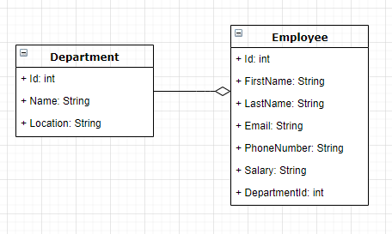

## User Stories

## Work Flow

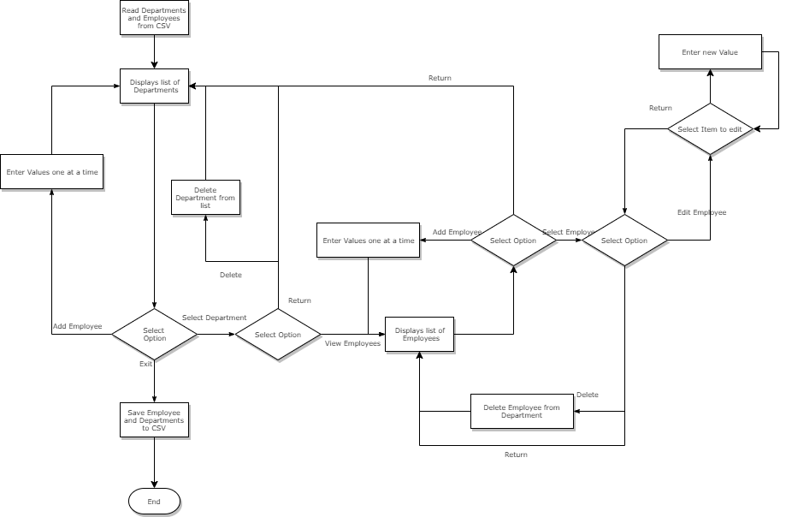When the user enters the system they will be presented with a list of all departments in the system that they can view or add new ones, Within the department they can edit a field, delete the record or add an employee. Once the user is finished the system will save before the system exits.

## Menu Structure

Item selection

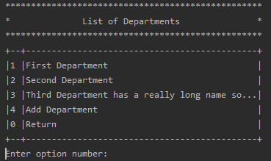

## 

Allows the user to select the item they wish to look at, add a new one or return the the prior screen

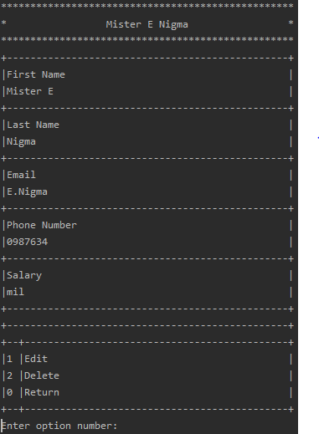Item Menu

Allows the user to view the item then edit, delete or return.

## Test Documentation

|  |  |
| --- | --- |
| User Story | General |
| Test Case ID | 1 |
| Description | Display the main menu |
| Given | 1. Application is not running 2. Data files exist on disk |
| When | 1. Application is started |
| Then | 1. Main menu is displayed 2. Asks to choose option |
| Test Status | Passed |

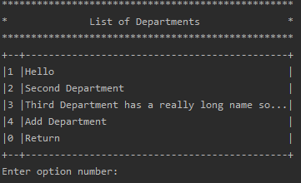

|  |  |
| --- | --- |
| User Story | Add New Department |
| Test Case ID | 2 |
| Description | Add a department into the system |
| Given | 1. Application is running  2. List of departments is displayed |
| When | 1. Enter option to Add Department  2. Enter Name  3. Enter Location |
| Then | 1. New Department Appears with new name  2. Asks to choose next option |
| Test Status | Passed |

|  |  |
| --- | --- |
| User Story | Display Department Details |
| Test Case ID | 3 |
| Description | Display the first Department |
| Given | 1. Application is running 2. List of Departments is displayed |
| When | 1. Enter option for first Department |
| Then | 1. Department is displayed 2. Asks to choose next option |
| Test Status | Passed |

|  |  |
| --- | --- |
| User Story | Edit Department Details |
| Test Case ID | 4 |
| Description | Modify the first Department |
| Given | 1. Application is running  2. First Department is displayed |
| When | 1. Enter option to Edit  2. Enter option for Name  3. Enter Name |
| Then | 1. Name is changed  2. Asks to choose next option |
| Test Status | Passed |

|  |  |
| --- | --- |
| User Story | Display Department Employees |
| Test Case ID | 5 |
| Description | Display the first Departments employee details |
| Given | 1. Application is running  2. First Department is displayed |
| When | 1. Enter option for Employees |
| Then | 1. List of Employees is displayed  2. Asks to choose next option |
| Test Status | Passed |

|  |  |
| --- | --- |
| User Story | Edit Employee Details |
| Test Case ID | 6 |
| Description | Modify the Employee |
| Given | 1. Application is running  2. Employee is displayed |
| When | 1. Enter option to Edit  2. Enter option for First Name  3. Enter new First Name |
| Then | 1. First Name is changed  2. Asks to choose next option |
| Test Status | Passed |

|  |  |
| --- | --- |
| User Story | Delete Employee |
| Test Case ID | 7 |
| Description | Remove an Employee from the system |
| Given | 1. Application is running  2. Employee is selected |
| When | 1. Enter option to Delete |
| Then | 1. See list of Employees (deleted one removed)  2. Asks to choose next option |
| Test Status | Passed |

|  |  |
| --- | --- |
| User Story | Delete Department |
| Test Case ID | 8 |
| Description | Remove a Department from the system |
| Given | 1. Application is running  2. Department is selected |
| When | 1. Enter option to Delete |
| Then | 1. See list of Departments (deleted one removed)  2. Asks to choose next option |
| Test Status | Passed |