# System Diagram Before Update

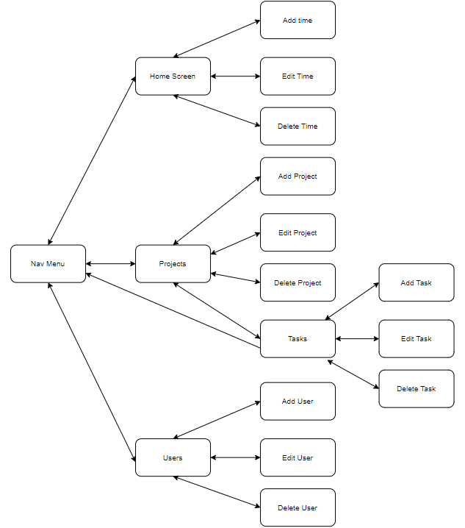

The system was a simple solution that allowed for creation of projects with tasks, then allowed time to be logged against those tasks with user management with a side navigation panel to navigate between the Home Screen for entering time, the Projects screen for managing projects and Tasks and the Users screen for managing users.

# System Diagram After Update

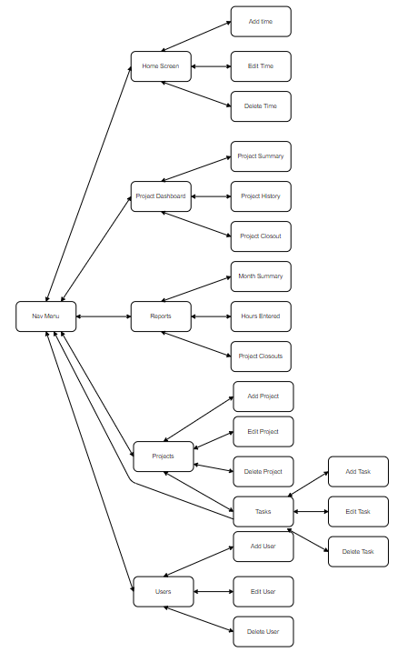

With the updated System we add the Project Dashboard and reporting screens. Via the Project dashboard we can maintain a comment log tracking the progress of the Project, this log can be viewed by the Project History Dialog. The Project Dashboard also links to a Project Summary Dialog that shows the time spent against a selected project and the Project Closeouts screen where a Setup user can end the lifecycle of a project. Via the reporting screens (Month Summary, Hours Entered and Project Closeouts) the users with the Reporting role can get information out of the system.

# Project Closeout Sequence Diagram

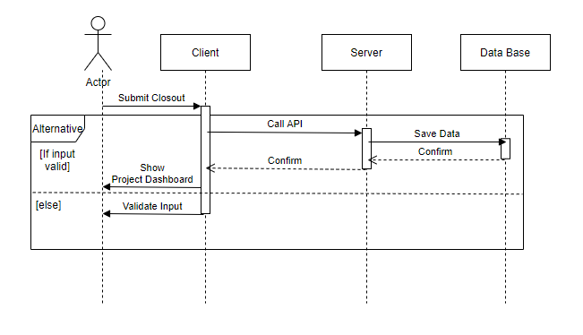

When a Setup user wants to closeout a project from the Project Closeout screen, they need to fill in all input fields then click the submit button, if all fields are filled and valid an API call is made to the server which in turn updated the ProjectCloseouts table on the Data Base. Once the Data base is updated the API returns to the client which redirects the user back to the Project Dashboard screen.

# Report Generation Sequence Diagram

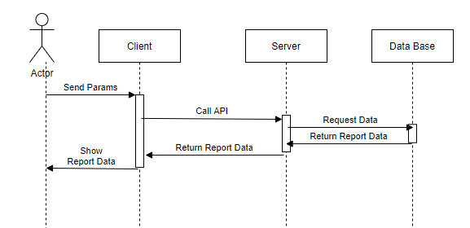

Each of the Reports in the system work in a similar way when the page is called or the parameters of the report are updated am API POST request is called on the server which in turn goes to the data base to retrieve the report data. That report data is returned to the Client who then displays the report data in a table format.

# Class Diagram

## API’s

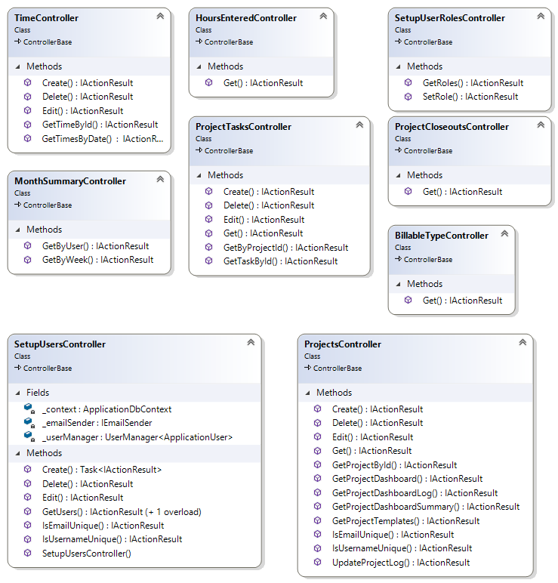

Every interaction an actor makes on the client side of the system that requires an action be made on the server side must go through an API call, the above are the classes that map to each API call

## Non-Report Entities

# 

All the Entities that are used to transfer Data between the client and the server via API calls

## Report Entities

# 

All the Entities that are used to transfer Data between the client and the server via API calls for reporting purposes

# Entity Relationship Diagrams

## User Tables

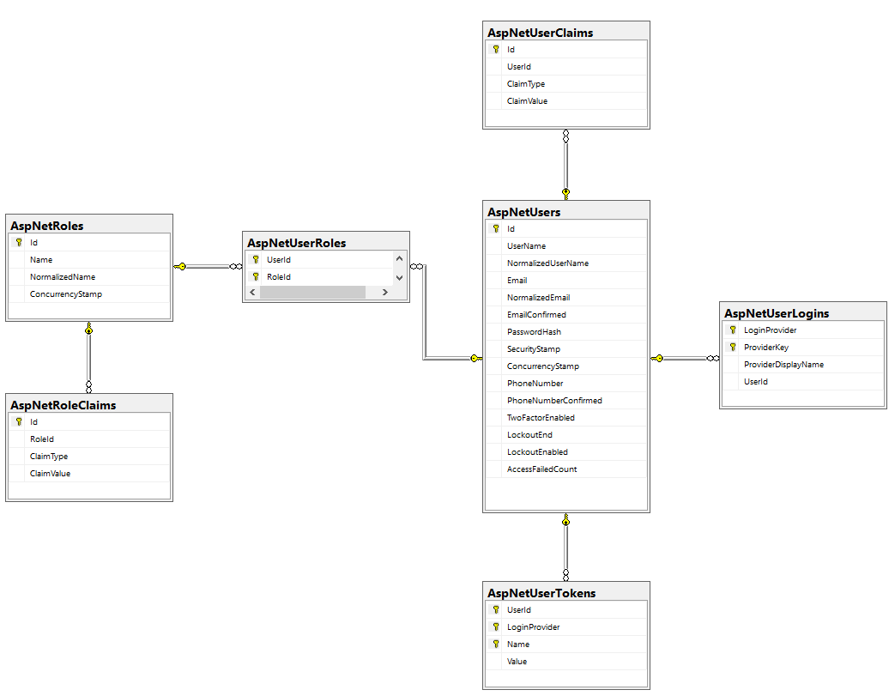

The Database tables used for Authorisation and Authentication

## Project/Time Tables

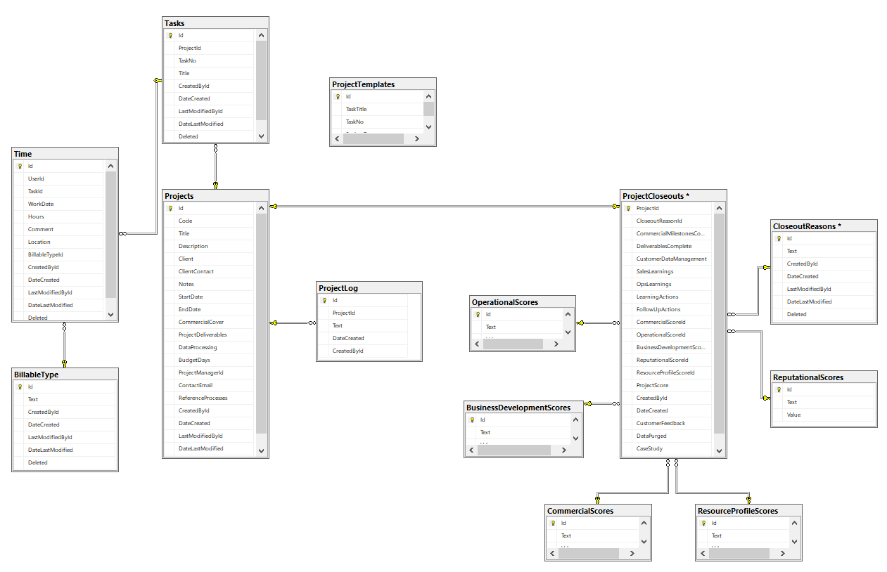

The Database tables used for tracking projects and time spent against each project

# Wire Frames

## Create Project

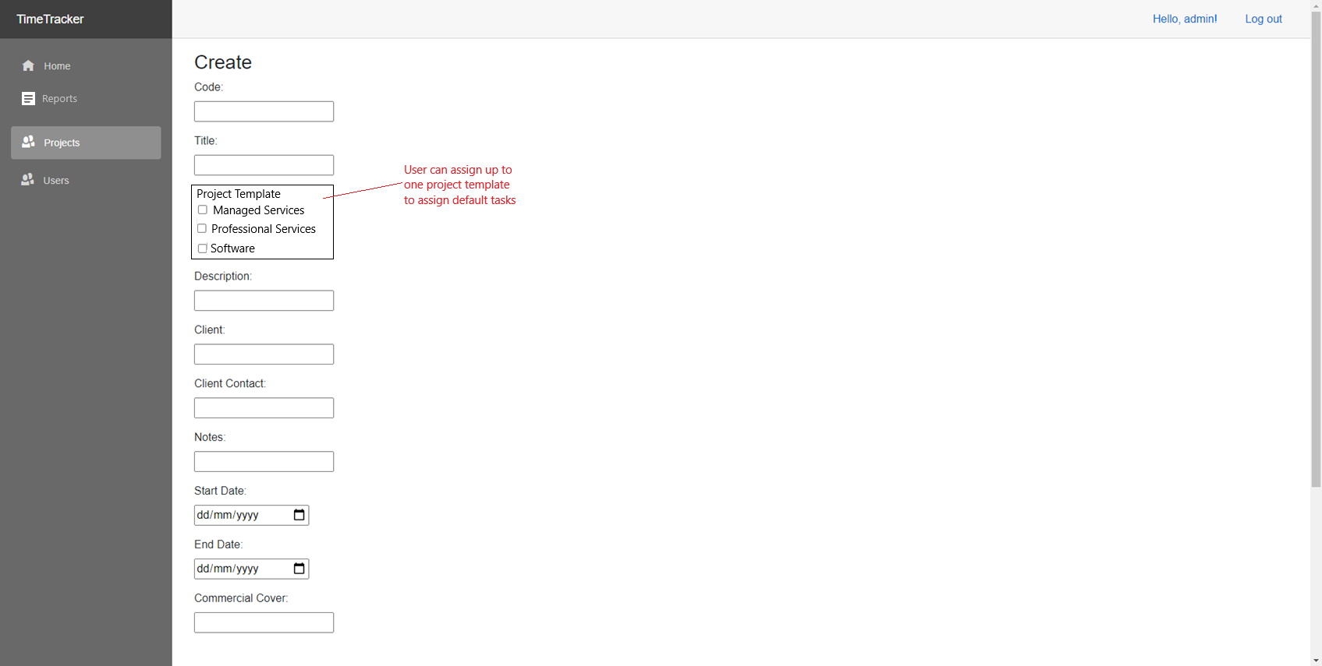

The top of the screen to create projects, this screen already exists in the system but we are adding the Project template section which allows tasks to be set according to templates

## Project Dashboard

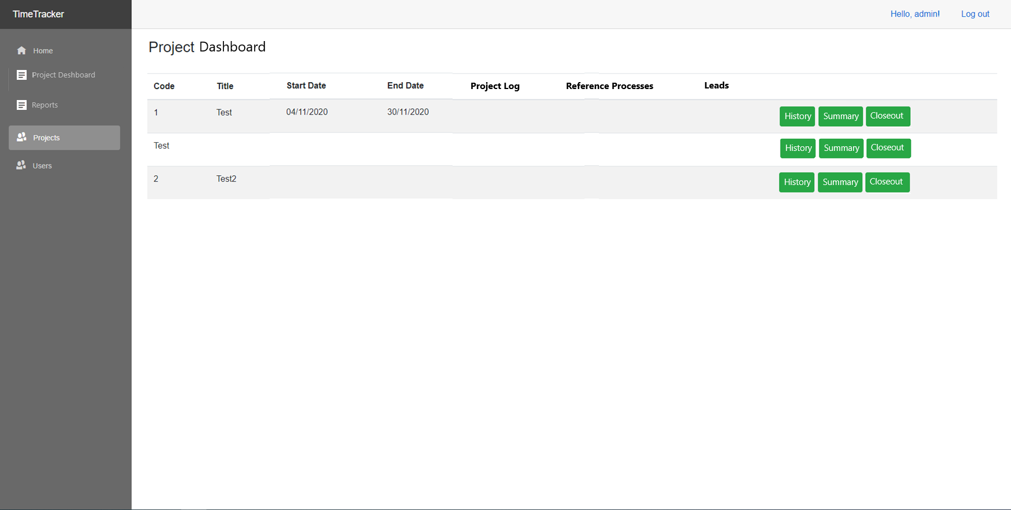

The Project Dashboard screen is a new screen that displays all information about current projects

## Project Closeout

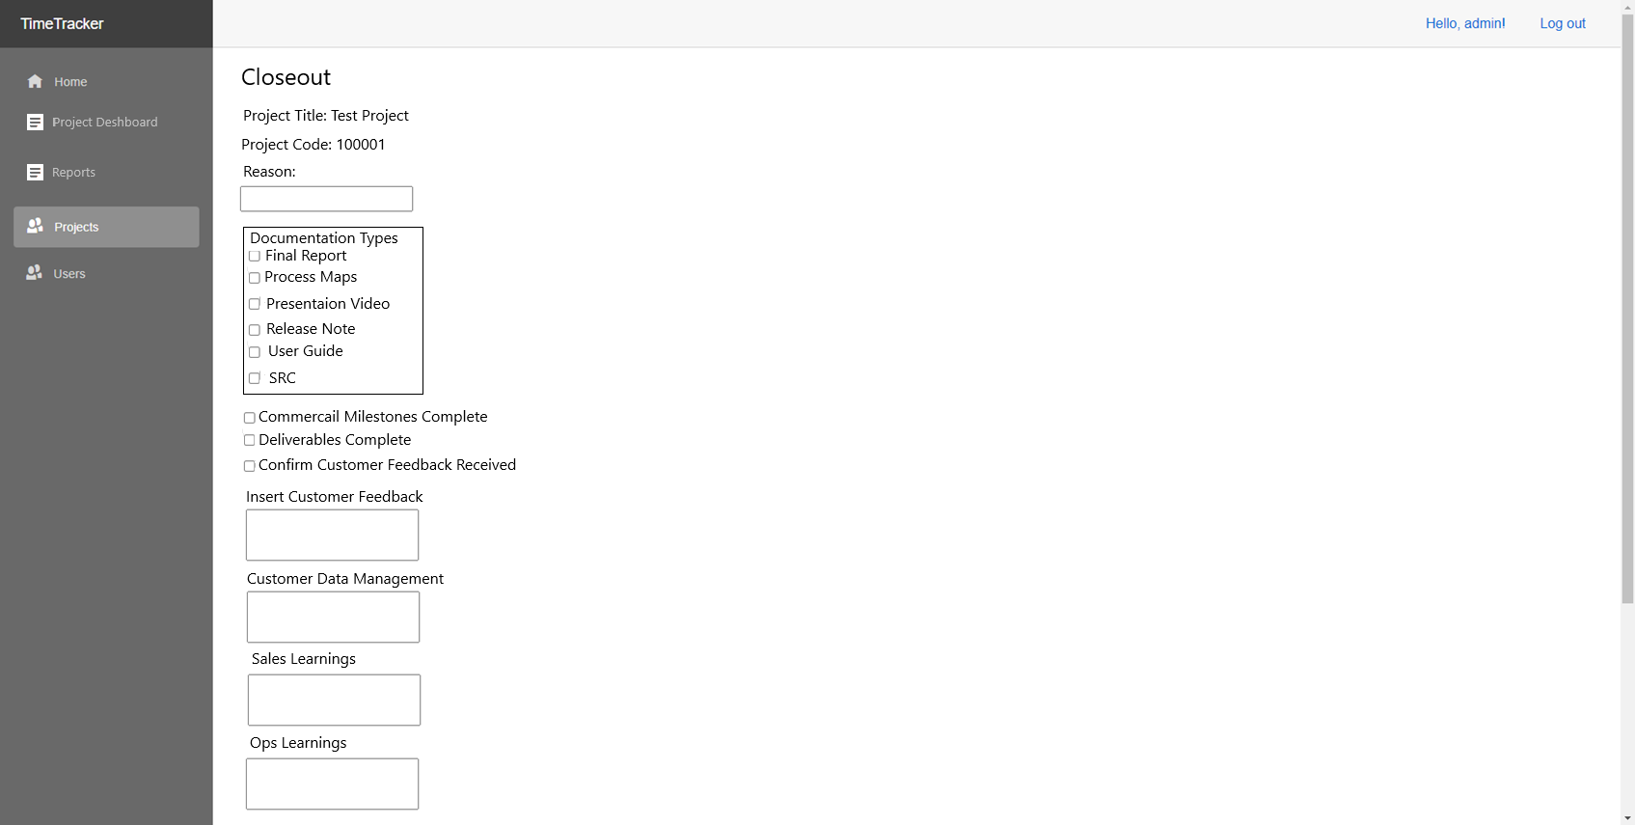

The Project closeout screen is the final stage of a project’s lifecycle, where a project is set from current to closed. By filling out and submitting a Closeout report the project is considered closed and removed from the projects screen, time screen and the project dashboard.

## Report Screens

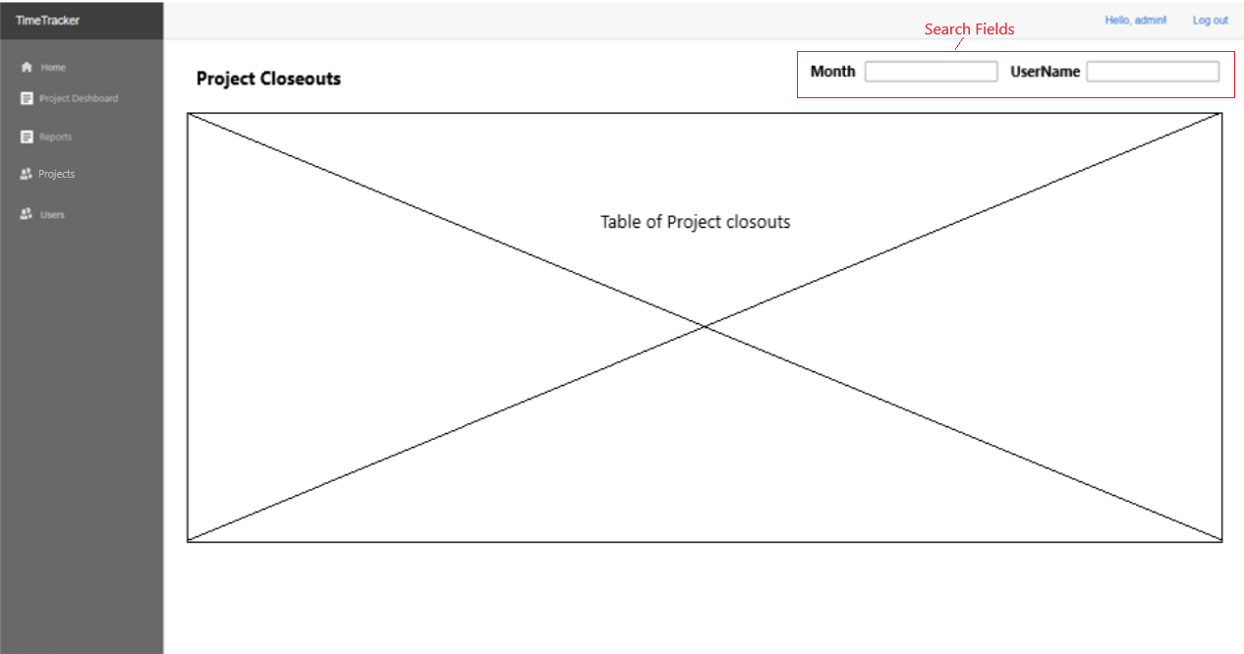

All report screens in the system will follow a similar layout with report title in the top left, report filters on the top right and the report data being displayed in a table in the centre of the screen.