|  |  |
| --- | --- |
| Athlone  2020 | **Athlone Institute of Technology**  **Faculty of Business and Hospitality**  **Higher Diploma in Science in Computing** |



Stewart Locke (A00277712)

Athlone

2020

Project Time Tracker

Table of Contents

1 Create Projects 4

1.1 Screenshot 4

1.2 Code 5

1.2.1 Client-side razor 5

1.2.2 Server-side C# 5

1.3 Issues 5

2 Project Dashboard 6

2.1 Screenshot 6

2.1.1 Full Dashboard 6

2.1.2 Project Log Dialog 6

2.1.3 History Dialog 6

2.1.4 Summary Dialog 6

2.2 Code 7

2.2.1 Client-side razor 7

2.2.2 Client-Side CSS 9

2.2.3 DB View 9

2.3 Issues 9

3 Project Closeout 10

3.1 Screenshot 10

3.2 Code 10

3.3 Issues 10

4 Hours Entered Report 11

4.1 Screenshot 11

4.2 Code 11

4.3 Issues 11

5 Month Summary Report 12

5.1 Screenshot 12

5.2 Code 12

5.3 Issues 13

6 Project Closeouts Report 13

6.1 Screenshot 13

6.2 Code 13

6.3 Issues 13

7 Waiting TImes 14

7.1 Screenshot 14

7.2 Issues 14

8 Web Hosted 14

8.1 Screenshot 14

8.2 Code 14

8.3 Issues 14

9 Target Google Chrome 14

Implementation

# Create Projects

## Screenshot

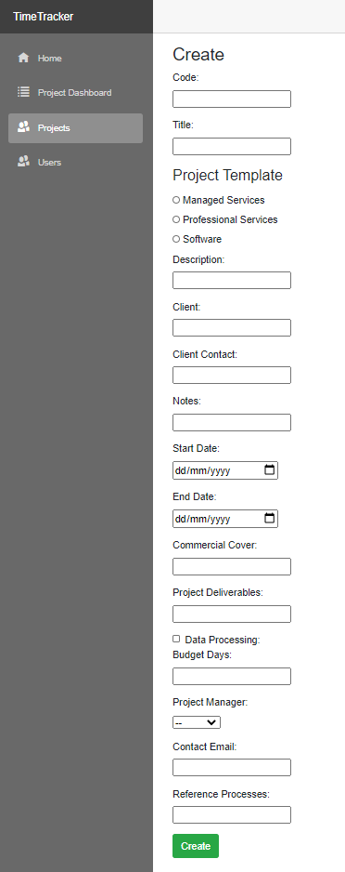

Newly added section

## Code

### Client-side razor



If the project had no id set (it’s a new project) and we have a list of template types for each template type print out a radio button.

### Server-side C#



If a project template type has been selected get the project templates that match that project type and add a new task to the newly created project

## Issues

My original wireframe had a fieldset box around the Project Template radio buttons but the Default styling of fieldset that comes with the Bootstrap 4.0 hides this box and I decided to leave it.

# Project Dashboard

## Screenshot

### Full Dashboard

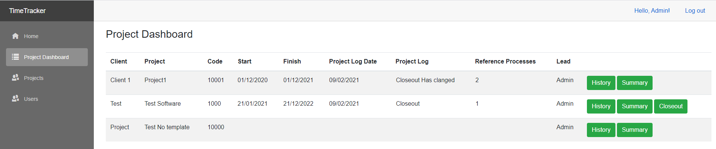

### Project Log Dialog

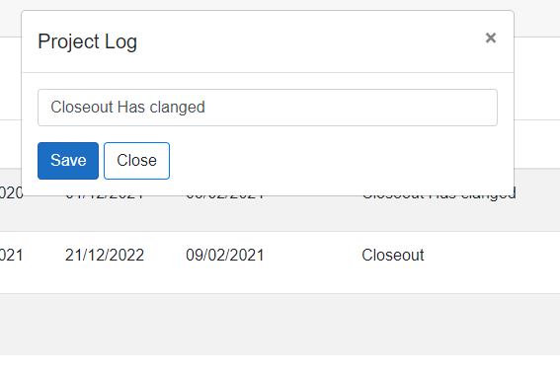

### History Dialog

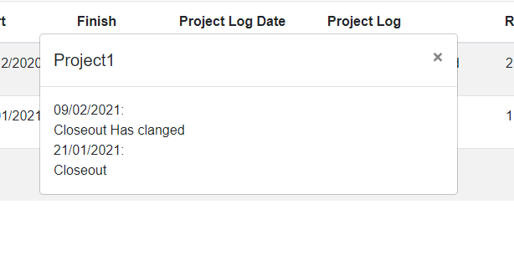

### Summary Dialog

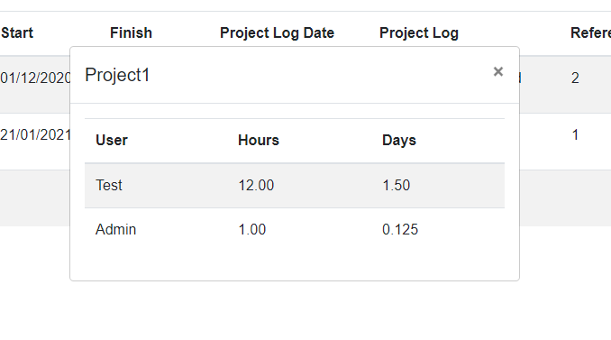

## Code

### Client-side razor



The /page directive is used to define the routing for the page.

We are checking if projects is still null then it hasn’t returned from the server yet, if it’s not null but with a length of 0 then the server has returned but there are no records to show and if it’s not null and length > 0 then we show the table of projects.

I decided to put the Project Log Dialog in the same file instead of extracting it to its own component as the information being displayed in the dialog is in the parent component and decoupling the two could require an extra server call.

The History Dialog and Summary Dialog are separate components that get passed the Project Id to show via their show functions.



OnInitializedAsync gets called as soon as the page loads, this method goes off to a service that in turn goes off to the server to retrieve the list of projects.

The ProjectLog function is called when a Project Log is clicked, it sets the project to display and sets the project log dialog to visible

The UpdateProjectLog function is called by the save button in the Project Log Dialog that calls a function in the IProjectService to call the API on the server updating the Project Log.

### Client-Side CSS



This CSS adds a red border to the sides of the Project Log cells when the mouse hovers over them.

### DB View



This is the DB view used to get the list of projects from the DB, we need to make a join on the Users table and a view of most recent project logs to get all the information needed to display.

We also confirm that the Project isn’t deleted and that it’s not closed, we check it’s not closed by checking that it doesn’t have a record in the ProjectCloseouts table.

## Issues

I had an issue with the styling of the hover event with the CSS initially the text would shift and sometimes change where line breaks occurred. I solved this issue by adding transparent borders that get turned red when the mouse hovers over the element.

# Project Closeout

## Screenshot

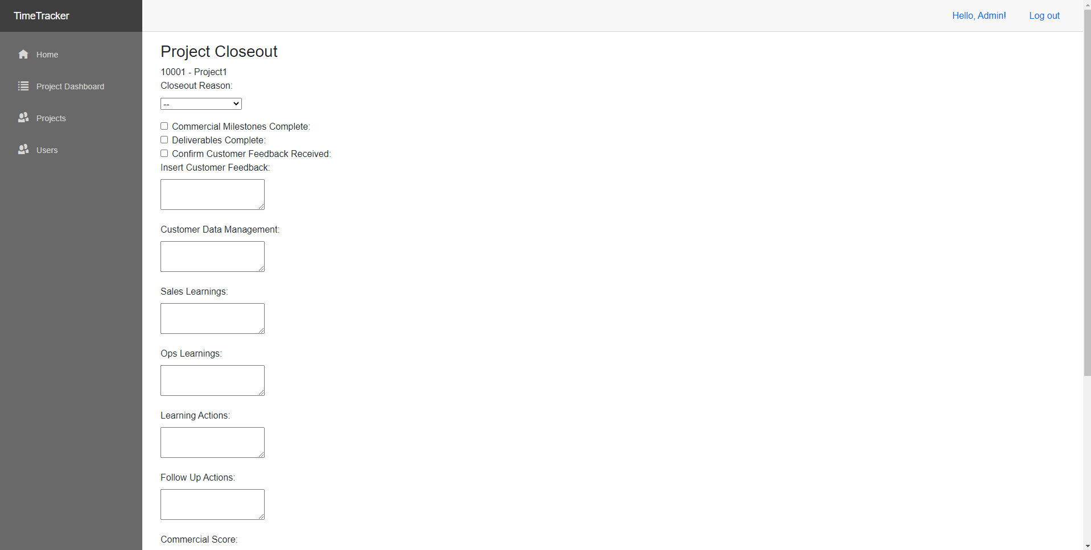

## Code



This is the code I was forced to use to calculate the Project score. The dropdowns set the projectCloseout Ids then I need to look through the list of values to find the corresponding score, which due to async operations and the value possibly being null I need to make a number of null checks and if I find null return 0.

## Issues

I ran into a few issues with this section. The first issue is that InputSelect doesn’t handle classes or integers so I was forced to use a custom InputSelectNumber component to handle the id’s, which are integers then use the above code to get the scores out of those ids.

# Hours Entered Report

## Screenshot

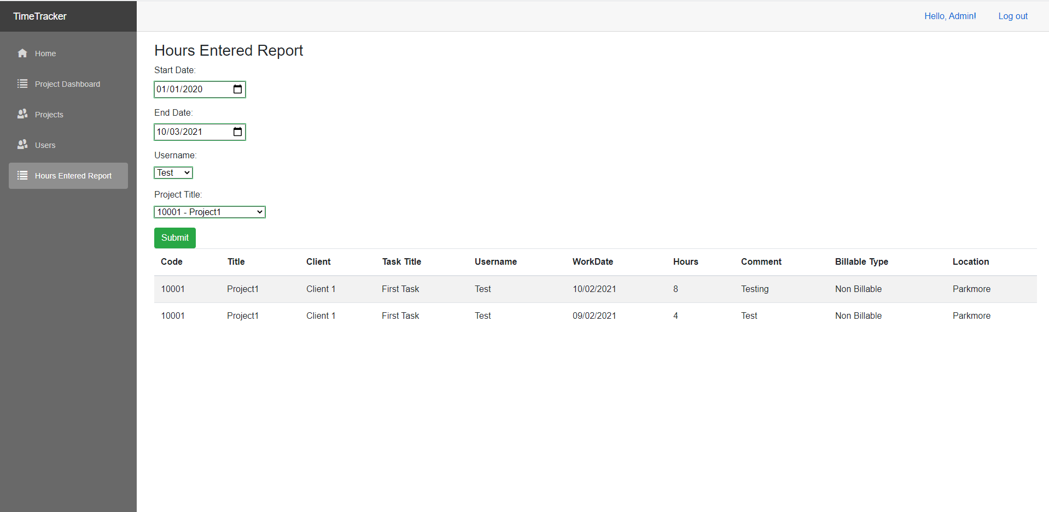

## Code

No interesting code

## Issues

No issues encountered

# Month Summary Report

## Screenshot

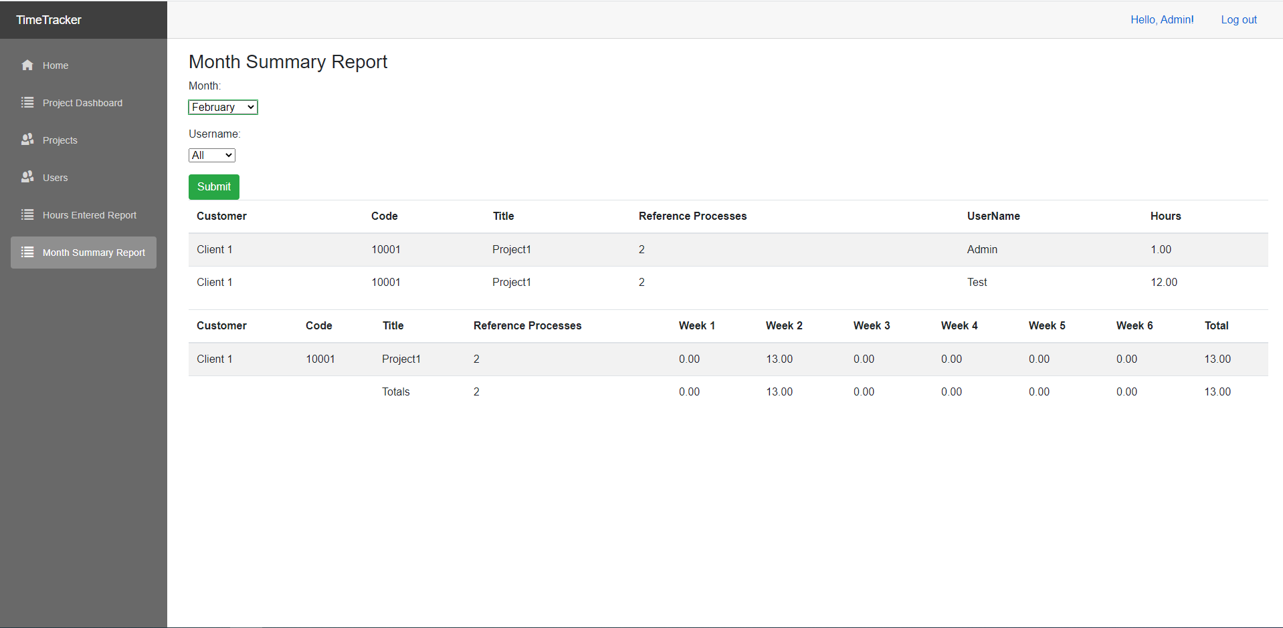

## Code





This is the code I used to call the DB stored procedure spMonthSummaryByUser, Entity Framework Core doesn’t support stored procedures so I am required to add the entities using a partial class and then call it using raw SQL.

## Issues

I ran into some issues with passing the values to the stored procedure and creating the returned object with the correct types, but with a bit of research I was able to find out that he numbers were being returned as a decimal.

# Project Closeouts Report

## Screenshot

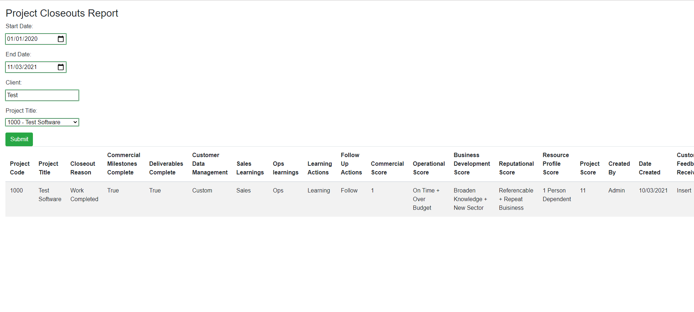

## Code

No interesting code

## Issues

No issues encountered