Cover Page
Student Name: Philip Hanley
Student Number: A00291827
Programme Title: AL_KCYBF_9_1 MSc in Software Design with Cyber Security
Year: 1st
Semester: 1
Module Title: Object Oriented Programming 1
Lecturer: Adrielle Moraes
Report Title: Object Oriented Programming Project Report
Due Date: Saturday 29th November 2025
Date Submitted:
Contents
Cover Page 1
Introduction 1
Reason for Choosing this Application 2
System Overview 2
UML Class Diagram 2
Data Flow Chart 4
Key Java Features Used 5
Object-Oriented Fundamentals 5
Interfaces and Polymorphism 5
Enums, Arrays, Collections, and API Usage 6
Advanced Java Features 6
Evaluation and Challenges 6

Introduction
In my project for OOP 1 I implanted a Gym Membership System made to showcase the main principles and modern Java features that I had learned in my study of this module. The application operates via an interactive console which allows the user to register as a gym member, pick a membership type, select a trainer and then a workout which in turn automatically books them a training session. The system demonstrates classes, inheritance, interfaces, enums, records, sealed classes, lambdas, exceptions and file handling.

Reason for Choosing this Application
I chose a Gym Membership application because it is a domain that is familiar and relevant to me and several of my classmates. This is because many of us workout at the TUS gym up here so processes such as signing up, choosing a membership and workout plans are easy to understand and apply into software features.
Additionally, the gym domain also maps naturally to object-oriented design as the entities (i.e. Members, PremiumMembers, Trainers, Workouts and Sessions all fit perfectly into class structures). This meant that I could show inheritance, interfaces, sealed classes and additional Java features in a realistic manner. The system remained simple enough to implement within the project timeline while still being rich enough to satisfy all assignment requirements.

System Overview
The application begins by prompting the user to enter their name, email, and membership type (BASIC, PREMIUM or VIP). Based on the choice, the system creates either a standard Member or a PremiumMember. The user then selects a trainer and a workout plan. A WorkoutSession is automatically scheduled for the next day and added to the GymScheduler.
At the end of the program, the system exports a summary of all sessions — including member and trainer names — to gym-summary.txt.
The program supports registering multiple members in one run, filtering premium users using lambdas and handling both checked and unchecked exceptions.

UML Class Diagram
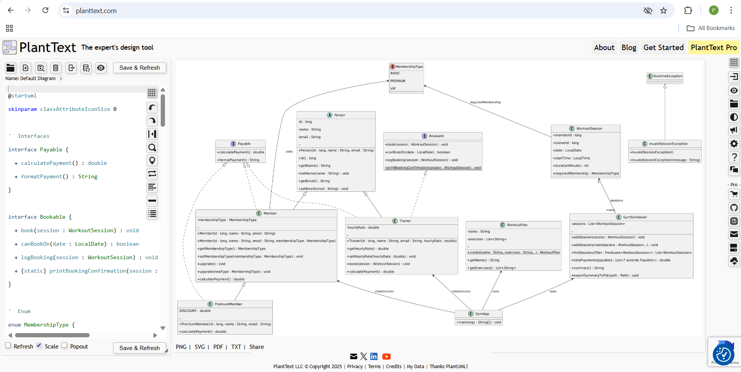
Figure 1: UML Class Diagram of the Gym Membership System. Made by Philip Hanley
This diagram shows how the classes, interfaces, enums and records in the system relate to one another, including inheritance, associations and implemented behaviours. The UML Diagram above displays a visual brainstorm of how the Gym Membership System is formatted and how the key components interact with one another. At the core of the diagram is a sealed abstract class (Person), which gives shared attributes (ID, name and email). Both the member and trainer class inherit from the class, reflecting the different types of people within the system. The subclass PremiumMember extends Member, which shows how the system handles specialised behaviour such as discounted payments.
Additionally represented are the supporting classes: WorkoutPlan is an immutable class that contains the exercises in a plan; MembershipType is an enum that stores fees and benefits; and WorkoutSession is a Java record that stores the specifics of a scheduled session. All sessions are controlled through the GymScheduler, which is associated with many WorkoutSession objects and offers capabilities such as filtering sessions and exporting summaries.
Lastly, the primary entry point that connects all of the classes is GymApp, which is shown at the bottom of the figure. Registration, trainer selection, session scheduling, and summary creation are all coordinated by it. All things considered, the UML diagram offers a clear overview of the structure of the system, demonstrating how inheritance, interfaces, enums, records, and associations are combined to create a comprehensive and well-structured program.

Data Flow Chart
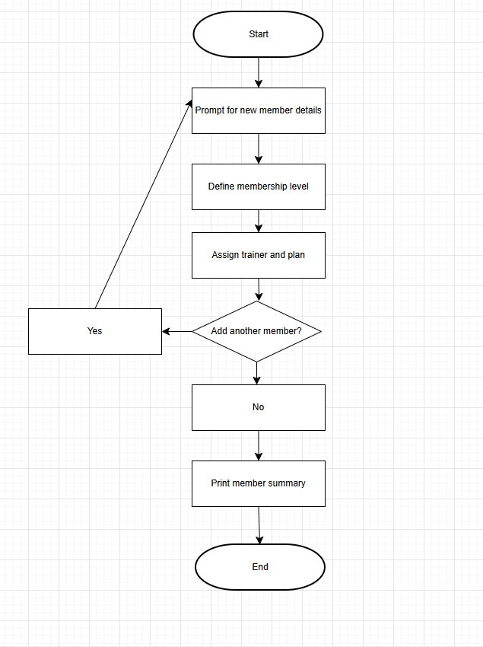
Figure 2: Flow Chart made by Philip Hanley on draw.io
This flowchart outlines the procedure done when adding a new member, assigning a trainer and plan and generating the final summary. The Gym Membership System's data flow is based on a simple procedure that follows how a gym might sign up new members. This sequence is well depicted in the flowchart. The user is prompted to provide the new member's details, including name and email, as soon as the program starts at the Start node. The system proceeds to define the membership level after obtaining the fundamental data. The type of Member object that is created in the system depends on the user's selection of whether the member will have a BASIC, PREMIUM, or VIP membership.
Assigning a trainer and a fitness plan comes next in the flow after the membership level has been selected. Because the user chooses from pre-established lists, the application always gets accurate data. The flowchart's major decision point, "Add another member?" is reached by the system once a trainer and plan have been selected. This choice governs the loop that permits more than one member to register within a single program run. If the user chooses "Yes," the system asks for a new member's information once more and the flow returns to the previous phase. Until the user determines they are done, this process is repeated.
The software moves on to the latter stages when No is chosen, signifying that there are no more members to add. A summary of the registered member or members and the sessions made for them is printed. The operation is then finished when the flow reaches the End node. This flowchart provides a clear, visual explanation of how data flows through the system, from user input to object creation to output and summary generation. It also precisely depicts the logical process in the GymApp class.

Key Java Features Used
This project was intentionally designed to meet all the requirements of the assignment. The below discusses the features in detail.

Object-Oriented Fundamentals
The Gym Membership System is built around clear object-oriented design. Each major part of a real gym — such as members, trainers, plans and sessions — is represented as a dedicated class. The Person class acts as the shared parent of Member and Trainer classes which allowed me to reuse the reoccurring attributes (i.e. ID, name and email) instead of rewriting them in every class. This also demonstrates inheritance in a very natural way.
In order to prevent repeating code when generating standard and premium members, I employed constructor chaining (this()) in the Member class. All subclasses use the super() keyword to initialize Person-inherited fields correctly. The system is encapsulated; getters and setters are used to access fields that are designated as private. Additionally, I added method overloading to the Member upgrade() methods, providing the class with two options to upgrade a user's membership. The fundamental ideas of object-oriented programming were reinforced by these minor but significant features.

Interfaces and Polymorphism
The system contains two interfaces: Payable and Bookable. Both were at use in order to highlight polymorphism in practical ways. The Payable interface allows different classes — such as Member, PremiumMember and Trainer — to compute payments through a common method. Even though each class calculates payments differently, they can all be processed together through the same interface type.
Modern Java interface features are displayed in the Bookable interface. It includes a private helper method, a static method for publishing confirmations, and a default method for logging. These demonstrate how interfaces can now provide behaviour in addition to method signatures. Trainer implements this interface, which is consistent with real-world reasoning, since only trainers are actually able to schedule a session. I was able to illustrate polymorphism and how Java allows several behaviour types through a single, cohesive framework by using these interfaces.

Enums, Arrays, Collections, and API Usage
I used an enum, MembershipType, to represent BASIC, PREMIUM and VIP membership levels. Each enum entry has its own monthly fee and an array of perks which provide the enum proper functionality instead of being used as a simple list. Arrays also show up whilst storing session durations in the scheduler and in the enum’s String() range of perks.
Collections are used heavily throughout the system. ArrayList is the main structure for storing members, trainers, workout plans and all workout sessions. This helped me dynamically add objects as the program runs. The Date and Time API (LocalData/LocalTime) is in function to make the valid session times, while StringBuilder and StringJoiner are used for creating the summary output. These practices kept the data structures flexible and the code appealing to the eye.

Advanced Java Features
The project includes several of the advanced language features listed in the assignment brief. I used a sealed class (Person) to control which classes are allowed to extend it. This works together with a pattern-matching switch in GymApp, which lets the program safely distinguish between Member, PremiumMember and Trainer when printing summaries.
Predicates and lambdas are used to search the scheduler for sessions and filter premium members. This gave several aspects of the project a contemporary, useful programming style. Both a custom unchecked exception (InvalidSessionException) and a checked exception (IOException) used when exporting the session summary to a text file serve as examples of exception management. When taken as a whole, these characteristics demonstrate how the project uses both traditional OOP principles and more recent Java versions.

Evaluation and Challenges
As I was able to apply the ideas from the module to a project that feels realistic rather than manufactured, building the gym membership system was a truly beneficial experience. In retrospect, the system satisfies the assignment's objectives, but getting there required overcoming a number of obstacles that deepened my understanding of Java.
Initialization of objects was one of the first problems I encountered. Membership types were not consistently defined correctly in early iterations of the software, resulting in unexpected NullPointerException problems whenever payment computations were performed. This forced me to step back and rethink how constructors were structured. These issues were resolved by adding safer defaults and verifying inputs, which also served as a reminder of how crucial it is to make sure every object begins its life in a correct state.
Predicates and lambdas also required some getting used to. Although I had a theoretical understanding of them, the concepts made sense when I used them to find sessions in the scheduler and filter premium members. Additionally, I discovered that variables that are captured and kept within lambdas must stay the same, which in turn solved the issue I had at the beginning of the project. This practice gave me a clearer idea of how Java mixes functional and object-oriented programming.
The interactive user input provided challenges that despite being on a smaller scale still proved to be significant. For instance, I had to make sure that the program didn’t crash in the scenario of a user inserting a false menu option (if a user pressed number 4 on the membership type when they should only press 1,2 or 3). With the use of both validation loops and error messages aided me in making the application more robust. These enhancements (albeit minor ones) helped me develop a smoother experience for the user and made me act with more caution when thinking about how real users may act. In summary, the system is stable, easy to follow and has a clear design and it also shows off inheritance, polymorphism, interfaces, sealed classes, records, and lambdas. The challenges I ran into taught me more than just Java code and practices as they reinforced good programming practices, problem solving skills and the need of trialling phases of the project frequently.
All things considered, the system has a clear design structure, is readable, and is stable. Inheritance, polymorphism, interfaces, sealed classes, records, immutable types, enums with state, lambdas and both checked and unchecked exceptions are all properly demonstrated. Beyond simply teaching me Java syntax, the obstacles I encountered reaffirmed excellent programming habits, problem-solving techniques and the importance of testing program components as they are developed.

Future Improvements
Although the current system satisfies all assignment requirements, it might be expanded in a number of ways in the future. Adding permanent storage, which saves members and sessions in between runs rather than just in memory, would be a beneficial enhancement. Text files, JSON, or a lightweight database might be used to accomplish this. To make the system more user-friendly, another improvement would be to replace the terminal interface with a graphical interface using JavaFX or Swing. Additionally, the booking system might be expanded to let users select times and dates, verify the availability of trainers, and cancel or change already scheduled sessions. Lastly, the application would be significantly more realistic if trainers and training plans could be created dynamically. These enhancements would build upon the existing design and further develop the system into a fully featured application.

Conclusion
In summary, the Gym Membership System effectively integrates all of the key ideas discussed in this session and applies them to a familiar and practical situation. In addition to utilizing contemporary Java features like sealed classes, records, enums with associated data, lambda expressions, and both checked and unchecked exceptions, the project makes excellent use of object-oriented concepts like inheritance, polymorphism, and encapsulation.
Throughout the duration of this project, I faced many hurdles in the development process that further highlighted good programming practices, especially the importance of verifying input, correctly initializing objects and testing the code on a frequent basis. In the end, solving these issues improved my Java skills and built on to the system’s dependability and structure. Overall, the project meets the targets and guidelines detailed for the assignment and provides a solid basis for further improvements which could include persistent storage, improved user interfaces and so on.

