gPRC KAFKA PRODUCER -> KAFKA CONSUMER COMMUNICATION

This pattern can be used in Kubernetes applications where we can establish a persistent TCP connection between two microservices via standard gRPC socket.
The architecture is that Kafka producer microservice sends events to a topic from which the Kafka consumer microservice consumes. Both producer and consumer validates the event produced and consumed via a serialized protobuf contract that is stored in the Kafka Schema Registry.
Infrastructure preparation

We have provided with a docker-compose.yml file that will allow you to start a Kafka broker and a Schema Registry:

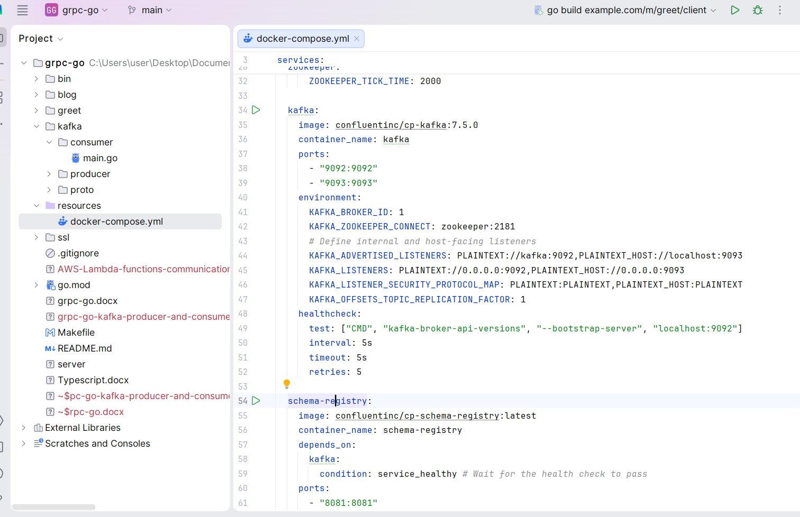

Run this command to start the infrastructure:

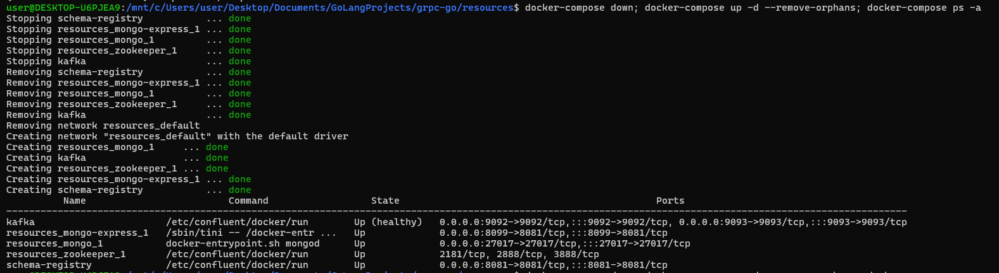
The Protocol Buffer Definition (user.proto)

This is the single source of truth for both Kafka producer and consumer microservices.

syntax = "proto3";
package user.v1;
message UserRequest {
int64 id = 1;
}
message UserResponse {
string name = 1;
}

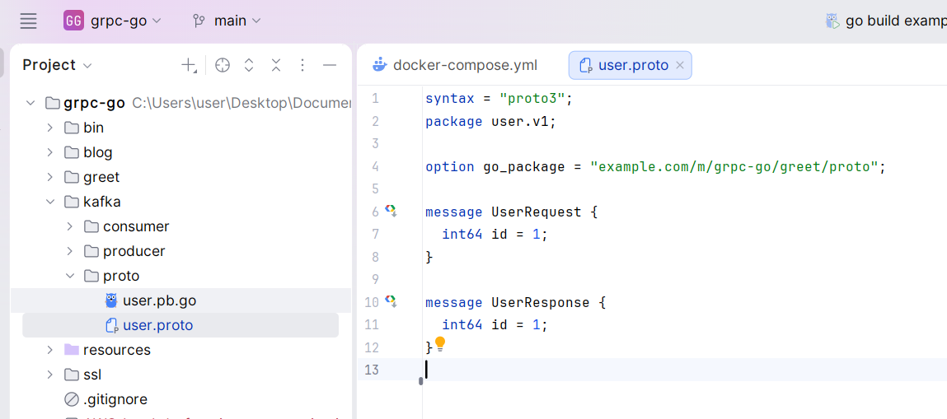

Kafka Producer

package main
import (
"fmt"
"log"
pb "example.com/m/kafka/proto"
"github.com/confluentinc/confluent-kafka-go/v2/kafka"
"github.com/confluentinc/confluent-kafka-go/v2/schemaregistry"
"github.com/confluentinc/confluent-kafka-go/v2/schemaregistry/serde"
"github.com/confluentinc/confluent-kafka-go/v2/schemaregistry/serde/protobuf"
)
func main() {
srClient, err := schemaregistry.NewClient(schemaregistry.NewConfig("http://localhost:8081"))
if err != nil {
log.Fatalf("Failed to create SR client: %s", err)
}
serConfig := protobuf.NewSerializerConfig()
ser, err := protobuf.NewSerializer(srClient, serde.ValueSerde, serConfig)
if err != nil {
log.Fatalf("Failed to create serializer: %s", err)
}
p, err := kafka.NewProducer(&kafka.ConfigMap{"bootstrap.servers": "localhost:9093"})
if err != nil {
log.Fatalf("Failed to create producer: %s", err)
}
defer p.Close()
topic := "user-updates-value"
for i := 1; ; i++ {
user := &pb.UserRequest{Id: int64(i)}
payload, err := ser.Serialize(topic, user)
if err != nil {
log.Printf("Serialization error: %s", err)
continue
}
err = p.Produce(&kafka.Message{
TopicPartition: kafka.TopicPartition{Topic: &topic, Partition: kafka.PartitionAny},
Value: payload,
}, nil)
if err != nil {
log.Printf("Produce error: %s", err)
}
if i%1000 == 0 {
p.Flush(15 * 10)
fmt.Printf("Successfully produced %d messages.\n", i)
}
}
}

Kafka Consumer

package main
import (
"fmt"
"log"
pb "example.com/m/kafka/proto"
"github.com/confluentinc/confluent-kafka-go/v2/kafka"
"github.com/confluentinc/confluent-kafka-go/v2/schemaregistry"
"github.com/confluentinc/confluent-kafka-go/v2/schemaregistry/serde"
"github.com/confluentinc/confluent-kafka-go/v2/schemaregistry/serde/protobuf"
)
func main() {
topic := "user-updates-value"
subject := "user-updates-value"
c, err := kafka.NewConsumer(&kafka.ConfigMap{
"bootstrap.servers": "localhost:9093",
"group.id": "my-local-group",
"auto.offset.reset": "earliest",
})
if err != nil {
log.Fatalf("Failed to create consumer: %s", err)
}
defer c.Close()
c.SubscribeTopics([]string{topic}, nil)
srClient, err := schemaregistry.NewClient(schemaregistry.NewConfig("http://localhost:8081"))
if err != nil {
log.Fatalf("Failed to create SR client: %s", err)
}
deser, err := protobuf.NewDeserializer(srClient, serde.ValueSerde, protobuf.NewDeserializerConfig())
if err != nil {
log.Fatalf("Failed to create deserializer: %s", err)
}
for {
msg, err := c.ReadMessage(-1)
if err == nil {
user := &pb.UserRequest{}
err := deser.DeserializeInto(subject, msg.Value, user)
if err != nil {
log.Printf("Deserialization error: %s", err)
continue
}
fmt.Printf("Received user ID: %d\n", user.Id)
} else {
log.Printf("Consumer error: %v (%v)\n", err, msg)
}
}
}

Make all
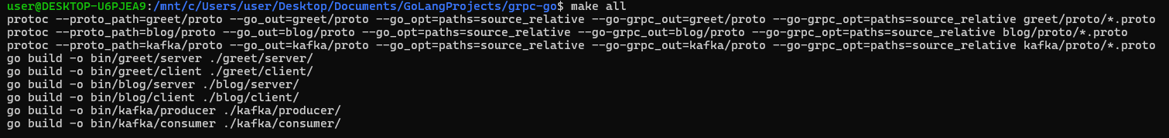

Open two Shell Windows, one for the Kafka producer and other for the Kafka consumer and run them:

