

# Actividad Evaluable: Repositorio

Marcos Castañeda

A01643274

15 / 09 / 2023

Git clone <link>

Cd <repositorio>

Mkdir <nueva carpeta>

Cd <nueva carpeta>

Touch <archivo.txt>

Nano <archivo.txt>

Git init (repositorio personal)

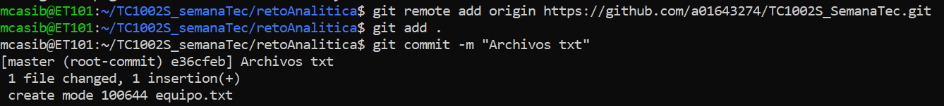

Git remote add <link repo personal>

Git add . (agregua todo)

Git commit -m (guarda mis cambios)

Git push origin master (sube los cambios al repo)

Liga repositorio: https://github.com/a01643274/TC1002S_SemanaTec.git