Winged Worlds Collide: Tracking Habitat Overlap and Landcover for Sharp-tailed and Greater Sage Grouse

Final Project: Analysis Progress Report 1
Justification: How does habitat overlap between Sharp-tailed and Greater Sage Grouse at lekking sites, in relation to land cover changes, proximity to water, and elevation, contribute to habitat fragmentation and hypothesized effects on the species' reproductive success?
Objective: To analyze the habitat overlap between Greater Sage Grouse and Columbian Sharp-tailed Grouse using GIS tools, focusing on land cover preferences, proximity to water, and their relationship to lekking sites.
Analysis Progress: I have prepared the data for the different analysis objectives. This preparation included:
- Clip Layers to the extent of AOI
- Adjust symbology of Seasonal Habitat
- Mosaic to Raster: DEM preparation
- Create Hillshade from DEM
- Ensure data projections are the same for each dataset
  - Use Geoprocessing tools “Project” or “Project Raster”
- Learn about the data and get it organized
  - Adjust transparency and overlay to better understand what data is being represented and the angle at which I can best start analyzing the different relationships of the data.
- Create General and Core Ranges for each species’ Lekking sites.
  - Creating MBG for each species, Kernel Density, export values to points, Sorting data and calculating 50% core and 95% general from kernel density, reclassify kd to each calculation.
Achievements and Hurdles: I have also continued to research additional data that may be able to help add helpful information during the analysis of the Greater Sage Grouse and Columbian Sharp-tailed Grouse habitats and Lekking sites. I located a seasonal habitat range for each species which actually solved one of the data challenges. I was able to confirm that I was not actually missing Lekking site data for the Columbian Sharp-tailed Grouse, but they do not utilize the western Box Elder region except for in the summer.

Pertinent Data progress:

Occupied Lekking sites and seasonal habitat range prior to any data preparation:
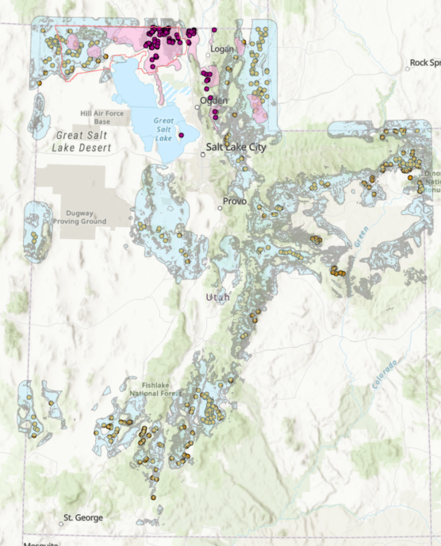

Calculated Core and home ranges and Minimum Bounding Geometry (points=lekking sites.)
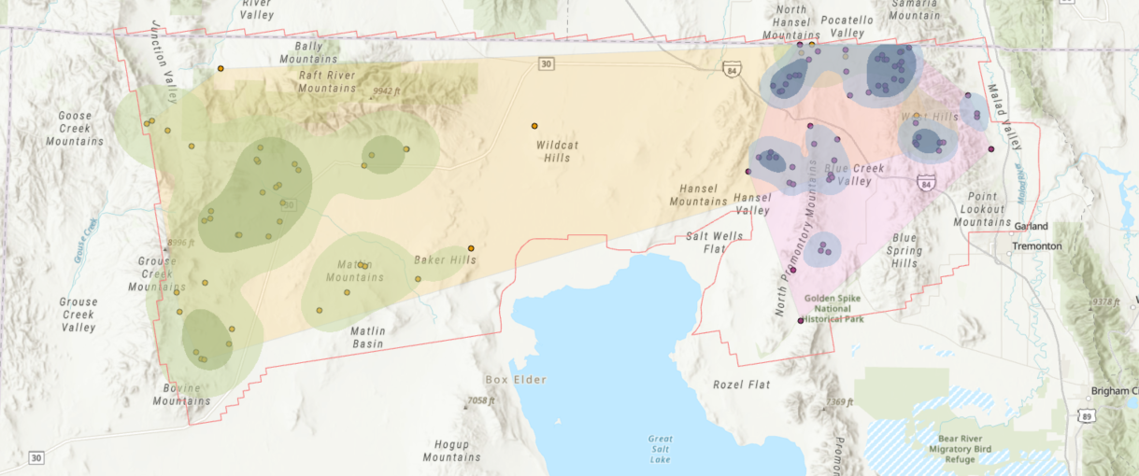
Greater Sage Grouse Seasonal Habitat Range: (Green=summer, purple=winter, peach=nesting- which is also covered by summer range.)
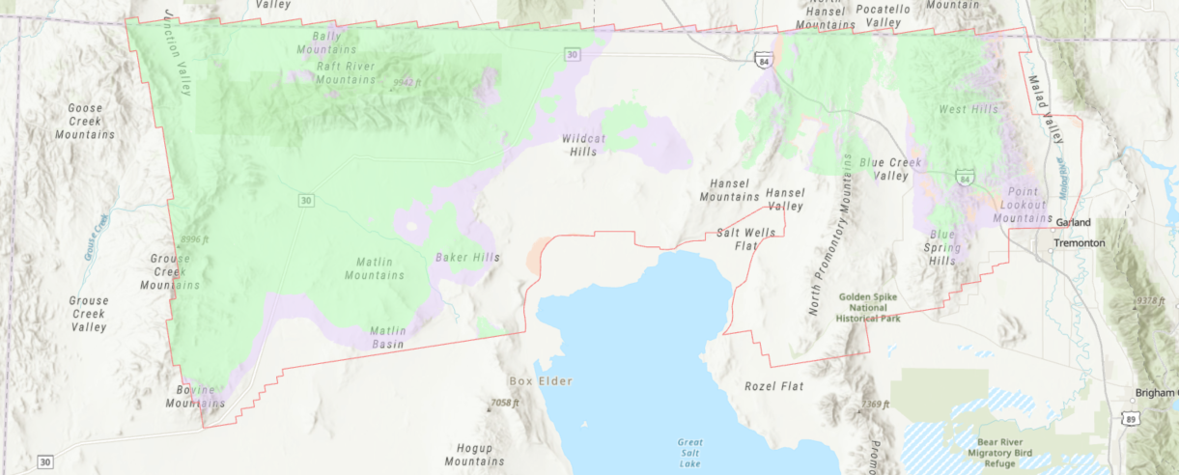
Columbian Sharp-tailed Grouse Seasonal habitat range: (blue= summer, yellow=year- long)
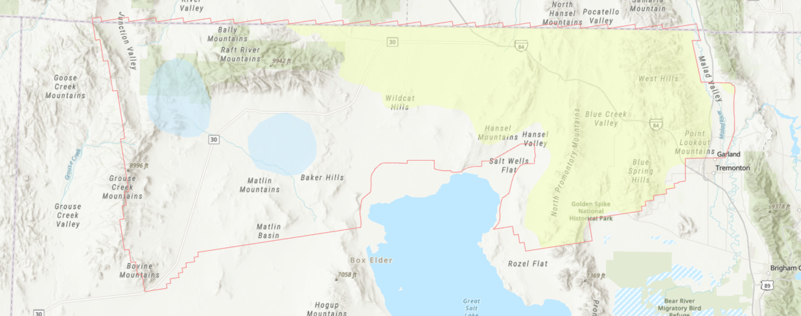
Box Elder County Area of Interest: Landcover, streams, hillshade, and occupied Lekking Sites. (Landcover and streams were massive files, so they were cut to the AOI)
