Date of publication xxxx 00, 0000, date of current version xxxx 00, 0000.
Digital Object Identifier 10.1109/ACCESS.2024.Doi Number
An Interpretable Visualization Framework for Brain Age Prediction Using a VGGNet-Based Model
Ting-An Chang, Shao-Yu Yan, Kuan-Chih Wang, and Chung-Wen Hung
National Yunlin University of Science and Technology, Yunlin 64002, Taiwan.
Corresponding author: Chung-Wen Hung (e-mail: clliu@yuntech.edu.tw).
ABSTRACT Brain age has been widely recognized as an important biomarker for monitoring adolescent brain development and assessing dementia risk. However, existing model visualization methods primarily highlight brain regions associated with aging, making it difficult to comprehensively reveal broader brain changes. In this study, we developed a VGGNet-based brain age prediction model and proposed the Softmax-Derived Brain Age Mapping algorithm to simultaneously identify brain regions associated with both youthful and aging features. The resulting saliency maps provide explicit representations of developmental and degenerative processes across different brain regions. Further analysis of the saliency maps across different samples revealed the sequence of human brain aging, showing that the frontal lobe is the earliest region to exhibit aging-related features, whereas the ventricles are the last. These findings are consistent with previous studies of brain aging. From an application perspective, we further explored the potential of the proposed framework in neurodegenerative diseases. The analysis reveals that dementia patients generally exhibit an advanced brain age, with cortical aging being markedly more pronounced than in age-matched healthy samples. Notably, although dementia cases were not included in the training set, the model was still able to localize abnormalities in relevant brain regions, underscoring its potential value as an assistive tool for early dementia diagnosis.
INDEX TERMS Brain age prediction, Convolutional neural networks, Dementia, Model visualization, Neuroimaging
- INTRODUCTION
With the intensification of declining birth rates and population aging, the demand for precision medicine has become increasingly urgent. Predicted Age Difference (PAD) has been shown to be highly associated with cognitive impairment and dementia, making brain age prediction an important tool for assessing neurodevelopment and identifying early cognitive decline. Franke et al. (2012) demonstrated that deep learning models based on Magnetic Resonance Imaging (MRI) can accurately predict brain age, providing reliable and quantifiable indicators for adolescent brain development. Similarly, Jonsson et al. (2019), Liem et al. (2017), and Cole et al. (2017) reported that PAD is strongly linked to cognitive decline, mild cognitive impairment (MCI), and Alzheimer’s disease (AD) in middle-aged and elderly populations. Consequently, brain age has increasingly been adopted as a formal clinical indicator in recent years.
Most existing models output brain age as a single scalar value, which limits their diagnostic applicability. If visualization techniques are integrated to elucidate how predictions are generated and to map the key brain regions involved, brain age prediction models would no longer serve merely as numerical indicators but rather as comprehensive frameworks that enable region-specific analyses of brain development and aging. Particularly for the early detection of dementia, a model capable of accurately tracking abnormal regional aging would provide substantial clinical value by enabling timely intervention, thereby helping to slow disease progression and improve patient quality of life.
Motivated by these considerations, this study proposes a deep learning–based brain age prediction framework that integrates brain MRI with a key region identification algorithm. The framework is capable of assessing brain development in adolescents and assisting in the identification of cognitive decline risk in older adults, holding significant implications for monitoring child development and preventing dementia.
The visualization technique Grad-CAM (Gradient-weighted Class Activation Mapping), proposed by Selvaraju

TABLE I
Summary of Best-Performing Brain Age Prediction Models
Articles | Dataset (n) | Training / Test (n) | Test Set Age Range  (Years) | MAE  (Years)
Chang et al., 2025 | CamCAN(483) | - | 18-88 | 5.47
Eltashani et al., 2025 | ABIDE I(228), ABIDE II(505), BNU(328), Berlin(142),  Cleveland Clinic(150), IXI(544), ADNI(219), Train-39(135) | 1801/225 | 6-90 | 3.56
Zheng et al., 2025 | Healthy Group(1,182)ª | 850/332 | 19-84 | 4.60
Pang et al., 2024 | CamCAN(651) | 521/130 | 18-89 | 7.46
Zhang et al. 2024 | IXI(459), CoRR(266), OASIS(264)  , ABIDE I(258), ABIDE II(217), Local Centers (118) | 1,464/118 | 18-94 | 3.08
Wood et al., 2022 | Local Hospital(19,807) | 15,146/4,661 | 18-95 | 2.97
Xifra-Porxas et al., 2021 | CamCAN(613) | - | 18-88 | 4.88
Wang et al., 2019 | Rotterdam Study(8,768) | 5865/550 | 46-96 | 4.45
Jonsson et al., 2019 | DeCODE(1,469), IXI(440), UK biobank(12,395) | 1,909/12,395^{b} | 45-80 | 3.63
Lancaster et al., 2018 | BAHC(2,003)^{c}, CamCAN(648) | - | 18-88 | 5.08
Liem et al., 2017 | LIFE(2,354) | 1177/1177 | 19-82 | 4.29
Cole et al., 2017 | BAHC(2,001)^{d} | 1601/200 | 18-90 | 4.16
ªThe Capital Medical University Xuanwu Hospital, in collaboration with 15 universities and hospitals nationwide, created a self-built dataset of whole-brain sMRI images collected from healthy volunteers using 3.0T MRI scans.
^{b}DeCODE and IXI are used as training datasets, while the UK Biobank is used as the test dataset.
^{c}BAHC includes 14 publicly available datasets: ABIDE(184), Beijing Normal University(181), Berlin School of Brain & Mind(49), CADDementia(12), Cleveland Clinic(31), ICBM(322), IXI(561), MCIC(93), MIRIAD(23), NEO2012(39), NKI(160), OASIS(288), WUSL(24), TRAIN-39(36).
^{d}BAHC includes 14 publicly available datasets: ABIDE(184), Beijing Normal University(179), Berlin School of Brain & Mind(49), CADDementia(12), Cleveland Clinic(31), ICBM(322), IXI(561), MCIC(93), MIRIAD(23), NEO2012(39), NKI(160), OASIS(288), WUSL(24), TRAIN-39(36).

et al. (2019), has been widely applied for highlighting salient regions in medical imaging and has inspired multiple variants. In the context of brain age prediction, Wood et al. (2022) employed the Guided Backpropagation algorithm and found that the model primarily focused on cerebrospinal fluid, particularly the lateral ventricles, underscoring their importance in brain age estimation. Similarly, Dartora et al. (2024) utilized SmoothGrad, another gradient-based technique, and identified periventricular, temporal, and insular regions as being highly influential in brain age prediction.
However, these approaches face inherent limitations when applied to brain age prediction. Since the output of brain age prediction is a single scalar value, gradient-based visualization techniques such as Grad-CAM and its variants typically highlight only regions strongly associated with aging features. To overcome this limitation, we propose a refined algorithm that can simultaneously identify regions associated with both youthful and aging features, thereby providing more comprehensive information in brain saliency maps.
RELATED WORKS
We reviewed recent literature on brain age prediction and summarized the best-performing models (Tables I and II). The results indicate that preprocessing, data augmentation, model architecture, and training strategies all play critical roles in determining model accuracy, and generalizability.
Common preprocessing techniques include the segmentation of gray matter (GM), white matter (WM), and cerebrospinal fluid (CSF), skull stripping, and image registration, which allow models to focus on brain structures most associated with age-related changes. Bias correction and intensity normalization further help to reduce imaging heterogeneity and smooth the loss surface, thereby facilitating model convergence. Data augmentation methods, such as rotation and translation, are frequently employed to enhance data diversity and reduce overfitting.
Model architecture is a critical factor influencing predictive performance. Although conventional convolutional neural networks (CNNs) have achieved certain success in brain age prediction, their performance has not been optimal. As shown in Table II, CNN-based models such as those reported by Wang et al. (2019) and Cole et al. (2017) yielded higher MAE values, indicating that traditional CNNs may not be the best choice for this task. Recent studies suggest that lightweight models exhibit stronger generalizability and improved accuracy, while ensemble approaches can further enhance reliability and mitigate overfitting (Peng et al., 2021).
However, evidence from the experimental results of Dufumier et al. (2021) and Hanson et al. (2024) suggests that data augmentation does not necessarily provide positive benefits. Dufumier et al. (2021) reported that, under standardized VBM preprocessing, data augmentation offered

TABLE II
Image Processing Methods and Models of Top Brain Age Prediction Models
Articles | Preprocessing Methods | Data Augmentations | Model Architecture
Chang et al., 2025 | T1-MRI: GM / WM / CSF segmentation, skull stripping, linear registration, spatial normalization, bias correction  rs-fMRI: Removal of initial volumes, slice-timing correction, motion correction, rigid-body registration, spatial normalization, gaussian smoothing, denoising, temporal filtering |  | BrainDCNw  Dual-modality (weighted rs-fMRI functional connectivity + weighted T1 brain volume) model.  (10-fold cross-validation).
Eltashani et al., 2025 | Skull stripping, linear registration, GM segmentation, resample and align | Weighted MAE Loss(assign higher importance to samples from underrepresented age groups). | Lightweight CNN  GM model.
Zheng et al., 2025 | Brain region segmentation, skull stripping, affine registration, volume normalization |  | RFBLSO  Brain region normalized volume feature model.
Pang et al., 2024 | Bias correction, skull stripping, affine registration, spatial smoothing, spatial normalization |  | Tri-UNet  WB model.
Zhang et al., 2024 | GM / WM segmentation, skull stripping, linear registration | Rotation of 0°-40°, Translation of 10 voxels. | VGG-13  WB, GM and WM combination model(10-fold cross-validation).
Wood et al., 2022 | Cropping to the same size, intensity normalization^{e} |  | DenseNet121  WB (non-skull-stripped) model.
Xifra-Porxas et al., 2021 | MRI: GM / WM / CSF segmentation, cortical segmentation, skull stripping, nonlinear registration, Z-score normalization  MEG: Filtering, resampling, denoising, leakage correction, source localization, brain region segmentation |  | CCA+GPR  MRI-MEG feature stacking model  (10-fold cross-validation)
Wang et al., 2019 | GM / WM / CSF segmentation, nonlinear registration, spatial modulation | Single-subject longitudinal model (one subject with one or multiple MRI scans from different time). | CNN  GM density map model.
Jonsson et al., 2019 | GM / WM segmentation, bias correction, skull stripping, rigid registration, Jacobian maps | Rotation of 0°-40°, Translation of 10 voxels. | ResNet  WB, Jacobian maps, GM and WM combination model (10-fold cross-validation).
Lancaster et al., 2018 | GM / WM segmentation, smoothing, affine registration, nonlinear registration, spatial normalization, modulation, bias correction |  | SVR  GMV and WMV combination model.
Liem et al., 2017 | Skull stripping, linear registration, filtering, nonlinear registration, mcflirt, GM / WM segmentation, bias correction, denoising |  | SVR+Random Forest  Multimodal stacking model（connectivity matrix 197, connectivity matrix 444, cortical thickness, cortical surface area, subcortical volumes）
Cole et al., 2017 | GM segmentation, motion artifact removal, nonlinear registration, resampling include modulation, spatial smoothing | Rotation of 0°-40°, Translation of 10 pixels. | CNN  GM normalized volume map model
^{e}T2-w MRI is used as the input, and for other models, if not specified, T1-w MRI is used as the input.

no significant advantages, and excessive augmentation could even disrupt the model’s ability to learn brain age–related imaging features. Similarly, Hanson et al. (2024) argued that the introduction of additional spatial variations during MRI acquisition (e.g., subject head motion) substantially reduces model accuracy, indicating that when imaging quality and spatial alignment are already highly standardized, further augmentations such as rotations or translations may act as sources of noise rather than improvements. The effectiveness of data augmentation in brain age prediction remains uncertain under standardized preprocessing.
EXPERIMENTS
This study proposes an interpretable visualization-driven brain age prediction model inspired by the VGGNet architecture, enabling fast and accurate brain age estimation from T1-weighted MRI scans. The proposed Softmax-Derived Brain Age Mapping (SD-BAM) is further applied to generate Brain Age Maps, providing visual clinical support (Fig. 1).
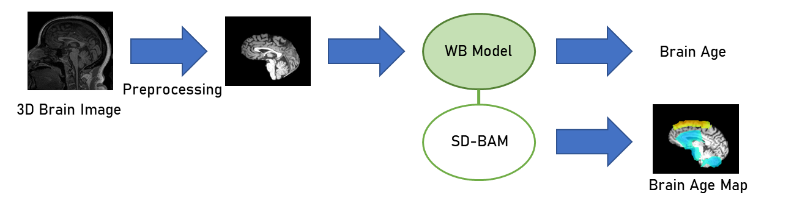
- System flow chart.
- DATA SETS
This experiment utilized T1-weighted 3D MRI scans from four publicly available neuroimaging datasets: ABIDE, ADNI, CamCAN, and IXI (Table III). The CamCAN dataset was obtained from the CamCAN repository (Taylor et al., 2017; Shafto et al., 2014). These datasets cover an age range of 6 to 90 years (Fig. 2), enabling the model to learn structural brain changes across the entire human lifespan. In total, 2,339 MRI scans were integrated, with a broad age span and balanced sample distributions across datasets, each containing more than 500 subjects, thereby ensuring sufficient training resources.
TABLE III
Statistical Data of Healthy Samples from Each Dataset
 | Samples | Average Age ± SD | Age Range | Female（%）
ABIDE | 561 | 17.1 ± 7.7 | 6-56 | 17.6%
ADNI | 562 | 71.5 ± 7.2 | 51-90 | 59.4%
CamCAN | 653 | 54.8 ± 18.6 | 18-89 | 50.5%
IXI | 563 | 48.7 ± 16.5 | 20-86 | 55.6%
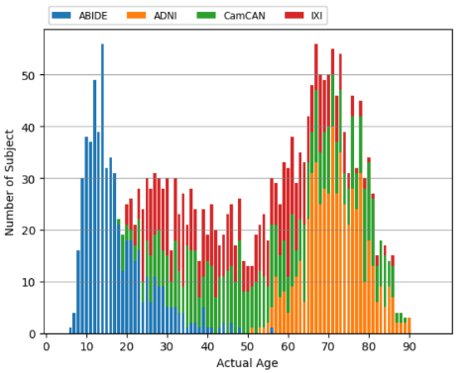
- Age distribution of healthy samples across datasets.
- DATA PREPROCESSING
Prior to model training, all T1-weighted 3D brain MRI scans were subjected to preprocessing. Since the proposed model performs six successive downsampling operations by a factor of two, the input images must have edge lengths divisible by 64 (i.e., $2^{6}$) to avoid boundary loss. Therefore, we first preprocessed the MNI template (189 × 197 × 233) by resampling it to 128 × 192 × 128, and subsequently used this template for image registration to ensure that all input images conformed to the required dimensions.
The preprocessing pipeline for whole-brain (WB) features is as follows. First, non-brain tissues were removed (skull stripping) using the U-net–based brain extraction model provided by ANTsPyNet (Tustison et al., 2021). Next, each image was rigidly registered to the preprocessed MNI152 template using SimpleITK. Finally, image intensity values were scaled using the 5th and 95th percentiles and normalized to the range [0,1] (Fig. 3).
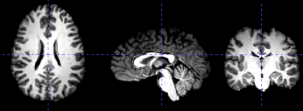
- Preprocessed Image
- MODEL ARCHITECTURE DESIGN
Our model design is inspired by VGGNet (Simonyan et al., 2015) and further guided by the architectures proposed by Peng et al. (2021) and Ding et al. (2023), where fully connected layers are replaced with convolutional layers to achieve a lightweight structure. The model consists of three main stages: feature extraction, nonlinear enhancement, and output adjustment.
In the feature extraction stage, five consecutive convolutional blocks (Conv Blocks) are employed. Within each Conv Block, the input passes sequentially through a convolutional layer (Conv Layer), a batch normalization layer (BN), a max pooling layer, and a ReLU activation function. The nonlinear enhancement stage operates similarly to the Conv Blocks, except that the convolutional kernel size is modified from 3×3×3 to 1×1×1.
Finally, a global average pooling layer and a 1×1×1 convolutional layer are used in the output adjustment stage to generate continuous brain age predictions. Two different output adjustment strategies were adopted for the brain age prediction task, namely the regression strategy and the softmax strategy. Both strategies share identical feature extraction and nonlinear enhancement modules, with the key difference lying only in the design of the output adjustment block.
Table IV presents the model architecture using the regression strategy. In this configuration, the output adjustment block consists of a global average pooling layer followed by a 1×1×1 convolutional layer, which transforms the extracted features into a single-channel continuous brain age prediction value.
TABLE IV
Model Architecture with Regression Strategy
Layer Configuration | Input → Output  (Channels)
Conv → BN → Pool → ReLU | 1 → 32
Conv → BN → Pool → ReLU | 32 → 64
Conv → BN → Pool → ReLU | 64 → 128
Conv → BN → Pool → ReLU | 128 → 256
Conv → BN → Pool → ReLU | 256 → 256
Conv (1×1×1) → BN → Pool → ReLU | 256 → 64
Global Average Pooling | -
Dropout | -
Conv (1×1×1) | 64 → 1
Table V presents the model architecture using the softmax strategy, which transforms the task from regression to classification. In this configuration, the output adjustment block also consists of a global average pooling layer followed by a 1×1×1 convolutional layer. Unlike the single-channel output of the regression strategy, the convolutional layer here produces a 50-dimensional vector. This vector is then passed

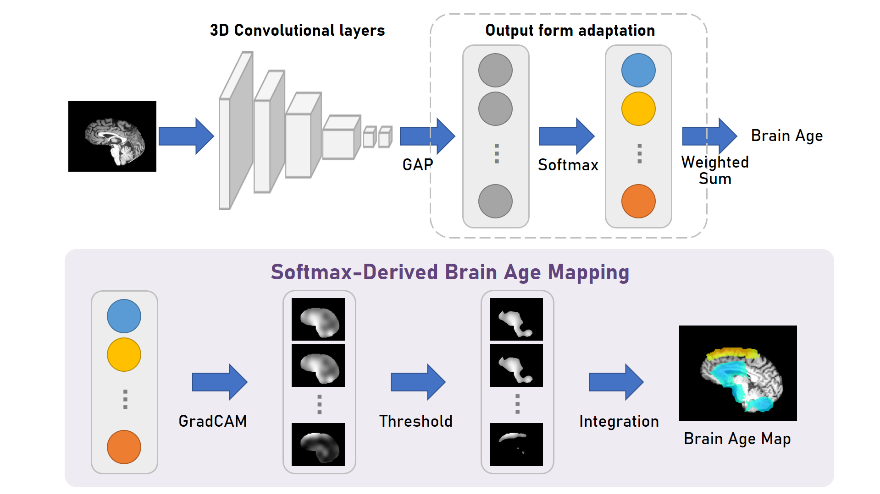
- Softmax-Derived Brain Age Mapping (55-year-old CN subject).

through a softmax function to generate the probability distribution over age classes (Table VI), and the final predicted brain age is computed using a weighted-sum approach.
TABLE V
Model Architecture with Softmax Strategy
Layer Configuration | Input → Output  （Channels）
Conv → BN → Pool → ReLU | 1 → 32
Conv → BN → Pool → ReLU | 32 → 64
Conv → BN → Pool → ReLU | 64 → 128
Conv → BN → Pool → ReLU | 128 → 256
Conv → BN → Pool → ReLU | 256 → 256
Conv (1×1×1) → BN → Pool → ReLU | 256 → 64
Global Average Pooling | -
Dropout | -
Conv (1×1×1) | 64 → 50
Softmax | -
Weighted Sum | 50 → 1

TABLE VI
Softmax Layer Output Illustration
Output of the Softmax layer
Channel $(i)$ | 1 | 2 | 3 | … | 48 | 49 | 50
Age Class ${(a}_{i})$ | 2 | 4 | 6 | … | 96 | 98 | 100
Probability ${(p}_{i})$ | p1 | p2 | p3 | … | p48 | p49 | p50
The predicted brain age in the softmax strategy is computed using a weighted-sum approach as follows:
$$\hat{\text{y}} \text{=}\sum_{\text{i}=\text{1}}^{\text{50}}{{\text{a}}_{\text{i}}\text{*}{\text{p}}_{\text{i}}}$$ | (1)
where $\hat{\text{y}}$ denotes the predicted brain age, ${\text{a}}_{\text{i}}$ represents the age corresponding to class $\text{i}$ , and ${\text{p}}_{\text{i}}$ is the probability of class $\text{i}$ being the predicted age.
- SOFTMAX-DERIVED BRAIN AGE MAPPING
To identify the brain regions most influential in the model’s brain age estimation, we designed a visualization algorithm based on Grad-CAM (Gradient-weighted Class Activation Mapping) (Selvaraju et al., 2019) tailored to the softmax strategy. This algorithm generates heatmaps of key regions for individual samples, referred to as Brain Age Maps (BAM). We denote this method as Softmax-Derived Brain Age Mapping (SD-BAM), and its architecture is illustrated in Fig. 4.
Recalling the output structure of the softmax layer (Table VI), the proposed algorithm applies Grad-CAM to compute the activation map ${\text{Cam}}_{\text{i}}$ for each age class probability. Each map is then refined through a masking process to produce ${\text{Cam}}_{\text{i}}^{\text{*}}$, and finally, all class-specific activation maps are integrated to form the Brain Age Map (BAM).
To prevent the cancellation of important voxels due to weak positive and negative responses during the integration process, we retained only those voxel intensities in ${\text{Cam}}_{\text{i}}$ that exceeded the 90th percentile value of its own intensity distribution, ${\text{Q}}_{0.9}\text{(}{\text{Cam}}_{\text{i}}\text{)}$. All voxel intensities below this threshold were set to zero, as defined in (2). This procedure highlights the most salient activation regions for each class, ensuring that they are not diminished or lost in the subsequent weighting process.
$${\text{Cam}}_{\text{i}}^{\text{*}}\text{=}{\text{Cam}}_{\text{i}} \text{∙} \text{1}\text{(}{\text{Cam}}_{\text{i}}\text{>}{\text{Q}}_{\text{0.9}}\text{(}{\text{Cam}}_{\text{i}}\text{))}$$ | (2)
where $i$ denotes the age class, ${\text{Cam}}_{\text{i}}^{\text{*}}$ is the masked activation map, and ${Cam}_{i}$ represents the original unprocessed activation map. ${\text{Q}}_{0.9}\text{(}{\text{Cam}}_{\text{i}}\text{)}$indicates the 90th percentile of voxel intensities in ${\text{Cam}}_{\text{i}}$ ​. Examples of the activation maps before and after masking are shown in Fig. 5.
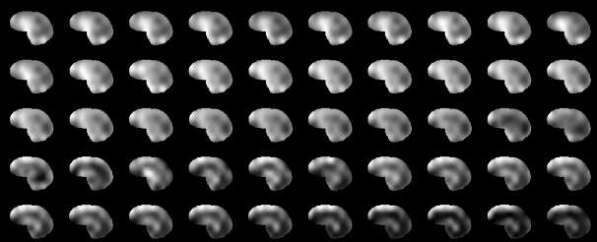
(a)
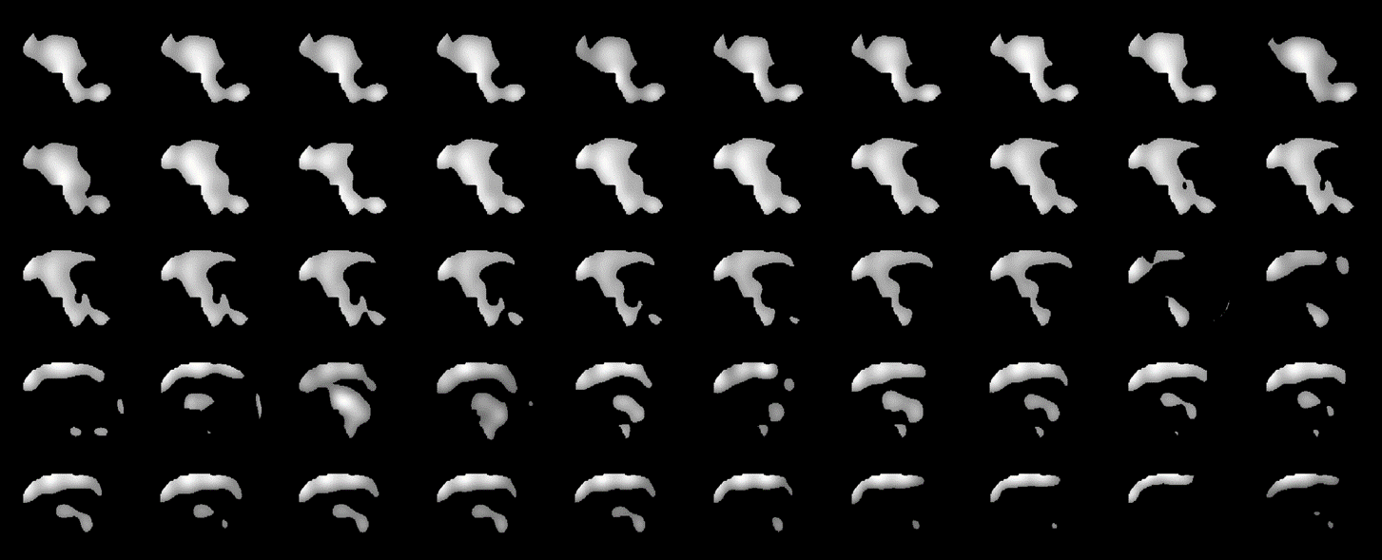
(b)
- Activation maps of age classes (55-year-old CN subject) : (a) Without mask (b) With mask.

The Brain Age Map (BAM) is defined as in (3). The negative regions (blue) indicate features that are strongly associated with brains under the age of 50, whereas the positive regions (red–orange) correspond to features that are strongly associated with brains over the age of 50.
$$\text{BAM }\text{=}\sum_{\text{i}=\text{1}}^{\text{50}}{{\text{(a}}_{\text{i}}\text{-} \text{50}\text{)}\text{*}{\text{p}}_{\text{i}}\text{*}{\text{Cam}}_{\text{i}}^{\text{*}}}$$ | (3)
where ${\text{a}}_{\text{i}}$ denotes the age corresponding to class $\text{i}$, ${\text{p}}_{\text{i}}$​​ is the model-predicted probability for class $\text{i}$, and ${\text{Cam}}_{\text{i}}^{\text{*}}$ ​ represents the Grad-CAM activation map of class $\text{i}$ , in which only voxels above the 90th percentile intensity are retained. Since all experiments in this study adopted a 5-fold ensemble strategy, the final BAM was obtained by averaging the BAMs of the five sub-models
Notably, as shown in Fig. 5(b), the BAMs clearly highlight regions such as the ventricles, cerebellum, and frontal sulcus. These key regions were fully preserved in the BAM and annotated with their corresponding colors (Fig. 4).
- TRAINING METHOD
The experiments were conducted using the widely adopted 5-fold cross-validation method, as in previous studies (Gong et al., 2021; Yang et al., 2022; Peng et al., 2021), to train the brain age prediction models. During inference, the final brain age estimate was obtained by averaging the outputs of the five fold-specific models (one trained on each fold). Following the approaches of Dartora et al. (2024), Jonsson et al. (2019), Peng et al. (2021), and Zhang et al. (2024), data augmentation was applied to 70% of the training samples. The augmentation procedures included gamma correction with a correction factor ranging from 0.5 to 2.0 (Rahman et al., 2016), translations of 3–5 voxels, and random rotations of 3°–5°. To further examine its effect, additional experiments were conducted without data augmentation for comparison. The training hyperparameters were set as follows: batch size = 4, learning rate = 0.001, and 300 epochs.
EXPERIMENTAL RESULTS AND DISCUSSION
- MODELS EVALUATION METHODS
To quantitatively assess the performance of the proposed brain age prediction models, two primary evaluation metrics were employed: mean absolute error (MAE) and predicted age difference (PAD). The MAE is defined as follows:
$$\text{MAE} \text{=} \frac{\text{1}}{\text{n}} \sum_{\text{i=}\text{1}}^{\text{n}}{ {\hat{y}}_{i} \text{-} {\text{y}}_{\text{i}}}$$ | (4)
where ${\hat{\text{y}}}_{\text{i}}$ represents the predicted brain age for the $\text{i}$-th subject, ${\text{y}}_{\text{i}}$ denotes the corresponding chronological age, and $n$ is the total number of samples.
In addition, PAD is calculated as the difference between the predicted and actual chronological age:
$$\text{P}\text{AD} \text{=} \hat{\text{y}} \text{-} \text{y}$$ | (5)
This metric is particularly useful for evaluating whether the model exhibits age-dependent bias, such as consistently overestimating or underestimating brain age in specific age groups.
- COMPARISONS OF REGRESSION AND SOFTMAX PERFORMANCE
To investigate the effect of dropout rate (Srivastava et al., 2014) on different output layer designs, we conducted comparative experiments on models with both regression and softmax strategies. Considering that most studies have employed the Adam optimizer (Kingma et al., 2014; Ding et al., 2023), while a few have adopted SGD (Peng et al., 2021), both optimizers were included as variables in this experiment. Apart from these factors, all models shared the same network architecture and dataset settings, and their performance was evaluated under the 5-fold ensemble framework.
TABLE VII
Comparison of Regression and Softmax Performance
Model | Optimizer | Dropout Rate | Training Set MAE | Test Set MAE
Regression | SGD | 0 | 1.19 | 4.66
 | Adam | 0 | 1.19 | 4.34
 | Adam | 0.2 | 1.42 | 4.38
Softmax | SGD | 0 | 1.13 | 4.43
 | Adam | 0 | 1.12 | 4.38
 | Adam | 0.2 | 1.06 | 4.33
 | Adam | 0.5 | 1.26 | 4.35
As shown in Table VII, both strategies achieved better training performance when using the Adam optimizer compared with SGD. We attribute this to the fact that the learning rate of standard SGD does not decay automatically during the training iterations. For the regression strategy, the best results were obtained with a dropout rate of 0. This can be explained by its single-class output design, in which the absence of a softmax layer after dropout causes the perturbation to directly and more significantly affect the final regression output, thereby degrading performance. In contrast, the softmax strategy performed best with a dropout rate of 0.2, whereas its performance began to decline at a dropout rate of 0.5. These findings suggest that the softmax layer is more tolerant to moderate dropout rates and, compared with the regression strategy, is better able to exploit dropout for alleviating overfitting.
Overall, the softmax strategy achieved performance comparable to that of the regression strategy under optimal hyperparameter settings. Given that the regression-by-classification approach of the softmax strategy enhances model interpretability through weighted averaging, we adopted the softmax strategy for subsequent experiments.
- EVALUATION OF DATA AUGMENTATION
This section presents evaluation plots of the model performance on the test set, with a focus on examining the impact of data augmentation on brain age prediction.
Fig. 6 shows scatter plots of predicted versus chronological ages, where the gray line represents the reference line (x=y) and the red line indicates the regression line of the model predictions. Fig. 6(a) and Fig. 6(b) correspond to the results with and without data augmentation, respectively. It can be clearly observed that the predictions of the model without augmentation align more closely with the reference line, indicating higher overall accuracy. In contrast, the predictions from the augmented model display greater divergence, suggesting that data augmentation may reduce predictive accuracy under the conditions of this study.
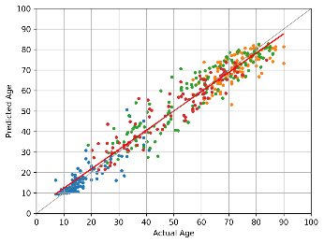  (a) | 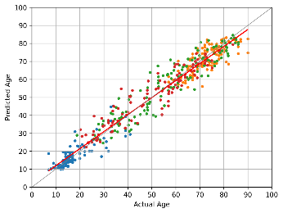  (b)
- Scatter chart of actual age and predicted age : (a) With data augmentation; and (b) Without data augmentation.

Fig. 7 presents the MAE distribution plots, where Fig. 7(a) and Fig. 7(b) correspond to the prediction results with and without data augmentation, respectively. It can be observed that in the model without augmentation, outliers with MAE greater than 15 occurred less frequently, indicating reduced instances of extreme prediction errors. Moreover, the denser distribution of points within the MAE < 5 range suggests higher prediction accuracy for the majority of samples.
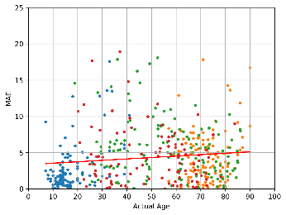  (a) | 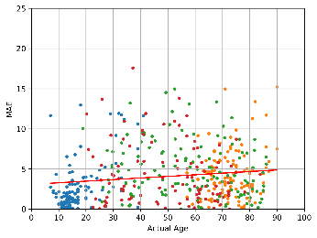  (b)
- MAE scatter plot: (a) With data augmentation; and (b) Without data augmentation.

Table VIII compares the performance of models trained with and without data augmentation on the test sets of ABIDE, ADNI, CamCAN, IXI, as well as on the overall test set. In all cases, the models without augmentation demonstrated superior predictive performance.
TABLE VIII
Comparison of Model Performance With and Without Data Augmentation
 | Test Set With Data Augmentation | Test Set Without Data Augmentation
ABIDE | 2.85 | 2.77
ADNI | 4.33 | 4.14
CamCAN | 5.53 | 4.90
IXI | 4.34 | 4.33
Whole Test Set | 4.33 | 4.08
For the overall test set, the model with data augmentation yielded an MAE of 4.33, whereas the model without augmentation achieved a reduced MAE of 4.08. The most notable improvement was observed on the CamCAN test set, where the MAE decreased from 5.53 to 4.90. Improvements were also seen in the ADNI and ABIDE datasets, where the MAE decreased from 4.33 to 4.14 and from 2.85 to 2.77, respectively, indicating that data augmentation consistently had a negative impact on predictive performance.
Table IX presents a comparison between this study and related works. On the ABIDE test set, our model achieved an MAE of 2.77 years, which is comparable to large-scale studies such as Jonsson et al. (2019; 3.63 years), Zhang et al. (2024; 3.08 years), and Wood et al. (2022; 2.97 years).
Overall, this study demonstrates strong data efficiency: using only 1,871 MRI scans, our model achieved accuracy close to that of large-scale studies.
TABLE IX
Comparison of Top Models in Brain Age Prediction Based on MAE
Articles | Training / Test  (images) | Test Set  Age Range  (years) | Test Set MAE  (years)
Ours | 1871/468 | 6-90 | 4.08
Ours | 1871/110 | 6-56 | 2.77
Eltashani et al., 2025 | 1801/225 | 6-90 | 3.56
Zheng et al., 2025 | 850/332 | 19-84 | 4.60
Zhang et al. 2024 | 1,464/118 | 18-94 | 3.08
Wood et al. 2022 | 15,146/4,661 | 18-95 | 2.97
Wang et al., 2019 | 5865/550 | 46-96 | 4.45
Jonsson et al., 2019 | 1,909/12,395 | 45-80 | 3.63
Liem et al., 2017 | 1177/1177 | 19-82 | 4.29
Cole et al., 2017 | 1601/200 | 18-90 | 4.16
We summarized studies that exclusively used CamCAN as the test set in Table X. Because CamCAN covers a wide age range, brain age prediction on this dataset is particularly challenging. In this study, by incorporating multiple datasets to expand the training set, we achieved an MAE of 4.90 on the CamCAN test set, outperforming most existing studies. Notably, Xifra-Porxas et al. (2021) combined brain MRI with MEG to reduce the MAE to 4.88 years; however, this approach required additional MEG acquisition, which increases both participant burden and cost. When relying on MRI alone, their model yielded an MAE of 5.33 years. By contrast, our model achieved a comparable level of accuracy using MRI only. These results demonstrate that augmenting training data with multiple datasets can overcome the limitations of insufficient samples and enhance predictive performance on specific datasets.
TABLE X
Comparison of Related Studies Using CamCAN as Test Set
Model | Training / Test  (n images) | Test Set MAE  (years)
Ours | 1871/135 | 4.90
Chang et al., 2025 | - | 5.47
Pang et al., 2024 | 521/130 | 7.46
Xifra-Porxas et al., 2021  (MRI+MEG) | - | 4.88
Xifra-Porxas et al., 2021  (MRI only) | - | 5.33
Lancaster et al., 2018 | 2003 / 648 | 5.08
- CLINICAL APPLICATIONS AND EFFICACY ACCESSMENT
We further explored the application of the model in neurodegenerative diseases. Fig. 8 compares the prediction results between Alzheimer’s disease (AD) samples and cognitively normal (CN) controls, where orange and gray denote AD and CN samples, respectively. For subjects aged 50–70, many AD samples exhibited “advanced brain age,” with predicted ages substantially exceeding chronological ages and falling outside the variation range of the CN group. In contrast, for subjects aged 80–90, a trend of “delayed brain age” was observed. According to the Limited Lifespan Hypothesis (Olshansky et al., 2024), the average human lifespan is approximately 85 years in the absence of biological aging interventions. Therefore, we speculate that individuals surviving to advanced ages tend to have healthier brain conditions, which may explain the manifestation of delayed brain age in this group.
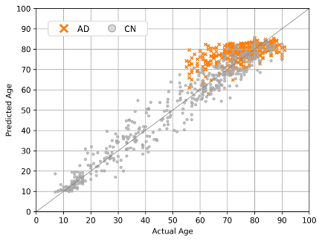
- Comparison of Predicted and Actual Age Across AD and CN Groups.
To explain why some AD samples still exhibited delayed brain age, we hypothesize that these individuals were already in a delayed state prior to disease onset. This was particularly evident among subjects over 80 years old, who likely had relatively healthier brain conditions before onset. Even after the accelerated aging associated with AD, it would take time before their brain age predictions shifted to an advanced state. Consequently, as shown in Fig. 8, a small number of samples still appeared delayed; however, their predicted brain ages never fell below the minimum values observed in age-matched CN subjects, indicating that they nevertheless exhibited an abnormal aging trajectory.
To compare brain age differences between AD and CN groups, we plotted PAD values as shown in Fig. 9, where orange and gray represent AD and CN samples, respectively. The results show that, for subjects aged 50–80, most AD samples exhibited “advanced brain age.” Notably, this phenomenon was observed even though the model was not trained on AD data, thereby confirming the strong association between PAD and dementia. For subjects aged 80–90, AD samples did not show clear advancement; however, their trend of “delayed brain age” was weaker compared to CN subjects. We attribute this to the accelerated brain aging caused by AD (Gautherot et al., 2021; Papouli et al., 2025; Huang et al., 2021).
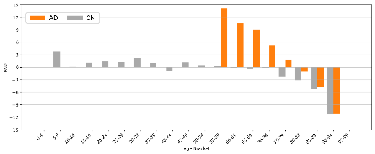
- Bar chart comparing of predicted and actual age across AD and CN groups.
- SOFTMAX-DERIVED BRAIN AGE MAPPING ANALISIS
We applied the SD-BAM algorithm to further analyze regional aging patterns across different ages and conditions. Fig. 10 illustrates the analysis for 20-year-old samples. In young subjects, the model primarily focused on the frontal lobe (particularly the right frontal lobe), ventricles, and cerebellum. For subjects with lower predicted brain ages at age 20, the BAM displayed deeper blue regions, whereas in those with higher predicted brain ages, the blue regions became noticeably lighter, indicating a weakening of youthful features in these areas.
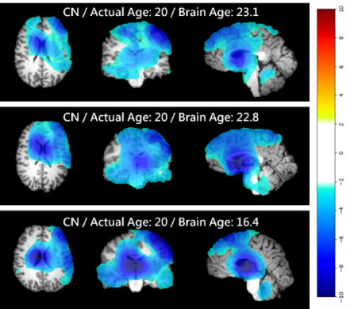
- BAM in a 20-year-old CN subject.
Next, we analyzed 55-year-old samples by examining BAMs for both healthy and AD subjects. For the healthy sample shown in Fig. 11, the model continued to focus strongly on the right frontal lobe, ventricles, and cerebellum. As brain age increased, the blue regions in the frontal lobe (representing youthful features) gradually faded and were replaced by orange-yellow regions (representing aging features). This indicates that the frontal cortex is among the earliest regions of the human brain to exhibit aging. In contrast, the ventricles and cerebellum remained marked in blue, suggesting that youthful features in these regions were still prominent, making them among the latest brain regions to undergo aging.
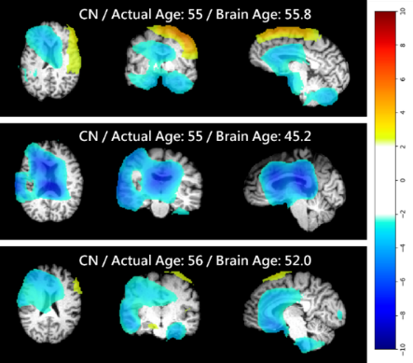
- BAM in a 55-year-old CN subject.
These findings are highly consistent with the perspective of Vickery et al. (2024), who reported that the sequence of human brain aging is closely linked to its evolutionary trajectory. Brain structures that are largely conserved with ancient primates, such as the ventricles, tend to exhibit later aging, whereas more recently evolved regions, such as the expansive frontal lobe in Homo sapiens, are more prone to earlier aging. This pattern can also be observed in Fig. 11: in the analysis of the 55-year-old healthy sample, the ventricular region is still predominantly marked in blue, indicating the preservation of youthful features, whereas the frontal lobe has already begun to display orange-yellow regions, reflecting the emergence of aging characteristics.
In contrast, the BAM of the 55-year-old AD sample shown in Fig. 12 exhibited a markedly different distribution. The model paid particular attention to the ventricles, where the blue regions were completely replaced by red–orange regions. This stands in sharp contrast to the age-matched healthy sample, indicating that the AD subject had already developed pronounced ventricular aging at this stage. This finding aligns with previously reported brain changes in dementia (Nestor et al., 2008; Pang et al., 2024), supporting the notion that accelerated ventricular aging and enlargement are strongly associated with AD.
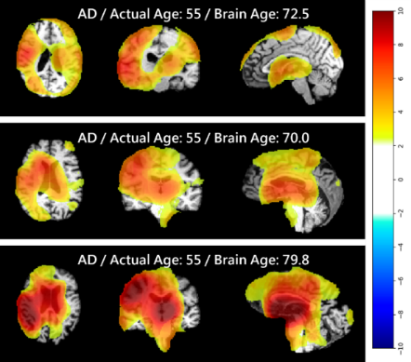
- BAM in a 55-year-old AD subject.
Finally, we analyzed 70-year-old samples, where Fig. 13 reveals distinct attention patterns compared with the 55-year-old samples. For the healthy subject, the model continued to focus on ventricular changes while also attending to the parietal and temporal lobes, particularly the left temporal region. This indicates that in older subjects, the temporal and parietal cortices gradually become key regions for the model in determining brain age.
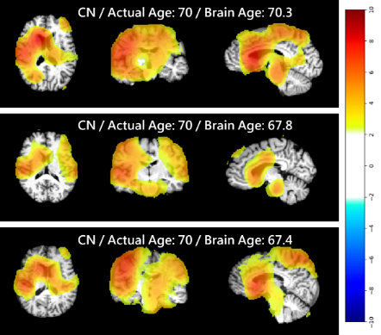
- BAM in a 70-year-old CN subject.
The BAM of the 70-year-old AD sample shown in Fig. 14 revealed more pronounced aging patterns, particularly in the ventricular region, which displayed larger areas of deep red compared with the 55-year-old AD sample. Relative to the age-matched healthy subject, the AD sample showed deeper red markings in the frontal, parietal, and temporal lobes as well as the ventricles, indicating potentially more severe cortical degeneration and ventricular enlargement.
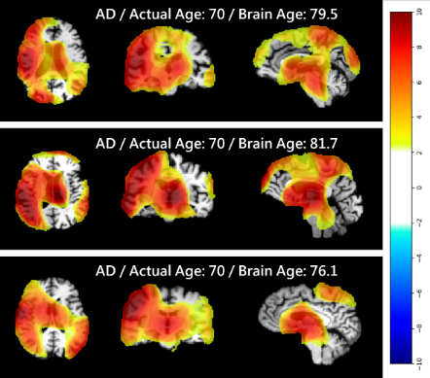
- BAM in a 70-year-old AD subject.
Examining the BAMs of the 55- and 70-year-old samples, we observed that AD subjects exhibited a marked expansion and intensification of red–orange regions, which represent aging features, compared with their healthy counterparts. Notably, no AD samples were included in the training data of this study. These findings confirm that AD indeed leads to accelerated brain aging and demonstrate that brain age can serve as a reliable quantitative marker. Moreover, through BAM, the neurodegenerative progression of different brain regions can be examined in greater detail.
- DISSCUSSIONS
This study proposed a lightweight model based on VGGNet (Simonyan et al., 2015) and evaluated the effects of preprocessing procedures, model design, and data augmentation on predictive performance. Finally, we integrated our newly developed algorithm, Softmax-Derived Brain Age Mapping (SD-BAM), to enable the visualization and identification of key brain regions.
The experimental results on the output adjustment layer showed that, compared with the regression strategy, the softmax strategy achieved better MAE performance. However, since the two strategies differ only in a small number of neurons, the overall difference in predictive accuracy was not substantial. From the perspective of model interpretability, the softmax strategy provides a key advantage, as its fixed weighting parameters elegantly assign physical meaning to the feature vectors.
This study observed a clear improvement in predictive performance after data augmentation was removed. We speculate that this may be related to our preprocessing pipeline: MNI registration and skull stripping had already substantially reduced inter-image variations in position and intensity, such that additional augmentation instead introduced unwanted noise.
PAD (Predicted Age Difference) analysis revealed a tendency of overestimation in younger subjects and underestimation in older subjects, indicating that sample size and distribution influence prediction accuracy. In particular, for individuals over 80 years of age, most samples exhibited delayed brain age. We attribute this to the fact that this age range approaches the human lifespan limit (Olshansky et al., 2024), such that those who survive beyond 80 years are more likely to maintain relatively healthy brain conditions. However, the extent to which this collective delayed brain age phenomenon arises from insufficient training samples versus genuinely healthier brain states remains to be further investigated. Importantly, our analysis shows that even when AD samples appear to exhibit delayed brain age, they still demonstrate a trend of accelerated aging. These results suggest that PAD remains an effective indicator of abnormal brain aging and holds potential as an early screening tool for dementia risk.
The BAM analysis revealed an important finding: when estimating brain age, the model focused particularly on cortical and hippocampal regions, which are closely associated with cognitive function. This not only aligns with conclusions from existing neuroscience literature (Franke et al., 2012; Walhovd et al., 2005; Lemaitre et al., 2012) but also demonstrates the model’s ability to automatically capture core brain regions related to aging and cognitive decline.
The SD-BAM algorithm provides visualization of both youthful and aging feature dimensions in brain age prediction models, thereby laying a solid foundation for clinical applications. However, the algorithm remains constrained by the classification-weighted output structure, limiting its applicability across all model architectures. Fortunately, our comparison of regression and softmax output strategies showed that, under appropriate dropout rates, both approaches achieved comparable performance. This suggests that models originally designed with regression outputs can be safely converted to the softmax framework without compromising accuracy.
In the CamCAN dataset, achieving significant improvements in brain age prediction accuracy has long been challenging. Xifra-Porxas et al. (2021) demonstrated that combining MRI and MEG modalities could enhance model performance, achieving an MAE of 4.88 years. However, our experiments showed that by incorporating external datasets into training, comparable performance (MAE = 4.90 years) could be achieved using MRI alone. This finding indicates that expanding the training dataset is an effective strategy for improving prediction accuracy on specific datasets. Moreover, this approach eliminates the need for additional MEG acquisition, thereby reducing clinical costs while maintaining competitive predictive performance.
CONCLUSIONS
This study conducted a comprehensive investigation of brain age prediction models. The experimental results on output adjustment layers revealed that, under the regression strategy, the absence of softmax regulation in the output layer caused dropout to degrade performance, with the best MAE achieved at a dropout rate of 0. In contrast, the softmax strategy benefited from the positive effect of dropout, achieving its best performance at a dropout rate of 0.2. At their respective optimal hyperparameter settings, the performances of the two strategies were comparable, with MAEs of 4.34 and 4.33 years, respectively, with the softmax strategy showing a slight advantage.
Regarding data augmentation, we observed that removing augmentation actually improved the performance of most models. Notably, the whole-brain model improved from 4.33 to 4.08 years, suggesting that spatial augmentations such as translation and rotation may have disrupted the alignment achieved by MNI registration and thereby degraded data quality. Importantly, after removing augmentation, our model achieved an MAE of 4.90 years on the CamCAN test set, outperforming most prior studies that relied solely on CamCAN MRI data.
Clinical application analysis revealed that patients with dementia aged 50–80 years generally exhibited advanced brain age, with predicted brain ages consistently higher than those of healthy controls across all age ranges. This finding suggests that brain age can serve as an effective quantitative indicator of dementia risk.
This study proposes a novel visualization technique, Softmax-Derived Brain Age Mapping (SD-BAM), which is capable of simultaneously identifying both youthful and aging brain features. In young healthy subjects, the model primarily focused on the frontal lobe, cerebellum, and ventricles, whereas in older healthy subjects, attention shifted to the ventricles, parietal lobe, and temporal lobe. Among these regions, the frontal lobe exhibited the earliest signs of degeneration, while the ventricles demonstrated the slowest aging, consistent with findings on human brain aging (Vickery et al., 2024). In dementia patients, broader aging features were observed compared to age-matched healthy controls, with aged regions even fully replacing previously youthful regions. These results support the reliability of the SD-BAM visualization technique. By generating Brain Age Maps (BAMs) directly from model gradients, SD-BAM enhances the depth of brain age assessment at low cost, demonstrating strong potential for applications in brain development monitoring and early dementia detection.
ACKNOWLEDGMENT
Data collection and sharing for this project was provided by the Cambridge Centre for Ageing and Neuroscience (CamCAN). CamCAN funding was provided by the UK Biotechnology and Biological Sciences Research Council (grant number BB/H008217/1), together with support from the UK Medical Research Council and University of Cambridge, UK.
REFERENCES
- K. Franke, E. Luders, A. May, M. Wilke, and C. Gaser, “Brain maturation: predicting individual BrainAGE in children and adolescents using structural MRI,” NeuroImage, vol. 63, no. 3, pp. 1305–1312, Nov. 2012.
- B. A. Jonsson, G. Bjornsdottir, T. E. Thorgeirsson, et al., “Brain age prediction using deep learning uncovers associated sequence variants,” Nature Communications, vol. 10, no. 5409, Nov. 2019.
- F. Liem, G. Varoquaux, J. Kynast, F. Beyer, S. K. Masouleh, J. M. Huntenburg, L. Lampe, M. Rahim, A. Abraham, R. C. Craddock, S. Riedel-Heller, T. Luck, M. Loeffler, M. L. Schroeter, A. V. Witte, A. Villringer, and D. S. Margulies, “Predicting brain-age from multimodal imaging data captures cognitive impairment,” NeuroImage, vol. 148, pp. 179–188, Mar. 2017.
- J. H. Cole, R. P. K. Poudel, D. Tsagkrasoulis, M. W. A. Caan, C. Steves, T. D. Spector, and G. Montana, “Predicting brain age with deep learning from raw imaging data results in a reliable and heritable biomarker,” NeuroImage, vol. 163, pp. 115–124, Dec. 2017.
- R. R. Selvaraju, M. Cogswell, A. Das, R. Vedantam, D. Parikh, and D. Batra, “Grad-CAM: Visual explanations from deep networks via gradient-based localization,” International Journal of Computer Vision, vol. 128, no. 2, pp. 336–359, Feb. 2020.
- D. A. Wood, et al., “Accurate brain-age models for routine clinical MRI examinations,” NeuroImage, vol. 249, p. 118871, Apr. 2022.
- C. Dartora, A. Marseglia, G. Mårtensson, G. Rukh, J. Dang, J. S. Muehlboeck, L. O. Wahlund, R. Moreno, J. Barroso, D. Ferreira, H. B. Schiöth, E. Westman, Alzheimer’s Disease Neuroimaging Initiative, Australian Imaging Biomarkers and Lifestyle Flagship Study of Ageing, Japanese Alzheimer’s Disease Neuroimaging Initiative, and AddNeuroMed Consortium, “A deep learning model for brain age prediction using minimally preprocessed T1w images as input,” Frontiers in Aging Neuroscience, vol. 15, p. 1303036, Feb. 2024.
- J. Wang, M. J. Knol, A. Tiulpin, F. Dubost, M. de Bruijne, M. W. Vernooij, H. H. H. Adams, M. A. Ikram, W. J. Niessen, and G. V. Roshchupkin, “Gray matter age prediction as a biomarker for risk of dementia,” Proceedings of the National Academy of Sciences of the United States of America, vol. 116, no. 42, pp. 21213–21218, Oct. 2019.
- H. Peng, W. Gong, C. F. Beckmann, A. Vedaldi, and S. M. Smith, “Accurate brain age prediction with lightweight deep neural networks,” Medical Image Analysis, vol. 68, p. 101871, Feb. 2021.
- B. Dufumier, P. Gori, I. Battaglia, J. Victor, A. Grigis, and E. Duchesnay, “Benchmarking CNN on 3D anatomical brain MRI: Architectures, data augmentation and deep ensemble learning,” arXiv preprint arXiv:2106.01132, 2021.
- J. L. Hanson, D. J. Adkins, E. Bacas, et al., “Examining the reliability of brain age algorithms under varying degrees of participant motion,” Brain Informatics, vol. 11, no. 9, 2024.
- X. Chang, X. Jia, S. B. Eickhoff, D. Dong, and W. Zeng, “Multi-center brain age prediction via dual-modality fusion convolutional network,” Medical Image Analysis, vol. 101, p. 103455, Jan. 2025.
- F. Eltashani, M. Parreno-Centeno, J. H. Cole, J. P. Papa, and F. Costen, “Brain age prediction using a lightweight convolutional neural network,” IEEE Access, vol. 13, pp. 6750–6763, 2025, doi: 10.1109/ACCESS.2025.3526520.
- J. Zheng, J. Wang, Z. Zhang, K. Li, H. Zhao, and P. Liang, “Brain age prediction based on brain region volume modeling under broad network field of view,” Computer Methods and Programs in Biomedicine, vol. 265, p. 108739, Jan. 2025.
- Y. Pang, Y. Cai, Z. Xia, et al., “Predicting brain age using Tri-UNet and various MRI scale features,” Scientific Reports, vol. 14, no. 13742, May 2024.
- X. Zhang, et al., “Brain age prediction using interpretable multi-feature-based convolutional neural network in mild traumatic brain injury,” NeuroImage, vol. 297, p. 120751, Jan. 2024.
- A. Xifra-Porxas, A. Ghosh, G. D. Mitsis, and M.-H. Boudrias, “Estimating brain age from structural MRI and MEG data: Insights from dimensionality reduction techniques,” NeuroImage, vol. 231, p. 117822, May 2021.
- J. L. Lancaster, R. Lorenz, R. Leech, and J. H. Cole, “Bayesian optimization for neuroimaging pre-processing in brain age classification and prediction,” Frontiers in Aging Neuroscience, vol. 10, p. 28, Feb. 2018.
- J. R. Taylor, N. Williams, R. Cusack, T. Auer, M. A. Shafto, M. Dixon, L. K. Tyler, R. N. Henson, and the Cam-CAN Consortium, “The Cambridge Centre for Ageing and Neuroscience (Cam-CAN) data repository: Structural and functional MRI, MEG, and cognitive data from a cross-sectional adult lifespan sample,” NeuroImage, vol. 144, pp. 262–269, Jan. 2017, doi: 10.1016/j.neuroimage.2015.09.018.
- M. A. Shafto, L. K. Tyler, M. Dixon, J. R. Taylor, J. B. Rowe, R. Cusack, A. J. Calder, W. D. Marslen-Wilson, J. Duncan, T. Dalgleish, R. N. Henson, C. Brayne, F. E. Matthews, and the Cam-CAN Consortium, “The Cambridge Centre for Ageing and Neuroscience (Cam-CAN) study protocol: A cross-sectional, lifespan, multidisciplinary examination of healthy cognitive ageing,” BMC Neurology, vol. 14, p. 204, Oct. 2014, doi: 10.1186/s12883-014-0204-1.
- N. J. Tustison, P. A. Cook, A. J. Holbrook, et al., “The ANTsX ecosystem for quantitative biological and medical imaging,” Scientific Reports, vol. 11, p. 9068, Apr. 2021.
- K. Simonyan and A. Zisserman, “Very deep convolutional networks for large-scale image recognition,” arXiv preprint, arXiv:1409.1556, 2015.
- W. Ding, X. Shen, J. Huang, H. Ju, Y. Chen, and T. Yin, “Brain age prediction based on resting-state functional MRI using similarity metric convolutional neural network,” IEEE Access, vol. 11, pp. 57071–57082, 2023, doi: 10.1109/ACCESS.2023.3283148.
- W. Gong, C. F. Beckmann, A. Vedaldi, S. M. Smith, and H. Peng, “Optimising a simple fully convolutional network for accurate brain age prediction in the PAC 2019 challenge,” Frontiers in Psychiatry, vol. 12, p. 627996, Feb. 2021.
- L. Yang, S. He, M. Liu, J. Li, Y. Zhang, and T. Liu, “Regularizing brain age prediction via gated knowledge distillation,” in Proceedings of Machine Learning Research (PMLR), vol. 172, pp. 375–389, 2022.
- S. Rahman, M. M. Rahman, M. Abdullah-Al-Wadud, G. D. Al-Quaderi, and M. Shoyaib, “An adaptive gamma correction for image enhancement,” EURASIP Journal on Image and Video Processing, vol. 2016, no. 1, pp. 1–13, Jan. 2016.
- N. Srivastava, G. Hinton, A. Krizhevsky, I. Sutskever, and R. Salakhutdinov, “Dropout: A simple way to prevent neural networks from overfitting,” Journal of Machine Learning Research, vol. 15, no. 1, pp. 1929–1958, Jun. 2014.
- D. P. Kingma and J. Ba, “Adam: A method for stochastic optimization,” arXiv preprint, arXiv:1412.6980, 2014.
- S. J. Olshansky, B. J. Willcox, L. Demetrius, et al., “Implausibility of radical life extension in humans in the twenty-first century,” Nature Aging, vol. 4, pp. 1635–1642, Dec. 2024.
- M. Gautherot, G. Kuchcinski, C. Bordier, A. R. Sillaire, X. Delbeuck, M. Leroy, X. Leclerc, J.-P. Pruvo, F. Pasquier, and R. Lopes, “Longitudinal analysis of brain-predicted age in amnestic and non-amnestic sporadic early-onset Alzheimer’s disease,” Frontiers in Aging Neuroscience, vol. 13, p. 729635, May 2021.
- A. Papouli and J. H. Cole, “Brain age prediction from MRI scans in neurodegenerative diseases,” Current Opinion in Neurology, vol. 38, no. 4, pp. 316–321, Aug. 2025.
- W. Huang, X. Li, H. Li, W. Wang, K. Chen, K. Xu, J. Zhang, Y. Chen, D. Wei, N. Shu, and Z. Zhang, “Accelerated brain aging in amnestic mild cognitive impairment: Relationships with individual cognitive decline, risk factors for Alzheimer disease, and clinical progression,” Radiology: Artificial Intelligence, vol. 3, no. 5, p. e200171, Sep. 2021.
- S. Vickery, K. R. Patil, R. Dahnke, W. D. Hopkins, C. C. Sherwood, S. Caspers, S. B. Eickhoff, and F. Hoffstaedter, “The uniqueness of human vulnerability to brain aging in great ape evolution,” Science Advances, vol. 10, no. 35, p. eado2733, Aug. 2024.
- S. M. Nestor, R. Rupsingh, M. Borrie, M. Smith, V. Accomazzi, J. L. Wells, J. Fogarty, R. Bartha, and the Alzheimer’s Disease Neuroimaging Initiative, “Ventricular enlargement as a possible measure of Alzheimer’s disease progression validated using the Alzheimer’s disease neuroimaging initiative database,” Brain, vol. 131, no. 9, pp. 2443–2454, Sep. 2008.
- K. B. Walhovd, A. M. Fjell, I. Reinvang, A. Lundervold, A. Dale, D. E. Eilertsen, B. T. Quinn, D. Salat, N. Makris, and B. Fischl, “Age-related changes in brain volumes across the adult lifespan and their relations to declarative memory: A cross-sectional and longitudinal study,” Neurobiology of Aging, vol. 26, no. 9, pp. 1261–1270, Sep. 2005.
H. Lemaitre, A. L. Goldman, F. Sambataro, B. A. Verchinski, A. Meyer-Lindenberg, D. R. Weinberger, and V. S. Mattay, “Normal age-related brain morphometric changes: Nonuniformity across cortical thickness, surface area and gray matter volume,” Neurobiology of Aging, vol. 33, no. 3, pp. 617.e1–617.e9, Mar. 2012.


Dr. Ting-An Chang received his Ph.D. in Computer and Communication Engineering from National Cheng Kung University, Taiwan, in 2018.
He is an Assistant Professor at the National Yunlin University of Science and Technology, Yunlin, Taiwan. His research interests include smart healthcare, computer vision, naked-eye 3D stereo display technology, and simultaneous localization and mapping (SLAM).


Shao-Yu Yan He is currently an undergraduate student in Engineering at National Yunlin University of Science and Technology, Yunlin, Taiwan, expected to graduate in 2025. His research focuses on data science and algorithms in smart healthcare, computer vision, and artificial intelligence (AI) applications.

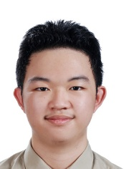
Kuan-Chih Wang He is currently an undergraduate student in Engineering at National Yunlin University of Science and Technology, Yunlin, Taiwan, expected to graduate in 2025. His research focuses on data science and algorithms in smart healthcare, computer vision, and artificial intelligence (AI) applications.


Chung-Wen Hung received the Ph.D. degree in electrical engineering from National Taiwan University, Taipei City, Taiwan, in 2006. He is currently a Professor and the Director of the advanced instrumentation center at the National Yunlin University of Science and Technology, Yunlin, Taiwan. His research interests include Artificial Intelligence (AI) landing, Internet of Things (IoT), and Industrial Internet of Things (IIoT).

