電通二乙微處理器實驗 實驗結報

實驗名稱 | 期中考
組別 | 51 | 組員 | 李承諺

- 實驗目的
LinkIt 7697 於 P6 接一按鈕, P7 接一 LED, A0 接光敏電阻, 另外接一個七段顯示器
1. LinkIt 7697 於按下 P6 按鈕時, P7 LED 每隔 0.5 秒閃爍一次.
2. 未按下按鈕時,七段顯示器, 每隔 0.5 秒依序顯示 0 – 9 數值
3. 持續將讀取到 A0 的 ADC 數值傳至 PC

- 實驗步驟
LinkIt 7697 於 P6 接一按鈕, P7 接一 LED, A0 接光敏電阻, 另外接一個七段顯示器讓 LinkIt 7697 於按下 P6 按鈕時, P7 LED 每隔 0.5 秒閃爍一次,並在未按下按鈕時,七段顯示器, 每隔 0.5 秒依序顯示 0 – 9 數值 ,最後讓光敏電阻測到的值顯示序列阜視窗上

- 程式碼
#include "SevSeg.h"
SevSeg sevseg;
const byte potPin = A3;
int val;
const byte NUM = 1;
const byte led[] = {7};
const int delaytime = 500;
const byte sw = 6;
int ii;
byte Hour = 0;
byte Min = 0;

void setup() {
Serial.begin(9600);
pinMode(led[ii], OUTPUT);
byte numDigits = 4;
byte digitPins[] = {2, 3, 4, 5};
byte segmentPins[] = {8, 9, 10, 11, 12, 13, 14, 15};
bool resistorsOnSegments = false; // 'false' means resistors are on digit pins
byte hardwareConfig = COMMON_CATHODE; // See README.md for options
bool updateWithDelays = false; // Default. Recommended
bool leadingZeros = false; // Use 'true' if you'd like to keep the leading zeros
pinMode(6, INPUT);
sevseg.begin(hardwareConfig, numDigits, digitPins, segmentPins, resistorsOnSegments, updateWithDelays, leadingZeros);
sevseg.setBrightness(90);

Serial.begin(9600);

}

void loop() {
// val = analogRead(potPin);
// Serial.begin(9600);

static unsigned long timer = millis();

boolean Pin6 = digitalRead (6); // Reset
if (Pin6 == HIGH) {
Min = Hour = 0;
for (ii = 0; ii < NUM; ii++)
{
digitalWrite(led[ii], HIGH);
}
delay(500);
for (ii = 0; ii < NUM; ii++)
{
digitalWrite(led[ii], LOW);
}
delay(500);
}
if (millis() - timer >= 500) {
timer += 500;

val = analogRead(potPin);
Serial.println("電阻值:");
Serial.println(val);

sevseg.setNumber(Min, 0);
Min = Min + 1;

if (Min == 10 )
{
Min = 0;
}

}
sevseg.refreshDisplay(); // Must run repeatedly

}

- 實驗結果及分析
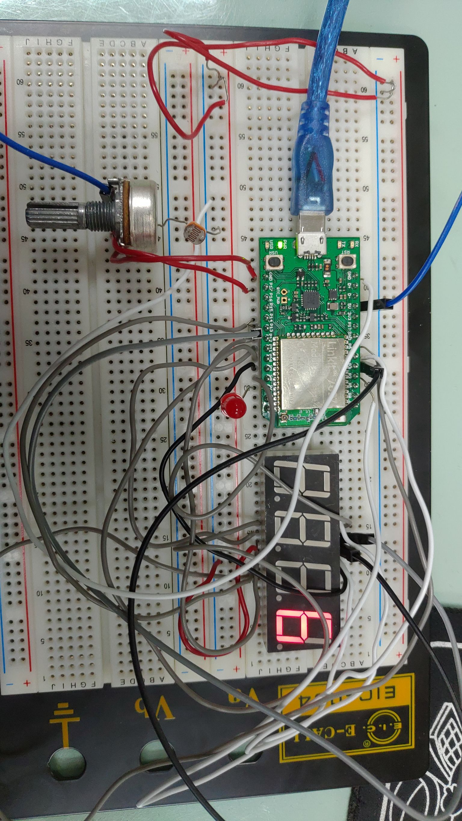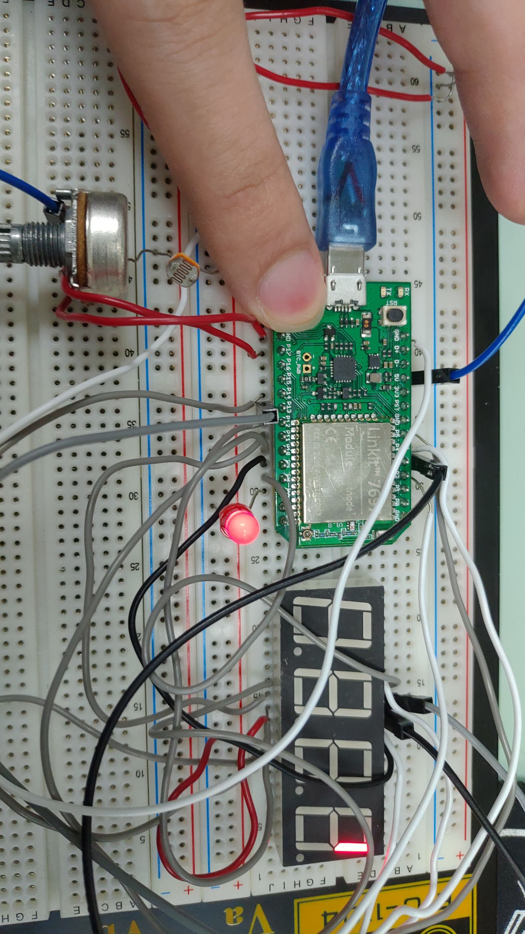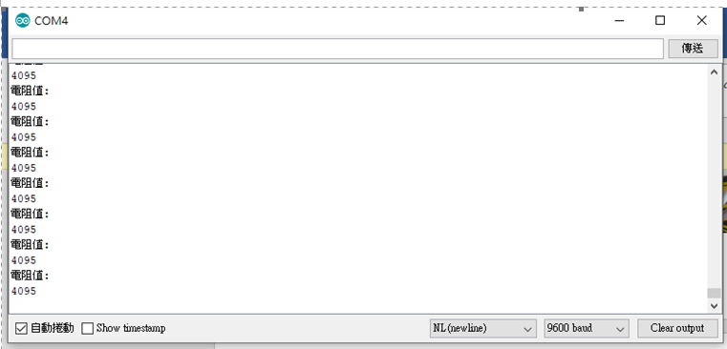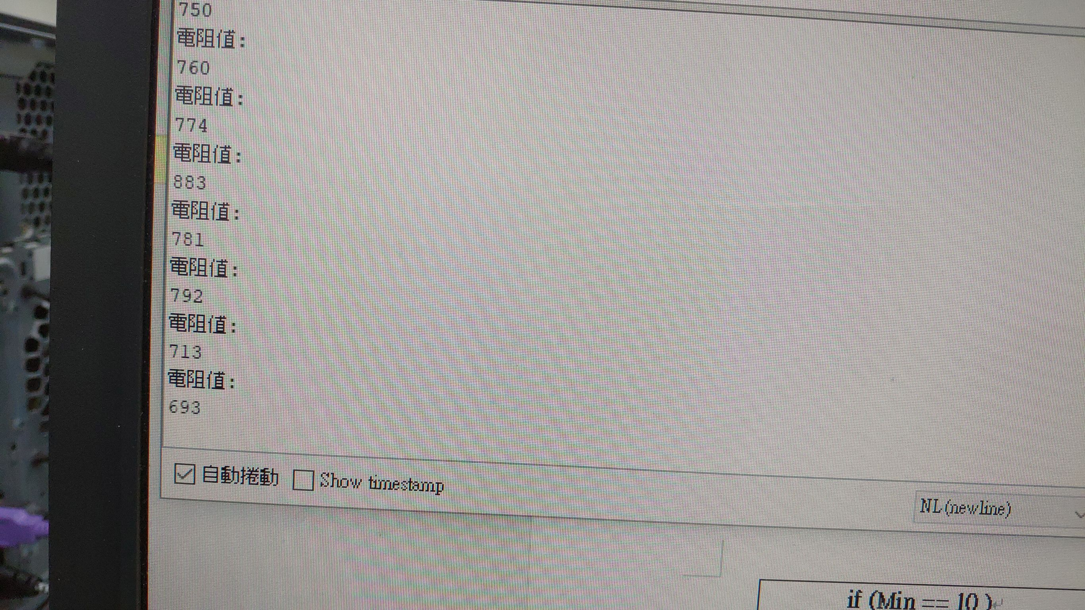
- 心得討論
考完期中考,希望這科能順利通過

