電通二乙微處理器實驗 實驗結報

實驗名稱 | Lab11
組別 | 51 | 組員 | 李承諺

- 實驗目的
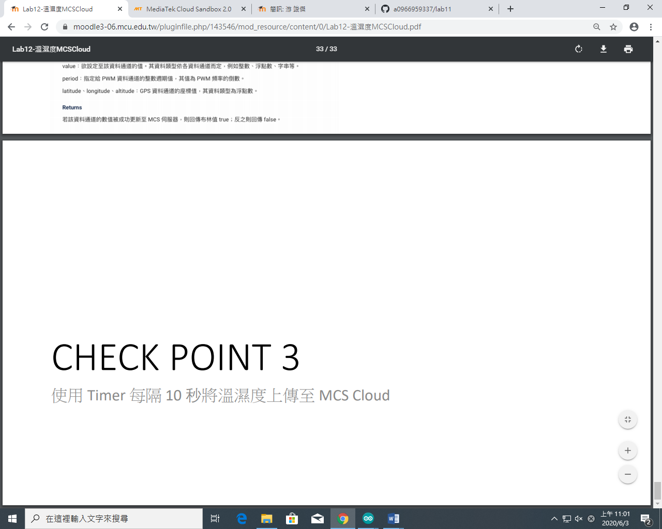
- 實驗步驟
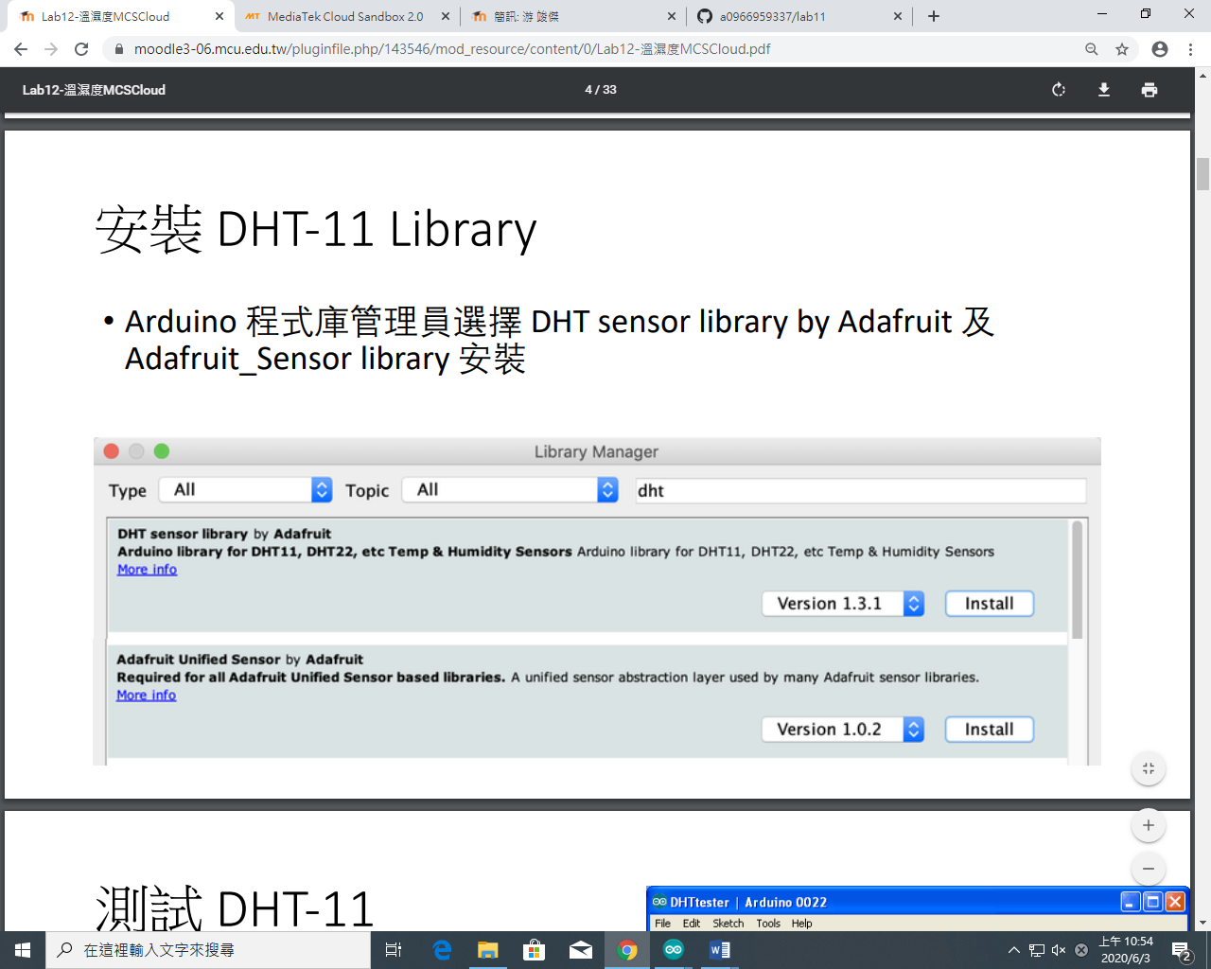

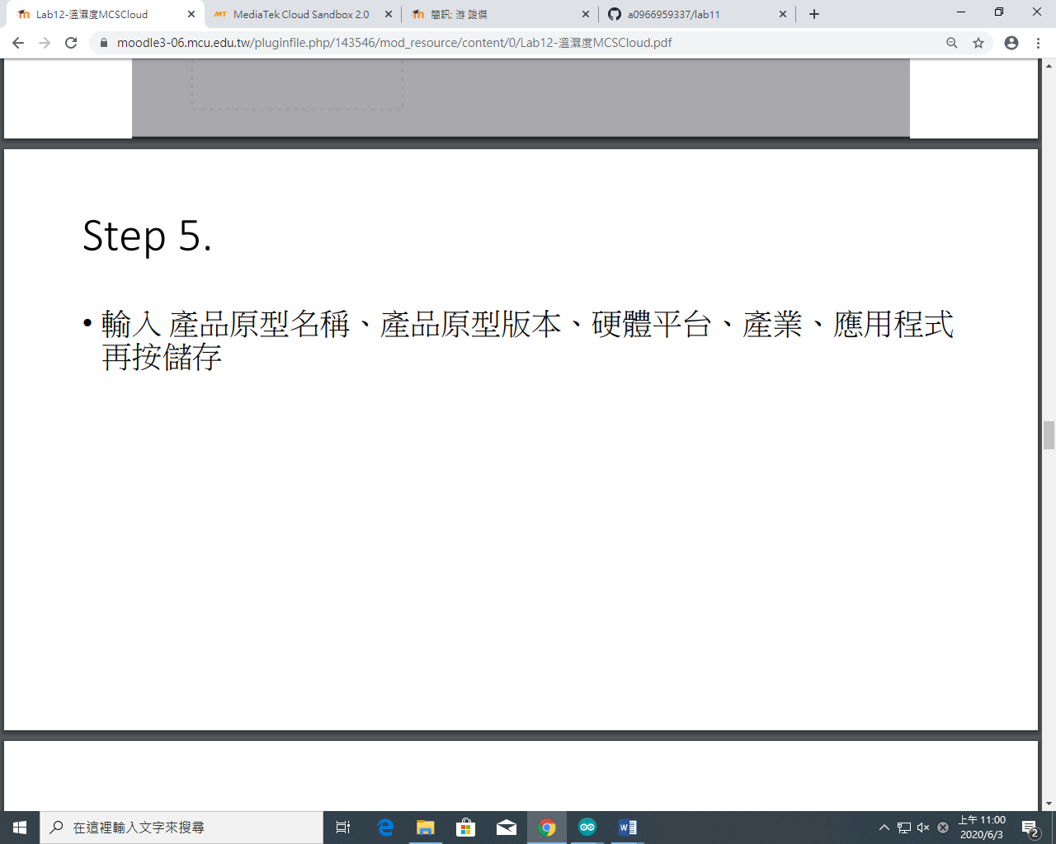
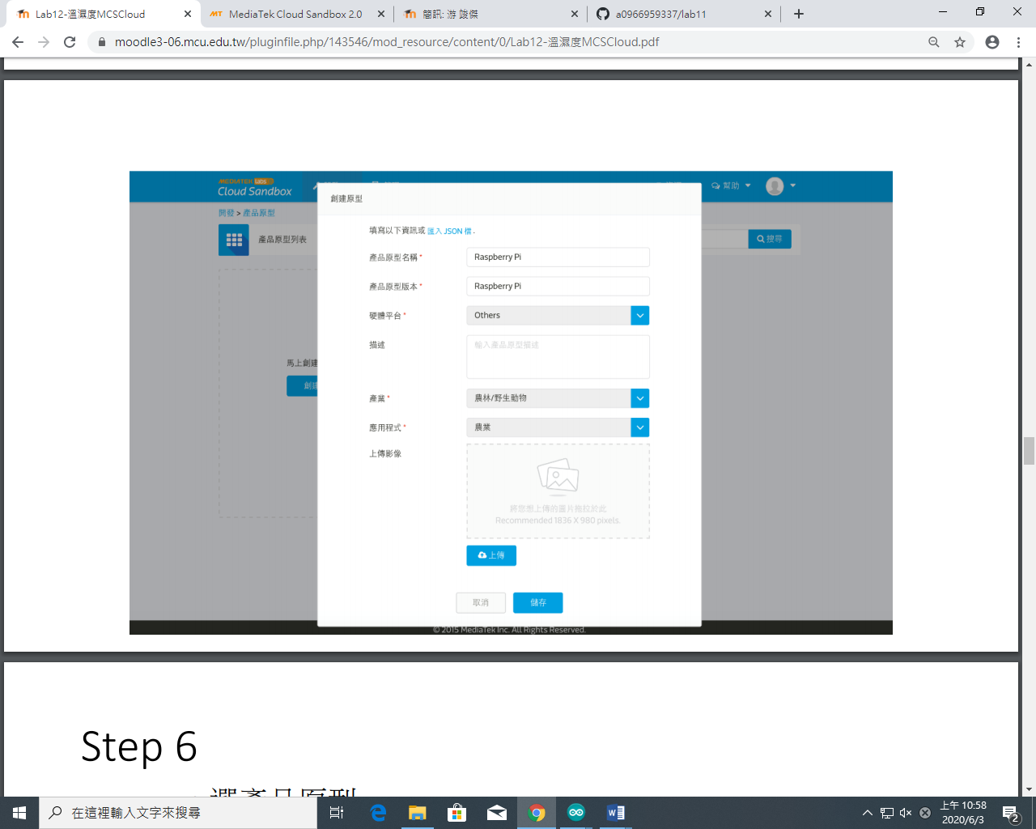
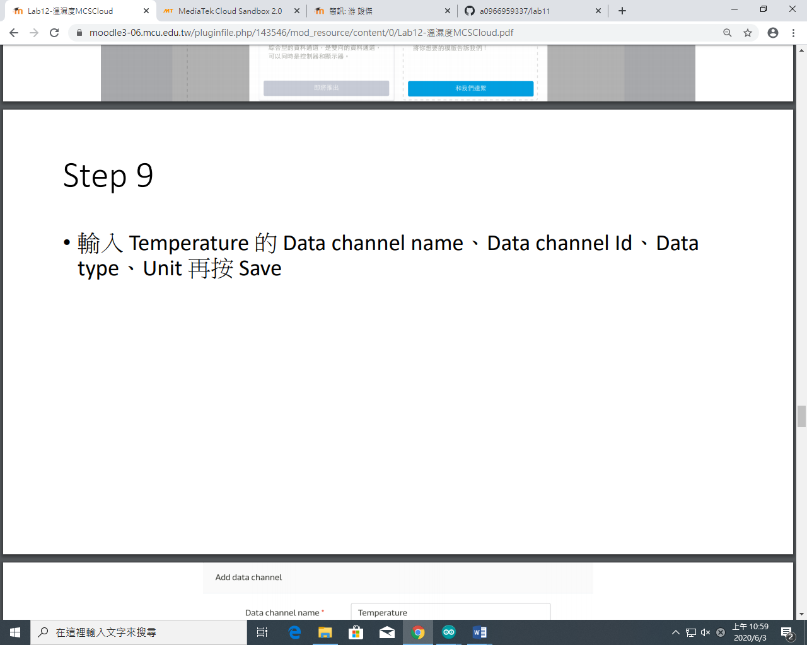
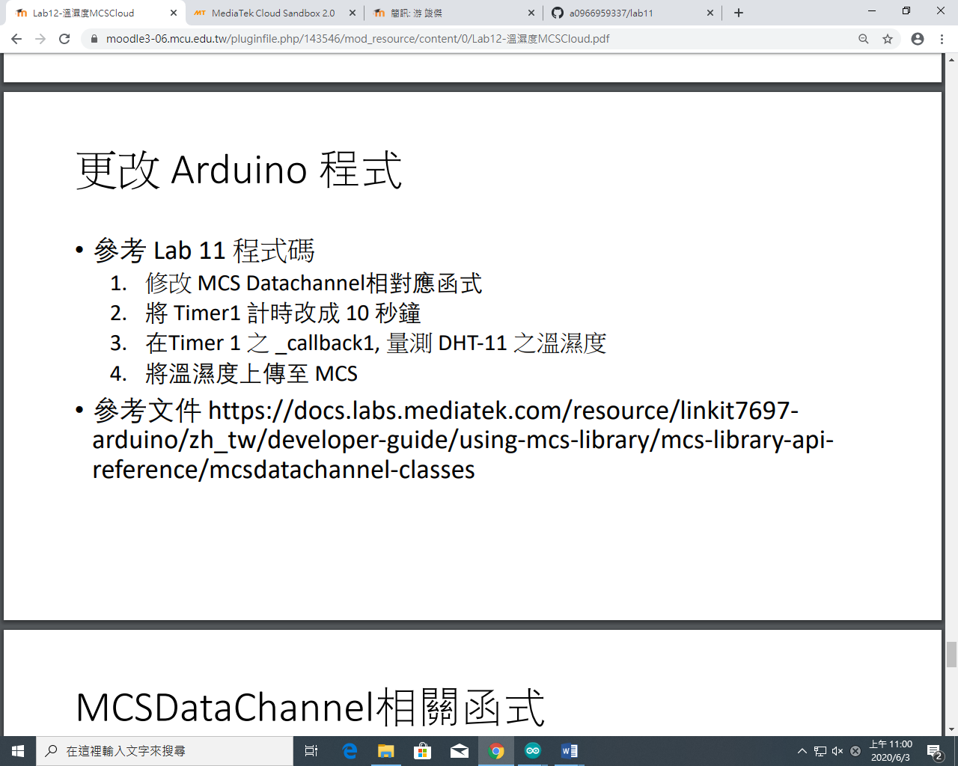
- 程式碼
#include <LWiFi.h>
#include <WiFiClient.h>
#include "MCS.h"
#include "DHT.h"

#define DHTPIN 2
#define DHTTYPE DHT11

// Assign AP ssid / password here
#define _SSID "AA202_2G"
#define _KEY "iteaa202"

DHT dht(DHTPIN, DHTTYPE);
// Assign device id / key of your test device
MCSDevice mcs("DtpOF1a1", "2RnmMW0h7alLa8E9");

// Assign channel id
// The test device should have 2 channel
// the first channel should be "Controller" - "On/Off"
// the secord channel should be "Display" - "On/Off"
MCSDisplayFloat Temperature("Temperature");
MCSDisplayFloat Humidity("Humidity");

void setup() {
// setup Serial output at 9600
Serial.begin(9600);
Serial.println(F("DHTxx test!"));

dht.begin();

// setup Wifi connection
while(WL_CONNECTED != WiFi.status())
{
Serial.print("WiFi.begin(");
Serial.print(_SSID);
Serial.print(",");
Serial.print(_KEY);
Serial.println(")...");
WiFi.begin(_SSID, _KEY);
}
Serial.println("WiFi connected !!");

// setup MCS connection
mcs.addChannel(Humidity);
mcs.addChannel(Temperature);

while(!mcs.connected())
{
Serial.println("MCS.connect()...");
mcs.connect();
}
Serial.println("MCS connected !!");
}

void loop() {
// call process() to allow background processing, add timeout to avoid high cpu usage
Serial.print("process(");
Serial.print(millis());
Serial.println(")");
mcs.process(100);
delay(1500);

float h = dht.readHumidity();
// Read temperature as Celsius (the default)
float t = dht.readTemperature();

// updated flag will be cleared in process(), user must check it after process() call.

if(!Humidity.set(h))
{
Serial.print("Failed to update remote");
Serial.println(Humidity.value());
}

if(!Temperature.set(t))
{
Serial.print("Failed to update remote");
Serial.println(Temperature.value());
}

// check if need to re-connect
while(!mcs.connected())
{
Serial.println("re-connect to MCS...");
mcs.connect();
if(mcs.connected())
Serial.println("MCS connected !!");
}
}

- 實驗結果及分析
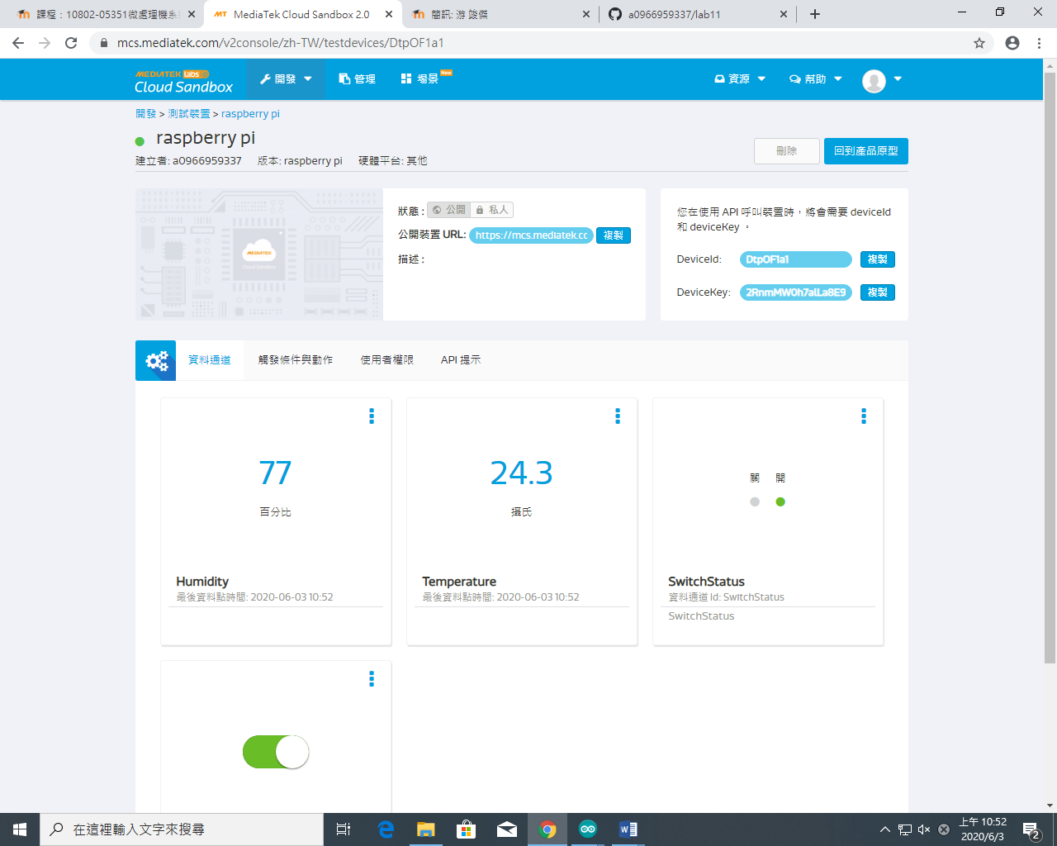
- 心得討論
今天做得還算簡單,希望下星期期末考能考好

