GUI For Google image downloaders .

Abstract :

developing a Python open Source program to make it available for Non-ITcians , by Designing a Simple GUI with python to provide access to the program ,

The Idea :

Google image downloaders is command line based python program used to scrape images from google , since it’s a command line program not everyone can use it or would tinker to know how to use it so to make it simpler we can develop and GUI for it and get a EXE file to use it everywhere , the final program will work at any WINDOWS environment and will be developed later to get a unix version ,

Technologies :

1. Tkinter  
   A GUI framework for python
2. Subprocess – to execute command in python script

Steps :

1. Design graphical user interface
2. Try GUI with command line
3. Extend program to accept Linux and windows systems
4. Publish it on Github
5. Check for extra development IDEA
6. Get EXE file .

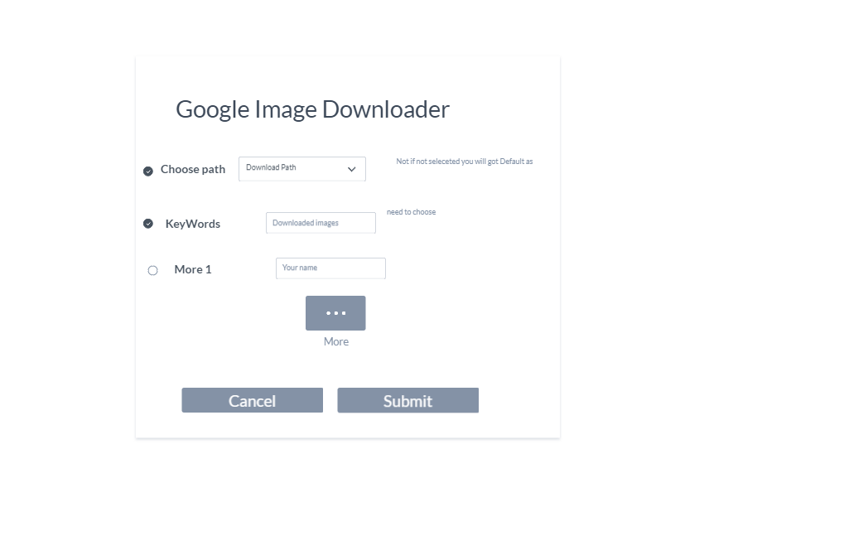Proto type :

Report – Version 0.1

Project Screen Shot:

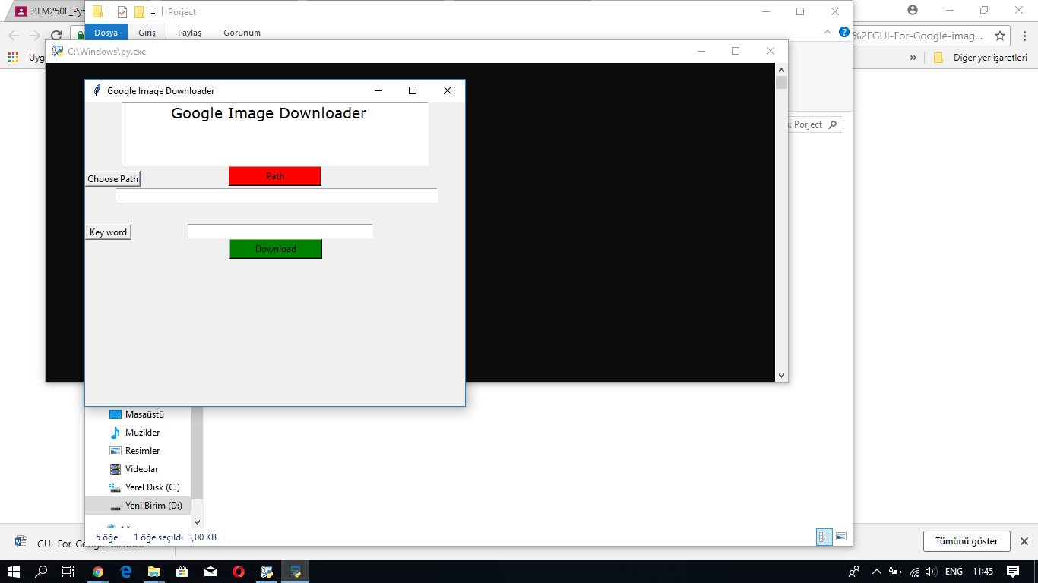

At this project we connected an open Source project with Graphical user interface using Tkinter and opened a pull request as GUI prototype at the main project to get it developed and worked better , you can see at the screen shot that use can get a path and download a specific pictures by writing the keywords .

We used Tkinter as GUI library and Sub process to communicate between two program , At short time we get it worked ,

To develop :

We can use a QT – improved version to draw the User interface and make it interesting :D .

For the design we did not use any framework since this days people tend to use material design and its much professional .

We have to add more panels and active the other parameters of the code ,

And at the end we can call the sub process to end and exit from the main program .