Experiment 7

**Kmeans Clustering of Text corpora**

|  |  |  |  |  |  |
| --- | --- | --- | --- | --- | --- |
| **Name:** | **:** | **Abhishek N N** | **Register No** | **:** | **20BCE1025** |
| Faculty | : | Dr. Alok Chauhan | Slot | : | L51-L52 AB1-605B |
| Course | : | Web Mining Lab | Code | : | CSE3024 |
| Programme | : | B.Tech CSE Core | Semester | : | Win – 22 - 23 |



Problem- 1:

Take any text corpora, apply necessary preprocessing and perform the k-means clustering on the corpora.

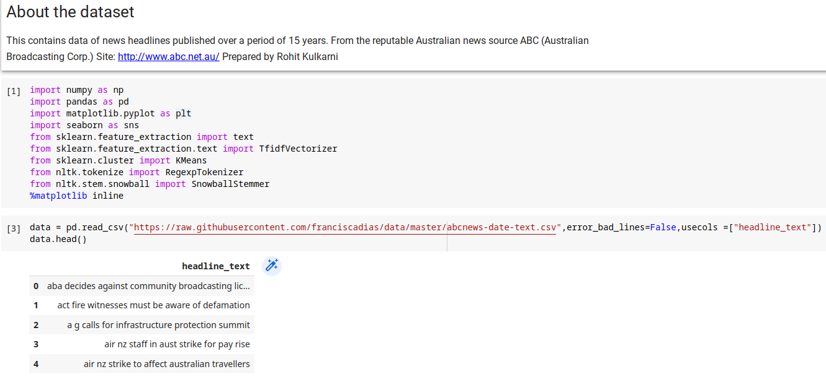

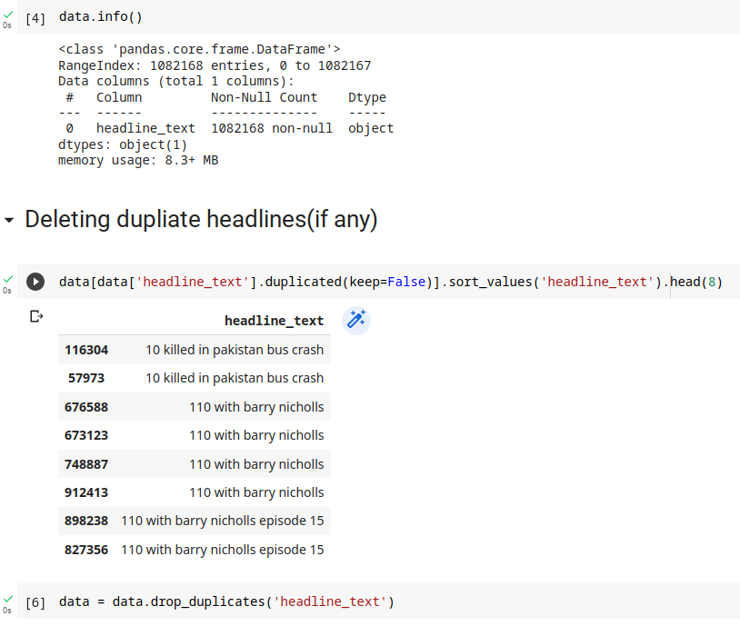

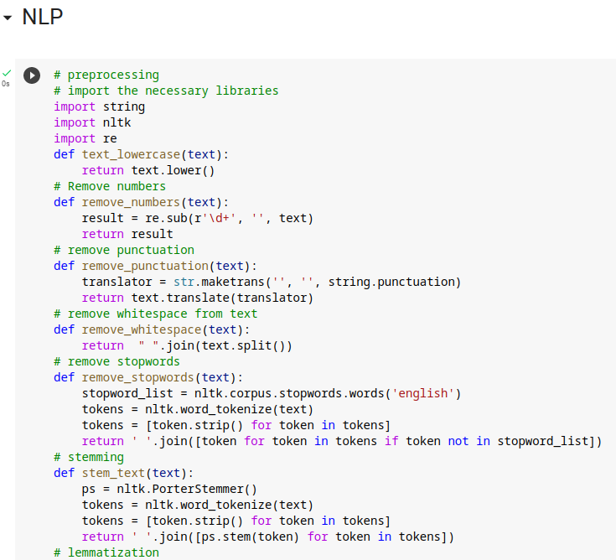

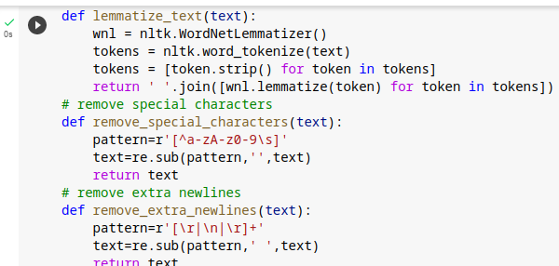

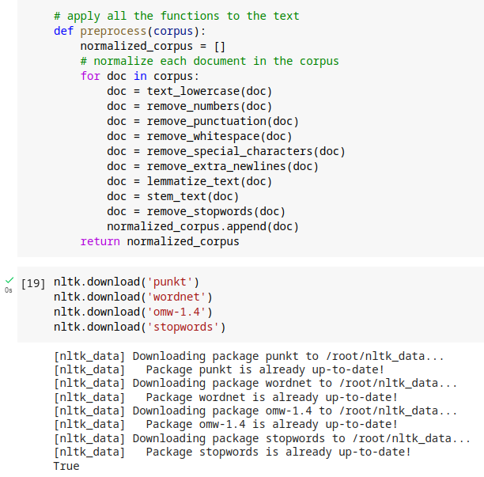

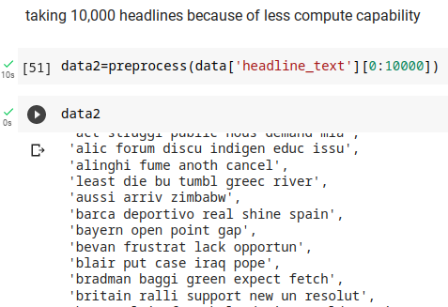

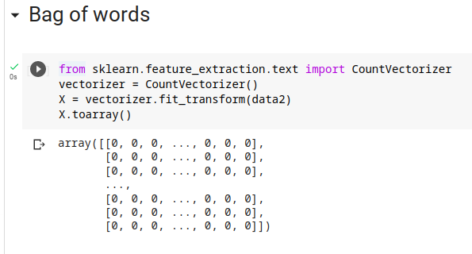

Note: Observe the clustering performance by doing different initializations of centroids as well as different number of clusters.

