I used to be suicidal

Golden Mornings

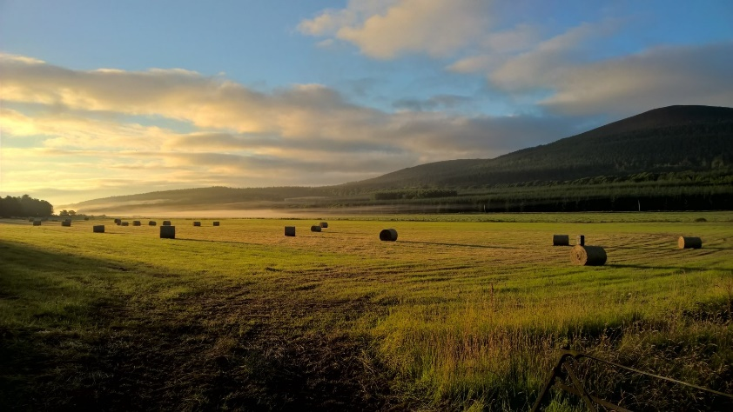

If you kill yourself today, you’ll miss the sunrise tomorrow.

Search on google when the sun will rise tomorrow.

Find a good spot that you can reach in time.

Prepare a playlist.

Go to bed early or stay up all night, just be ready for the sunrise.

Go to your spot 20 minutes before sunrise and enjoy the view. Enjoy the breeze. Enjoy the morning.

Cold Drinks

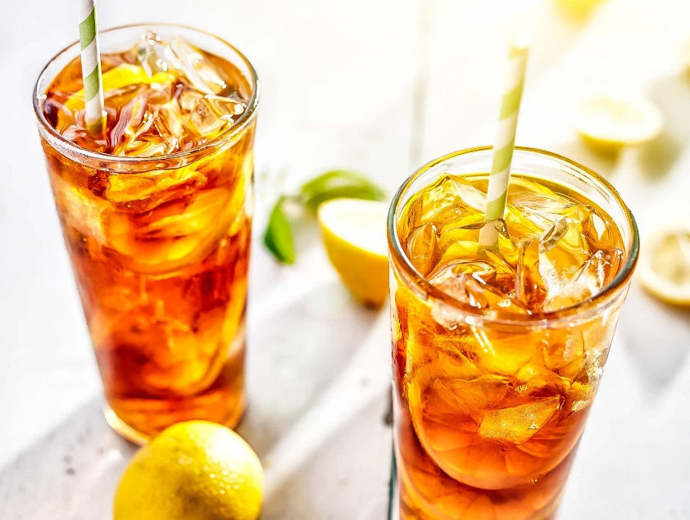

If you kill yourself today, you won’t get to taste a cold drink again.

Get ice cubes.

Get your favourite soft drink.

Make a big cold glass and blabla