RESEARCH PROPOSAL FORM
(also referred to as the ‘Statement of Intent Form’, or SOI)

To be submitted by the researcher to the Institute Research Sub-Committee (IRC)

Research Title:
Maltese Flora Classifier

Institute name
Institute of Information & Communication Technology
Course / Programme:
B.Sc. Software Development (Hons.)
Level and year of study
Level 6 Year 3
Main area of study being proposed:

This study focuses on a pre-developed prototype which produces image classifications of Maltese indigenous flora after training a model using an image classification algorithm and a custom dataset. The intention is to improve said prototype by using newer versions of the algorithm and different variants of datasets. The process would also involve the use of additional libraries and APIs namely flora databases which will aid to improve the user experience of the prototype.

Name of Researcher:  Isaac Tanti | Researcher’s I.D. Number:  0248296M
Signature of Researcher | Date of submission of Form
Name of Tutor (or Recommended Tutor):

Personal Motivation for the Choice of Research Theme.
The Maltese islands are filled with life and vegetation and it is home to some very rare and unique plants. Unfortunately, a few numbers of people are educated about the subject and this might bring risks that one day these plants are either forgotten or simply become extinct. With the help of computer vision as a deep learning method, an image classification tool can be developed using an object detection algorithm which is used to train a model with a custom-built dataset that contains images of Malta’s unique flora. This tool can be used in conjunction with other tools to form an application which can be used to teach primary and secondary students about the local flora.

Outline of Key Literature and Theoretical Framework or Propositions.
The human brain is known to recognize objects by evaluating visual information and extracting semantically meaningful features such as shapes, measurements and line-segments. Computer vision on the other hand works differently as they must process other but less meaningful features from visual data such as textures, shades, colours etc. (Zhang, 2010) Computer vision is an engineering and science technique based on visual data that strive to create and automate useful systems to aid in real physical scenarios. (Yousaf, Azhar, Murtaza and Hussain, 2018) The main target of machine learning is to use custom made or past information to solve a given problem. In this scenario, using computer vision, a machine will be trained to recognize patterns in digital visuals by providing it a set of graphical data which is relevant to the desirable result of classification. (Alpaydin, 2010)
A deep learning-based model uses feature extraction from deep learning networks and a deep learning object detection is usually designed as a two-stage detector to highlight precision, but a single-stage detector may still have an exceptional precision rate with a faster output. (Ren, He, Girshick and Sun, 2017)
Soviany and Ionescu had explained in their research paper that currently there are two primary types of object detectors, which are single-stage and two-stage detectors. A two-stage detector generally provides the better precision rate of accuracy than single-stage detectors. On the other hand, although not as accurate as two-stage detectors, a single-stage detector provides its detection in a much shorter period of time. They concluded that unless a system requires the best precision rate of accuracy, a single-stage detector still provides great accuracy results and in a very short time. (Soviany and Ionescu, 2018)
YOLOv3 is an extremely accurate and quick recognitional algorithm which uses a single neural network on a graphic, divides it into different regions and bounding boxes which will reflect on the result of probability prediction. However, it is considered to be overparameterized as it has over ten million different parameters. Furthermore, small devices aren’t capable to host such algorithm as it requires a lot of resources to run. (Redmon, J. and Farhadi, 2019)

Faster R-CNN is also a very quick and accurate recognitional algorithm. It works by extracting a feature map from the original image and a separate network is used to predict the region proposal. It is later reshaped using region of interest which is later used to classify the image. It is also a resource demanding algorithm and requires a powerful environment to work. (Liu, 2018)

Significance of the Study.
This aim of this research is to improve a prototype which enables users to identify and give out information about local flora found on the Maltese islands. This study would allow the developer to learn and understand new technological techniques namely computer vision.

Hypotheses and/or Research Question/s
With the help of computer vision as a deep learning method, various types of local flora can be classified. The main target of this research is to deliver a tool that will enable users to identify local flora found in the Maltese islands and give out information about said flora.
This study will aid to answer a number of research questions such as:
- How can the acquired datasets be improved to produce a better accuracy rate?
- Can the prototype be improved with the use of other technological techniques?
- Are there any other computer vision methods which would better the performance of the prototype?

Target Participants and Research Methods for Data Collection and Analysis
In order to address the identified research questions, hypothesis and make use of computer vision, a pipeline is to be followed to help understand the workflow of this project. The idea is to take a four phase approach: obtain the required resources such as libraries and datasets, prepare the dataset by dividing it into two datasets (training and testing), prepare the training environment and adjust configuration, and finally, train the model using the dataset and an image classification algorithm. If the results are not acceptable, repeat process, if the results are acceptable proceed. A clear diagram of the four phases can be observed below.

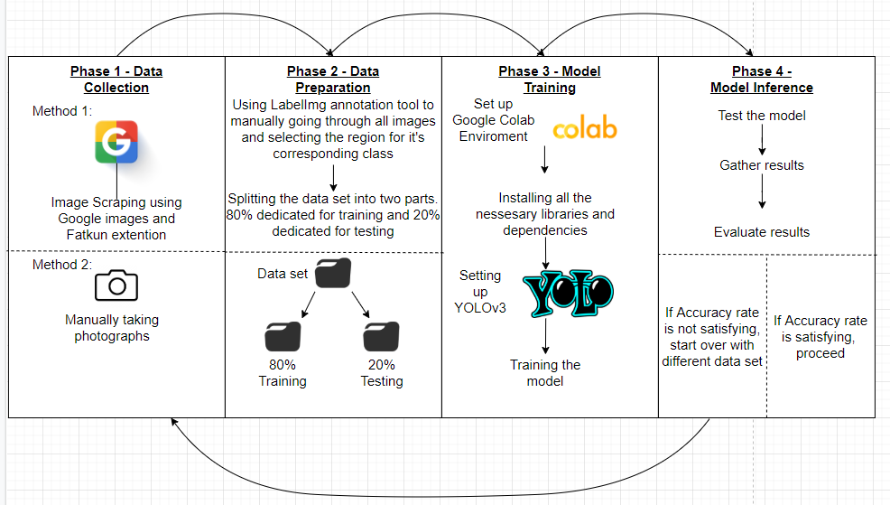
Figure 1 – Pipeline
Once the model training process has been complete, the process of integrating the model with other tools would commence. This will eventually result in the implementation of a user friendly application.

Anticipated Contributions of the Study.
With the help of this research, it is envisaged that:
- The local flora gets acknowledged, properly maintained and preserved
- Provide an educational service which could be used by primary or secondary teachers to teach students about the Maltese local flora.
- The publication of the research done which includes methods used and results for other researchers observe

Dissertation Project Plan.
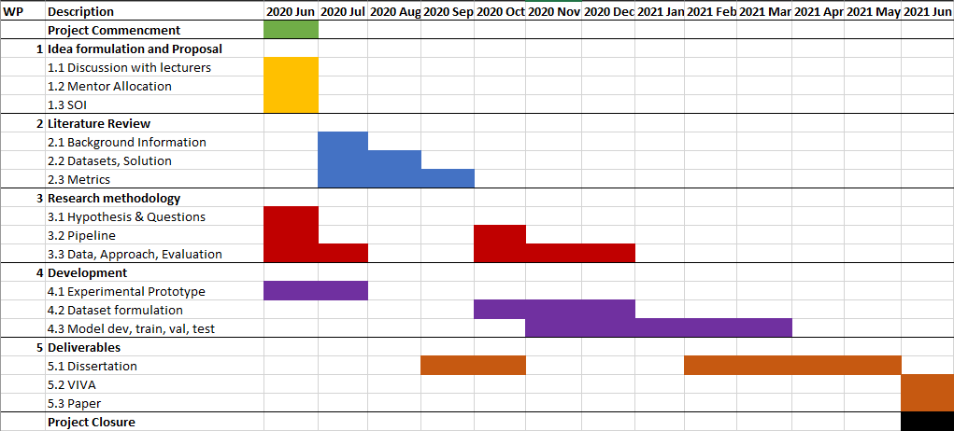

Figure 2 – Gantt Chart

Ethical Considerations.
Refer to guidance points below. You are also additionally required to read MCAST Document 074 ‘Research Ethics Policy and Procedure’ that is available on the College website via link http://www.mcast.edu.mt/179
Research shall be conducted in such a manner so as to avoid any psychological and physical harm to humans and animals and financial damage to organizations:
- Only the supervisor and examiners will have access to any data gathered.
- Participants will remain free to withdraw from the study at any time without having to provide any reason. In the case of withdrawal, all the records and information collection will be deleted.
- The participant, who is the sole proprietor of the data provided, is granting that such data would be processed for this study purposes only.
- The data collection process will be a transparent process.
- All transcriptions and/or electronic recordings reflecting the data collected, once exhausted, are to be deleted
- Confidentiality, anonymity and data protection procedures are to be ethically abided by.
- The researcher would provide a soft copy of the study to the participant, if required.

Enter details here regarding possibility of issues regarding confidential personal data:
All the material including images required for this project can be publicly obtained or downloaded from the internet. All images follow the data protection act and does not breach any laws.

Enter details here regarding possibility of physical harm:
The research undertaken here does not present any physical harm to any type of life; thus this is not applicable.

Enter details here regarding possibility of moral harm:
This researched theme and subject does not in anyway present any form of moral harm; thus making this not applicable.
Enter details here regarding possibility of business harm:
All resources used are either legally obtained or open source. All research papers referenced in this document and in the final project have been legally obtained. This research project will not in any way breach any legal or ethical regulations.

List of Key References:

Zhang, B., 2010. Computer vision vs. human vision. 9th IEEE International Conference on Cognitive Informatics (ICCI'10),.
Alpaydin, E., 2010. Introduction To Machine Learning. Cambridge, Mass.: MIT Press.

Yousaf, M., Azhar, K., Murtaza, F. and Hussain, F., 2018. Visual analysis of asphalt pavement for detection and localization of potholes. Advanced Engineering Informatics, 38, pp.527-537.

Ren, S., He, K., Girshick, R. and Sun, J., 2017. Faster R-CNN: Towards Real-Time Object Detection with Region Proposal Networks. IEEE Transactions on Pattern Analysis and Machine Intelligence, 39(6), pp.1137-1149.
Soviany, P. and Ionescu, R., 2018. Optimizing the Trade-Off between Single-Stage and Two-Stage Deep Object Detectors using Image Difficulty Prediction. 2018 20th International Symposium on Symbolic and Numeric Algorithms for Scientific Computing (SYNASC),.
Liu, Y., 2018. An Improved Faster R-CNN for Object Detection. 2018 11th International Symposium on Computational Intelligence and Design (ISCID),.
Redmon, J. and Farhadi, A., 2018. Yolov3: An incremental improvement. arXiv preprint arXiv:1804.02767.

This section is to be filled in by the representative of the Institute Research Sub-Committee (IRC) prior to forwarding of this Form to the ‘MCAST Research Ethics Committee’ for final ethics approval:
Nature of Ethical Consideration | Outcome (Tick) | Comments/Advice
All ethical issues have been adequately tackled.
Possibility of issues regarding misuse of data or some form of harm.

Details of Representative to the Institute Research Sub-Committee.
Name | Signature
Designation | Date

Annex 1: Participant Information Letter

Sample: 
Title of Research: ___________________________________________________________________
You are being invited to take part in a research study. Before you decide to participate, it is important for you to understand why the research is being done and what it will involve. Please take time to read the following information carefully and discuss it with others if you wish. Ask us if there is anything that is not clear or if you would like more information.
What is the purpose of the study?
This research is being undertaken on…

Why have I been chosen?
You have been chosen because…

Do I have to take part?
It is up to you to decide whether or not your take part. If you decide to take part you will be given this information sheet to keep and be asked to sign a corresponding consent form.

What will happen to me if I take part?
You will then be given a questionnaire on.../your data will be used…/your image will be used…

What are the possible disadvantages and risks of taking part?
There are no disadvantages or risks foreseen in taking part in the study.

What are the possible benefits of taking part?
By taking part you will be contributing to the development of a set of recommendations for…

What if something goes wrong?
If you wish to complain or have any concerns about any aspect of the way in which you have been approached or treated during the course of this study, please contact…(researcher is to give his/her MCAST email as a contact)

Will my details be kept confidential?
All information which is collected about you during the course of the research will be kept strictly confidential so that only the researcher carrying out the research will have access to such information and will not be shared with any other individuals. Participants should note that data/images collected from this project may be retained and published in an anonymized form. By agreeing to participate in this project, you are consenting to the retention and publication of data.

What will happen to the results of the research study?
The results will be written up into a dissertation for my final project of my Bachelor…

Who is organizing the research?
The research is conducted as part of a degree in …

Who may I contact for further information?
If you would like more information about the research before you decide…(researcher is to give his/her MCAST email as a contact)

Thank you for your interest in this research…
Annex 2: Participant (or Guardian) Consent Form

Sample:

Title of Research: ____________________________
Name of Researcher: ___________________________

Please initial box

- I confirm that I have read and understand the Information Letter
for the above study and have had the opportunity to ask questions.
- I understand that my/my charge’s participation is voluntary and that I/my charge am/are free to withdraw at any time without giving any reason.

3. I agree to allow my daughter/son/charge to take part in the above study.
(Statement 3 is to be included only when guardians/parents are involved in giving consent)

___________________ _________________ _____________
Name of Participant/
Guardian Date Signature

Researcher Date Signature

1 for participant; 1 for researcher

