Abstract
Particle-in-cell (PIC) simulations generate large volumes of multivariate particle trajectory data, creating a need for automated feature extraction and grouping. Building on previous work on deep clustering of particle trajectories, this study extends the input representation to include particle position, momentum components, and local electromagnetic fields. The workflow transforms multichannel time series into time–frequency spectrograms and uses a convolutional autoencoder to learn low-dimensional representations. These representations are then used for cluster initialization and deep clustering refinement with a reconstruction constraint, enabling particle grouping without predefined labels. A one-dimensional convolutional autoencoder operating on raw time series is included as a reference approach. An elbow-based criterion is incorporated to select the number of clusters within a prescribed range, reducing reliance on manual specification. Clustering quality is evaluated primarily using the silhouette score, with reconstruction errors and visualizations providing supplementary diagnostics. The study assesses the applicability of spectrogram-based deep clustering to multivariate particle trajectories from PIC simulations.

1. Introduction
Particle-in-cell (PIC) simulations are an important numerical tool for studying plasma dynamics. They can record particle positions, momenta, and electromagnetic fields sampled along particle trajectories, producing large collections of multivariate time series. As the number of tracked particles, recorded time steps, and available variables increases, inspecting individual trajectories or comparing a small number of two-dimensional projections becomes insufficient for systematic analysis. Automated feature extraction and the grouping of particles with similar trajectory characteristics therefore represent an important task in PIC data analysis.
Unsupervised learning offers a way to address this task without requiring predefined particle labels. By constructing suitable data representations and grouping samples according to their similarity, large trajectory datasets can be organized into more manageable subsets. Markidis et al. introduced an automated workflow for classifying particle trajectories from plasma simulations by combining the fast Fourier transform, principal component analysis, K-means clustering, and silhouette analysis. Their application to electron trajectories in a magnetic reconnection simulation established a basis for exploring particle trajectory datasets through dimensionality reduction and clustering. Automatic Particle Trajectory Classification in Plasma Simulations

Deep representation learning provides a further approach to processing complex trajectory data. Autoencoders learn low-dimensional features through an input reconstruction task, allowing high-dimensional samples to be represented in a compact space. Deep Embedded Clustering (DEC) couples representation learning with cluster assignment, iteratively adjusting the feature representation and cluster centers to support the clustering objective. This approach provides a framework in which the representation used to group samples is learned from the data. Unsupervised Deep Embedding for Clustering Analysis

The present study builds directly on the internship report Exploring Particle In Cell Simulation Data Using Artificial Intelligence by Medina Moreira. That work investigated unsupervised particle trajectory analysis using position and kinetic energy time series, spectrogram representations, convolutional autoencoders, and deep clustering. The report also identified the absence of momentum and electromagnetic field information in the dataset and suggested extending the workflow by incorporating additional variables as input channels. This proposed extension forms the starting point of the present study, which applies the existing framework to richer particle trajectory descriptions and examines the associated data processing and clustering performance. [Exploring Particle In Cell Simulation Data Using Artificial Intelligence](C:/Users/10650/Desktop/stage/Andres and Moreira - Exploring Particle In Cell Simulation Data Using Artificial Intelligence.pdf)

Extending the input to additional variables introduces several data processing challenges. Position, momentum, and electromagnetic fields have different numerical scales and temporal characteristics, making their relative contributions sensitive to preprocessing. Additional variables also increase the dimensionality of each sample and may introduce correlated or redundant information. Channel normalization, feature extraction, and clustering evaluation must therefore be considered together when constructing a multivariate trajectory representation. Following the previous workflow, this study uses spectrograms to represent the evolution of local frequency content within each time series. The spectrograms of different variables are combined into a multichannel input for feature learning with a convolutional autoencoder.

The input variables considered here comprise particle position \(x\), momentum components \(p_x\) and \(p_y\), electric field components \(E_x\) and \(E_y\), and the magnetic field component \(B_z\), with the fields recorded along particle trajectories. The workflow first normalizes the variables and converts their time series into spectrograms. A convolutional autoencoder then learns low-dimensional representations, which are used to initialize cluster centers through K-means. Subsequent deep clustering refinement retains a reconstruction constraint while updating the representation and cluster assignments. Both fixed cluster counts and an elbow-based selection strategy are considered, with the latter selecting the number of clusters within a prescribed candidate range.

【图一】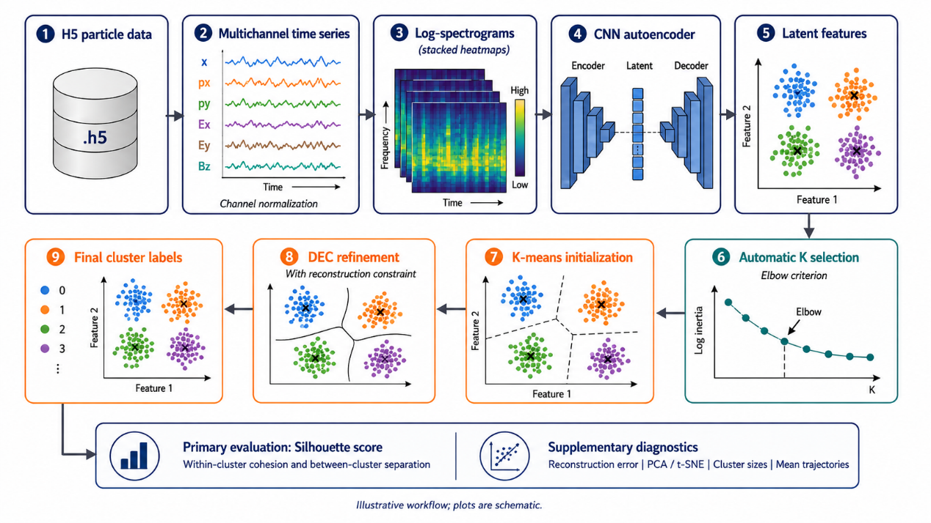
Figure 1. Overview of the spectrogram-based deep clustering workflow for multivariate PIC particle trajectories. Time series of particle position, momentum components, and local electromagnetic fields are normalized and transformed into multichannel log-spectrograms. A convolutional autoencoder learns latent representations, from which the number of clusters is selected using an elbow criterion. K-means initialization is followed by deep clustering refinement with a reconstruction constraint to obtain the final cluster assignments. Clustering quality is evaluated primarily using the silhouette score, with reconstruction errors, visualizations, and cluster statistics providing supplementary diagnostics. All plots are schematic.

Because predefined particle labels are unavailable, clustering quality is assessed primarily through internal validation. The silhouette score is used as the main evaluation metric, quantifying within-cluster cohesion and between-cluster separation by comparing each sample’s distances to samples in its own cluster and in its nearest neighboring cluster. Silhouettes: A Graphical Aid to the Interpretation and Validation of Cluster Analysis Its interpretation depends on the feature space and distance metric used for evaluation. Reconstruction errors, cluster size distributions, and dimensionality-reduction visualizations provide supplementary diagnostics. A one-dimensional convolutional autoencoder operating directly on the original time series is included as a reference approach to help assess the effect of the spectrogram representation.

The main objective of this study is to extend the previous spectrogram-based deep clustering workflow to multivariate particle data and assess its feature extraction and grouping performance. The remainder of this paper is organized as follows. Section 2 describes the dataset, input variables, and preprocessing procedures. Section 3 presents the multichannel spectrogram construction, convolutional autoencoder, deep clustering procedure, and cluster-count selection strategy. Section 4 introduces the experimental setup and reports the clustering results, primarily through silhouette analysis, together with comparisons against the reference approach. Section 5 discusses the applicability and limitations of the workflow and concludes the paper.

2. Data and Problem Definition
2.1 Data Source and Organization
This study uses PIC particle-tracking data provided within the research project to investigate unsupervised clustering of multivariate particle trajectories. The dataset is stored in HDF5 format and contains records of particle position, momentum components, and electromagnetic field components for 12,800 particles at 6,010 recorded time points.
Each variable is organized as a two-dimensional array of size \(6010 \times 12800\), with the first dimension corresponding to time and the second to particles. A shared time array specifies the recording times, while particle identifiers associate the variables and clustering results with individual particles. Variable names, coordinate components, and numerical conventions follow those of the supplied dataset.
Each particle’s multivariate time series over the available recording interval constitutes one analysis sample. The same time indices are used across all variables to maintain correspondence between channels. Particle identifiers are retained for tracking samples and associating outputs with the original records; they are not used as input features or predefined class labels.
2.2 Input Variables and Multichannel Representation
The preceding study constructed clustering inputs primarily from particle position and kinetic energy time series and proposed extending the workflow to include momentum and electromagnetic field information. The present work follows this direction by adapting the input representation to incorporate these additional types of particle records. [Exploring Particle In Cell Simulation Data Using Artificial Intelligence](C:/Users/10650/Desktop/stage/Andres and Moreira - Exploring Particle In Cell Simulation Data Using Artificial Intelligence.pdf)
The main configuration uses six input channels: \(x\), \(p_x\), \(p_y\), \(E_x\), \(E_y\), and \(B_z\), as summarized in Table 1. The available \(p_z\) component is not included in this configuration.
Table 1. Input channels used for multivariate particle trajectory clustering.
Category | Variable | Description
Position | \(x\) | Particle position along the \(x\)-axis
Momentum | \(p_x\) | \(x\)-component of particle momentum
Momentum | \(p_y\) | \(y\)-component of particle momentum
Electric field | \(E_x\) | Electric field component along \(x\), recorded along the particle trajectory
Electric field | \(E_y\) | Electric field component along \(y\), recorded along the particle trajectory
Magnetic field | \(B_z\) | Magnetic field component along \(z\), recorded along the particle trajectory
Each channel contains the temporal evolution of one variable, and the six channels jointly describe an individual particle over the recording interval. The variables differ in numerical scale, fluctuation amplitude, and temporal behavior, motivating a common data organization procedure and channel-specific standardization.
Figure 2 presents the standardized six-channel time series of the first five particles in the dataset. The same color identifies the same particle in every panel. These examples illustrate the input structure and temporal variation across channels; they are not selected as representatives of the resulting clusters.
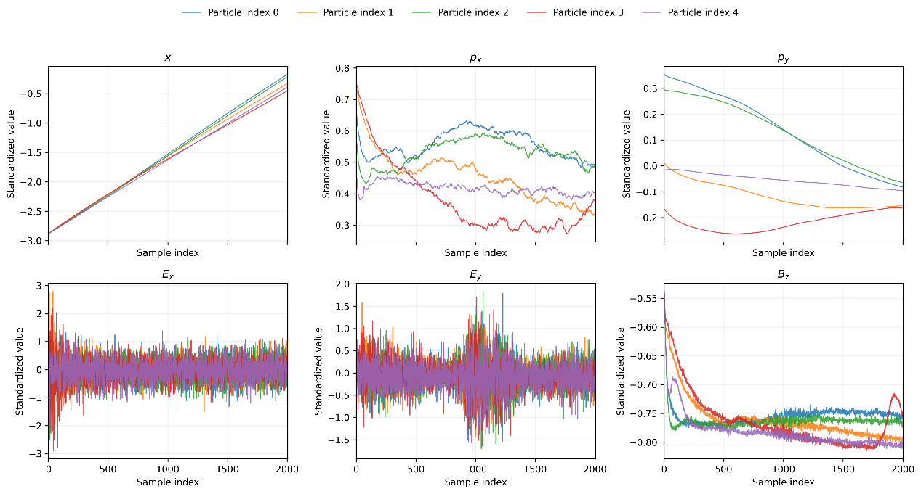
[Insert Figure 2 here: standardized six-channel particle time series.]
Figure 2. Standardized six-channel time series for five example particles. The panels show \(x\), \(p_x\), \(p_y\), \(E_x\), \(E_y\), and \(B_z\) for the first five particles in the dataset. Particle indices 0–4 correspond to identifiers 1–5, and the same color denotes the same particle across all panels. Each channel is standardized using its mean and standard deviation across all particles and selected time points. The horizontal axis gives the sample index after fixed-stride subsampling, yielding 2,004 points separated by 1200 in the dataset’s recorded time convention.

2.3 Uniform Temporal Sampling and Standardization
The original time array extends from 0 to 2,403,600, with a constant interval of 400 between consecutive records. These values follow the time convention of the supplied dataset. To reduce the computational cost of spectrogram construction and model training, records are selected using a fixed stride of three. This produces 2,004 time points with a uniform interval of 1200 and retains both the first and last recording times for the present dataset.
The same sampling indices are applied to every particle and channel, preserving temporal order and correspondence between variables. Sampling selects existing recorded values directly, without interpolation. Each particle is therefore represented by a multichannel time-series array of size \(6 \times 2004\). No additional anti-aliasing low-pass filter is applied during this subsampling step, so preservation of frequency content above the reduced Nyquist limit is not assumed.
Before spectrogram construction, each channel is standardized to account for differences in numerical scale. The mean and standard deviation are calculated across all 12,800 particles and all 2,004 selected time points for that channel. Values are then transformed by subtracting the channel mean and dividing by its standard deviation. A single pair of standardization parameters is shared by all particles within each channel, rather than normalizing each particle independently.
This procedure produces dimensionless standardized values while preserving relative amplitude differences between particles within the same channel. The time series shown in Figure 2 use the same standardization parameters as the inputs to spectrogram construction. Because these parameters are estimated from the entire analysis dataset, this preprocessing configuration supports exploratory clustering of the supplied dataset.
2.4 Spectrogram Representation and Clustering Task
The standardized time series are converted into log-magnitude spectrograms separately for each channel. Following resizing and channel-wise standardization in the spectrogram domain, the resulting arrays form the input to the convolutional autoencoder. Each channel is represented on a \(33 \times 60\) grid, giving an input tensor of size \(6 \times 33 \times 60\) for each particle.
The six channels correspond to the selected variables, while the two remaining dimensions represent the resized frequency and time axes. These dimensions specify the network input grid and do not represent the numbers of independent frequency bins and time windows in the original transform. Spectrogram computation uses a sampling frequency of one, expressing frequency in cycles per sampled point. The transform parameters and resizing procedure are described in the methodology section.
The clustering task is to partition particle trajectories into groups using these multichannel representations without predefined class labels. Treating individual trajectories as samples and grouping them through feature extraction and clustering follows the general task formulation adopted in previous PIC trajectory classification studies. Automatic Particle Trajectory Classification in Plasma Simulations
Each particle receives one final cluster label for the complete analysis interval; separate labels are not assigned to individual temporal segments. Cluster indices identify the resulting groups and carry no predefined class names or ordering. The convolutional autoencoder learns a low-dimensional representation, which is subsequently used for cluster initialization and refinement. The number of clusters can be specified in advance or selected within a prescribed candidate range using an elbow criterion.
2.5 Clustering Evaluation
Because reference class labels are unavailable, clustering is assessed using internal validation, with the silhouette score serving as the primary metric. This score compares each sample’s average distance to samples in its own cluster with its average distance to samples in the nearest neighboring cluster, thereby quantifying within-cluster cohesion and between-cluster separation. Silhouettes: A Graphical Aid to the Interpretation and Validation of Cluster Analysis
Silhouette scores are computed using Euclidean distances in the learned latent space, with subsampling used to limit computational cost. Higher values indicate more compact and separated groups under the chosen representation and distance metric. The score describes clustering structure and is not interpreted as classification accuracy against ground-truth labels.
Reconstruction errors provide supplementary information about the model’s ability to reproduce its inputs. Cluster size distributions describe how particles are allocated among groups, while PCA and t-SNE visualizations assist in presenting the learned feature structure. Detailed evaluation settings and quantitative results are reported in the experimental section.

4. Methodology
4.1 Overview
This study uses an unsupervised deep clustering workflow based on multichannel spectrograms to extract features from particle trajectories and automatically group particles. The workflow comprises spectrogram construction, convolutional autoencoder pretraining, cluster-count selection and initialization, and deep clustering refinement with a reconstruction constraint.
The approach builds on the previous use of spectrograms and convolutional autoencoders for particle time-series analysis and adapts the input to six channels containing position, momentum, and electromagnetic field information. [Exploring Particle In Cell Simulation Data Using Artificial Intelligence](C:/Users/10650/Desktop/stage/Andres and Moreira - Exploring Particle In Cell Simulation Data Using Artificial Intelligence.pdf) First, the standardized time series described in Section 3 are converted into multichannel spectrograms. A reconstruction task is then used to learn low-dimensional features, from which the number of clusters and initial cluster centers are determined. Finally, the representation and particle assignments are refined through joint optimization of reconstruction and clustering losses.
The overall workflow is shown in Figure 1.
4.2 Multichannel Spectrogram Construction
A spectrogram is computed separately for each of the six standardized time series associated with each particle. The implementation uses the SciPy spectrogram function with a window length of 256 samples and a hop size of 128 samples, corresponding to 50% overlap between adjacent windows. A Tukey window with a shape parameter of 0.25 is used, and the mean is removed within each window. A one-sided magnitude spectrum is returned. The sampling frequency is set to one, so frequencies are expressed in cycles per sampled point. SciPy spectrogram documentation
The magnitude spectrum is transformed according to
\[ S_{\log}=\log(1+S), \]
where \(S\) denotes the magnitude spectrum. This transformation compresses its numerical dynamic range before network processing.
For a time series containing 2,004 samples, these settings produce 129 frequency bins and 14 time windows. Only complete windows are used, without padding at the end of the sequence; the remaining samples do not form an additional frame. Bilinear interpolation subsequently resizes the log-magnitude spectrogram to a fixed \(33\times60\) grid. This operation resamples the existing representation and does not introduce additional independent temporal or spectral information.
The resized spectrograms are standardized separately for each channel, using the mean and standard deviation computed across all particles and all spectrogram grid points in that channel. The six channels are then combined into an input tensor of size \(6\times33\times60\) for each particle. Figure 3 illustrates the resulting six-channel input for one particle.
[Insert Figure 3 here: six-channel standardized log-magnitude spectrograms.]
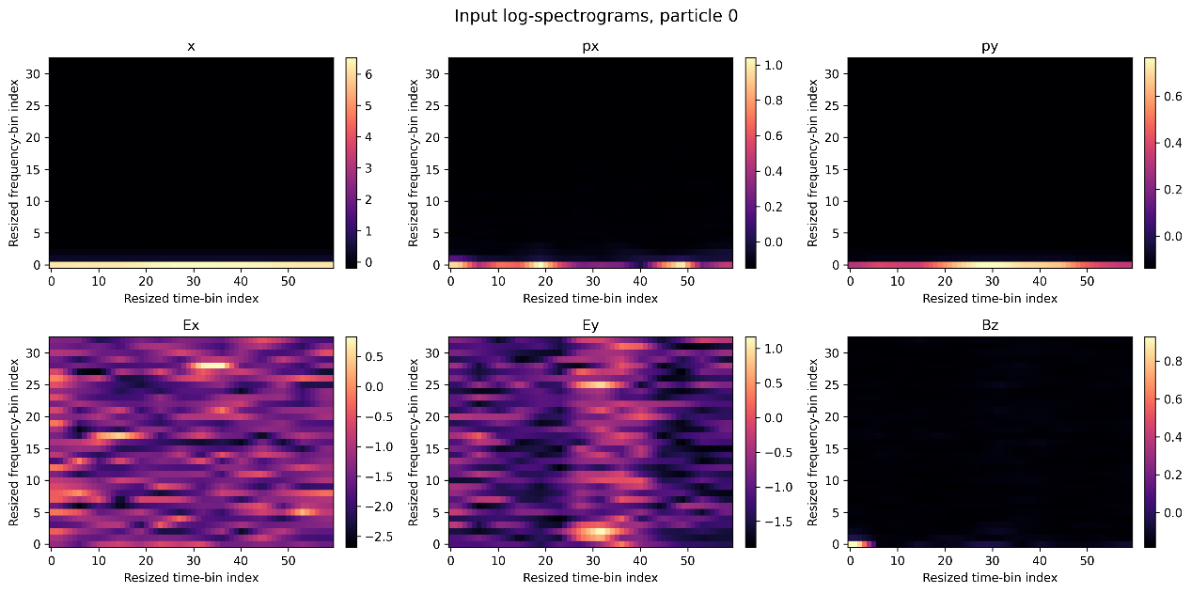
Figure 3. Six-channel spectrogram input for an example particle. The panels correspond to \(x\), \(p_x\), \(p_y\), \(E_x\), \(E_y\), and \(B_z\). Each time series is transformed into a magnitude spectrogram, logarithmically compressed, resized, and standardized channel-wise to form the convolutional autoencoder input. The horizontal and vertical axes indicate the resized time-bin and frequency-bin indices, respectively. Colors represent standardized log-magnitude values, with an independent color scale for each panel.
4.3 Convolutional Autoencoder and Reconstruction Pretraining
The convolutional autoencoder consists of an encoder and a decoder. The encoder compresses the multichannel spectrogram into a low-dimensional feature vector, while the decoder reconstructs the input from that vector. Minimizing the reconstruction error provides the feature representation used for subsequent clustering.
For particle \(i\), let \(X_i\) denote its six-channel spectrogram input. With encoder \(f_\theta\) and decoder \(g_\phi\), the latent representation and reconstruction are
\[ z_i=f_\theta(X_i), \qquad \widehat{X}_i=g_\phi(z_i), \]
where \(z_i\in\mathbb{R}^{32}\), and \(\theta\) and \(\phi\) are the trainable encoder and decoder parameters, respectively.
The encoder contains four two-dimensional convolutional layers with 8, 16, 32, and 64 output channels. Each layer uses a \(3\times3\) kernel, a stride of two, padding of one, and a ReLU activation. The final convolutional output is flattened and mapped to a 32-dimensional feature vector through a linear fully connected layer.
The decoder first maps the latent vector back to the convolutional feature dimensions through a fully connected layer. Four transposed convolutional layers then reconstruct the multichannel representation. ReLU activations follow the first three transposed convolutional layers, while the final layer has no nonnegative activation constraint, allowing reconstruction of standardized inputs containing negative values. Bilinear interpolation adjusts the output to the original input dimensions. The main architecture is summarized in Table 2.
Table 2. Main components of the convolutional autoencoder. Dimensions exclude the batch axis.
Stage | Operation | Output dimensions
Input | Six-channel spectrogram | \(6\times33\times60\)
Encoder layer 1 | Two-dimensional convolution + ReLU | \(8\times17\times30\)
Encoder layer 2 | Two-dimensional convolution + ReLU | \(16\times9\times15\)
Encoder layer 3 | Two-dimensional convolution + ReLU | \(32\times5\times8\)
Encoder layer 4 | Two-dimensional convolution + ReLU | \(64\times3\times4\)
Feature compression | Flattening + linear fully connected layer | 32
Decoder input | Linear fully connected layer + reshaping | \(64\times3\times4\)
Decoder | Four transposed convolutional layers | \(6\times34\times50\)
Output resizing | Bilinear interpolation | \(6\times33\times60\)
Pretraining minimizes a channel-weighted mean squared error:
\[ L_{\mathrm{recon}} = \frac{ \displaystyle \sum_{i\in\mathcal{B}} \sum_{c=1}^{C} w_c \left\|\widehat{X}_{i,c}-X_{i,c}\right\|_F^2 }{ BHW\displaystyle\sum_{c=1}^{C}w_c }, \]
where \(\mathcal{B}\) denotes the current batch, \(B\) is its number of samples, \(C=6\) is the number of channels, and \(H=33\) and \(W=60\) are the spectrogram grid dimensions. The squared Frobenius norm sums the squared reconstruction errors over all grid points within a channel.
For the channel ordering \(x,p_x,p_y,E_x,E_y,B_z\), the weights are
\[ \boldsymbol{w}=(1,\;1,\;1,\;0.2,\;0.2,\;1). \]
This configuration reduces the relative contribution of electric-field reconstruction errors to the training objective while retaining all six channels as inputs. The channel-specific reconstruction errors reported as diagnostics are computed separately without applying these weights.
During pretraining, particles are randomly divided into an 80% training subset and a 20% validation subset, containing 10,240 and 2,560 particles, respectively. Training uses the Adam optimizer with a learning rate of \(10^{-3}\), a batch size of 64, and a maximum of 200 epochs. Pretraining stops when the validation loss has not improved for 15 consecutive epochs. The model with the lowest validation loss is selected for subsequent clustering.
This split is used to monitor reconstruction training. Because the standardization parameters are estimated from the entire analysis dataset, the validation subset is not treated as an independent generalization test set.
4.4 Cluster-Count Selection and Initialization
After pretraining, the encoder extracts 32-dimensional features for all particles. K-means is applied in this feature space for candidate cluster counts \(K=2,\ldots,12\). Each candidate configuration uses 100 initializations, with a maximum of 1,000 iterations per initialization. The solution with the smallest within-cluster sum of squared distances is retained.
For a candidate cluster count \(K\), the K-means inertia is
\[ I(K) = \sum_{i=1}^{N} \left\|z_i-\mu_{a_i}\right\|_2^2, \]
where \(N\) is the number of particles, \(a_i\) is the K-means assignment of particle \(i\), and \(\mu_{a_i}\) is the corresponding cluster center.
The number of clusters is selected using an elbow criterion based on log inertia. The candidate cluster counts and their log-inertia values are independently rescaled to \([0,1]\). The perpendicular distance from each resulting point to the line connecting the first and last candidate points is then calculated. The candidate with the largest distance is selected as the elbow.
Silhouette scores are also computed for the candidate configurations as supplementary information; their maximum is not used to determine \(K\). Once the cluster count is selected, the corresponding K-means centers initialize the deep clustering layer. The initial particle assignments are retained for subsequent comparison.
4.5 Deep Clustering Refinement with a Reconstruction Constraint
Clustering refinement follows the soft-assignment and target-distribution update procedure of DEC. Given particle features \(z_i\) and cluster centers \(\mu_j\), soft assignments are calculated using Student’s t-distribution:
\[ q_{ij} = \frac{ \left(1+\|z_i-\mu_j\|_2^2/\alpha\right)^{-(\alpha+1)/2} }{ \displaystyle\sum_{k=1}^{K} \left(1+\|z_i-\mu_k\|_2^2/\alpha\right)^{-(\alpha+1)/2} }, \qquad \alpha=1. \]
Here, \(q_{ij}\) represents the soft assignment of particle \(i\) to cluster \(j\), with assignments summing to one for each particle. Unsupervised Deep Embedding for Clustering Analysis
An auxiliary target distribution is constructed from the current assignments:
\[ f_j=\sum_{i=1}^{N}q_{ij}, \qquad p_{ij} = \frac{q_{ij}^{\,2}/f_j} {\displaystyle\sum_{k=1}^{K}q_{ik}^{\,2}/f_k}. \]
The quantity \(f_j\) is the total soft-assignment mass of cluster \(j\). Squaring the assignments emphasizes higher-confidence memberships, while normalization by cluster frequency adjusts the relative contributions of different clusters. The target distribution is computed using all particles and updated after each epoch. It remains fixed during the following epoch’s gradient updates and is excluded from backpropagation.
The decoder and reconstruction loss are retained during clustering refinement to constrain changes to the input representation. Combining reconstruction and clustering objectives follows the structure-preservation approach introduced in IDEC. Improved Deep Embedded Clustering with Local Structure Preservation
The clustering loss for the current batch is
\[ L_{\mathrm{cluster}} = \sum_{i\in\mathcal{B}} \sum_{j=1}^{K} p_{ij}\log\frac{p_{ij}}{q_{ij}}. \]
The joint training objective is
\[ L = L_{\mathrm{recon}} + \lambda L_{\mathrm{cluster}}, \qquad \lambda=5\times10^{-4}. \]
The reconstruction term is the channel-weighted loss used during pretraining. The KL term is summed over particles and clusters within the current batch rather than averaged over particles. Its coefficient must therefore be interpreted together with the loss reduction and batch size, which is fixed at 64.
The objective follows the reconstruction-plus-weighted-clustering form used in the preceding report. The coefficient adopted here was selected following exploratory comparisons of clustering weights. Differences in input standardization, reconstruction weighting, and KL reduction prevent direct numerical equivalence with the coefficient reported in the preceding study.
During refinement, a randomly selected 50% of the particles, corresponding to 6,400 samples, participate in gradient updates. Soft assignments and target distributions are computed for all 12,800 particles before training and after each epoch. Consequently, particles excluded from the refinement gradient updates still contribute to target-distribution construction and are not treated as an independent test set.
Refinement uses Adam with a learning rate of \(10^{-3}\). The reconstruction loss updates the encoder and decoder, while the clustering loss updates the encoder and cluster centers. Final labels are obtained from the soft assignments:
\[ y_i=\underset{j}{\arg\max}\;q_{ij}. \]
These discrete labels are used for output and monitoring and do not participate in gradient computation. Figure 4 illustrates the model structure and these dependencies.
[Insert Figure 4 here: revised CNN–DEC architecture diagram.]
4.6 Training Monitoring and Model Selection
The final configuration performs 350 epochs of deep clustering refinement. Total loss, reconstruction loss, the unweighted KL term, and its weighted contribution are recorded at each epoch. Changes in particle assignments are also monitored.
The label-change rate between consecutive epochs is defined as
\[ \delta^{(t)} = \frac{1}{N} \sum_{i=1}^{N} \mathbf{1} \left[ y_i^{(t)}\neq y_i^{(t-1)} \right], \]
where \(\mathbf{1}[\cdot]\) is the indicator function. This metric gives the fraction of particles reassigned between consecutive epochs. Refinement runs for the prescribed number of epochs; the label-change rate is used as a diagnostic and does not trigger early stopping.
After each epoch, the silhouette score is computed using Euclidean distances in the current latent space for a subset of 5,000 particles selected with a fixed random seed. The score is used for both training monitoring and model selection, with the highest-scoring candidate retained. Its interpretation in terms of within-cluster cohesion and between-cluster separation follows Rousseeuw’s definition. Silhouettes: A Graphical Aid to the Interpretation and Validation of Cluster Analysis
After model selection, final labels are generated for all particles, and the silhouette score is recalculated on a subset of 10,000 particles. The final reported score may therefore differ slightly from the epoch-level monitoring score. Because model selection and final evaluation use the same analysis dataset, these scores are reported as internal clustering assessments rather than independent test performance.
The workflow retains the representations and labels obtained before refinement, together with epoch-level losses and assignment changes. Final outputs include particle identifiers, cluster labels, latent features, sampling settings, and loss weights, allowing assignments to be associated with the original trajectories. The main settings are summarized in Table 3.
Table 3. Main settings of the final analysis workflow.
Parameter | Setting
Time-series dimensions per particle | \(6\times2004\)
Spectrogram window length / hop size | 256 / 128
Network input dimensions | \(6\times33\times60\)
Latent dimensionality | 32
Autoencoder training / validation split | 80% / 20%
Maximum pretraining epochs / early-stopping patience | 200 / 15
Pretraining and refinement optimizer | Adam
Pretraining and refinement learning rate | \(10^{-3}\)
Batch size | 64
Candidate cluster counts | 2–12
K-means initializations / maximum iterations | 100 / 1,000
Cluster-count selection | Elbow of the normalized log-inertia curve
Particles used for refinement gradient updates | 6,400
Particles used to construct target distributions | 12,800
Clustering loss coefficient | \(5\times10^{-4}\)
KL reduction | Sum over minibatch particles and clusters
Refinement epochs | 350
Monitoring / final silhouette sample size | 5,000 / 10,000
Model-selection criterion | Highest monitoring silhouette score

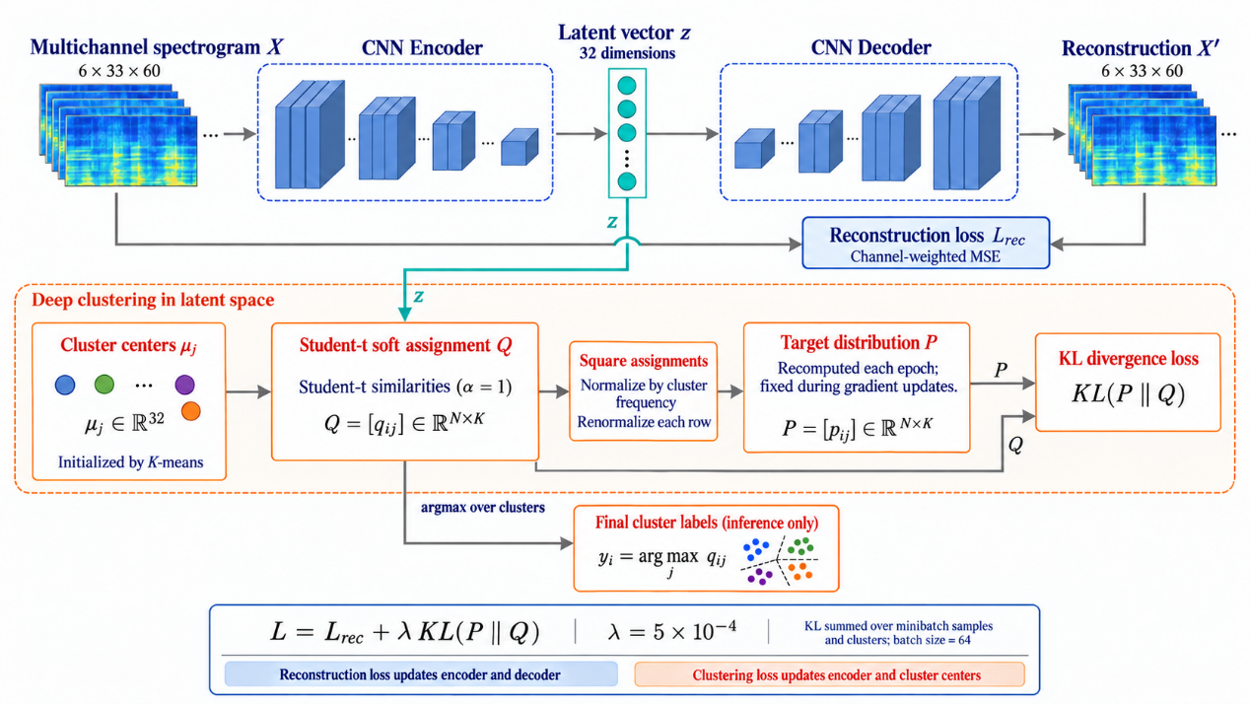
Figure 4. Convolutional autoencoder and deep clustering refinement with a reconstruction constraint. The encoder maps each six-channel spectrogram to a 32-dimensional representation, from which the decoder reconstructs the input. Latent features and cluster centers jointly determine soft assignments \(Q\), which are used to construct the auxiliary target distribution \(P\). Training combines a channel-weighted reconstruction loss with a KL clustering loss using \(\lambda=5\times10^{-4}\). The KL term is summed over minibatch particles and clusters. Reconstruction updates the encoder and decoder, while clustering updates the encoder and cluster centers. Final labels are obtained by selecting the largest soft assignment for each particle. Spectrograms, latent features, and cluster distributions in the diagram are schematic.
5. Experimental Design
5.1 Objectives and General Settings
Two comparative experiments are conducted to evaluate the spectrogram-based deep clustering workflow for multivariate particle trajectories. The first uses principal component analysis (PCA) followed by K-means as a linear dimensionality reduction baseline. The second applies a one-dimensional convolutional autoencoder followed by DEC directly to multichannel time series, providing a reference for comparison with the time–frequency representation used by the main method.
All methods use the same 12,800 particles and six input channels: position \(x\), momentum components \(p_x\) and \(p_y\), and local electromagnetic field components \(E_x\), \(E_y\), and \(B_z\). Identical temporal sampling indices are applied to all channels, yielding 2,004 uniformly spaced samples per particle. Time-series standardization uses the channel-wise means and standard deviations calculated across all particles and selected time points. These normalization parameters are shared across the experiments.
The representation dimension used for clustering is fixed at 32 for all methods. The elbow criterion used by the spectrogram workflow selects five clusters; consequently, both comparative experiments use \(K=5\). A fixed random seed of 42 is used, and the final silhouette evaluation is performed on the same subset of 10,000 particles, aligned by particle ID.
5.2 Compared Methods
The input representations, dimensionality reduction procedures, and clustering stages are summarized below.
Method | Input representation | Construction of the 32-dimensional representation | Clustering procedure
PCA + K-means | Six-channel spectrograms | Flattening followed by PCA | K-means
1D CNN + DEC | Six-channel standardized time series | One-dimensional convolutional autoencoder | K-means initialization followed by DEC refinement
Spectrogram CNN + DEC | Six-channel spectrograms | Two-dimensional convolutional autoencoder | K-means initialization followed by DEC refinement
PCA + K-means. This baseline uses the same spectrogram preprocessing as the main method, including time-series standardization, spectrogram computation, logarithmic transformation, resizing, and spectrogram standardization. Each particle is represented by a spectrogram tensor of size \(6\times33\times60\), which is flattened into an 11,880-dimensional vector.
PCA reduces this vector to 32 dimensions without whitening. K-means then partitions the resulting representations into five clusters. Both PCA and K-means are fitted using all particles. K-means uses 100 initializations and a maximum of 1,000 iterations.
This experiment provides a baseline that does not require neural network training. The cumulative explained variance of PCA is reported as a supplementary description of dimensionality reduction, while clustering is evaluated primarily through the silhouette score in the 32-dimensional PCA space.
1D CNN + DEC. This method directly takes standardized particle time series of size \(6\times2,004\) as input. The encoder uses four one-dimensional convolutional layers to extract temporal features and maps them to a 32-dimensional latent vector. The decoder reconstructs the six-channel time series from this representation.
After autoencoder pretraining, K-means initializes five cluster centers in the latent space. DEC subsequently refines the representation and cluster centers through joint reconstruction and clustering optimization. Final cluster labels are obtained from the soft assignments of the selected model.
This experiment provides a deep learning reference that operates directly on multichannel time series. Its convolutional depth and channel widths correspond to those of the spectrogram network, while the latent dimension and principal training settings are shared. Because the input shapes and convolutional operations differ, the two networks do not have identical parameter counts. The comparison therefore concerns the complete input representations and their corresponding network configurations.
Spectrogram CNN + DEC. This is the main method of the study. The six-channel particle time series are transformed into multichannel spectrograms, from which a two-dimensional convolutional autoencoder learns 32-dimensional representations. K-means initializes the cluster centers, and DEC subsequently updates the network parameters and cluster centers.
The preprocessing, network architecture, and joint optimization objective are described in the Methods section. The final training configuration is used for comparison with the two reference methods.
5.3 Training Settings for the Deep Models
Both convolutional models are trained in two stages: autoencoder pretraining and clustering refinement.
During pretraining, 80% of the particles are used to optimize the autoencoder, and the remaining 20% are used to monitor reconstruction loss. Training runs for a maximum of 200 epochs and stops if the validation reconstruction loss does not improve for 15 consecutive epochs. The model weights corresponding to the lowest validation loss are restored. Both models use the Adam optimizer with a learning rate of \(10^{-3}\) and a batch size of 64.
The reconstruction objective is a channel-weighted mean squared error. For the channel order \(x,p_x,p_y,E_x,E_y,B_z\), the weights are
\[ \boldsymbol{w}=(1,\;1,\;1,\;0.2,\;0.2,\;1). \]
The squared reconstruction errors are multiplied by their channel weights, averaged over all elements in the minibatch, and divided by the mean channel weight. This maintains the reconstruction-loss definition used by the main method.
During DEC refinement, the joint objective is
\[ L=L_{\mathrm{recon}}+\lambda L_{\mathrm{cluster}}, \qquad \lambda=5\times10^{-4}. \]
Here, \(L_{\mathrm{cluster}}\) is the KL divergence summed over all particles and clusters within the current minibatch. Both deep models use the same clustering weight and batch size, preserving the interpretation of the clustering contribution to the objective.
Following the implementation of the main method, a fixed subset containing 50% of the particles is used for gradient updates during DEC training. The target distribution is updated using the soft assignments of all particles. DEC also uses Adam with a learning rate of \(10^{-3}\), with a training budget of 350 epochs.
A fixed subset of 5,000 particles is used to monitor the latent-space silhouette score during DEC training and select model weights for final evaluation. Consequently, the reported final results correspond to the selected model and do not necessarily correspond to the last training epoch.
These data partitions control optimization and monitoring. Since normalization, cluster initialization, and target-distribution updates involve the full particle dataset, the reported scores constitute internal clustering evaluation on the available data.
5.4 Primary Evaluation Metric
The silhouette score is the primary clustering evaluation metric. For particle \(i\), it is defined as
\[ s(i)=\frac{b(i)-a(i)} {\max\{a(i),b(i)\}}, \]
where \(a(i)\) is the mean distance between particle \(i\) and the other particles in its cluster. The quantity \(b(i)\) is the smallest mean distance between particle \(i\) and the particles belonging to any other cluster. The overall score is the average over the evaluation sample:
\[ S=\frac{1}{N_{\mathrm{eval}}} \sum_{i=1}^{N_{\mathrm{eval}}}s(i). \]
Higher scores indicate greater within-cluster cohesion and between-cluster separation under the chosen representation and distance metric.
To control computational cost while maintaining a consistent evaluation sample, all methods use the same 10,000 particles selected with a fixed random seed. Euclidean distance is used throughout, and both within-cluster and between-cluster mean distances are calculated within this sample. The evaluation spaces are:
- PCA + K-means: the 32-dimensional PCA representation.
- 1D CNN + DEC: the 32-dimensional latent representation of the selected time-series model.
- Spectrogram CNN + DEC: the 32-dimensional latent representation of the selected spectrogram model.
The comparison therefore reports internal clustering scores in each method’s own representation space. The corresponding evaluation space is explicitly identified in the results table. Classification accuracy is not reported because predefined particle-class labels are unavailable.
5.5 Presentation of Results
The principal results are presented in a table comparing the silhouette scores of the three methods, together with the representation dimension, cluster count, and evaluation sample size.

6. Results and Analysis
6.1 Comparison of Silhouette Scores
The silhouette scores of the three methods are summarized in the table below. All methods use the same six-channel particle data, a 32-dimensional representation, and five clusters. Evaluation is performed on the same subset of 10,000 particles.
[Insert the silhouette comparison table here.]
Method | Evaluation space | Representation dimension | Number of clusters | Silhouette
PCA + K-means | PCA representation | 32 | 5 | 0.29957
1D CNN + DEC | Time-series latent space | 32 | 5 | 0.79637
Spectrogram CNN + DEC | Spectrogram latent space | 32 | 5 | 0.87985
Table caption: Silhouette comparison of the three methods. Scores are calculated using Euclidean distance on the same evaluation sample, within each method’s own 32-dimensional representation space.
PCA + K-means achieves a silhouette score of 0.29957. This method compresses the spectrogram input through a linear projection before clustering, providing a baseline for comparison with the deep learning approaches.
The 1D CNN + DEC method, which processes multichannel time series directly, achieves a silhouette score of 0.79637. Its higher score indicates that, under the present configuration, the combination of one-dimensional convolutional representation learning and clustering refinement produces a representation with a higher internal clustering score than the PCA baseline.
Spectrogram CNN + DEC achieves the highest silhouette score, 0.87985, exceeding the 1D result by approximately 0.08348. For the dataset and training configurations considered here, the spectrogram-based workflow therefore obtains the highest score for within-cluster cohesion and between-cluster separation in its final representation space.
6.2 Training Process of the Spectrogram Method
The training curves provide supplementary information about the optimization of the main method. They show the reconstruction losses during autoencoder pretraining, together with the joint loss and latent-space silhouette during DEC refinement.
[Insert a three-panel figure here using the following files from the final spectrogram results folder.]

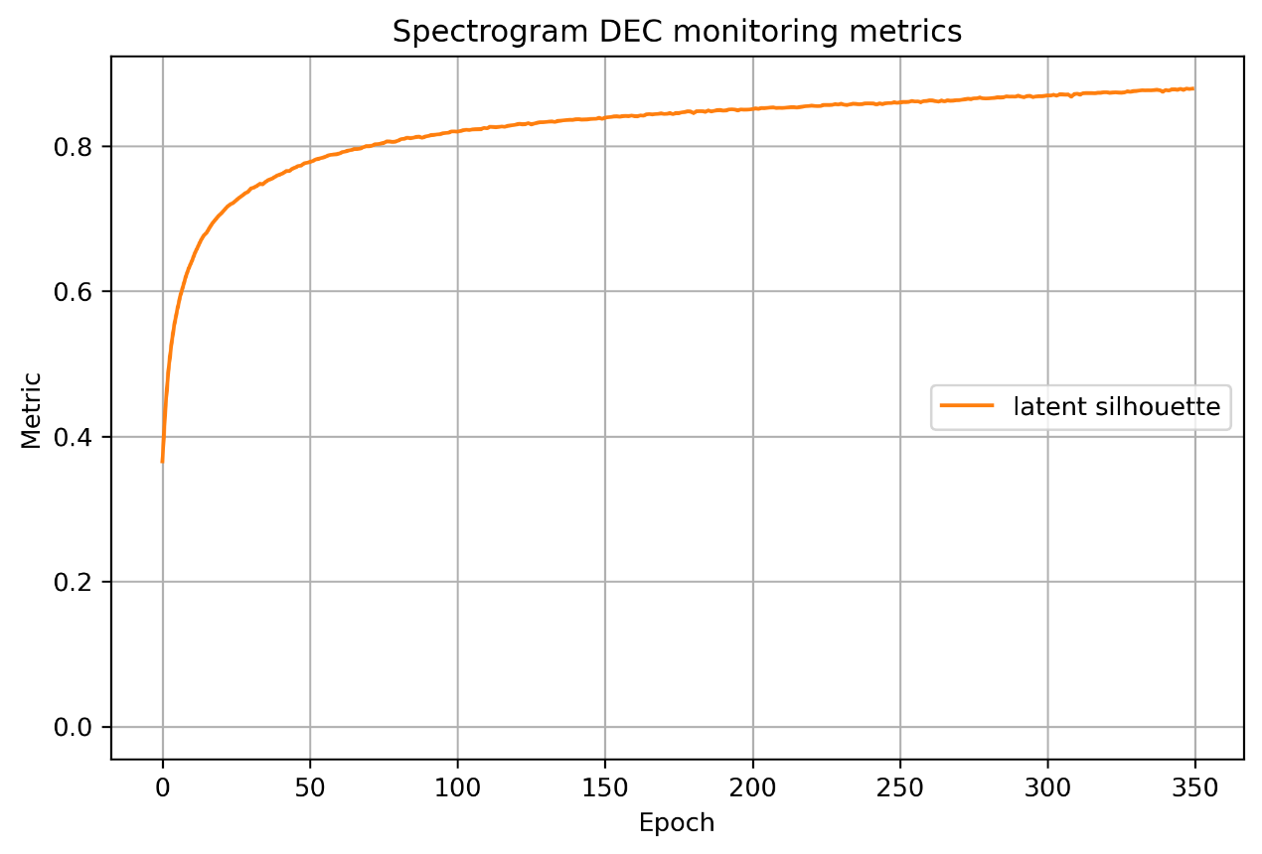
Figure X : Latent-space silhouette and the fraction of particles whose labels change between consecutive epochs. Training-time silhouette monitoring uses a fixed sample of 5,000 particles, while final evaluation uses 10,000 particles.

During pretraining, the training and validation reconstruction losses are used to monitor learning and select the autoencoder weights for the clustering stage. DEC then jointly optimizes reconstruction and clustering objectives, updating both the representation and the cluster centers.
The clustering term is defined as the KL divergence summed over the current minibatch and weighted by \(5\times10^{-4}\). The loss plot therefore shows the weighted KL contribution, allowing its numerical magnitude to be compared with the reconstruction term. The coefficient must be interpreted together with the loss reduction convention; its magnitude alone does not determine the influence of clustering optimization.
The main method completes 350 DEC training epochs. The silhouette score monitored during training uses a fixed sample of 5,000 particles, whereas the final comparison uses 10,000 particles. The monitored and final scores therefore need not be identical. Final evaluation also uses the selected model weights, which do not necessarily correspond to the last training epoch.
These curves describe the optimization and model-selection process. The comparison between methods remains based on the final scores obtained using the common evaluation sample in Section 6.1.
6.3 Reconstruction of the Six-Channel Spectrograms
To illustrate the reconstruction behavior of the autoencoder, the input and reconstructed spectrograms of a selected particle are displayed side by side for all six channels. The reconstruction is generated using the pretrained model with the lowest validation reconstruction loss.
[Insert 04_ae_reconstruction_best_spectrogram_k_auto_without_pz.png here.]
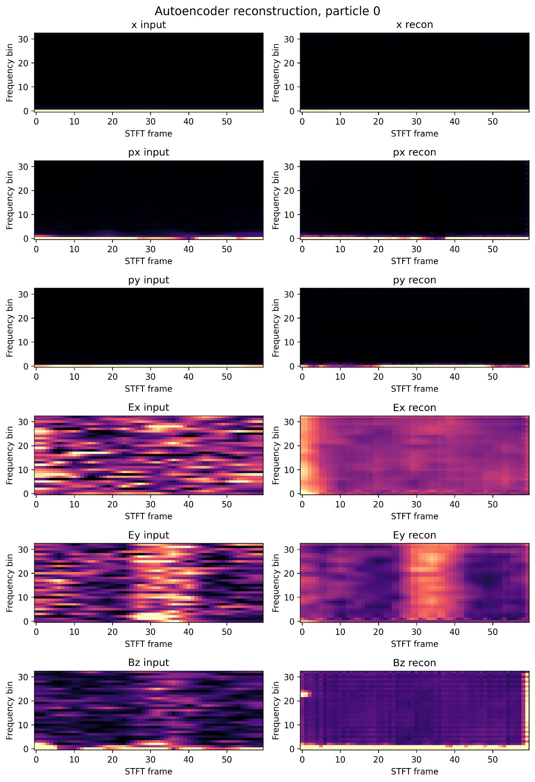
Figure X. Six-channel spectrogram reconstruction by the pretrained autoencoder. The left column shows the input spectrograms of a selected particle, and the right column shows the corresponding reconstructions. Rows represent the \(x\), \(p_x\), \(p_y\), \(E_x\), \(E_y\), and \(B_z\) channels, respectively. Reconstructions are obtained from the pretrained model with the lowest validation reconstruction loss.

The six channels describe particle position, momentum components, and local electromagnetic field components. The paired display provides a visual comparison between the input and reconstruction for each channel, allowing differences in spectral distributions and local details to be examined.
Reconstruction and silhouette evaluation describe different aspects of the model. Reconstruction assesses the ability of the autoencoder to reproduce its input, whereas silhouette characterizes the grouping structure in the selected representation space. The reconstruction figure is therefore used as a supplementary diagnostic rather than a direct criterion for clustering quality.
6.4 Visualization of the Final Clustering
The final 32-dimensional representations of the spectrogram method are projected into two dimensions using PCA and t-SNE. Particles are colored according to their final cluster assignments.
[Insert a two-panel figure here.]
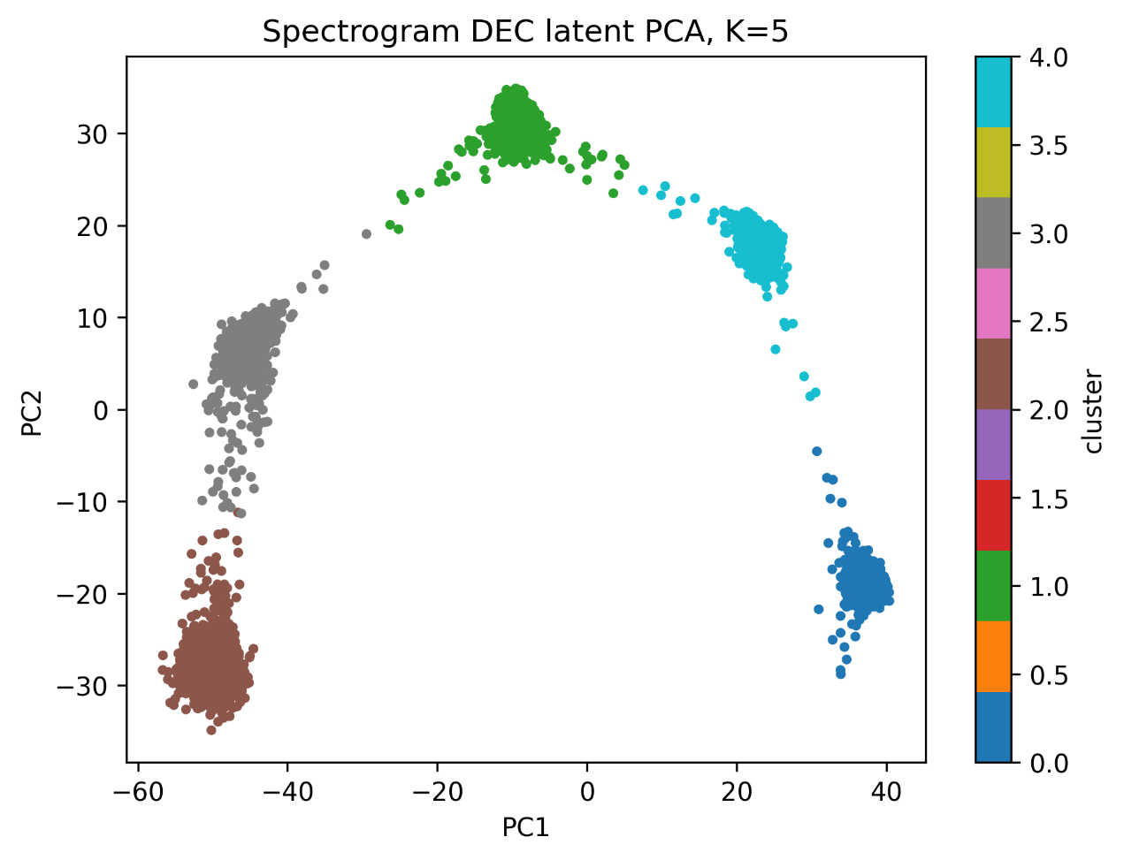
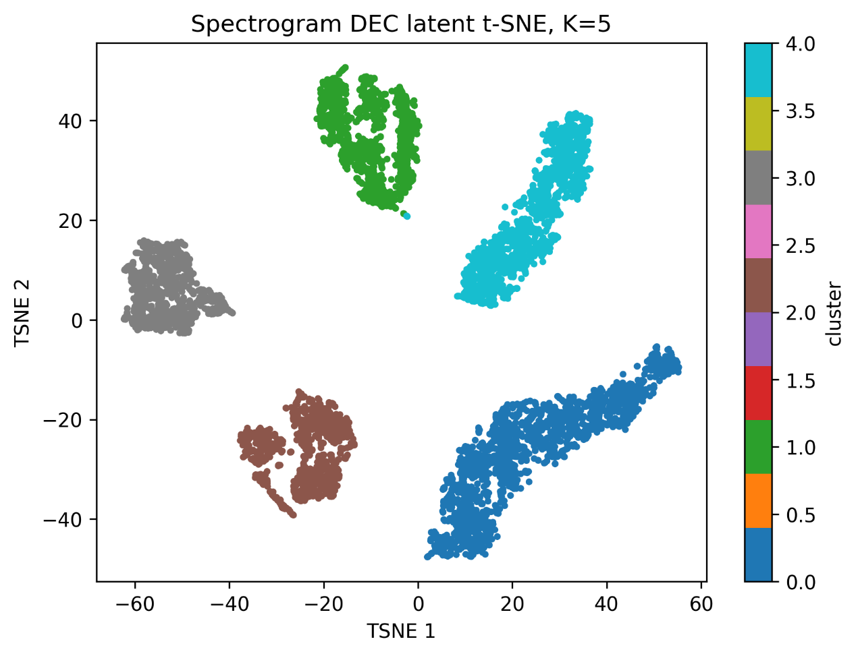
Figure X. Two-dimensional visualization of the final spectrogram CNN + DEC representations. (a) PCA projection. (b) t-SNE projection. Colors indicate the five final cluster assignments. Clustering and silhouette evaluation are performed in the 32-dimensional latent space; the two-dimensional projections are used only for visualization.

The PCA projection provides a linear view of the latent distribution, while the t-SNE projection offers a supplementary visualization of local neighborhood relationships. Both plots use the previously obtained final labels; clustering is not repeated in the two-dimensional coordinates.
These visualizations support qualitative inspection of the cluster distributions. Because a two-dimensional projection preserves only part of the high-dimensional structure, visual distances do not directly represent distances in the complete latent space. The reported silhouette score is calculated using all 32 latent dimensions.
6.5 Final Cluster Sizes
The main method partitions the 12,800 particles into five nonempty clusters. Their sizes and proportions are listed below.

Cluster | Number of particles | Percentage of all particles
C0 | 3,884 | 30.34%
C1 | 2,314 | 18.08%
C2 | 2,068 | 16.16%
C3 | 1,818 | 14.20%
C4 | 2,716 | 21.22%
Total | 12,800 | 100.00%
Table caption: Particle counts and proportions of the five final clusters obtained using spectrogram CNN + DEC.
The largest cluster contains 3,884 particles, accounting for 30.34% of the dataset, while the smallest contains 1,818 particles, or 14.20%. All five clusters contain substantial numbers of particles, with no empty clusters or clusters containing only a small number of particles.
The cluster-size distribution supplements the silhouette evaluation by describing how particles are distributed among the groups. Cluster size alone does not establish the correctness of a partition, nor does the clustering objective require equally sized groups.

7. Conclusions, Limitations, and Implications
7.1 Conclusions
This study develops an unsupervised workflow based on time–frequency representations and convolutional deep clustering for multivariate particle trajectories generated by particle-in-cell (PIC) simulations. Building on previous work on particle trajectory clustering, the input is extended to six channels comprising particle position, momentum components, and local electromagnetic field components. Following uniform temporal sampling and standardization, the channels are transformed into spectrograms. A two-dimensional convolutional autoencoder extracts low-dimensional representations, and particle groups are obtained through K-means initialization followed by DEC refinement.
Using silhouette as the primary evaluation metric, the spectrogram CNN + DEC method is compared with PCA + K-means and 1D time-series CNN + DEC. All three methods use 32-dimensional representations and five clusters, with evaluation performed on the same sample of 10,000 particles. The silhouette scores of PCA + K-means, 1D CNN + DEC, and spectrogram CNN + DEC are 0.29957, 0.79637, and 0.87985, respectively. The spectrogram-based method achieves the highest internal clustering score in its representation space among the methods examined.
These results support spectrogram-based convolutional deep clustering as a feasible approach for organizing multivariate PIC particle trajectories. The workflow transforms high-dimensional, multichannel particle records into low-dimensional representations suitable for grouping and retrieval, without requiring predefined class labels. Training curves, spectrogram reconstructions, latent-space projections, and cluster sizes provide supplementary descriptions of the model’s behavior and outputs.
7.2 Limitations
The evaluation relies primarily on the silhouette score. This metric describes within-cluster cohesion and between-cluster separation under a particular representation and distance measure, but does not directly establish whether the particle groups correspond to ground-truth categories. Since each method is evaluated in its own representation space, the comparison reflects internal clustering structure within those representations. The scores cannot be directly interpreted as classification accuracy or as equivalent improvements in the original trajectory space.
The experiments use a single available PIC particle dataset. Performance under other simulation conditions, time intervals, or particle samples has not been evaluated. Data standardization, cluster initialization, and DEC target-distribution updates all involve the current dataset. The reported results therefore constitute internal evaluation on the available data and do not establish generalization to unseen data.
Spectrogram preprocessing also introduces representational trade-offs. Logarithmic magnitude spectrograms and resizing are used to construct inputs of a consistent shape. This representation does not explicitly retain complete phase information and may reduce some local detail. The resulting groups consequently depend on the selected channels, sampling procedure, and spectrogram parameters, and should not be regarded as the only possible partition of the particle trajectories.
7.3 Implications and Potential Applications
This study provides a computational workflow for converting multivariate simulation outputs into particle groups that can support subsequent analysis. When individual inspection of large numbers of particle records is impractical, cluster labels can serve as an organizational index, allowing researchers to browse trajectories by group, extract representative samples, and compare variable distributions across groups. This organization can provide a structured starting point for further analysis and reduce reliance on manual inspection of individual trajectories.
The joint use of position, momentum, and local electromagnetic field information also provides a reusable approach to multichannel particle data analysis. Uniform sampling, standardization, representation learning, and clustering evaluation form a connected processing workflow. Saving preprocessing parameters, model weights, and particle labels can support result verification and subsequent reuse.
Within the scope of this study, clustering provides a computational means of organizing particle records. The resulting groups can serve as inputs to subsequent domain-specific analysis, helping researchers select particle populations of interest for closer examination. Their practical value ultimately depends on whether they support these downstream tasks effectively, beyond the value of a single clustering metric.

