世新大學資訊管理學系

資料庫管理系統

期末報告

**二手車管理系統**

資科三甲 A107222008 楊佑鴻

資科三甲 A107222010 簡霆安

資科三甲 A107222051 羅煜騰

中華民國109年12月29日

．EER model 分析設計

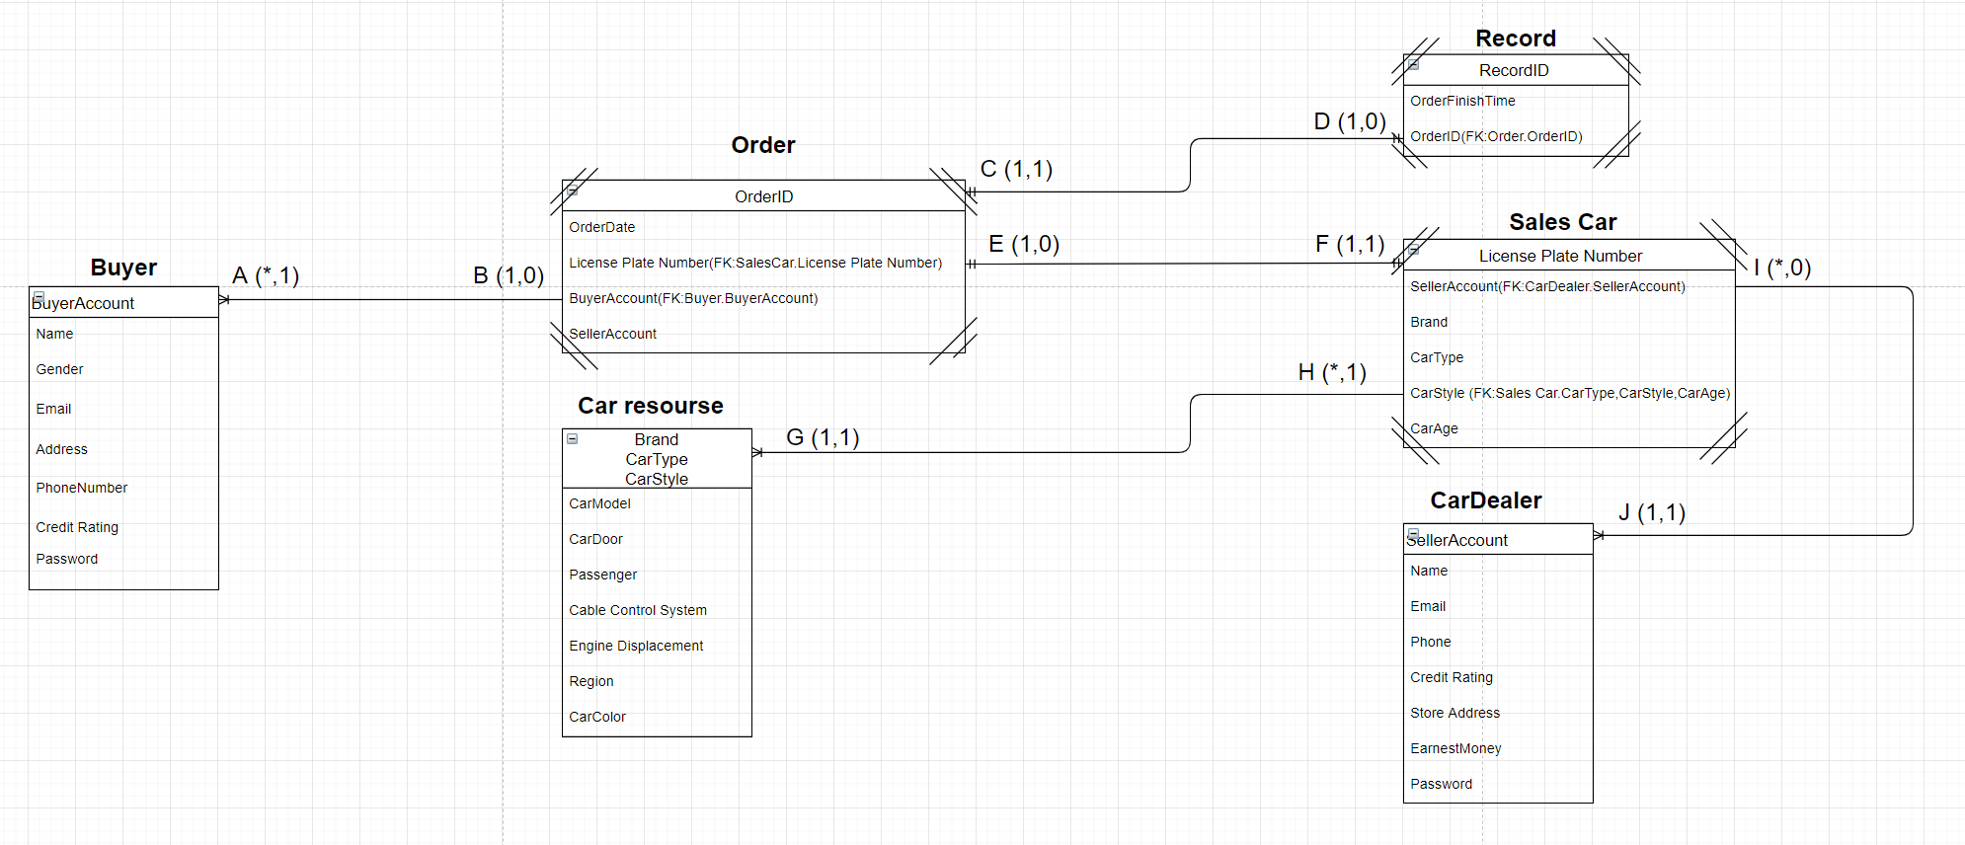

A(I,D,U) = (NA,C,NA)

B(I,D,U) = (R,NA,R)

C(I,D,U) = (NA,R,NA)

D(I,D,U) = (C,NA,C)

E(I,D,U) = (R,NA,R)

F(I,D,U) = (NA,C,NA)

G(I,D,U) = (NA,C,C)

H(I,D,U) = (R,NA,NA)

I(I,D,U) = (R,NA,R)

J(I,D,U) = (NA,C,NA)

．系統設計相關表格

|  |  |  |  |  |  |
| --- | --- | --- | --- | --- | --- |
| Relationship | | Cardinality | | RI | |
| Parent | Child | MAX | min | Parent | Child |
| Order | Buyer | 1,* | 0,1 | I:R  D:NA  U:R | I:NA  D:C  U:NA |
| Order | Record | 1,1 | 1,0 | I:NA  D:R  U:NA | I:C  D:NA  U:C |
| Order | Sales Car | 1,1 | 0,1 | I:R  D:NA  U:R | I:NA  D:C  U:NA |
| Sales Car | Car resourse | *,1 | 0,1 | I:NA  D:NA  U:NA | I:C  D:C  U:C |
| Salse Car | Car Dealer | *,1 | 1,1 | I:R  D:NA  U:R | I:NA  D:C  U:NA |

Buyer

|  |  |  |  |  |
| --- | --- | --- | --- | --- |
| Column Name | Type | Key | NULL Status | Remarks |
| BuyerID | Varchar(12) | PK | NOT RULL |  |
| Password | Varchar(20) |  | NOT RULL |  |
| Name | Varchar(15) |  | NOT ROLL |  |
| Gender | Varchar(1) |  | NOT ROLL |  |
| Email | Varchar(20) |  | NOT ROLL |  |
| Address | Varchar(50) |  | NOT ROLL |  |
| PhoneNumber | int(10) |  | NOT ROLL |  |

Cardealer

|  |  |  |  |  |
| --- | --- | --- | --- | --- |
| Column | Type | Key | NULL Status | Remarks |
| CarDealerID | Varchar(12) | PK | NOT NULL |  |
| Password | Varchar(20) |  | NOT NULL |  |
| Name | Varchar(15) |  | NOT NULL |  |
| Email | Varchar(20) |  | NOT NULL |  |
| PhoneNumber | int(11) |  | NOT NULL |  |
| StoreAddress | Varchar(15) |  | NOT NULL |  |
| EarnestMoney | int(11) |  | NOT NULL |  |

Carresource

|  |  |  |  |  |
| --- | --- | --- | --- | --- |
| Column | Type | Key | NULL Status | Remarks |
| Brand | Varchar(20) | PK | NOT NULL |  |
| CarType | Varchar(20) | NOT NULL |  |
| CarStyle | Varchar(20) | NOT NULL |  |
| CarModel | Varchar(10) |  | NOT NULL |  |
| CarDoor | int(11) |  | NOT NULL |  |
| Passenger | int(11) |  | NOT NULL |  |
| CableControlSystem | Varchar(10) |  | NOT NULL |  |
| EngineDisplacement | Varchar(10) |  | NOT NULL |  |
| CarColor | Varchar(10) |  | NOT NULL |  |

Orderform

|  |  |  |  |  |
| --- | --- | --- | --- | --- |
| Column | Type | Key | NULL Status | Remarks |
| OrderID | Varchar(10) | PK | NOT NULL |  |
| OrderDate | Datatime |  | NOT NULL |  |
| LicensePlate | Varchar(7) | FK | NOT NULL |  |
| BuyerID | Varchar(12) | FK | NOT NULL |  |
| CarDealerID | Varchar(12) |  | NOT NULL |  |

Record

|  |  |  |  |  |
| --- | --- | --- | --- | --- |
| Column | Type | Key | NULL Status | Remarks |
| RecordID | Varchar(10) | PK | NOT NULL |  |
| RecordDate | date |  | NOT NULL |  |
| OrderID | Varchar(10) | FK | NOT NULL |  |
| BuyerCredutRaing | Int(10) |  | NOT NULL |  |
| CDCreditRating | Int(10) |  | NOT NULL |  |

Salescar

|  |  |  |  |  |
| --- | --- | --- | --- | --- |
| Column | Type | Key | NULL Status | Remarks |
| LicensePlate | Varchar(7) | PK | NOT NULL |  |
| CarDealerID | Varchar(12) | FK | NOT NULL |  |
| Brand | Varchar(20) | FK | NOT NULL |  |
| CarType | Varchar(20) | FK | NOT NULL |  |
| CarStyle | Varchar(20) | FK | NOT NULL |  |
| CarAge | Int(10) |  | NOT NULL |  |
| Region | Varchar(10) |  | NOT NULL |  |
| Price | Int(10) |  | NOT NULL |  |

．資料庫相關資料

Buyer

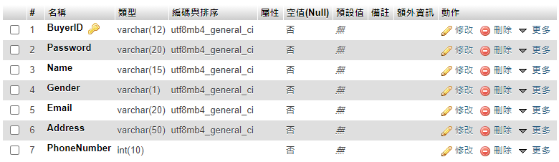

Car Dealer

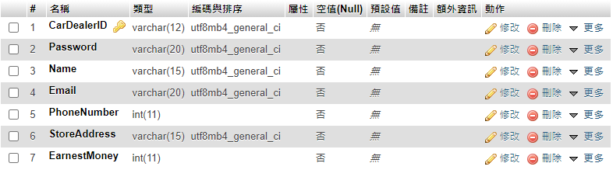

Car Resource

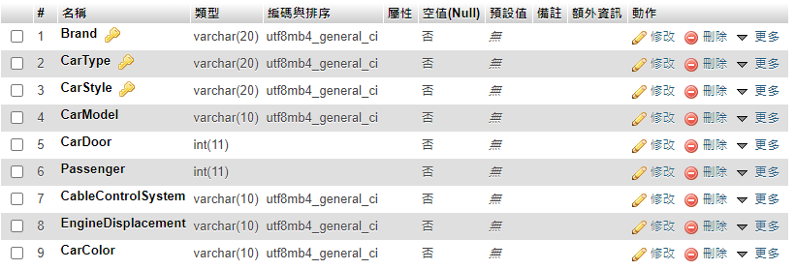

Orderfrom

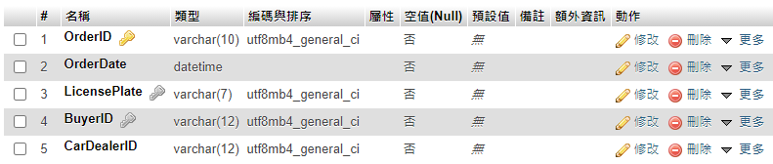

Record

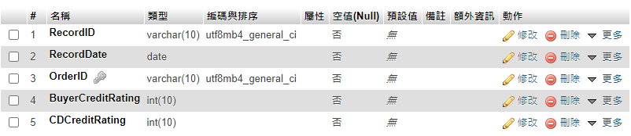

Sales Car

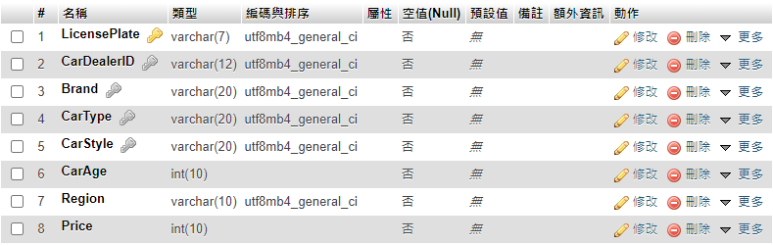

．程式演示

表單介面

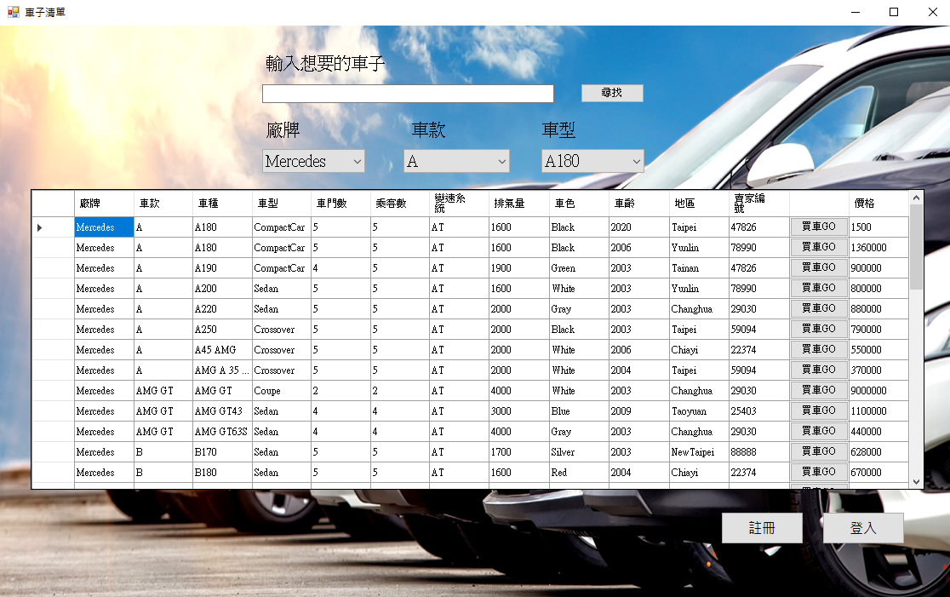

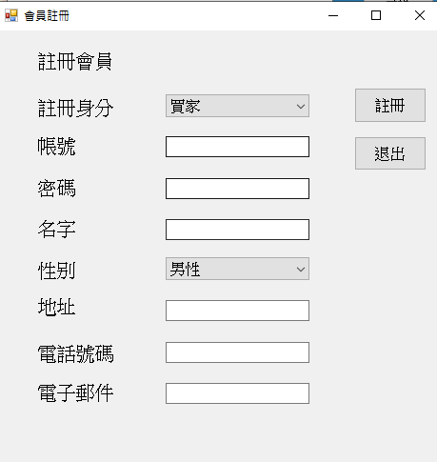

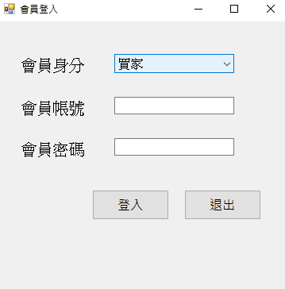

買家介面

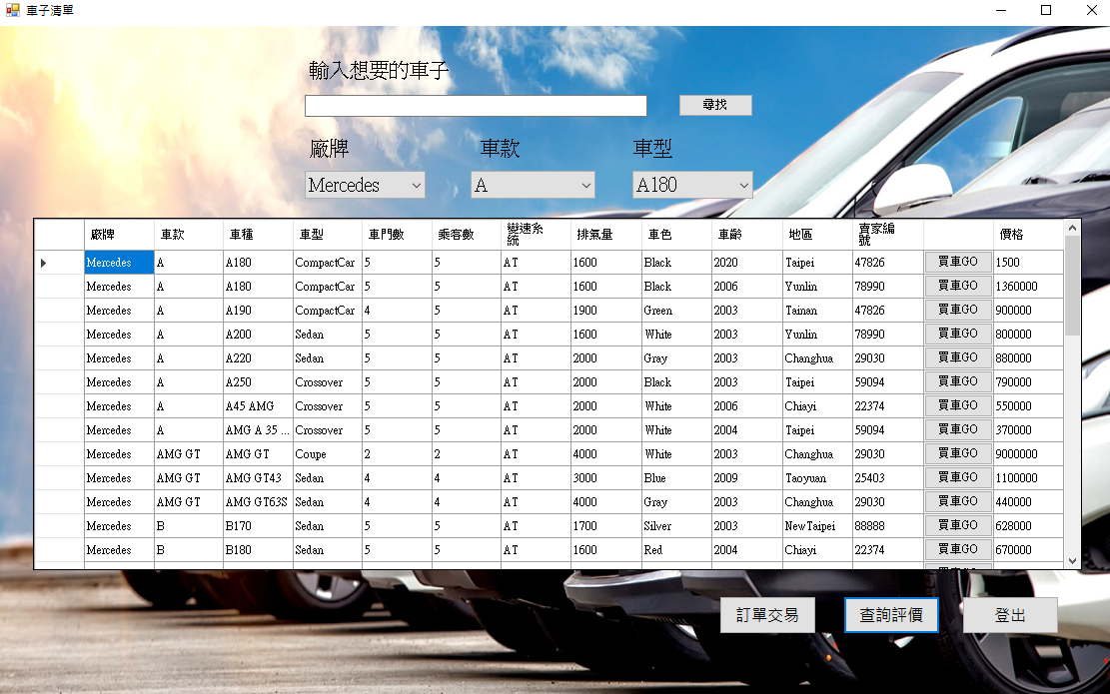

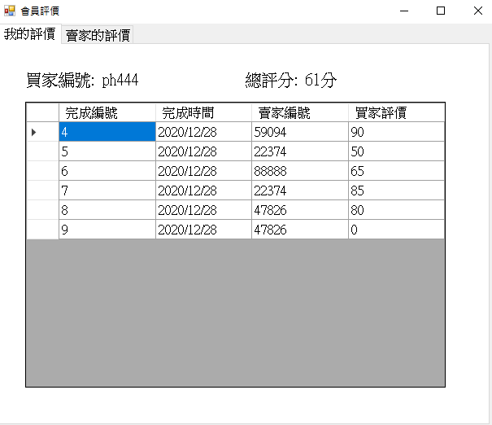

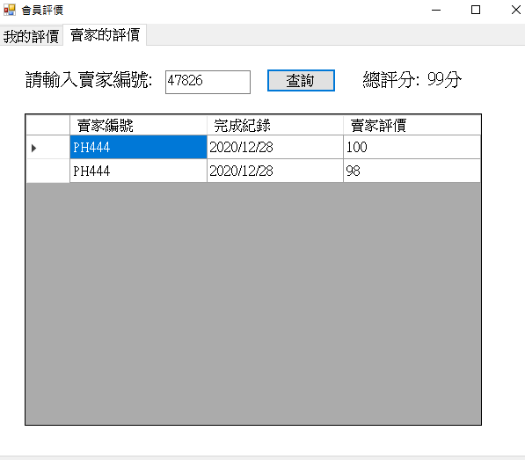

訂單系統

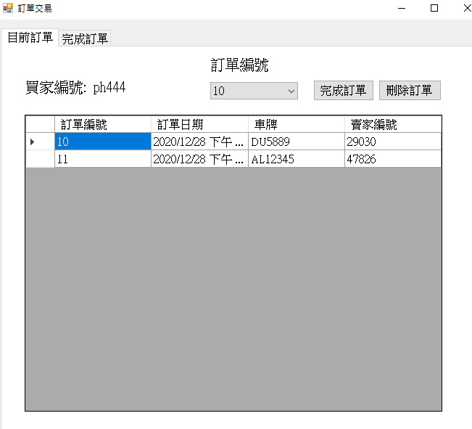

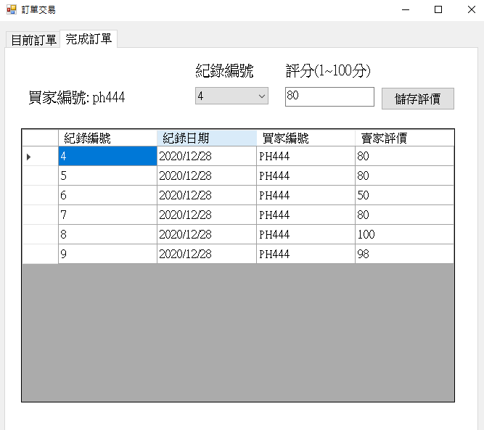

賣家介面

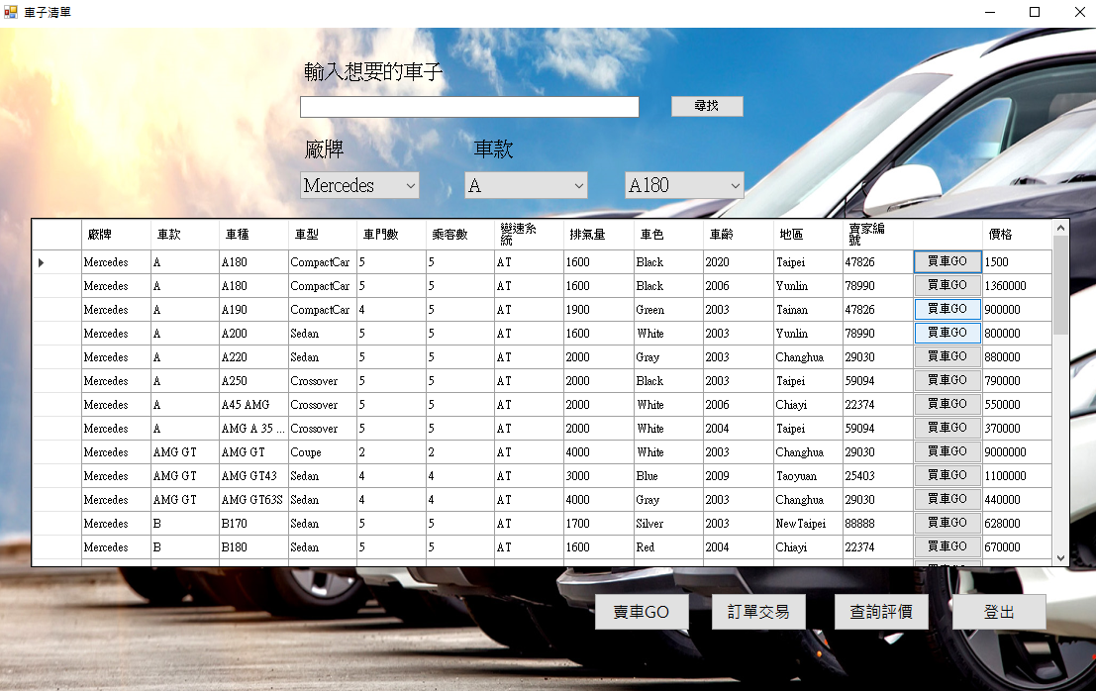

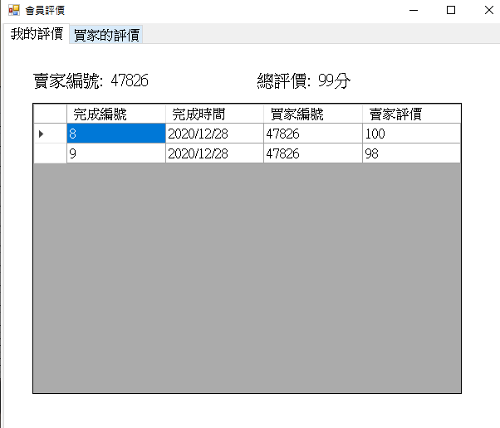

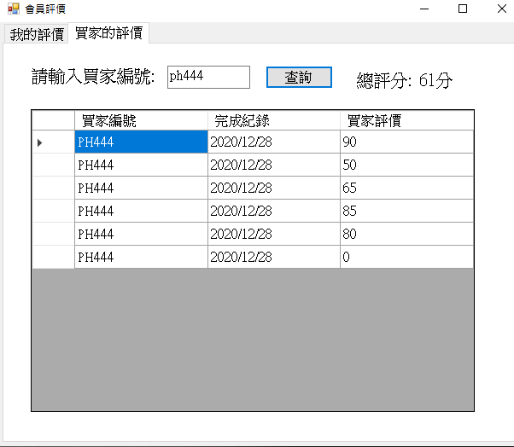

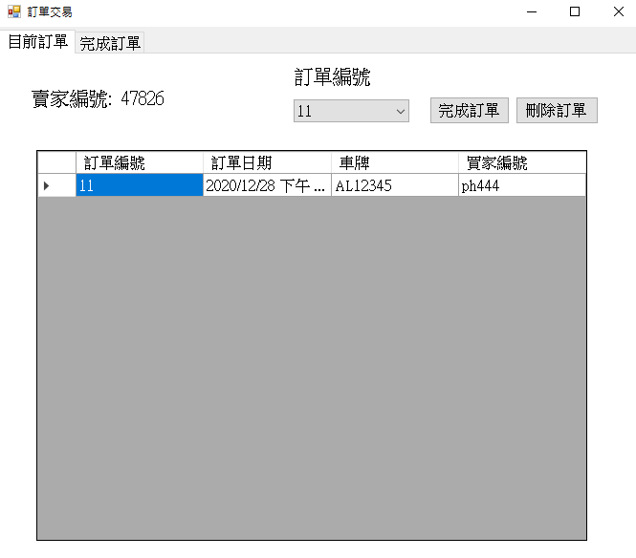

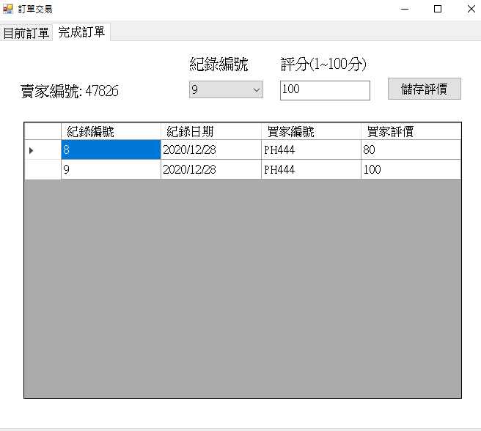

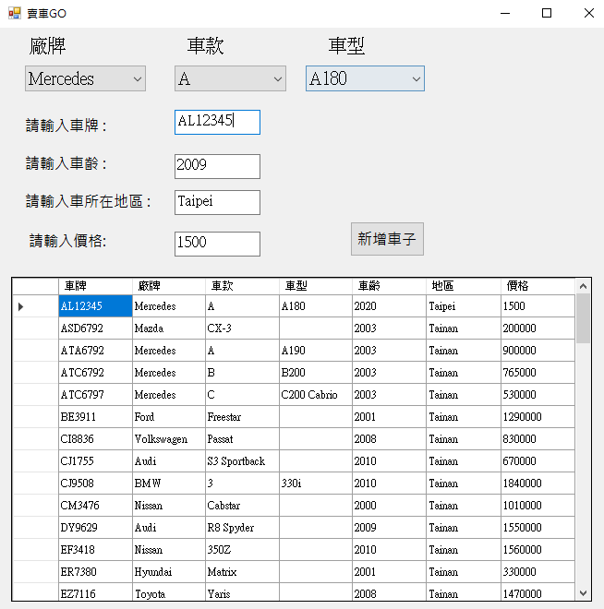

．組員工作分配表

|  |  |  |  |
| --- | --- | --- | --- |
|  | 楊佑鴻 | 簡霆安 | 羅煜騰 |
| 文件 | 25% | 25% | 50% |
| EER model 分析設計 | 33% | 33% | 33% |
| 系統設計相關表格 | 30% | 30% | 40% |
| 資料庫程式設計 | 40% | 40% | 20% |
| 系統測試執行 | 45% | 30% | 25% |