11.13\*: This exercise examines the relationship between files and inodes on a UNIX or Linux system. You can complete this exercise on the Linux virtual machine that is provided with this text.

(1) In the source code available with this text, open file1.txt and examine its contents. Next, obtain the inode number of this file with the command:   
*ls –li file1.txt*

**Create a hard link between file1.txt and file2.txt:   
*ln file1.txt file2.txt*  
What are the inode values of file1.txt and file2.txt?

A: 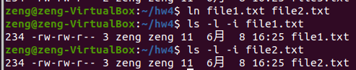

inode values都為234。

Are they the same or different? Do the two files have the same or different contents?

都一樣，inode values與contents都一樣。

(2) Next, edit file2.txt and change its contents. Examine the contents of file1.txt. Are the contents of file1.txt and file2.txt the same or different? Next, remove file1.txt. Does file2.txt still exist as well? Check what system call is used for removing file2.txt by the following command: *strace rm file2.txt*.

A:改變file2後 ，file1與file2內容依然一樣。

刪除file1,file2依然存在。

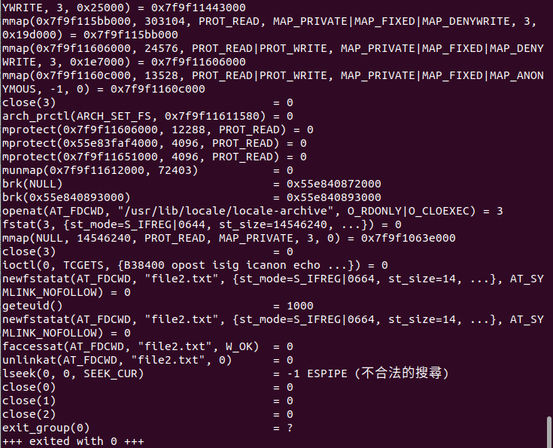

使用Unlinkat()刪除file2.txt

(3) Create a soft link to file3.txt by the following command: *ln –s file3.txt file4.txt*  
Are the inode numbers of file3.txt and file4.txt the same, or is each unique? Next, edit the contents of file4.txt. Have the contents of file3.txt been altered as well? Last, delete file3.txt. Explain what happens when you attempt to edit file4.txt.

A: *file3.txt file4.txt* 的inode不一樣

因為是軟連結的關係，修改file4.txt的同時，file3.txt.也會跟著改

但是軟連結的原檔案若被刪除，那麼相關的軟連接的檔案就會變成死連結，無法修改甚至開啟。

12.16\*: Write a program that implements the following disk-scheduling algorithms:  
(a) FCFS  
(b) SSTF  
(c) SCAN  
(d) C-SCAN

給定一個queue array 以及CYLINDERS設定為0-4999，然後輸出4種演算法的執行順序，以下為截圖畫面(使用onlineGDB編譯):

