

v1.0

31-August-2022

USER MANUAL

AZURE ARM TEMPLATE 2NIC-1VM-GLM

# PATENT PROTECTION

A10 Networks, Inc. products are protected by patents in the U.S. and elsewhere. The following website is provided to satisfy the virtual patent marking provisions of various jurisdictions including the virtual patent marking provisions of the America Invents Act. A10 Networks, Inc. products, including all Thunder Series products, are protected by one or more of U.S. patents and patents pending listed at: a10-virtual-patent-marking.

# TRADEMARKS

A10 Networks, Inc. trademarks are listed at: a10-trademarks.

# CONFIDENTIALITY

This document contains confidential materials proprietary to A10 Networks, Inc. This document and information and ideas herein may not be disclosed, copied, reproduced, or distributed to anyone outside A10 Networks, Inc. without prior written consent of A10 Networks, Inc.

# DISCLAIMER

This document does not create any express or implied warranty about A10 Networks, Inc. or about its products or services, including but not limited to fitness for a particular use and non-infringement. A10 Networks, Inc. has made reasonable efforts to verify that the information contained herein is accurate, but A10 Networks, Inc. assumes no responsibility for its use. All information is provided "as-is." The product specifications and features described in this publication are based on the latest information available; however, specifications are subject to change without notice, and certain features may not be available upon initial product release. Contact A10 Networks, Inc. for current information regarding its products or services. A10 Networks, Inc. products and services are subject to A10 Networks, Inc. standard terms and conditions.

# ENVIRONMENTAL CONSIDERATIONS

Some electronic components may possibly contain dangerous substances. For information on specific component types, please contact the manufacturer of that component. Always consult local authorities for regulations regarding proper disposal of electronic components in your area.

# FURTHER INFORMATION

For additional information about A10 products, terms and conditions of delivery, and pricing, contact your nearest A10 Networks, Inc. location, which can be found by visiting [www.a10networks.com](http://www.a10networks.com).

Contents

PATENT PROTECTION 1

TRADEMARKS 1

CONFIDENTIALITY 1

DISCLAIMER 1

ENVIRONMENTAL CONSIDERATIONS 2

FURTHER INFORMATION 2

Introduction to Install vThunder on Microsoft Azure 3

Overview of Microsoft Azure 4

Azure Terminology 7

System Requirements 8

Pre-requisites 10

Installation vThunder on Microsoft Azure 11

Chapter 1 - Core vThunder Installation & Basic Setup. 11

Configure 11

Install 14

Verify 15

Chapter 2 - vThunder SLB Setup. 15

Configure 15

Install 18

Chapter 3 - vThunder GLM Setup. 18

Configure 18

Install 19

Chapter 4 - Let us Verify. 19

Login to vThunder 19

# Introduction to Install vThunder on Microsoft Azure

vThunder for Microsoft Azure is a fully operational, software-only version of the ACOS Series Server Load Balancer (SLB), or Application Delivery Controller (ADC) device. It is configurable by ACOS CLI, GUI, AXAPI, and Harmony Controller. For more information see Virtual Instances in Harmony Controller.

vThunder is a virtual appliance, yet it retains most of the functionality available on the hardware based ACOS appliances. Managing vThunder is the same as managing hardware based ACOS device, and vThunder has the same CLI configurations and GUI presentation.

The networking configuration for vThunder is also like hardware based ACOS devices. The maximum throughput of vThunder for Azure is variable and depends on vThunder software license purchase and type instance used to deploy vThunder.

*A10 Networks brings Out-Of-Box template to deploy vThunder along with multiple features and functionality with pre-defined format into azure cloud.*

Please refer below section for more details.

* Two Network Card Interface (2NIC).
* 1 vThunder Virtual Machines (1VM).
* Server Load Balancing (SLB).
* GLM Licenses (GLM).
* TLS/SSL Certification (SSL).

# Overview of Microsoft Azure

With the move to the cloud, many teams have adopted agile development methods. These teams iterate quickly. They need to repeatedly deploy their solutions to the cloud, and know their infrastructure is in a reliable state. As infrastructure has become part of the iterative process, the division between operations and development has disappeared. Teams need to manage infrastructure and application code through a unified process.

To meet these challenges, you can automate deployments and use the practice of infrastructure as code. In code, you define the infrastructure that needs to be deployed. The infrastructure code becomes part of your project. Just like application code, you store the infrastructure code in a source repository and version it. Any one on your team can run the code and deploy similar environments.

To implement infrastructure as code for your Azure solutions, use azure resource manager templates. The template is a json native file that defines the infrastructure and configuration for your project. The template uses declarative syntax, which lets you state what you intend to deploy without having to write the sequence of programming commands to create it. In the template, you specify the resources to deploy and the properties for those resources.

**Microsoft Azure** (formerly known as Windows Azure) is Microsoft’s cloud computing platform. Azure is an industry leader for both infrastructure-as-a-service (IaaS) and platform-as-a-ser- vice (PaaS). Azure offers a combination of managed and unmanaged services that lets customers deploy and manage their applications as they see fit.

The Azure cloud computing platform runs on Microsoft data centre and is globally dis- tributed across more than a dozen countries. Such global distribution helps ensure customers receive high performance, regardless of where they are located.

Azure is flexible and can support virtually any operating system, from Windows to Linux, any programming language, from Java to C++, and any database, from SQL to Oracle. Azure also offers 99.95% uptime and is the platform that Microsoft uses to run many of its popular ser- vices, such as Bing, Skype, Xbox, and Office 365.

A10 Networks vThunder virtual device can be set up as an instance in Azure’s cloud and can be used to provide a robust server load balancing (SLB) service.

Microsoft Azure uses the following tools to create and manage resources:

**Azure Portal** - A web console to create and monitor Azure resources. For more information, refer to <https://azure.microsoft.com/en-in/features/azure-portal/>

**Azure PowerShell** - A set of cmdlets used for managing Azure resources from the command line. Launch Azure PowerShell from a browser within the Azure Cloud Shell or install the software on the system to start a local PowerShell session.

For more information, refer to <https://docs.microsoft.com/en-us/powershell/>

**Azure CLI**- Can also be launched from a browser within the Azure Cloud Shell or install the software on the system to start a local CLI session. For more information, refer to <https://docs.microsoft.com/en-us/cli/azure/overview?view=azure-cli-latest>

You **can** launch Cloud Shell from the top navigation bar of the Azure portal.

FIGURE 1-1: Launching Cloud Shell



The following figure shows how vThunder fits into the Microsoft Azure infrastructure.

FIGURE 1-2: vThunder for Microsoft Azure

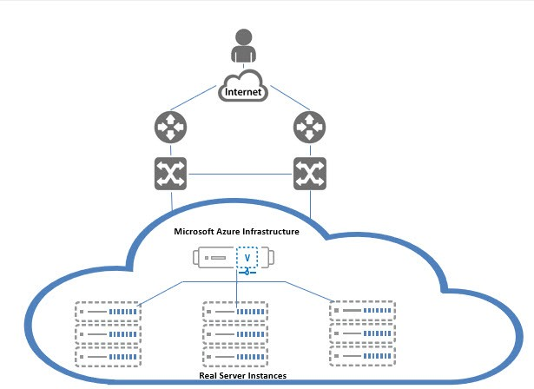

Below diagram shows process flow and different azure resources and system components are connected to each other’s.

# Azure Terminology

**Azure account** — The Azure account created has different support plans for different regions. For more information on different Azure regions and availability of types of virtual machines in these regions, refer to

<https://docs.microsoft.com/en-us/azure/virtual-machines/linux/overview>

**Resource group** — A resource group is a logical group of all the resources related to an Azure solution. Azure offers flexibility in the allocation of resources to resource groups.

For more information, refer to

[https://docs.microsoft.com/en-us/azure/azure-resource-manager/resource-group- overview](https://docs.microsoft.com/en-us/azure/azure-resource-manager/resource-group-%20overview/)

**Availability set** — An availability set is a logical grouping of Azure VM resources so that each VM resource is isolated from other resources when deployed. This hardware isolation ensures that a minimum number of VMs are impacted during a failure. For more information, refer to

[https://docs.microsoft.com/en-us/azure/azure-resource-manager/resource-group- overview](https://docs.microsoft.com/en-us/azure/azure-resource-manager/resource-group-%20overview/)

**Virtual network** — The Microsoft Azure Virtual Network service enables resources to securely communicate with other resources in an Azure network in the cloud. A virtual network is hence logical isolation of the Azure cloud for an Azure account. You can connect different virtual networks and to on-premises networks. For more information, refer to

[https://docs.microsoft.com/en-us/azure/virtual-machines/windows/tutorial-avail- ability-sets](https://docs.microsoft.com/en-us/azure/virtual-machines/windows/tutorial-avail-%20ability-sets/)

**Network security group (NSG)** — A network security group (NSG) contains a list of security rules that allow or deny network traffic to resources connected to Azure virtual networks (VNet). The NSGs can be associated with subnets or individual NICs attached to the VMs. When an NSG is associated with a subnet, the rules apply to all the resources connected to the subnet.

# System Requirements

Below all azure cloud resources will be created.

All templates come with default value it can be change while execution.

1. Azure Resource Group.

New resource group will be created with the specified name and location, in case does not exist.

Default name: *vth-rg1*

1. Azure Storage Account.

New storage account will be created inside resource group.

In case storage account already exists, it will prompt error “The storage account named is already taken”.

**Details:**

**Storage Account Name:** *vthunderstorage*

**Performance**: Standard

**Replication**: Read-access geo-redundant storage (RA-GRS)

**Account kind**: StorageV2 (general purpose v2)

1. Virtual Machine Instance.

**Basic Details:**

**Product: A10 vThunder**

**Instance Name:** *vth-inst1*

**Operating system**: Linux

**Default Size**: Standard_B4ms (4 vCPUs, 16 GiB Memory)

Note:

**Highly recommended to do assessment of your projected traffic before selecting any size.

** Instances name and size can be customized in parameter file.

**Supported VM Sizes**

|  |  |  |
| --- | --- | --- |
| ***Series*** | ***Size*** | ***Qualified Name*** |
| A series | Standard A2  Standard A2v2  Standard A2mv2  Standard A4v2  Standard A4mv2  Standard A3  Standard A4  Standard A8 v2 | Standard_A2  Standard_A2_v2  Standard_A2m_v2  Standard_A4_v2              Standard_A4m_v2  Standard_A3  Standard_A4  Standard_A8_v2 |
| B series | Standard B2s  Standard B2ms  Standard B4ms | Standard_B2_s  Standard_B2ms  Standard_B4ms |
| D series | Standard D2v2  Standard D2sv3  Standard D4v3  Standard D4sv3  Standard D3v2  Standard Ds3v2  Standard D5v2 | Standard_D2_v2  Standard_D2s_v3  Standard_D4_v3  Standard_D4s_v3  Standard_D3_v2  Standard_Ds3_v2  Standard_D5_v2 |
| F series | Standard F4s  Standard F8  Standard F16s | Standard_F4s  Standard_F8  Standard_F16s |

Few of sizes are getting retried soon from azure, please refer [Virtual Machine series | Microsoft Azure](https://azure.microsoft.com/en-in/pricing/details/virtual-machines/series/).

For more information, please refer as below.

<https://docs.microsoft.com/en-us/azure/virtual-machines/sizes-> [general](http://sales@a10networks.com/)

<https://docs.microsoft.com/en-us/azure/virtual-machines/linux/sizes>.

1. Virtual Cloud Network. [VCN]

Default address prefix for virtual network is 10.0.0.0/16.

Default name: *vth-vnet*

1. Subnets.

Total two subnets will be created. Address prefix can be configured in parameter file.

1. Network Security Group. [NSG]

Default all interfaces are associated with security group.

Default name: *vth-nsg*

Default Security Rules:

1. Network Interface Card. [NIC]

Default name:

*vth-inst1-mgmt-nic1*

*vth-inst1-data-nic2*

Each vThunder consist of two types of NIC.

* Management Interface with public IP
* Data Interfaces with primary private IP. [Ethernet 1]

# Pre-requisites

Please find below detailed pre-requisites to install template using ARM.

1. Azure account and valid subscription.

Azure Portal—A web console to create and monitor Azure resources. For more information, refer to <https://azure.microsoft.com/en-in/features/azure-portal/>

1. Azure CLI [2.39.0]— Can also be launched from a browser within the Azure Cloud Shell or install the software on the system to start a local CLI session. For more information, refer to <https://docs.microsoft.com/en-us/cli/azure/overview?view=azure-cli-latest>

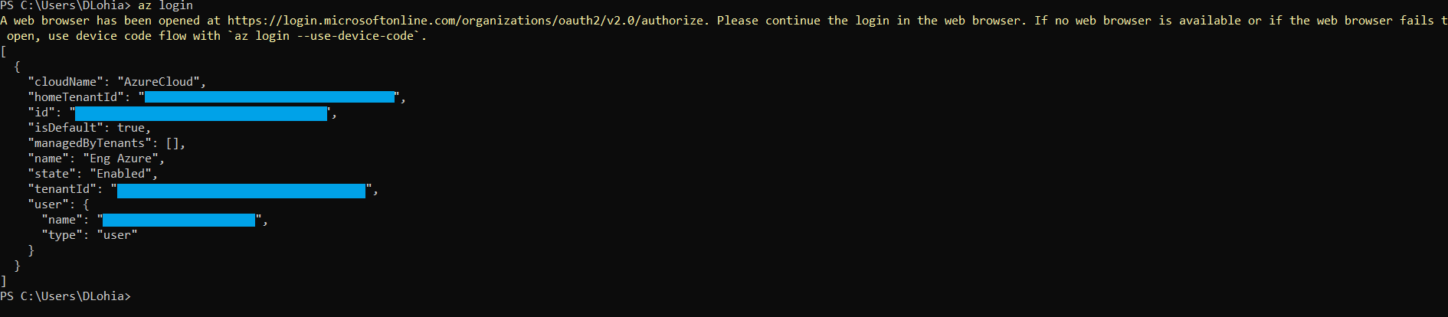

1. Windows PowerShell 7.0.6 LTS or 7.1.3, 7.2.2 or any higher. Recommended 7.2.2.

[Installing PowerShell on Windows - PowerShell | Microsoft Docs](https://docs.microsoft.com/en-us/powershell/scripting/install/installing-powershell-on-windows?view=powershell-7.2)

Azure PowerShell—A set of cmdlets used for managing Azure resources from the command line. Launch Azure PowerShell from a browser within the Azure Cloud Shell or install the software on the system to start a local PowerShell session. For more information, refer to <https://docs.microsoft.com/en-us/powershell/>

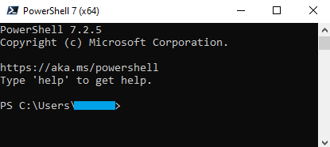  
Install Az Modules: Install-Module Az



1. Policy Setting in PowerShell.

Set execution policy to Unrestricted:

Set-ExecutionPolicy -Scope Process -ExecutionPolicy Bypass



1. Generate SSL certificate to apply on vThunder (Optional).
2. [ARM-TEMPLATES/ARM-2NIC-1VM-GLM · develop · ax / A10-Azure-ARM-Templates-internal · GitLab (a10networks.com)](https://gitlab.a10networks.com/ax/a10-azure-arm-templates-internal/-/tree/develop/ARM-TEMPLATES/ARM-2NIC-1VM-GLM)

# Installation vThunder on Microsoft Azure

## Chapter 1 - Core vThunder Installation & Basic Setup.

### Configure

Refer ARM_TMPL_2NIC_1VM_PARAM.json file to customize default values. Please find below in details.

**Setting vThunder Default Credentials**

Default credential is mentioned in below image, this is only required during VM creation.

Username: *vth-user*

Password: *vth-Password*

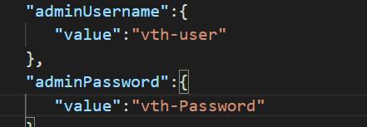

Note: vThunder will get provision using above credential but those are temporary. As soon as it gets provision, vThunder will auto delete all users other than default user.

So, use below credentials for login.

Username: admin

Password: a10

**VMSS Size [VThunder]**

Any size which supports at least 2 NIC.

Please refer ‘Qualified Name’ column under supported vm sizes section to select any other size.

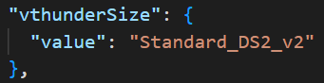

**vThunder Image**

User can pick available image from Azure marketplace.

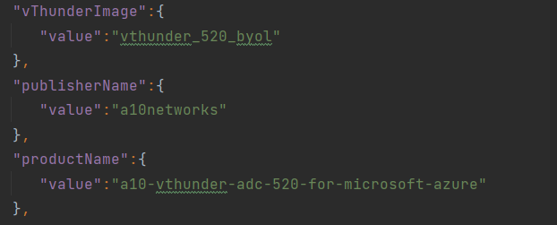

**Network Interfaces Card**

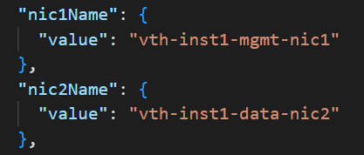

**Subnets**

Default subnets value

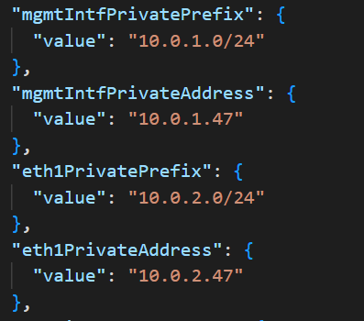

**Network Security Group**

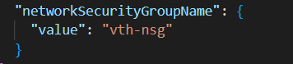

**DNS Label Prefix – vThunder Host Name**

**Storage Account Name**

If storage account is already existed, script will give the error “The storage account named is already taken.”

**vThunder Instance**

One vThunder instances will be created. User can change Instance name and size from parameter file.

**Operating system**: Linux

**Size**: Standard DS2 v2 (2 vcpus, 7 GiB memory)

### Install

1. Open powershell 7 from start menu.

2. Create azure resource group.

Default name: *vth-rg1*

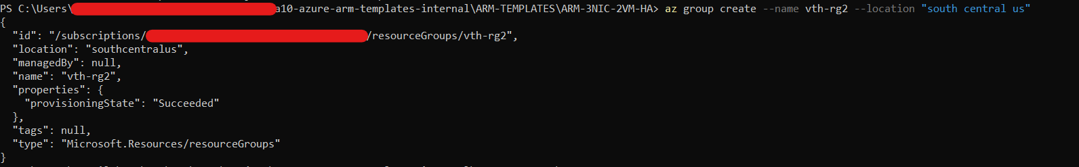

az group create --name vth-rg1 --location "south central us"

3. Run below command. 

az deployment group create -g *vth-rg1* --template-file ARM_TMPL_2NIC_1VM_1.json --parameters ARM_TMPL_2NIC_1VM_PARAM.json

### Verify

On azure portal

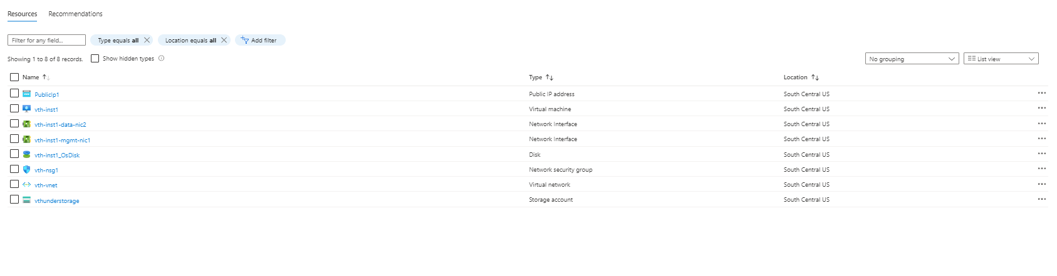

## Chapter 2 - vThunder SLB Setup.

### Configure

Please configure below parameters in ARM_TMPL_2NIC_1VM_SLB_CONFIG_PARAM.json

**SLB Server Host/Domain**

1. SLB server host value is management NIC private IP address of instance acting as server. Instead of host domain name also can be used by replacing key host with fqdn-name.

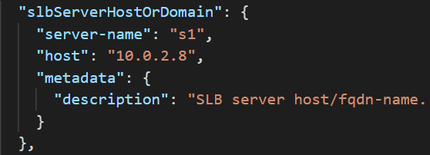

Description: - SLB server host/fqdn-name for. To use domain name, replace host with fqdn-name and IP address with domain name

**SLB Server Ports**

1. Default ports are

**Service Group List**

1. Default ports for serviceGroupList.

**Virtual Sever**

1. Default of virtual server name is “vs1”.

Note

1. Check ARM_TMPL_2NIC_1VM_SLB_CONFIG_PARAM.json file, and make sure all configurations are correct.
2. SLB script check management interface name presents in ARM PARAM file and using this name gets public IP of vthunder instance.

**SSL Configuration**

1. Default SSL configuration is disable. No SSL will be applied.
2. While running the SLB Script User will get option to enable on cli.

If user want apply SSL need to give input as ‘Y’

1. Default value of SSL certificate.

For example:

*“sslConfig”: {*

*“requestTimeOut”: 40,*

*“Path”: “C:\Users\........\........\......\certs\server.pem”,*

*“File”: “server”,*

*“CertificationType”: “pem”*

*}*

1. Supported certification type .pem.

### Install

Users need to run the following script for installation of SLB. .\ARM_TMPL_2NIC_1VM_SLB_CONFIG_2.ps1 -resourceGroup *vth-rg1*

## 

## Chapter 3 - vThunder GLM Setup.

### Configure

Please configure below parameters in ARM_TMPL_2NIC_1VM_GLM_CONFIG_PARAM.json

Users must give GLM account details.

{

  "parameters": {

    "user_name": {

      "value": "<user_email_address>"

    },

    "user_password": {

      "value": "<user_password>"

    },

    "entitlement_token": {

      "value": "<license-entitilement-token>"

    }

  }

}

### Install

Run This script for applying GLM license on both vthunder

.\ARM_TMPL_2NIC_1VM_GLM_CONFIG_3.ps1

## Chapter 4 - Let us Verify.

### Login to vThunder

vThunder can be access by ssh to instance or GUI.

SSH to vThunder Instance:

Open putty and connect.

IP: Get 2vthunders login

User Id [Default]: admin

Password [Default]: a10

After login.

Execute Command -> enable

Password -> <just press enter>

#### SLB Verification

After successfully installation you can see your slb config on vThunder, refer below image

#### GLM License Provision Verification

After successfully installation you can see your GLM config on vThunder, refer below image.

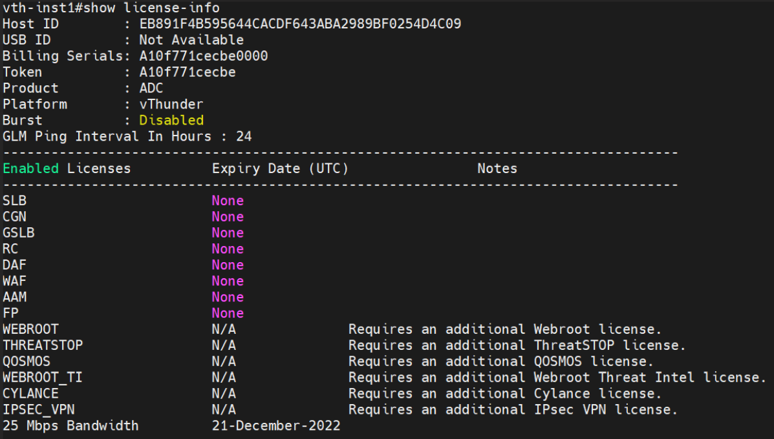

#### SSL Certificate Verification

After successfully installation you can see your ssl config on vThunder, refer below image.



#### Accessing the URL

Open any browser and type https://<vthunder_public_IP>

Enter username – admin

Enter Password – a10

Output:

