ARM Template – 2 NIC 1 vThunder Instances Test Cases

1. Resource Creation
   1. Resource Group
      1. Expected Outcome: 1 resource group should get created if not exists else existing resource group will be used.
      2. Actual Outcome:
         1. 1 new resource group name “vthunder-resource-group” is created when it was not present.

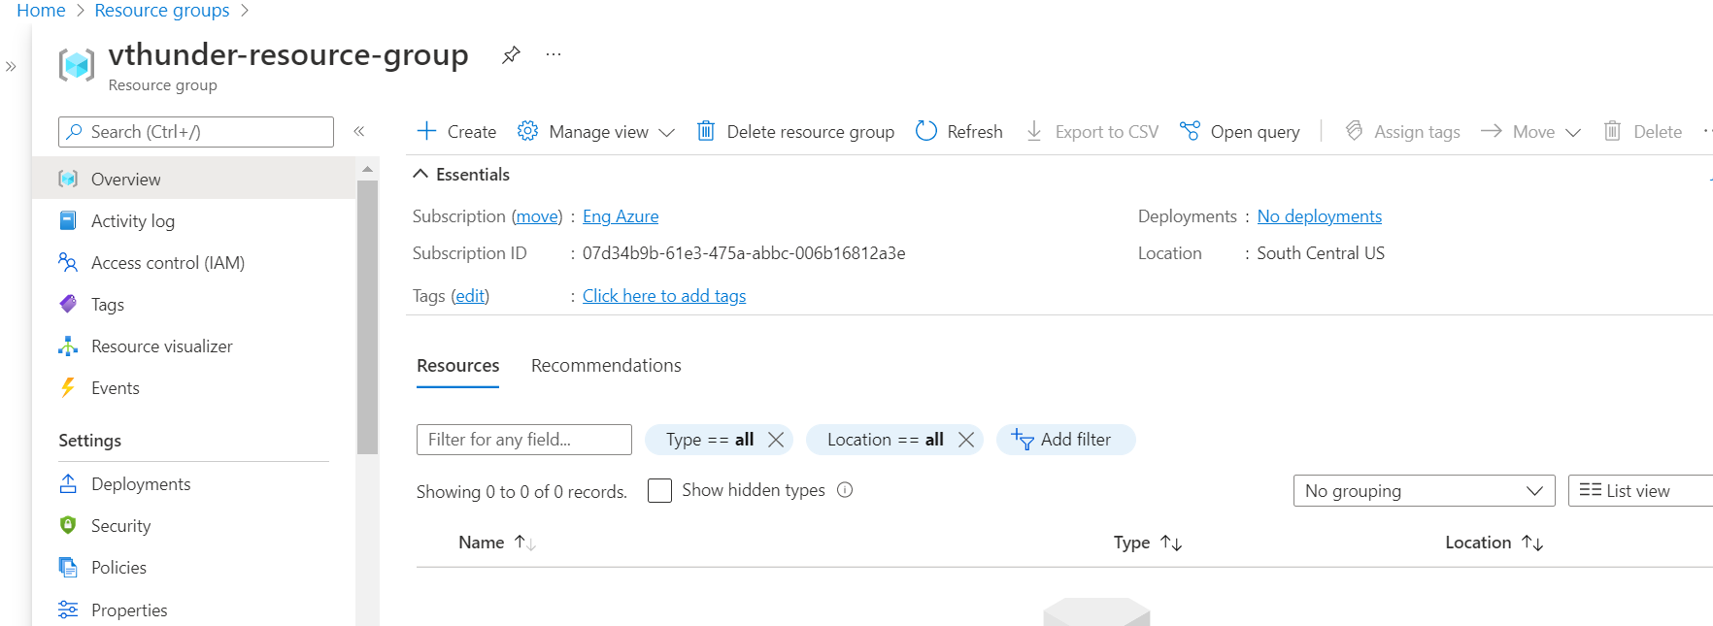

* + - 1. When resource group is “vthunder-resource-group” is present then resource group is used.
  1. Storage Account
     1. Expected Outcome: 1 storage account should get created if not exists else existing storage account will be used.
     2. Actual Outcome:
        1. 1 storage account name “vthunderstoragetest” is created when not already present.

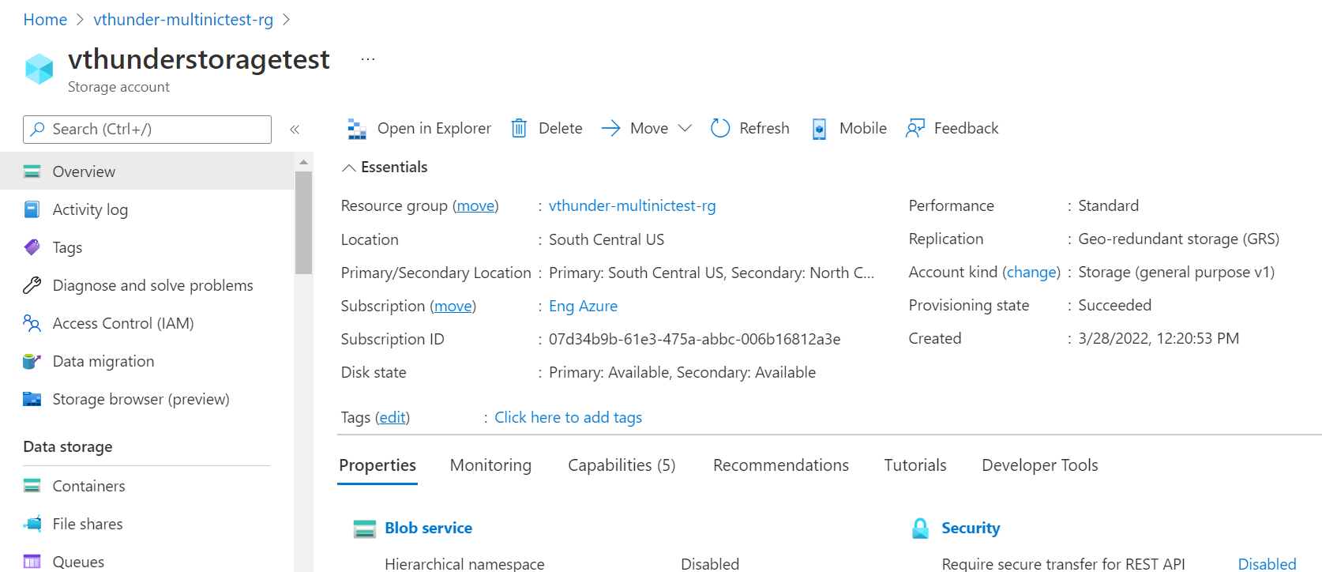

* + - 1. When storage account “vthunderstoragetest” already exists then it is used.
  1. Interfaces
     1. Expected Outcome: 2 interfaces (1 management, 1 data interfaces)should get created, and each interface is from different subnet.
     2. Actual Outcome: 2 interfaces are created and attached to VMs.

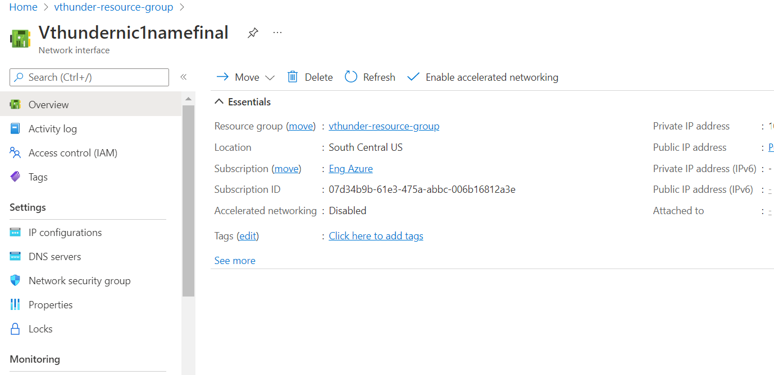

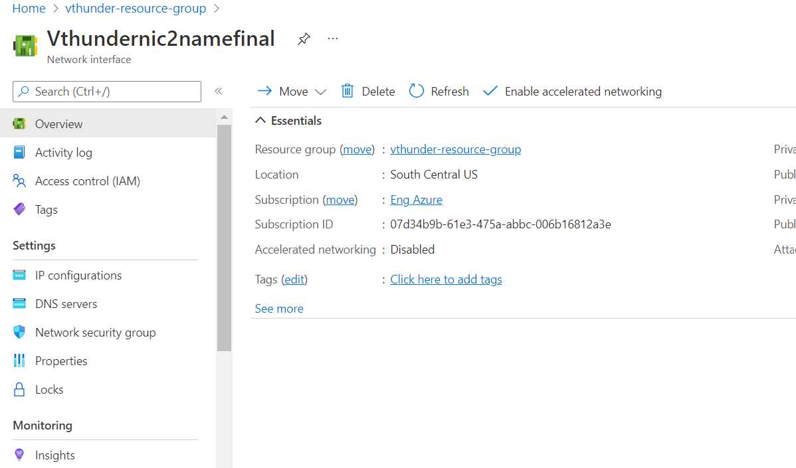

* 1. Subnets
     1. Expected Outcome: 2 subnets should get created. And first subnet should attached with network security group.
     2. Actual Outcome: 2 subnets are created. And first subnet should attached with network security group.

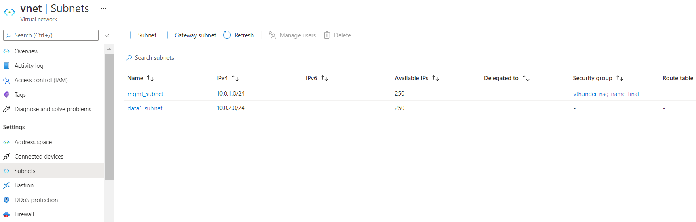

* 1. Virtual Network
     1. Expected Outcome: 1 virtual network should get created if not exists else present virtual network will be used.
     2. Actual Outcome: 1 virtual network is created name “vnet”.

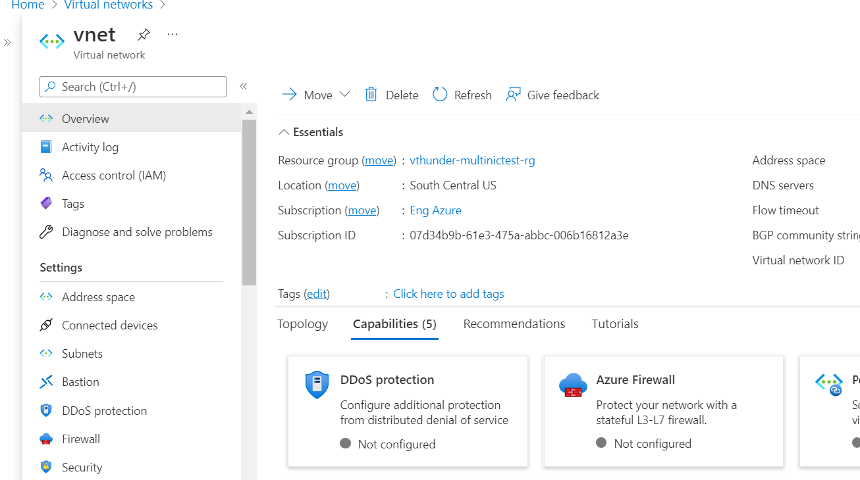

* 1. Public Ips
     1. Expected Outcome: 1 public ip should get created.
     2. Actual Outcome:

1 public ip is created and attached to first interfaces.



* 1. NSGs
     1. Expected Outcome: 1 NSG should get created
     2. Actual Outcome: 1 NSG is created and attached to VMs.

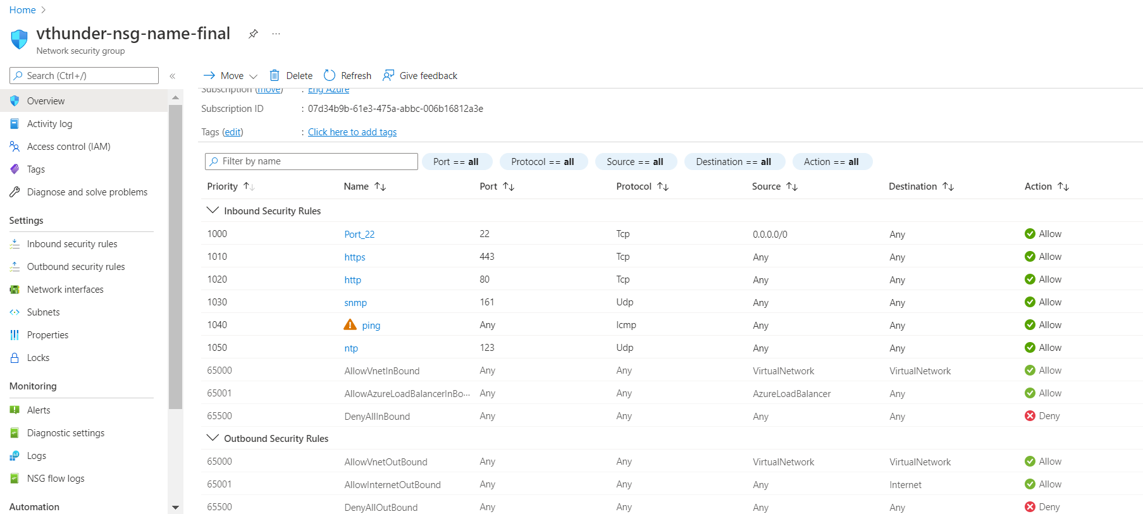

* 1. vThunder Instances
     1. Expected Outcome: 1 vThunder instances should get created having given configurations
     2. Actual Outcome: 1 vThunder instances are created having given configuration.

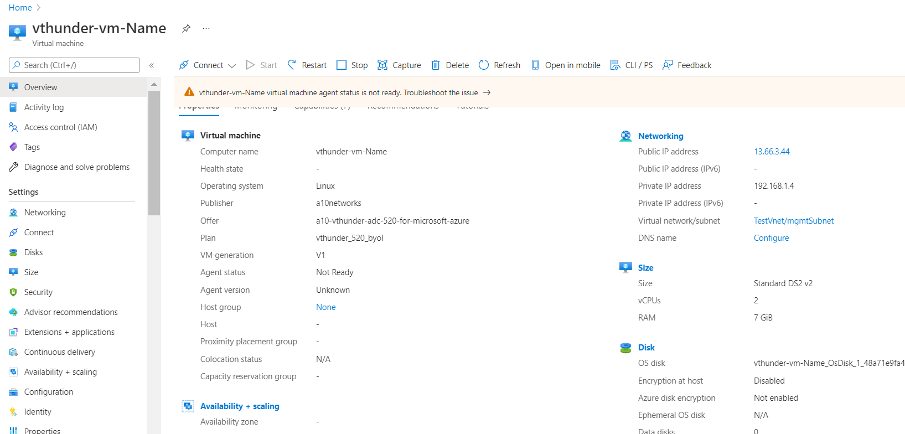

Note: You have to change parameter file values before each deployment, and you have to give unique values which is not already attached or present in that resource group. But this rule is not applicable for storage name and virtual network name.

If you have given storage name or virtual network name which is already present in same resource group then you will not get an error, but if you have given storage name and virtual network name which is already present in another resource group then you will get an error, so you have to give accordingly. you can use same storage name and virtual network name(as previous deployment) within same resource group for any number of deployments.

You will have to change parameter file each time, before deploying arm template, parameters that you will have to change are:

* NIC1Name(for both arm and powershell template)
* NIC2Name(for both arm and powershell template)
* addressPrefixValue(for both arm and powershell template)
* mgmtIntfPrivateAddress(for arm template)
* eth1PrivateAddress(for both arm and powershell template)
* DnsLabelPrefix name(for both arm and powershell template)
* NetworkSecurityGroupName. (for both arm and powershell template)
* PublicIpAddressName(for arm template)
* VmName(Optional) (for both arm and powershell template)
* VmSize(size you want to use you can change it accordingly)
* VThunderImage(A10 networks recommended vthunder image version)

# vThunder IP Configuration

1. vThunder-1
   * 1. 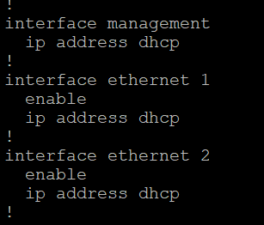

# vThunder SLB Configuration

## vThunder-1

* + 1. 