

v1.0

31-August-2022

USER MANUAL

AZURE ARM TEMPLATE GSLB

# PATENT PROTECTION

A10 Networks, Inc. products are protected by patents in the U.S. and elsewhere. The following website is provided to satisfy the virtual patent marking provisions of various jurisdictions including the virtual patent marking provisions of the America Invents Act. A10 Networks, Inc. products, including all Thunder Series products, are protected by one or more of U.S. patents and patents pending listed at: a10-virtual-patent-marking.

# TRADEMARKS

A10 Networks, Inc. trademarks are listed at: a10-trademarks.

# CONFIDENTIALITY

This document contains confidential materials proprietary to A10 Networks, Inc. This document and information and ideas herein may not be disclosed, copied, reproduced, or distributed to anyone outside A10 Networks, Inc. without prior written consent of A10 Networks, Inc.

# DISCLAIMER

This document does not create any express or implied warranty about A10 Networks, Inc. or about its products or services, including but not limited to fitness for a particular use and non-infringement. A10 Networks, Inc. has made reasonable efforts to verify that the information contained herein is accurate, but A10 Networks, Inc. assumes no responsibility for its use. All information is provided "as-is." The product specifications and features described in this publication are based on the latest information available; however, specifications are subject to change without notice, and certain features may not be available upon initial product release. Contact A10 Networks, Inc. for current information regarding its products or services. A10 Networks, Inc. products and services are subject to A10 Networks, Inc. standard terms and conditions.

# ENVIRONMENTAL CONSIDERATIONS

Some electronic components may possibly contain dangerous substances. For information on specific component types, please contact the manufacturer of that component. Always consult local authorities for regulations regarding proper disposal of electronic components in your area.

# FURTHER INFORMATION

For additional information about A10 products, terms and conditions of delivery, and pricing, contact your nearest A10 Networks, Inc. location, which can be found by visiting [www.a10networks.com](http://www.a10networks.com).

Contents

PATENT PROTECTION 1

TRADEMARKS 1

CONFIDENTIALITY 1

DISCLAIMER 1

ENVIRONMENTAL CONSIDERATIONS 2

FURTHER INFORMATION 2

Introduction to Installing vThunder on Microsoft Azure 4

Overview of Microsoft Azure 4

Azure Terminology 8

System Requirements 9

Pre-requisites 12

Install GSLB on Microsoft Azure 13

Chapter 1 - Core vThunder Installation & Basic Setup. 13

Configure 13

Install 16

Verify 17

Chapter 2 - vThunder Change Password. 18

Configure 18

Install 19

Chapter 3 – GSLB configuration Setup. 19

Configure 21

Install 21

Sites and Controller Complete Configurations: 21

Note 21

Verify 21

Chapter 4 - Let us Verify. 21

GSLB Group 21

GSLB Protocol 21

DNS lookup 21

# Introduction to Installing vThunder on Microsoft Azure

vThunder for Microsoft Azure is a fully operational, software-only version of the ACOS Series Server Load Balancer (SLB), or Application Delivery Controller (ADC) device. It is configurable by ACOS CLI, GUI, AXAPI, and Harmony Controller.

vThunder is a virtual appliance, yet it retains most of the functionality available on the hard- ware based ACOS appliances. Managing vThunder is the same as managing hardware based ACOS device, and vThunder has the same CLI configurations and GUI presentation.

The networking configuration for vThunder is also like hardware based ACOS devices. The maximum throughput of vThunder for Azure is variable and depends on vThunder software license purchase and type instance used to deploy vThunder.

*A10 Networks brings Out-Of-Box template to deploy vThunder along with multiple features and functionality with pre-defined format into azure cloud.*

Please refer below section for more details.

# Overview of Microsoft Azure

With the move to the cloud, many teams have adopted agile development methods. These teams iterate quickly. They need to repeatedly deploy their solutions to the cloud, and know their infrastructure is in a reliable state. As infrastructure has become part of the iterative process, the division between operations and development has disappeared. Teams need to manage infrastructure and application code through a unified process.

To meet these challenges, you can automate deployments and use the practice of infrastructure as code. In code, you define the infrastructure that needs to be deployed. The infrastructure code becomes part of your project. Just like application code, you store the infrastructure code in a source repository and version it. Any one on your team can run the code and deploy similar environments.

To implement infrastructure as code for your Azure solutions, use azure resource manager templates. The template is a json native file that defines the infrastructure and configuration for your project. The template uses declarative syntax, which lets you state what you intend to deploy without having to write the sequence of programming commands to create it. In the template, you specify the resources to deploy and the properties for those resources.

**Microsoft Azure** (formerly known as Windows Azure) is Microsoft’s cloud computing platform. Azure is an industry leader for both infrastructure-as-a-service (IaaS) and platform-as-a-service (PaaS). Azure offers a combination of managed and unmanaged services that lets customers deploy and manage their applications as they see fit.

The Azure cloud computing platform runs on Microsoft data center and is globally dis- tributed across more than a dozen countries. Such global distribution helps ensure customers receive high performance, regardless of where they are located.

Azure is flexible and can support virtually any operating system, from Windows to Linux, any programming language, from Java to C++, and any database, from SQL to Oracle. Azure also offers 99.95% uptime and is the platform that Microsoft uses to run many of its popular ser- vices, such as Bing, Skype, Xbox, and Office 365.

A10 Networks vThunder virtual device can be set up as an instance in Azure’s cloud and can be used to provide a robust global server load balancing (GSLB) service.

Microsoft Azure uses the following tools to create and manage resources:

**Azure Portal** - A web console to create and monitor Azure resources. For more information, refer to <https://azure.microsoft.com/en-in/features/azure-portal/>

**Azure PowerShell** - A set of cmdlets used for managing Azure resources from the command line. Launch Azure PowerShell from a browser within the Azure Cloud Shell or install the software on the system to start a local PowerShell session.

For more information, refer to <https://docs.microsoft.com/en-us/powershell/>

**Azure CLI—** Can also be launched from a browser within the Azure Cloud Shell or install the software on the system to start a local CLI session. For more information, refer to <https://docs.microsoft.com/en-us/cli/azure/overview?view=azure-cli-latest>

You **can** launch Cloud Shell from the top navigation bar of the Azure portal.

FIGURE 1-1: Launching Cloud Shell



The following figure shows how vThunder fits into the Microsoft Azure infrastructure.

FIGURE 1-2: vThunder for Microsoft Azure

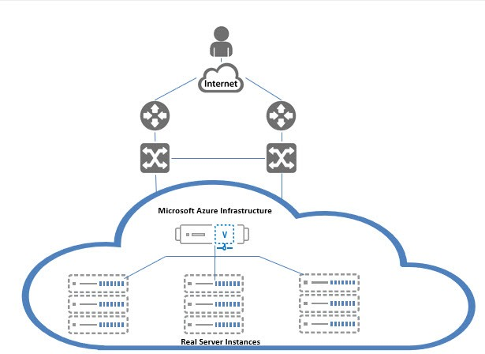

Below diagram shows the topology of 2 regions GSLB. 1 gslb controller and 2 site devices in each region.

FIGURE 1-3: GSLB Topology

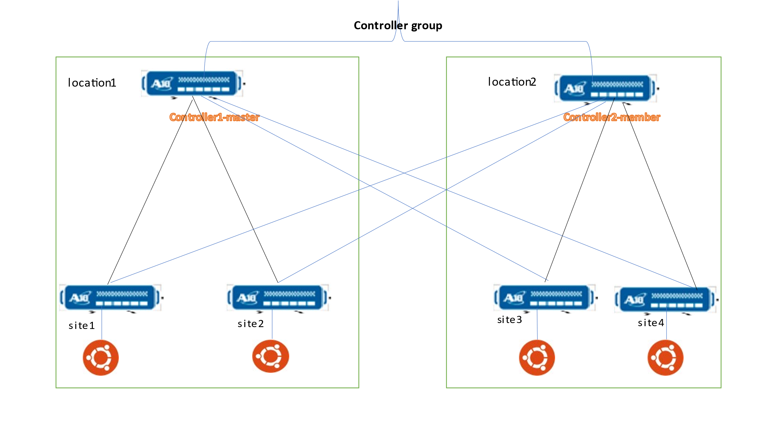

# Azure Terminology

**Azure account** — The Azure account created has different support plans for different regions. For more information on different Azure regions and availability of types of virtual machines in these regions, refer to

<https://docs.microsoft.com/en-us/azure/virtual-machines/linux/overview>

**Resource group** — A resource group is a logical group of all the resources related to an Azure solution. Azure offers flexibility in the allocation of resources to resource groups.

For more information, refer to

[https://docs.microsoft.com/en-us/azure/azure-resource-manager/resource-group- overview](https://docs.microsoft.com/en-us/azure/azure-resource-manager/resource-group-%20overview/)

**Availability set** — An availability set is a logical grouping of Azure VM resources so that each VM resource is isolated from other resources when deployed. This hardware isolation ensures that a minimum number of VMs are impacted during a failure. For more information, refer to

[https://docs.microsoft.com/en-us/azure/azure-resource-manager/resource-group- overview](https://docs.microsoft.com/en-us/azure/azure-resource-manager/resource-group-%20overview/)

**Virtual network** — The Microsoft Azure Virtual Network service enables resources to securely communicate with other resources in an Azure network in the cloud. A virtual network is hence logical isolation of the Azure cloud for an Azure account. You can con- nect different virtual networks and to on-premises networks. For more information, refer to

[https://docs.microsoft.com/en-us/azure/virtual-machines/windows/tutorial-avail- ability-sets](https://docs.microsoft.com/en-us/azure/virtual-machines/windows/tutorial-avail-%20ability-sets/)

**Network security group (NSG)** — A network security group (NSG) contains a list of security rules that allow or deny network traffic to resources connected to Azure virtual networks (VNet). The NSGs can be associated with subnets or individual NICs attached to the VMs. When an NSG is associated with a subnet, the rules apply to all the resources connected to the subnet.

# System Requirements

Below all azure cloud resources will be created.

1. Azure Resource Group.

New resource group need be created with the specified name and location, in case does not exist.

Run following command:

az group create --name <resource-group-name> --location <location-name>

For example:

az group create --name gslb-test-rg --location "South Central Us"

1. Azure Storage Account.

New Standard_GRS storage account will be created inside resource group.

One storage account is created in each GSLB region. So, total of 2 storage accounts.

In case storage account already exists, it will prompt error “The storage account named is already taken”.

The storage account name can be configured in parameter file ARM_TMPL_GSLB_PARAM.json.

1. Virtual Machine Instance.

**A10 vThunder**:

Image: a10-vthunder-adc-520-for-microsoft-azure

Size: Standard_A4_v2

NICs: 1 MGMT+2 DATA

Name:

$vmName+$region1+”1” region1 controller

$vmName+$region1+”2” region1 site device 1

$vmName+$region1+”3” region1 site device 2

$vmName+$region2+”1” region2 controller

$vmName+$region2+”2” region2 site device 1

$vmName+$region2+”3” region2 site device 2

**Real Servers (Linux Ubuntu 16.04.0-LTS):**

Size: Standard_B2s

NICs: 1MGMT+1DATA

Name:

$linuxName+$region1+”1” region1 linux 1

$linuxName+$region1+”2” region1 linux 2

$linuxName+$region2+”1” region2 linux 1

$linuxName+$region2+”2” region2 linux 2

**A10 vThunder Supported VM Sizes**

|  |  |  |
| --- | --- | --- |
| ***Series*** | ***Size*** | ***Qualified Name*** |
| A series | Standard A4_v2  Standard A4m_v2  Standard/Basic A4  Standard A8_v2 | Standard_A4_v2  Standard_A4m_v2  Standard_A4  Standard_A8_v2 |
| B series | Standard B2_s  Standard B2ms  Standard B4ms | Standard_B2_s  Standard_B2ms  Standard_B4ms |
| D series | Standard D3_v2  Standard DS3_v2  Standard D5_v2 | Standard_D3_v2  Standard_DS3_v2  Standard_D5_v2 |
| F series | Standard F4s  Standard F8  Standard F16s | Standard_F4s  Standard_F8  Standard_F16s |

Few of sizes are getting retried soon from azure, please refer [Virtual Machine series | Microsoft Azure](https://azure.microsoft.com/en-in/pricing/details/virtual-machines/series/).

For more information, please refer as below.

<https://docs.microsoft.com/en-us/azure/virtual-machines/sizes-> [general](http://sales@a10networks.com/)

<https://docs.microsoft.com/en-us/azure/virtual-machines/linux/sizes>.

1. Virtual Cloud Network. [VCN]

Virtual network was created for each GSLB region.

Default address prefix for virtual network are 10.1.0.0/16 and 10.2.0.0/16

Name: *$region1+vnet1, $region2+vnet2*

1. Subnets.

Three subnets will be created in each GSLB region. Address prefix can be configured in parameter file.

Default name:

*mgmt_subnet_steps*

*data1_subnet_steps*

*data2_subnet_steps*

1. Public IP address.

Each A10 device is assigned a public IP address for the management interface and a secondary IP configuration for data interface on client side. The public IP address for secondary IP configuration is used in gslb config by controller.

Each Real server (Linux) has a public IP address assigned to the management interface

The public ip addresses are dynamic

1. Private IP address.

Each A10 device has a private IP address for the management, primary IP configuration and secondary IP configuration for client side data interface, server side data interface. The secondary IP configuration for client side data interface is used as a VIP IP address in SLB/GSLB configuration.

Each Real Server (Linux) has a private IP address assigned to the data interface.

The Private IP addresses are static. Subnet changes for private IP address need to be made in the parameter file.

1. Network Security Group. [NSG]

For each A10 device, the management, client side data interface and server side data interface have NSGs assigned with Allow permissions for relevant ports.

For each Real Server (Linux), the management and data interfaces have NSGs with Allow permissions for relevant ports.

1. Regions.

The 2 regions are user configurable and can be changed in the parameter file ARM_TMPL_GSLB_PARAM.json. By default, eastus and eastus2 are used.

# Pre-requisites

Please find below detailed pre-requisites to install template using ARM.

1. Azure account and valid subscription.

Azure Portal—A web console to create and monitor Azure resources. For more information, refer to <https://azure.microsoft.com/en-in/features/azure-portal/>

1. Azure CLI— Can also be launched from a browser within the Azure Cloud Shell or install the software on the system to start a local CLI session. For more information, refer to <https://docs.microsoft.com/en-us/cli/azure/overview?view=azure-cli-latest>

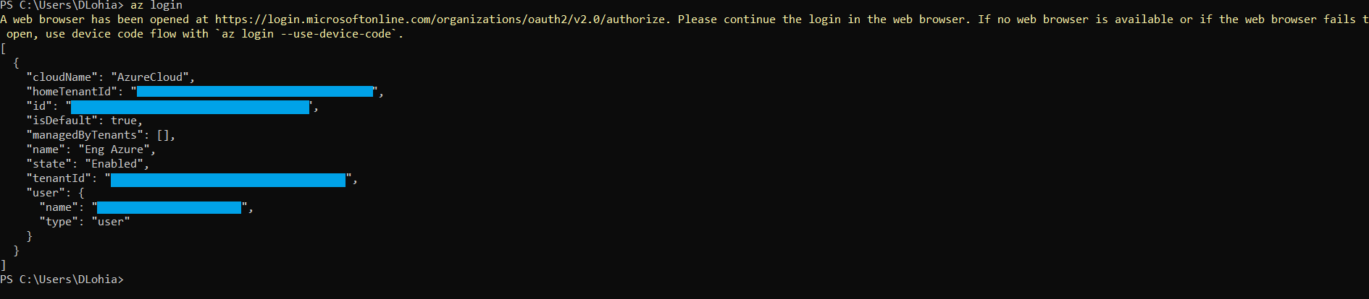

1. Windows PowerShell 7.0.6 LTS or 7.1.3, 7.2.2 or any higher. Recommended 7.2.2.

[Installing PowerShell on Windows - PowerShell | Microsoft Docs](https://docs.microsoft.com/en-us/powershell/scripting/install/installing-powershell-on-windows?view=powershell-7.2)

Azure PowerShell—A set of cmdlets used for managing Azure resources from the command line. Launch Azure PowerShell from a browser within the Azure Cloud Shell or install the software on the system to start a local PowerShell session. For more information, refer to <https://docs.microsoft.com/en-us/powershell/>

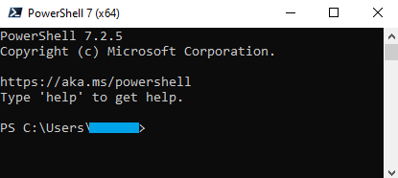  
Install Az Modules: Install-Module Az



1. Policy Setting in powershell.

Set execution policy to Unrestricted: “Set-ExecutionPolicy -Scope Process -ExecutionPolicy Bypass”



1. Document editor Notepad++ or Notepad or Any.

[Downloads | Notepad++ (notepad-plus-plus.org)](https://notepad-plus-plus.org/downloads/)

# Install GSLB on Microsoft Azure

## Chapter 1 - Core vThunder Installation & Basic Setup.

### Configure

Refer ARM_TMPL_GSLB_PARAM.json file to customize default values. Please find below in details.

**Setting vThunder Default Credentials**

Default credential is mentioned in below image, this is only required during VM creation.

Username: *vth-user*

Password: *vth-Password*

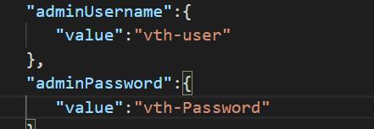

**VM Name**

Default vThunder VM name prefix.

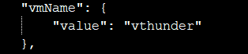

**vThunder VM Size**

Default size is set as below. It can be changes as per needs. Please refer ‘Qualified Name’ column under supported vm sizes section to select any other size. All sizes works for this instance.

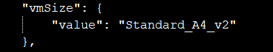

**vThunder Image**

User can pick available image from Azure marketplace.

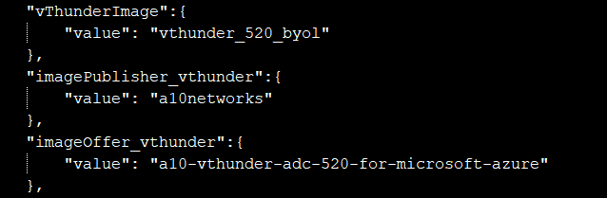

**Regions**

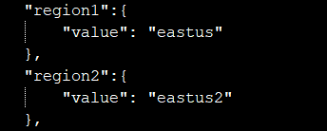

**Subnets**

Default subnets value

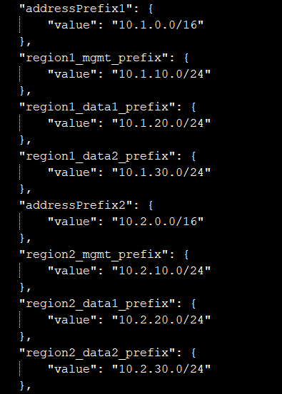

**Network Security Group**

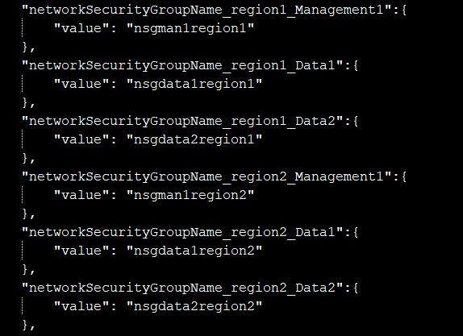

**Storage Account Name**

If storage account is already existed, script will give the error “The storage account named is already taken.”

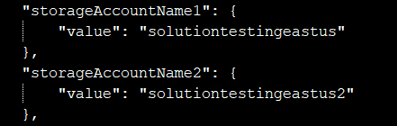

### Install

1. Open Powershell 7 from start menu.

2. Do login

*az login*

3. Create azure resource group manually.

*az group create --name gslb-test-rg --location "South Central Us"*

4. Run below command to deploy the GSLB infrastructure.

*az deployment group create -g gslb-test-rg --template-file ARM_TMPL_GSLB_1.json --parameters ARM_TMPL_GSLB_PARAM.json*

### Verify

Open the resource group on Azure portal, check the 6 vThunder and 4 Linux instances are created succeed. Check the private IP and public IP are assigned correctly.

1. Check instances.

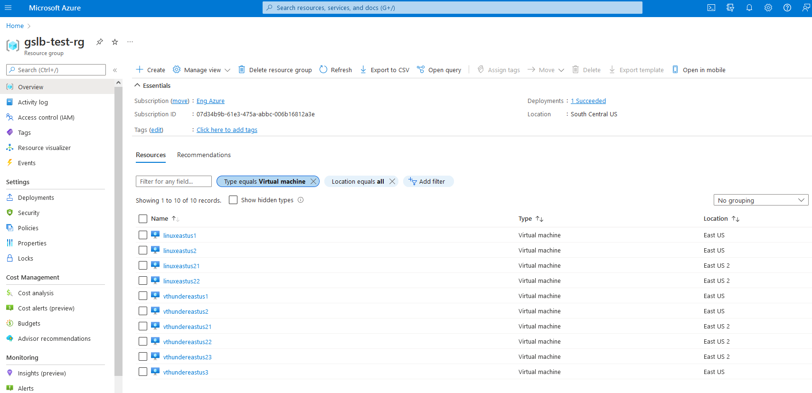

1. Check mgmt interface public IP, private IP and security rule.

1. Check vThunder client side data interface private IP and secondary private and public IP

## Chapter 2 - vThunder Change Password.

### Configure

Please configure below parameters in

ARM_TMPL_GSLB_SLB_PARAM.json

Resource group name: gslb-test-rg

vThUsername: admin.

### Install

Users need to run the following script for change password of vThunder.

.\ARM_TMPL_GSLB_CHANGE_PASSWORD_2.ps1

While running the change password script, user need to provide default and new password in the command prompt.

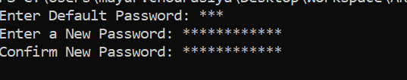

Description: - Default password value will be a10.

## Chapter 3 – GSLB configuration Setup.

The PowerShell script ARM_TMPL_GSLB_CONFIG.ps1 configures 1 GSLB controller (A10 vThunder), 2 site devices (A10 vThunder) in each region.

For each site device, the script enables interfaces, configures slb configuration and enables site devices to be a gslb device. A default route is also configured pointing to the client side data interface for traffic to exit the vthunder, the default route IP addresses will vary as per the user environment. We can configure it in the configuration file ARM_TMPL_GSLB_SLB_PARAM.json.

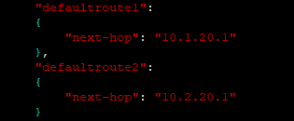

Except for the real server IP address, all other addresses are obtained dynamically from user environment. Finally, a write memory is done. Following is a site device configuration example.

ip route 0.0.0.0 /0 10.1.20.1

!

slb server s1 10.1.30.8

health-check-disable

port 80 tcp

health-check-disable

!

slb service-group sg tcp

member s1 80

!

slb virtual-server vs1 10.1.20.9

port 80 tcp

source-nat auto

service-group sg

!

!

gslb protocol enable device

For each GSLB controller, the interfaces are enabled and the device is configured with the required GSLB configuration (service-ip, gslb sites, gslb policy, gslb zone, gslb virtual server, gslb group, enabling/disabling specific geolocation parameters). The script enables “system geo-location load GeoLite2-City “by default. This can be changed from the parameter file. A default route is also configured pointing to the client side data interface for traffic to exit the vthunder. Finally, a write memory is done. Following is a controller configuration example.

ip route 0.0.0.0 /0 10.1.20.1

!

slb virtual-server gslb-server 10.1.20.8

port 53 udp

gslb-enable

!

gslb service-ip vs1 10.1.20.9

external-ip 137.117.81.170

port 80 tcp

!

gslb service-ip vs2 10.1.20.10

external-ip 137.117.81.196

port 80 tcp

!

gslb service-ip vs3 10.2.20.9

external-ip 20.242.97.42

port 80 tcp

!

gslb service-ip vs4 10.2.20.10

external-ip 20.62.107.135

port 80 tcp

!

gslb group default

enable

primary 20.242.96.218

priority 255

!

gslb site eastus_1

geo-location "North America,United States"

slb-dev slb1 104.211.58.124

vip-server vs1

!

gslb site eastus_2

geo-location "North America,United States"

slb-dev slb2 104.211.58.122

vip-server vs2

!

gslb site eastus2_1

geo-location "North America.United States.California.San Jose"

slb-dev slb3 20.230.76.141

vip-server vs3

!

gslb site eastus2_2

geo-location "North America.United States.California.San Jose"

slb-dev slb4 20.230.78.91

vip-server vs4

!

gslb policy a10

metric-order health-check geographic

dns server

!

gslb zone gslb.a10.com

policy a10

service 80 www

dns-a-record vs1 static

dns-a-record vs2 static

dns-a-record vs3 static

dns-a-record vs4 static

!

gslb protocol status-interval 1

!

gslb protocol enable controller

### Configure

User can set following configurations in ARM_TMPL_GSLB_SLB_PARAM.json based on their needs.

* slbServerHostOrDomain1(servername, host)

For slb server configuration on site device. The real server (ubuntu) IP addresses connect to site 1 (site device 1 of region 1).

* slbServerHostOrDomain2(servername, host)

For slb server configuration on site device. The real server (ubuntu) IP addresses connect to site 2 (site device 2 of region 1).

* slbServerHostOrDomain3(servername, host)

For slb server configuration on site device. The real server (ubuntu) IP addresses connect to site 3 (site device 1 of region 2).

* slbServerHostOrDomain4(servername, host)

For slb server configuration on site device. The real server (ubuntu) IP addresses connect to site 4 (site device 2 of region 2).

* slbServerPortList1(port-number, protocol)
* slbServerPortList2(port-number, protocol)
* slbServerPortList3(port-number, protocol)
* slbServerPortList4(port-number, protocol)

For port configuration under slb server on site devices.

* serviceGroupList1(name, protocol, member-list)
* serviceGroupList2(name, protocol, member-list)
* serviceGroupList3(name, protocol, member-list)
* serviceGroupList4(name, protocol, member-list)

For service group configuration on site devices.

* virtualServerList1(virtual-server-name, value)
* virtualServerList2(virtual-server-name, value)
* virtualServerList3(virtual-server-name, value)
* virtualServerList4(virtual-server-name, value)

For slb virtual-server configuration on site devices.

* serviceipList1(node-name, value)
* serviceipList2(node-name, value)
* serviceipList3(node-name, value)
* serviceipList4(node-name, value)

For gslb service-ip configuration on controller.

* siteList1(site-name, vip-name, device-name, geo-location)
* siteList2(site-name, vip-name, device-name, geo-location)
* siteList3(site-name, vip-name, device-name, geo-location)
* siteList4(site-name, vip-name, device-name, geo-location)

For gslb site configuration on controller.

* geolocation

For system geo-location configuration on controller.

* dnsPolicy

For gslb policy configuration on controller.

* gslbserverList1(virtual-server-name, ip-address, value)
* gslbserverList2(virtual-server-name, ip-address, value)

For slb virtual-server configuration on controllers.

* gslbprotocolStatus

For gslb protocol configuration on controller.

* gslbcontrollerGroup1(name, priority)
* gslbcontrollerGroup2(name, priority)

For gslb group configuration on controller.

* gslbzone(service-port, service-name, name)

For gslb zone configuration on controller.

* defaultroute1
* defaultroute2

Default route for vThunder instances.

### Install

Run below command to start the Powershell script.

*.\ARM_TMPL_GSLB_CONFIG_3.ps1*

While running the SLB script user need to provide the correct password in the command prompt



When the script is running, before the configuration of devices starts, it asks the user to enter resource-group name:

Supply values for the following parameters:

resourceGroupName:

Then the script authenticates with azure. After the authentication is successful, the script moves forward with the main configuration.

### Sites and Controller Complete Configurations:

1. CONTROLLER 1- Master CONFIG:

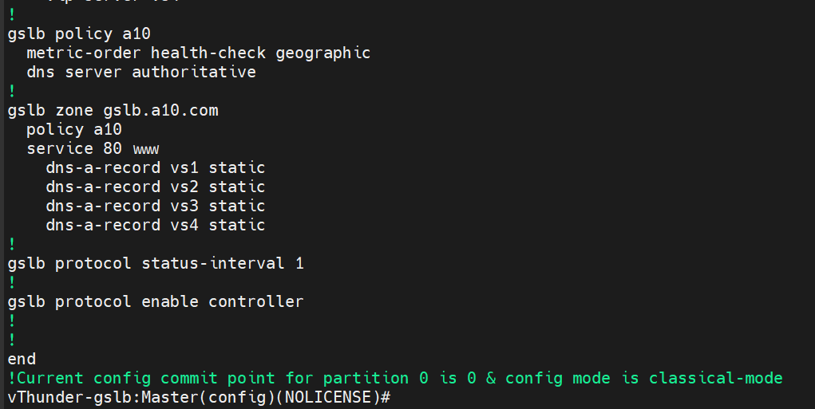

1. CONTROLLER 2-Member CONFIG:

1. SITE 1(eastus_1) configuration:

1. SITE 2(eastus_2) configuration:

1. SITE 3(eastus2_1) configuration:

1. SITE 4(eastus2_2) configuration:

### Note

1. The end user needs to take care of the license of the vThunder instances.
2. The end user needs to take care of the controller IP addresses known to their ldns server.
3. The end user needs to take care of the real server configurations (apache etc.)
4. The PS Script by default sets “no system geo-location load iana” and “system geo-location load GeoLite2-City”

### Verify

Check the GSLB controller and site devices configuration on both regions, make sure they are added correctly.

## Chapter 4 - Let us Verify.

### GSLB Group

1. Master

1. Member

### Text Description automatically generatedGSLB Protocol

1. Master

1. Member

### DNS lookup

Use master controller’s public IP of client side data interface as DNS server IP to do DNS lookup. We can get the site device client side interface public IP in round robin based on the client location.

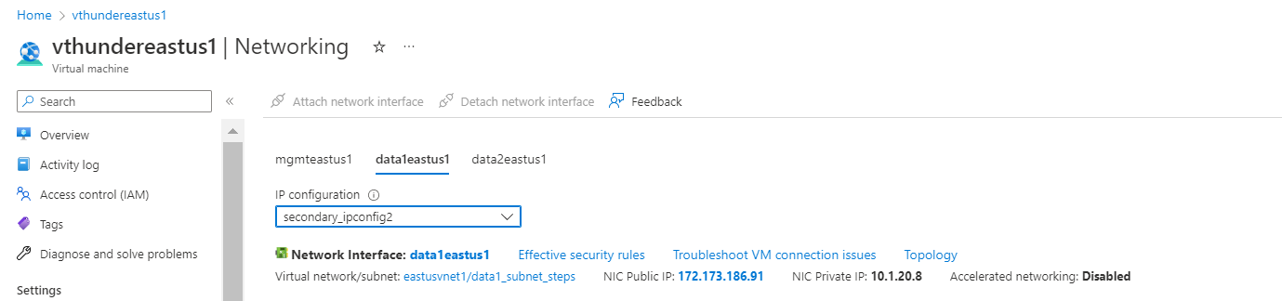

***$ dig @*172.173.186.91 *www.gslb.a10.com***

***$ dig @*172.173.186.91 *www.gslb.a10.com***

***$ wget <secondary_data_public_ip>***

*Steps:*

*Install apache server on all linux machine.*

*Go to the networking section of site device.*

*Copy secondary_data_public_ip address of site vthunder device or Or you can copy each ip one by by from dig output (Answer section) and check with wget.*

*hit:*

*wget <**secondary_data_public_ip >.*

