Powershell Template – 2 NIC 1 vThunder GLM Instances Test Cases

1. Resource Creation
   1. Resource Group
      1. Expected Outcome: 1 resource group should get created if not exists else existing resource group will be used.
      2. Actual Outcome:
         1. 1 new resource group name “vthunder-resource-group” is created when it was not present.

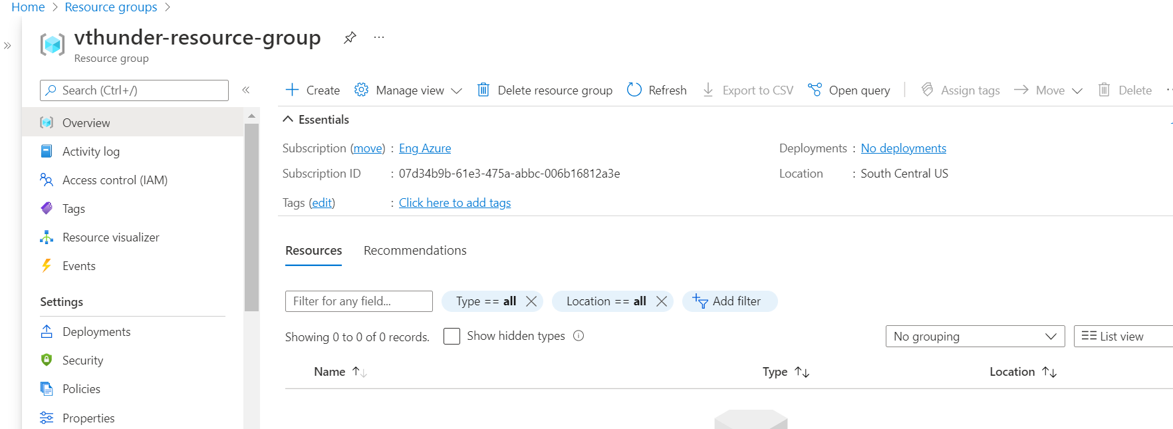

* + - 1. When resource group is “vthunder-resource-group” is present then resource group is used.
  1. Storage Account
     1. Expected Outcome: 1 storage account should get created if not exists else existing storage account will be used.
     2. Actual Outcome:
        1. 1 storage account name “vthunderstoragetest” is created when not already present.

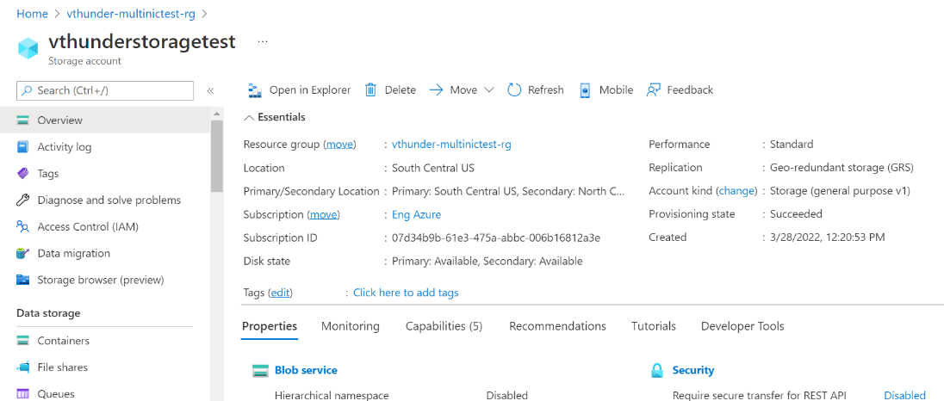

* + - 1. When storage account “vthunderstoragetest” already exists then it is used.
  1. Interfaces
     1. Expected Outcome: 2 interfaces (1 management, 1 data interfaces)should get created, and each interface is from different subnet.
     2. Actual Outcome: 2 interfaces are created and attached to VMs.

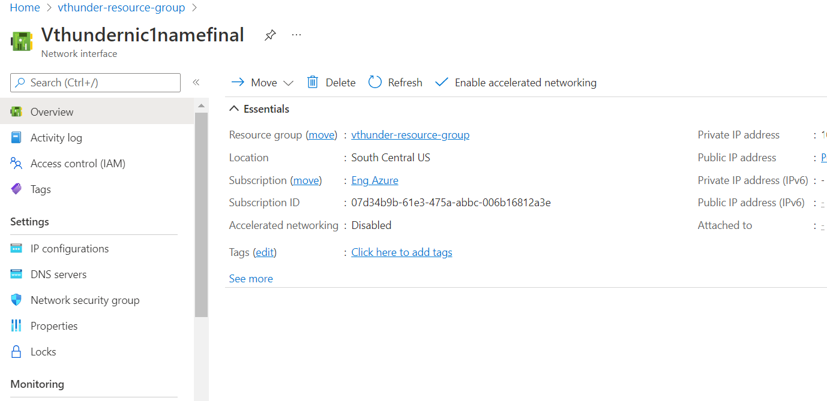

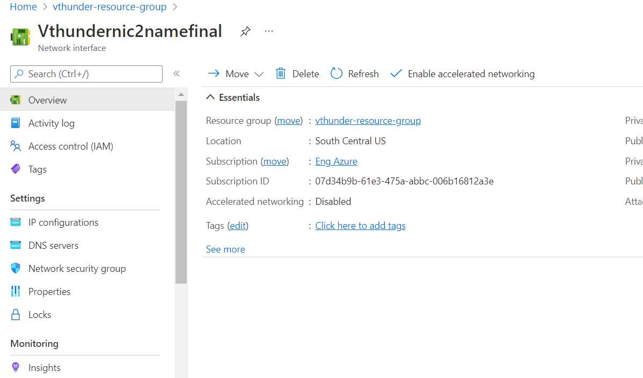

* 1. Subnets
     1. Expected Outcome: 2 subnets should get created. And first subnet should attached with network security group.
     2. Actual Outcome: 2 subnets are created. And first subnet should attached with network security group.

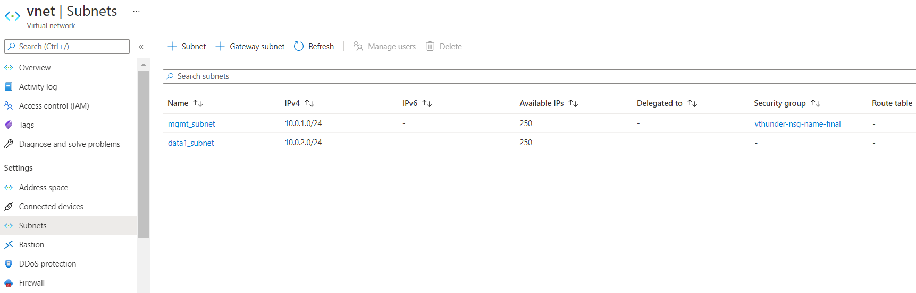

* 1. Virtual Network
     1. Expected Outcome: 1 virtual network should get created if not exists else present virtual network will be used.
     2. Actual Outcome: 1 virtual network is created name “vnet”.

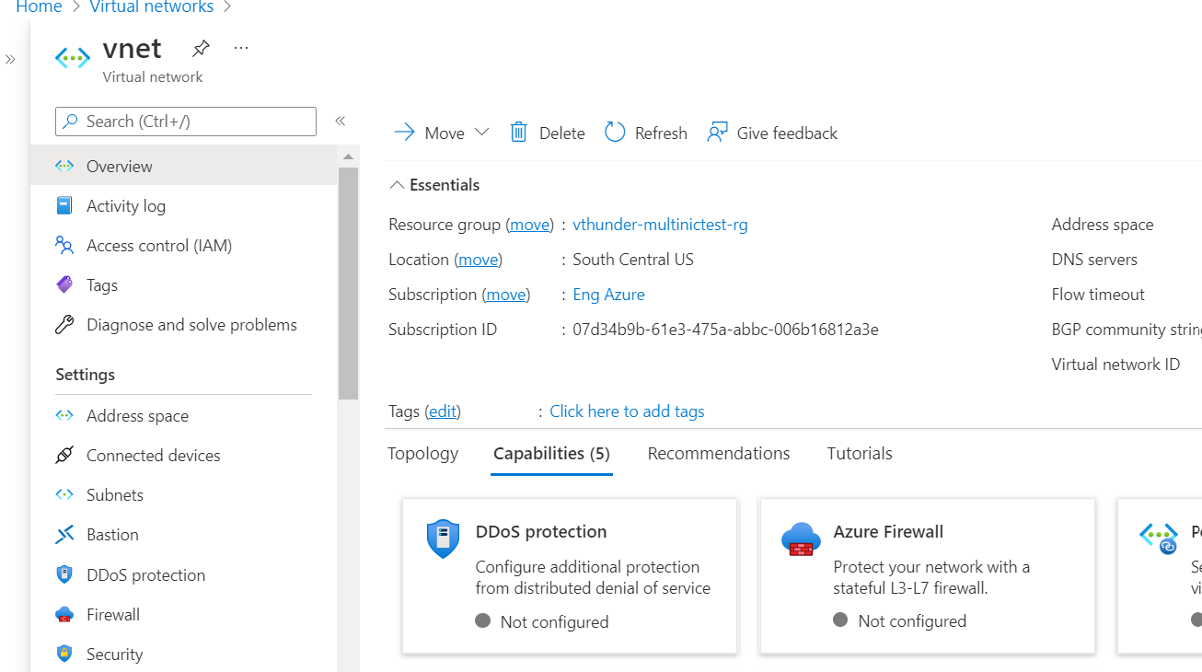

* 1. Public Ips
     1. Expected Outcome: 1 public ip should get created.
     2. Actual Outcome:

1 public ip is created and attached to first interfaces.



* 1. NSGs
     1. Expected Outcome: 1 NSG should get created
     2. Actual Outcome: 1 NSG is created and attached to VMs.
        1. 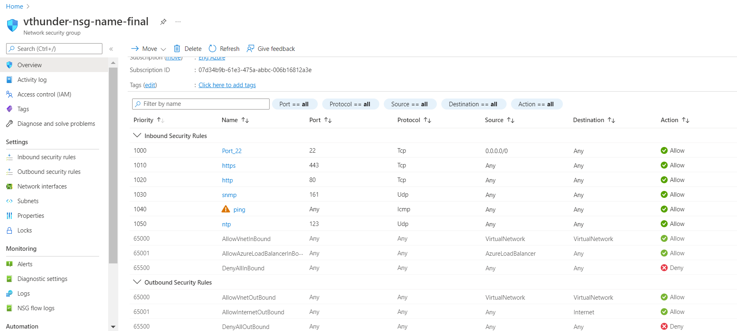
  2. vThunder Instances
     1. Expected Outcome: 1 vThunder instances should get created having given configurations
     2. Actual Outcome: 1 vThunder instances are created having given configuration.

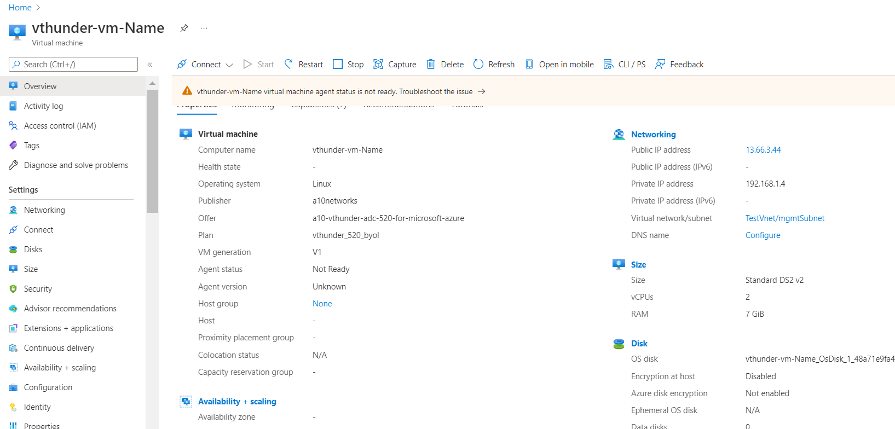

# vThunder IP Configuration

1. vThunder-1
   * 1. 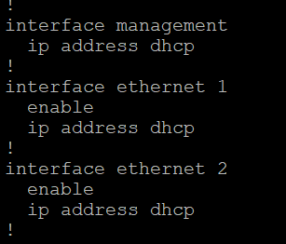

# vThunder SLB Configuration

## vThunder-1

* + 1. 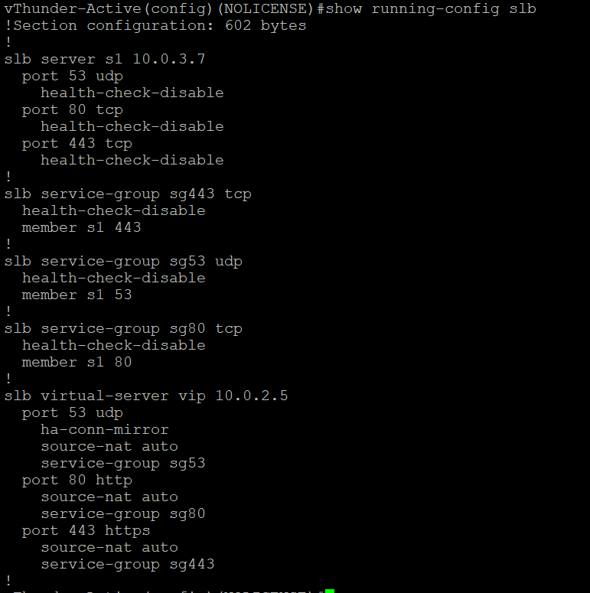

ARM Template – 2 NIC 1 vThunder GLM Test cases

1. License Activation
   1. Activate license
      1. Expected Outcome: license will be activated if not activated.
      2. Actual Outcome: license will be activated if not activated.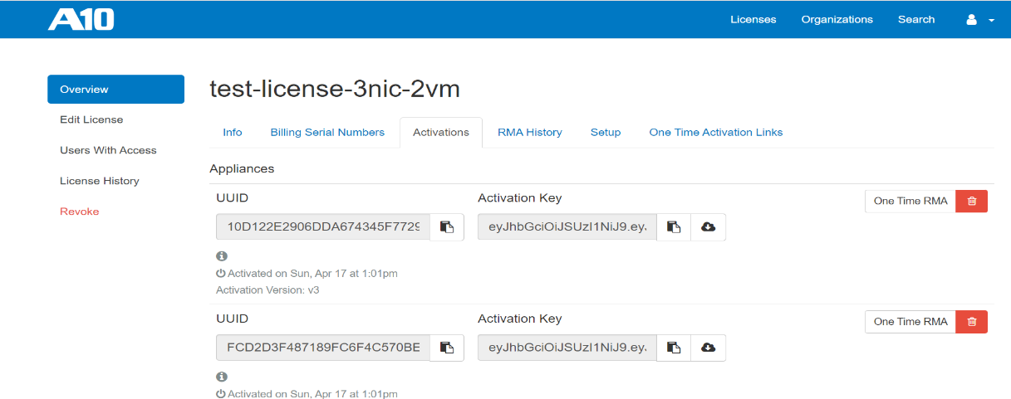
   2. Apply GLM license
      1. Expected Outcome: license will be applied on vthunder
      2. Actual Outcome: license will be applied on vthunder

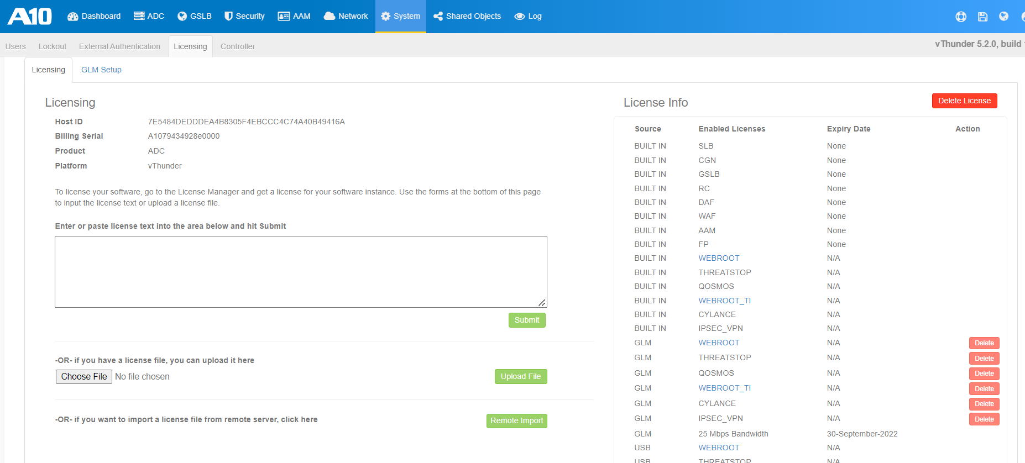

* 1. Set Glm configuration
     1. Expected Outcome: primary dns, vthunder entitlement token will be set and glm management port, enable request well be set with value 1
     2. Actual Outcome: primary dns, vthunder entitlement token will be set and glm management port, enable request well be set with value 1

