PowerShell Template – 3 NIC 2 vThunder HA Test Cases

Table of Contents

PowerShell Template Input 5

PowerShell Template User Authentication 5

vThunder IP Configuration 6

vThunder SLB Configuration 7

vThunder-1 7

vThunder-2 7

vThunder SSL Configuration 8

vThunder-1 8

vThunder-2 8

vThunder HA Configuration 8

vThunder-1 8

vThunder-2 8

vThunder DNS and IP Route Configuration 9

SLB Test Cases 9

Case-1: Auto Scale VMSS (Addition of new servers) 9

Case-2: Auto Scale VMSS ( Delete servers) 11

HA Test Cases 13

Without failover (vThunder-1 is in active and vThunder-2 is in standby mode) 13

vThunder-1 goes on standby mode 15

vThunder-1 again become active 16

vThunder-1 and vThunder-2 both are on standby mode 17

PS Template – 3 NIC 2 vThunder HA GLM Test Cases 18

License Activation 18

Activate license 18

Apply GLM license 18

Set GLM configuration 18

Automation Account Test Cases 19

1. Resource Creation
   1. Resource Group
      1. Expected Outcome: 1 resource group should get created if not exists else existing resource group will be used.
      2. Actual Outcome:
         1. 1 new resource group name “narayana-bup-vip” is created when it was not present.

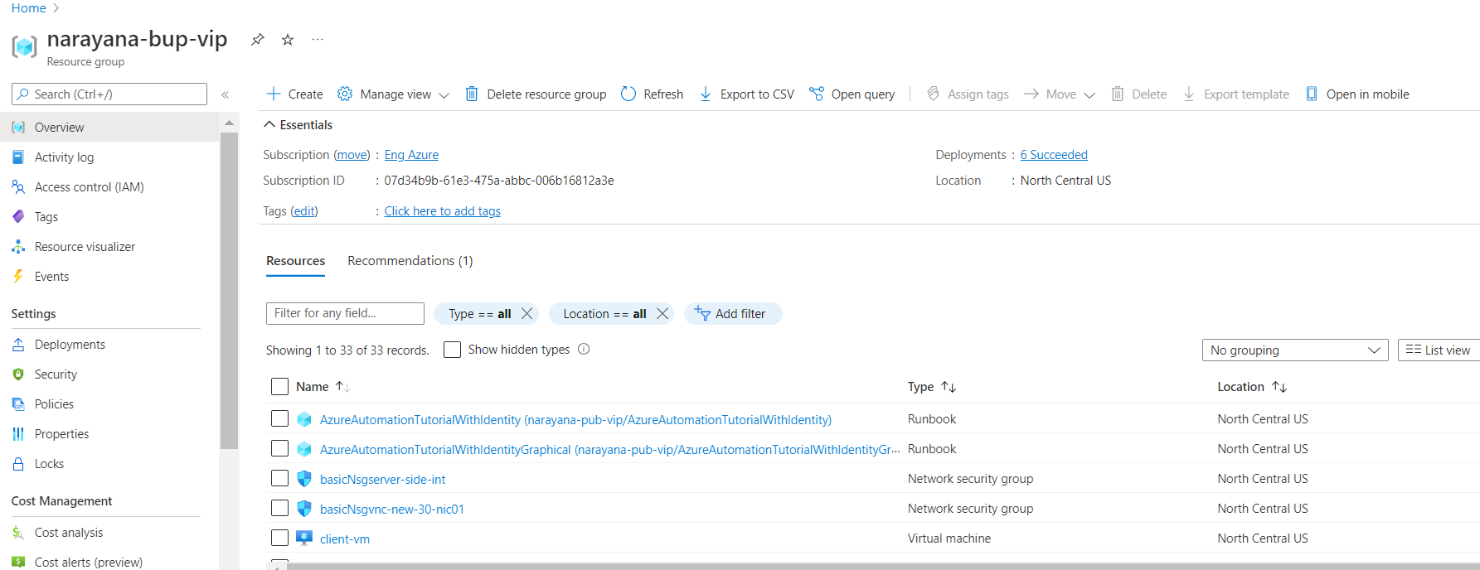

* + - 1. When resource group is “narayana-bup-vip” is present then resource group is used.
  1. Storage Account
     1. Expected Outcome: 1 storage account should get created if not exists else existing storage account will be used.
     2. Actual Outcome:
        1. 1 storage account name “newstorpublicpvip” is created when not already present.

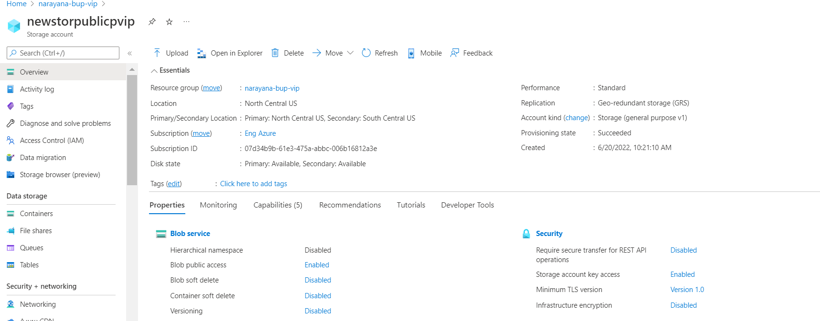

* + - 1. When storage account “newstorpublicpvip” already exists then it is used.
  1. Interfaces
     1. Expected Outcome: 6 interfaces (2 management, 4 data interfaces)should get created.
     2. Actual Outcome: 6 interfaces are created and attached to VMs.

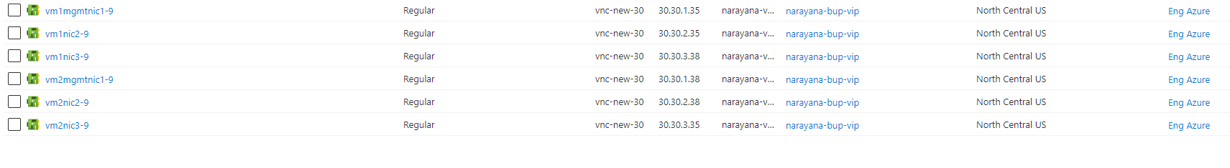

* 1. Subnets
     1. Expected Outcome: 3 subnets should get created.
     2. Actual Outcome: 3 subnets are created.

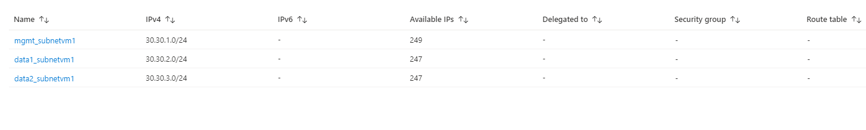

* 1. Virtual Network
     1. Expected Outcome: 1 virtual network should get created if not exists else present virtual network will be used.
     2. Actual Outcome: 1 virtual network is created name “vnc-new-30”.

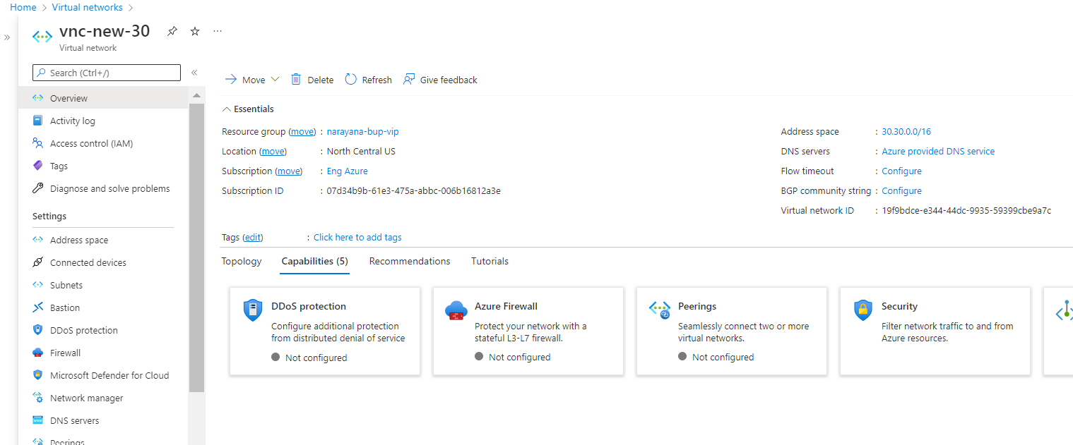

* 1. Public IP’s
     1. Expected Outcome: 6 public IP’s should get created according to user input.
     2. Actual Outcome:

6 public IP’s is created and attached to all interfaces.

* + - * 1. 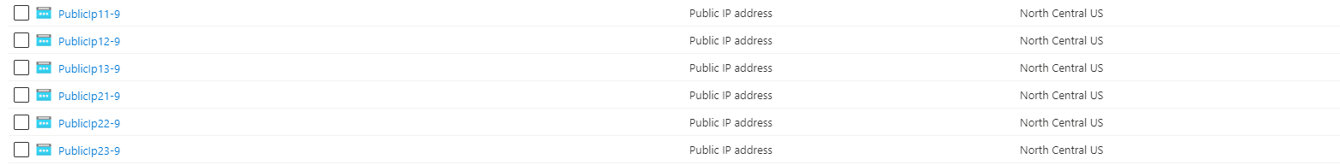
  1. NSGs
     1. Expected Outcome: 2 NSG should get created (1 for vm 1 and another for vm2 )
     2. Actual Outcome: 2 NSG is created and attached to VMs.

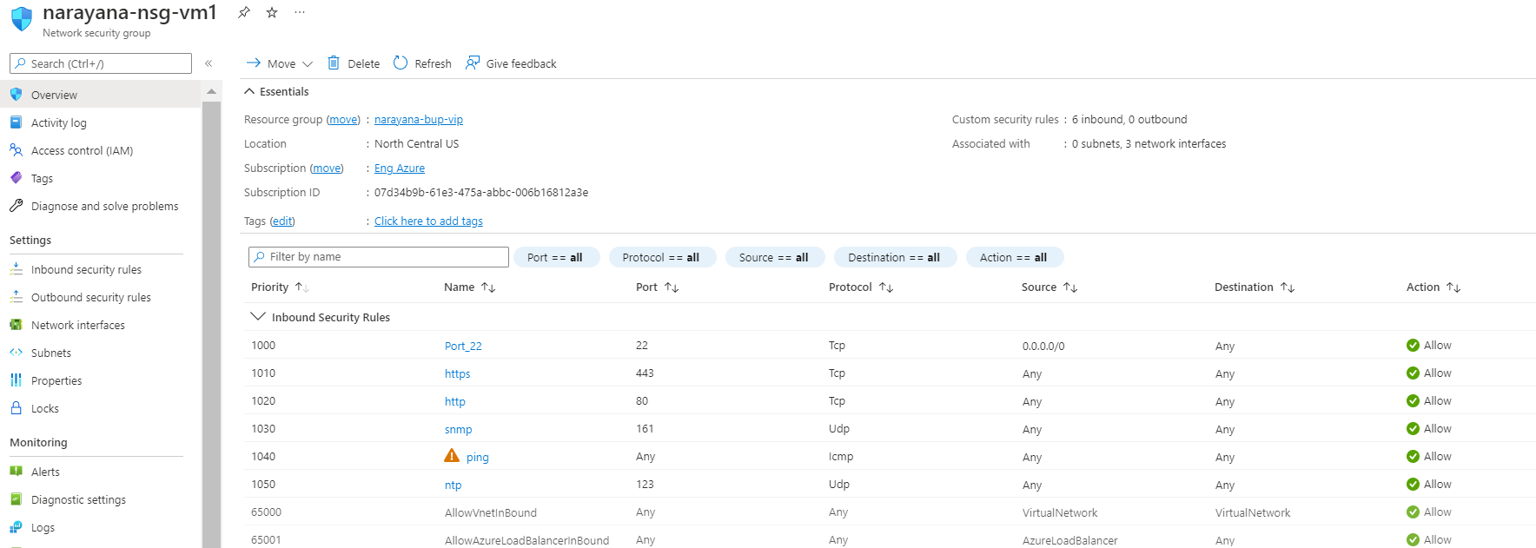

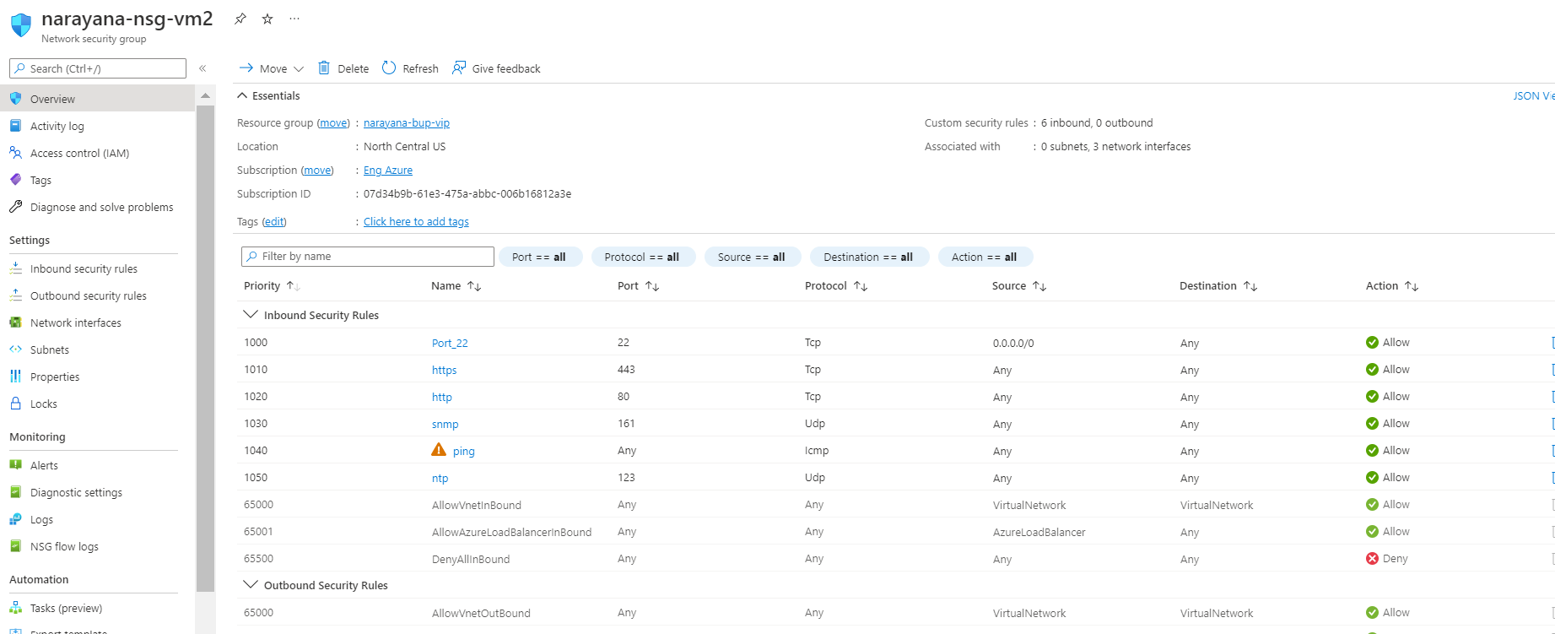

* 1. vThunder Instances
     1. Expected Outcome: 2 vThunder instances should get created having same configuration.
     2. Actual Outcome: 2 vThunder instances are created having same configuration.
        1. 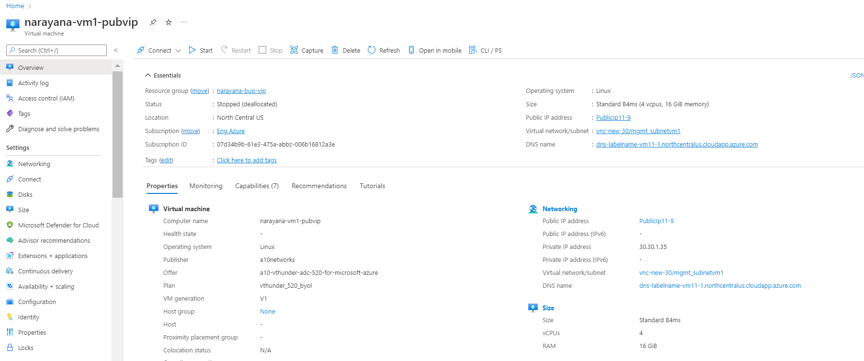
        2. 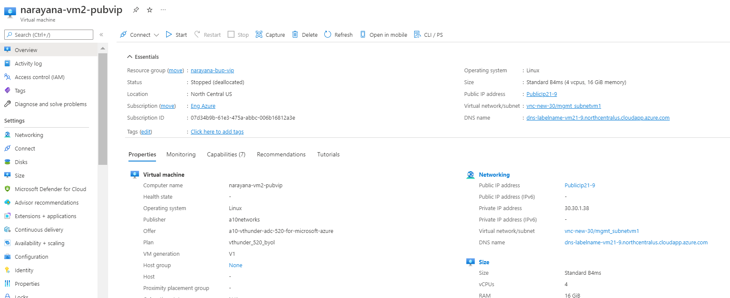

# PowerShell Template Input

* 1. Expected Inputs: resourceGroup, storageaccount, location, public IP’s for data interfaces
  2. Actual Inputs: resourceGroup, storageaccount, location, public IP’s for data interfaces

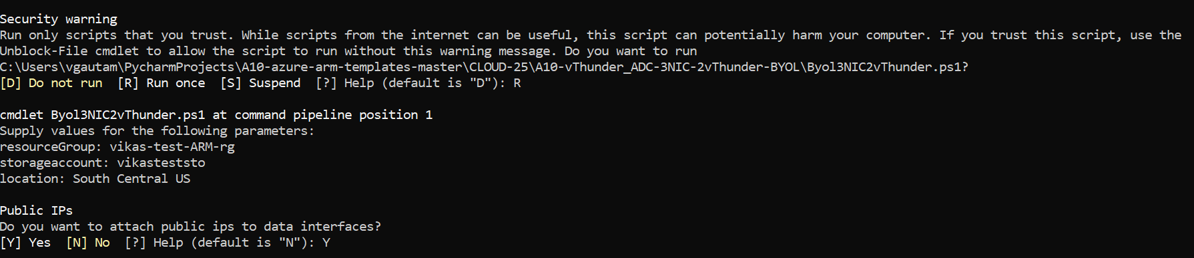

# PowerShell Template User Authentication

* 1. Expected Outcome: User should get pop up to get authenticated with Azure Portal
  2. Actual Outcome: User is getting pop up to get authenticated with Azure Portal
     1. 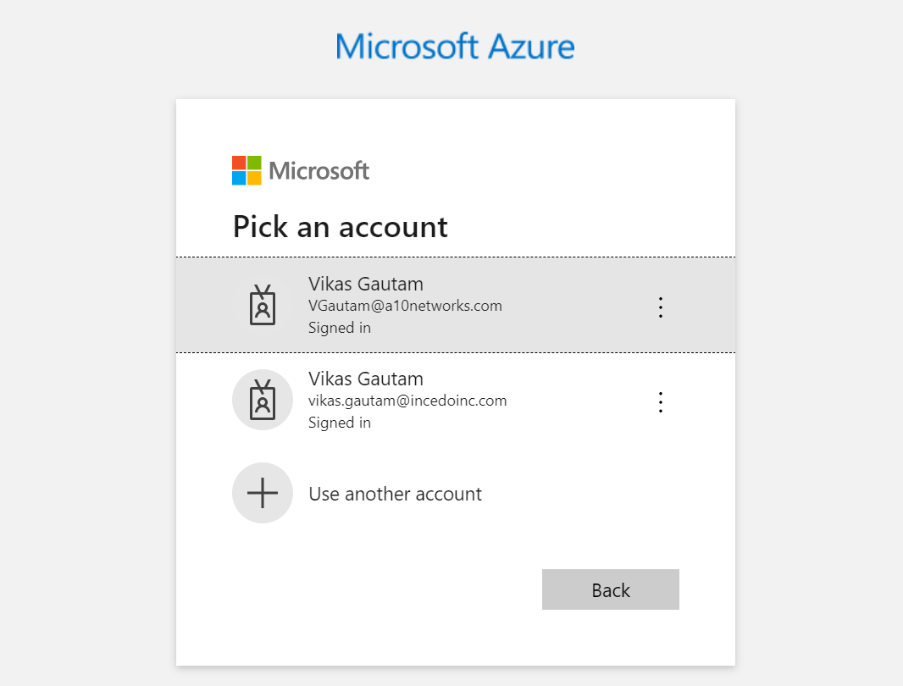

# vThunder IP Configuration

1. vThunder-1
   * 1. 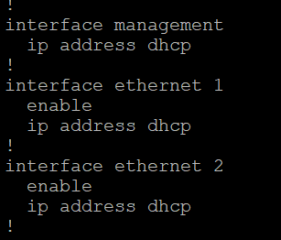
2. vThunder-2
   * 1. 

# vThunder SLB Configuration

## vThunder-1

* + 1. 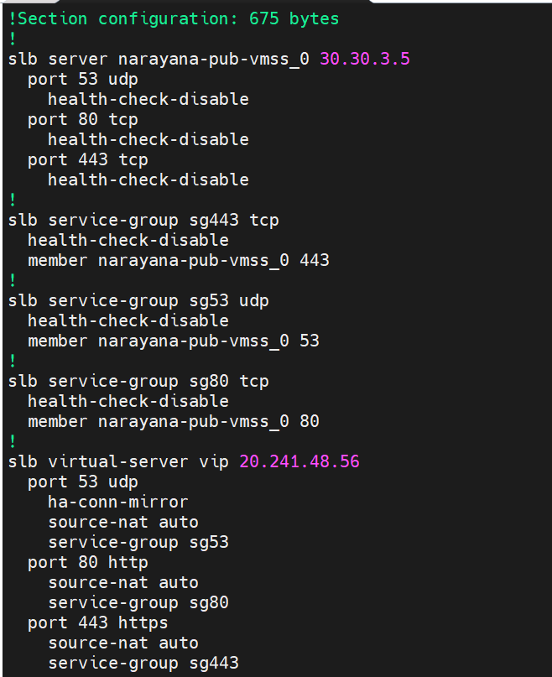

## vThunder-2

* + 1. 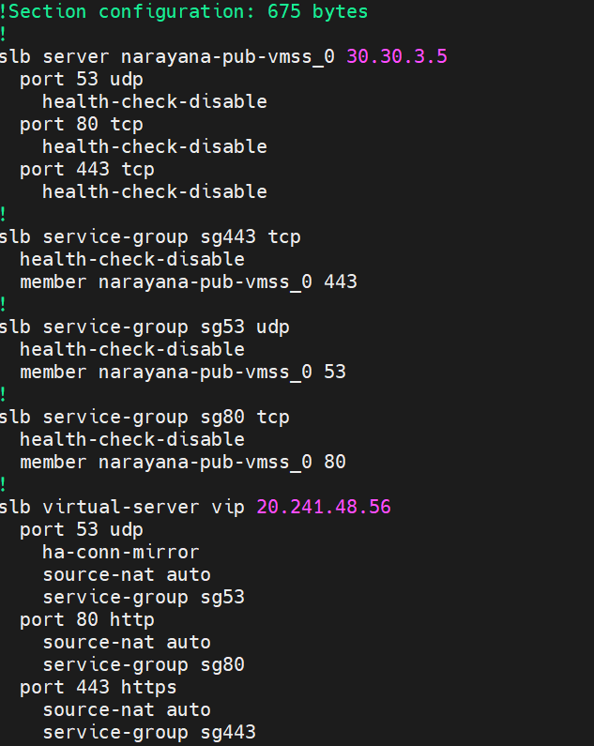

# vThunder SSL Configuration

## vThunder-1

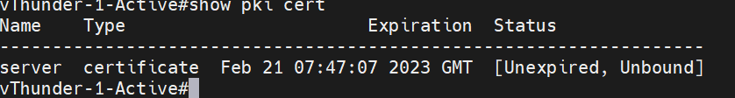

## vThunder-2

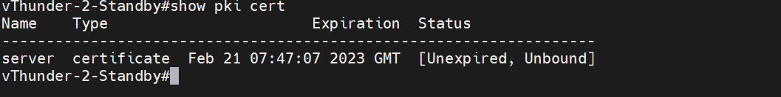

# vThunder HA Configuration

## vThunder-1

* + 1. 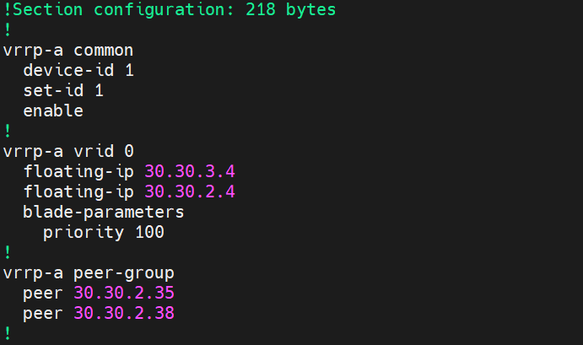

## vThunder-2

* + 1. 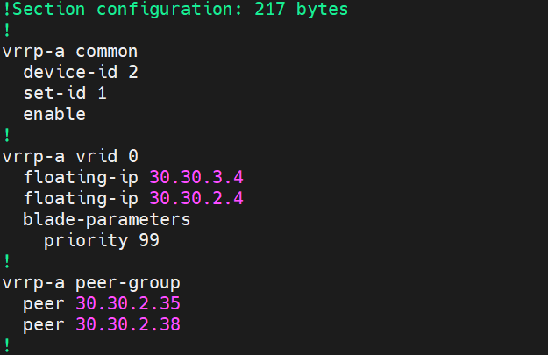

# vThunder DNS and IP Route Configuration

1. vThunder-1
   * 1. 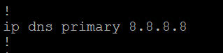
     2. 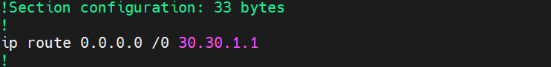
2. vThunder-2
   * 1. 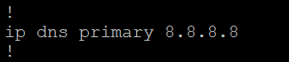
     2. 

# SLB Test Cases

## Case-1: Auto Scale VMSS (Addition of new servers)

1. Expected Outcome: Add new servers created on virtual machine scale set on both vThunders instances
2. Actual Outcome: New servers are added on vThunders SLB configuration.
   1. Current instances on VMSS
   2. 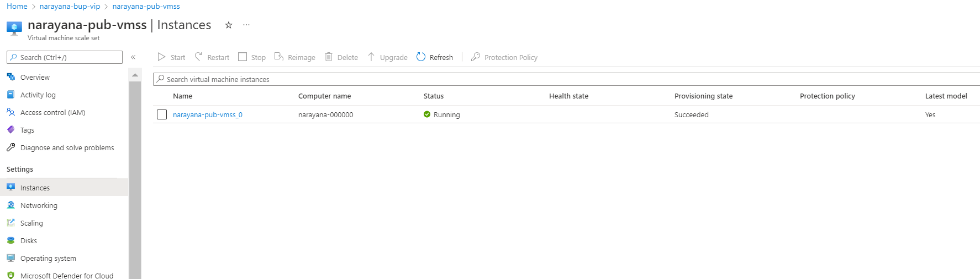
   3. SLB configuration on vThunder
   4. 
   5. After auto scale

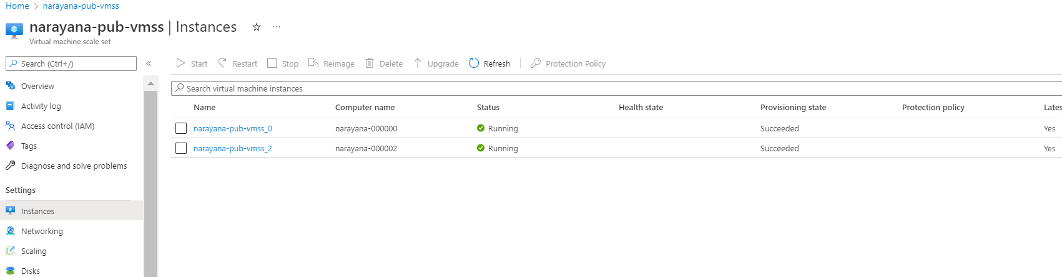

* 1. 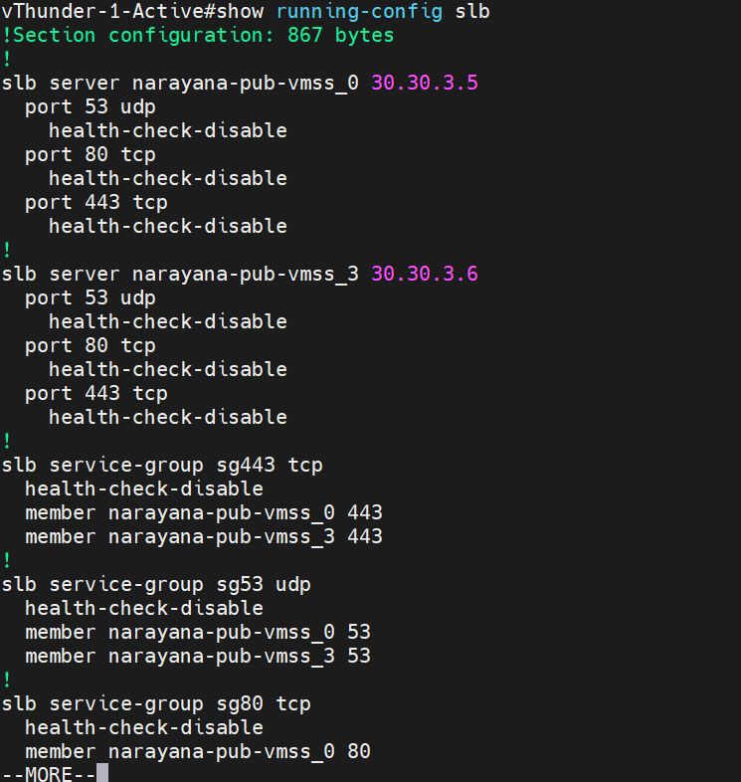

## Case-2: Auto Scale VMSS ( Delete servers)

1. Expected Outcome: Deleted servers should be removed from SLB configuration of both vThunders.
2. Actual Outcome: Deleted servers are removed from SLB configuration of both vThunders.
3. Current instances on VMSS
4. 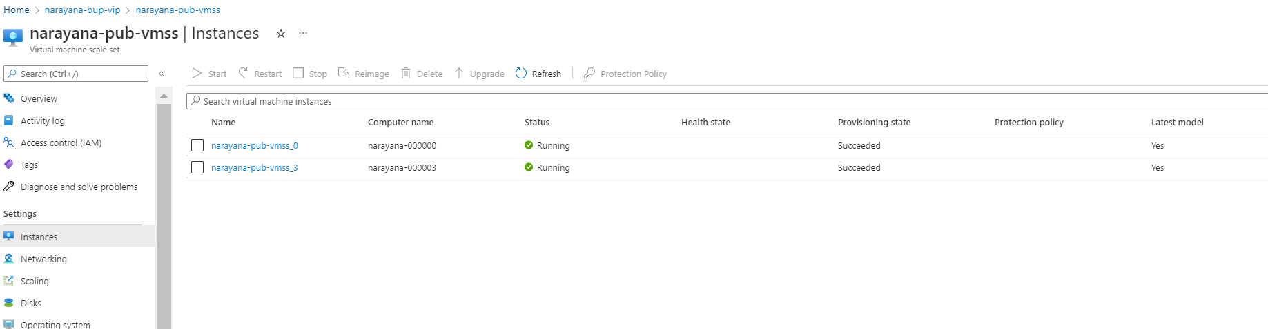
5. SLB configuration 
6. After deleting 1 servers

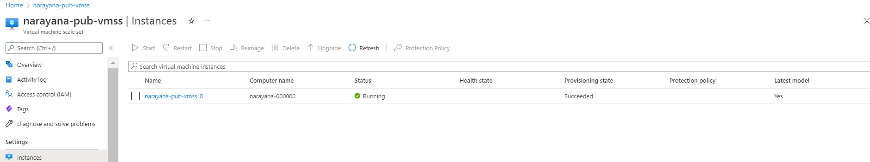

1. SLB configuration 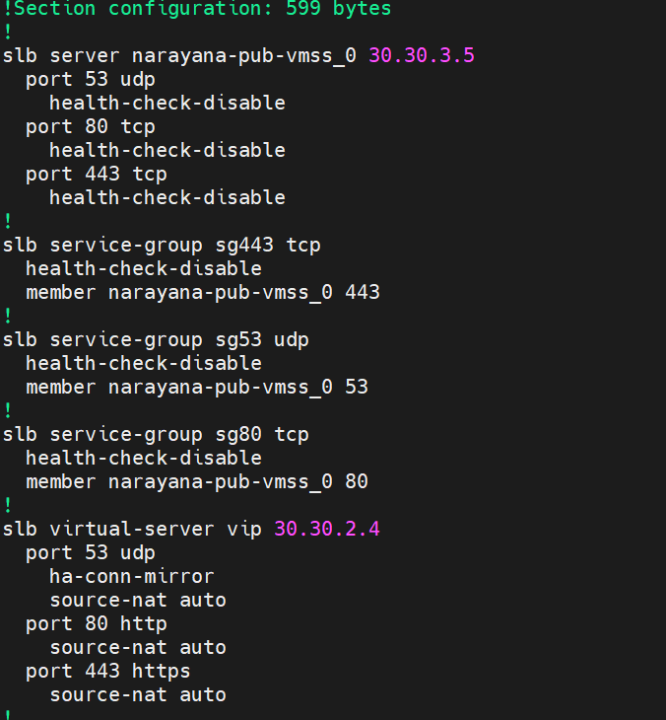

# HA Test Cases

## Without failover (vThunder-1 is in active and vThunder-2 is in standby mode)

* + 1. Expected Outcome: Active vThunder (master) will act as SLB and second vthunder will be on standby mode.
    2. Actual Outcome: Activate vThunder (master) is acting as SLB and second vthunder is on standby mode.
       1. Client VM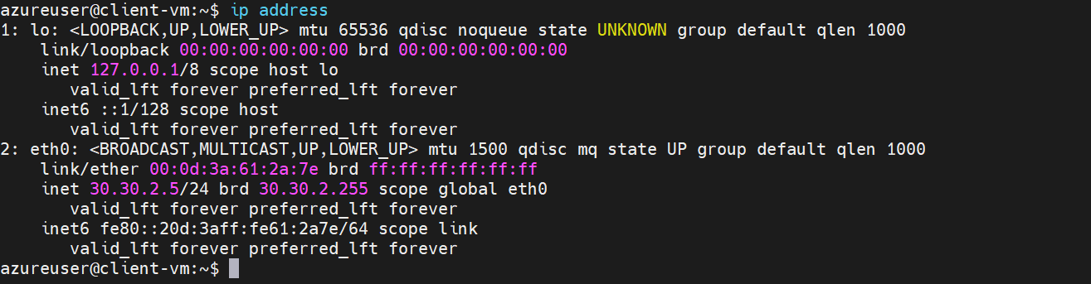
       2. Server VM 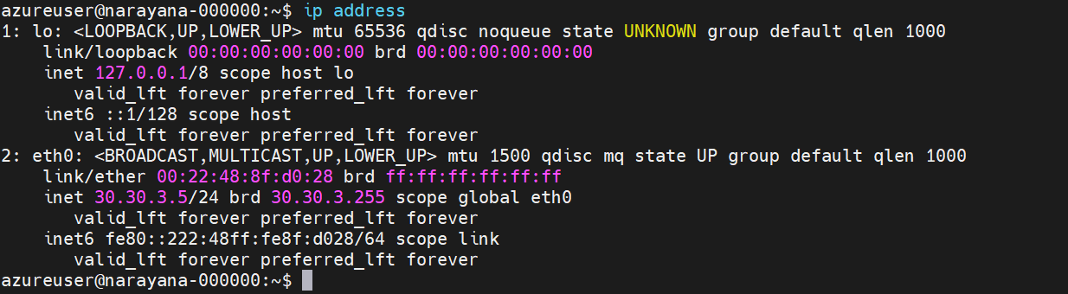
       3. Curl command for client vm to VIP
          1. Expected Outcome: Apache server running on server vm should be accessible from client vm using VIP. VIP should be present as a secondary IP in client side interface of vThunder-1 and FIP should be present as a secondary IP in server side interface of vThunder-2.
          2. Actual Outcome: Apache server running on server vm is accessible from client vm using VIP. VIP is present in client side interface and FIP is present in server side interface.

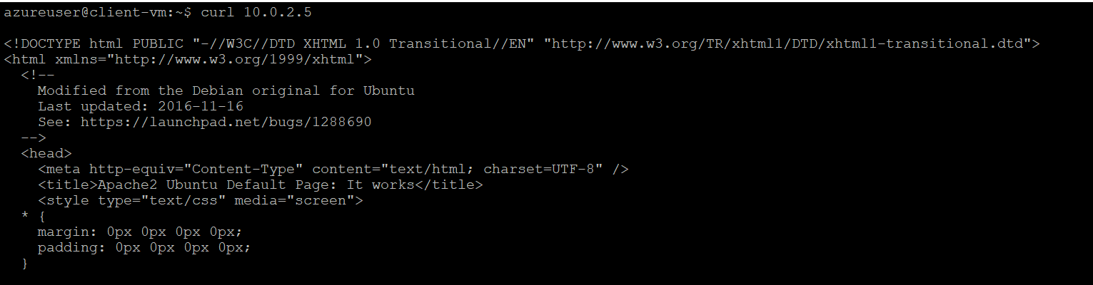

30.30.2.4

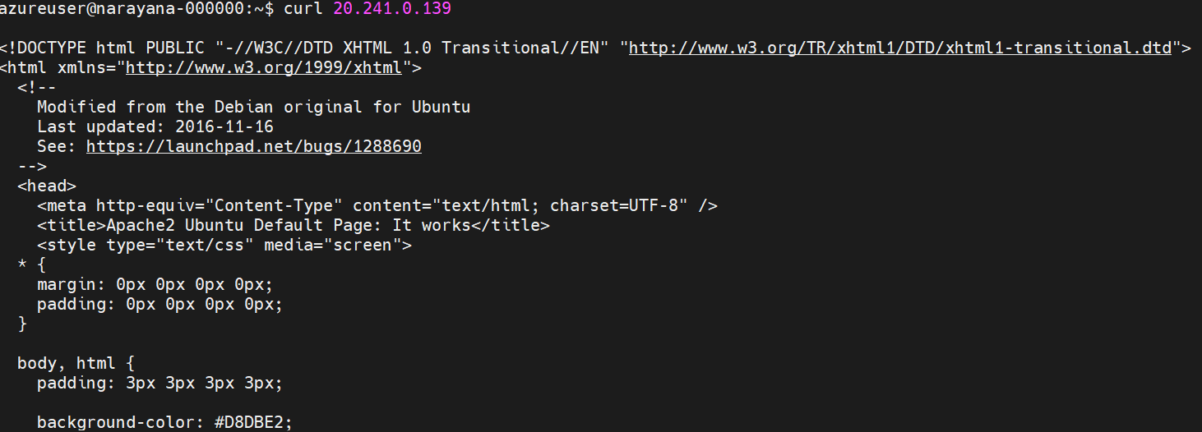

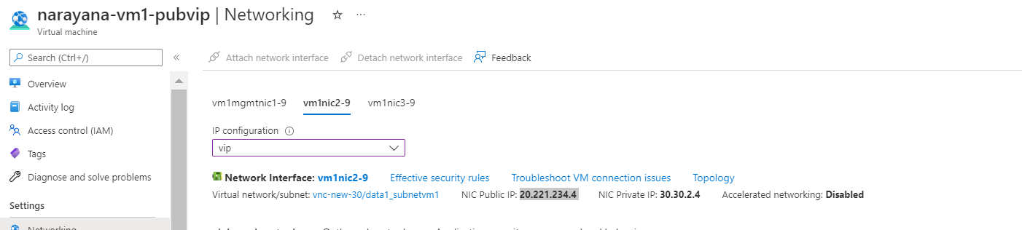

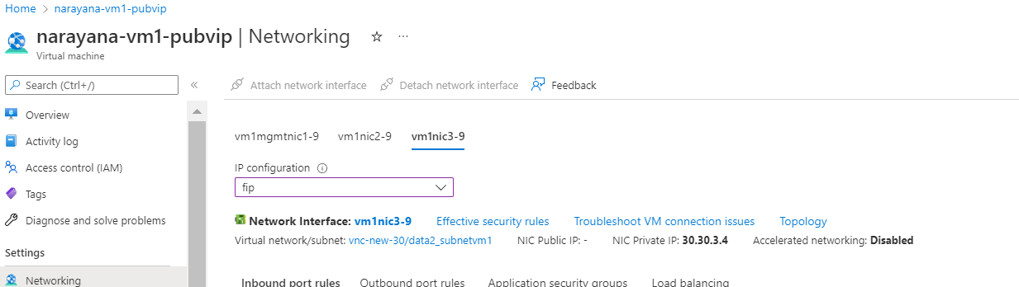

## vThunder-1 goes on standby mode

* + 1. Expected Outcome: vThunder-2 will become active and VIP and FIP attached to vThunder-1 will be attached to vthunder-2. Client vm should be able to access Apache server running on server vm using VIP.
    2. Actual Outcome: vThunder-2 is active. VIP and FIP attached to vThunder-1 are attached to vthunder-2. Client vm is able to curl Apache server using VIP.

VIP 30.30.2.4 should switch from vthunder 1 to vthunder 2

FIP 30.30.3.4 should switch from vthunder 1 to vthunder 2

* + - 1. Curl command from client vm to server vm



30.30.2.4



* + - 1. vThunder-1 state

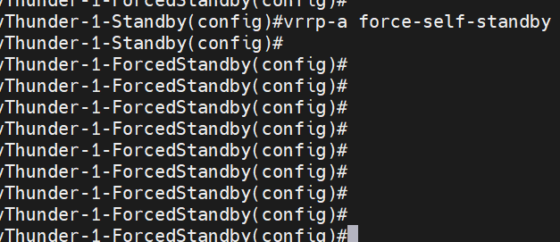

* + - 1. vThunder-2 state

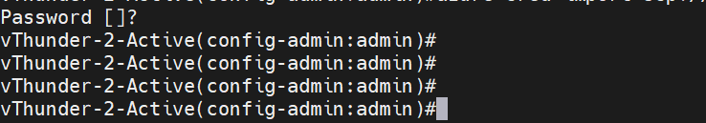

## vThunder-1 again become active

* + 1. Expected Outcome: VIP and FIP from vthunder-2 will be detached and attached to vthunder-1. Client vm should be able to curl Apache server running on server vm using VIP.
    2. Actual Outcome: VIP and FIP from vthunder-2 is detached and attached to vthunder-1. Client vm is able to curl Apache server running on server vm using VIP.
       1. VIP in vThunder-1 client side interface 
       2. FIP in vThunder-1 server side interface 
       3. vThunder-1 state 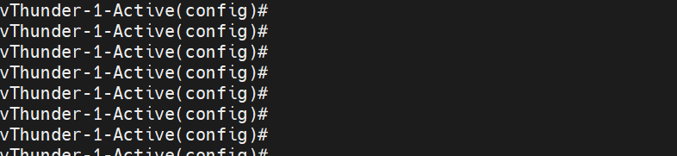
       4. vThunder-2 state 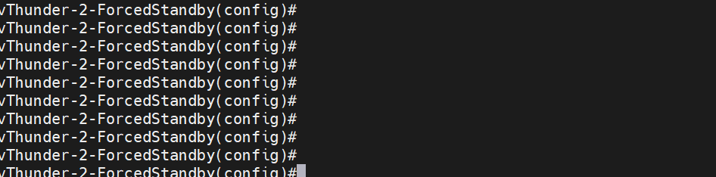
       5. Curl command from client vm



30.30.2.4



## vThunder-1 and vThunder-2 both are on standby mode

* + 1. Expected Outcome: VIP and FIP will remain where it was. Client vm will not able to reach Apache server running on server vm.
    2. Actual Outcome: VIP and FIP is remained where it was. Client vm is not able to reach Apache server running on server vm.
       1. vThunder-1 state 
       2. vThunder-2 state 

# PS Template – 3 NIC 2 vThunder HA GLM Test Cases

## License Activation

### Activate license

* + 1. Expected Outcome: license will be activated if not activated.
    2. Actual Outcome: license will be activated if not activated.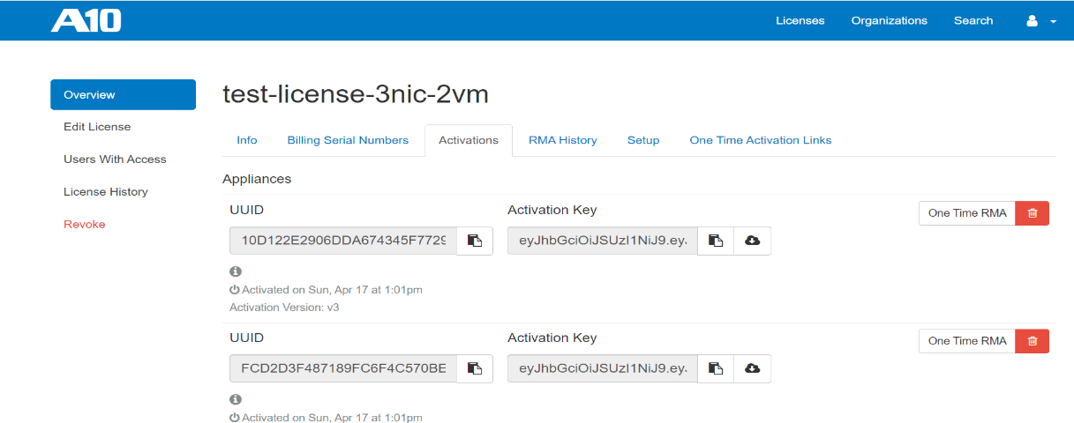

### Apply GLM license

* + 1. Expected Outcome: license will be applied on vthunder
    2. Actual Outcome: license will be applied on vthunder

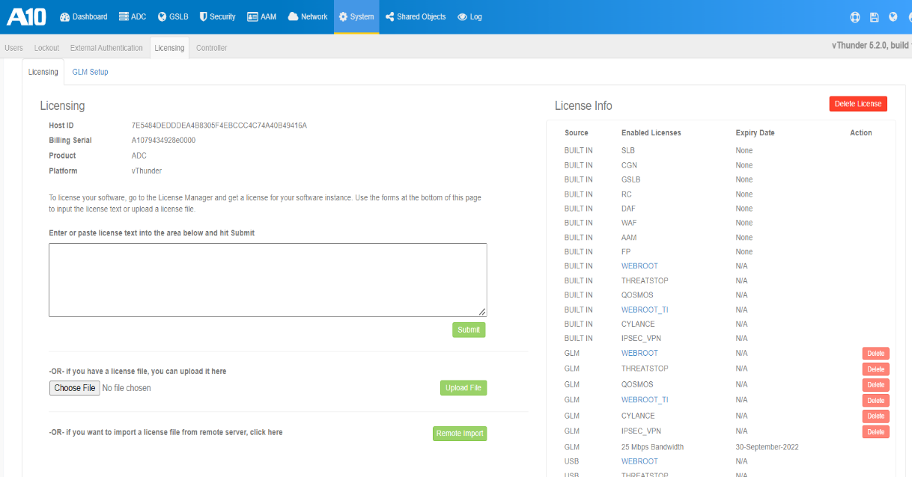

### Set GLM configuration

* + 1. Expected Outcome: primary dns, vthunder entitlement token will be set and glm management port, enable request will be set with value 1
    2. Actual Outcome: primary dns, vthunder entitlement token will be set and glm management port, enable request will be set with value 1

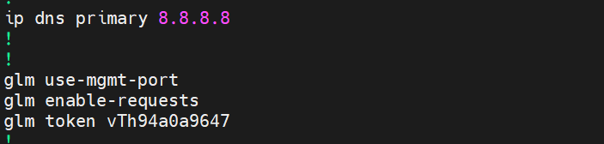

# Automation Account Test Cases

1. Expected Outcome: User should get pop up to get authenticated with Azure Portal
2. Actual Outcome: User is getting pop up to get authenticated with Azure Portal

1. Automation Account

1. Expected Outcome: Automation account should get created if not exists else existing resource group will be used.

2.Actual Outcome:

* + 1. New resource group name “automation-account” is created when it was not present.

1. Automation Account Variables
2. Expected Outcome: Automation account variables should get created if not exists else it will give “already exit error”
3. Actual Outcome:

# Log Outputs

Expected Outcome: Runbook errors should be logged, and user should be able to see error output.

Actual Outcome: Runbook errors are registered as an error and displayed to user as a output and error.

