CFT Template – 2 NIC 1 vThunder Instance SLB-SSL Dev Test Report

Contents

Resource Creation 1

Stack 1

Interfaces 2

Subnets 3

Virtual Network 3

Security Group 4

vThunder Instances 6

Public Ip 6

Internet Gateway 7

vThunder IP Configuration 7

Slb verification 7

SSL verification 8

Traffic Testing 9

# 

# Resource Creation

## Stack

Expected outcome: one stack should get created with all resources needed.

Actual outcome: one stack is created with all resources needed.

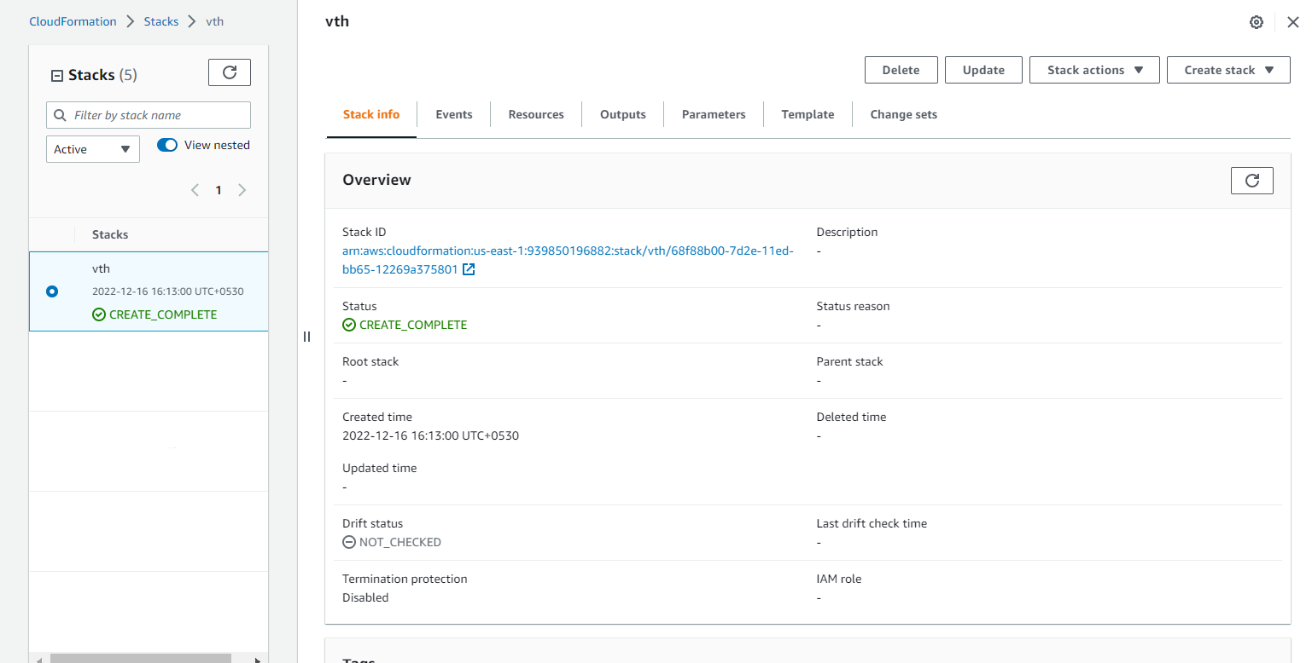

## Interfaces

* Expected Outcome: 2 interfaces (1 management, 1 data interfaces) should get created and each interface is from different subnet.
* Actual Outcome: 2 interfaces are created and attached to ec2 instance.
  + 1. Management Interface

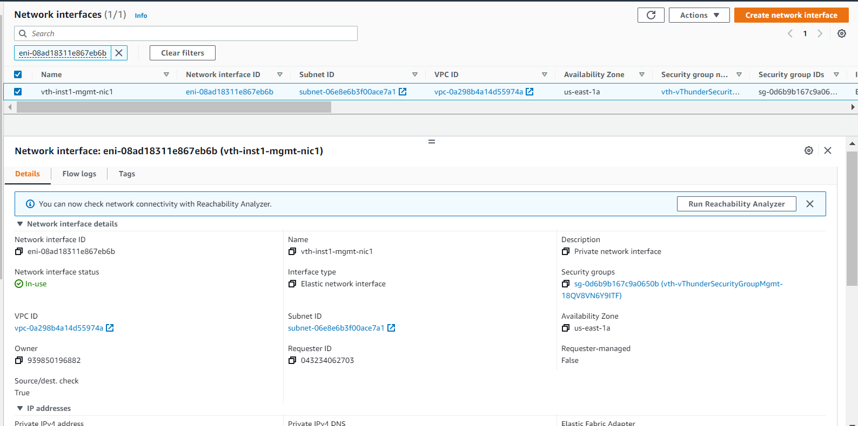

* + 1. Data Interface

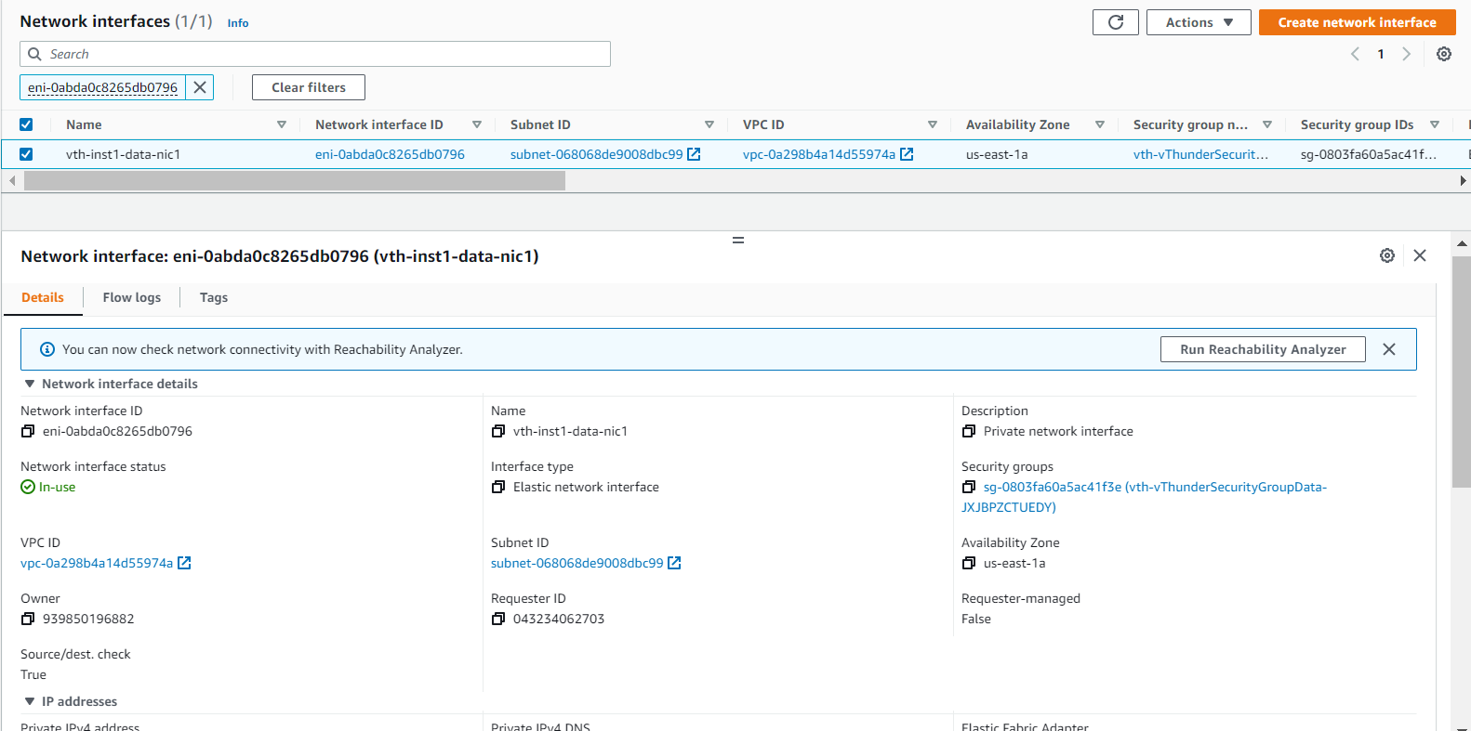

## Subnets

* Expected Outcome: 2 subnets should get created.
* Actual Outcome: 2 subnets are created.

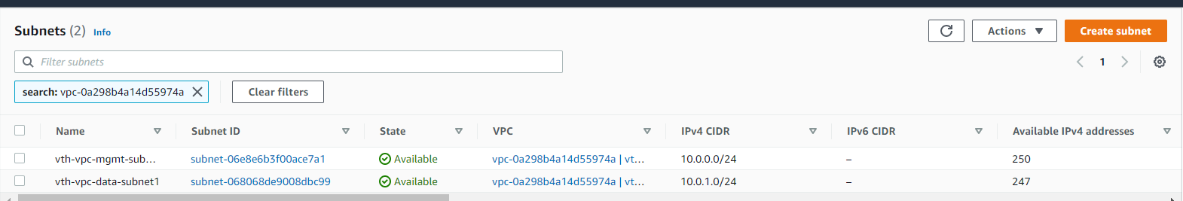

## Virtual Network

* Expected Outcome: 1 virtual network should get created if not exists else present virtual network will be used.
* Actual Outcome: 1 virtual network is created.

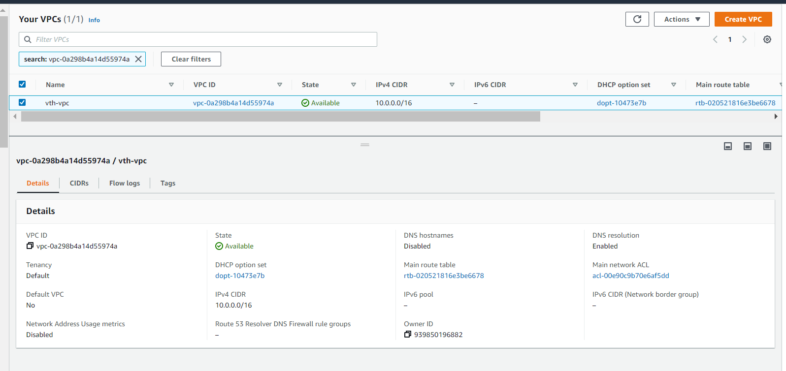

## Security Group

* Expected Outcome: 2 Security Group should get created.
* Actual Outcome: 2 Security Group is created and attached to VMs.

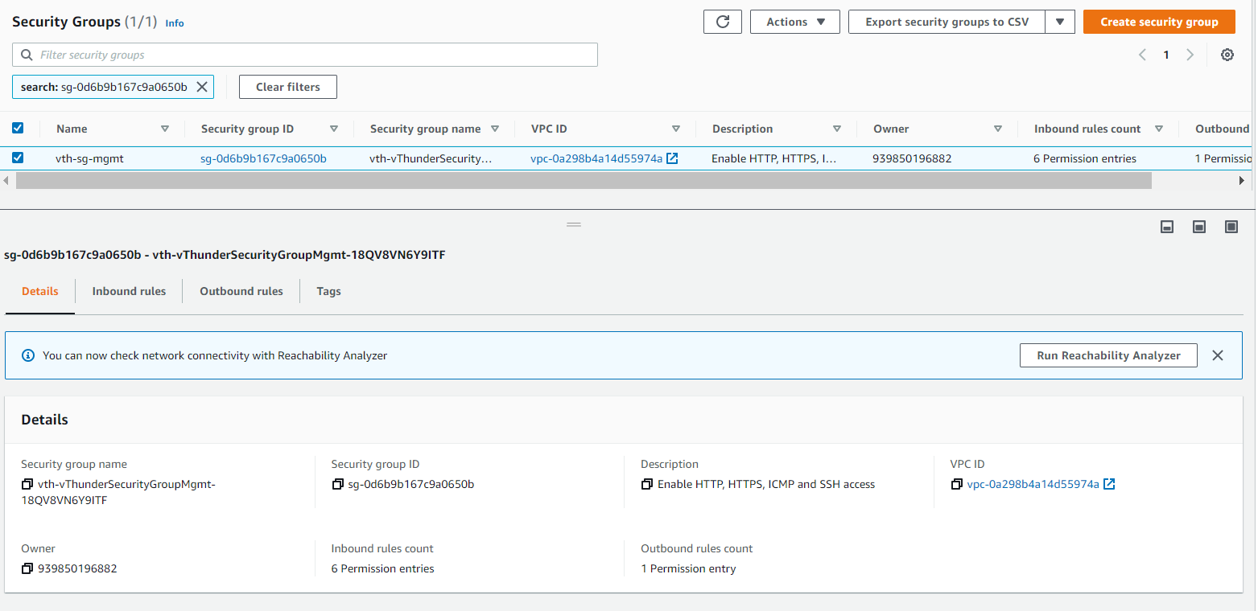

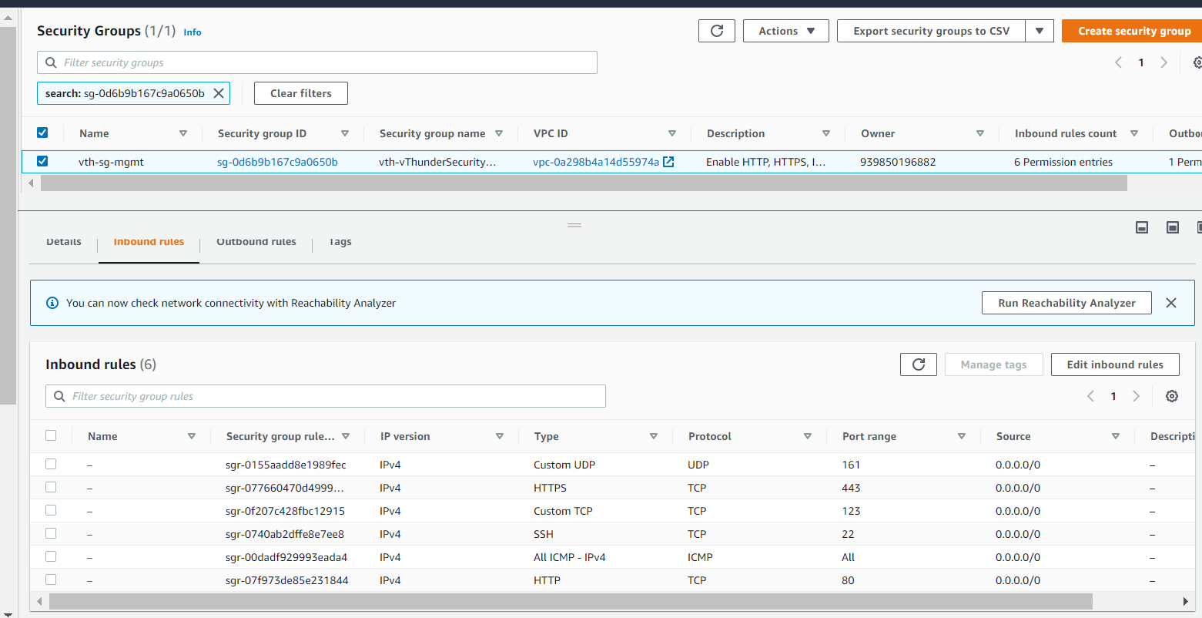

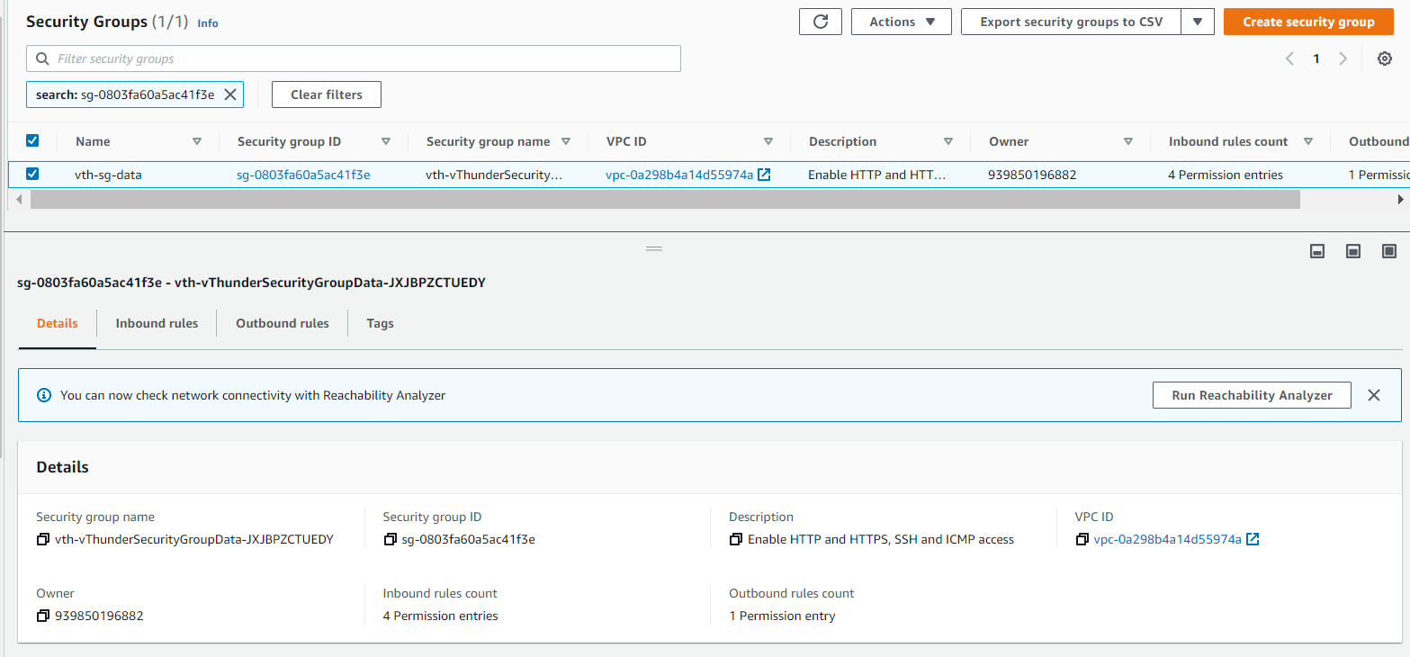

## 

## vThunder Instances

* Expected Outcome: 1 vThunder instances should get created having given configuration.
* Actual Outcome: 1 vThunder instances are created having given configuration.

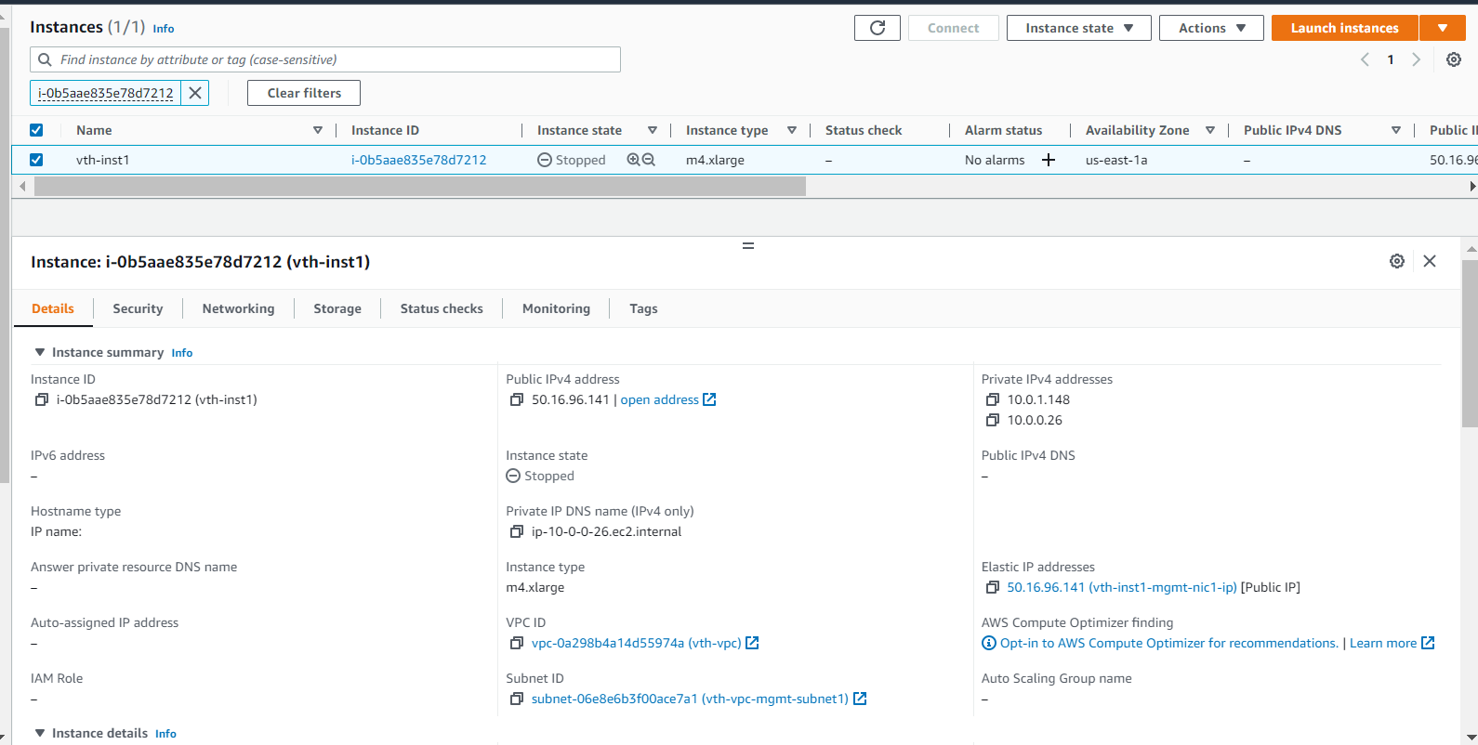

## Server

* Expected Outcome: 1 server instance should get created.
* Actual Outcome: 1 server instance are created.

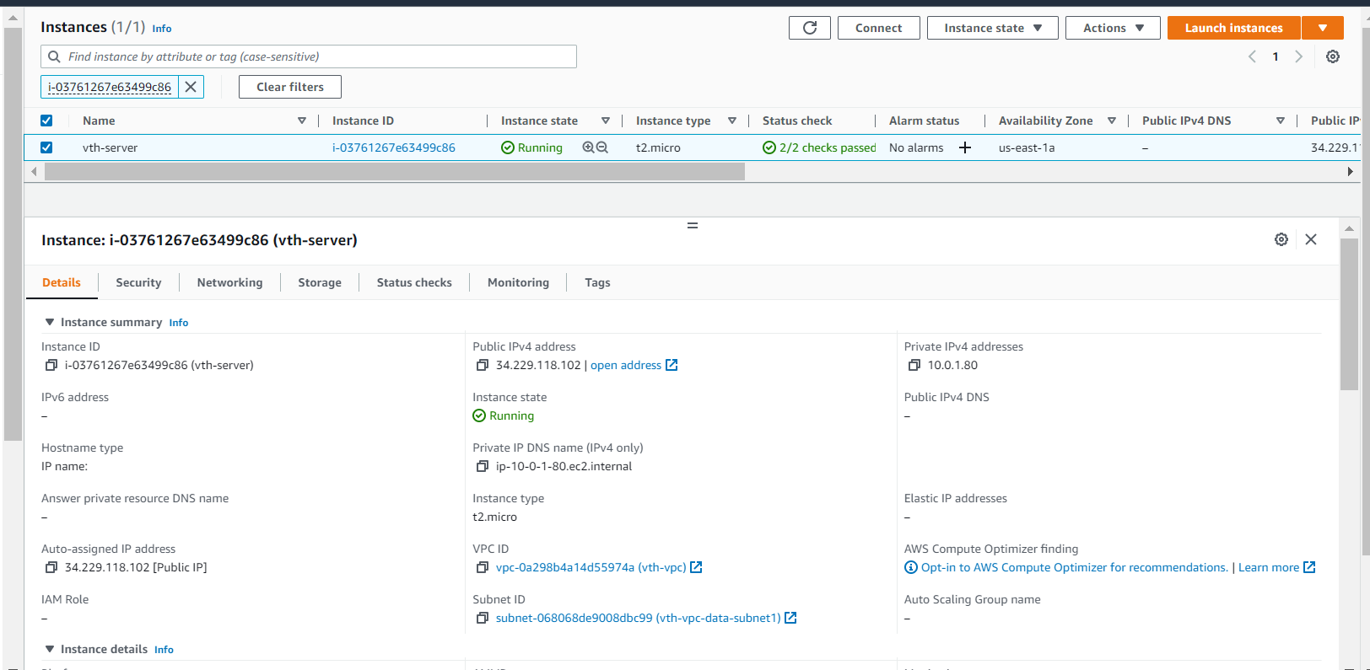

## Public Ip

* Expected Outcome: 1 public ip should get created.
* Actual Outcome: 1 public ip is created and attached to first interfaces.

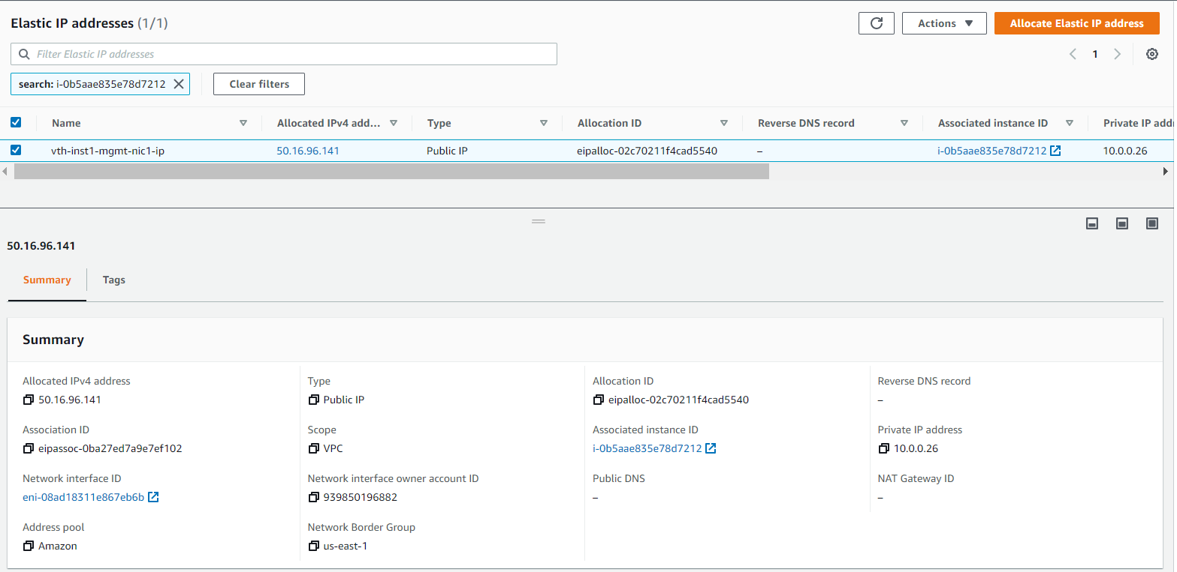

## 

## Internet Gateway

* Expected outcome: one internet gateway should be created
* Actual outcome: one internet gateway is created.

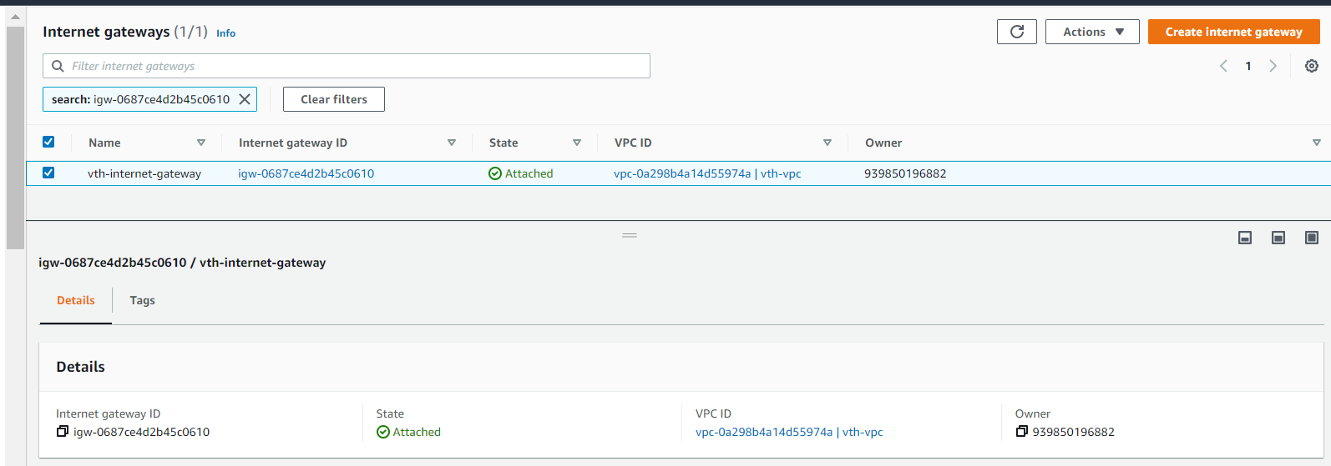

# vThunder IP Configuration

### Slb verification

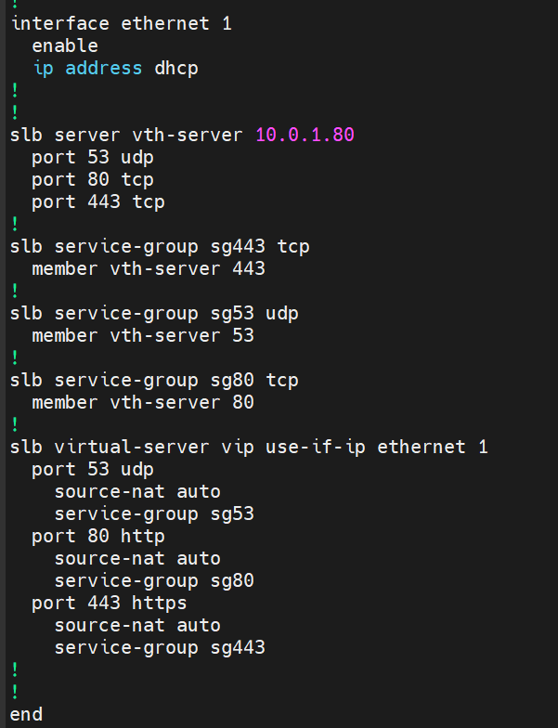

### SSL verification

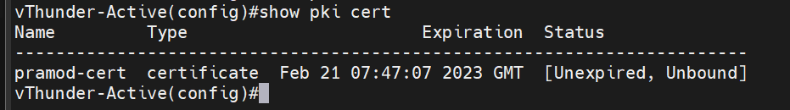

### Traffic Testing

