CFT Template – 3 NIC 2 vThunder HA, GLM PUBLIC VIP Backend AutoScale Test Cases

Contents

Resource Creation 2

vThunder IP Configuration 5

vThunder SLB Configuration 7

vThunder-1 7

vThunder-2 8

vThunder SSL Configuration 9

vThunder-1 9

vThunder-2 9

vThunder HA Configuration(* ) 9

vThunder-1 9

vThunder-2 10

vThunder DNS and IP Route Configuration 10

SLB Test Cases 11

Case-1: Auto Scale VMSS (Addition of new servers) 11

Case-2: Auto Scale VMSS ( Delete servers) 12

HA Test Cases 13

Without failover (vThunder-1 is in active and vThunder-2 is in standby mode) 13

vThunder-1 goes on standby mode 15

# Resource Creation

* 1. Resource Stack
     1. Expected Outcome: 1 resource stack with 32 resources should get created.
     2. Actual Outcome:

1 resource stack (vth-auto-test) with 32 resources get created.

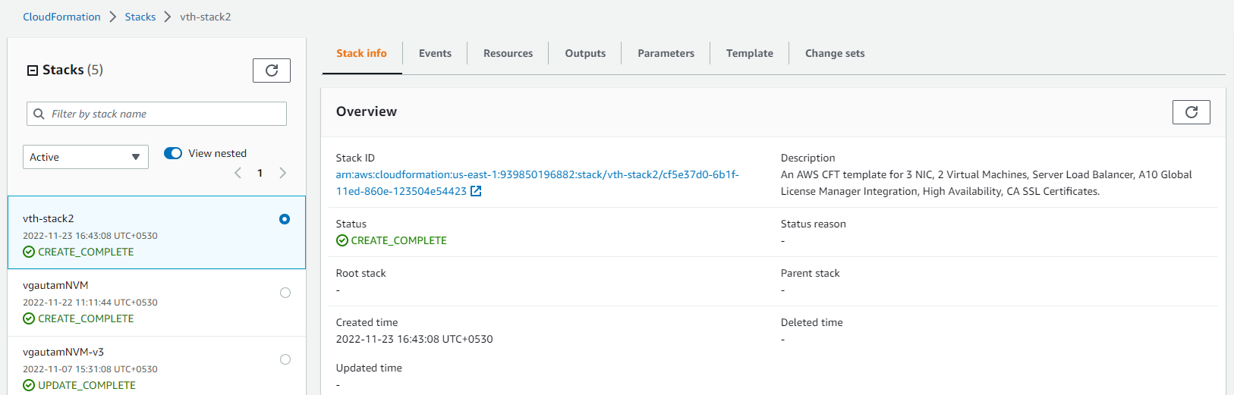

* 1. S3 Bucket
     1. Expected Outcome: 1 S3 Bucket should get created with name “vth-cft-backend-auto-bucket” and object should be there in it.
     2. Actual Outcome:

1 S3 Bucket gets created with name “vth-cft-backend-auto-bucket” and object is there in it.

* 1. Interfaces
     1. Expected Outcome: 6 interfaces (2 management, 4 data interfaces) should get created.
     2. Actual Outcome: 6 interfaces are created and attached to VMs.

* 1. Subnets
     1. Expected Outcome: 3 subnets should get created.
     2. Actual Outcome: 3 subnets are created.

* 1. Virtual Network
     1. Expected Outcome: 1 virtual network should get created
     2. Actual Outcome: 1 virtual network is created name “vth-vpc”.

* 1. Public IP’s
     1. Expected Outcome: 3 public ip’s should get created.
     2. Actual Outcome:

3 public ip’s should are created

* 1. Security Group
     1. Expected Outcome: 2 Security group should get created.
     2. Actual Outcome: 2 Security group gets created

* 1. vThunder Instances
     1. Expected Outcome: 2 vThunder instances should get created having same configuration.
     2. Actual Outcome: 2 vThunder instances are created having same configuration.

* 1. AutoScaling Group
     1. Expected Outcome:1 AutoScaling group should get created.
     2. Actual Outcome: 1 AutoScaling group is created
  2. EventBridge
     1. Expected Outcome:1 Eventbridge should get created.
     2. Actual Outcome: 1 Eventbridge get created.

* 1. Lambda Function
     1. Expected Outcome:1 lambda function should get created.
     2. Actual Outcome: 1 lambda function is created.

# 

# vThunder IP Configuration

1. vThunder-1

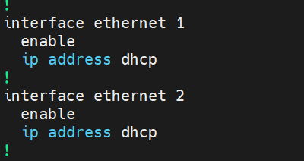

1. vThunder-2

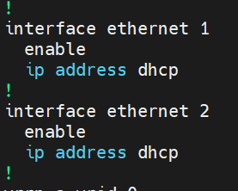

# vThunder SLB Configuration

## vThunder-1

## vThunder-2

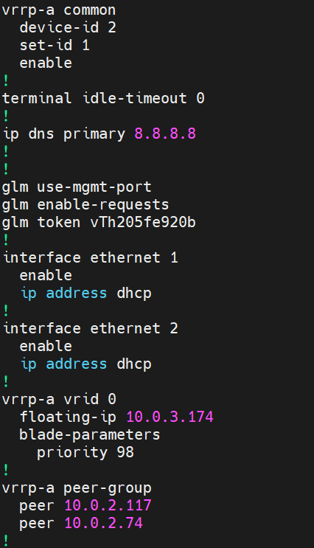

# vThunder SSL Configuration

## vThunder-1

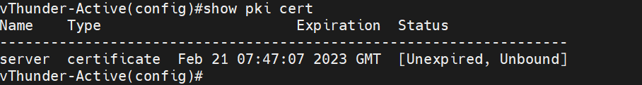

## vThunder-2

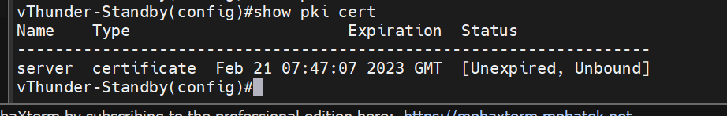

# vThunder HA Configuration(* )

## vThunder-1

## vThunder-2

# vThunder DNS and IP Route Configuration

1. vThunder-1
   * 1. 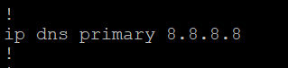
     2. Text

        Description automatically generated with medium confidence
2. vThunder-2
   * 1. 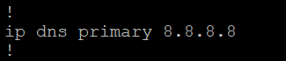
     2. Text

        Description automatically generated with medium confidence

# SLB Test Cases

## Case-1: Auto Scale VMSS (Addition of new servers)

1. Expected Outcome: Add new servers created on virtual machine scale set on both vThunders instances
2. Actual Outcome: New servers are added on vThunders SLB configuration.

Existing Configuration vThunder 1:

After Autoscale vThunder 1:

Existing configuration Vthunder 2:

After Autoscaling Vthunder 2:

## Case-2: Auto Scale VMSS ( Delete servers)

1. Expected Outcome: Deleted servers should be removed from SLB configuration of both vThunders.
2. Actual Outcome: Deleted servers are removed from SLB configuration of both vThunders.
3. Current instances on VMSS

SLB configuration

1. After deleting 1 servers [vThunder 1]

1. After deleting 1 servers [vThunder 2]

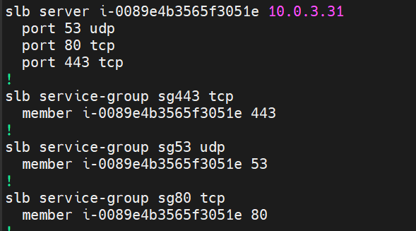

# HA Test Cases

## Without failover (vThunder-1 is in active and vThunder-2 is in standby mode)

* + 1. Expected Outcome: Active vThunder (master) will act as SLB and second vthunder will be on standby mode.
    2. Actual Outcome: Activate vThunder (master) is acting as SLB and second vthunder is on standby mode.

vth-inst1 is in active mode (with FIP and VIP attached)

vth-inst2 is in standby mode (no FIP and VIP attached)

vThunder 1:

vThunder2:

Curl command for client vm to VIP

1)Expected Outcome: Apache server running on server vm should be accessible from client vm using VIP. VIP should be present as a secondary IP in client side interface of vThunder-1 and FIP should be present as a secondary IP in server side interface of vThunder-2.

2)Actual Outcome: Apache server running on server vm is accessible from client vm using VIP. VIP is present in client side interface and FIP is present in server side interface.

Curl command for client vm to Public IP

1)Expected Outcome: Apache server running on server vm should be accessible from client vm using Elastic IP address of Data NIC of vThunder-1

2)Actual Outcome: Apache server running on server vm is accessible from client vm using Elastic IP address of Data NIC of vThunder-1.

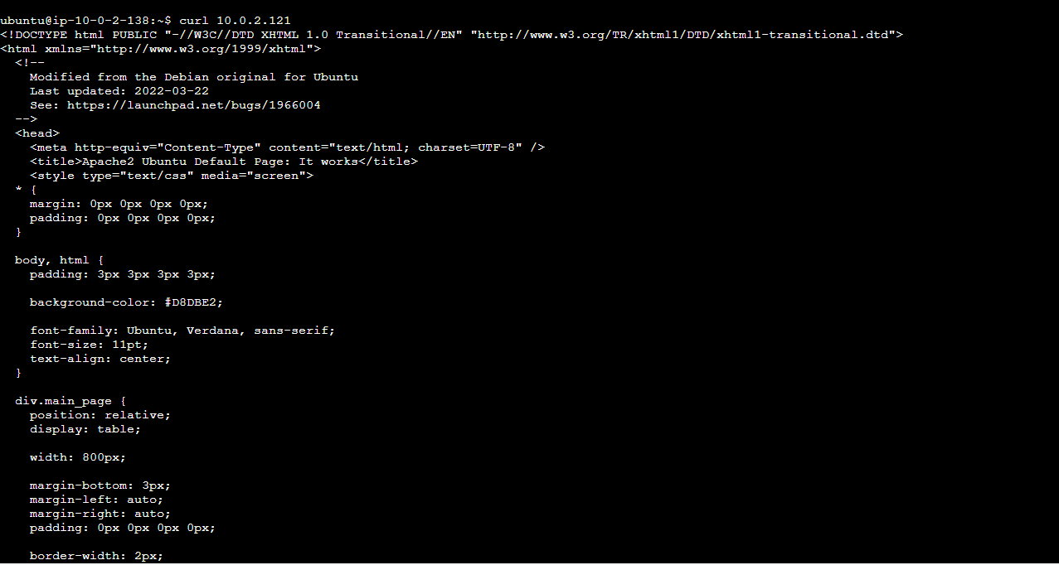

## vThunder-1 goes on standby mode

* + 1. Expected Outcome: vThunder-2 will become active and VIP and FIP attached to vThunder-1 will be attached to vthunder-2. Client vm should be able to access Apache server running on server vm using VIP.
    2. Actual Outcome: vThunder-2 is active. VIP and FIP attached to vThunder-1 are attached to vthunder-2. Client vm is able to curl Apache server using VIP.

VIP should switch from vthunder 1 to vthunder 2

FIP should switch from vthunder 1 to vthunder 2

vThunder-1 state

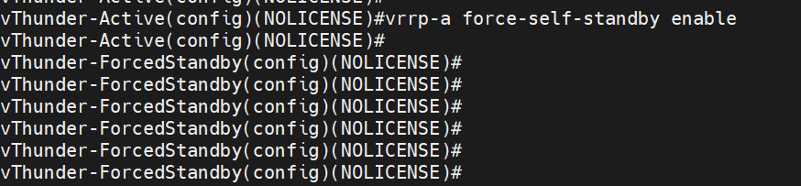

vThunder-2 state

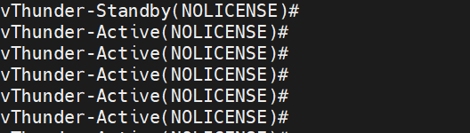

Traffic Test after we stop the active vThunder and then standby will be active:

Traffic Testing after VIP and FIP change from vThunder1 to vThunder2.

