AWS Template – 3 NIC 2 vThunder HA Instances Dev Testing

Table of Contents

Resource Creation 2

Resource Stack 2

Interfaces 2

Subnets 2

Virtual Network 3

Public Ips 3

NSGs 4

vThunder Instances 7

vThunder Networking Configuration on AWS 8

vThunder-1 8

Management Interface 8

Data Interface (Client Side) 9

Data Interface (Server Side) 9

vThunder-2 10

Management Interface 10

Data Interface (Client Side) 10

Data Interface (Server Side) 11

vThunder IP Configuration 11

Slb verification 11

SSL verification 13

HA verification 13

# Resource Creation

## Resource Stack

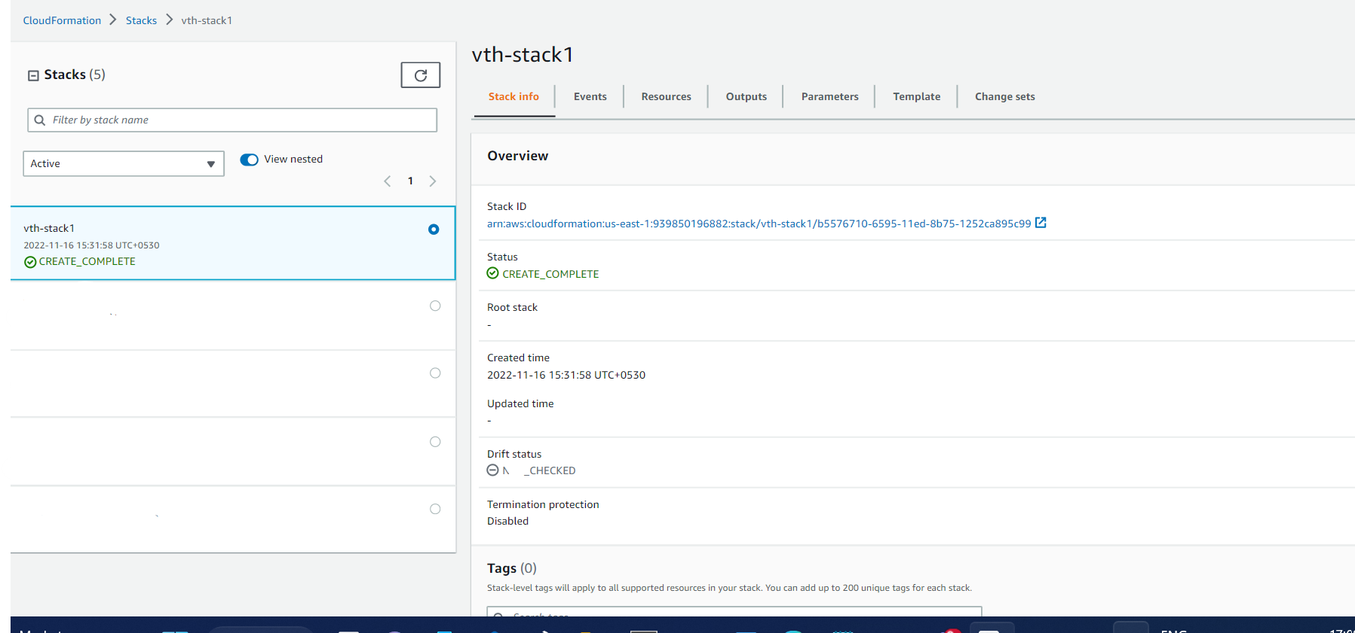

## Interfaces

* Expected Outcome: 7 interfaces (2 management, 4 data interfaces and one server ) should get created, and each interface is from different subnet.
* Actual Outcome: 6 interfaces are created and attached to VMs.

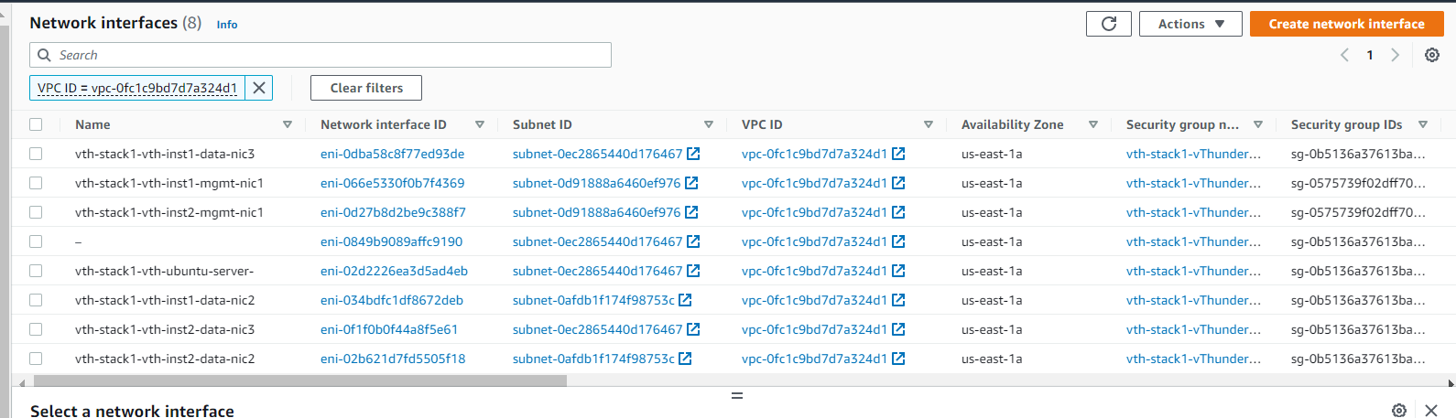

## Subnets

* Expected Outcome: 3 subnets should get created.
* Actual Outcome: 3 subnets are created.

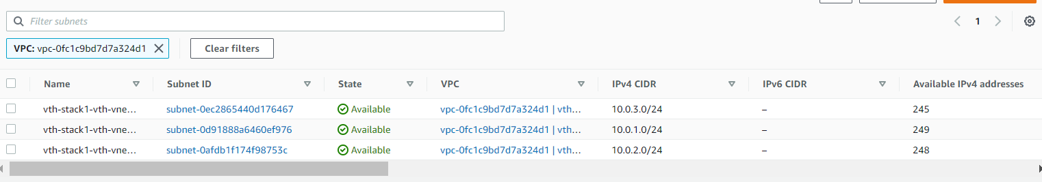

## Virtual Network

* Expected Outcome: 1 virtual network should get created if not exists else present virtual network will be used.
* Actual Outcome: 1 virtual network is created name “vThunder-VPC”.

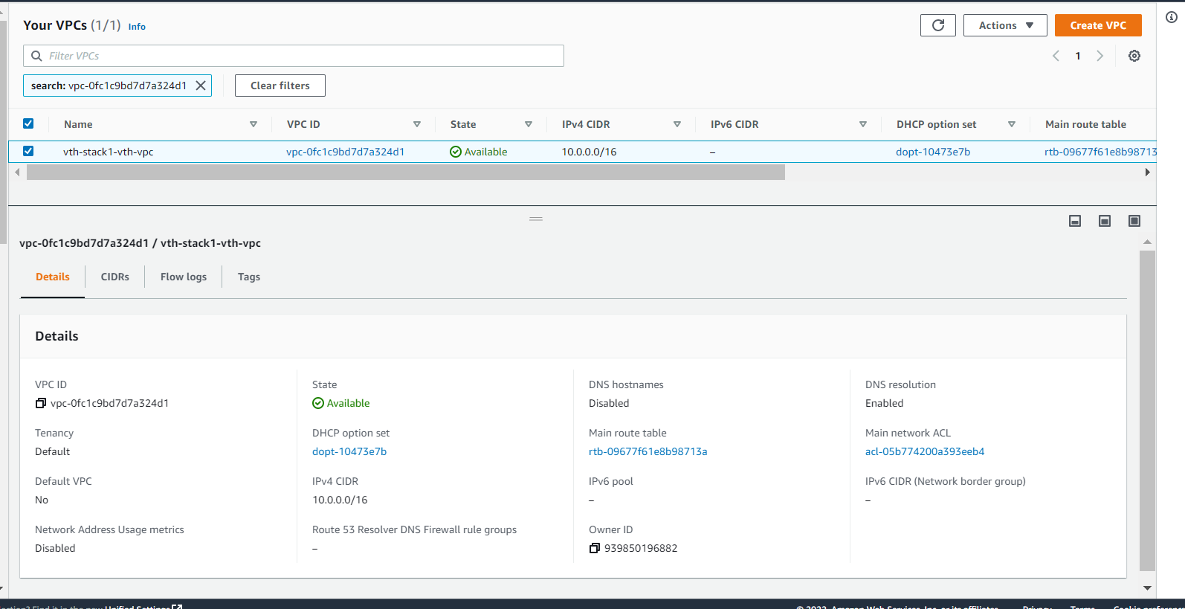

## Public Ips

* Expected Outcome: 2 public EIP get created and assigned to generated instances.
* Actual Outcome: 2 public EIP get created and assigned to generated instances

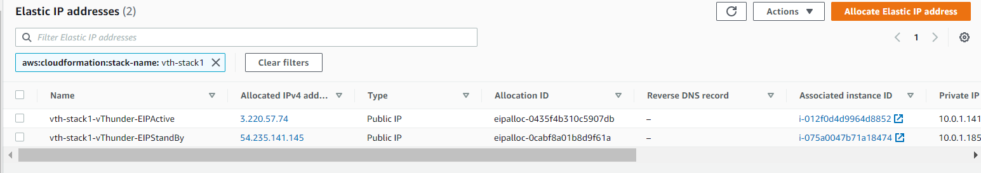

{stack name}-vThunder-EIPActive is assigned to instance 1.

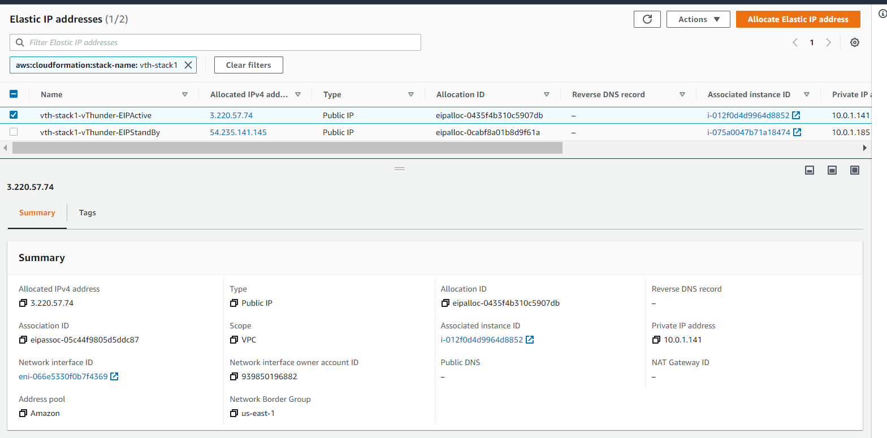

{stack name}-vThunder-EIPStandBy is assigned to instance 2.

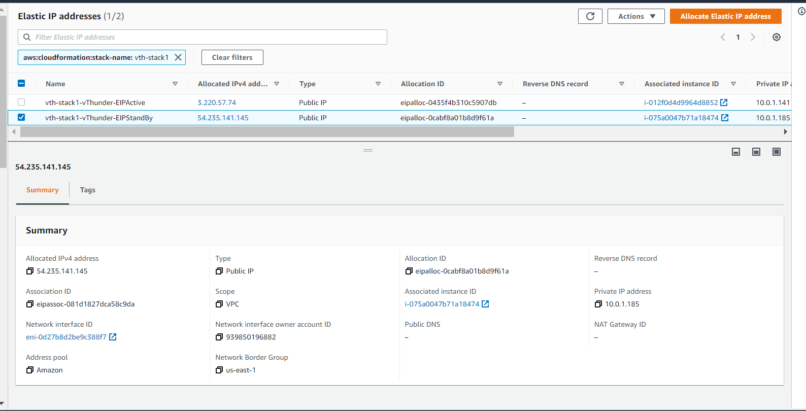

## NSGs

* Expected Outcome: 2 security groups should get created and must have inbound rules.
* Actual Outcome: 2 security groups is created and attached to VMs and there are some inbound security rules created.

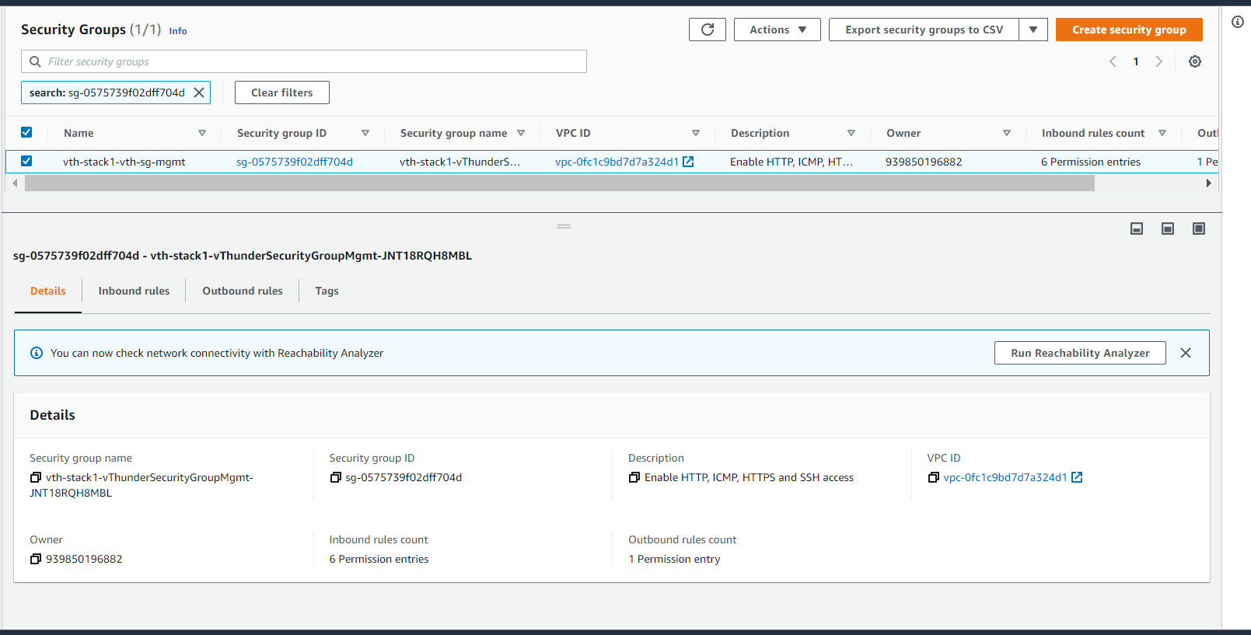

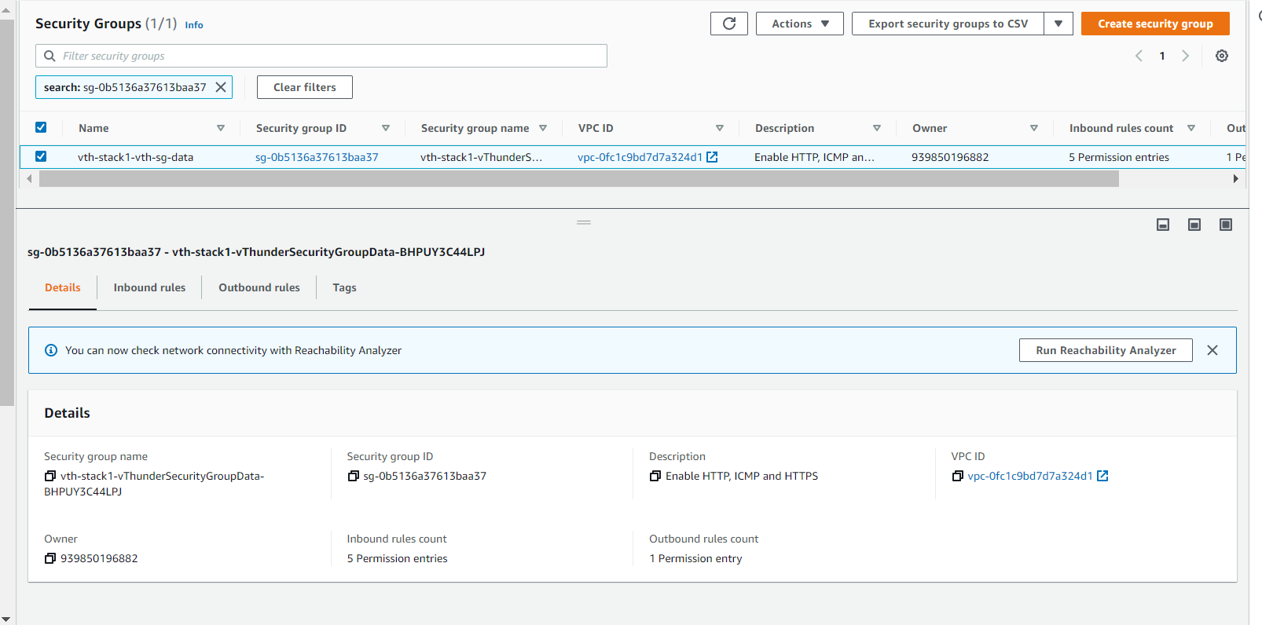

Network Security Group Inbound rules.

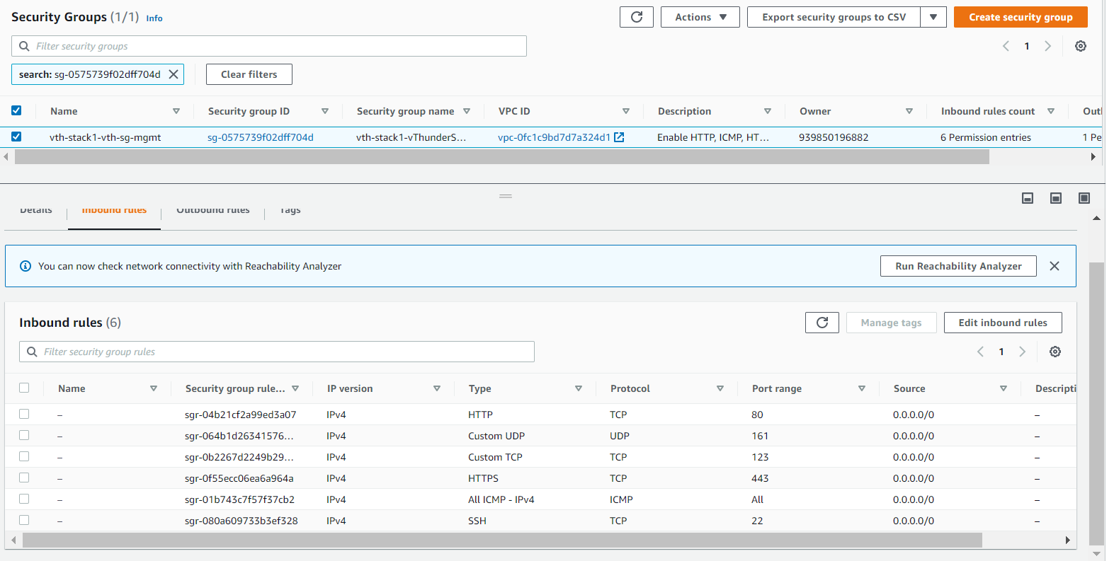

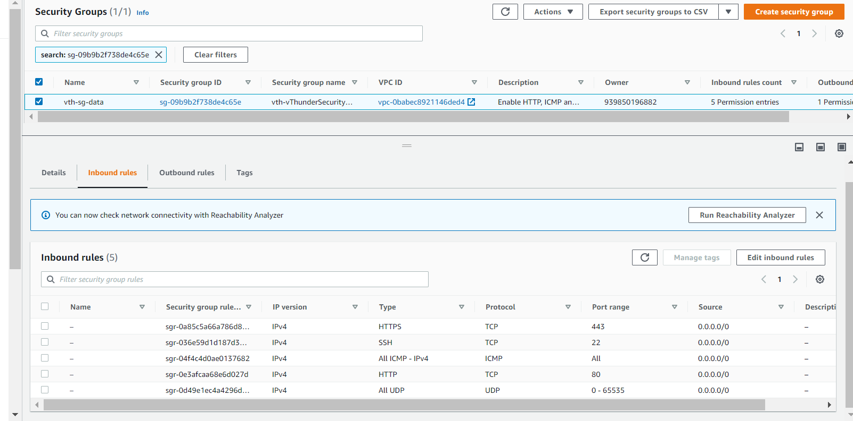

Network Security Group Outbound rules.

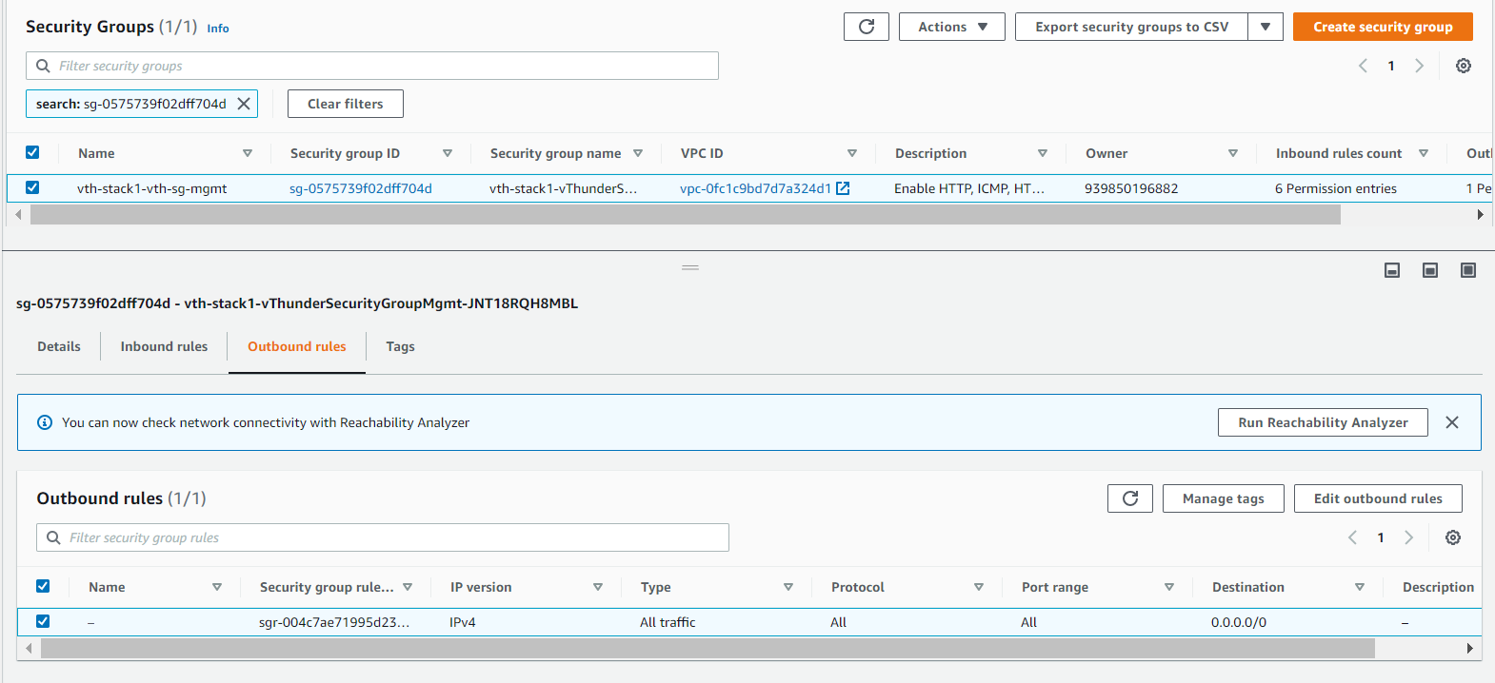

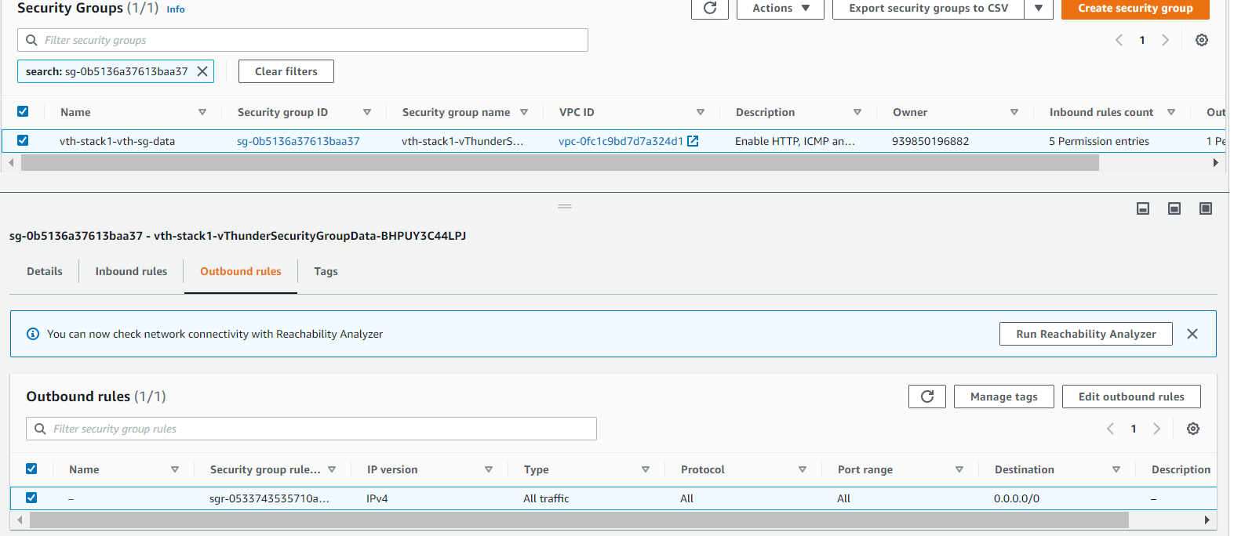

## vThunder Instances

* Expected Outcome: 2 vThunder instances should get created.
* Actual Outcome: 2 vThunder instances are created.

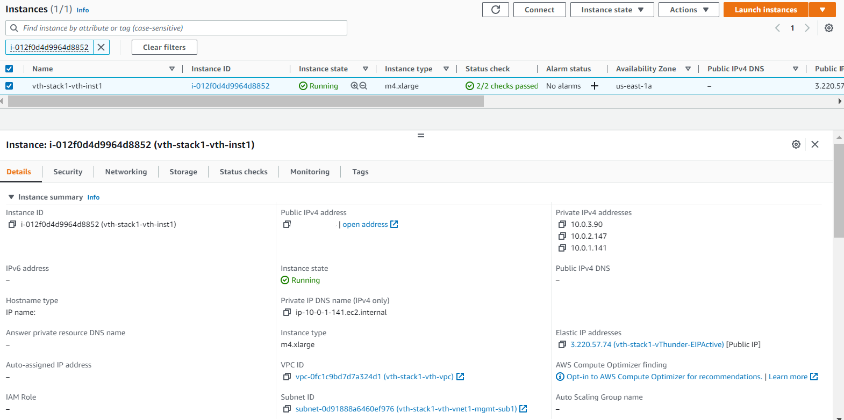

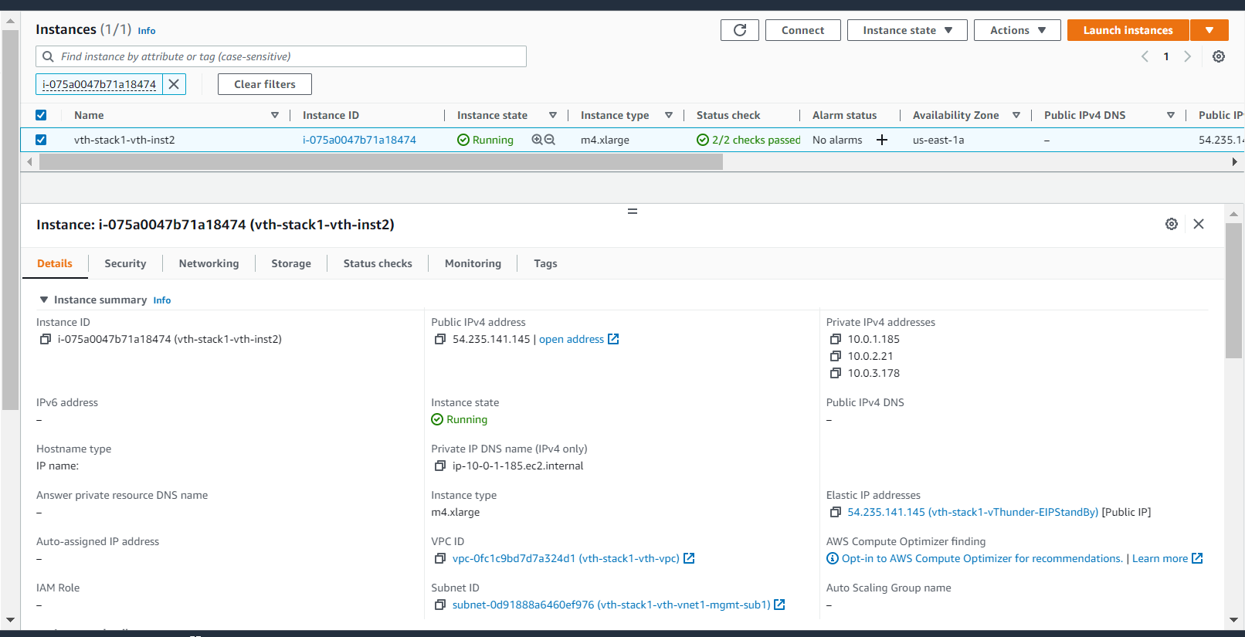

# vThunder Networking Configuration on AWS

## vThunder-1

### Management Interface

* Expected Outcome: Management interface will have only primary ip, no secondary ip.
* Actual Outcome: Management interface has only primary ip.

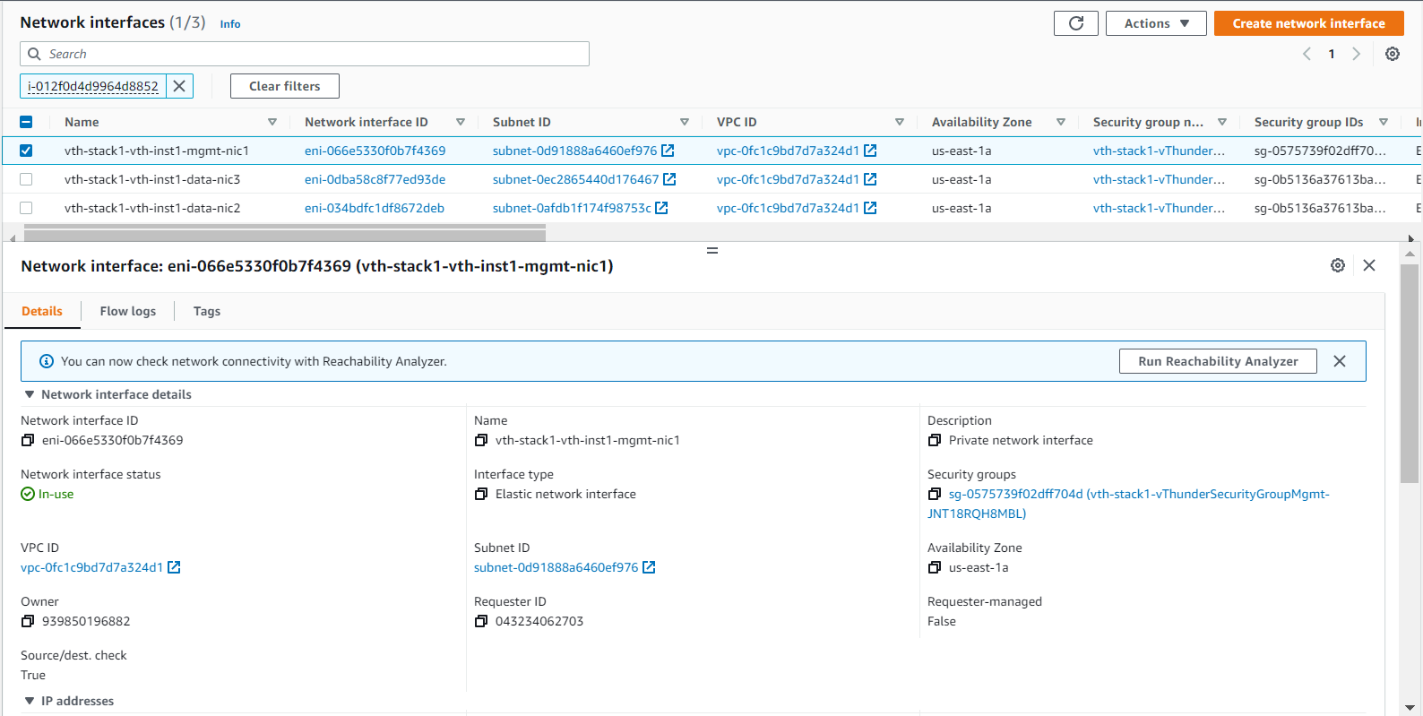

### Data Interface (Client Side)

* Expected Outcome: Client side data interface will have 1 primary ip and 1 private secondary ip.
* Actual Outcome: Client side data interface has 1 primary ip and 1 private secondary ip.

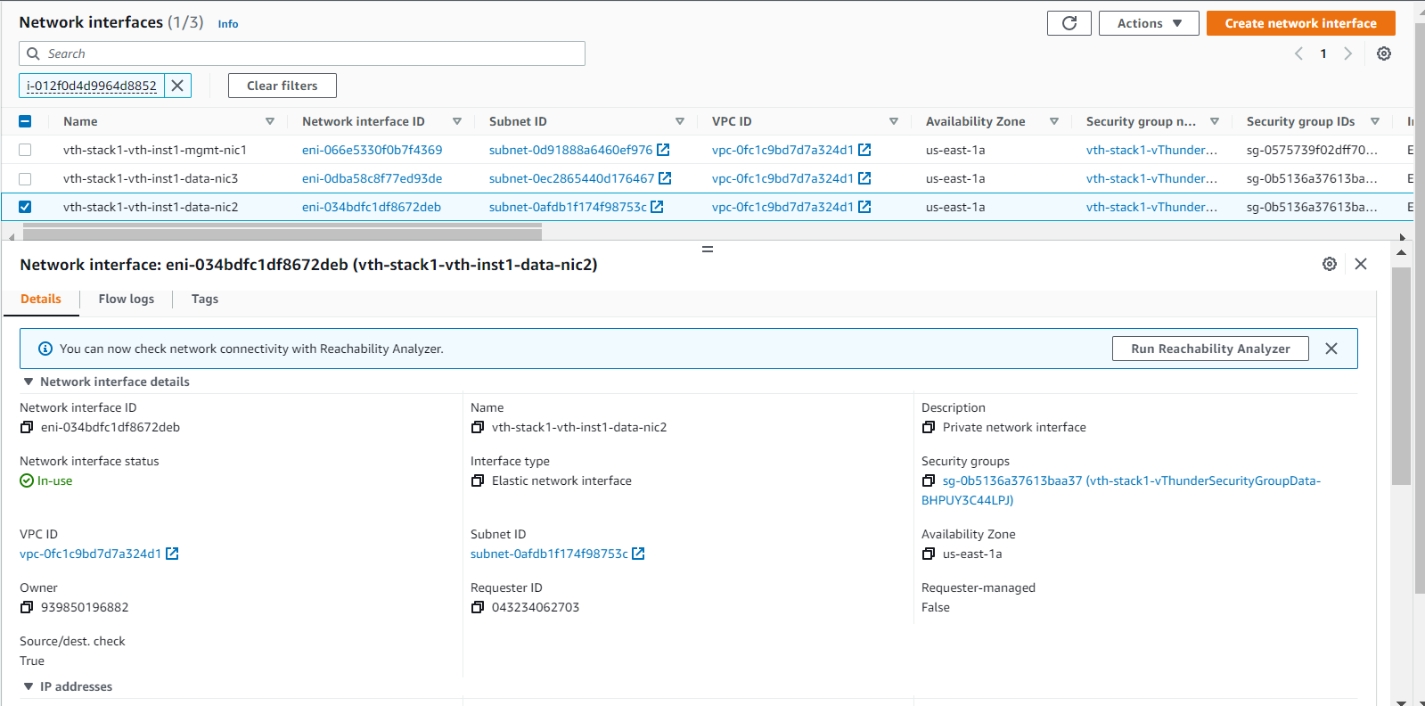

### Data Interface (Server Side)

* Expected Outcome: Server side interface will have 1 primary ip and 1 private secondary ip.
* Actual Outcome: Server side interface has 1 primary ip and 1 private secondary ip.

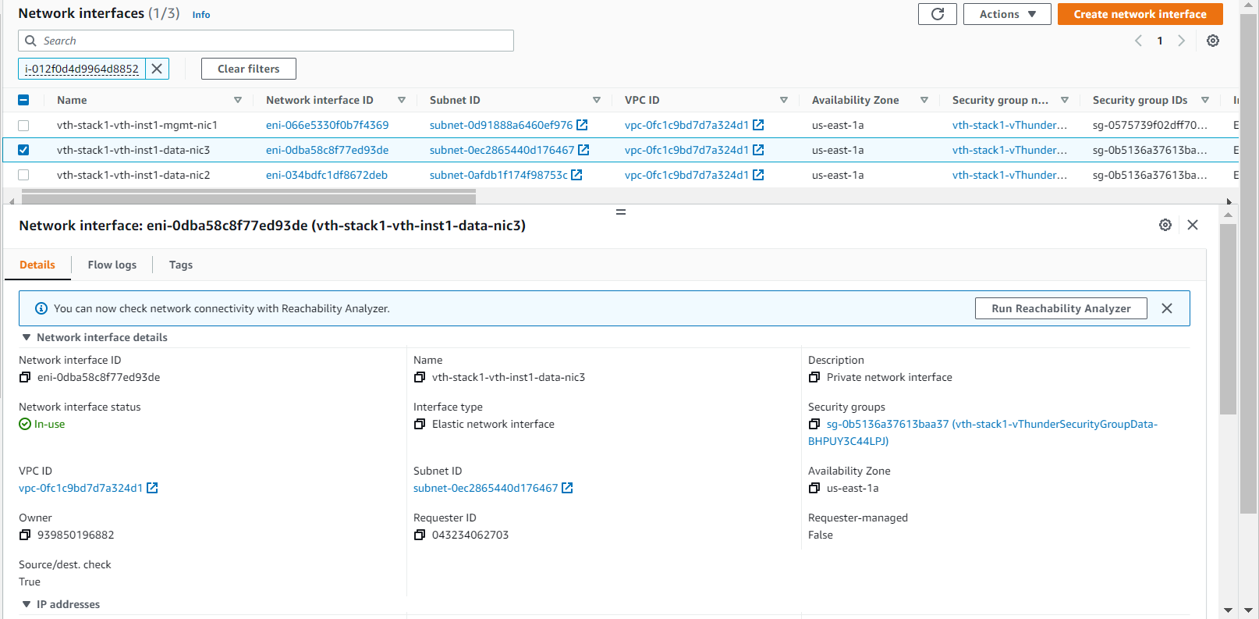

## vThunder-2

### Management Interface

* Expected Outcome: Management interface will have only primary ip, no secondary ip.
* Actual Outcome: Management interface has only primary ip.

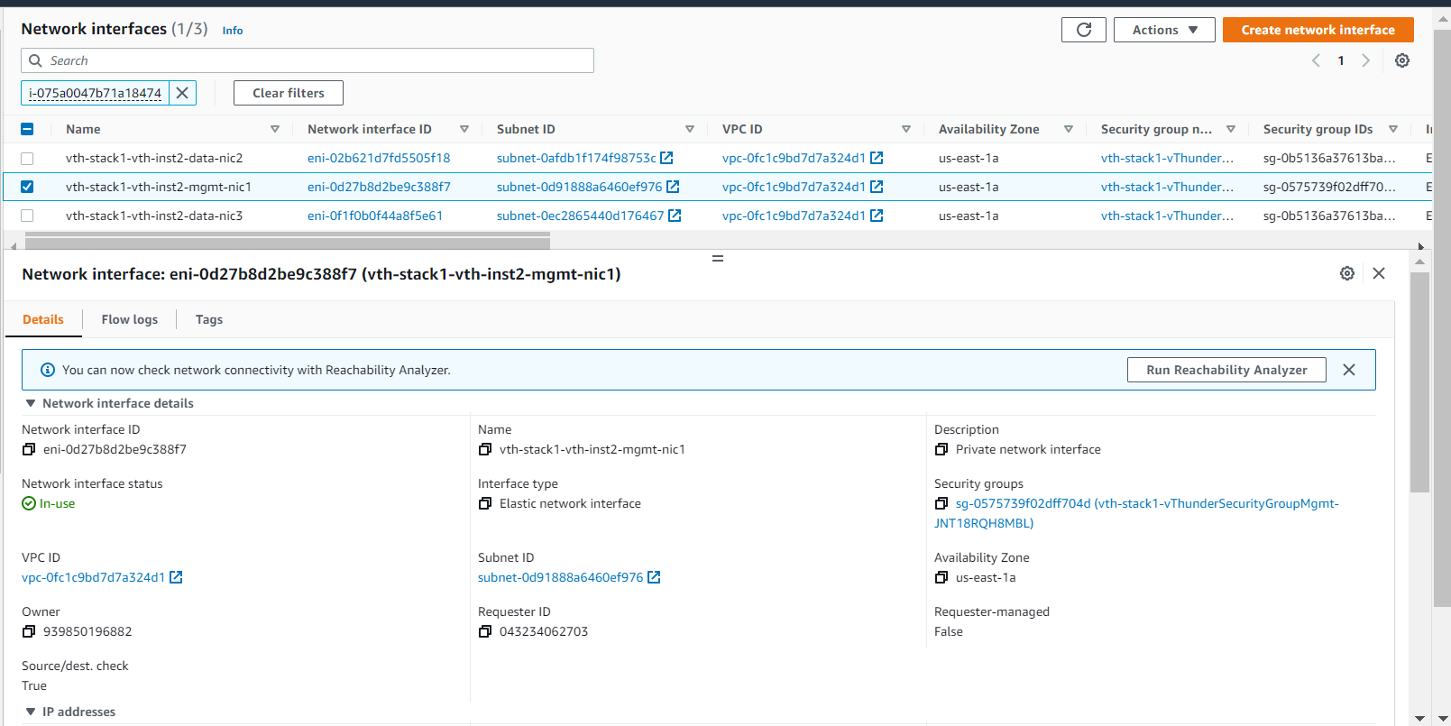

### Data Interface (Client Side)

* Expected Outcome: Client side data interface will have 1 primary ip and no private secondary ip.
* Actual Outcome: Client side data interface has 1 primary ip and no private secondary ip.

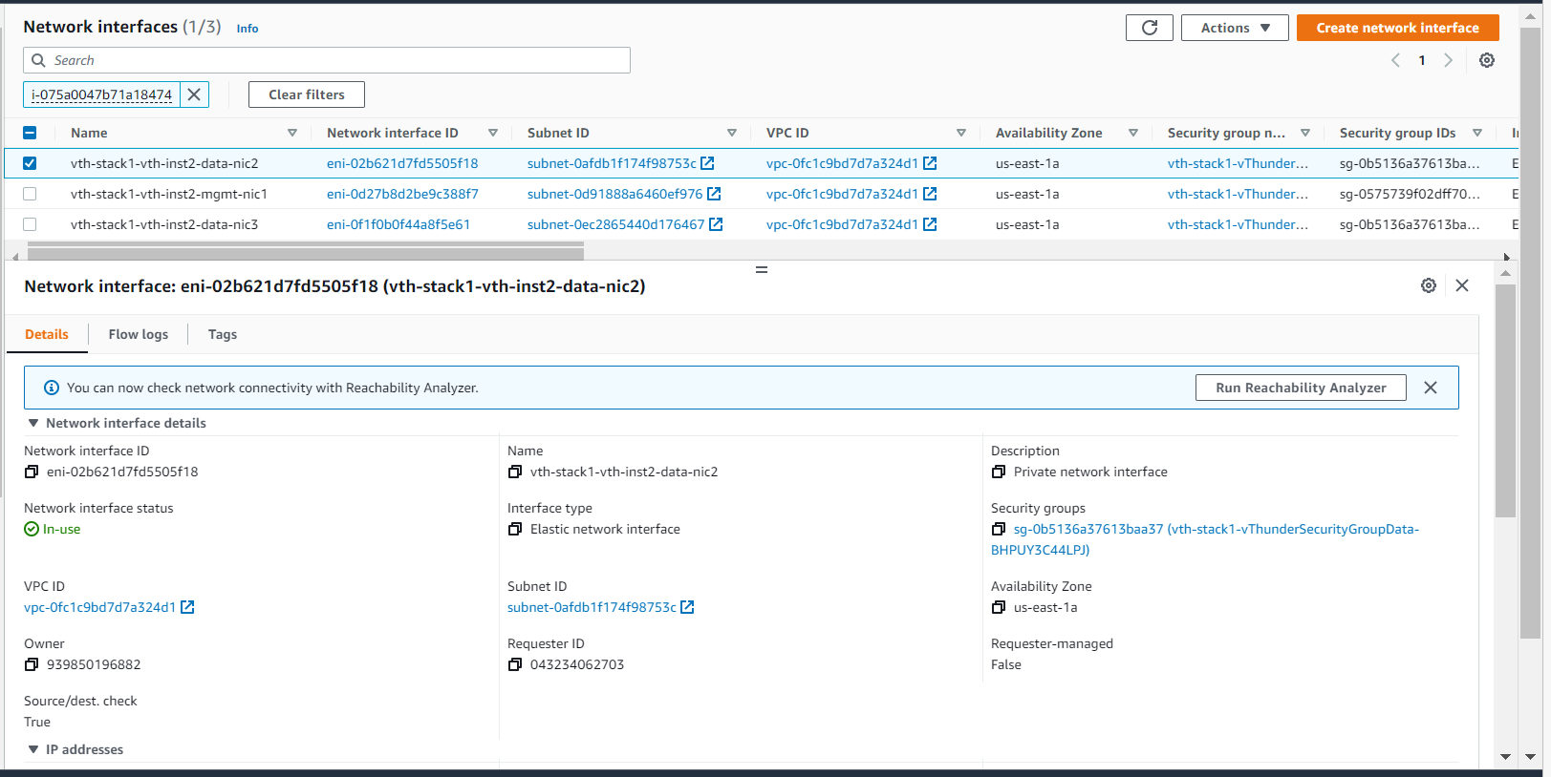

### Data Interface (Server Side)

* Expected Outcome: Server side interface will have 1 primary ip and no private secondary ip.
* Actual Outcome: Server side interface has 1 primary ip and no private secondary ip.

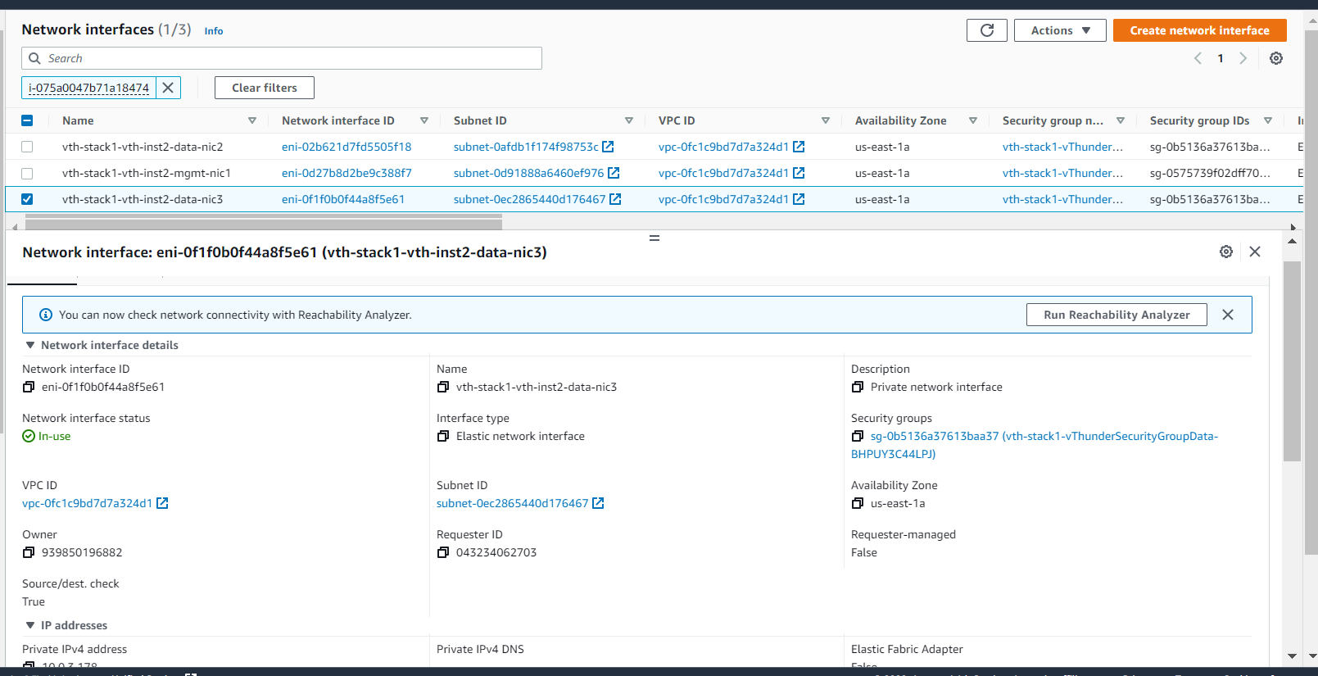

# vThunder IP Configuration

### Slb verification

*vThunder 1(stack name-vth-inst-1)*

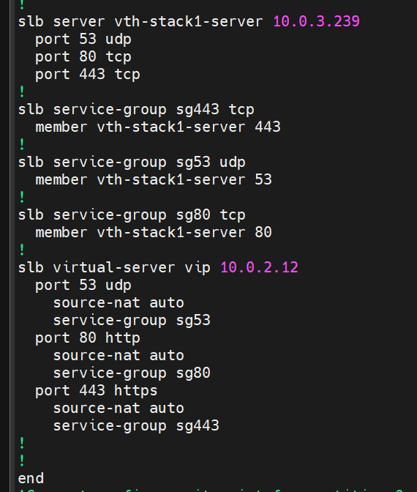

*vThunder 2(stack name-vth-inst-2)*

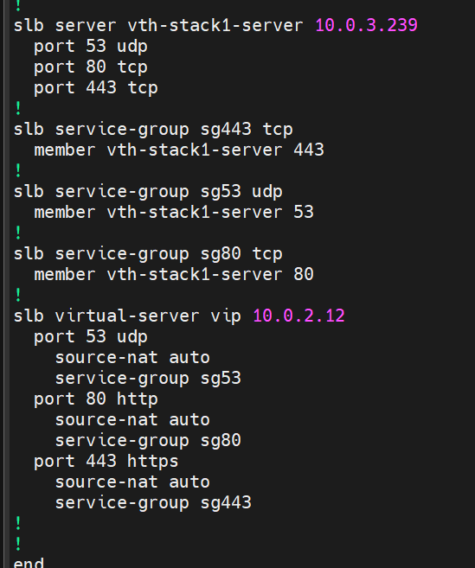

### SSL verification

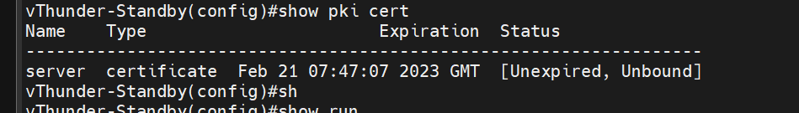

### HA verification

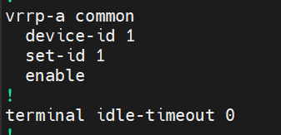

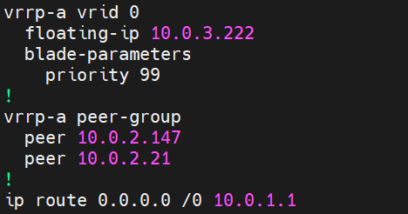

*vThunder 2(stack name-vth-inst-2)*

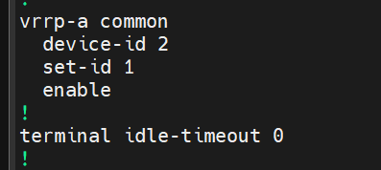

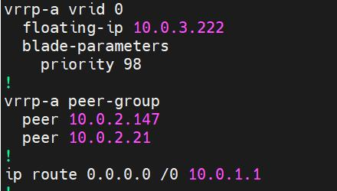

vth-stack1-vth-inst1

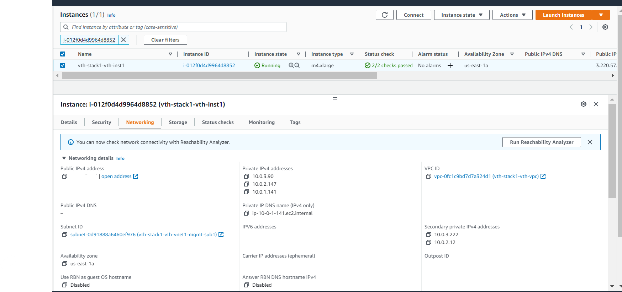

vth-stack1-vth-inst2

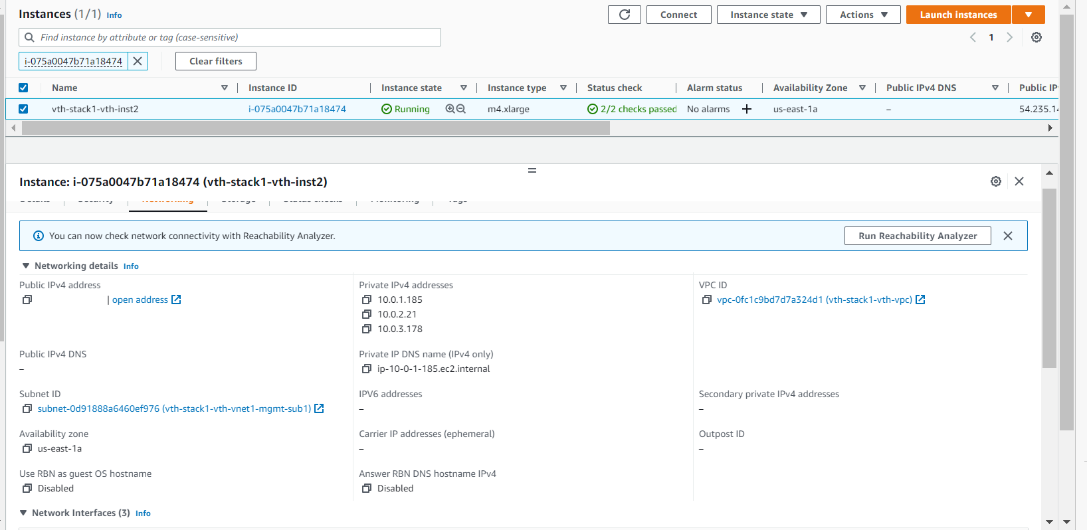

#### Traffic testing

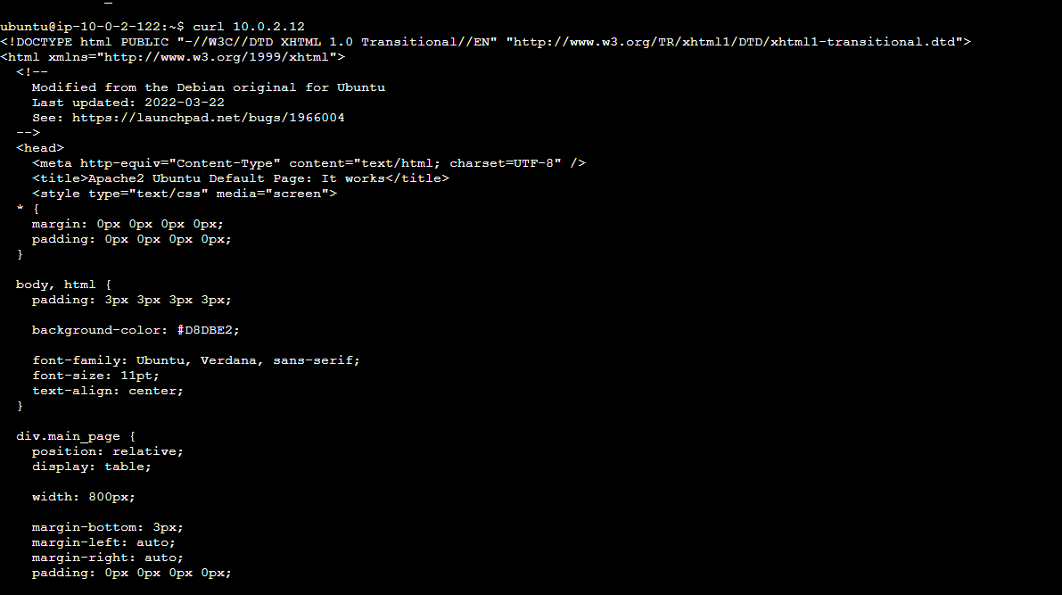

**After Force StandBy:**

vth-stack1-vth-inst1

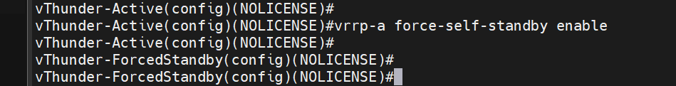

vth-stack1-vth-inst2

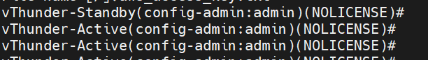

vth-stack1-vth-inst1

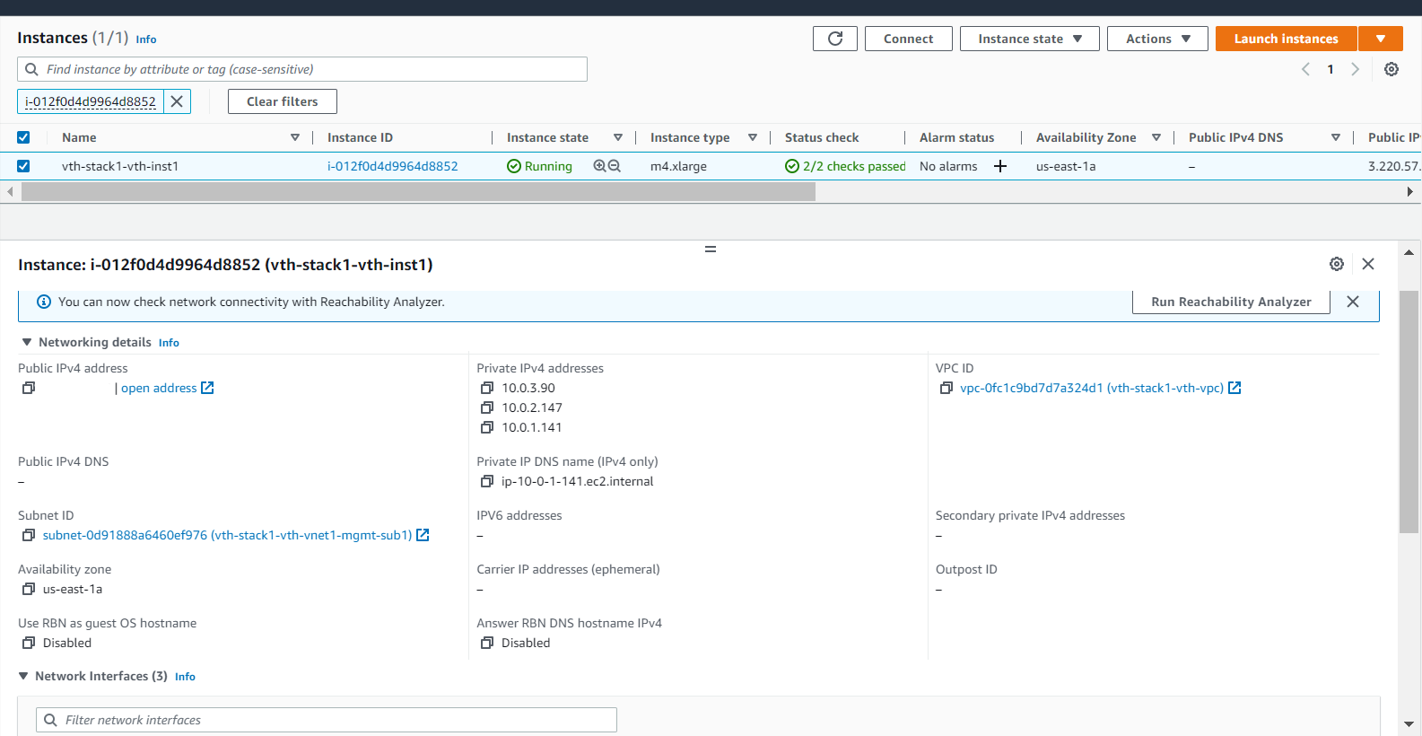

vth-stack1-vth-inst2

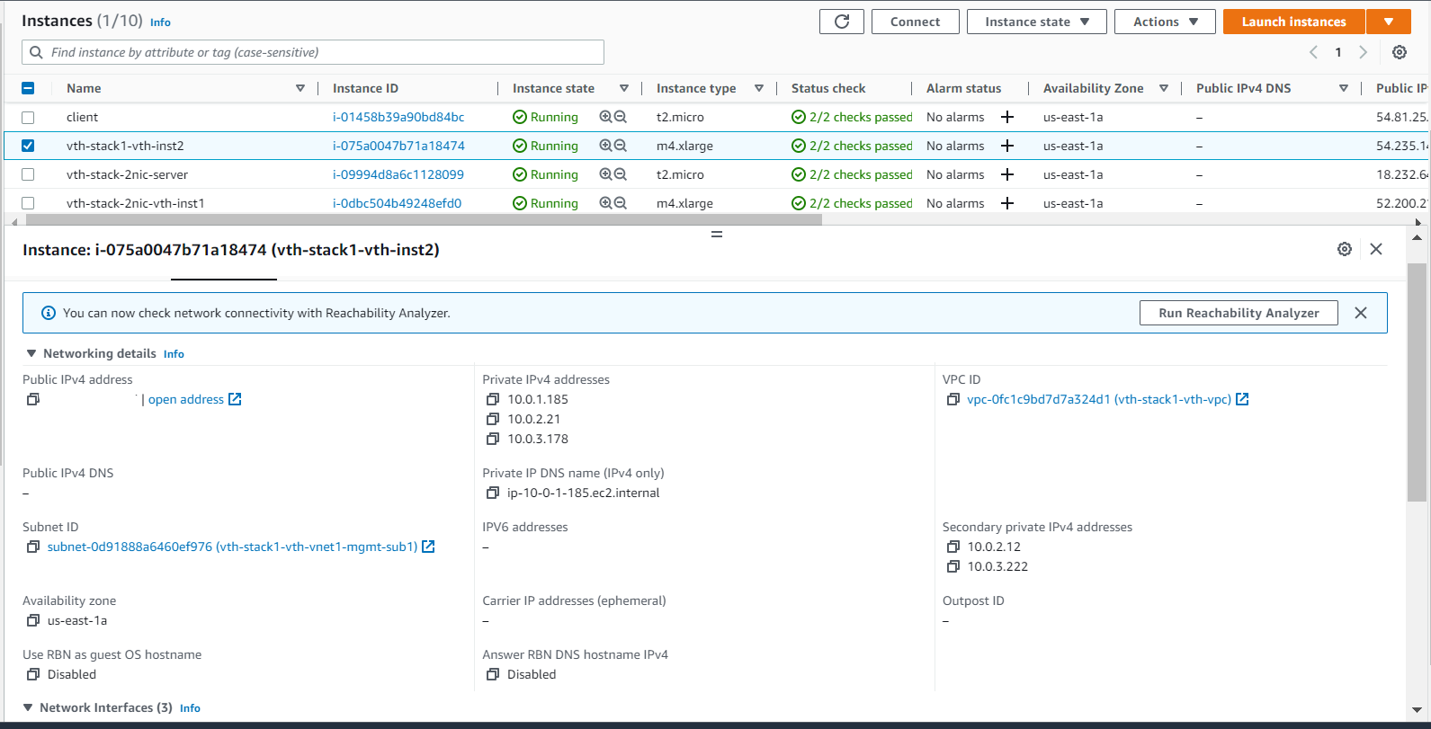

#### Traffic testing

