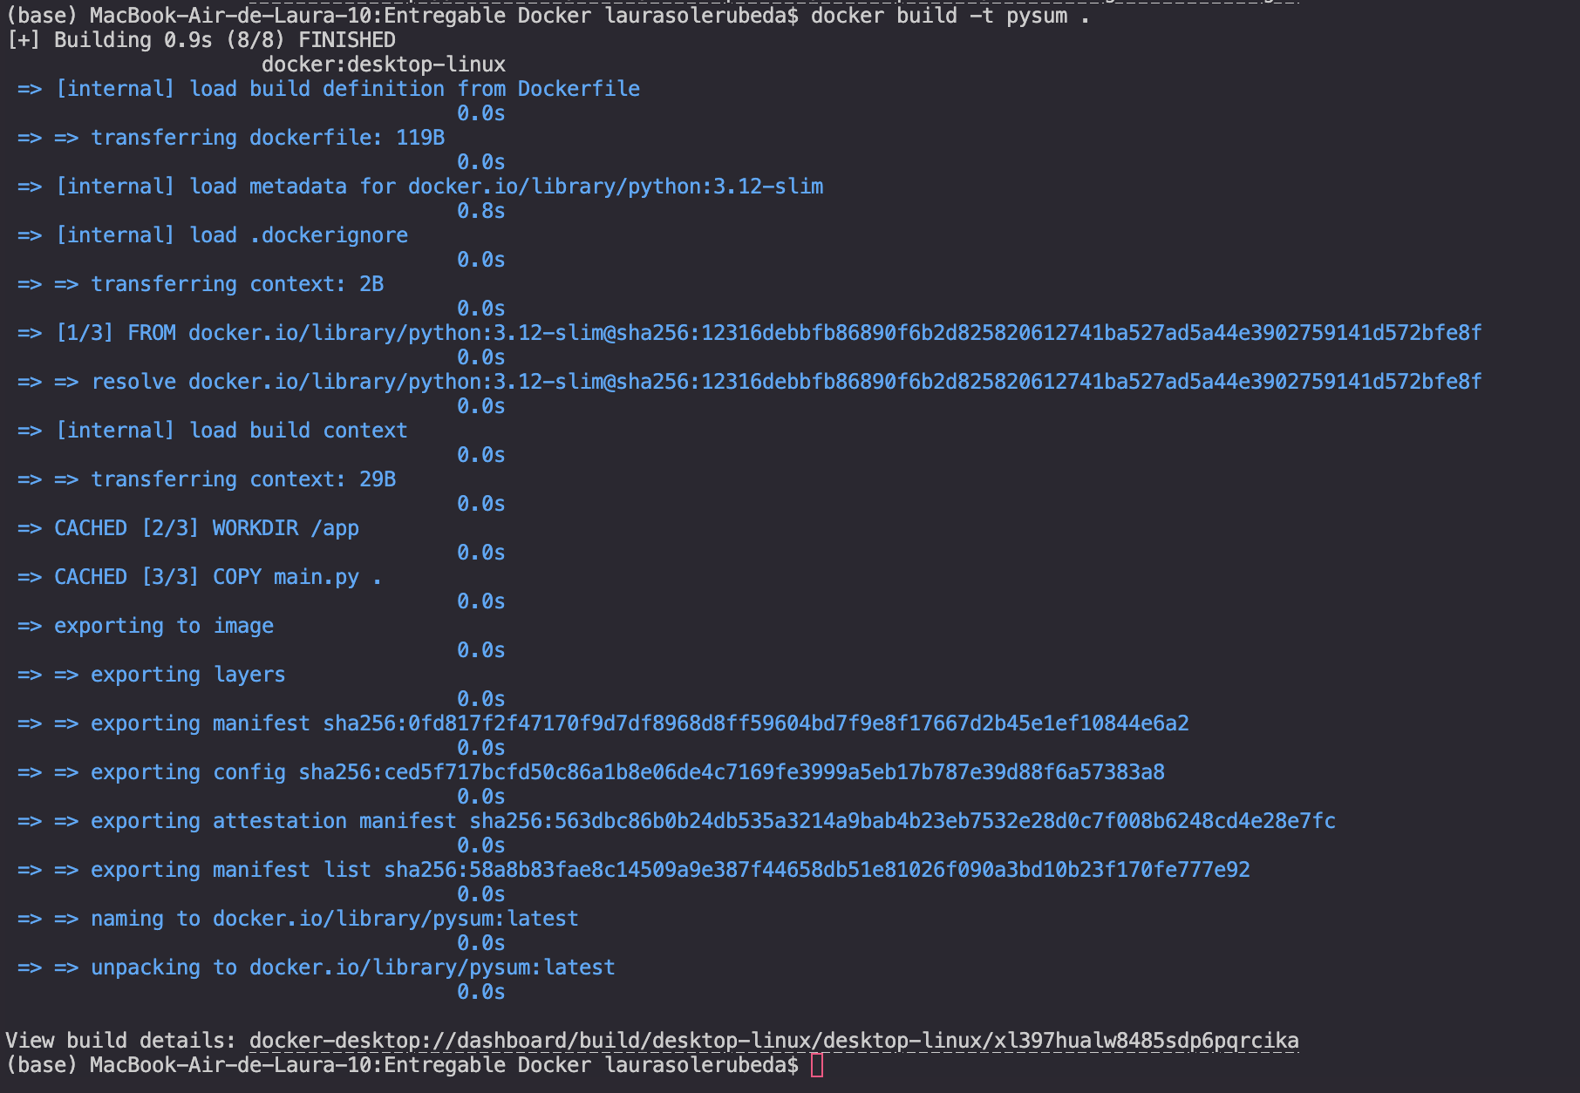
https://hub.docker.com/r/laurasolerubeda/pysum

