Examination Seat No: ___________

CERTIFICATE

Mumbai Educational Trust

Institute of Computer Science

M.C.A. Sem-III
2020-2021

This is to certify that Mr. Rushdan Niaz Ahmed Bijapure of MCA Sem-III
(CBCGS) Rollno 1003 has successfully completed practical assignments in the
subject of MCAPR301 MINI PROJECT during academic year 2020-2021 as specified
by the UNIVERSITY OF MUMBAI.

________________ ___________
Faculty in-charge Principal

_________________________
External examiner

INDEX
Subject: MINI PROJECT Semester: III

Sr. No. | Title
1 | Introduction
2 | System Study
3 | Analysis and Design
4 | Testing and Validation
5 | User Manual
6 | Conclusion

1.INTRODUCTION

  - Introduction to project
My project entitled “Electricity Billing System” aims is to generate electricity bill with all the charges. Manual system that is employed is extremely laborious and quite inadequate. It only makes the process more difficult and hard. I have used core java and PostgreSQL for developing our project to solve these issues.

  - Problem Definition

The aim of our project is to develop a system that is meant to partially computerize the work performed in the Electricity Board like generating monthly electricity bill, record of consuming unit of energy, store record of the customer.

  - Objectives of Project
The firm handles all of the work manually, which is very tedious and mismanaged. The objective of our project is as follows:
a. To keep the information of Customer.
b. To calculate bill on the information of consuming unit of energy of current month.
c. To calculate the bill on the basis of consuming unit of energy of previous month.

  - Scope of Project
My project aims at Business process automation, i.e. I have tried to computerize various processes of Electricity Billing System. In the sector of electricity board we have computerizes their department

2.SYSTEM STUDY

  - Existing System
The exiting system consists of manual labor which is tedious and error prone. It only makes the process more difficult and hard. The old manual system was suffering from a series of drawbacks. Since whole of the system was to be maintained with hands the process of keeping, maintaining and retrieving the information was very tedious and lengthy. The records were never used to be in a systematic order. there used to be lots of difficulties in associating any particular transaction with a particular context. If any information was to be found it was required to go through the different registers, documents there would never exist anything like report generation. There would always be unnecessary consumption of time while entering records and retrieving records. One more problem was that it was very difficult to find errors while entering the records. Once the records were entered it was very difficult to update these records.

  - Disadvantages of exiting system
It lacks the following properties
a. It satisfy the user requirement
b. Be easy to understand by the user and operator
c. Be easy to operate
d. Have a good user interface
e. Be expandable
f. Tasks are delivered on schedule within the budget.

  - Proposed system
The proposed system includes the use of programming language and the use of powerful DBMS for the development of the project that will facilitate and support all the points which are discussed above.

  - Use Case
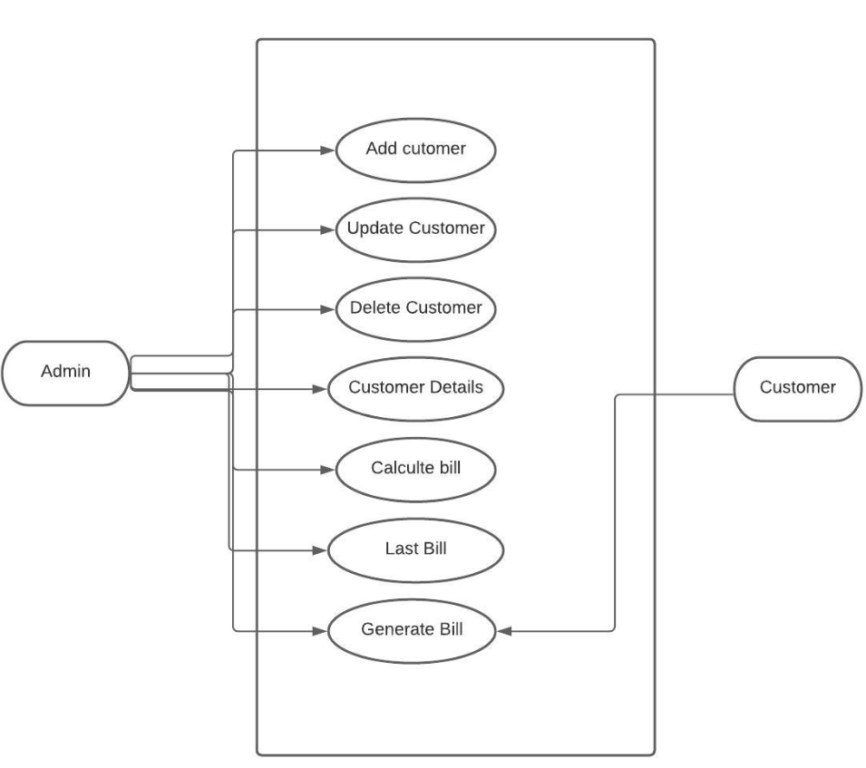

3.ANALYSIS AND DESIGN
  - S/W and H/W requirement specification
S/W required are
jdk 14/15 and PostgreSQL
Hardware requirement includes
A computer with running OS.

  - Flowchart
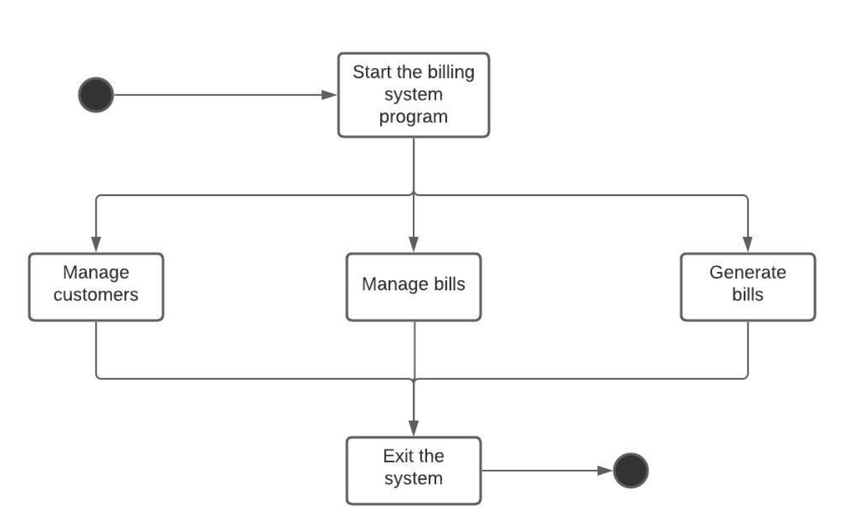
  - Module design and organization
This project includes Modules/Table designs
a. bill
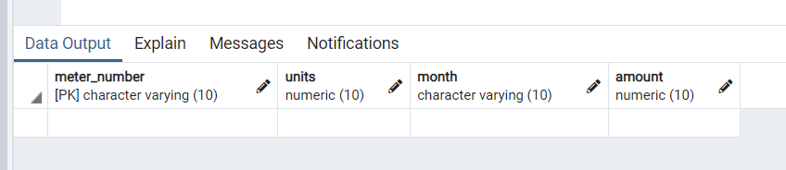
The bill table include the above columns where meter number is set to primary key and units and amount is set to numeric to perform certain arithmetic operations to calculate the bill of a customer on the basis of the units of electricity consumed.

b. cust (Customer table)
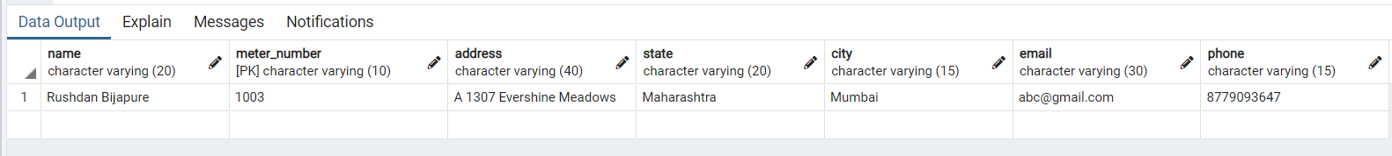
This table is just used to display all the existing users this is the reason why all the columns are set to var-char and in this table too meter number is set to primary key.

4.TESTING AND VALIDATION
Testing is vital for the success of any software. no system design is ever perfect. Testing is also carried in two phases. first phase is during the software engineering that is during the module creation. second phase is after the completion of software. this is system testing which verifies that the whole set of programs hanged together.
  - White Box testing
In this technique, the close examination of the logical parts through the software are tested by cases that exercise species sets of conditions or loops. all logical parts of the software checked once. errors that can be corrected using this technique are typographical errors, logical expressions which should be executed once may be getting executed more than once and error resulting by using wrong controls and loops.
  - Black Box testing
This method enables the software engineer to device sets of input techniques that fully exercise all functional requirements for a program. black box testing tests the input, the output and the external data. it checks whether the input data is correct and whether we are getting the desired output.
  - Alpha testing
Acceptance testing is also sometimes called alpha testing. Be spoke systems are developed for a single customer. The alpha testing proceeds until the system developer and the customer agree that the provided system is an acceptable implementation of the system requirements.
  - Beta testing
On the other hand, when a system isto be marked as a software product, another process called beta testing is often conducted. During beta testing, a system is delivered among a number of potential users who agree to use it. The customers then report problems to the developers. This provides the product for real use and detects errors which may not have been anticipated by the system developers.
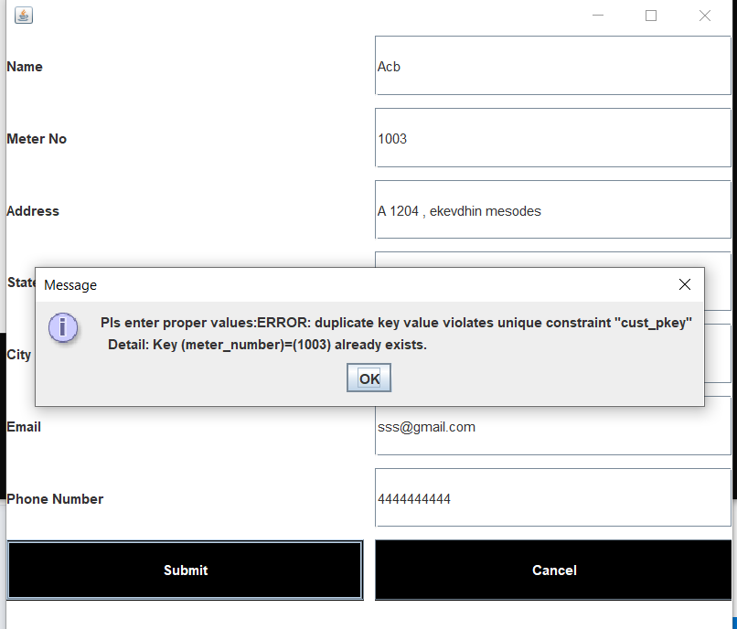
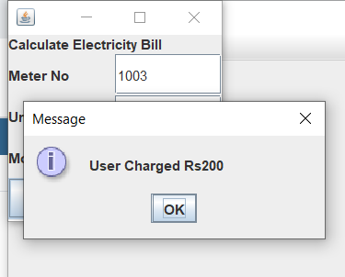
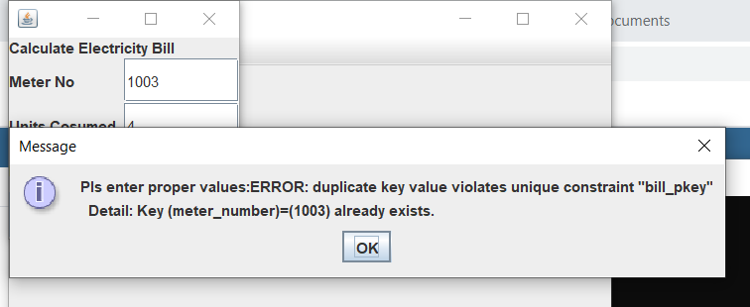
Some of the examples where I tried to give a new user the same meter number and then tired to charge the same customer twice.

5.USER MANUAL
  - Master
The mater module contains functions of adding ,updating and deleting a customer's. It also includes the functionality to see all the exiting customers of the system.
  - User
The user module contains the functionality to calculate the bill view the users who have been charged till now and also contains an option which leads to and dummy payment gateway.
  - Report
The report module helps the admin to generate a bill which can then be clipped and send to the user on the registered email id.
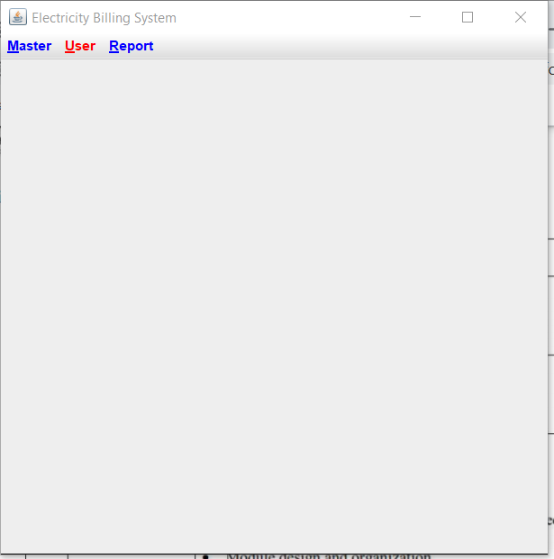
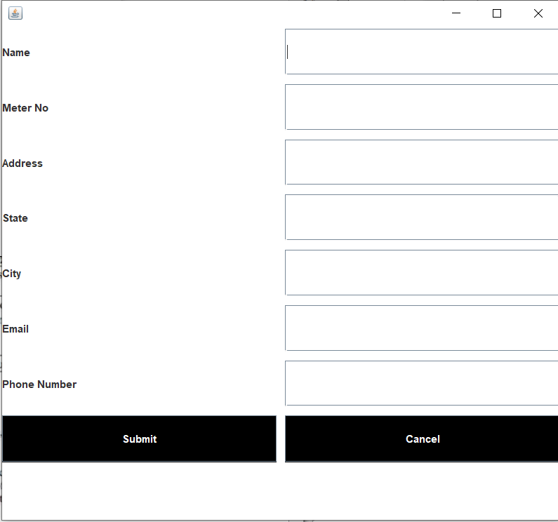
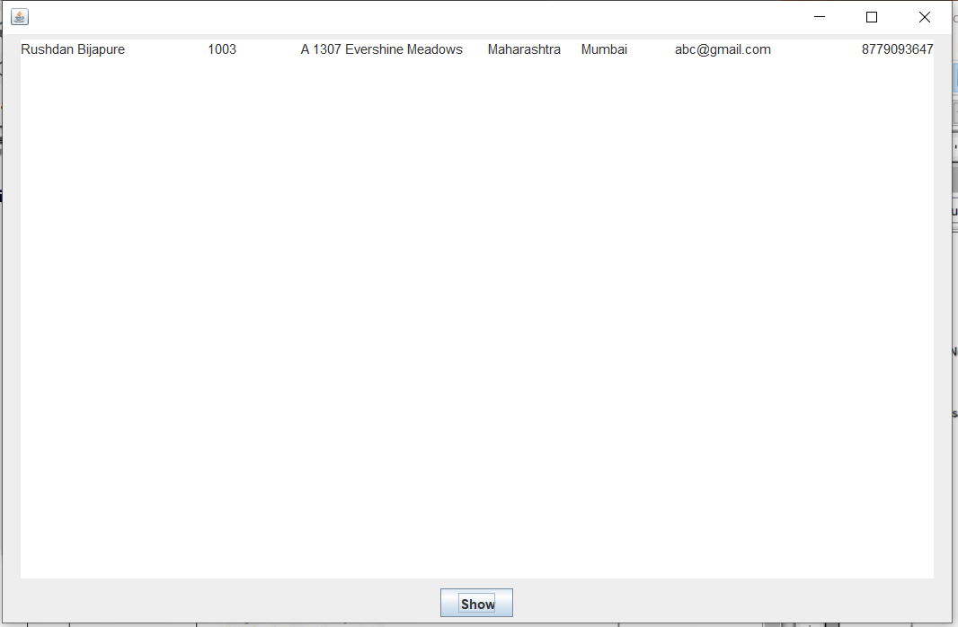

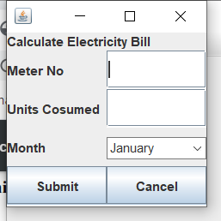
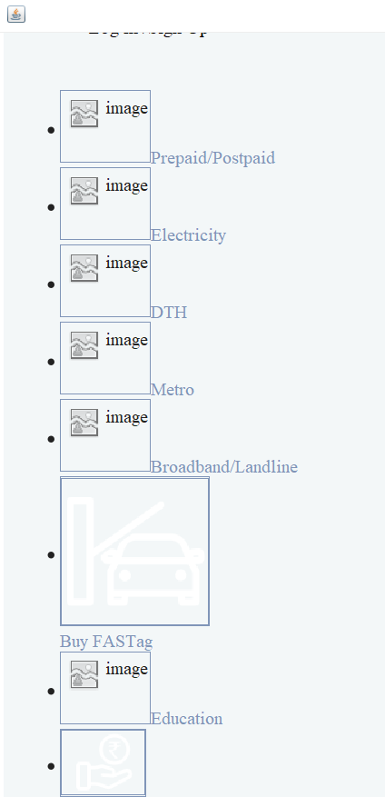
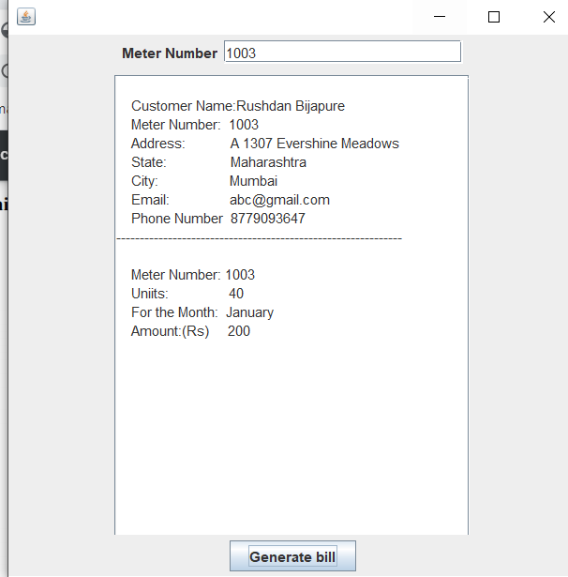

6.CONCLUSION
I have tried to develop a system that can be a great help for the owner of the referred electricity department to receiving bill from the customer. Despite all my efforts there are some bugs in the system, which are still to be removed.
Enhancements:
I have left all the options open so that if there is any other future requirement in the system by the user for the enhancement of the system then it is possible to implement them.
I hope that the project will serve its purpose for which it is develop there by underlining success of process.

