yun -y install postfix

修改配置文件
vim /etc/postfix/main.cf

- 修改邮件服务主机名
myhostname = mail.ygjmail.com
- 修改mydomain = ygjmail.com
- 修改myorigin = $mydomain
- 修改smtp监听端口
inet_interfaces = all
- 修改通讯协定
inet_protocols = IPv4
- 修改mydestination = $myhostname, localhost.$mydomain, localhost, $mydomain
- 修改mynetworks = 0.0.0.0/0
- relay_domains = $mydestination
- alias_maps = hash:/etc/aliases
- alias_database = hash:/etc/aliases

postfix check检查

/etc/init.d/postfix restart 重启服务

yum install dovecot* -y

/ect/dovecot.conf

protocols = imap pop3 lmtp

listen = *

systemctl restart dovecot

查看程序运行端口
yum install net-tools -y

netstat -ntl

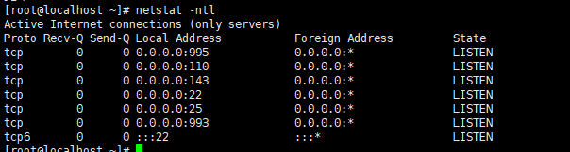

yum install cyrus-sasl*
systemctl restart saslauthd

foxmail测试
useradd ygj111;echo 123456|passwd --stdin ygj111
useradd ygj112;echo 123456|passwd --stdin ygj112

mkdir -p /home/ygj111/mail/.imap/INBOX/
mkdir -p /home/ygj112/mail/.imap/INBOX/

chown -R ygj111.ygj111 /home/ygj111/
chown -R ygj112.ygj112 /home/ygj112/

Dovecot Smtp 验证设置

/etc/dovecot/conf.d/10-auth.conf
disable_plaintext_auth = no

/etc/dovecot/conf.d/10-mail.conf
mail_location = mbox:~/mail:INBOX=/var/mail/%u

/etc/dovecot/conf.d/10-ssl.conf
ssl = no

开放端口：
firewall-cmd --add-port=25/tcp --permanent
firewall-cmd --add-port=110/tcp --permanent
firewall-cmd --reload
systemctl stop firewalld.service
systemctl start firewalld.service
systemctl restart firewalld.service
设置开机启动
systemctl enable named

-------------------------------------------------------------------------------
postfix 虚拟用户配置

